WEEKLY REPORT and MEETING AGENDA

Report #: 1 Project Name: Robust soil moisture sensor network
Date: 10/29/2017 Prepared by: Kerry Zeng

Agenda for the meeting
- Discuss Individual Progress.
- Discuss any roadblocks they have on their current work: hardware wiring/soldering, create webserver and database, and establish serial Bluetooth connection.
- Split team up and work on the different portions of the project.
- Do a progress report and discuss and split remaining work among team members.

Overall accomplishments since last meeting
- Created an Agile Storyboard
- Created designs for moisture sensor
- Bought materials for the project

Tasks completed by each team member since last meeting

Task description | Assigned to | Completed?
Create Design for 3d Printed Encasings | Henry | Yes
Wire the sensor and Arduino and get readings from the sensor | Jingyu | Yes
Write Helper Methods to Serialize Sensor Inputs to JSON | Kerry | Yes
Write Database Schema for storing Sensor readings |  | Yes
Install Libraries and write sample code for Bluetooth communication | Curtis | Yes
Do research on Bluetooth | Hunter | Yes

Plans for next period
- Establish two-way communication between Arduino and Raspberry Pi
- Finish writing API for the server
- 3d Print and combine all of the hardware into one package

Task assignment per team member (to be completed before the next meeting)

Task description | Assigned to
Write endpoints for server | Kerry
Establish Bluetooth Server on Raspberry Pi | Curtis
Solder and make battery powered sensors without the encasing | Jingyu
3d Print Encasings | Henry

Project management status
- A lot of progress was made on the hardware portion. All pins were soldered onto the board and the sensors were connected. The designs for the 3d printed encasing is done and now it needs to printed.
- The progress on the software is divided up into 3 parts. The Arduino for the Moisture sensing, the Raspberry Pi cluster head that sends data to the server, and the server itself. A lot of progress was made on the server, but the Arduino code is a little slower. The team needs a little bit of time to learn how to code in Arduino and how Bluetooth Low Energy works.
- We bought half of the materials needed and are planning to buy the rest as we finish the different components. We will buy the server once we finish writing the software for it. We will also buy more sensors once we finish writing all the code for the moisture sensors.
- The teamwork is overall good. Team members are polite to one another and there is a lot of cohesion between individual members, but not as much within the entire group. Additionally, the team needs a little more time to mesh and be able to work together when people need help. Most of the team won’t do things unless specifically told to.

Minutes from previous meeting
We discussed what we each did in the meeting
- Kerry worked with Curtis to install the required libraries for Bluetooth Communication on the Raspberry Pi 3. He said he would work on the server/database communication with the Raspberry Pi 3.
- Henry said he completed the designs for the Plastic Encasing and bought the items.
- Curtis said he worked on the Bluetooth Communication and had some code he wanted to try on the Pi.
- Jingyu said she was able to get readings from the moisture sensors using the built in ADC and print it to the console.
- Hunter said he did some research.
- Discussed which
- The team split into 3 sub-teams: Kerry was going to work on the webserver and the database, Curtis and Hunter were going to work on the Bluetooth Communication, and Jingyu and Henry worked on soldering and creating the sensor-microcontroller.
- Results from the meeting:
  - Database Schema was created and Node server was initialized
  - Wrote a Python helper methods include a Moisture Sensor reading object and a ORM that converts it to JSON.
  - Soldered pins onto Beetle BLE and wired the moisture sensors
  - Was able to receive messages from the Beetle BLE, but couldn’t transmit.
- Distributed the tasks for next meeting.

Moisture Sensor Design
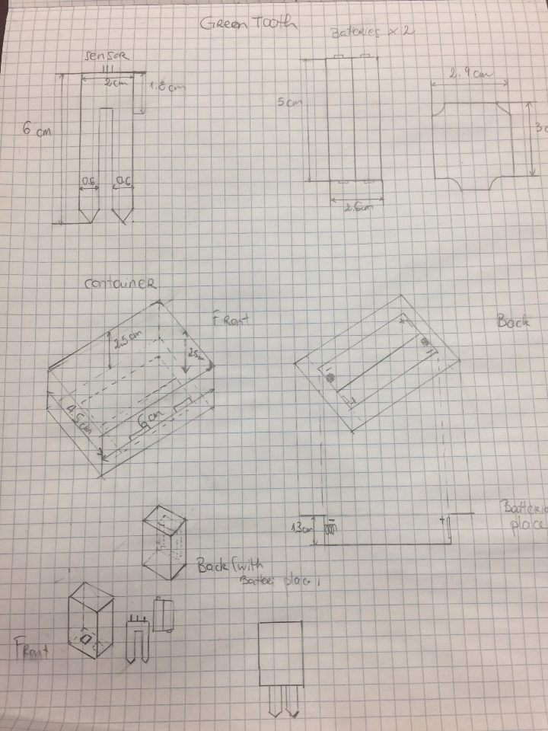
Moisture Sensor Readings on Arduino
