官网下载python-3.6.8-embed-amd64，拿python36.zip替换ide里面的base_library.zip

AirtestIDE\app\plugins\editor\template\base_template.py添加通用头

# -*- encoding: utf-8 -*-

import sys,os

thisdir = os.path.abspath(os.path.dirname(__file__))

workdir = os.path.abspath(os.getcwd())

sys.path.append(os.path.abspath(os.path.join(thisdir,'..','..','..')))

from comlib.exception import errorcatch,DingException,StopException,LOW,NORMAL,HIGH

from comlib import com,workspace,TMApkManager,TMIPAManager,ApkInfo

from models.testhelp import TestHelper,sleeptouch,logplus,exists_and_touch

from models.testhelp import assert_skipthis,assert_stopalltest

from models.pocohelp import *

curDevice = G.DEVICE

curSerialno = G.DEVICE.serialno

python模块airtest\cli\runner.py

AirtestCase类的

setUp方法添加self.err = None

runTest方法Exception改为BaseException，添加self.err=err

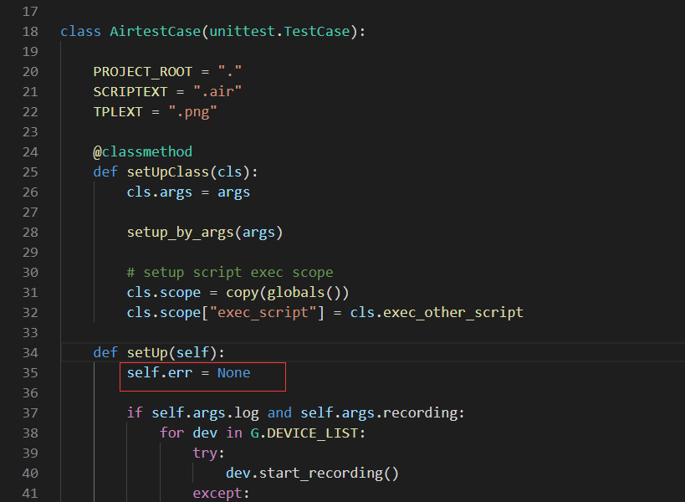

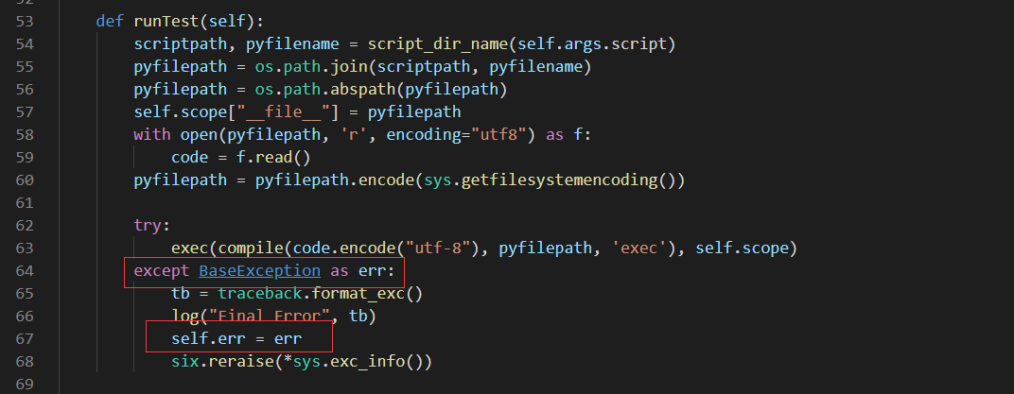

模块的run_script方法修改为如下

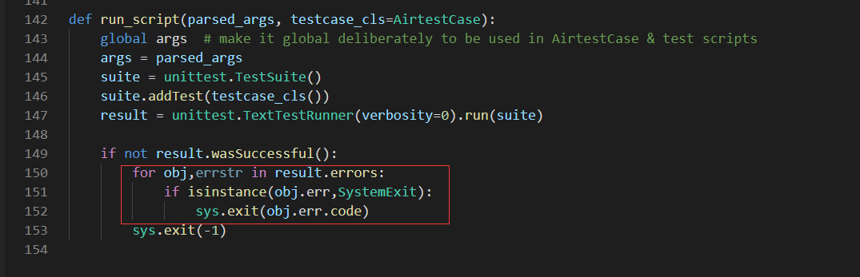

python模块airtest\core\android\javacap.py第2行添加

from time import sleep

get_frames函数添加重试

count = 0

while count < 3:

proc, nbsp, localport = self._setup_stream_server()

s = SafeSocket()

s.connect((self.adb.host, localport))

try:

t = s.recv(24)

break

except OSError as e:

s.close()

nbsp.kill()

proc.kill()

self.adb.remove_forward("tcp:%s" % localport)

count += 1

self.adb.shell('am force-stop com.netease.nie.yosemite')

sleep(3)

print('[retry]*******************************************************')

proc, nbsp, localport = self._setup_stream_server()

# # 等待安卓端socket建立

# sleep(1)

# s = SafeSocket()

# s.connect((self.adb.host, localport))

# t = s.recv(24)

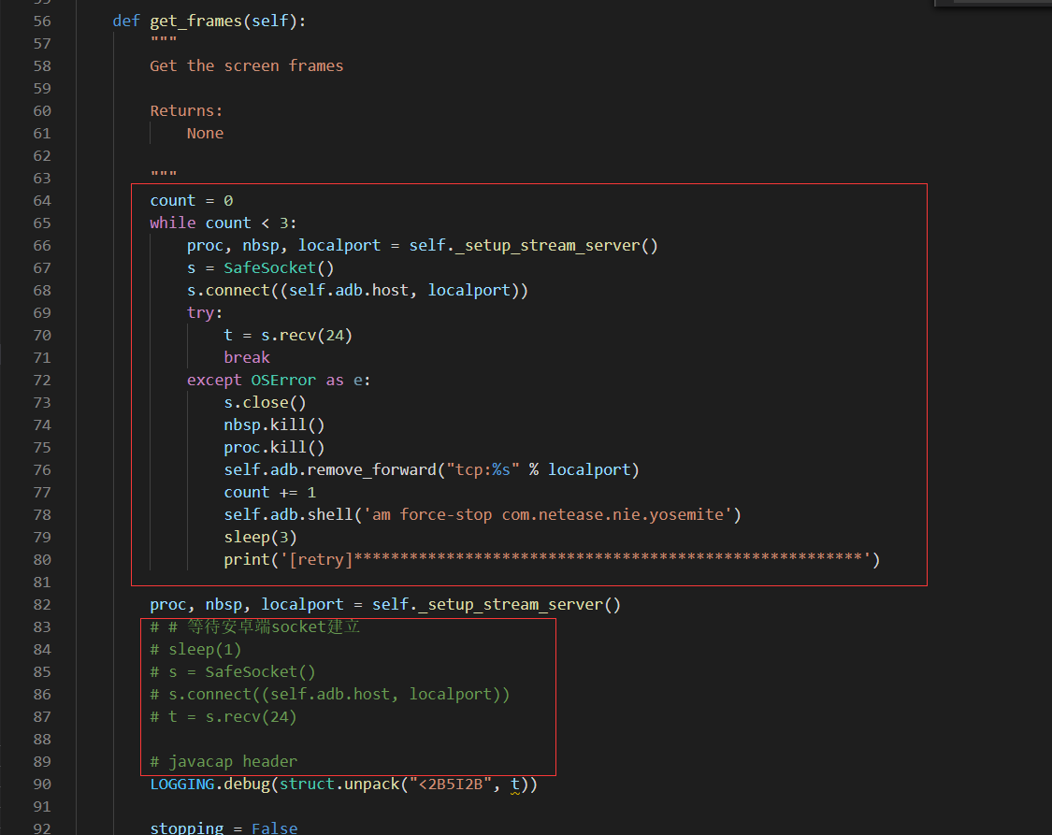

Poco的poco\utils\airtest\input.py改self.use_render_resolution = True

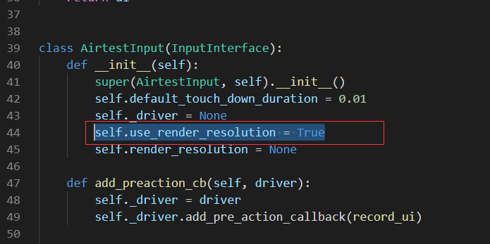

Airtest cli\parser.py 文件添加一行代码

ap.add_argument("--paramfile", help="air脚本内可用参数",required=False)

