CaPView

**Table of contents**

Welcome to CaPView 3

Getting started with CapView 6

Installation 9

Introduction 14

About CaPView 17

System requirements 20

Getting help 23

CaPView license agreement 26

Overview of the user interface 30

Main Window 34

Operation 38

**Welcome to CaPView**

Welcome to CaPView

Next



CapView is an easy to use yet powerful and intuitive 3D visualization environment which provides a clear and efficient user interface to help making rapid decisions on prostate biopsy regions.

This help documentation is designed so you can quickly learn CaPView as a new user or enhance your knowledge as a regular one.

Copyright © 2013 by CCIPD. All Rights Reserved.

*Created with the Personal Edition of HelpNDoc:* [*Easily create HTML Help documents*](http://www.helpndoc.com/feature-tour)

**Getting started with CapView**

Getting started with CaPView

Welcome to CaPView ››

Parent Previous Next

**New to CaPView**

* Read the Introduction section to know more about CapView, its different editions and system requirements.

Copyright © 2013 by CCIPD Software. All Rights Reserved.

*Created with the Personal Edition of HelpNDoc:* [*Full-featured Documentation generator*](http://www.helpndoc.com)

**Installation**

Getting started with CaPView

Welcome to CaPView ››

Parent Previous Next

## Installation

1. Double-click the installer executable file.



1. A welcome window will pop-up, click the “Next >” button to continue.

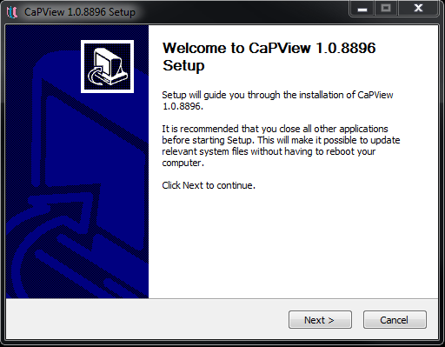

1. Read the end user license agreement, check the box and click the “Next >” button to continue.

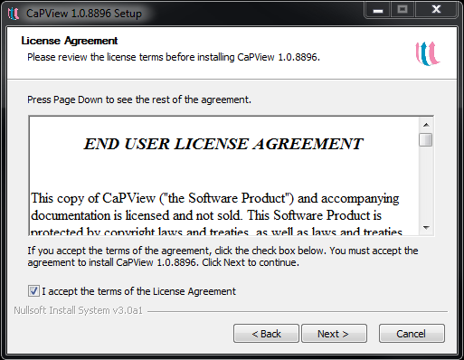

1. The Start menu folder Window will now show up, you may choose the name of the program group folder in the start menu or leave the default name as it is (CaPView). Click the “Install” button to continue.

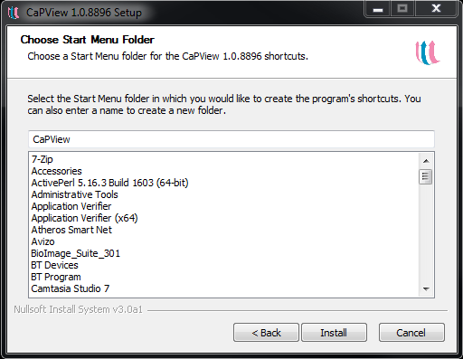

1. Select the installation folder where the program executable and associated files will be installed. If you leave it without change, it will be installed in the “Program Files” directory. Click the “Next>” button to continue.

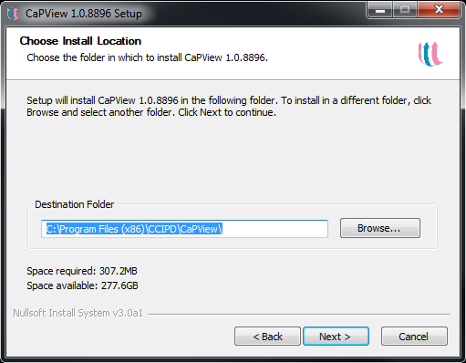

1. The installation will start, when the progress bar comes to the end, click the “Next >” button to finish the installation.

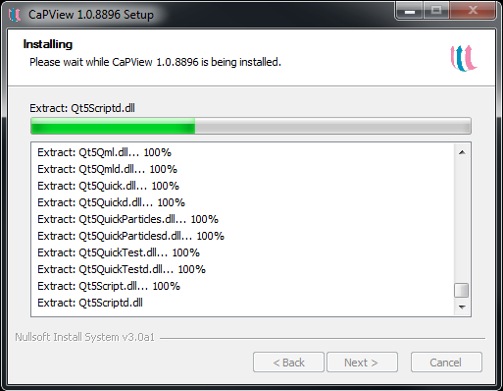

1. After setup is complete, click the “Finish” button to run CapView for the first time.

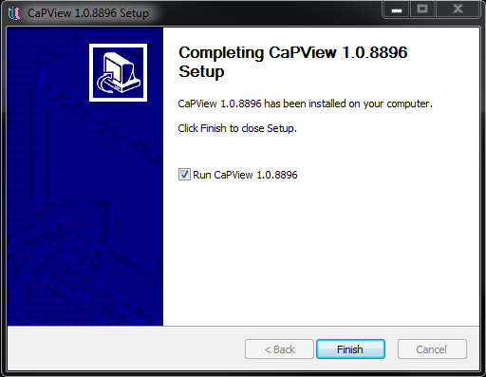

Copyright © 2013 by CCIPD Software. All Rights Reserved.

*Created with the Personal Edition of HelpNDoc:* [*Easily create iPhone documentation*](http://www.helpndoc.com/feature-tour/iphone-website-generation)

**Introduction**

Introduction

Previous Next

* About CapView
* System requirements
* Getting help
* CaPView license agreement

Copyright © 2013 by CCIPD Software. All Rights Reserved.

*Created with the Personal Edition of HelpNDoc:* [*Full-featured EPub generator*](http://www.helpndoc.com/create-epub-ebooks)

**About CaPView**

About CapView

Introduction ››

Parent Previous Next

**CapView is an easy to use yet powerful and intuitive 3D visualization environment which provides a clear and efficient user interface to help making rapid decisions on prostate biopsy regions.**

**CaPView is a simple program which loads and displays MRI volume images. It also visualizes the cancer classification data generated at CCIPD.**

**It gives the radiologist a flexible, yet simple, means of deciding biopsy regions.**

**Currently, It is only intended for research purposes.**

Copyright © 2013 by CCIPD Software. All Rights Reserved.

*Created with the Personal Edition of HelpNDoc:* [*Free help authoring tool*](http://www.helpndoc.com/help-authoring-tool)

**System requirements**

System requirements

Introduction ››

Parent Previous Next

CaPView’s recommended system configuration includes:

* Windows XP, Windows Vista, Windows 7 or Windows 8
* 1 GB of RAM
* 500 MB of free disk space
* 800 x 600 screen resolution or higher

Copyright © 2013 by CCIPD Software. All Rights Reserved.

*Created with the Personal Edition of HelpNDoc:* [*Free PDF documentation generator*](http://www.helpndoc.com)

**Getting help**

Getting help

Introduction ››

Parent Previous Next

This help file can either be viewed off-line when installed with CaPView.

**Off-line access**

The off-line help file is part of the CaPView installation. To launch it, either press the F1 key or click the "CapView Help" button at the top right of CaPView's main menu bar.

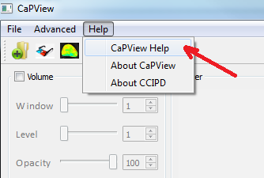

**Getting the help file in a printing form**

Alternatively, you can get a printable PDF or Word version of CaPView's documentation upon request by sending an email to ahmad.algohary@case.edu

Copyright © 2013 by CCIPD. All Rights Reserved.

*Created with the Personal Edition of HelpNDoc:* [*Free HTML Help documentation generator*](http://www.helpndoc.com)

**CaPView license agreement**

CCIPD CaPView End User License Agreement

Introduction ››

Parent Previous Next

***END USER LICENSE AGREEMENT***

This copy of CaPView ("the Software Product") and accompanying documentation is licensed and not sold. This Software Product is protected by copyright laws and treaties, as well as laws and treaties related to other forms of intellectual property. Center For Computational Imaging and Personalized Diagnostics or its subsidiaries, affiliates, and suppliers (collectively "CCIPD") own intellectual property rights in the Software Product. The Licensee's ("you" or "your") license to download, use, copy, or change the Software Product is subject to these rights and to all the terms and conditions of this End User License Agreement ("Agreement").

**Acceptance**

YOU ACCEPT AND AGREE TO BE BOUND BY THE TERMS OF THIS AGREEMENT BY INSTALLING, USING, OR COPYING THE SOFTWARE PRODUCT. IF YOU DO NOT AGREE TO ALL OF THE TERMS OF THIS AGREEMENT, YOU MUST NOT INSTALL, USE, OR COPY THE SOFTWARE PRODUCT.

**License Grant**

This Agreement entitles you to install and use one copy of the Software Product. In addition, you may make one archival copy of the Software Product. The archival copy must be on a storage medium other than a hard drive, and may only be used for the reinstallation of the Software Product. This Agreement does not permit the installation or use of multiple copies of the Software Product, or the installation of the Software Product on more than one computer at any given time, on a system that allows shared used of applications, on a multi-user network, or on any configuration or system of computers that allows multiple users. Multiple copy use or installation is only allowed if you obtain an appropriate licensing agreement for each user and each copy of the Software Product.

**Restrictions on Transfer**

Without first obtaining the express written consent of CCIPD, you may not assign your rights and obligations under this Agreement, or redistribute, encumber, sell, rent, lease, sublicense, or otherwise transfer your rights to the Software Product.

**Restrictions on Use**

You may not use, copy, or install the Software Product on any system with more than one computer, or permit the use, copying, or installation of the Software Product by more than one user or on more than one computer. If you hold multiple, validly licensed copies, you may not use, copy, or install the Software Product on any system with more than the number of computers permitted by license, or permit the use, copying, or installation by more users, or on more computers than the number permitted by license.

You may not decompile, "reverse-engineer", disassemble, or otherwise attempt to derive the source code for the Software Product.

**Restrictions on Alteration**

You may not modify the Software Product or create any derivative work of the Software Product or its accompanying documentation. Derivative works include but are not limited to translations. You may not alter any files or libraries in any portion of the Software Product.

**Restrictions on Copying**

You may not copy any part of the Software Product except to the extent that licensed use inherently demands the creation of a temporary copy stored in computer memory and not permanently affixed on storage medium. You may make one archival copy which must be stored on a medium other than a computer hard drive.

**Disclaimer of Warranties and Limitation of Liability**

UNLESS OTHERWISE EXPLICITLY AGREED TO IN WRITING BY CCIPD, CCIPD MAKES NO OTHER WARRANTIES, EXPRESS OR IMPLIED, IN FACT OR IN LAW, INCLUDING, BUT NOT LIMITED TO, ANY IMPLIED WARRANTIES OF MERCHANTABILITY OR FITNESS FOR A PARTICULAR PURPOSE OTHER THAN AS SET FORTH IN THIS AGREEMENT OR IN THE LIMITED WARRANTY DOCUMENTS PROVIDED WITH THE SOFTWARE PRODUCT.

CCIPD makes no warranty that the Software Product will meet your requirements or operate under your specific conditions of use. CCIPD makes no warranty that operation of the Software Product will be secure, error free, or free from interruption. YOU MUST DETERMINE WHETHER THE SOFTWARE PRODUCT SUFFICIENTLY MEETS YOUR REQUIREMENTS FOR SECURITY AND UNINTERRUPTABILITY. YOU BEAR SOLE RESPONSIBILITY AND ALL LIABILITY FOR ANY LOSS INCURRED DUE TO FAILURE OF THE SOFTWARE PRODUCT TO MEET YOUR REQUIREMENTS. CCIPD WILL NOT, UNDER ANY CIRCUMSTANCES, BE RESPONSIBLE OR LIABLE FOR THE LOSS OF DATA ON ANY COMPUTER OR INFORMATION STORAGE DEVICE.

UNDER NO CIRCUMSTANCES SHALL CCIPD, ITS DIRECTORS, OFFICERS, EMPLOYEES OR AGENTS BE LIABLE TO YOU OR ANY OTHER PARTY FOR INDIRECT, CONSEQUENTIAL, SPECIAL, INCIDENTAL, PUNITIVE, OR EXEMPLARY DAMAGES OF ANY KIND (INCLUDING LOST REVENUES OR PROFITS OR LOSS OF BUSINESS) RESULTING FROM THIS AGREEMENT, OR FROM THE FURNISHING, PERFORMANCE, INSTALLATION, OR USE OF THE SOFTWARE PRODUCT, WHETHER DUE TO A BREACH OF CONTRACT, BREACH OF WARRANTY, OR THE NEGLIGENCE OF CCIPD OR ANY OTHER PARTY, EVEN IF CCIPD IS ADVISED BEFOREHAND OF THE POSSIBILITY OF SUCH DAMAGES. TO THE EXTENT THAT THE APPLICABLE JURISDICTION LIMITS CCIPD'S ABILITY TO DISCLAIM ANY IMPLIED WARRANTIES, THIS DISCLAIMER SHALL BE EFFECTIVE TO THE MAXIMUM EXTENT PERMITTED.

**WARRANTY DISCLAIMER**: THE SOFTWARE IS PROVIDED “AS IS”, AT THE END USER'S OWN RISK, WITHOUT EXPRESS OR IMPLIED WARRANTY OR CONDITION OF ANY KIND.  CCIPD DISCLAIM ANY WARRANTIES OF MERCHANTABILITY, FITNESS FOR A PARTICULAR PURPOSE OR NON-INFRINGEMENT. UNDER NO CIRCUMSTANCES, INCLUDING NEGLIGENCE, WILL CCIPD ( INCLUDING ITS AFFILIATES, OFFICERS, EMPLOYEES, AGENTS, SUPPLIERS OR LICENSORS), OR ANY OTHER PARTY INVOLVED IN THE CREATION, PRODUCTION, PROMOTION, OR MARKETING OF THE SOFTWARE, ANY OF ITS CONTENT, BE LIABLE TO ANY OTHER PARTY FOR ANY INCIDENTAL, SPECIAL, INDIRECT, RELIANCE, PUNITIVE OR CONSEQUENTIAL DAMAGES, INCLUDING LOST DATA, BUSINESS INTERRUPTION, LOSS OF USE, LOST REVENUE, LOST PROFITS, WRONG DIAGNOSIS OR WRONG TREATMENT ARISING OUT OF OR RELATING TO THIS LICENSE OR THE USAGE OF THE SOFTWARE, OR ITS CONTENT, EVEN IF CCIPD HAS BEEN ADVISED OF THE POSSIBILITY OF SUCH DAMAGES. CCIPD DO NOT WARRANT THAT THE SOFTWARE WILL MEET THE END USER'S REQUIREMENTS OR THAT ITS OPERATION THEREOF WILL BE UNINTERRUPTED OR ERROR FREE.  SOME STATES DO NOT ALLOW THE TYPES OFDISCLAIMERS IN THIS PARAGRAPH, SO SOFTWARE IS NOT ALLOWED OR LICENSED TO BE USED IN THESE STATES.

**NOT FOR MEDICAL ADVICE**:  CAPVIEW IS NOT PROVIDING ANY MEDICAL ADVICE VIA SOFTWARE.  THE SOFTWARE IS NOT A MEDICAL DEVICE, NOR IS IT INTENDED FOR USE IN THE DIAGNOSIS, CURE, TREATMENT OR PREVENTION OF DISEASE. IT SHOULD ONLY BE USED FOR RESEARCH PURPOSES. ANY ACTION THAT YOU MAY TAKE AS A RESULT OF INFORMATION, ANALYSIS, OR VISUALIZATION ON THIS SOFTWARE IS ULTIMATELY YOUR RESPONSIBILITY.

**Limitation of Remedies and Damages**

Your remedy for a breach of this Agreement or of any warranty included in this Agreement is the correction or replacement of the Software Product. Selection of whether to correct or replace shall be solely at the discretion of CCIPD. CCIPD reserves the right to substitute a functionally equivalent copy of the Software Product as a replacement. If CCIPD is unable to provide a replacement or substitute Software Product or corrections to the Software Product, your sole alternate remedy shall be a refund of the purchase price for the Software Product exclusive of any costs for shipping and handling.

Any claim must be made within the applicable warranty period. All warranties cover only defects arising under normal use and do not include malfunctions or failure resulting from misuse, abuse, neglect, alteration, problems with electrical power, acts of nature, unusual temperatures or humidity, improper installation, or damage determined by CCIPD to have been caused by you. All limited warranties on the Software Product are granted only to you and are non-transferable. You agree to indemnify and hold CCIPD harmless from all claims, judgments, liabilities, expenses, or costs arising from your breach of this Agreement and/or acts or omissions.

**Governing Law, Jurisdiction and Costs**

This Agreement is governed by the laws of Ohio, without regard to Ohio's conflict or choice of law provisions.

**Severability**

If any provision of this Agreement shall be held to be invalid or unenforceable, the remainder of this Agreement shall remain in full force and effect. To the extent any express or implied restrictions are not permitted by applicable laws, these express or implied restrictions shall remain in force and effect to the maximum extent permitted by such applicable laws.

Copyright © 2013 by CCIPD Software. All Rights Reserved.

*Created with the Personal Edition of HelpNDoc:* [*Free EBook and documentation generator*](http://www.helpndoc.com)

**Overview of the user interface**

Overview of the user interface

Previous Next

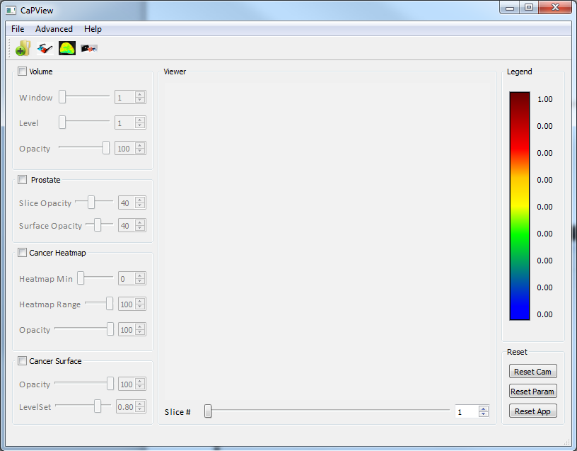

**1. File menu**

* Load Volume Image
* Load Prostate Mask
* Load Periferal Zone Mask
* Load Central Gland Mask
* Load the Cancer probabilities Image
* Save the Viewer
* Save the Program User Interface
* Exit the application

**2. Advanced menu**

* Change the color of the Prostate Surface
* Change the color of the Periferal Zone Surface
* Change the color of the Central Gland Surface
* Change the color of the Cancer Surface

**3. Help menu**

* CaPView Help: Opens the program help file
* About CaPView: Displays a short message about the CaPView Program
* About CCIPD: Displays a short message about the CCIPD lab.

**4. Quick access tool-bar**

* Load Volume Image
* Load Prostate Mask
* Load the Cancer probabilities Image
* Save the Viewer

**5. Status bar**

* Get stats about your operation
* Get information about potential errors

Copyright © 2013 by CCIPD Software. All Rights Reserved.

*Created with the Personal Edition of HelpNDoc:* [*Easily create CHM Help documents*](http://www.helpndoc.com/feature-tour)

**Main Window**

Introduction

Overview of the user interface ››

Parent Previous Next

One of the most important features of CaPView is that it simplifies the MRI visualization process via laying out all the required options on one user-friendly user interface.

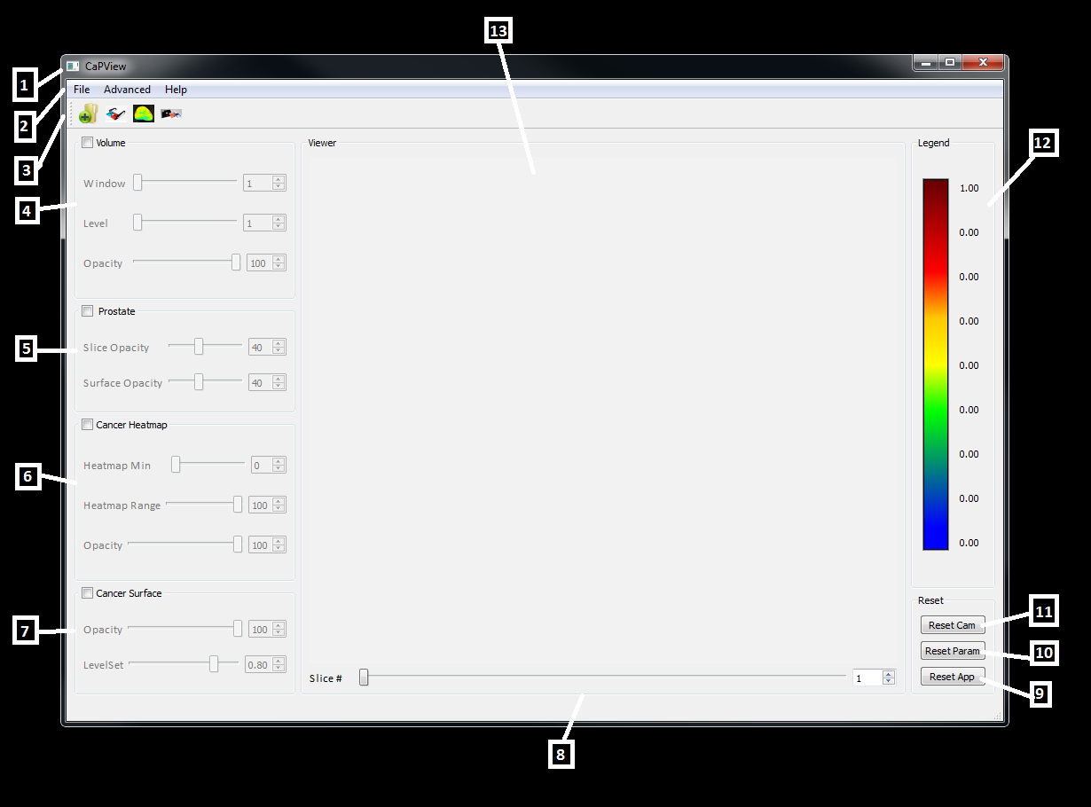

1. 1. The Main Application Window: It has all the program functionalities.

2. The Menu Bar: This has three menus:

1. File: for loading, saving medical image files and quitting the program
2. Advanced: for changing the surface colors of the loaded objects (Prostate, CG, PZ & cancer)
3. Help: Contains the help material for the program.

3. Tool Bar: This contains shortcuts to the most commonly used actions (Load Volume Image, Load Mask, Load Cancer Probabilities Image).

4. Volume control group box: contains three sliders and editable spin boxes:

1. Window Width Slider: modifies the window width of the currently displayed volume.
2. Window Level slider: modifies the window level of the currently displayed volume.
3. Opacity Slider: modifies the opacity/transparency of the currently displayed volume.

The Volume control group box has a check box which shows/hides the volume while visualizing the volume data. This checkbox, with the sliders, are enabled only when the volume image is already loaded.

5. Prostate control group box: This controls the visualization of the loaded prostate mask.

It contains two sliders and editable spin boxes:

1. Slice Opacity: modifies the opacity/transparency of the currently displayed prostate 2D slices.
2. Surface Opacity: modifies the opacity/transparency of the currently displayed prostate 3D surface.

The Prostate control group box has a check box which shows/hides the prostate objects (2D Slices and 3D surfaces) while visualizing the volume data. This checkbox, with the sliders, are enabled only when the prostate mask image is already loaded.

6. Cancer Heatmap control group box: This controls the visualization of the loaded cancer probabilities image. The dark red color represents the highest cancer probability while the blue is for the lowest. Displayed ranges can be modified via the range control sliders.

It contains three sliders and editable spin boxes:

1. Heatmap Min slider: which controls the minimum cancer probability value to be displayed. All values below this value will not be displayed.
2. Heatmap Max slider: which controls the maximum cancer probability value to be displayed. All values above this one will be labeled as cancerous and will be given the dark red color.
3. Opacity: modifies the opacity/transparency of the currently displayed heatmap.

The heatmap control group box has a check box which shows/hides the cancer probabilities image. This checkbox, with the sliders, are enabled only when the probabilities image is already loaded.

7. Cancer Surface control group box: This controls the visualization of the cancer surface calculated from the loaded cancer probabilities image. This depends on the levelset value selected. All the values above this value will be considered as cancerous and will be added to the constructed surface.

It contains two sliders and editable spin boxes:

1. Opacity: modifies the opacity/transparency of the currently displayed surface.
2. Levelset Value: which controls threshold value of cancer.

The Cancer Surface control group box has a check box which shows/hides the constructed cancerous regions. This checkbox, with the sliders, are enabled only when the probabilities image is already loaded.

8. Slice Number Slider: this enables the user to traverse volume slices.

9. “Reset App” button: resets the whole program, clears the viewer and resume its starting state.

10. “Reset Params” button: resets all the parameters to their default values, all sliders are set to their mid-value accordingly.

11. “Reset Cam” button: resets the viewer. This action brings all the hidden, or not fully displayed, parts of the volume objects to the viewable area of the central viewer.

12. The legend with the range values: this is the color legend of the cancer probabilities. It can be modified by moving the heatmap min and max sliders. Colors are not changed but the numbers over the legend bar are fully controllable.

13. The central viewer of the program where volume slices and cancer probabilities surfaces are displayed.

Copyright © 2013 by CCIPD Software. All Rights Reserved.

*Created with the Personal Edition of HelpNDoc:* [*Easily create iPhone documentation*](http://www.helpndoc.com/feature-tour/iphone-website-generation)

**Operation**

Introduction

Overview of the user interface ››

Parent Previous Next

Each time you launch CaPView, the application by default shows the main startup dialog window that allows you to load, visualize and manipulate data files:

## 

## Loading (Volume Images, Prostate Masks & Probabilities Files)

To load a volume: Select in the File menu:

File -> Load -> Volume Image

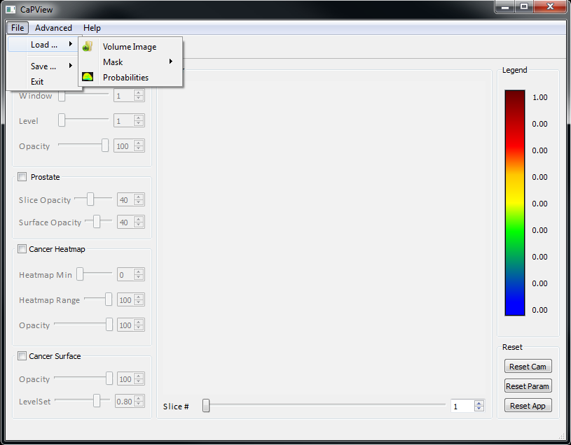

You can also press the first shortcut icon in the toolbar to load a volume image.

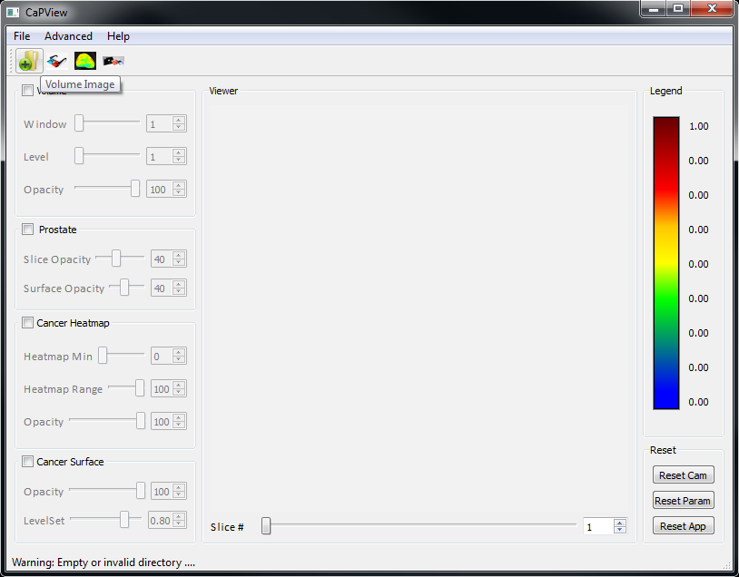

In the same manner, you can load the prostate mask image file and the corresponding cancer probabilities image.

## Saving

You can save a snapshot of the 3D viewer on the user interface window with all the included objects (volume slices, prostate surface, …) with you own settings as a regular image file by selecting “Save Viewer Image As …” in

File -> Save -> Save Viewer Image As

You may also save a snapshot of the whole user interface by selecting “Save App Image As …” in

File -> Save -> Save App Image As

This can help you send your optimally selected settings to another user to be used later. You do not need to save settings if you are the only user of the program as all the user options and program parameter and geometry settings will all be saved and loaded automatically at the exit and startup of the program.

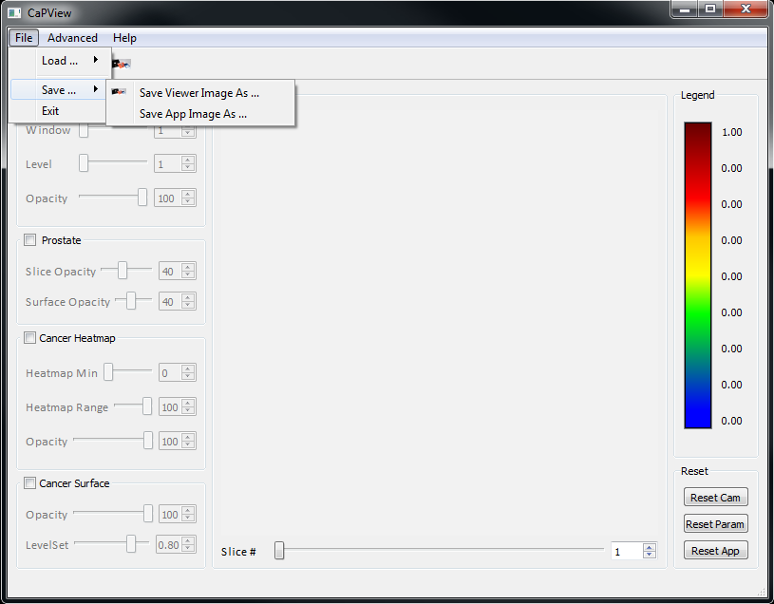

Copyright © 2013 by CCIPD Software. All Rights Reserved.

*Created with the Personal Edition of HelpNDoc:* [*Easy CHM and documentation editor*](http://www.helpndoc.com)