4.Solution method
To efficiently solve for solutions to this model, a heuristic or metaheuristic is required. Most heuristics have some common problems when dealing with complex optimization problems: they may converge to the local optimal solution too early, or the convergence speed is slow. In order to overcome the above problems, we propose an improved jellyfish search algorithm (IJS) to solve our model. The schematic flowchart of IJS is shown in Fig. 2, and the specific steps are described in Sections 4.1 and 4.2.
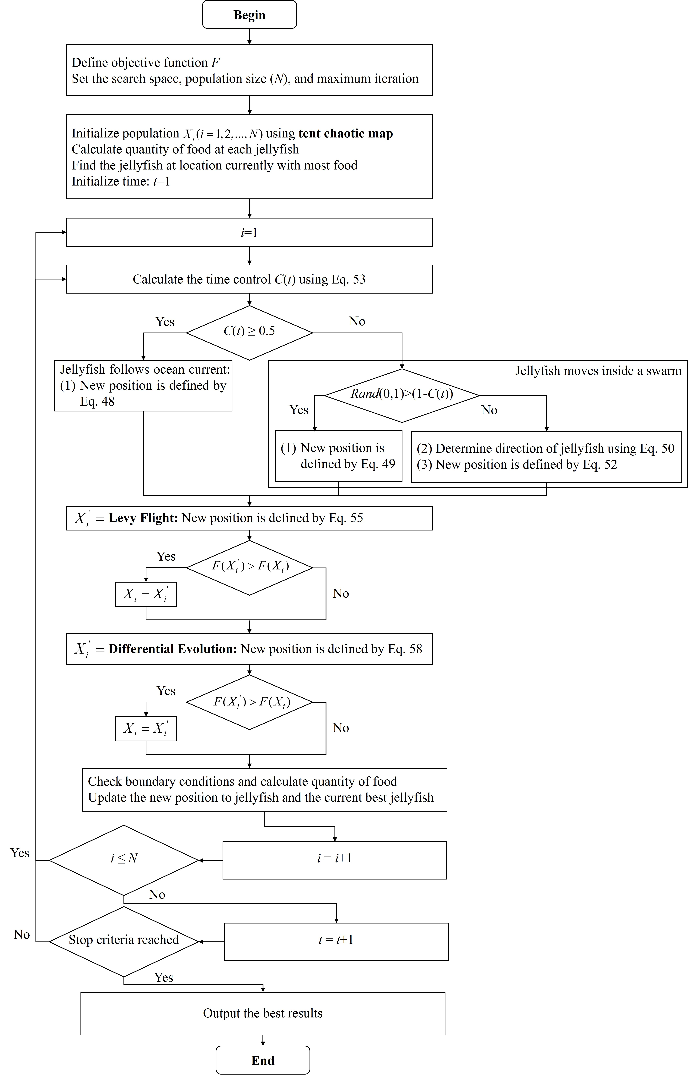
Fig. 2. Schematic flowchart of IJS

4.1 Solution representation
In this study, integer encoding is used to represent the scheme for bus allocation and scheduling. Let $K^{*}$ and $R^{*}$ be the total fleet size and the daily number of bus runs, respectively. A solution is a scheme for bus allocation and scheduling $X$={$x$, $y$, $λ$ } containing three parts: the first part is the bus scheduling scheme $x$ with dimension of $1×R^{*}$; the second is the bus type allocation scheme $y$ with dimension of $1×K^{*}$; and the third is the bus passenger capacity allocation scheme $λ$ with dimension of $1×K^{*}$. The total dimension of solution $X$ is $D=1×(R^{*}+2K^{*})$. Fig. 3 shows an example of a scheme with $K^{*}$=6 and $R^{*}$=12.
In Fig. 3, $X$={[1, 2, 3, 2, 1, 3, 4, 5, 6, 4, 5, 6], [0, 1, 2, 2, 0, 1], [70, 55, 60, 80, 100, 90]}. The bus scheduling scheme $x$ is [1, 2, 3, 2, 1, 3, 4, 5, 6, 4, 5, 6], where each element denotes the bus number serving the corresponding run. The bus type allocation scheme $y$ is [0, 1, 2, 2, 0, 1], where each element denotes the vehicle type of each bus (0, 1, and 2 represent small, medium, and large, respectively). The bus passenger capacity allocation scheme $λ$ is [70, 55, 60, 80, 100, 90], where each element denotes the percentage of passenger capacity to vehicle capacity on each bus. For example, No. 3 bus is a large-size vehicle with 60% vehicle capacity for passenger service to serves the 3rd and 6th runs.
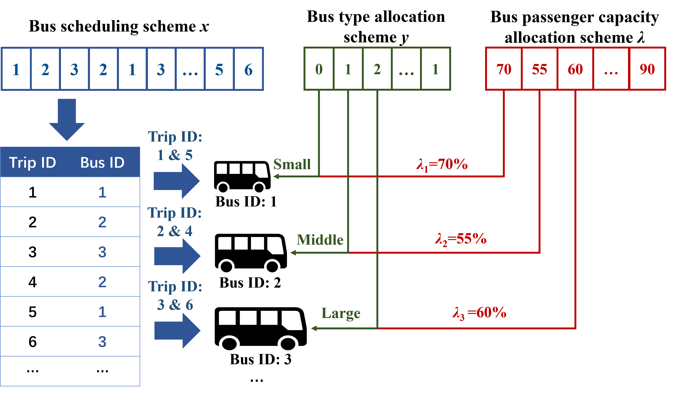
Fig. 3. An example of an encoding scheme $X$ with $K^{*}$=6 and $R^{*}$=12

4.2 Improved Jellyfish Search
The proposed IJS is an enhanced version of the jellyfish search algorithm (JS) [38] proposed by Cho and Truong (2021) to improve their framework of searching for a global optimal solution. To mimic the food search behavior of jellyfish in the ocean, a scheme for bus allocation and scheduling $X_{i}$ corresponds to the location of jellyfish i. The fitness (i.e., food quantity) of the location is quantified by objective function $F(X_{i})$. The IJS is based on three idealized rules: (i) jellyfish either follow the ocean current or move within the swarm. The switch between these two movements is handled by a time control mechanism; (ii) jellyfish are attracted to locations with a higher food quantity; (iii) The food quantity found by jellyfish is determined by the corresponding location.

4.2.1 Population initialization
Different from the logistic chaotic map used by the JS to initialize jellyfish population, we adopt the tent chaotic map in the proposed IJS, which has better traversal, greater uniformity and faster iteration speed. Tent chaotic map is more suitable for generating chaotic sequences in our problem [39]. The population initialization can be expressed as follows:
$$\begin{aligned}X_{i+1}=\left\{\begin{matrix}μ_{tent}X_{i},{ X}_{i}<0.5 \\ μ_{tent}\left(1-X_{i}\right),{ X}_{i}≥0.5\end{matrix}\right.\#\left(47\right)\end{aligned}$$
where $X_{i}$ is the initial location of the ith jellyfish, which is generated by the tent chaotic map; $μ_{tent}$ is a parameter that controls the distribution pattern of the tent chaotic sequence.

4.2.2 Ocean current
Jellyfish are attracted to ocean currents because they contain large amounts of nutrients. The direction of the current is determined by calculating the average vector of the vectors from the location of each jellyfish to that of the jellyfish with the best objective function in the swarm. Equation (48) updates the location of each jellyfish within the current:
$$\begin{aligned}X_{i}^{t+1}=X_{i}^{t}+rand\left(0,1\right)×\left(X_{best}^{t}-β_{d}×rand\left(0,1\right)×\bar{μ}\right)\#\left(48\right)\end{aligned}$$
where $X_{i}^{t}$ is the location of the ith jellyfish in the tth iteration; $X_{best}^{t}$ is the best location in the current jellyfish population; $β_{d}$ is the distribution coefficient; $\bar{μ}$ is the mean location of all jellyfish in the population.

4.2.3 Jellyfish swarm
When the jellyfish swarm initially forms, most of the jellyfish engage in group movement, i.e. passive movement. New locations are generated as follows:
$$\begin{aligned}X_{i}^{t+1}=X_{i}^{t}+γ^{'}×rand\left(0,1\right)×\left(U_{b}-L_{b}\right)\#\left(49\right)\end{aligned}$$
where $γ^{'}$ is a motion coefficient related to the length of motion around the locations of the jellyfish; $U_{b}$ and $L_{b}$ are the upper bound and lower bound of search spaces, respectively.
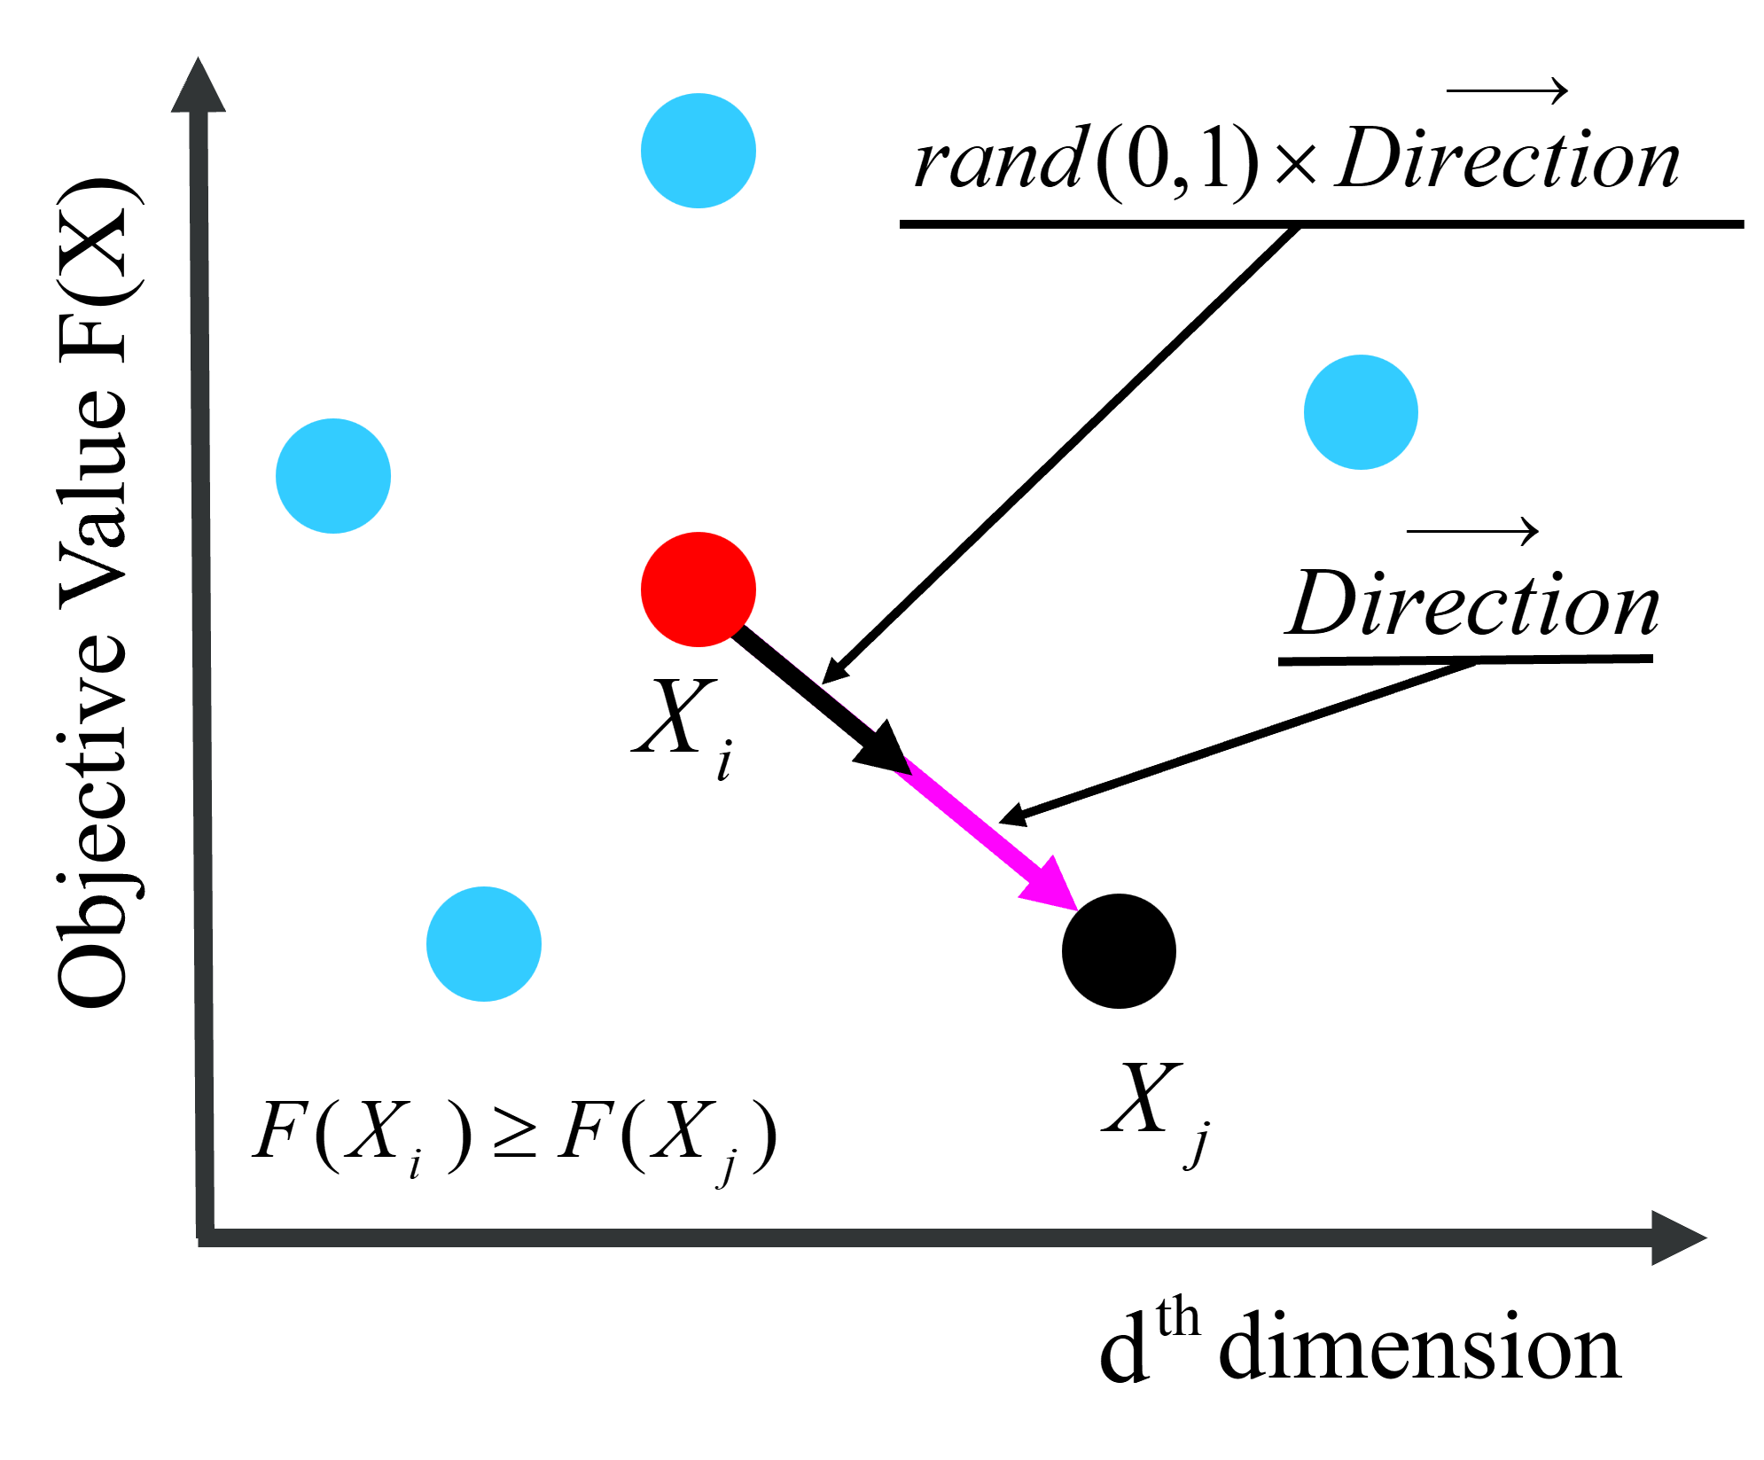 | 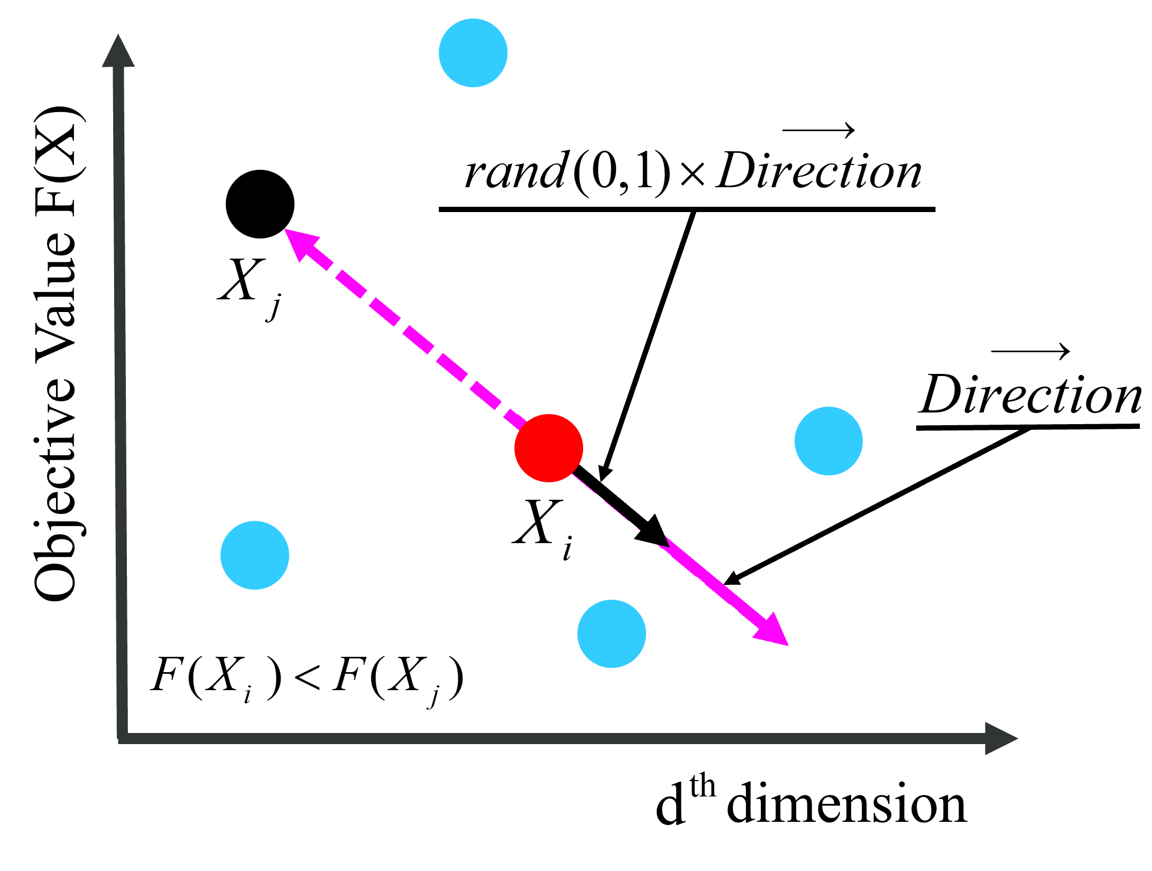
- Direction of active movement when $F(X_{i})≥F(X_{j})$ | - Direction of active movement when  $F(X_{i})<$ $F(X_{j})$
Fig. 4. Direction of movement in a swarm
Over time, the jellyfish take the initiative to move closer to their companions with more food found. Their directions of movement are shown in Equation (50), i.e. active movement. The generation of new locations is shown in Equations (51) and (52). A schematic diagram of jellyfish movement is shown in Fig. 4.
$$\begin{aligned}\vec{Direction}=\left\{\begin{matrix}X_{j}^{t}-X_{i}^{t},F\left(X_{j}^{t}\right)≥F\left(X_{i}^{t}\right) \\ X_{i}^{t}-X_{j}^{t},F\left(X_{j}^{t}\right)<F\left(X_{i}^{t}\right)\end{matrix}\right.\#\left(50\right)\end{aligned}$$
$$\begin{aligned}\vec{Step}=rand\left(0,1\right)×\vec{Direction}\#\left(51\right)\end{aligned}$$
$$\begin{aligned}X_{i}^{t+1}=X_{i}^{t}+\vec{Step}\#\left(52\right)\end{aligned}$$
where $X_{i}^{t}$ is the location of the ith jellyfish in the tth iteration; $X_{j}^{t}$ is a jellyfish randomly selected from the population.

4.2.4 Time control mechanism
Over time, jellyfish gather together in ocean currents to form a swarm. When the current is changed, the jellyfish enter another current and create another swarm. Passive movement begins preferentially within a jellyfish swarm. As time passes, individual jellyfish tend to move actively. In order to regulate passive and active movements, the IJS introduces a time control mechanism that regulates the switch. This consists of a time control function $C(t)$ and a threshold constant $C_{0}$, where the control function is:
$$\begin{aligned}C\left(t\right)=\left|\left(1-\frac{t}{Max_{it}}\right)×\left(2×rand\left(0,1\right)-1\right)\right|\#\left(53\right)\end{aligned}$$
where $C(t)$ is a random value that fluctuates in the interval [0, 1] as the number of iterations increases, $C_{0}=0.5$; $Max_{it}$ is the maximum number of iterations. When $C(t)≥C_{0}$, the jellyfish follow the ocean current for movement; conversely, the jellyfish move only within the swarm, i.e., active and passive movement. Fig. 5 simulates the current phase, jellyfish swarm phase, and time control mechanism.
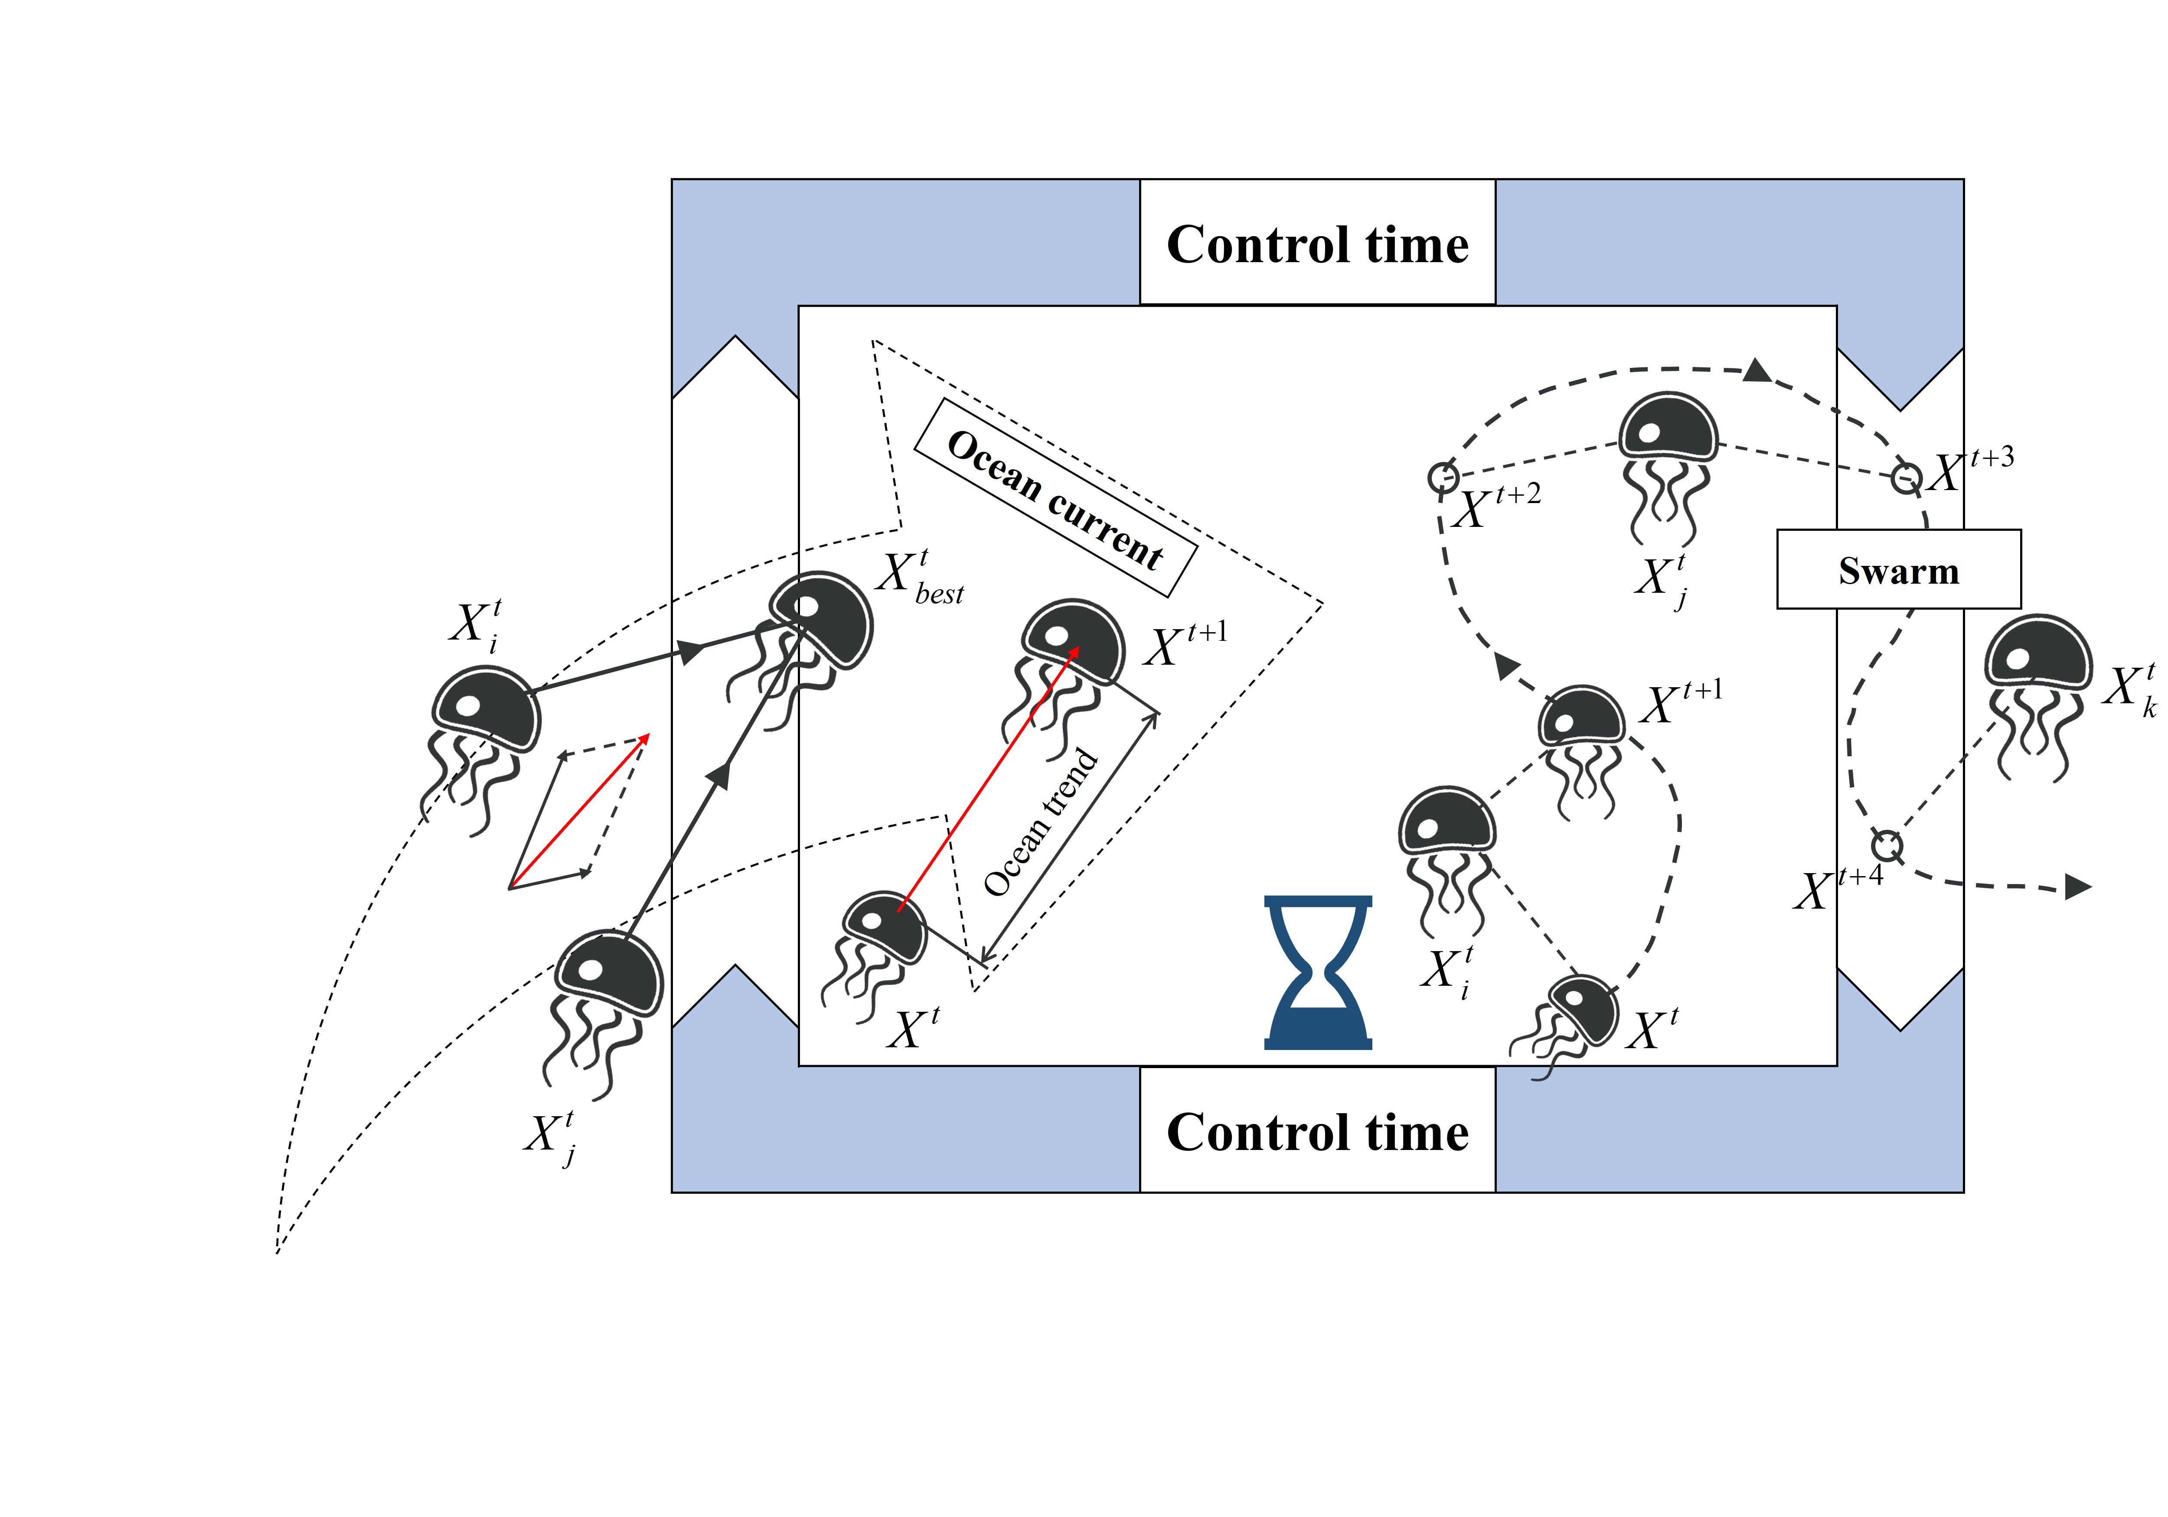
Fig. 5. Simulation of ocean current, swarm and time control

4.2.5 Levy Flight
In order to avoid the problem of the original JS falling into a local optimum and leading to premature convergence, the IJS introduces Levy flight. Levy flight is a strategy that enhances the global search capability. It can help the algorithm to jump out of the local optimum and explore a wider solution space [40]. New locations are updated based on Levy flight as follows:
$$\begin{aligned}Levy\left(β_{Levy}\right)=\frac{u}{|v|^{\frac{1}{β_{Levy}}}}\#\left(54\right)\end{aligned}$$
$$\begin{aligned}X_{i}^{t+1}=X_{i}^{t}+α×Levy\left(β_{Levy}\right)\#\left(55\right)\end{aligned}$$
where $α$ is a scale parameter for the step size, which is a random number in the interval [0,1]; $u$ and $v$ are random numbers generated by normal distribution; $β_{Levy}$ is the stable distribution parameter of Levy flight, $β_{Levy}=1.5$.

4.2.6 Differential Evolution
In this study, the differential evolution (DE) strategy is introduced to enhance the global search capability and quality of solutions. Proposed by Storn and Price (1995) [41], DE is an optimization technique that mimics the process of genetic recombination in biological evolution. It generates new candidate solutions by combining the differences between the current optimal individual and other individuals. The specific steps are as follows:
Step 1 (mutation): Two different individuals are randomly selected from the jellyfish population to generate a mutant vector. We use Equation (56) to realize the mutation:
$$\begin{aligned}V_{i}^{t}=X_{i}^{t}+α^{*}×\left(X_{j}^{t}-X_{k}^{t}\right)\#\left(56\right)\end{aligned}$$
where $X_{j}^{t}$ and $X_{k}^{t}$ are two different jellyfish individuals randomly selected from the population in the tth iteration; $α^{*}$ is a scale parameter for the step size, which is a random number in the interval [0,1].
Step 2 (crossover): We use a binary crossover strategy in this study, where the crossover probability CR determines the extent to which the mutant vector is mixed with the current individual. The total dimension of each jellyfish individual is $D$, which is the sum of the dimensions of the bus scheduling scheme ($1×R^{*}$), the bus type allocation scheme ($1×K^{*}$), and the bus passenger capacity allocation scheme ($1×K^{*}$), i.e., $D=1×(R^{*}+2K^{*})$. In the tth iteration, we introduce crossover between mutant vector and the current individual and form the trial vector $U_{i,d}^{t}$. For the dth dimension of $U_{i,d}^{t}(d=1,2,...,D)$：
$$\begin{aligned}U_{i,d}^{t}=\left\{\begin{matrix}V_{i,d}^{t},rand_{i,d}<CR \\ X_{i,d}^{t},rand_{i,d}≥CR\end{matrix}\right.\#\left(57\right)\end{aligned}$$
where $V_{i,d}^{t}$ is the dth dimension of $V_{i}^{t}$; CR is set to 0.5 in this study; $rand_{i,d}$ is a random number in the interval [0,1] to control the selection of the dth dimension of the ith individual in the crossover process.
Step 3 (selection): Better individuals are selected for the next generation of the population by comparing the fitness of the trial vector with that of the current individual:
$$\begin{aligned}X_{i}^{t}=\left\{\begin{matrix}U_{i}^{t},F\left(U_{i}^{t}\right)≥F\left(X_{i}^{t}\right) \\ X_{i}^{t},F\left(U_{i}^{t}\right)<F\left(X_{i}^{t}\right)\end{matrix}\right.\#\left(58\right)\end{aligned}$$
In the proposed IJS, Levy flight and differential evolution are applied sequentially, and each is wrapped by a greedy selection so that a worse trial can never replace a better incumbent. After the ocean-current or swarm movement produces a candidate position, Levy flight perturbs it through Equation (55) to generate a second candidate; the greedy selection then compares this candidate with the pre-perturbation position by fitness and retains the better one. Differential evolution next acts on the retained position, generating a third candidate by mutation and crossover (Equations (56) and (57)), and the greedy selection in Equation (58) decides whether this candidate replaces the current position. The rationale for this design is that the two operators play complementary roles: Levy flight widens the search through occasional long-range jumps, whereas differential evolution refines the solution by recombining population information. Inserting a selection between them lets each operator contribute independently, because the intermediate selection preserves any improvement obtained by Levy flight, so a subsequent differential-evolution trial cannot overwrite it, and vice versa. The two search behaviors are therefore coupled without one cancelling the gains of the other.

4.2.7 Boundary conditions
When the jellyfish moves out of the bounded search area, it returns to the opposite bound based on Equation (59):
$$\begin{aligned}X_{i,d}^{t+1}=\left\{\begin{matrix}\left(X_{i,d}^{t}-U_{b,d}\right)+L_{b,d},X_{i,d}^{t}>U_{b,d} \\ \left(X_{i,d}^{t}-L_{b,d}\right)+U_{b,d},X_{i,d}^{t}<L_{b,d}\end{matrix}\right.\#\left(59\right)\end{aligned}$$

4.2.8 Pseudocode of IJS
The IJS, in addition to maintaining the advantages of the JS, can significantly improve the global search capability and convergence speed. We also show better performance and adaptability in the following experiments, with a total time complexity of $O(N×(R^{*}+2K^{*})×Max_{it})$. The pseudocode of the IJS for solving the proposed model is shown in Fig. 6.
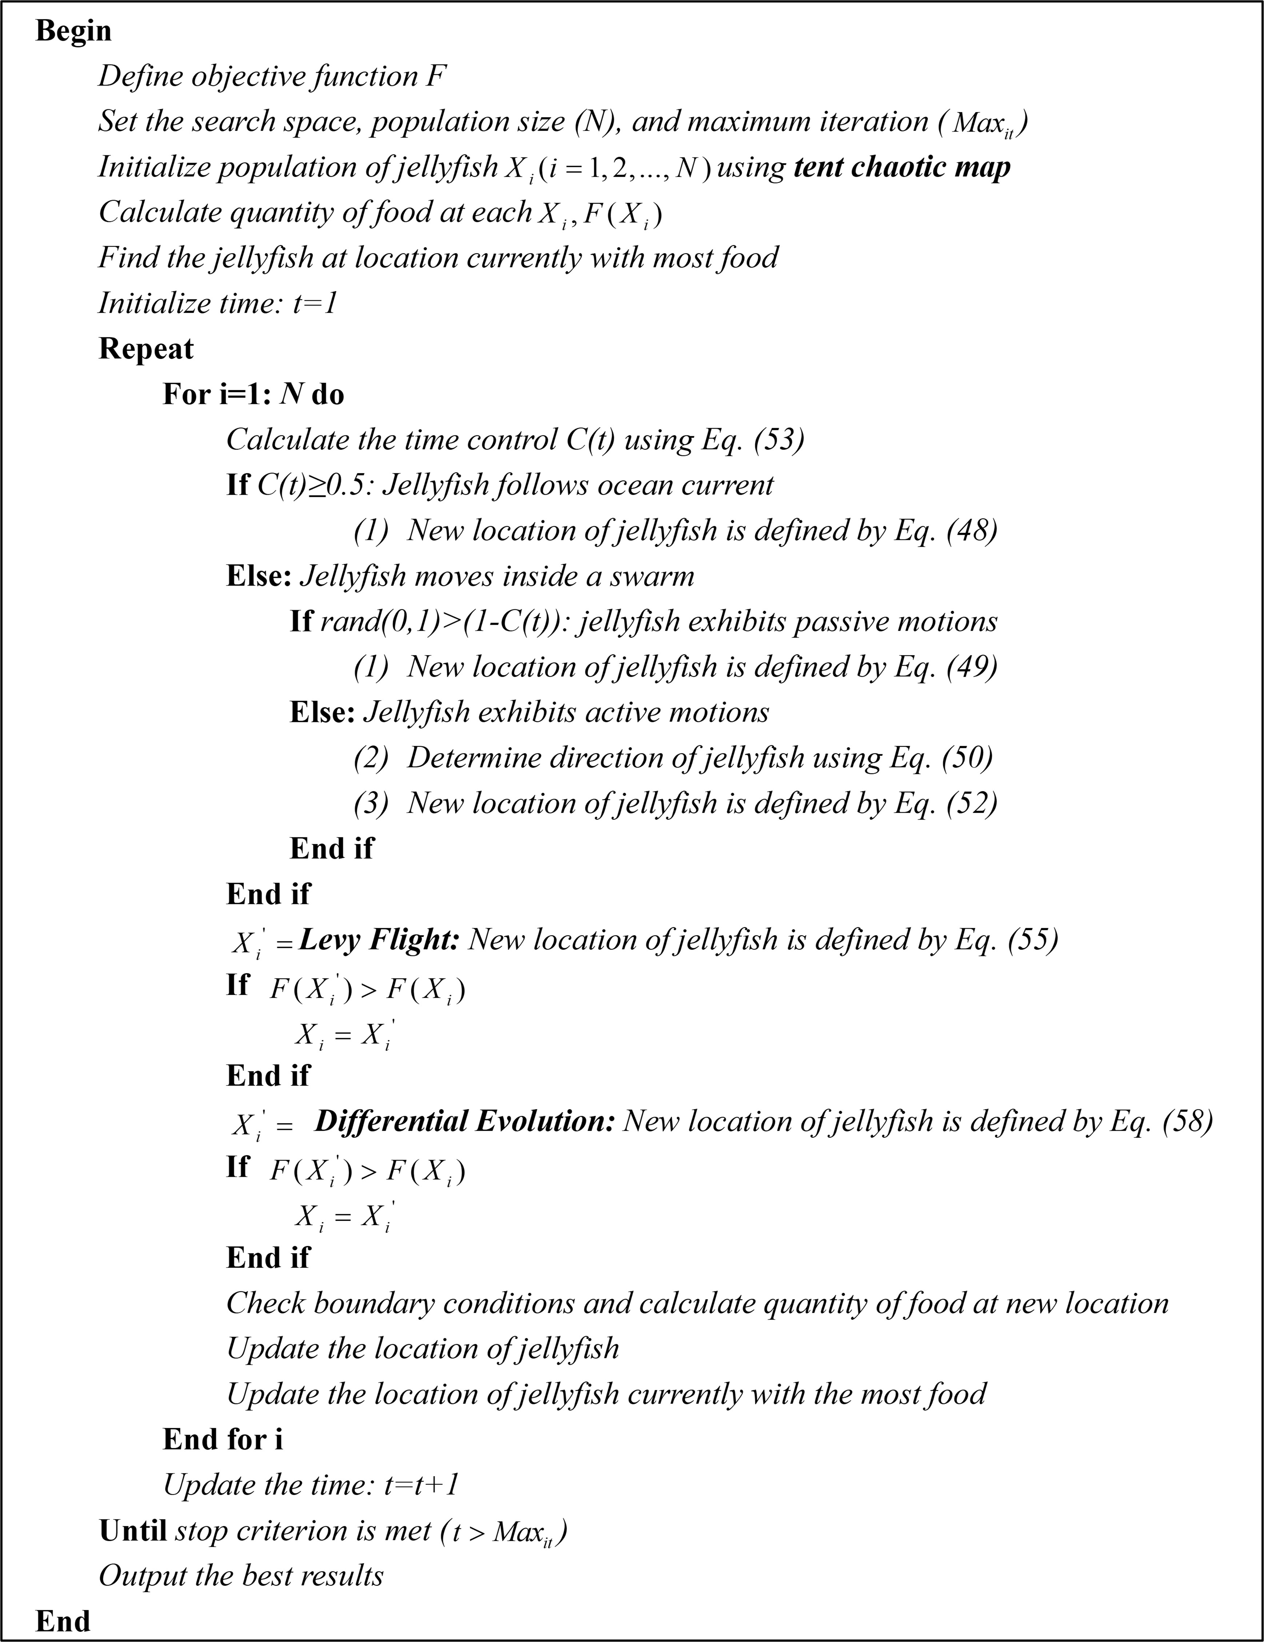
Fig. 6. Pseudocode of the IJS

5. Numerical experiments
Computational experiments were conducted to (1) illustrate the good performance of the proposed algorithm for urban-rural bus networks, (2) compare the proposed PFSM with the separated passenger and freight transport, and (3) discuss the implications of the sensitivity of passenger-freight demand, maximum passenger travel time, minimum percentage of passenger capacity to vehicle capacity and weight-zone. The following experiment focuses on selecting evaluation indicators from three aspects, namely economy, efficiency and environment, to analyze the daily operational benefits of urban- rural bus systems. All algorithms were coded in MATLAB R2023a and executed on a Windows 10 computer equipped with AMD Ryzen 7 6800H, Radeon Graphics 3.20 GHz CPU, and 16 GB RAM.

5.1 Performance of IJS for urban-rural bus networks

5.1.1 Data description and parameter setting
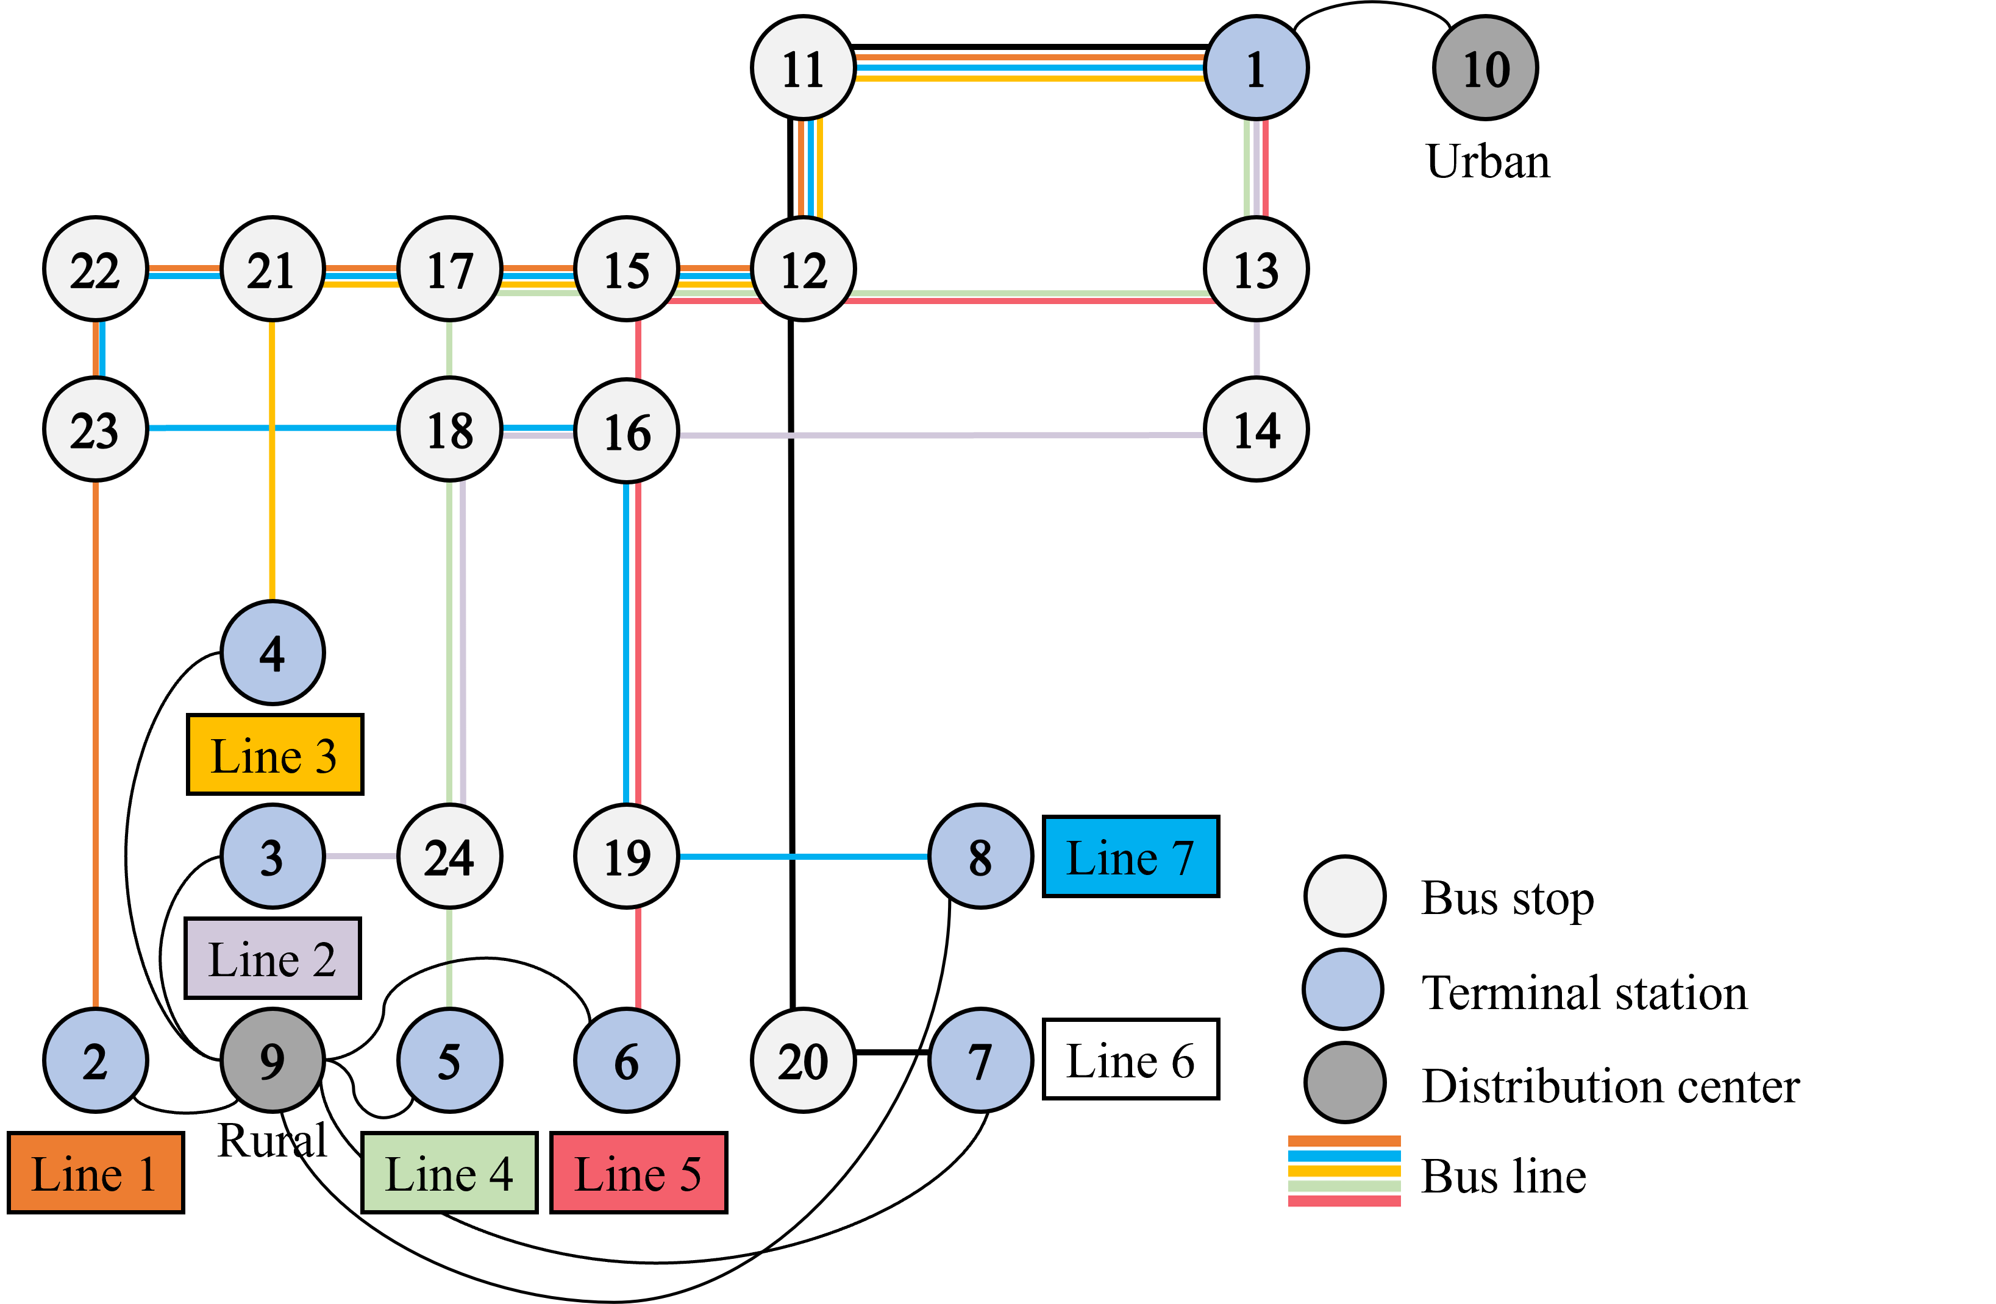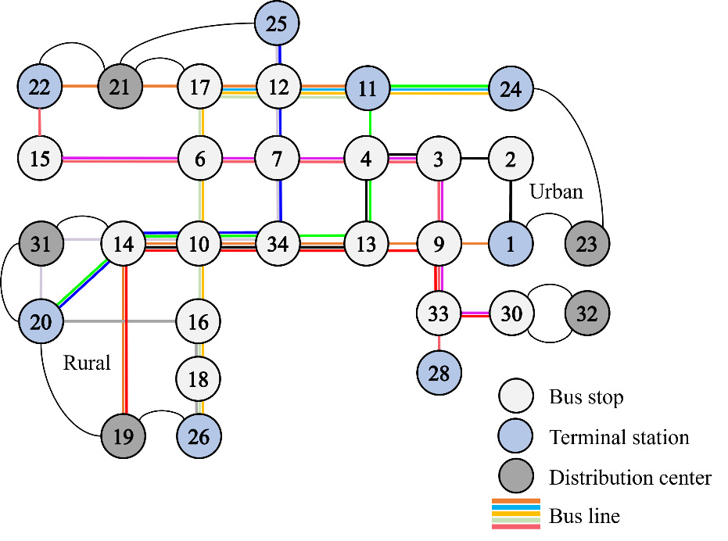
(a) S1 (7 routes, 14 buses) (b) S2 (13 routes, 26 buses)
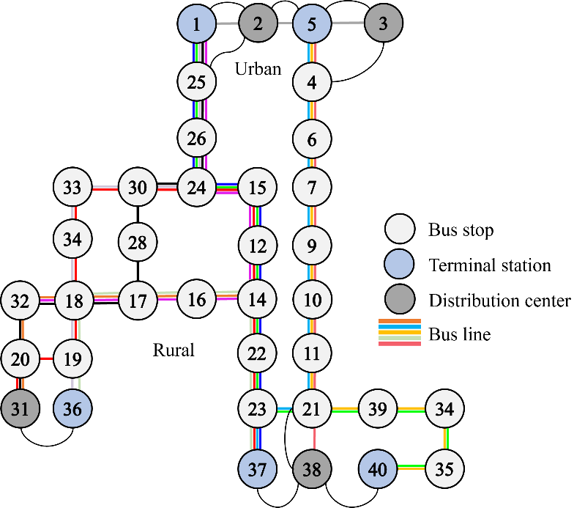
(c) S3 (19 routes, 38 buses)
Fig. 7. Simulated urban-rural bus networks
In order to verify the effectiveness of the proposed IJS in solving optimization problems of urban-rural bus network under PFSM, genetic algorithm (GA), particle swarm optimization (PSO), grey wolf optimizer (GWO), and JS are selected as the benchmarks to compare their performances. In this section, the experiments were conducted using three networks of increasing size (as shown in Fig. 7): S1 (7 routes, 14 buses) based on the simulated network of Zeng et al. [30], S2 (13 routes, 26 buses) based on the Qianjiang urban-rural network in Hubei, and S3 (19 routes, 38 buses) based on the Xianghe urban-rural network in Hebei. Some lines have overlapping intervals. Both rural and urban bus terminals are adjacent to DCs, and parcels are loaded onto buses at rural DC and unloaded at urban DC. The bus type for each line are classified as small, medium, and large. The relevant configuration parameters are shown in Table 1, and the departure timetables are shown in Appendix Table A3-A5. We summarize the on-demand requests for passenger and cargo in Appendix Table A6-A8.
Table 1. Configuration parameters for different types of buses
Vehicle type | Purchasing cost $ϕ_{}^{\text{buy}}$ (RMB/day) | Base fare of passenger service $γ_{u}$ (RMB/person) | Additional fare of passenger service $η_{}^{u}$ (RMB/km) | Base fare of freight service $γ_{f}$ (RMB/item) | Additional fare of freight service $η_{f}$ (RMB/km) | Vehicle capacity $V$ (m³)
Small | 421.23 | 2.5 | 0.17 | 1 | 0.05 | 13.56
Medium | 506.23 |  | 0.22 |  |  | 20.3
Large | 678.08 |  | 0.27 |  |  | 30.6

5.1.2 Benchmarks
We select GA, PSO, GWO, and JS as the benchmarks in the following experiments: (1) GA is a metaheuristic that mimics natural selection and the genetic principles (Holland, 1975) [42]; (2) PSO is a metaheuristic that simulates the behavior of animal cluster pattern (Kennedy & Eberhart, 1995) [43]; (3) GWO is a metaheuristic that simulates the hunting behavior of grey wolves (Mirjalili et al., 2014) [44]; (4) JS is metaheuristic that simulates the behavior of jellyfish in the ocean and is the original version of our proposed algorithm (Cho & Truong, 2021) [38].

5.1.3 Results analysis
On each network, IJS is compared with JS, GWO, PSO, and GA in runtime and solution quality. Each instance is solved ten times to smooth randomness; the reported runtime is the average wall-clock time and the reported quality is the best system benefit F, as shown in Table 2.
Table 2. Runtime (s) and best system benefit (RMB/day) across three network scales
Algorithm | Runtime (s) |  |  | Best system benefit F (RMB/day)
 | S1 (7, 14) | S2 (13, 26) | S3 (19, 38) | S1 (7, 14) | S2 (13, 26) | S3 (19, 38)
IJS | 50.01 | 115.98 | 144.58 | 594.65 | 1052.25 | 1460.01
JS | 104.15 | 241.54 | 301.10 | 594.65 | 1052.25 | 1460.01
GWO | 85.26 | 197.73 | 246.49 | 594.65 | 1052.25 | 1196.38
PSO | 53.88 | 124.95 | 155.77 | 594.65 | 641.99 | 799.85
GA | 78.06 | 181.03 | 225.68 | 222.21 | -2469.04 | -1227.64
In runtime, IJS is consistently the fastest among the high-quality solvers. Across the three scales, IJS reduces the runtime by about 52% relative to the standard JS and by about 7.2% relative to PSO, and the gap is stable as the network grows. This speed-up comes from the tent chaotic initialization and the adaptive operator switching, which lower the number of iterations needed for convergence.
In solution quality, the advantage of IJS widens with scale. At the smallest scale S1, IJS, JS, GWO, and PSO all reach the same optimum of RMB 594.65, and only GA falls behind at RMB 222.21. As the network grows, the baseline solvers degrade. At S2 and S3, GA returns infeasible negative-profit solutions (-2469.04 and -1227.64 RMB/day), and PSO drops to 641.99 and 799.85, whereas IJS holds the best value at 1052.25 and 1460.01. This shows that the chaotic search and the sequential Levy-DE operators keep IJS effective on larger, more constrained instances where standard metaheuristics lose feasibility or stall.
Table 3. System daily profit and average travel time, before vs after optimization
Scale | Z before | Z after | Z gain | T̄ before (min) | T̄ after (min) | T̄ change
S1 (7, 14) | 285.37 | 1883.34 | +560% | 47.51 | 53.40 | +12.4%
S2 (13, 26) | 527.98 | 3401.03 | +544% | 59.16 | 67.77 | +14.6%
S3 (19, 38) | 573.61 | 4286.24 | +647% | 61.18 | 71.08 | +16.2%
At the system level, the benefit of optimization grows with scale. As Table 3 shows, the daily profit rises by 560%, 544%, and 647% from S1 to S3 after optimization, while the average travel time increases by 12.4%, 14.6%, and 16.2%. The travel-time increase grows slowly relative to the profit gain, which indicates that PFSM scales to larger urban-rural networks without a disproportionate loss of passenger service.
All algorithms have a population size of 100 and the maximum number of iterations of 150. We obtain the fitness and computational time for each algorithm for solving the optimal solution in the simulated network. Fig. 8 shows the iteration curves of the GA, PSO, GWO, JS and IJS.
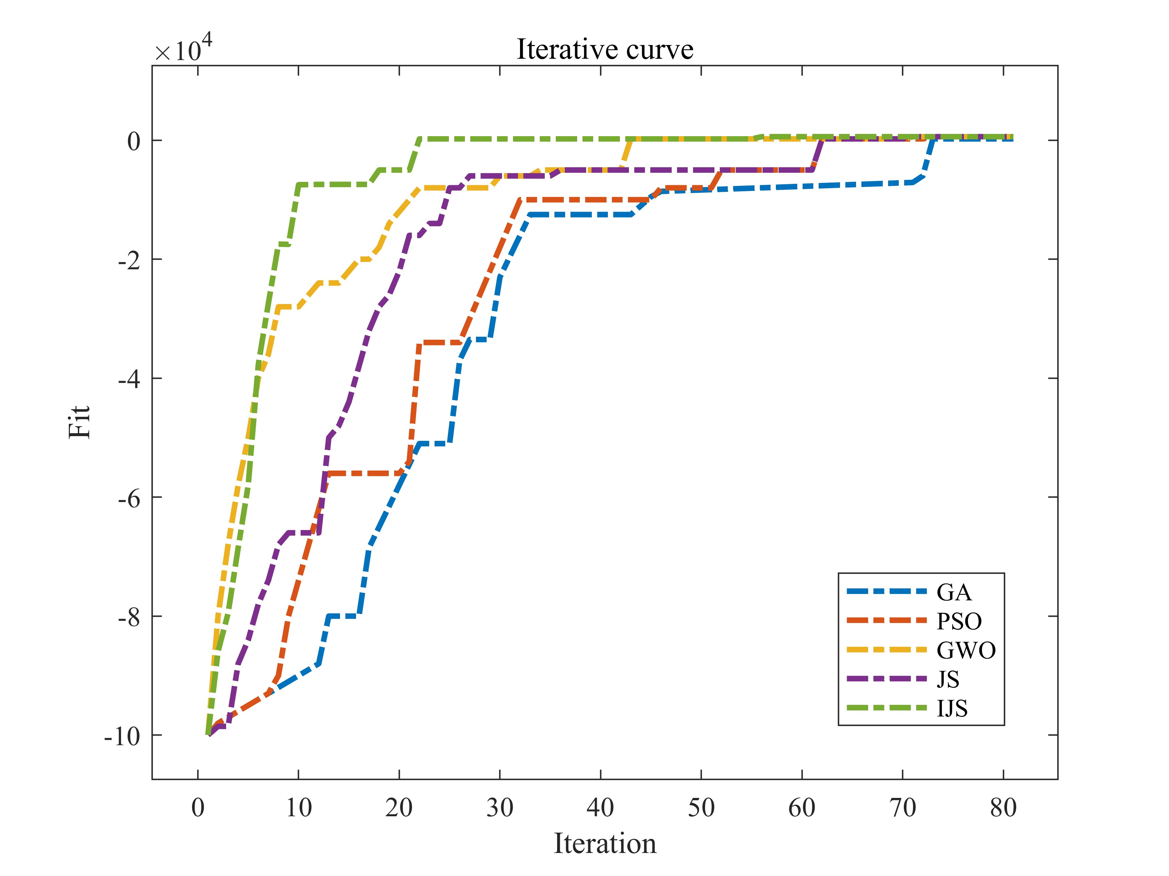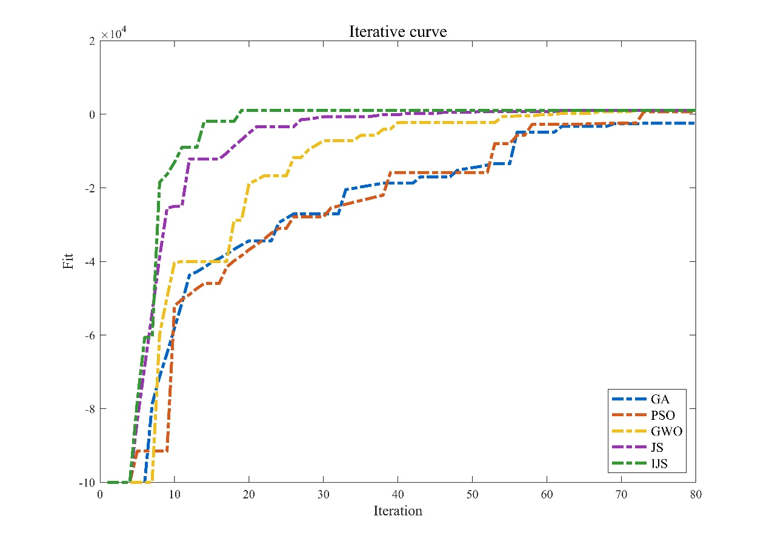
(a) S1 (7 routes, 14 buses) (b) S2 (13 routes, 26 buses)
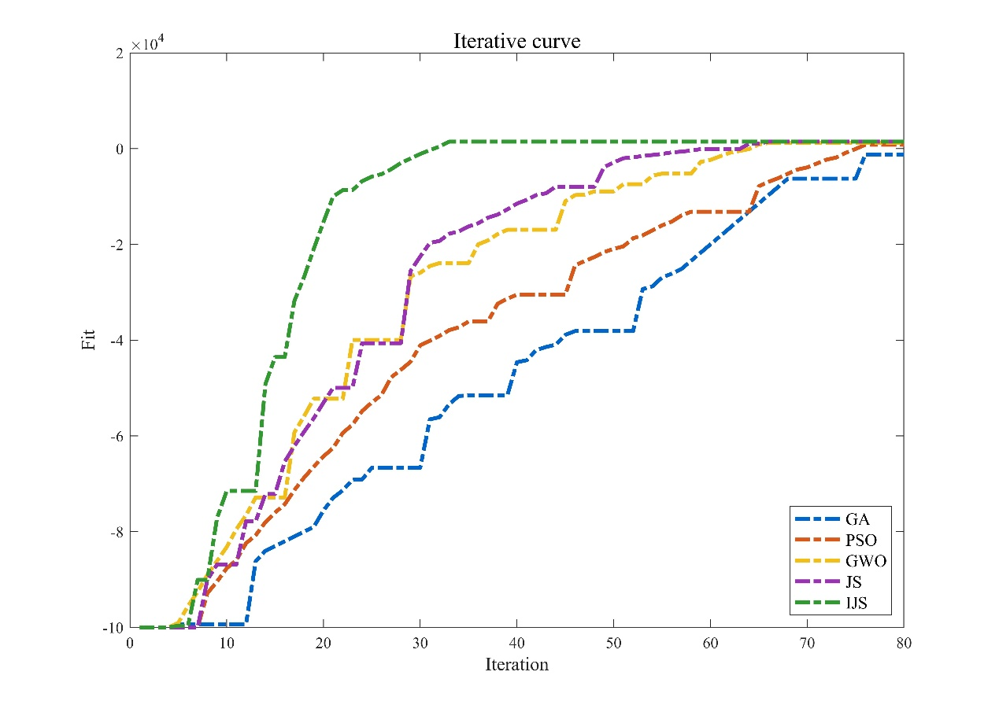
(c) S3 (19 routes, 38 buses)
Fig. 8. Iteration curves of different algorithms
In the simulation experiments of the urban-rural bus network, IJS is the algorithm with the shortest solution time, the fastest convergence speed and the best solution quality among all algorithms. Specifically, except for the GA, PSO, GWO, JS, and IJS can find the same optimal solution by 80th iterations, which is better than the final solution obtained by the GA. Therefore, GA performs the worst both in terms of computational time and solution quality, which indicates that it is not suitable for dealing with the proposed problem. As an enhanced version of the JS, the IJS is not only 51.98% shorter than the JS in terms of solution time and about 7.2% shorter than the PSO, but also outperforms the other algorithms in terms of the quality of the solution at each iteration. It can be seen that the IJS has stronger global search capability and faster convergence speed than the JS, demonstrating excellent performance and adaptability in urban-rural transit network optimization problems. Therefore, the subsequent experiments use the IJS with optimal performance for model solving.

5.2 Comparison between PFSM and separated passenger and parcel transport
In order to quantify the advantages of PFSM in urban-rural bus operations, this study compares the daily bus operation metrics of PFSM and separated passenger and parcel transport. In this study, the separated passenger and parcel transport refers to medium-sized truck dispatching from the logistics system to transport parcels and medium-sized electric buses scheduling by the bus operators to serve passengers, both of which operate independently.

5.2.1 Data description and parameter setting
Based on the empirical study case of Zeng et al [30], the operation data of two urban-rural bus lines are collected in Yushe County, Shanxi Province, China, including information on the bus passenger-freight demand distribution of each line, timetable, vehicle scheduling, and bus fleet size. The two urban-rural bus lines depart from different rural starting terminals but share the same urban terminal and vehicle resources, as shown in Fig. 9. The rural terminals and the urban terminal are close to DC 11 and DC 10 at a distance of 3km and 2km, respectively. There is an ITSC in the middle section of both lines (ITSCs 4 and 16). Line 1 covers 8 stops, with a total length of 40.2km and an average single trip time of 70 minutes. Line 2 has a total length of 37.3km, 7 stops, and an average single trip time of 65 minutes. The distance matrix between stops is shown in Table 4. The freight lines are essentially the same as the bus lines, transporting parcels to and from rural DC 11 and urban DC 10, passing through ITSCs 4 and 16 on the way.
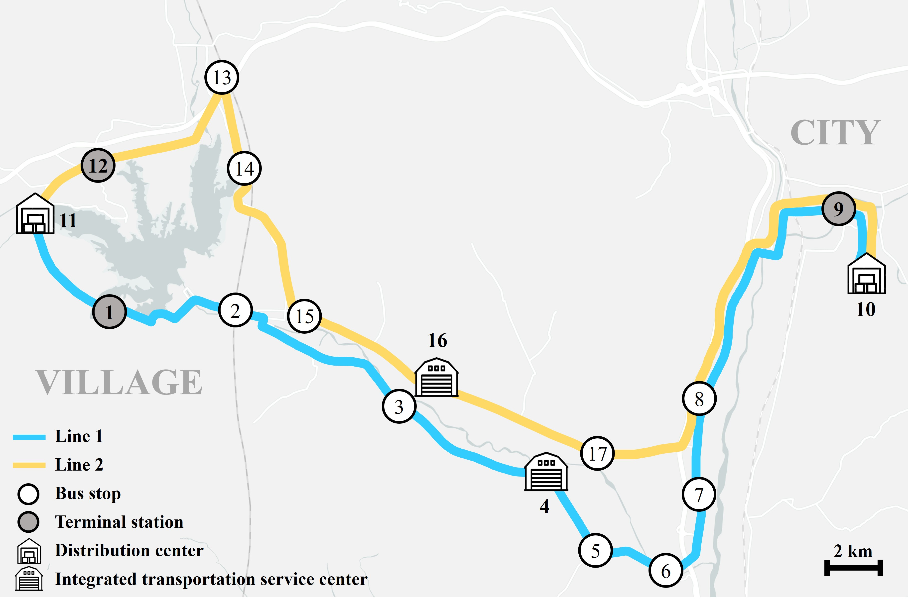
Fig. 9. Urban-rural bus lines in Yushe
Table 4 Bus line information of the urban-rural bus routes
Bus line 1 |  |  | Bus line 2
From | To | Distance (km) | From | To | Distance (km)
10 | 1 | 3.00 | 10 | 12 | 3.00
1 | 2 | 6.12 | 12 | 13 | 3.63
2 | 3 | 6.58 | 13 | 14 | 3.19
3 | 4 | 4.90 | 14 | 15 | 4.40
4 | 5 | 2.16 | 15 | 16 | 3.49
5 | 6 | 3.60 | 16 | 17 | 5.83
6 | 7 | 2.60 | 17 | 8 | 4.51
7 | 8 | 2.00 | 8 | 9 | 12.28
8 | 9 | 12.28 | 9 | 11 | 2.00
9 | 11 | 2.00
Due to the tidal characteristics of urban-rural commuting and the asymmetric distribution of passenger demand spatially and temporally, the following pattern exists in the timetable of the two bus lines: buses depart from the countryside to the city in the morning, from the city to the countryside in the afternoon, and stop in other off-peak hours, as shown in Table 5. The total daily demands for passengers and parcels are 300 and 1500, respectively. The OD demand information for passengers and parcels is shown in Appendix Table A9. Note that there are currently six buses serving two urban-rural bus lines, but the schedule does not fully utilize the fleet capacity because these buses also serve other bus lines.
Table 5 Bus line timetable
Bus line 1 |  |  | Bus line 2
Morning trip from node 1 to node 9 |  |  | Morning trip from node 12 to node 9
No. | Departure | Arrival | No. | Departure | Arrival
1 | 6:00 | 7:10 | 7 | 6:10 | 7:15
2 | 7:30 | 8:40 | 8 | 8:10 | 9:15
3 | 9:00 | 10:10 | 9 | 10:10 | 11:15
Afternoon trip from node 9 to node 1 |  |  | Afternoon trip from node 9 to node 12
4 | 15:00 | 16:10 | 10 | 15:10 | 16:15
5 | 16:30 | 17:40 | 11 | 17:10 | 18:15
6 | 18:00 | 19:10 | 12 | 19:10 | 20:15

5.2.2 Results and analysis
For the separated passenger and parcel transport, both buses and trucks are medium-sized vehicles. According to the configuration parameter standard for different types of trucks in China, the vehicle capacity of a medium-sized truck is 17.28m³, the cost of fuel consumption is RMB 1.6/km, the average purchasing cost is RMB 850/day, and the wage of a truck driver is RMB 500/day. The optimal scheme for vehicle allocation and scheduling under PFSM is shown in Table 6.

Table 6. Optimal scheme for vehicle allocation and scheduling under PFSM
Bus number | Scheduling | Vehicle type | percentage of passenger capacity
1 | No.1→ No.5 | Small | 100%
2 | No.2→ No.4 | Small | 100%
3 | No.3→ No.6 | Medium | 80%
4 | No.7→ No.10 | Large | 50%
5 | No.8→ No.11 | Medium | 90%
6 | No.9→ No.12 | Large | 70%

As Table 6 shows, the fleet size and the scheduling pattern are unchanged, yet the vehicle type and the passenger capacity share on each bus differ markedly across runs, which reshapes the operational outcome. To separate the gain of electrification from the gain of operational optimization, three modes are compared on the same two routes. Mode A is the separated baseline, in which diesel trucks deliver parcels and electric buses serve passengers independently. Mode B is unoptimized PFSM, in which the dedicated trucks are withdrawn and parcels are shifted onto the six existing buses, but the current timetable is retained and a fixed 50% passenger-to-freight split is imposed on a uniform medium-sized fleet. Mode B therefore merges the two flows without any fleet or capacity optimization. Mode C is the proposed optimized PFSM, with differentiated vehicle types and dynamic capacity allocation. Table 7 reports the daily metrics across economic, efficiency, capacity-utilization, and environmental dimensions; the last column gives the change from Mode B to Mode C, which isolates the contribution of optimization.
Table 7. Daily operational metrics across the three modes
Operational metric | A: Separated transport |  | B: Unoptimized PFSM |  | C: Optimized PFSM |  | B → C change
 | Truck | Bus | Truck | Bus | Truck | Bus
Economic dimension
Fleet size | 4 | 6 | 0 | 6 | 0 | 6 | –
Total running distance (km) | 350.28 | 465.42 | 0 | 465.42 | 0 | 525.42 | +12.89%
$C_{\text{idle}}$ (RMB) | 55.8 | 26 | 0 | 83 | 0 | 71 | −14.45%
$C_{\text{km}}$ (RMB) | 589.48 | 390.6 | 0 | 406.41 | 0 | 429.83 | +5.76%
$C_{\text{fix}}$ (RMB) | 3400 | 3037.38 | 0 | 3037.38 | 0 | 3211.08 | +5.71%
$C$ (RMB) | 4045.28 | 3453.98 | 0 | 3526.79 | 0 | 3711.91 | +5.24%
$E_{f}$ (RMB) | – | – | – | 2862.35 | – | 3257.64 | +13.81%
$E_{u}$ (RMB) | – | 991.82 | – | 764.91 | – | 991.82 | +29.66%
$Z$ (RMB) | – | −2462.16 | – | 64.47 | – | 537.55 | +733.79%
Efficiency dimension
$T_{\text{cruise}}$ (min) | – | 28.3 | – | 28.3 | – | 32.31 | +14.17%
$T_{det}$ (min) | – | 5.04 | – | 6.29 | – | 7.61 | +20.98%
$T_{\text{dwell}}$ (min) | – | 1.2 | – | 1.8 | – | 2.1 | +16.67%
$T_{\text{wait}}$ (min) | – | 4.15 | – | 4.22 | – | 4.2 | −0.47%
$\bar{T}$ (min) | – | 38.69 | – | 40.61 | – | 46.22 | +13.81%
Passengers served | – | 300 | – | 235 | – | 300 | +27.66%
Capacity-utilization dimension
Vehicle type mix | – | Medium | – | Medium | – | S / M / L | –
Parcels carried | 1500 | – | – | 1326 | – | 1500 | +13.12%
Environmental dimension
Diesel CO₂ (kg/day) | 140.61 | – | – | – | – | – | –
Bus electricity (kWh/day) | – | 349.06 | – | 363.81 | – | 392.44 | +7.86%
Bus CO₂ (kg/day) | – | 278.1 | – | 289.85 | – | 312.66 | +7.87%
System CO₂ (kg/day) | 418.71 |  | 289.85 |  | 312.66 |  | +7.87%
Carbon intensity (kg CO₂/served unit) | 0.2326 |  | 0.1857 |  | 0.1737 |  | −6.45%
Reading down the four dimensions, a consistent pattern emerges: merging the two flows (A to B) removes the truck fleet and lifts the system close to breakeven, whereas optimization (B to C) is what converts the merged system into a profitable, fully served, and carbon-efficient operation. The four dimensions are examined in turn.
Economically, Mode A runs a daily deficit of RMB 2462.16, because the four dedicated trucks bear the full freight cost. Withdrawing the trucks in Mode B removes that burden and brings the system close to breakeven at RMB 64.47. Optimization then raises the daily profit to RMB 537.55, a further gain that the fixed-split Mode B cannot reach. Two effects drive this jump. First, freight revenue rises from RMB 2862.35 to 3257.64 (+13.81%) and passenger revenue from RMB 764.91 to 991.82 (+29.66%), because differentiated vehicle types and dynamic capacity allocation match supply to the spatial and temporal mismatch between the two demands and so serve more of both. Second, the cost increase that accompanies this fuller service is modest: total cost rises by only 5.24%, since the larger running distance is offset by lower idle cost (-14.45%). The result is a clear hierarchy in profit, A < B < C, in which optimization contributes the decisive margin.
In service efficiency, the average passenger travel time rises from 38.69 min in Mode A to 40.61 min in Mode B and 46.22 min in Mode C. The increase is the cost of carrying parcels on passenger vehicles, and it is dominated by longer cruise time (+14.17%) and longer detention time (+20.98%), both of which trace back to the extra dwell time at freight stops and the higher load. Mode B already adds delay while serving fewer passengers, which signals that delay alone is not a reliable indicator of service quality. The decisive contrast lies in demand fulfilment: Mode B carries only 235 of 300 passengers and 1326 of 1500 parcels, because the rigid 50% split starves both services, whereas Mode C meets the full demand of 300 passengers (+27.66%) and 1500 parcels (+13.12%). The additional 7.53 min in Mode C therefore buys complete service rather than degraded service, and it stays within the maximum travel time constraint.
The capacity-utilization dimension explains why the two PFSM modes diverge so sharply. Mode B fixes a uniform medium fleet and a 100%-then-50% split, which cannot follow the demand profile; the freight space is too tight where parcels concentrate and too loose elsewhere. Mode C replaces this with a small-medium-large mix and a dynamic ratio between 50% and 100%, which forms a passenger-dominated and a freight-dominated vehicle group. Two small or medium buses concentrate on passengers, while two large buses exploit the larger residual volume to absorb the freight task of the four withdrawn trucks. This differentiation is the mechanism behind both the revenue gain and the full-demand fulfilment reported above.
Environmentally, electrification drives the absolute reduction, while optimization governs the carbon efficiency. System CO₂ falls from 418.71 kg/day in Mode A to 312.66 kg/day in Mode C, a cut of 25.33%, achieved mainly by replacing diesel trucks with electric buses. The dynamic energy model then exposes a finer trend. Mode B emits slightly less in absolute terms (289.85 kg/day) than Mode C (312.66 kg/day), because Mode B keeps a uniform medium fleet, whereas Mode C deploys some larger buses and raises the running distance by 12.89% to finish the full task, while bus electricity and bus CO₂ increase by 7.87%. This small increase is not a loss of environmental performance but the energy needed to complete the transport that Mode B leaves undone. Once emissions are normalized by the demand actually served, the optimized scheme is the most efficient: carbon intensity falls from 0.1857 to 0.1737 kg CO₂ per served unit, a reduction of 6.45%. Carbon intensity is defined here as system CO₂ divided by the total demand served (passengers plus parcels), so that energy use is comparable across service levels; Modes A and C both serve the full 1800 units, whereas Mode B serves only 1561.
Taken together, the three-mode comparison shows that the benefit of PFSM rests on two distinct mechanisms. Electrification of freight delivers the absolute CO₂ reduction, whereas scheduling and capacity optimization raises the carbon efficiency per unit transported and, at the same time, secures full demand and profitability. The decarbonization of PFSM is therefore produced by the optimized operating process, not by vehicle electrification alone. For this two-route case, the optimized scheme carries about 547,500 parcels per year, removes four dedicated diesel trucks, and cuts system CO₂ by about 38.71 tons per year relative to separated transport.
According to the Greenhouse Gas Protocol [45], the carbon emission factor of diesel fuel is 2.6765 kg CO₂/L. Since the fuel consumption of a medium-sized truck is 0.15 L/km, its CO₂ emissions are 0.40 kg/km. The daily freight transport mileage of the conventional mode is 350.28 km, which results in 140.60 kg of CO₂ emissions. Although electric buses produce no tailpipe emissions, the upstream grid generation is not negligible. The grid CO₂ emission factor of 0.7967 kg/kWh adopted here is the 2023 North China regional grid baseline factor published by the Ministry of Ecology and Environment of China (2024), the grid that serves the Shanxi case. To test robustness against grid decarbonization, two forward-looking scenarios are added: a 2030 scenario (0.62 kg/kWh, on the current 14th Five-Year Plan trajectory) and a 2035 scenario (0.45 kg/kWh, consistent with the National Energy Administration (2024) target of a non-fossil share above 50%). Under these scenarios the annual CO₂ reduction per route rises from 19.12 t (2023) to 22.84 t (2030) and 26.34 t (2035), which shows that the decarbonization benefit of PFSM grows, rather than shrinks, as the grid becomes cleaner [46]. By optimizing the electric bus type and capacity allocation, PFSM replaces medium-sized trucks for freight service. Its daily electricity consumption is 392.44 kWh and the corresponding CO₂ emissions are 312.66 kg, which is 25.33% lower than the separated passenger and parcel transport. In summary, in this case with two DCs, PFSM transports about 547,500 parcels per year, saving 19,178 L of freight fuel and reducing CO₂ emissions by 38.71 tons. If the mode is extended across China, it could save about 3,317.79 million liters of fuel and directly reduce CO₂ emissions by about 7,853,900 tons, equivalent to a 1.25% reduction in the 2023 national motor-vehicle CO₂ total. This is a significant contribution to reducing carbon emissions and improving air quality, and provides an effective solution for green transport. This is a significant contribution to reducing carbon emissions and improving air quality, providing an effective solution to green transport.

5.3 Sensitivity Analysis
To demonstrate the reliability and validity of optimal solutions with respect to changes in the values of parameters, this section further investigates the sensitivity of passenger-freight demand, maximum passenger travel time, minimum percentage of passenger capacity to vehicle capacity, and weight-zone based on the case in Section 5.2.

5.3.1 Passenger-freight demand
Passenger-freight demand is an important factor that affects the operating profit and passenger travel time. Fig. 10 displays the effect of different passenger and freight demands on the operating profit and passenger travel time. The passenger demand takes the values of {100, 300, 500, 700, 900} and the freight demand takes the values of {500, 1000, 1500, 2000, 2500}, representing the change process of passenger and freight demand levels from low to high. The OD demand values between stops are modified based on the ratio of the above total demand to the original total demand in Appendix Table A9.
From Fig. 10 (a), for the operating profit $Z$, it can be seen that bus operations are prone to losses when the passenger-freight demand is low, indicating that PFSM may not be suitable for scenarios with low demand. In particular, the minimum value of -1577.28 RMB/day is reached when the passenger-freight demand is {100, 500}. As the passenger-freight demand increases to {100, 2000}, {300, 1500}, {500, 1000}, or {700, 1000}, the bus system is moved into the black. The above passenger-freight demands may be the minimum criteria to promote the profitability of the bus system under PFSM. When the passenger-freight demand is {900, 2500}, it reaches the maximum value of 5946.98 RMB/day. The color change of the heat map clearly shows the gradual increase of profit from negative (loss) in the lower left corner to positive (profit) in the upper right corner, which indicates that the total profit increases with the increase of passenger-freight demand. Although total profit increases whenever either passenger or freight demand increases, there is a difference in the extent to which passenger and freight demands contribute to operating profit.
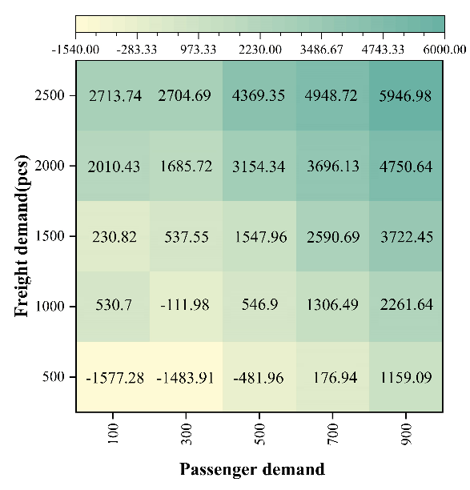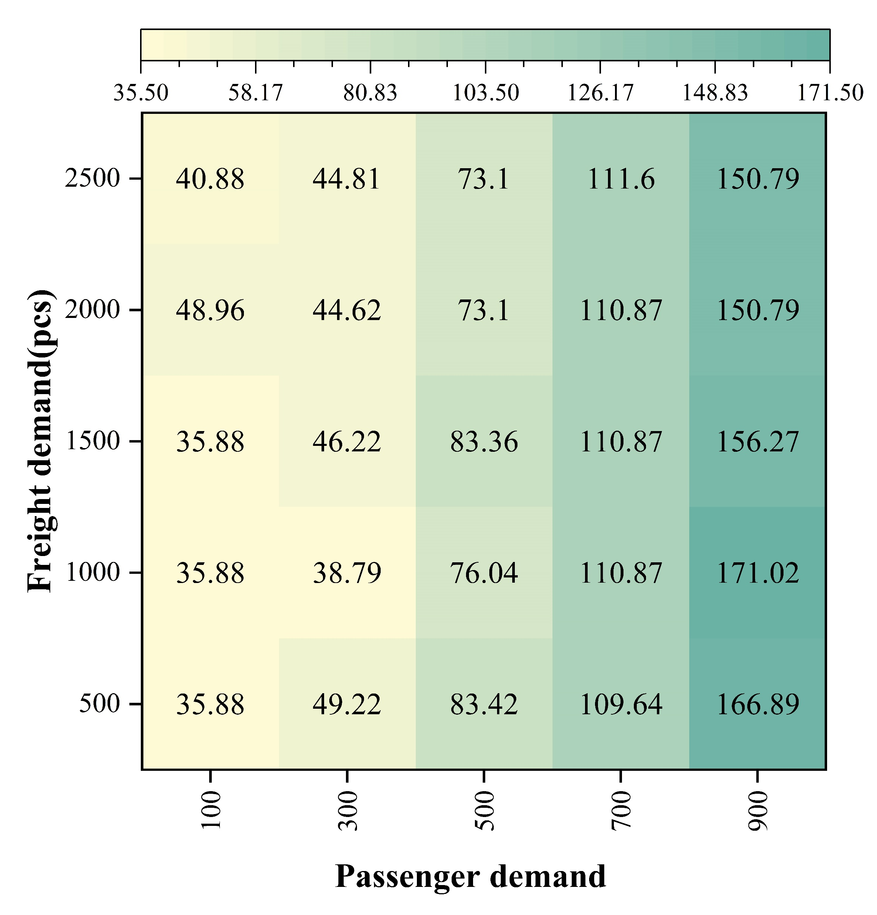
(a) Operating profit (RMB/day) (b) Passenger average travel time (min)
Fig. 10. Operating profit and passenger average travel time under PFSM with different passenger-freight demands
From Fig. 10 (b), for the passenger average travel time $\bar{T}$, it can be seen that the minimum value of 35.88 min is reached when the passenger-freight demand is {100, 500}, {100, 1000}, and {100, 1500}, respectively. The maximum value of 171.02 min is reached when the passenger-freight demand is {900, 1000}, resulting in a large number of secondary passenger detentions. Different from $Z$, the heat map has a more pronounced color change horizontally than vertically. The similar colors in the same column suggest that passenger demand has a greater impact on $\bar{T}$ than freight demand, showing a nonlinear growth. Under the same passenger demand scenario, the range of $\bar{T}$ values is relatively stable compared with Fig. 10 (a). This indicates that an increase in the number of passengers significantly increases the boarding/alighting time and the passenger detention time, thus seriously affecting $\bar{T}$. This effect tends to intensify with the incremental increase in passenger demand and the efficiency of PFSM will face more challenges. Besides, in some combinations of passenger-freight demand, an increase in freight demand reduces $\bar{T}$ instead. This is because under higher freight demand, fleet configuration tends to select medium- and large-sized buses in order to satisfy both passenger and freight demands, thus expanding the space for carrying more passengers and parcels, and improving the efficiency and the passenger travel experience.
In order to further explore the profit contribution differences between passengers and cargoes under different passenger demand levels, we introduce profit contribution ratio (PCR), space-based profit contribution ratio (SPCR), and income equivalence ratio (IER) as the evaluation indicators. PCR denotes the number of parcels transported whose profit is equal to the profit made by transporting one passenger; IER indicates the ratio of the number of passengers to the number of parcels to be transported to obtain the same revenue; and SPCR represents the profit ratio of using the same capacity to serve passengers and freight separately. In general, the capacity of a seat allows for stacking of 10 small parcels.
Table 8. Difference in profit contribution between passengers and parcels at different passenger demand levels
Passenger demand level | PCR | IER | SPCR
Low (100) | 1:0.59 | 1:1.693 | 1:5.91
Medium (500) | 1:0.50 | 1:2.0107 | 1:4.98
High (900) | 1:0.46 | 1:2.1988 | 1:4.57
From the above table, the freight service profit is greater than the passenger service profit in any passenger demand scenario, and the gap widens gradually with the growth of passenger demand. Based on PCR and IER, the unit profit contribution of freight transport is 0.46-0.59 times that of passenger transport. In terms of SPCR, the economic value of transporting parcels in the same space is about 4.57-5.91 times that of passenger transport. In summary, the economic advantage of freight service is more significant under PFSM, and that advantage is greater as passenger demand grows, probably because of the saturation of vehicle occupancy in the high passenger demand scenario and the need to increase vehicle capacity to serve both passengers and parcels.

5.3.2 Maximum passenger travel time
The maximum passenger travel time $T_{max}$ is an important factor to ensure the operational efficiency of urban-rural bus routes, and it plays a role in regulating the conflict between economic efficiency and service level of the bus operation scheme. If the value of $T_{max}$ is too large, the scheme may neglect passengers travel experience and satisfaction, thus reducing the attractiveness and operational efficiency of urban-rural buses; if the value is too small, it may limit the optimization space of the bus operation scheme and reduce the economic and environmental benefits of bus operation, even causing the fail to obtain a feasible solution [23]. Fig. 11 summarizes the economic and time metrics for the operation of urban-rural bus routes under different values of $T_{max}$.
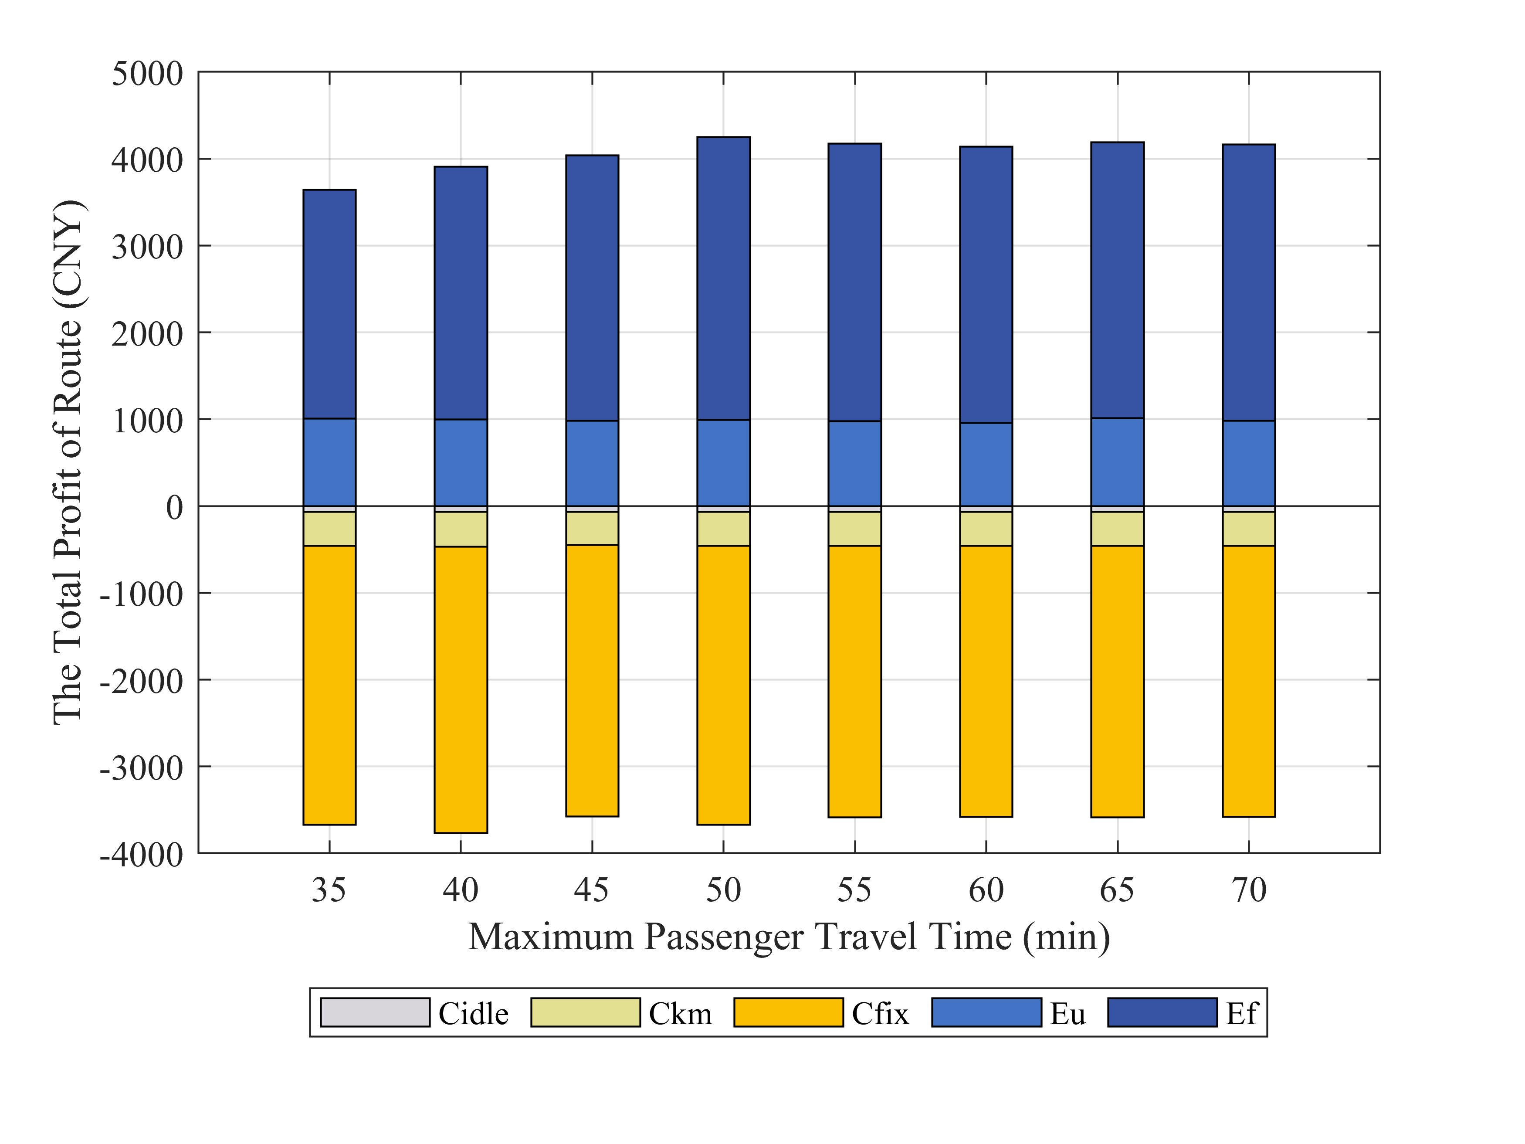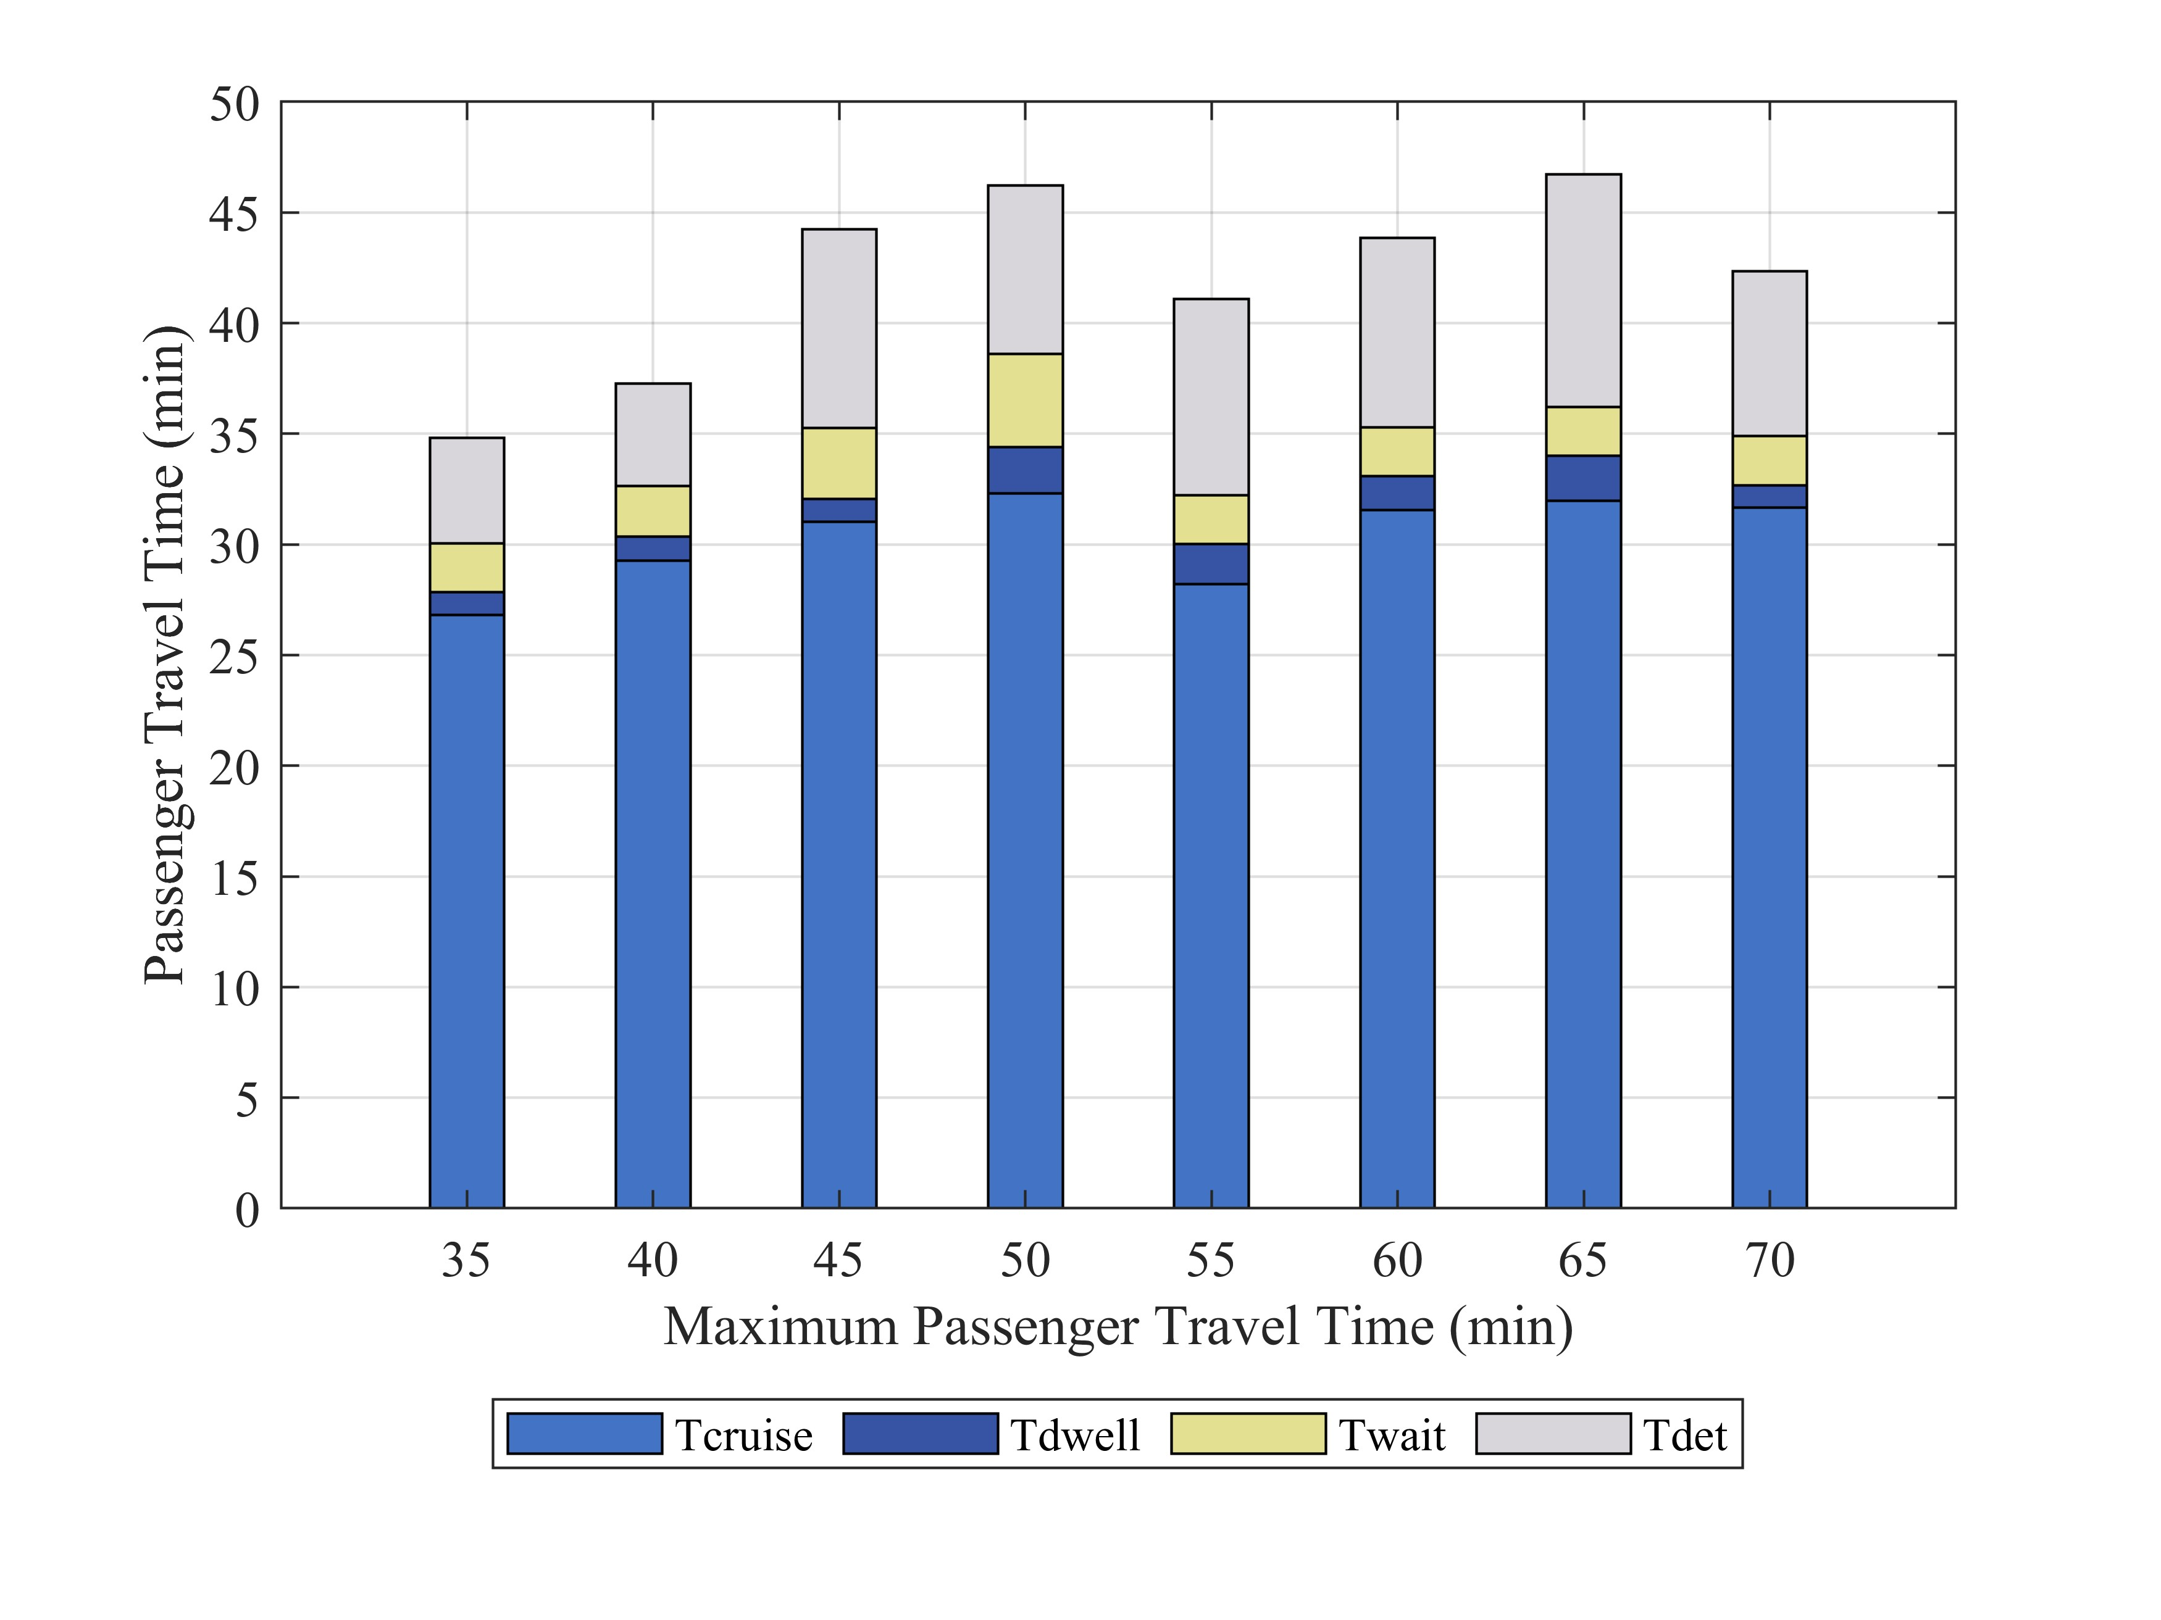
(a) Economic metrics (b) Time metrics
Fig. 11. Economic and time metrics for the operation of urban-rural bus routes under different values of $T_{max}$
It can be seen that the total operating profit $Z$ increases with the increase of $T_{max}$, and tends to stabilize when $T_{max}$ is greater than 50 minutes. When $T_{max}$= 35, $Z$ = -26.53 RMB/day, indicating that the bus system incurs a slight loss in order to fully guarantee the efficiency of passenger travel. This is mainly because the profit of transporting parcels with limited vehicle capacity is higher than the profit of carrying passengers under PFSM, but in order to satisfy the $T_{max}$ constraint, the optimization model guarantees the adequate passenger supply by reducing the freight capacity. The reduction of the revenue from freight services makes a slight loss. The profit increases rapidly with the gradual increase of $T_{max}$. When $T_{max}$50, the value of $Z$ fluctuates within the range of [507.39, 595.24], which is 120%-122% more than the profit of the traditional separated passenger and parcel transport. This implies that the operating profit of the bus system has reached a nearly saturated state, where the capacity allocation of passenger and freight services is reasonable to meet the corresponding demand.
In terms of average passenger travel time $\bar{T}$, when $T_{max}$ is less than 40 minutes, $\bar{T}$ approaches $T_{max}$. As $T_{max}$ increases, $\bar{T}$ is no longer close to $T_{max}$ and stabilizes at 41-46 minutes, an increase of 4%-20% compared to the conventional mode. This shows that the optimal scheme has balanced the benefits between passengers and the operator within the acceptable range of $T_{max}$, rather than sacrificing the interests of passengers endlessly. In order to balance the economic benefits and the level of service, it is recommended that $T_{max}$ is set to 50 min.

5.3.3 Minimum percentage of passenger capacity to vehicle capacity
For the minimum percentage of passenger capacity to vehicle capacity on a bus ($λ_{min}$), choosing the appropriate value allows the optimal scheme to balance operational benefits and service quality. If $λ_{min}$ is too small, it may lead to an oversupply of passengers and reduce the level of bus service; if $λ_{min}$ is too large, it may affect the freight demand and reduce the revenue. Fig. 12 shows the economic and time metrics of urban-rural bus operations under different values of $λ_{min}$.
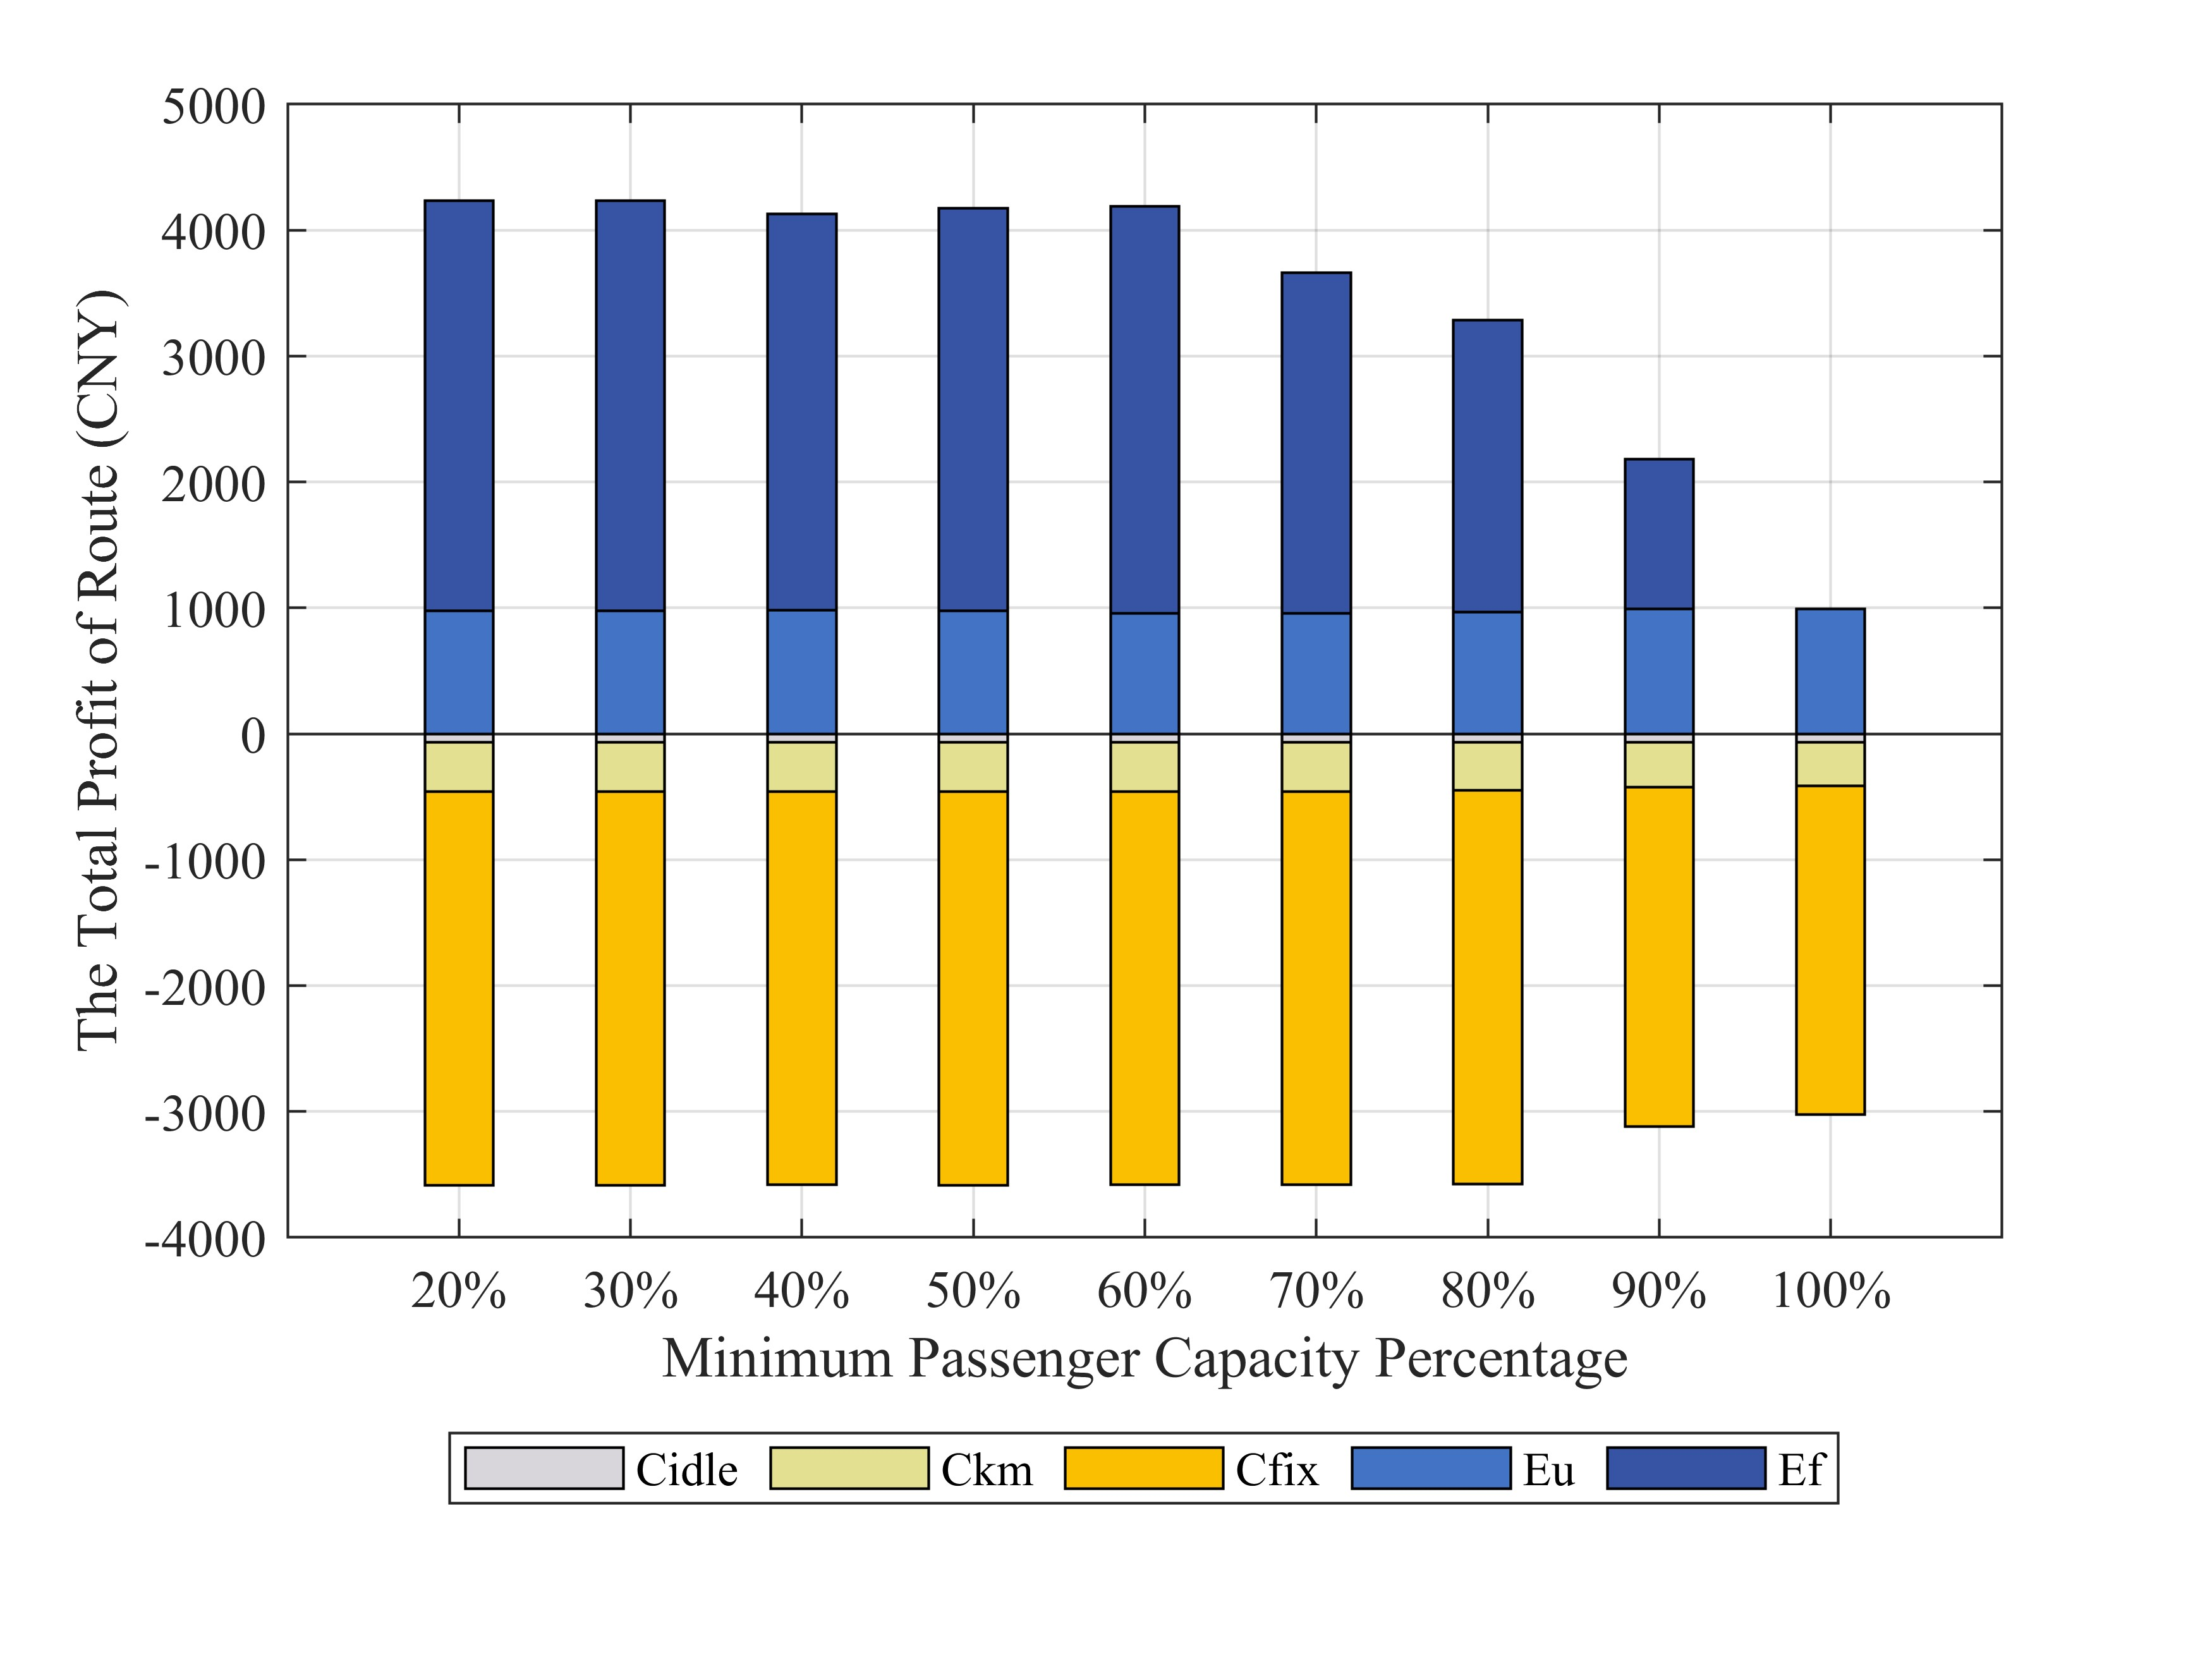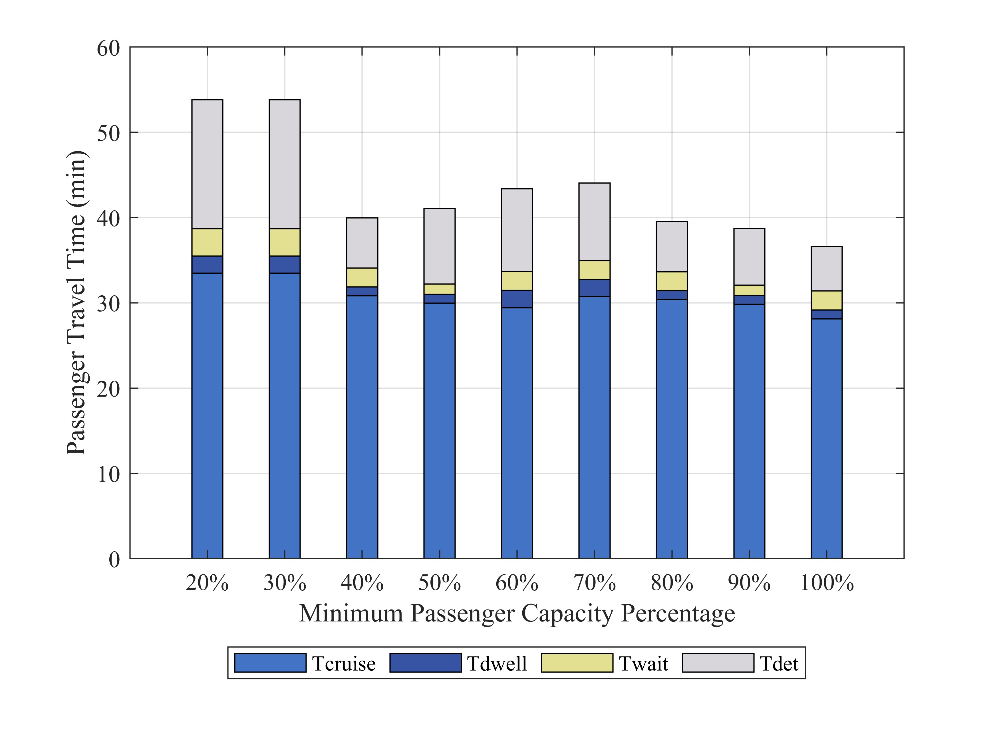
(a) Economic metrics (b) Time metrics
Fig. 12. Economic and time metrics for the operation of urban-rural bus routes under different values of $λ_{min}$
As $λ_{min}$ increases, the total operating profit $Z$ is stable at around 4200 RMB/day and then decreases, while $\bar{T}$ has a fluctuating trend of decreasing, then increasing and decreasing again. In terms of $Z$, when $λ_{min}$< 40%, $Z$ reaches the maximum value of 628.63 RMB/day; when 40%$≤$ $λ_{min}≤$60%, $Z$ slightly decreases but is stable in the interval [498.53, 572.4], increasing by 121%-124% than the profit of separated passenger and parcel transport. When $λ_{min}$> 60%, $Z$ decreases rapidly as $λ_{min}$ increases and begins to turn from profit to loss. The main reason is that buses with a small $λ_{min}$ can satisfy most freight demands with considerable economic benefits. As $λ_{min}$ increases, the remaining freight capacity on buses shrinks, resulting in a decline in revenue from freight services.
In terms of average passenger travel time $\bar{T}$, when $λ_{min}$ increases from 20% to 30%, $\bar{T}$ remains unchanged, mainly because the freight supply still exceeds demand in this condition and the reduction in freight capacity does not change the total dwell time. When $λ_{min}$ grows from 30% to 40%, the equilibrium between freight supply and demand is disrupted, and the compression of freight capacity leads to a reduction in the number of parcels carried, thus reducing the delay caused by freight service, with a significant decrease of $\bar{T}$. However, when 40%$≤λ_{min}≤$70%, an increase in $λ_{min}$ increases $\bar{T}$ by 3%-12% compared with the traditional mode. This is mainly due to the fact that the increase in the number of passengers carried leads to the additional dwell time while the expanding passenger capacity accommodates more passengers. When $λ_{min}$>70, $\bar{T}$ decreases to a minimum value of 36.64 min as $λ_{min}$ increases. One reason is that the passenger supply is greater than the demand and the expansion of the passenger capacity no longer increases the number of passengers. The other reason is that the reduction of the freight capacity results in the decreasing number of parcels, thus reducing the travel delay by freight services. In summary, we recommend $λ_{min}∈\left[40\%,60\%\right]$ to ensure the efficiency of passenger travel at the simultaneous maximization of operating profits.

5.3.4 Pareto frontier and weight-zone sensitivity
Profit and passenger travel time are conflicting objectives, so a single solution cannot optimize both. To make the trade-off explicit, the profit weight w₁ is scanned from 0.1 to 0.9 (with w₂ = 1 − w₁) and the Pareto frontier between daily profit Z and average travel time T̄ is traced. Travel time is also expressed as a percentage change relative to the 38.69 min baseline of mode A, so the service cost at each weight is clear. Table 9 reports the frontier and Fig. 13 plots it.
Table 9. Weight-zone sensitivity (ΔT̄ relative to the 38.69 min baseline of mode A)
w₁ | w₂ | Z (RMB/day) | T̄ (min) | ΔT̄ | Zone
0.1 | 0.9 | 388.82 | 39.12 | +1.11% | Service
0.2 | 0.8 | 489.18 | 43.26 | +11.81% | Service
0.3 | 0.7 | 537.55 | 46.22 | +19.46% | Balanced (knee)
0.4 | 0.6 | 543.43 | 49.09 | +26.88% | Balanced
0.5 | 0.5 | 552.92 | 50.79 | +31.27% | Balanced
0.6 | 0.4 | 558.57 | 51.45 | +32.98% | Balanced
0.7 | 0.3 | 563.75 | 53.74 | +38.90% | Profit
0.8 | 0.2 | 595.77 | 55.43 | +43.27% | Profit
0.9 | 0.1 | 608.73 | 58.90 | +52.24% | Profit
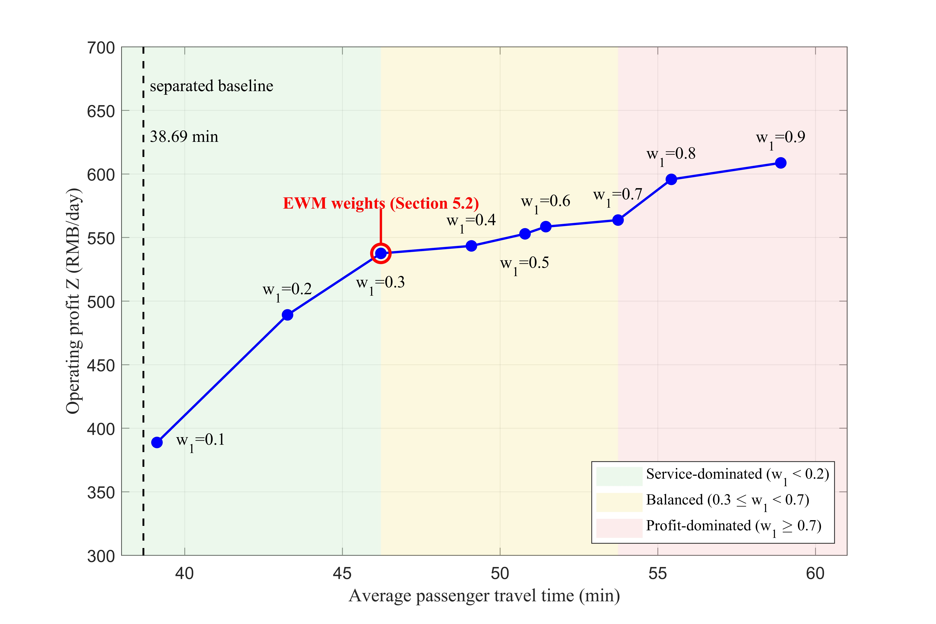
Fig. 13. Pareto frontier of daily profit versus average travel time; the entropy-weight operating point lies at the knee of the frontier.
The frontier splits into three zones. In the service zone (w₁ < 0.3), profit can be raised at a small cost in travel time: moving from w₁ = 0.1 to 0.2 lifts profit from RMB 388.82 to 489.18 while travel time grows by only about 4 min. In the balanced zone (0.3 ≤ w₁ < 0.7), profit gains flatten while the travel-time penalty keeps climbing: profit rises only from 537.55 to 558.57, yet T̄ increases from 46.22 to 51.45 min. In the profit zone (w₁ ≥ 0.7), each additional unit of profit demands a disproportionate increase in travel time, with T̄ exceeding 53 min.
The entropy-weight operating point sits at the knee of the frontier. At w₁ = 0.3, the scheme attains RMB 537.55 in daily profit at 46.22 min, which keeps almost all of the achievable profit while avoiding the steep travel-time penalty of the profit zone. The knee location explains why the entropy weight method, although objective, yields a balanced rather than an extreme solution.
In practice, the transition from the existing separated system to PFSM can be staged along the weight w₁. An operator may begin in the service zone, where freight is introduced with only a small effect on passenger travel time, and then move toward the balanced knee as parcel demand and operational confidence grow. The extreme profit zone is not recommended, because the marginal travel-time cost there erodes the social value of the service. This staged path lets the system capture the freight revenue early while protecting the passenger level of service.

5.4 Policy implications and applications
The policy implications are organized along four dimensions, namely environment, social service, sustainable development, and policy, each expressed as a transferable strategy rather than a route-specific calculation.
(i) Environmental dimension: pairing fleet electrification with operational efficiency.
The decarbonization of PFSM comes from the operating process, not from vehicle electrification alone, and the grid-scenario test indicates that the carbon saving grows rather than shrinks as the power grid becomes cleaner. The per-route annual reduction is in the order of twenty-odd tonnes of CO₂ under current and near-term grid conditions. Two transferable measures follow. First, the electrification of urban-rural bus fleets should be advanced in step with grid decarbonization, because the carbon return on each electric bus increases over its service life. Second, the carbon performance of these services should be accounted on a per-served-unit basis under a life-cycle boundary, so that the efficiency gained through capacity allocation is credited rather than masked by a longer running distance. On this footing, operators that adopt PFSM can be incorporated into a transport carbon-credit mechanism that rewards the measured intensity reduction [47].
(ii) Social-service dimension: safeguarding passenger service while extending freight reach.
Because parcels are carried on scheduled buses rather than on separate trucks, the same fleet extends regular collection and delivery to villages along the route and raises the reach of rural logistics, while the optimization shows that passenger demand can still be met in full at only a small cost in travel time. The sensitivity analysis indicates that passenger travel time responds far more to passenger volume than to parcel volume, which yields a service rule applicable to any route: passenger demand should be satisfied first, and freight should be loaded into the residual capacity. To keep this balance robust as demand varies, operators should hold the passenger-capacity share and the maximum passenger travel time within bounds that protect service, and regulators should treat these bounds as a service guarantee rather than leaving them to the operator alone [48].
(iii) Sustainable-development dimension: moving from subsidy dependence to self-financing.
Optimization lets the freight margin offset the operating cost of a route that would otherwise run at a loss, and the network-scale results show that this margin widens as the system grows, so the self-financing capacity is not limited to a single corridor. The transferable strategy is to use freight revenue to support the public-service obligation, with a revenue-feedback rule under which part of the freight margin funds higher peak-hour frequency and better stops. A staged transition is advisable: an operator may introduce freight where it adds little travel time and then move toward a balanced operating point as parcel demand grows, while avoiding an extreme profit setting in which each additional unit of profit demands a disproportionate increase in travel time [49].
(iv) Policy dimension: providing the rules that let the operating gains scale.
The gains depend on a mixed fleet and a dynamic passenger-to-freight ratio rather than a uniform fleet with a fixed split, and this mechanism is general rather than specific to one route. Three policy actions follow. First, a franchising rule should permit scheduled buses to carry parcels and should embed the service bounds noted above, so that passenger quality is protected as the practice spreads. Second, vehicle and route standards should allow the passenger-dominated and freight-dominated grouping that drives the revenue and full-service gains, since a single-type requirement would remove the mechanism. Third, an investment arrangement that combines central subsidy, local special-purpose bonds, and social capital can fund the buses and the distribution points at the rural and urban ends, which lowers the entry cost for counties beginning the transition. Together these rules allow the route-level result to extend across the wider network without relying on the favorable conditions of any single corridor [50].

Conclusion
To further expand the optimization theory of urban-rural bus operation under PFSM and maximize its economic and environmental benefits, this study proposes an ‘economy-efficiency-low-carbon’ -oriented resource reconfiguration strategy. Considering the collaborative optimization of multi-type bus scheduling and dynamic vehicle capacity allocation for urban-rural bus routes, we formulate a bilevel optimization model to investigate this strategy, and then a novel improved jellyfish search algorithm is designed to solve the transforming model by the entropy weight method. Two case studies of three simulated bus networks and two urban-rural bus lines in Shanxi Province, China, are used to examine the effectiveness of the proposed methodology in improving the economic benefits of urban-rural bus systems, reducing carbon emissions, and guaranteeing the level of bus service, respectively. We also obtain policy insights and give recommendations to the government on how to regulate the urban-rural bus operation under PFSM.
The proposed model can be further extended in future research. For example, the proposed model is based on the known OD demand, but there exist large uncertainties in passenger-freight transport demand in the actual operation, which has a certain impact on the reliability of the model application. Besides, due to space limitation, we do not include the timetable optimization in the model. However, there is an interactive feedback relationship between timetable setting and vehicle scheduling, which will significantly raise the requirements for the complexity and accuracy of the model solution. Therefore, our future research work will be devoted to investigating the influence of passenger-freight demand fluctuations on the travel delays and optimize bus timetable and vehicle scheduling cooperatively to enhance the theoretical and practical values.

References
- IEA (2025), Breakthrough Agenda Report 2025, IEA, Paris. https://www.iea.org/reports/breakthrough-agenda-report-2025/road-transport. Licence: CC BY 4.0.
- X. Qu, S. Wang, D. Niemeier. On the urban-rural bus transit system with passenger-freight mixed flow. Commun. Transp. Res., 2 (2022), p. 100054.
- Z. Di, L. Yang, J. Qi, Z. Gao. 2018. Transportation network design for maximizing flow-based accessibility. Transportation Research Part B: Methodological, 110 (2018), pp. 209-238.
- L. Sörensen, A. Bossert, J.-P. Jokinen, et al. How much flexibility does rural public transport need? Implications from a fully flexible DRT system. Transp Policy (Oxf), 100 (2021), pp. 5-20.
- China State Post Bureau. (2025). Statistical Bulletin on Postal Industry Development 2024. Beijing: China State Post Bureau.
- European Commission. (2007). Green Paper: Towards a New Culture for Urban Mobility (COM(2007) 551 final). Brussels: Commission of the European Communities.
- Ministry of Transport of the People's Republic of China. (2024). Guiding Opinions on Integrated Development of Rural Passenger, Freight, and Postal Services. Retrieved from https://xxgk.mot.gov.cn/2020/jigou/ysfws/202401/t20240102_3979968.html.
- People's Daily. (2024, April 15). “Integration of passenger, freight, and postal services with over 50,000 sites and 11,000 routes to enhance rural connectivity (Policy interpretation)”. Chinese Government Website. https://www.gov.cn/zhengce/202404/content_6945251.htm
- Li, F., Guo, X., Zhou, L., Wu, J., & Li, T. (2022). A capacity matching model in a collaborative urban public transport system: integrating passenger and freight transportation. International Journal of Production Research, 60(20), 6303-6328. https://doi.org/10.1080/00207543.2021.1991021
- Z. Li, A. Shalaby, M.J. Roorda, et al., Urban rail service design for collaborative passenger and freight transport, Transp. Res. Part E Logist. Transp. Rev. 147 (2021) 102205.
- F. Bruzzone, F. Cavallaro, S. Nocera, The integration of passenger and freight transport for first-last mile operations, Transp. Policy (Oxf) 100 (2021) 31-48.
- Liu B, Zhang HS, Liu K, Zhou YB, Destech P I. Case Study on the Planning Strategies of Urban and Rural Transit Integration Based on Characteristics Analysis-Zhoushan Island of China [C]//International Conference on Transportation (ICTR). Destech Publications, Inc, 2013: 119-124.
- V. Ghilas, E. Demir, and T. Van Woensel. Integrating passenger and freight transportation: Model formulation and insights, Eindhoven Univ. Technol., Eindhoven, The Netherlands, Working Paper 441, 2013.
- Trentini, R. Masson, F. Lehuédé, N. Malhene, O. Peton, and H. Tlahig. A shared ‘passengers & goods’ city logistics system, in Proc. ICIS, 2012, p. 10.
- G. Cheng, D. Guo, J. Shi, et al., When packages ride a bus: towards efficient city-wide package distribution, in: 2018 IEEE 24th International Conference on Parallel and Distributed Systems (ICPADS), IEEE, 2018, pp. 259-266.
- Z. Peng, R. Feng, C. Wang, et al., Online bus-pooling service at the railway station for passengers and parcels sharing buses: a case in Dalian, Expert Syst. Appl. 169(2021), 114354.
- He Y, Yang Z. Optimization of express distribution by cooperatively using private trucks and buses. Journal of Traffic and Transportation Engineering, 2017, 17(06): 97-103.
- Bruno Machado, Carina Pimentel, Amaro de Sousa. Integration planning of freight deliveries into passenger bus networks: Exact and heuristic algorithms. Transportation Research Part A: Policy and Practice, 2023, 171, 103645.
- Jonas Hatzenbühler, Erik Jenelius, Gyözö Gidófalvi, Oded Cats. Modular vehicle routing for combined passenger and freight transport. Transportation Research Part A: Policy and Practice, 2023, 173, 103688.
- Bruno Machado, Carina Pimentel, Amaro de Sousa. 2023. Urban logistics transportation system combining passenger and freight flows: a heuristic approach. Transportation Research Procedia, Volume 72, 2023, Pages 4476-4483.
- B. Wu, X. Zuo, G. Chen, G. Ai, X. Wan. 2024. Multi-agent deep reinforcement learning based real-time planning approach for responsive customized bus routes. Computers & Industrial Engineering, Volume 188, February 2024, 109840.
- K. Cochrane, S. Saxe, M. J. Roorda, and A. Shalaby, Moving freight on public transit: Best practices, challenges, and opportunities, Int. J. Sustain. Transp., vol. 11, no. 2, pp. 120-132, Feb. 2017.
- Trentini and N. Mahléné. Toward a shared urban transport system ensuring passengers & goods cohabitation, TeMA-J. Land Use Mob. Environ., vol. 3, no. 2, pp. 37-46, 2010.
- R. Van Duin, B. Wiegmans, L. Tavasszy, B. Hendriks, and Y. He. Evaluating new participative city logistics concepts: The case of cargo hitching, Transp. Res. Proc., vol. 39, pp. 565-575, Jan. 2019.
- Sala L, Wright S, Cottrill C, et al. Generating demand responsive bus routes from social network data analysis. Transportation Research Part C: Emerging Technologies, 2021, 128: 103194.
- Konrad Steiner, Stefan Irnich. Schedule-Based Integrated Intercity Bus Line Planning via Branch-and-Cut. Transportation Science, 2018, 52(4): 882-897.
- Patlins P, Pocs R. Small Shipment Delivery's Quality Improvement in Cities with Unstable Traffic [C]//Proceedings of the 30th European Conference on Modelling and Simulation. ECMS, 2016, 211-216.
- Tao Wang, Hongzhang Shao, Xiaobo Qu, Jonas Eliasson, Consolidating passenger and freight transportation in an urban-rural transit system, Fundamental Research, Volume 4, Issue 6, 2024, Pages 1603-1612.
- He D, Ceder A, Zhang W, et al. Optimization of a rural bus service integrated with e-commerce deliveries guided by a new sustainable policy in China. Transportation Research Part E: Logistics and Transportation Review, 2023, 172, 103069.
- Zeng Z, Qu X. Optimization of Electric Bus Scheduling for Mixed Passenger and Freight Flow in an Urban-Rural Transit System. IEEE Transactions on Intelligent Transportation Systems, 2023, 24(1): 1288-1298.
- Jie Lin, Fangni Zhang. Modular vehicle-based transit system for passenger and freight co-modal transportation. Transportation Research Part C: Emerging Technologies, 2024, 160, 104545.
- Bie Y, Zhou H, Yang M. Resource Configuration and Daily Operational Scheduling for Urban Electric Bus Route under the Hybrid Power Supply Strategy. Energy, 2025: 135097.
- J. Ji, Y. Bie, Z. Zeng, L. Wang, Trip energy consumption estimation for electric buses, Communications in Transportation Research, 2 (2022) 100069.
- Lien, J. W., Mazalov, V. V., Melnik, A. V., and Zheng, J. Wardrop equilibrium for networks with the BPR latency function. International Conference on Discrete Optimization and Operations Research, 2016. Springer, Cham, 9869, 37-49.
- Xu, X. D., Chen, A., Cheng, L., and Lo, H. K. Modeling distribution tail in network performance assessment: A mean-excess total travel time risk measure and analytical estimation method. Transportation Research Part B, 2014. 66(8): 32-49.
- Anastasia Spiliopoulou, Ioannis Papamichail, Markos Papageorgiou, Ioannis Tyrinopoulos, John Chrysoulakis, 2015. Macroscopic Traffic Flow Model Calibration Using Different Optimization Algorithms, Transportation Research Procedia, Volume 6, 2015, Pages 144-157, ISSN 2352-1465, https://doi.org/10.1016/j.trpro.2015.03.012.
- Guohui Li, Haonan Deng, Hong Yang. 2024. A multi-factor combined traffic flow prediction model with secondary decomposition and improved entropy weight method, Expert Systems with Applications, 2024, 255, 124424. https://doi.org/10.1016/j.eswa.2024.124424.
- Jui-Sheng Cho, Dinh-Nhat Truong, 2021. A Novel Metaheuristic Optimizer Inspired By Behavior of Jellyfish in Ocean, Applied Mathematics and Computation. Computation, Volume 389, 15 January 2021, 125535. DOI: https://doi.org/10.1016/j.amc.2020.125535.
- Liu, M., Zhang, Y., Guo, J. et al. 2023. An Adaptive Lion Swarm Optimization Algorithm Incorporating Tent Chaotic Search and Information Entropy. Int J Comput Intell Syst 16, 39 (2023). https://doi.org/10.1007/s44196-023-00216-7.
- Xin-She. Yang and Suash Deb, 2009. Cuckoo Search via Lévy flights, 2009 World Congress on Nature & Biologically Inspired Computing (NaBIC), Coimbatore, India, 2009, pp. 210-214, doi: 10.1109/NABIC.2009.5393690.
- Storn, R., & Price, K. 1997. Differential evolution: A simple and efficient heuristic for global optimization over continuous spaces. Journal of Global Optimization, 11(4), 341-359.
- Holland J H. Adoption in Natural and Artificial System. MIT Press, 1975.DOI:10.1002/pmh.179.
- Kennedy, J., & Eberhart, R. C. (1995). Particle swarm optimization. In Proceedings of the IEEE International Conference on Neural Networks (ICNN'95), Vol. 4, pp. 1942-1948.
- Mirjalili, S., Mirjalili, S. M., & Lewis, A. (2014). Grey wolf optimizer. Advances in Engineering Software, 69, 46-61.
- World Resources Institute, GHG Protocol Tool for Energy Consumption in China (Version 2.1), 2013. https://ghgprotocol.org/sites/default/files/GHG-Protocol-Tool-for-Energy-Consumption-in-China-V2%201_0.pdf
- Yiming Bie, Wei Qin, Jiabin Wu, 2024. Optimal electric bus scheduling method under hybrid energy supply mode of photovoltaic-energy storage system-power grid, Applied Energy, Volume 372, 2024, 123774, ISSN 0306-2619, https://doi.org/10.1016/j.apenergy.2024.123774.
- Holland, S. P., Mansur, E. T., Muller, N. Z., & Yates, A. J. (2021). The environmental benefits of transportation electrification: Urban buses. Energy policy, 148, 111921.
- Sustainable Bus. (2021). Electric bus, main fleets and projects around the world. Retrieved March 15, 2026, from https://sustainable-bus.com/electric-bus/electric-bus-public-transport-main-fleets-projects-around-world/ (2021)
- Pei, M., Hu, Y., Han, W., Qu, X., & Zou, C. (2024). Life-cycle analysis of economic and environmental effects for electric bus transit systems. Transportation Research Part D: Transport and Environment, 131, 104205.
- Xue Bing, Zhi-Chun Li, Xiaowen Fu, Optimization of urban-rural bus services with shared passenger-freight transport: Formulation and a case study, Transportation Research Part A: Policy and Practice, 2025, 192, 104355. https://doi.org/10.1016/j.tra.2024.104355.

Appendix
Table A1 Summary of representative studies
Reference | Scenario | Core focus | Optimization objective | Method / Algorithm | Main contribution
Ghilas et al. [13] | Urban | Passenger‑parcel scheduling | Service efficiency and operational feasibility | Mathematical model + CPLEX | Proposed integrated PFSM scheduling between terminals
Trentini et al. [14] |  | Last‑mile goods delivery | Last-mile delivery efficiency | Adaptive large neighborhood search | Explored city logistics with shared passenger‑goods buses
Cheng et al. [15] |  | Parcel delivery via public transport | Parcel delivery success rate and coverage | Mixed‑integer linear programming | Verified high delivery coverage near bus stops
Peng et al. [16] |  | Online bus‑pooling service | Passenger fairness and service efficiency | Two‑stage optimization | Realized passenger matching and parcel delivery sequentially
He & Yang [17] |  | Collaborative express delivery | Total operational cost | Cost minimization model | Optimized batches, departure times and distribution routes
Machado et al. [18] |  | Freight integration in transit networks | System efficiency under stochastic freight demand | Stochastic programming + heuristics | Designed transit network under uncertain freight demand
Hatzenbühler et al. [19] |  | Modular vehicle routing | Travel time and cost | Combinatorial optimization | Optimized vehicle configuration and routing for PFSM
Steiner & Irnich [26] | Urban-Rural | Bus line planning | Integrated bus line planning efficiency | Branch‑and‑cut | Achieved schedule‑based integrated intercity bus planning
Patlins & Pocs [27] |  | Shipment delivery quality | Small shipment delivery quality improvement | Simulation and modelling | Improved delivery reliability in unstable traffic
Wang et al. [28] |  | Passenger‑freight consolidation | Resource integration and system performance | Mixed‑integer programming | Integrated passenger and freight in urban‑rural transit
He et al. [29] |  | Dynamic rural bus scheduling | Timetable optimality and service reliability | MILP + hybrid heuristic | Optimized timetables for e‑commerce integrated PFSM
Zeng & Qu [30] |  | Electric bus scheduling | Total travel cost | Dynamic programming + subgradient method | Minimized travel cost with freight time windows
Lin et al. [31] |  | Multimodal PFSM system | Scheduling and allocation optimality | Mixed‑integer programming + two‑stage algorithm | Co-optimized vehicle scheduling and freight allocation

Table A2 List of notations
Abbreviations | Definition | $$e_{r}$$ | Predicted electricity consumption of run r in kWh
PFSM | Passenger-Freight Shared Mobility | $$G_{n}$$ | Curb weight of bus type n in kg
DC | Distribution centers | $$x_{k}^{r}$$ | Binary variable; equals 1 if bus k serves run r, and 0 otherwise
ITSC | Integrated transportation service centers | $$y_{k}^{n}$$ | Binary variable; equals 1 if the type of bus k is type n, and 0 otherwise
IJS | Improved Jellyfish Search Algorithm | $$F$$ | System benefit
JS | Jellyfish Search Algorithm | $$Z$$ | Total operating profit
GA | Genetic Algorithm | $$C_{\text{km}}$$ | Total running cost
PSO | Particle Swarm Optimization | $$C_{\text{dwell}}$$ | Total dwell cost
GWO | Grey Wolf Optimizer | $$C_{\text{fix}}$$ | Total purchasing cost
Parameters | Definition | $$C_{\text{toll}}$$ | Total toll cost
$$P_{elec}$$ | Electricity price in RMB/kWh | $$E_{u}$$ | Transit passenger fare revenue
$$ϕ_{\text{dwell}}$$ | Value of dwell time | $$E_{f}$$ | Revenue of freight service
$$ϕ_{n}^{\text{buy}}$$ | Purchasing cost of bus type n | $$T$$ | Total passenger travel time
$$T_{max}$$ | Maximum passenger travel time | $$T_{\text{cruise}}$$ | Total in-vehicle travel time
$$η_{n}^{u}$$ | Charged thereafter per kilometer of bus type n for passenger service | $$T_{\text{dwell}}$$ | Total dwell time
$$η_{f}$$ | Charged thereafter per kilometer for freight service | $$T_{\text{wait}}$$ | Total passenger waiting time
$$v_{f}$$ | Free-flow travel time of roadway segments | $$T_{det}$$ | Total passenger detention time
$$L_{u}$$ | Initial distance included in the base fare of passenger service | $$T_{i,j}^{r}$$ | In-vehicle travel time between (i, j) of the bus serving the rth run
$$L_{f}$$ | Initial distance included in the base fare of freight service | $$ε_{i,j}^{r}$$ | Stochastic perturbation term under the normal distribution $N\left(0,σ^{2}\right)$
$γ_{u}$, $γ_{f}$ | Base fares of passenger and freight services | $$P_{r,i}^{det}$$ | Number of stranded passengers after the rth run leaves stop i
$$L_{r}$$ | Running distance of the rth run in km | $$P_{r,i}^{\text{wait}}$$ | Number of passengers waiting for the rth run at stop i
$$V_{n}$$ | Vehicle capacity of bus type n in m³ | $$P_{r,i}^{\text{re}}$$ | Number of seats remaining when the bus serving the rth run arrives at stop i
$r_{i,j}$, $p_{i,j}$ | Performance value and weight of the ith alternative based on jth evaluation index | $o_{r,i}^{u}$, $d_{r.i}^{u}$ | Number of passengers boarding and alighting at stop i on the bus serving the rth run
$$O$$ | Number of alternatives | $o_{r,i}^{f}$, $d_{r,i}^{f}$ | Number of parcels loading and unloading at stop i on the bus serving the rth run
$$K^{*}$$ | Total fleet size | $d_{i,j}^{r}$, $q_{i,j}^{r}$ | Number of passengers and the amount of cargo transported from stop i to stop j in the rth run
$$Max_{it}$$ | Maximum number of iterations for the IJS | $$Δ_{r,m}^{u\left(i,j\right)}$$ | Dwell times of a bus serving the rth run at stop m
$U_{b}$, $L_{b}$ | Upper bound and lower bound of search spaces | $$Δ_{p}$$ | Average delay of a boarding/alighting passenger in seconds
$$β_{d}$$ | Distribution coefficient | $$Δ_{f}$$ | Average delay of a loading/unloading parcel in seconds
$$γ^{'}$$ | Motion coefficient related to the length of motion around the locations of the jellyfish | $$Δ_{\text{toll}}$$ | Road toll of a bus
$$C_{0}$$ | Threshold constant to regulate passive and active movements of the jellyfish | $$L_{\text{toll}}$$ | Toll mileage of a bus route in km
$α$, $u$, $v$ | Parameters for Levy flight | $a_{i,j}^{r}$, $Q_{i,j}^{r}$, $C_{i,j}^{r}$ | Free-flow travel time, demand volume, and capacity of the bus serving the rth run between (i, j)
$$α^{*}$$ | Scale parameter for the step size in the mutation step of the differential evolution | ${\hat{T}}_{i,j}^{r}$, $μ_{i,j}^{r}$, $σ_{i,j}^{r}$,$Ω\left(⋅\right)$ | Time budget value, mean, standard deviation, and distributing function of in-vehicle travel time of the bus serving the rth run between (i, j)
$$R^{*}$$ | Daily number of bus runs | $$R_{i,j}^{r}$$ | Probability that the actual in-vehicle travel time from stops i to j of the bus serving the rth run is not greater than the travel time budget
$$D$$ | The total dimension of a scheme for bus allocation and scheduling | $t_{r,i}$, $t_{r,i}^{'}$ | Times when the rth run arrives at stop i and the (r-1)-th run departs from stop i
$$μ_{tent}$$ | Parameter that controls the distribution pattern of the tent chaotic sequence | $$X_{i}$$ | Initial location of the ith jellyfish
$$β_{Levy}$$ | Stable distribution parameter of Levy flight | $X_{i}^{t}$, $X_{i,d}^{t}$ | Location of the ith jellyfish in the tth iteration and the dth dimension of $X_{i}^{t}$
CR | Crossover probability of the differential evolution | $$U_{i,d}^{t}$$ | dth dimension of trial vector of the ith individual in the tth iteration
$$rand_{i,d}$$ | Random number to control the selection of the dth dimension of the ith individual in the crossover process | $$X_{best}^{t}$$ | Best location in the current jellyfish population
$$γ$$ | Confidence level of in-vehicle travel time | $$\bar{μ}$$ | Mean location of all jellyfish in the population
$$n^{*}$$ | Number of evaluation indices | $V_{i}^{t}$, $V_{i,d}^{t}$ | Mutant vector of the ith individual in the tth iteration and the dth dimension of $V_{i}^{t}$
$$α_{i}$$ | Toll rate for class i | $$u\left(i,j\right)$$ | Equals 1 if stop i locates upstream of stop j in the stop sequence; and -1 otherwise
$$β_{k}^{n}$$ | Seat number of bus k with type n | $\tilde{S}$, $\tilde{K}$ | Skewness and kurtosis of the in-vehicle travel time
$${\overline{v}}_{p}$$ | Average spatial volume of a seat in a bus in m³ | $$w_{j}$$ | Weighting factor of the jth index
$$S$$ | Set of bus stops | $$E_{j}$$ | Information entropy of the jth evaluation index
$β$, $z$ | Calibration parameters of the improved BPR function | Auxiliary Symbols | Definition
$R$, $N$, $K$ | Sets of bus runs, vehicle types, and bus numbers | $$C(t)$$ | Time control function $C(t)$
$$β_{j}$$ | Seat number threshold for different classes | $$\left\lfloor ⋅\right\rfloor$$ | Floor function
Variables | Definition | $$Φ_{γ}$$ | $γ$ -quantile of a standard normal distribution
$$λ_{k}$$ | Percentage of passenger capacity to vehicle capacity on bus k | $$D_{i}\left(t\right)$$ | Cumulative passenger arrival function at stop i
$$δ_{i}$$ | Binary variable; equals 1 if stop i allows for cargo loading/unloading, and 0 otherwise

Table A3 The departure timetable of S1
Line ID | Request ID | Departure | Arrival | Energy consumption
Line 1 | 1 | 15:00 | 16:50 | 30 kWh
 | 2 | 17:00 | 18:50 | 30 kWh
Line 2 | 3 | 15:30 | 17:00 | 25 kWh
 | 4 | 17:30 | 19:00 | 25 kWh
Line 3 | 5 | 16:30 | 18:00 | 25 kWh
Line 4) | 6 | 15:10 | 16:40 | 25 kWh
 | 7 | 17:10 | 18:40 | 25 kWh
Line 5 | 8 | 16:50 | 18:20 | 25 kWh
Line 6 | 9 | 16:40 | 17:50 | 19 kWh
Line 7 | 10 | 17:20 | 20:00 | 44 kWh
Table A4 The departure timetable of S2
Line ID | Request ID | From ID | To ID | Departure | Arrival
Line 1 | 1 | 1 | 9 | 08:05 | 10:54
 | 2 | 9 | 1 | 22:06 | 23:54
Line 2 | 3 | 20 | 25 | 06:01 | 08:35
 | 4 | 25 | 20 | 17:14 | 18:31
Line 3 | 5 | 26 | 11 | 06:01 | 07:12
 | 6 | 11 | 26 | 17:32 | 19:49
Line 4 | 7 | 19 | 19 | 09:37 | 11:12
 | 8 | 19 | 19 | 22:00 | 00:37
Line 5 | 9 | 24 | 21 | 08:06 | 09:17
 | 10 | 21 | 24 | 16:22 | 19:10
Line 6 | 11 | 28 | 19 | 09:05 | 11:15
 | 12 | 19 | 28 | 22:40 | 00:59
Line 7 | 13 | 32 | 28 | 08:05 | 10:54
 | 14 | 28 | 32 | 22:06 | 23:54
Line 8 | 15 | 19 | 31 | 08:44 | 11:43
 | 16 | 31 | 19 | 21:04 | 23:21
Line 9 | 17 | 28 | 22 | 10:14 | 12:41
 | 18 | 22 | 28 | 22:49 | 01:28
Line 10 | 19 | 27 | 19 | 07:58 | 10:58
 | 20 | 19 | 27 | 21:20 | 22:47
Line 11 | 21 | 29 | 28 | 07:15 | 09:50
 | 22 | 28 | 29 | 20:16 | 22:51
Line 12 | 23 | 30 | 19 | 09:05 | 11:41
 | 24 | 19 | 30 | 22:07 | 23:26
Line 13 | 25 | 23 | 19 | 10:29 | 12:36
 | 26 | 19 | 23 | 20:55 | 23:55
Table A5 The departure timetable of S3
Line ID | Request ID | From ID | To ID | Departure | Arrival
Line 1 | 1 | 31 | 1 | 07:35 | 09:17
 | 2 | 1 | 31 | 19:52 | 21:46
Line 2 | 3 | 1 | 31 | 08:06 | 09:55
 | 4 | 31 | 1 | 16:46 | 19:02
Line 3 | 5 | 31 | 1 | 06:38 | 08:39
 | 6 | 1 | 31 | 19:48 | 22:02
Line 4 | 7 | 1 | 31 | 07:40 | 09:33
 | 8 | 31 | 1 | 19:18 | 21:02
Line 5 | 9 | 31 | 1 | 06:13 | 08:27
 | 10 | 1 | 31 | 19:35 | 21:08
Line 6 | 11 | 1 | 31 | 10:33 | 12:06
 | 12 | 31 | 1 | 20:50 | 22:27
Line 7 | 13 | 31 | 1 | 10:33 | 12:50
 | 14 | 1 | 31 | 18:26 | 20:02
Line 8 | 15 | 1 | 31 | 09:05 | 11:02
 | 16 | 31 | 1 | 19:40 | 21:25
Line 9 | 17 | 34 | 35 | 07:14 | 09:28
 | 18 | 35 | 34 | 16:07 | 18:25
Line 10 | 19 | 35 | 36 | 09:44 | 12:07
 | 20 | 36 | 35 | 18:38 | 20:48
Line 11 | 21 | 37 | 38 | 06:24 | 08:22
 | 22 | 38 | 37 | 17:36 | 20:05
Line 12 | 23 | 38 | 37 | 10:41 | 12:40
 | 24 | 37 | 38 | 16:50 | 18:53
Line 13 | 25 | 28 | 27 | 06:28 | 08:04
 | 26 | 27 | 28 | 16:09 | 18:25
Line 14 | 27 | 1 | 28 | 09:18 | 11:00
 | 28 | 28 | 1 | 20:12 | 21:47
Line 15 | 29 | 26 | 39 | 10:44 | 12:56
 | 30 | 39 | 26 | 18:52 | 20:34
Line 16 | 31 | 39 | 26 | 08:34 | 10:09
 | 32 | 26 | 39 | 17:30 | 19:27
Line 17 | 33 | 29 | 40 | 07:34 | 09:15
 | 34 | 40 | 29 | 17:07 | 18:49
Line 18 | 35 | 40 | 29 | 08:00 | 10:22
 | 36 | 29 | 40 | 17:40 | 19:32
Line 19 | 37 | 33 | 32 | 09:56 | 12:00
 | 38 | 32 | 33 | 16:10 | 18:24

Table A6 On-demand request for passenger (P) and cargo (C) of S1
No. | From | To | Pickup time window | Load (P/C) | No. | From | To | Pickup time window | Load (P/C)
1 | 1 | 2 | [14:55, 15:25] | 30 P | 21 | 12 | 24 | [16:40, 17:50] | 30 P
2 | 11 | 22 | [15:10, 15:40] | 30 P | 22 | 1 | 6 | [16:50, 17:20] | 30 P
3 | 21 | 23 | [16:00, 16:30] | 30 P | 23 | 12 | 19 | [17:10, 17:40] | 30 P
4 | 1 | 23 | [16:50, 15:20] | 30 P | 24 | 15 | 6 | [17:10, 17:40] | 30 P
5 | 15 | 2 | [17:20, 17:50] | 30 P | 25 | 1 | 7 | [16:40, 17:50] | 30 P
6 | 17 | 22 | [17:35, 18:05] | 30 P | 26 | 1 | 12 | [16:40, 17:50] | 30 P
7 | 1 | 3 | [15:25, 15:55] | 30 P | 27 | 11 | 20 | [17:00, 17:30] | 30 P
8 | 13 | 16 | [15:35, 16:00] | 30 P | 28 | 1 | 18 | [17:20, 18:00] | 30 P
9 | 14 | 24 | [15:35, 16:00] | 30 P | 29 | 17 | 19 | [18:00, 18:30] | 30 P
10 | 1 | 24 | [17:30, 18:00] | 30 P | 30 | 18 | 8 | [18:00, 18:30] | 30 P
11 | 18 | 3 | [18:20, 18:50] | 30 P | 31 | 10 | 9 | [15:00, 15:30] | 250 C
12 | 16 | 24 | [17:55, 18:25] | 30 P | 32 | 10 | 9 | [15:10, 15:40] | 250 C
13 | 1 | 4 | [16:25, 16:55] | 30 P | 33 | 10 | 9 | [15:30, 16:00] | 250 C
14 | 12 | 4 | [17:00, 17:30] | 30 P | 34 | 10 | 9 | [16:30, 17:00] | 250 C
15 | 15 | 21 | [17:25, 17:55] | 30 P | 35 | 10 | 9 | [16:40, 17:10] | 250 C
16 | 1 | 5 | [15:10, 15:40] | 30 P | 36 | 10 | 9 | [16:50, 17:20] | 250 C
17 | 1 | 15 | [15:10, 15:40] | 30 P | 37 | 10 | 9 | [17:00, 17:30] | 250 C
18 | 12 | 18 | [15:20, 15:50] | 30 P | 38 | 10 | 9 | [17:10, 17:40] | 250 C
19 | 1 | 24 | [17:10, 17:40] | 30 P | 39 | 10 | 9 | [17:20, 17:50] | 250 C
20 | 17 | 5 | [17:40, 18:10] | 30 P | 40 | 10 | 9 | [17:30, 18:00] | 250 C

Table A7 On-demand request for passenger (P) and cargo (C) of S2
No. | From | To | Pickup time window | Load (P/C) | No. | From | To | Pickup time window | Load (P/C)
1 | 22 | 8 | [15:27, 16:29] | 50 P | 41 | 30 | 9 | [20:42, 22:48] | 15 P
2 | 12 | 7 | [15:53, 16:09] | 17 P | 42 | 28 | 29 | [11:47, 14:28] | 24 P
3 | 16 | 4 | [13:56, 13:05] | 25 P | 43 | 18 | 32 | [13:17, 16:04] | 34 P
4 | 26 | 24 | [20:57, 23:07] | 16 P | 44 | 18 | 22 | [16:57, 16:08] | 27 P
5 | 5 | 22 | [06:37, 07:37] | 44 P | 45 | 25 | 10 | [12:04, 15:26] | 39 P
6 | 5 | 4 | [13:04, 13:55] | 15 P | 46 | 30 | 27 | [07:13, 10:24] | 50 P
7 | 16 | 18 | [21:13, 22:46] | 47 P | 47 | 25 | 31 | [06:22, 08:48] | 20 P
8 | 28 | 27 | [20:55, 20:43] | 15 P | 48 | 22 | 26 | [11:53, 14:58] | 27 P
9 | 26 | 22 | [09:15, 10:12] | 23 P | 49 | 2 | 26 | [06:05, 09:08] | 14 P
10 | 28 | 12 | [14:29, 15:55] | 24 P | 50 | 4 | 17 | [18:20, 19:29] | 48 P
11 | 7 | 4 | [06:05, 07:10] | 42 P | 51 | 25 | 18 | [19:16, 19:30] | 50 P
12 | 31 | 14 | [18:57, 18:10] | 45 P | 52 | 16 | 13 | [06:39, 07:15] | 25 P
13 | 25 | 17 | [20:18, 23:44] | 22 P | 53 | 8 | 14 | [20:44, 22:49] | 20 P
14 | 13 | 19 | [12:03, 12:47] | 44 P | 54 | 8 | 11 | [15:06, 15:59] | 39 P
15 | 5 | 16 | [18:07, 19:37] | 47 P | 55 | 25 | 26 | [12:04, 13:06] | 34 P
16 | 6 | 27 | [22:20, 24:13] | 27 P | 56 | 8 | 3 | [17:34, 20:42] | 27 P
17 | 17 | 26 | [10:42, 12:29] | 10 P | 57 | 22 | 1 | [19:52, 22:06] | 50 P
18 | 1 | 30 | [09:04, 10:32] | 20 P | 58 | 30 | 10 | [19:11, 21:39] | 45 P
19 | 23 | 5 | [13:23, 15:10] | 31 P | 59 | 28 | 18 | [16:54, 17:53] | 24 P
20 | 20 | 1 | [15:59, 15:56] | 27 P | 60 | 29 | 16 | [20:36, 23:21] | 30 P
21 | 8 | 7 | [10:17, 12:38] | 19 P | 61 | 21 | 12 | [21:13, 23:51] | 13 P
22 | 14 | 17 | [22:31, 24:57] | 23 P | 62 | 18 | 1 | [22:12, 22:15] | 24 P
23 | 28 | 18 | [07:00, 09:49] | 31 P | 63 | 16 | 31 | [21:28, 21:05] | 30 P
24 | 17 | 11 | [20:35, 23:35] | 16 P | 64 | 26 | 16 | [15:42, 17:30] | 35 P
25 | 5 | 10 | [07:53, 09:37] | 15 P | 65 | 13 | 21 | [09:47, 10:12] | 46 P
26 | 9 | 3 | [15:23, 15:57] | 34 P | 66 | 18 | 19 | [09:53, 10:18] | 30 P
27 | 16 | 7 | [17:49, 20:39] | 16 P | 67 | 12 | 20 | [06:45, 07:17] | 23 P
28 | 11 | 12 | [19:01, 20:47] | 32 P | 68 | 19 | 9 | [21:06, 21:36] | 35 P
29 | 16 | 18 | [11:50, 11:24] | 32 P | 69 | 31 | 29 | [16:11, 16:16] | 39 P
30 | 15 | 13 | [20:22, 22:52] | 48 P | 70 | 5 | 26 | [21:04, 21:09] | 19 P
31 | 2 | 13 | [18:21, 20:55] | 26 P | 71 | 1 | 21 | [21:01, 21:59] | 270 C
32 | 23 | 26 | [16:01, 16:56] | 39 P | 72 | 9 | 31 | [11:16, 14:13] | 388 C
33 | 17 | 3 | [09:38, 12:22] | 44 P | 73 | 31 | 27 | [12:06, 12:42] | 207 C
34 | 8 | 25 | [12:16, 12:45] | 17 P | 74 | 4 | 31 | [22:58, 23:03] | 314 C
35 | 13 | 24 | [19:04, 21:39] | 34 P | 75 | 19 | 14 | [19:50, 21:29] | 360 C
36 | 20 | 27 | [16:25, 18:35] | 15 P | 76 | 16 | 31 | [08:29, 11:56] | 217 C
37 | 27 | 25 | [11:39, 13:25] | 45 P | 77 | 32 | 26 | [13:09, 13:57] | 258 C
38 | 14 | 31 | [11:42, 11:18] | 33 P | 78 | 15 | 32 | [13:17, 16:31] | 253 C
39 | 16 | 20 | [13:51, 14:09] | 46 P | 79 | 4 | 23 | [13:41, 13:49] | 386 C
40 | 15 | 12 | [22:29, 22:35] | 28 P | 80 | 22 | 23 | [20:17, 22:16] | 254 C

Table A8 On-demand request for passenger (P) and cargo (C) of S3
No. | From | To | Pickup time window | Load (P/C) | No. | From | To | Pickup time window | Load (P/C)
1 | 16 | 19 | [15:03, 16:55] | 33 P | 41 | 28 | 3 | [16:54, 17:46] | 20 P
2 | 4 | 36 | [19:31, 19:48] | 30 P | 42 | 3 | 36 | [18:53, 18:38] | 22 P
3 | 20 | 21 | [19:19, 19:54] | 38 P | 43 | 3 | 27 | [16:02, 16:16] | 28 P
4 | 26 | 19 | [17:30, 17:32] | 40 P | 44 | 28 | 38 | [14:26, 14:02] | 26 P
5 | 25 | 11 | [16:39, 17:10] | 32 P | 45 | 17 | 16 | [15:59, 15:40] | 38 P
6 | 1 | 31 | [14:36, 14:48] | 34 P | 46 | 15 | 28 | [15:07, 15:00] | 30 P
7 | 23 | 1 | [17:07, 18:10] | 26 P | 47 | 3 | 26 | [17:21, 17:36] | 35 P
8 | 28 | 34 | [15:21, 16:25] | 27 P | 48 | 23 | 39 | [15:33, 16:54] | 27 P
9 | 12 | 32 | [16:17, 17:27] | 26 P | 49 | 33 | 37 | [16:00, 16:53] | 28 P
10 | 39 | 18 | [16:41, 16:59] | 36 P | 50 | 9 | 6 | [18:30, 19:57] | 38 P
11 | 26 | 27 | [16:01, 16:45] | 39 P | 51 | 23 | 36 | [18:03, 18:32] | 36 P
12 | 2 | 10 | [15:53, 15:21] | 24 P | 52 | 30 | 4 | [18:51, 18:37] | 31 P
13 | 25 | 10 | [15:06, 16:59] | 30 P | 53 | 25 | 40 | [19:02, 19:13] | 22 P
14 | 23 | 1 | [19:01, 19:33] | 21 P | 54 | 3 | 31 | [17:11, 18:20] | 28 P
15 | 39 | 8 | [17:35, 17:30] | 34 P | 55 | 26 | 15 | [17:56, 18:07] | 21 P
16 | 4 | 13 | [18:21, 19:19] | 34 P | 56 | 31 | 9 | [17:23, 18:51] | 29 P
17 | 9 | 2 | [14:25, 14:58] | 27 P | 57 | 5 | 6 | [19:55, 19:50] | 34 P
18 | 30 | 28 | [14:57, 14:53] | 36 P | 58 | 2 | 6 | [15:48, 16:41] | 40 P
19 | 14 | 22 | [17:10, 18:49] | 20 P | 59 | 36 | 24 | [16:55, 17:46] | 40 P
20 | 4 | 32 | [18:17, 19:18] | 23 P | 60 | 34 | 33 | [19:01, 19:33] | 36 P
21 | 2 | 24 | [17:41, 17:23] | 24 P | 61 | 5 | 4 | [16:45, 17:29] | 254 C
22 | 14 | 12 | [17:23, 18:47] | 23 P | 62 | 4 | 3 | [17:53, 17:20] | 184 C
23 | 30 | 12 | [18:13, 18:54] | 31 P | 63 | 3 | 2 | [17:12, 18:44] | 259 C
24 | 9 | 25 | [14:27, 14:37] | 36 P | 64 | 3 | 5 | [16:28, 17:48] | 252 C
25 | 22 | 40 | [16:22, 17:53] | 31 P | 65 | 3 | 4 | [17:04, 17:41] | 255 C
26 | 1 | 8 | [16:33, 17:36] | 20 P | 66 | 5 | 4 | [15:50, 15:37] | 205 C
27 | 34 | 19 | [14:53, 15:25] | 37 P | 67 | 3 | 2 | [17:37, 17:44] | 207 C
28 | 38 | 39 | [19:51, 19:35] | 28 P | 68 | 5 | 1 | [17:46, 17:56] | 225 C
29 | 7 | 22 | [16:22, 17:51] | 34 P | 69 | 1 | 3 | [18:17, 19:01] | 270 C
30 | 19 | 16 | [19:01, 20:30] | 20 P | 70 | 3 | 5 | [17:44, 17:36] | 168 C
31 | 15 | 6 | [16:03, 16:02] | 21 P | 71 | 1 | 5 | [15:38, 16:18] | 234 C
32 | 28 | 2 | [17:57, 18:59] | 29 P | 72 | 4 | 2 | [16:23, 16:35] | 175 C
33 | 38 | 5 | [17:18, 18:41] | 20 P | 73 | 1 | 3 | [17:02, 17:05] | 268 C
34 | 38 | 32 | [15:32, 15:57] | 30 P | 74 | 1 | 2 | [17:12, 18:26] | 238 C
35 | 25 | 28 | [14:50, 15:34] | 20 P | 75 | 4 | 3 | [17:04, 17:55] | 289 C
36 | 22 | 40 | [14:49, 14:15] | 28 P | 76 | 4 | 3 | [16:35, 16:16] | 208 C
37 | 33 | 32 | [16:32, 17:16] | 28 P | 77 | 2 | 1 | [18:49, 18:02] | 295 C
38 | 38 | 21 | [14:15, 14:39] | 24 P | 78 | 3 | 1 | [16:20, 16:32] | 155 C
39 | 7 | 8 | [19:28, 19:18] | 20 P | 79 | 2 | 4 | [15:28, 15:40] | 180 C
40 | 8 | 28 | [19:29, 20:10] | 26 P | 80 | 5 | 2 | [16:53, 16:56] | 268 C

Table A9 On-demand request for passenger (P) and cargo (C)
No. | From | To | Pickup time window | Load (P/C)
1 | 3 | 9 | [6:10, 8:10] | 15 P
2 | 12 | 9 | [6:30, 8:30] | 15 P
3 | 16 | 8 | [7:00, 8:00] | 15 P
4 | 8 | 9 | [7:25, 9.25] | 15 P
5 | 10 | 4 | [7:45, 9:45] | 15 P
6 | 4 | 8 | [8:00, 10:00] | 15 P
7 | 15 | 9 | [8:35, 11:35] | 15 P
8 | 8 | 9 | [9:10, 11:10] | 15 P
9 | 2 | 8 | [9:20, 11:20] | 15 P
10 | 14 | 17 | [10:10, 12:10] | 15 P
11 | 9 | 12 | [15:10, 16:40] | 15 P
12 | 4 | 10 | [15:20, 16:20] | 15 P
13 | 9 | 15 | [16:00, 17:10] | 15 P
14 | 9 | 3 | [16:30, 18:00] | 15 P
15 | 17 | 12 | [16:40, 17:50] | 15 P
16 | 8 | 4 | [16:45, 17:45] | 15 P
17 | 9 | 1 | [17:00, 18:30] | 15 P
18 | 8 | 16 | [17:40, 19:50] | 15 P
19 | 9 | 8 | [18:00, 19:00] | 15 P
20 | 8 | 1 | [18:30, 19:30] | 15 P
21 | 10 | 11 | [6:00, 8:00] | 150 C
22 | 10 | 11 | [6:10, 8:10] | 120 C
23 | 10 | 4 | [7:30, 9:30] | 120 C
24 | 4 | 11 | [8:10, 10:10] | 120 C
25 | 10 | 16 | [9:00, 11:00] | 120 C
26 | 16 | 11 | [10:10, 12:10] | 120 C
27 | 11 | 10 | [15:00, 17:30] | 150 C
28 | 11 | 10 | [15:10, 17:30] | 120 C
29 | 11 | 4 | [16:30, 18:30] | 120 C
30 | 4 | 10 | [17:00, 18:30] | 120 C
31 | 11 | 16 | [18:00, 19:30] | 120 C
32 | 16 | 10 | [19:00, 19:30] | 120 C

