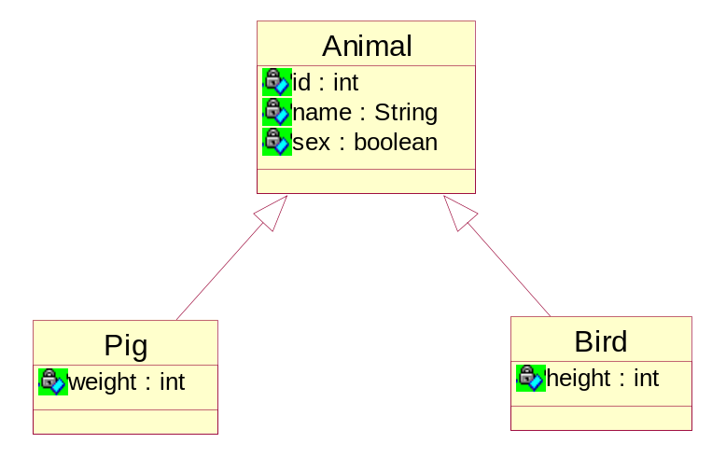
每棵继承树映射成一张表
t_animal
id | name | sex | weight | height | type
1 | 猪猪 | true | 100 |  | P
2 | 鸟鸟 | false |  | 50 | B

