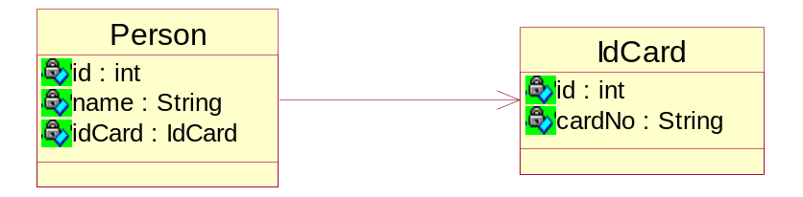

t_person
id | name
- | 菜10
- | 容祖儿
t_idcard
id | cardNo
1 | 8888888888
2 | 9999999999

