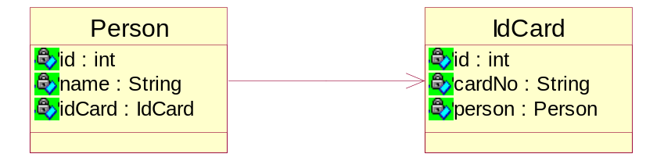

t_person
id | name | idcard
- | 菜10 | 100
- | 容祖儿 | 200
t_idcard
id | cardNo
100 | 8888888888
200 | 9999999999

