1. RcsSdk.getNav()

Sdk/Interface.js

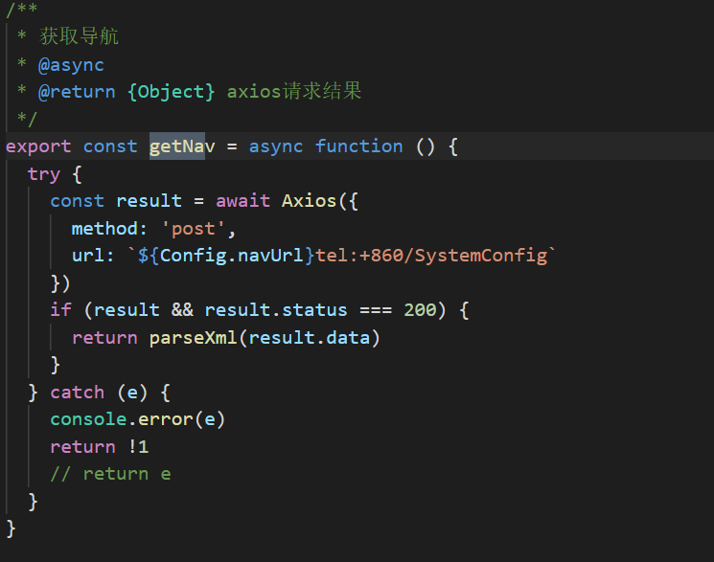

1. getSessionIdAsync()

sdk/interface.js

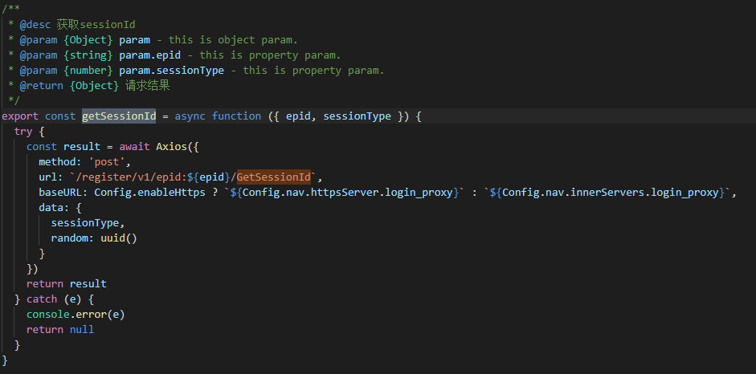

1. 生成二维码

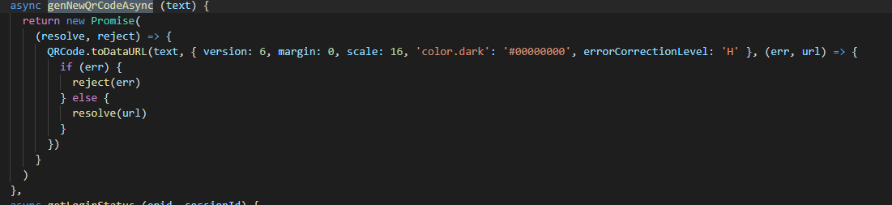

1. 轮询 polling

Sdk/interface.js

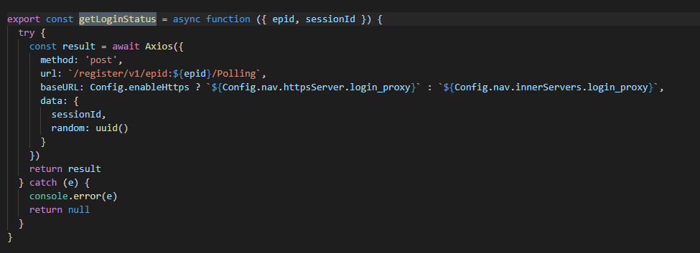

1. 登入

RCSSdk.js

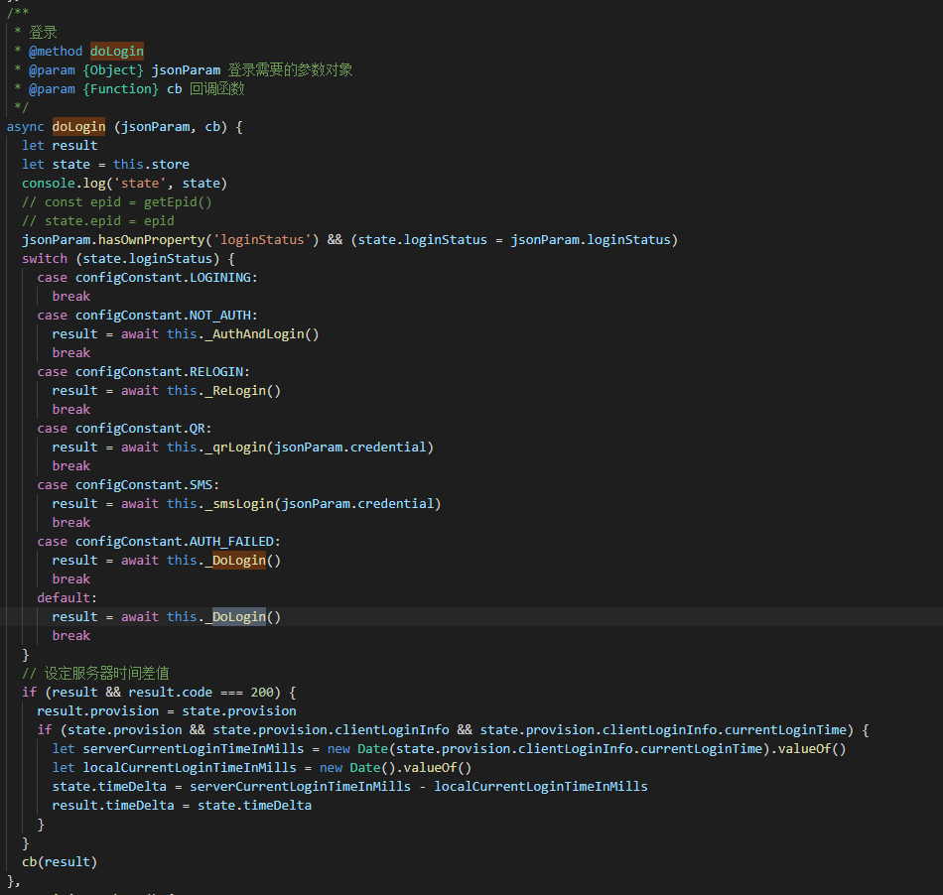

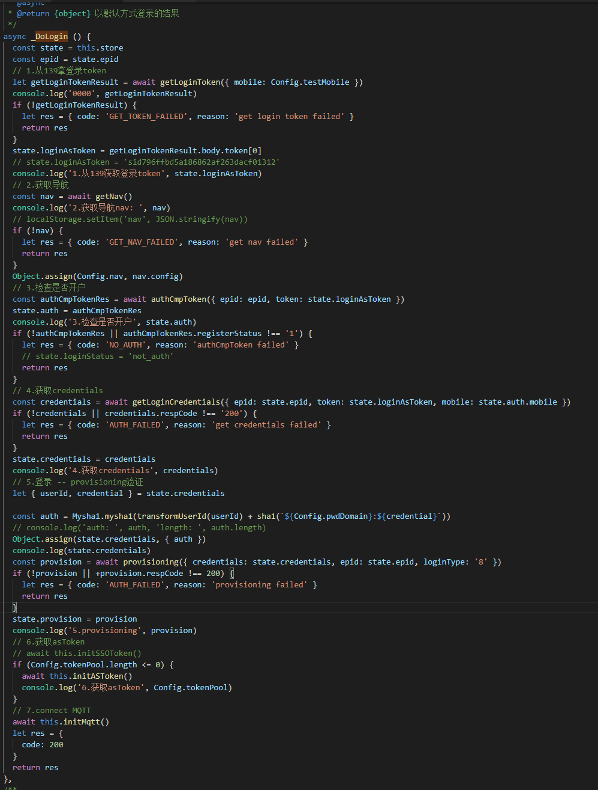

1. initAllData—pullCurrprofile---rcssdk.getUserInfo()

sdk/interface.js

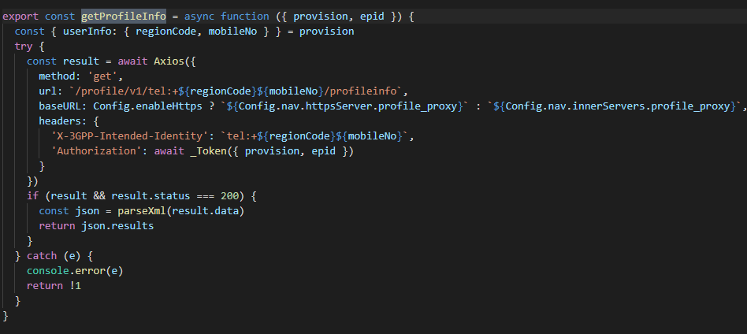

1. initAllData—initDialog—IO.dialog.pullRecents()---rcsSdk.getLastestContact

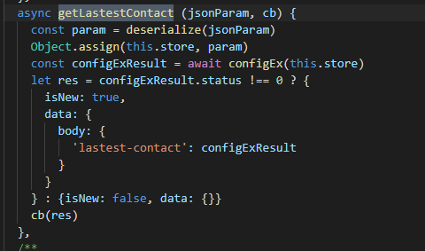

configEx

sdk/interface.js

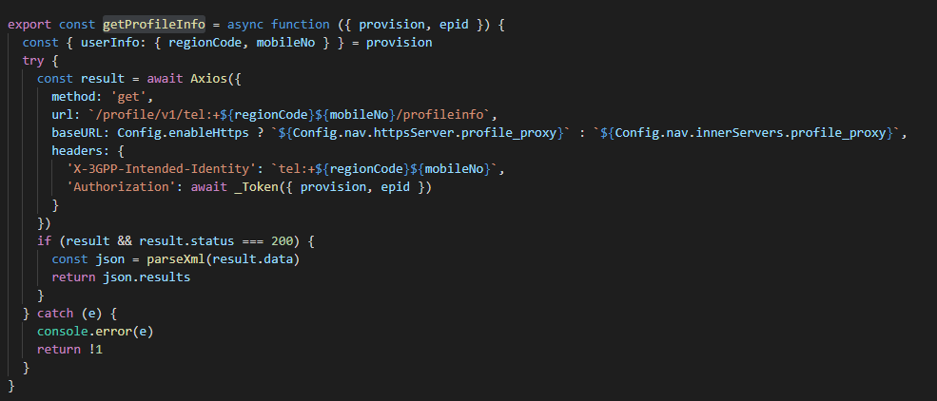

1. initAllData—pullAddressBook-rcssdk.addressbook_list

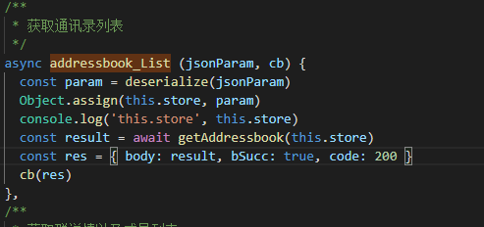

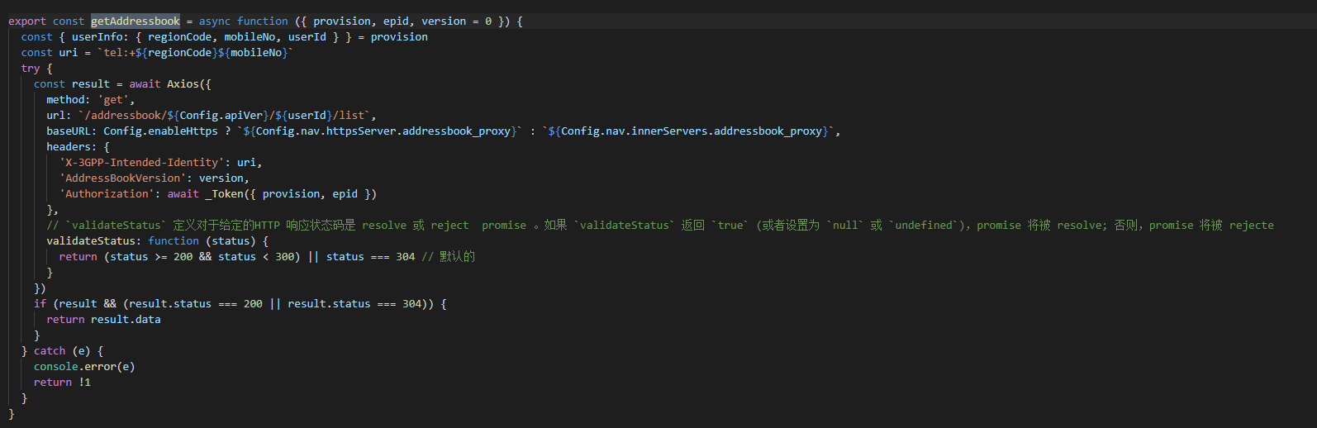

1. initAllData—pullCurrPortrait—rcsSdk.rcsDownloadPortrait

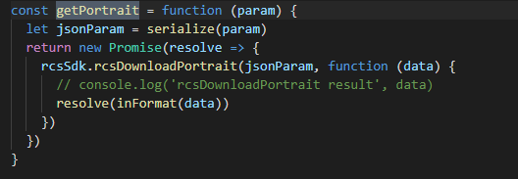

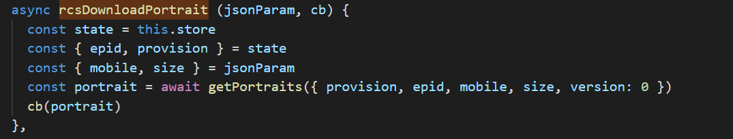

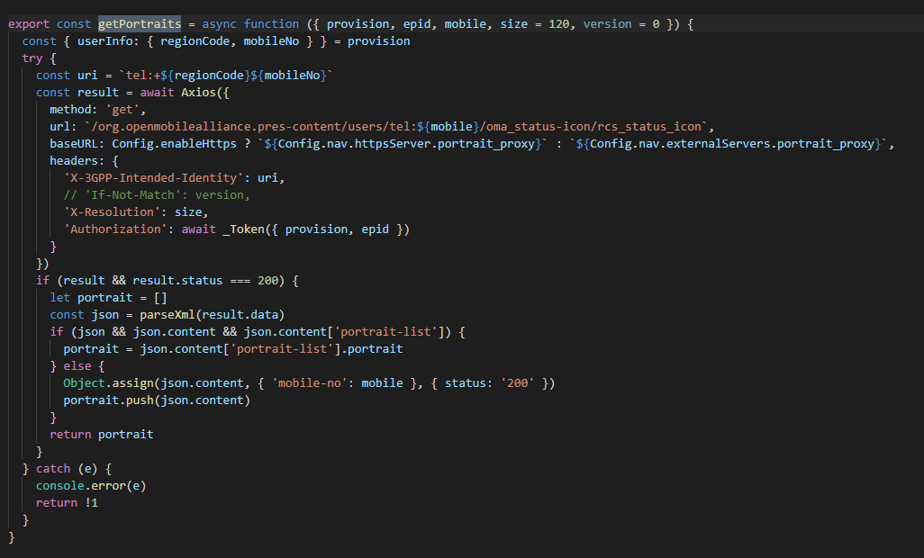

1. initAllData—pullContactList—

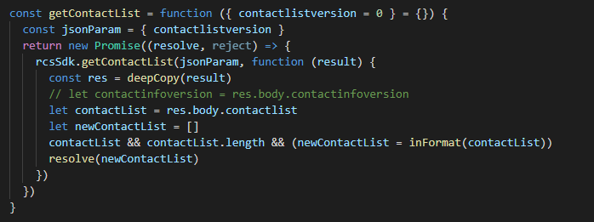

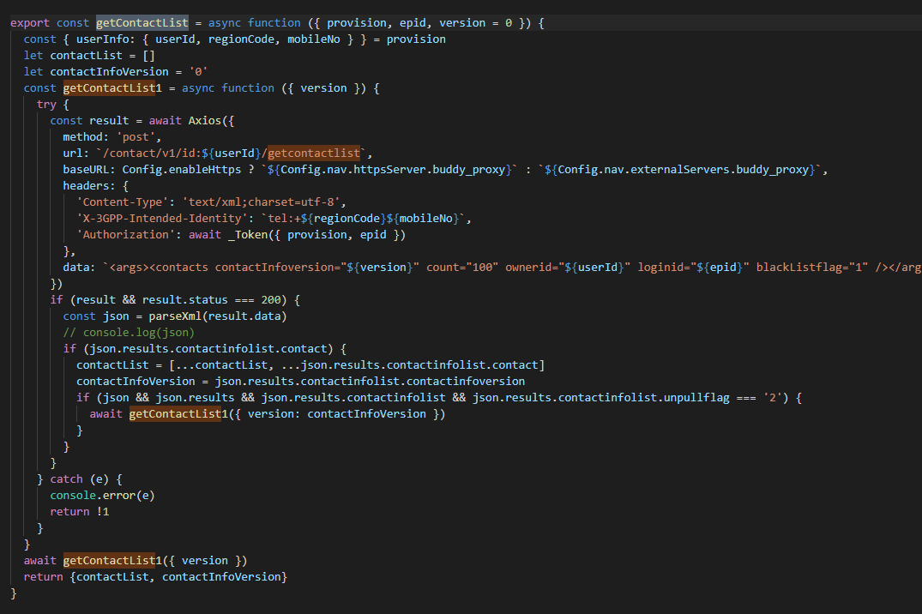

1. initAllData—pullGroupList—

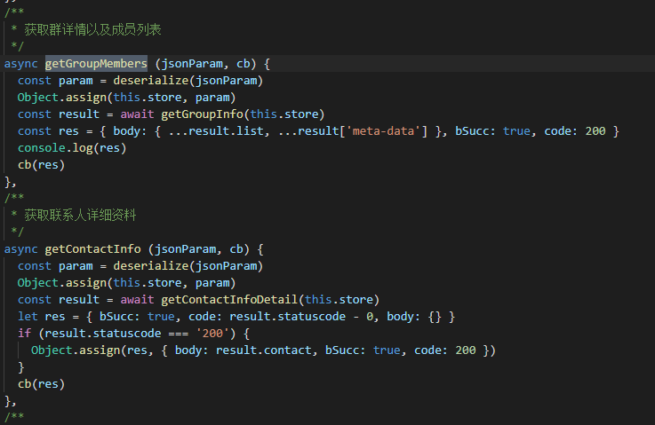

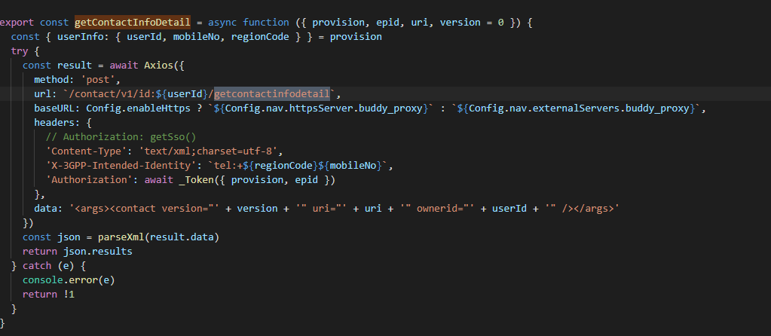

1. initAllData—pullCurrPortrait—

