Supplementary Materials: The Bias Fraction from Negative Control Calibration
Zeng Zhechun et al.
2026-08-14

1. eAppendix 1. The observed bias fraction (OBF) and Fieller confidence sets

1.1 Observed bias fraction
The main text defines the bias fraction as the share of the total calibrated signal attributable to bias. A companion quantity, the observed bias fraction (OBF), divides the estimated bias by the uncalibrated estimate:
$$OBF=\frac{|{\hat{μ}}_{B}|}{|{\hat{ψ}}_{\text{obs}}|}.$$
OBF answers “of the association as estimated before calibration, what share is bias?” In the beta-blocker analysis, $|{\hat{μ}}_{B}|=0.190$ and $|{\hat{ψ}}_{\text{obs}}|=0.184$, giving OBF = 1.03; the estimated bias is comparable to the entire observed association. For GDMT, OBF = 0.44, because the observed association ($|{\hat{ψ}}_{\text{obs}}|=0.438$) is larger than the estimated bias. OBF is scale-invariant like BF, but unbounded, and it is unstable when the observed estimate is near zero. We report OBF as a descriptive companion; all classifications use BF.

1.2 Fieller confidence sets
The signed ratio $ρ=μ_{B}/\tilde{ψ}$ underlies BF through $BF=|ρ|/(1+|ρ|)$. Fieller’s theorem gives the set of $ρ$ values consistent with the data at level $1−α$ [1]. With $m_{1}={\hat{μ}}_{B}$, $m_{2}=\tilde{ψ}={\hat{ψ}}_{\text{obs}}−{\hat{μ}}_{B}$, $v_{11}=Var({\hat{μ}}_{B})$, $v_{22}={\hat{σ}}_{\text{obs}}^{2}+v_{11}$, and $v_{12}=−v_{11}$ (the primary estimate is independent of the negative controls), the confidence set contains all $ρ$ satisfying
$$(m_{1}−ρm_{2})^{2}≤z_{α/2}^{2}(v_{11}−2ρv_{12}+ρ^{2}v_{22}).$$
When the coefficient of $ρ^{2}$ is negative, the set is the exterior of a finite interval, unbounded in both tails; when the discriminant is negative the set is empty or the whole line. We estimated $v_{11}$ from the variance of ${\hat{μ}}_{B}$ across bootstrap resamples.
- Beta-blocker: the Fieller set was exterior, $(−∞,−1.62]∪[1.45,∞)$. Only ratios inside [-1.62, 1.45] are excluded at 95%. The calibrated estimate ($\tilde{ψ}=0.006$) is tiny relative to its uncertainty ($\tilde{σ}=0.088$), so the ratio is poorly identified in the frequentist sense. The bootstrap CI on BF, [0.74, 0.99], lies entirely above 0.5, and the zone assignment is unaffected.
- GDMT: the Fieller set was interior, [0.42, 1.8], straddling 1, consistent with the mixed classification.
The lesson of the Fieller exercise is that when the calibrated estimate is near zero, no interval method can pin down the ratio; readers should rely on the zone assignment from the BF bootstrap CI and on the calibrated p-value, rather than on the precise numeric value of BF or BER.

2. eAppendix 2. What BF does not estimate
The metric does not estimate the true treatment effect; it summarizes the relationship between estimated bias and the residual effect after calibration. A bias-dominated classification means “the calibrated estimate does not support a causal claim”, not “the true effect is zero”. The metric does not identify the source of bias, whether healthy-adherer confounding, indication bias, or another channel of unmeasured confounding. It does not provide a probability or posterior distribution over the true effect. When $\tilde{ψ}≈0$, a BF near 1 could reflect either a genuinely null treatment effect or a bias that approximately cancels a non-zero true effect; the metric cannot distinguish these cases.

3. eAppendix 3. When calibration-based diagnostics should not be used
Insufficient negative controls. With $K<5$, the empirical null estimate is too imprecise. We recommend at least 8-10 controls with adequate event counts.
Non-exchangeable controls. If negative controls are affected by outcome-specific mechanisms that do not operate on the primary endpoint, the bias distribution estimated from the controls will misrepresent the bias affecting the primary analysis.
Heterogeneous bias directions. The empirical null model assumes the negative controls share a bias direction. Opposite-direction bias attenuates ${\hat{μ}}_{B}$ toward zero and makes BF optimistic.
Small residual effects. When the true treatment effect is near zero, the underlying ratio’s denominator is near zero. On the BF scale this appears as values near 1, wide bootstrap CIs, and unbounded Fieller sets. Read such values as “signal saturated by bias”, not as precise fractions.

4. eAppendix 4. RECORD-PE reporting checklist
The study is reported following the RECORD-PE guidelines [2]. The completed checklist is available from the authors upon request.

5. eAppendix 5. TARGET trial emulation checklist
The target trial emulation is reported following the TARGET (Transparent Reporting of Observational Studies Emulating a Target Trial) statement, published simultaneously in JAMA and BMJ in 2025 [3]. The TARGET guideline organizes 21 reporting items into six sections (abstract, introduction, methods, results, discussion, other information) and is supplemented by template 1 for the target trial protocol and its observational emulation and by a flow diagram template for emulations with a unique time of eligibility and treatment strategies distinguishable at baseline. The completed 21-item checklist is provided in eTable 7, the target trial protocol and observational emulation in eTable 8, baseline characteristics by treatment strategy in eTable 9, and the participant flow diagram in eFigure 7. The emulation was not prospectively registered because it is a methodological illustration.

6. eAppendix 6. Alignment with the 5-step design framework of Ren et al. (2026)
Ren et al. [4] proposed a 5-step framework for designing a target trial, developed through a cross-sectional survey of 237 TTE studies and expert consensus. The beta-blocker case study was assessed against this framework.
Table S7: Alignment of the beta-blocker case study with the 5-step target trial design framework of Ren et al. (2026).
Framework step | Requirement | Case study adherence
Step 1: Define the causal question | Articulate the causal estimand and the hypothetical trial that would answer it | Causal estimand: log RR of 1-year all-cause mortality for >=50% vs <50% target beta-blocker dose. Hypothetical trial: parallel-group RCT of dose achievement during index hospitalization.
Step 2: Identify and categorize the application scenario | Classify the study into one of 8 recurring clinical scenarios | Scenario: estimating effectiveness of an intervention in actual clinical settings (one of the 8 scenarios in Ren et al.); secondary scenario: extending evidence to a population underrepresented in pivotal HFrEF trials (MIMIC-IV captures real-world inpatients, many with comorbidities excluded from MERIT-HF/CIBIS-II).
Step 3: Specify PICO according to the application scenario | Define Population, Intervention, Comparator, and Outcome aligned with the scenario | P: adults hospitalized with HF, not on BB at admission, 7-day grace period (N=14,677). I: >=50% target BB dose during index admission. C: <50% target dose. O: 1-year all-cause mortality after the grace period (including post-discharge deaths).
Step 4: Review existing or similar RCTs to guide trial design | Review prior RCTs with the same or similar PICO; justify the choice of trial to emulate | Pivotal RCTs reviewed (MERIT-HF 1999, CIBIS-II 1999, COPERNICUS 2001, DAPA-HF 2019). Trial emulated: a hypothetical pragmatic trial of in-hospital dose achievement rather than an existing RCT, because no RCT has evaluated a dose-threshold strategy during the index hospitalization with 1-year mortality follow-up in this population.
Step 5: Develop a transparent protocol | Prespecify eligibility, treatment strategies, assignment, follow-up, outcomes, causal contrast, and analysis plan | Protocol components prespecified: eligibility (new-user design, baseline covariates n=10), treatment strategy (point treatment with 7-day grace period), assignment (TMLE with SuperLearner), follow-up (1 year after the grace period, including post-discharge deaths), outcome (all-cause mortality), causal contrast (ITT-like via TMLE), analysis plan (primary TMLE + negative control calibration + sensitivity analyses). Not prospectively registered (methodological illustration).

7. eAppendix 7. Methodologic self-audit against the 7 core components of Ren et al. (2026)
Ren et al. identified 7 core methodologic components for TTE implementation and found that 43.5% of published TTE studies failed to report all 7. The table below documents this paper’s adherence.
Table S8: Methodologic self-audit of the beta-blocker case study against the 7 core TTE components.
Component | Requirement (Ren et al. 2026) | Case study status
1. Eligibility criteria | Rely solely on baseline information; avoid postbaseline eligibility; use sequential design when multiple eligibility windows exist | COMPLIANT. Eligibility based on baseline covariates (age, sex, vitals, labs, ECG). 7-day grace period applied to avoid immortal time bias. No postbaseline information used for eligibility. Single eligibility window.
2. Treatment strategies | Predefine point or sustained strategies; prefer active-comparator new-user design; consider prevalent new-user for established comparators | PARTIALLY COMPLIANT. Point treatment strategy predefined (>=50% vs <50% target dose during index admission). Active comparator used (<50% dose). New-user design implemented. Limitation: dose is a thresholded point exposure, not a sustained strategy.
3. Assignment procedures | Emulate randomization via propensity scores, G-methods, or doubly robust estimators; align method with treatment strategy type | COMPLIANT. TMLE with SuperLearner (doubly robust estimator). Both treatment model (g-model) and outcome model (Q-model) used SL.glm as the sole learner (parsimonious specification for the 10-covariate space; see eAppendix 8).
4. Follow-up | Use visual diagram to align eligibility, treatment initiation, and follow-up at time zero; avoid immortal time bias | COMPLIANT. Time zero aligned at the end of the 7-day grace period. Follow-up extends to 1 year after the grace period, ascertained from MIMIC-IV date-of-death records including post-discharge deaths, so hospital discharge is not a competing risk. The visual flow diagram of the eligibility and follow-up process is provided in eFigure 7.
5. Outcomes | Prespecify primary and secondary outcomes; document definitions, data sources, and validation procedures | COMPLIANT. Primary outcome prespecified: all-cause mortality within 1 year after the grace period (deaths on days 8-365). Source: MIMIC-IV date-of-death records, capturing in-hospital and post-discharge deaths. Binary outcome.
6. Causal contrast | Clearly specify ITT vs per-protocol; justify based on research question and treatment strategy type | COMPLIANT. Causal contrast is ITT-like (effect of being assigned to >=50% dose strategy at baseline, estimated via TMLE). Not a per-protocol analysis. Justified by the point-treatment design and the absence of post-baseline treatment switching.
7. Statistical methods | Align with causal contrast; address unmeasured confounding; report sensitivity analyses; for dynamic strategies use clone-censor-weight + G-methods | COMPLIANT AND EXTENDED. TMLE aligned with ITT-like contrast. Unmeasured confounding addressed via negative control calibration with the bias fraction (the core contribution of this paper), placing this study in the 30.8% minority of TTE studies that address unmeasured confounding (Ren et al. 2026). Sensitivity analyses: leave-one-out NC exclusion, SuperLearner configuration variation, grace period variation, GDMT known-effect comparison.
Summary of self-audit. Of the 7 components, 6 are fully compliant (the visual flow diagram of the eligibility and follow-up process has been added in eFigure 7, upgrading the follow-up component to compliant), 1 is partially compliant (treatment strategy, because the point-treatment design classifies a thresholded exposure at a single time point rather than a sustained strategy), and the statistical methods component is compliant and extended beyond the Ren et al. baseline by incorporating negative control calibration with BF for unmeasured confounding. The partial compliance in the treatment strategy component reflects the methodological-illustration nature of this paper rather than a clinical trial report; the limitations are acknowledged in the main text.

8. eAppendix 8. TMLE implementation details
All TMLE estimations used the ltmle R package [5]:
- Treatment model (g-model): SuperLearner with SL.glm as the sole learner
- Outcome model (Q-model): SuperLearner with SL.glm as the sole learner
- Covariates (n = 10): age, sex, heart rate, QRS duration, QTc interval, atrial fibrillation, left bundle branch block, creatinine, estimated glomerular filtration rate, potassium
- Missing data: MICE with 5 imputed datasets [6]
- Variance estimation: influence-curve-based standard errors
Note on SuperLearner library specification. For the primary analysis, both the g-model and the Q-model used SL.glm as the sole learner. This parsimonious configuration reflects the low-dimensional covariate space (10 baseline variables, $N=14,677$), where a simple parametric specification is often sufficient and reduces the risk of overfitting in sparse data; TMLE’s double-robustness property ensures consistency if either nuisance model is correctly specified. Because the ltmle package applies a single SL.library argument to both nuisance models simultaneously, the sensitivity analysis varied the library for the g-model and Q-model jointly. The three configurations (SL.glm alone, SL.glm + SL.gam, and SL.glm + SL.gam + SL.xgboost) produced BF = 0.9, 0.9, and 0.92, with bootstrap 95% CIs [0.75, 1], [0.75, 1], and [0.72, 1], each lying entirely above the bias-dominated threshold of 0.5. The underlying ratio varied 20-fold across these configurations (BER, 17.8 to 413.2); the bounded scale absorbed this variation. The qualitative conclusion is insensitive to the library choice. For future implementations with higher-dimensional covariate spaces or larger samples, richer libraries for both nuisance functions are advisable.

9. eAppendix 9. Bootstrap procedure
For $b=1,…,B$ (default $B=2000$ for the primary analysis; $B=500$ for leave-one-out analyses to reduce computational burden):
- Sample $K$ indices with replacement from $\{1,…,K\}$
- Fit the empirical null to the bootstrap control set, obtaining ${\hat{μ}}_{B}^{(b)}$
- Compute ${\tilde{ψ}}^{(b)}={\hat{ψ}}_{\text{obs}}−{\hat{μ}}_{B}^{(b)}$
- Compute ${BF}^{(b)}=|{\hat{μ}}_{B}^{(b)}|/(|{\hat{μ}}_{B}^{(b)}|+|{\tilde{ψ}}^{(b)}|)$
The $(1−α)×100\%$ CI is the $α/2$ and $1−α/2$ quantiles of $\{{BF}^{(b)}\}$ on the logit scale, back-transformed to [0,1]; this equals the percentile CI of BER on the log scale, transformed. The point estimate is the bootstrap median on the logit scale, back-transformed, so point estimate and CI come from the same distribution. Iterations where the empirical null fit fails are set to NA rather than silently substituted.

10. eAppendix 10. Consistency property
Under the shared bias structure assumption and with $K≥2$ negative controls whose bias estimates satisfy ${\hat{γ}}_{k}∼N(μ_{B},\sqrt{{\hat{τ}}_{k}^{2}+σ_{B}^{2}})$, the estimator
$$\hat{BF}=\frac{|{\hat{μ}}_{B}|}{|{\hat{μ}}_{B}|+|{\hat{ψ}}_{\text{obs}}−{\hat{μ}}_{B}|},$$
where ${\hat{μ}}_{B}$ is the maximum likelihood estimate from the empirical null model, is consistent for $|μ_{B}|/(|μ_{B}|+|ψ|)$ as $K→∞$ under standard regularity conditions.
Derivation. Under bias exchangeability, each negative control estimate is an observation from the bias-generating process: ${\hat{γ}}_{k}=μ_{B}+δ_{k}+ε_{k}$ with $δ_{k}∼N(0,σ_{B}^{2})$ and $ε_{k}∼N(0,{\hat{τ}}_{k}^{2})$, so ${\hat{γ}}_{k}∼N(μ_{B},\sqrt{{\hat{τ}}_{k}^{2}+σ_{B}^{2}})$ marginally. The MLE ${\hat{μ}}_{B}$ is consistent for $μ_{B}$ as $K→∞$. The bias-corrected estimate $\tilde{ψ}={\hat{ψ}}_{\text{obs}}−{\hat{μ}}_{B}$ converges in probability to $ψ$, since ${\hat{ψ}}_{\text{obs}}\overset{p}{→}ψ+μ_{B}$ and ${\hat{μ}}_{B}\overset{p}{→}μ_{B}$. The map $f(μ_{B},ψ)=|μ_{B}|/(|μ_{B}|+|ψ|)$ is continuous at every point of the parameter space, including $ψ=0$, where $f(μ_{B},0)=1$ for $μ_{B}≠0$. By the continuous mapping theorem, $\hat{BF}$ converges in probability to $|μ_{B}|/(|μ_{B}|+|ψ|)$. No exclusion of $ψ=0$ is needed, in contrast to the unbounded ratio, whose population limit diverges at the null.
Remark (finite K behavior). With fixed $K$, $\hat{BF}$ is a ratio of correlated random variables, and the bootstrap CI accounts for estimation uncertainty in ${\hat{μ}}_{B}$. Fieller’s theorem provides an alternative confidence set for the underlying ratio [1] (eAppendix 1).

11. eAppendix 11. Properties of the metric
Property 1 (Boundedness and ceiling). $BF∈[0,1]$ by construction, with BF = 1 when the calibrated estimate is zero. The boundedness removes the need for special handling of infinite values at the null and caps the influence of a near-zero denominator on the scale of reported values. The price is a ceiling effect: BF cannot exceed 1, so at true BF near 1 the estimator is biased downward on average.
Property 2 (Metric under no bias). When $μ_{B}=0$, the estimated BF is near zero. When $μ_{B}≠0$ but $ψ=0$, the population BF is 1, and the estimator approaches 1 with sampling variability below the ceiling.
Property 3 (Bootstrap consistency). The nonparametric bootstrap is consistent for the distribution of $\hat{BF}$ when $K$ is fixed, subject to the standard smoothness conditions; the logit transform keeps the bootstrap distribution approximately symmetric. The bootstrap remains valid in the sense of smooth functionals except at $\tilde{ψ}=0$, where the underlying ratio is not Hadamard differentiable; in that region the Fieller set (eAppendix 1) is the honest summary.

12. eTable 1. Comparison of BF and the calibrated p-value
Feature | BF | Calibrated p-value
Output type | Continuous fraction in [0,1] | Binary significance test
Question answered | How large is bias relative to the residual effect? | Is there evidence of an effect after bias correction?
Scale | Scale-invariant, bounded | Depends on sample size
Interpretation when non-significant | Distinguishes “bias dominated” from “borderline” | Cannot distinguish these scenarios
Behavior at the null | BF = 1 | p close to 1
Computation | From OHDSI pipeline quantities | From OHDSI pipeline
Recommended use | Alongside calibrated p-value and CI | Current standard

13. eTable 2. Simulation study design
Simulation study design. Total: 7 x 6 x 2 x 2 x 2 = 336 conditions, 200 repetitions each (67,200 total). BF_true values span {0.111, 0.143, 0.200, 0.250, 0.273, 0.333, 0.400, 0.429, 0.500, 0.571, 0.600, 0.667, 0.727, 0.750, 0.800, 0.857, 0.889} plus the null (BF_true = 1). The 30% violation level is implemented as round(K x 0.3) shifted controls, 4/12 = 33.3% for K = 12 and 8/25 = 32.0% for K = 25. The random draws use common random numbers across violation levels (documented variance-reduction choice).
Factor | Levels (count) | N levels
True effect size (psi) | 0, -0.05, -0.10, -0.15, -0.20, -0.30, -0.40 (7) | 7
Systematic bias (mu_B) | -0.05, -0.10, -0.15, -0.20, -0.30, -0.40 (6) | 6
Bias heterogeneity (sigma_B) | 0.05, 0.10 (2) | 2
Number of negative controls (K) | 12, 25 (2) | 2
Exchangeability violation | 0%, 30% (2) | 2

14. eTable 3. CI-based classification heuristic results
CI-based classification heuristic vs point-estimate rule across all 336 conditions (67,200 repetitions). The CI-based rule issued a decisive (non-mixed) classification in 47.6% of repetitions; those decisive calls were 86.8% accurate.
Zone | N repetitions | Point-estimate accuracy, % | CI-based accuracy, % | CI classified as mixed, %
Bias-dominated (BF_true > 0.5 or null) | 33600 | 80.3 | 57.5 | 42.0
Mixed (1/3 <= BF_true <= 0.5) | 22400 | 41.8 | 81.9 | 81.9
Effect-dominated (BF_true < 1/3) | 11200 | 95.5 | 75.5 | 24.5
Overall | 67200 | 70.0 | 68.6 | 52.4
Two patterns emerge. First, the CI-based rule is conservative by construction: a substantial fraction of repetitions were absorbed into the mixed category, which is why mixed-zone accuracy rose while bias- and effect-dominated accuracy fell relative to the point-estimate rule. Second, the rule is selective: its 47.6% decisive classifications were 86.8% accurate. Increasing the number of negative controls from 12 to 25 raised the decisive rate (43.7% to 51.6%). A mixed CI-based classification should be read as insufficient evidence to distinguish bias from effect, not as evidence that the two are comparable.

15. eTable 4. Leave-one-out sensitivity analysis
Leave-one-out sensitivity analysis. Full-data BF = 0.91. All 12 exclusions remained in the bias-dominated zone (BF > 0.5).
Excluded negative control | BF | 95% CI | Zone
infection | 0.982 | [0.671, 0.994] | Bias-dominated
gi_bleed | 0.966 | [0.690, 0.995] | Bias-dominated
fall | 0.982 | [0.700, 0.995] | Bias-dominated
uti_only | 0.966 | [0.679, 0.993] | Bias-dominated
cellulitis | 0.989 | [0.668, 0.994] | Bias-dominated
cataract | 0.987 | [0.692, 0.995] | Bias-dominated
osteoarthritis | 0.960 | [0.692, 0.995] | Bias-dominated
traffic_accident | 0.965 | [0.729, 0.995] | Bias-dominated
hemorrhoids | 0.961 | [0.655, 0.995] | Bias-dominated
bph | 0.927 | [0.741, 0.991] | Bias-dominated
gout | 0.890 | [0.815, 0.974] | Bias-dominated
tendinitis | 0.983 | [0.665, 0.995] | Bias-dominated

16. eTable 5. SuperLearner sensitivity analysis
SuperLearner sensitivity analysis. All three configurations remained in the bias-dominated zone with bootstrap CIs entirely above 0.5. The auxiliary ratio varied 20-fold (17.8 to 413.2) while BF moved by 0.02.
SuperLearner configuration | BF | 95% CI | BER (auxiliary) | Zone
SL.glm | 0.901 | [0.748, 0.995] | 9.1 | Bias-dominated
SL.glm + SL.gam | 0.896 | [0.753, 0.995] | 8.6 | Bias-dominated
SL.glm + SL.gam + SL.xgboost | 0.918 | [0.718, 0.995] | 11.2 | Bias-dominated

17. eTable 6. Grace period sensitivity analysis
Grace period sensitivity analysis. Calibrated RR ranged from 0.995 to 1.049, and all BF estimates remained in the bias-dominated zone (BF > 0.5).
 | Grace period (days) | N (cohort) | Uncalibrated RR | Calibrated RR | BF | Classification
mean | 3 | 14677 | 0.8357 | 1.0110 | 0.9456 | bias-dominated
mean1 | 5 | 14677 | 0.8222 | 0.9948 | 0.9731 | bias-dominated
mean2 | 7 | 14677 | 0.8305 | 1.0048 | 0.9755 | bias-dominated
mean3 | 10 | 14555 | 0.8382 | 1.0141 | 0.9315 | bias-dominated
mean4 | 14 | 14410 | 0.8666 | 1.0485 | 0.8009 | bias-dominated
The grace period was varied between 3 and 14 days and the beta-blocker TMLE estimate and credibility metric were recomputed at each value. The calibrated risk ratio estimates ranged from 0.995 to 1.049, and all BF estimates remained in the bias-dominated zone. The qualitative conclusion is robust to the grace period specification.
Note that the TMLE model and empirical null were refit independently at each grace period value; consequently, the 7-day entry (uncalibrated RR = 0.831, BF = 0.976) is close to but does not exactly reproduce the primary analysis (uncalibrated RR = 0.832, BF = 0.906). The small divergence arises because BF is a ratio estimator whose denominator (the calibrated estimate) is near zero in this application, so minor refitting differences are amplified; the bias-dominated classification is unaffected.

18. eTable 7. Completed TARGET 21-item checklist
Completed TARGET 21-item reporting checklist. Abbreviated item wording adapted from the TARGET statement [3]; full wording is available at https://target-guideline.org/.
Section | Item | TARGET checklist item (abbreviated) | Location reported in this manuscript
Abstract | 1a | Identify that the study attempts to emulate a target trial using observational data. State the study objectives and briefly summarize the specified target trial. | Abstract (Objective; Design, Setting, and Participants)
Abstract | 1b | Report the data sources used for emulation. | Abstract (Design, Setting, and Participants)
Abstract | 1c | Summarize key assumptions, statistical methods, findings and conclusions. | Abstract (Methods; Results; Conclusions and Relevance)
Introduction | 2 | Describe the scientific background of the study and the gap in knowledge. | Introduction (paragraphs 1-2)
Introduction | 3 | Summarize the causal question. | Introduction (paragraph 1); Methods (Case study design)
Introduction | 4 | Describe the rationale for emulating a target trial with the available data. Cite randomized trials informing the design of the target trial if applicable. | Introduction; Methods (GDMT known-effect comparison); eTable 8
Methods | 5 | Cite the data sources contributing to the analyses and for each one describe: original purpose, type, geographic locations, setting and time-period. | Methods (Case study design)
Methods | 6a/7a | Eligibility criteria: describe (specification) and operationalize with the data (emulation). | Methods (Case study design); eTable 8
Methods | 6b/7b | Treatment strategies: describe (specification) and operationalize with the data (emulation). | Methods (Case study design); eTable 8
Methods | 6c/7c | Assignment procedures: describe (specification) and operationalize with the data (emulation). | Methods (Case study design); eTable 8
Methods | 6d/7d | Follow-up: describe (specification) and operationalize with the data (emulation). Visual diagram recommended. | Methods (Case study design); eTable 8; eFigure 7
Methods | 6e/7e | Outcomes: describe (specification) and operationalize with the data (emulation). | Methods (Case study design); eTable 8
Methods | 6f/7f | Causal contrasts: describe (specification) and operationalize with the data (emulation). | Methods (The bias fraction); eTable 8
Methods | 6g | Identifying assumptions: describe (specification) and operationalize with the data (emulation), including baseline confounding due to lack of randomization. | Methods (Notation and setting: bias exchangeability); Discussion (Limitations); eTable 8
Methods | 6h | Data analysis plan: describe the data analysis procedures and any associated statistical modelling assumptions, including approaches for handling missing data. | Methods; eTable 8; Supplement (bootstrap and implementation details)
Methods | 6h.ii | Sensitivity analyses to assess the sensitivity of the results to the choice of operationalizations, assumptions and analysis. | Results (Sensitivity analyses; eTables 3-6)
Results | 8 | Report numbers of individuals assessed for eligibility, eligible, and assigned to each treatment strategy. A flow diagram is strongly recommended. | eFigure 7
Results | 9 | Describe the distribution of characteristics of individuals at baseline, by treatment strategy. | eTable 9
Results | 10 | Summarize length of follow-up and describe reasons for end of follow-up for each treatment strategy and causal contrast. | eFigure 7; Methods (Case study design)
Results | 11 | Describe the frequency of missing data in all variables, by treatment strategy when applicable. | eTable 9; Methods (imputation via MICE)
Results | 12 | Describe the frequency or distribution of each outcome, by treatment strategy. | eFigure 7; Results (Calibration results)
Results | 13 | Report the effect estimates for each causal contrast with corresponding measures of precision, including both absolute and relative measures of effect, when applicable. | Results (Tables 1-2; Figures 1-2)
Results | 14 | Report results of all analyses to assess the sensitivity of the estimates to choices in operationalizations, assumptions and analysis. | Results (Sensitivity analyses; eTables 3-6)
Discussion | 15 | Provide an interpretation of the key findings. | Discussion (Principal findings; Clinical interpretation)
Discussion | 16 | Discuss the limitations of the study considering differences between the target trial and its emulation and the plausibility of assumptions, including assumptions regarding baseline confounding due to lack of randomization. | Discussion (Limitations; When calibration-based diagnostics should not be used)
Other information | 17 | Provide the institutional research board or ethics committee that approved the study and approval numbers, if relevant. | Methods (ethics statement)
Other information | 18 | State whether, when and where the study protocol was registered. | eAppendix 5 (not registered; methodological illustration)
Other information | 19 | Provide information on whether data, analytic code and/or other materials are accessible, and where and how they can be accessed. | Data sharing statement; analysis code repository URL
Other information | 20 | Provide the sources of funding and detail the role of the funders in the design, conduct and reporting of the study. | Funding statement
Other information | 21 | State any conflicts of interest and financial disclosures for all authors. | Conflict of interest disclosures

19. eTable 8. Target trial protocol and observational emulation (TARGET template 1)
Specification of the target trial protocol and its observational emulation, following TARGET template 1. The hypothetical trial and the observational emulation share the same causal estimand; the observational emulation uses an achieved-dose point treatment and adjusts for unmeasured confounding through negative control calibration. eFigure 7 documents the participant flow.
Protocol component | Target trial | Observational emulation
Causal estimand | Log relative risk of 1-year all-cause mortality for adults hospitalized with heart failure, comparing randomization to in-hospital titration to at least 50% of guideline-recommended target beta-blocker dose versus titration to less than 50%, with random assignment and blinding not required of the patient or clinician. | Same estimand, estimated with TMLE [7] using the Observational Health Data Sciences and Informatics empirical calibration pipeline.
Eligibility criteria | Adults hospitalized with heart failure; contraindications to either strategy (cardiogenic shock, severe bradycardia, high-grade atrioventricular block, eGFR < 15 mL/min/1.73 m^2, prior beta-blocker use within 90 days) excluded. | Operationalized with MIMIC-IV (v2.2) with the ECG extension (v1.0.1) [8]: I50.x diagnosis codes, adults aged 18 years or older, ECG within 48 hours, exclusions above, and survival through the 7-day grace period.
Treatment strategies | Strategy A: titrate to at least 50% of guideline-recommended target beta-blocker dose during the index hospitalization. Strategy B: receive less than 50% of target dose during the index hospitalization. | Operationalized by the maximum prescribed beta-blocker dose as a percentage of the guideline-recommended target dose during the index hospitalization, dichotomized at 50%.
Assignment procedures | Random assignment at baseline, with participants and clinicians aware of allocation. | No randomization; treatment classification based on achieved dose at time zero (end of 7-day grace period). Baseline confounding addressed by TMLE adjustment for 10 covariates and by negative control calibration.
Follow-up | Follow-up from time zero to 1 year or death, whichever occurs first. | Operationalized as the interval days 8 to 365 from admission, with all-cause death ascertained from MIMIC-IV date-of-death records (in-hospital and post-discharge) and survivors administratively censored at 1 year.
Outcome(s) | All-cause mortality within 1 year. | Same endpoint, captured as a binary indicator of death within the follow-up window.
Causal contrast(s) | Intention-to-treat contrast on the log relative risk scale. | Same intention-to-treat-like contrast for a point-treatment strategy classified at time zero; not a per-protocol analysis.
Identifying assumptions | No unmeasured confounding conditional on baseline covariates; consistency; positivity. | Baseline exchangeability conditional on 10 baseline covariates is plausible; bias exchangeability (shared bias structure) is addressed by negative control calibration [9].
Data analysis plan | Log-binomial regression or analogous model with covariate adjustment; sensitivity analyses for unmeasured confounding; prespecified analysis plan. | TMLE with SuperLearner (SL.glm sole learner) for both nuisance models, MICE imputation with 5 datasets, empirical null fitting via EmpiricalCalibration, BF with bootstrap 95% confidence intervals (B = 2000), prespecified sensitivity analyses (leave-one-out negative control, SuperLearner library variation, grace period 3-14 days, GDMT known-effect comparison).

20. eTable 9. Baseline characteristics of the eligible cohort by treatment strategy
Baseline characteristics of the eligible cohort (n = 14,677) by treatment strategy, drawn from the 10 baseline covariates used in the TMLE adjustment (age, sex, heart rate, QRS duration, QTc interval, atrial fibrillation, left bundle branch block, creatinine, eGFR, potassium) together with additional variables available in MIMIC-IV. Continuous variables are reported as mean (SD); skewed variables (creatinine, troponin T, NT-proBNP) are reported as median [interquartile range]. Categorical variables are reported as n (%). Standardized mean differences (SMDs) compare the two treatment strategies; values below 0.1 indicate adequate balance. Laboratory values with substantial missingness (potassium 72.1%, sodium 95.9%, troponin T 58.9%, NT-proBNP 84.4%, creatinine and eGFR 3.3%, hemoglobin 5.4%) were imputed by multiple imputation by chained equations with 5 datasets for the primary TMLE analysis.
Variable | Overall (N = 14,677) | ≥ 50% target dose (n = 1,772) | < 50% target dose (n = 12,905) | SMD
Age, y | 71.3 (13.6) | 70.0 (12.9) | 71.4 (13.6) | 0.106
Female | 6702 (45.7) | 702 (39.6) | 6000 (46.5) | 0.139
Age ≥ 75 y | 6679 (45.5) | 719 (40.6) | 5960 (46.2) | 0.113
Heart rate, bpm | 79.9 (18.2) | 81.5 (17.9) | 79.7 (18.2) | 0.103
QRS duration, ms | 106.7 (25.6) | 108.9 (26.2) | 106.4 (25.5) | 0.096
QTc interval (Bazett), ms | 458.7 (29.6) | 463.5 (28.2) | 458.1 (29.7) | 0.189
Atrial fibrillation | 4836 (32.9) | 684 (38.6) | 4152 (32.2) | 0.135
Left bundle branch block | 1060 (7.2) | 160 (9.0) | 900 (7.0) | 0.076
Creatinine, mg/dL | 1.1 [0.8, 1.5] | 1.2 [0.9, 1.7] | 1.1 [0.8, 1.5] | 0.142
eGFR, mL/min/1.73 m² | 59.9 (28.3) | 56.4 (28.0) | 60.4 (28.4) | 0.142
eGFR < 60 mL/min/1.73 m² | 7156 (50.4) | 975 (55.4) | 6181 (49.7) | 0.114
Potassium, mEq/L | 4.2 (0.6) | 4.3 (0.7) | 4.2 (0.6) | 0.142
Sodium, mEq/L | 112.0 (2.3) | 112.1 (2.4) | 112.0 (2.3) | 0.067
Hemoglobin, g/dL | 10.8 (1.9) | 11.1 (2.0) | 10.8 (1.9) | 0.199
Troponin T, ng/mL | 0.1 [0.0, 0.4] | 0.1 [0.0, 0.6] | 0.1 [0.0, 0.4] | 0.038
NT-proBNP, pg/mL | 3680.0 [1403.5, 9184.0] | 3409.5 [1470.2, 7941.5] | 3718.0 [1390.0, 9329.0] | 0.080
ECGs during index stay, No. | 2.8 (2.0) | 3.1 (2.1) | 2.7 (1.9) | 0.193

21. eAppendix 12. Negative control definitions and quality assessment
The 12 negative control outcomes were selected under three criteria: (1) no plausible causal pathway from beta-blocker exposure to the outcome, (2) at least 50 events for stable estimation, and (3) representation across diverse clinical domains to minimize correlation between controls.
Overlap assessment. Three infectious outcomes in the set have partially overlapping case definitions: infection (a broad composite) encompasses cases also captured by uti_only (urinary tract infection) and cellulitis (skin/soft tissue infection). This nesting means these three controls are not fully independent observations from the bias-generating process. The remaining 9 controls are definitionally independent. We retained all 12 controls in the primary analysis because (a) the empirical null model accounts for between-control heterogeneity ($σ_{B}$), which partially mitigates the correlation, and (b) the leave-one-out sensitivity analysis (eTable 4) confirmed that excluding any single control, including the nested ones, did not materially change the classification. The effective independent control count is closer to 10 than 12, and the bootstrap CI may be slightly anti-conservative because of this correlation.
Causal channel assessment. Each negative control was evaluated for potential causal pathways from beta-blocker exposure. Of particular note, fall was flagged because beta-blockers can cause bradycardia and orthostatic hypotension, established risk factors for falls. The observed protective association (RR < 1) for this outcome likely reflects healthy-adherer confounding overwhelming any true harm signal, but this heterogeneity means fall is not an ideal negative control. The leave-one-out analysis confirmed that excluding fall did not change the BF classification (remained bias-dominated), supporting the robustness of the primary conclusion. Future applications should exclude outcomes with known causal channels from the primary negative control set.
Empirical null fit diagnostics. Fitting the empirical null to the 12 negative controls (EmpiricalCalibration::fitNull) yielded an estimated mean bias of -0.19 (SD 0.068) on the log-RR scale. Standardized residuals showed no significant departure from normality (Shapiro-Wilk p = 0.168), and the largest standardized residual was 2.32 (gout); leave-one-out recalibration excluding gout retained a bias-dominated classification. The QQ plot with a simulated 95% confidence envelope (eFigure 5) provides a visual assessment consistent with the empirical null assumption.
Table S1: Negative control outcomes with clinical domain, causal channel assessment, and pharmacological justification. Three infection-related outcomes (infection, uti_only, cellulitis) have partially overlapping case definitions, reducing the effective independent control count.
Outcome | Domain | Events | RR [95% CI] | Potential causal channel | Pharmacological justification
infection | Infectious | 4705 | 0.81 [0.77, 0.85] | None identified | BB no antibacterial mechanism
gi_bleed | Gastrointestinal | 1535 | 0.82 [0.74, 0.91] | None identified | BB no effect on mucosal integrity
fall | Trauma | 83 | 0.66 [0.41, 1.08] | Potential: bradycardia/hypotension may increase fall risk | BB may affect fall risk via bradycardia; flagged as imperfect NC
uti_only | Infectious | 3620 | 0.82 [0.77, 0.87] | None identified (nested within infection) | BB no antibacterial mechanism (UTI subset of infection)
cellulitis | Dermatologic | 1339 | 0.79 [0.71, 0.88] | Nested within infection (skin/soft tissue) | BB no effect on skin integrity (cellulitis subset of infection)
cataract | Ophthalmologic | 317 | 0.76 [0.60, 0.96] | None identified | BB no effect on lens opacity progression
osteoarthritis | Rheumatologic | 1502 | 0.83 [0.75, 0.91] | None identified | BB no effect on degenerative joint disease
traffic_accident | Trauma | 77 | 0.86 [0.53, 1.39] | None identified | BB no effect on accident risk
hemorrhoids | Gastrointestinal | 674 | 0.70 [0.60, 0.83] | None identified | BB no effect on hemorrhoidal tissue
bph | Genitourinary | 938 | 0.90 [0.79, 1.02] | None identified | BB no known effect on prostatic growth
gout | Rheumatologic | 1847 | 1.00 [0.91, 1.09] | None identified | BB no uric acid pathway effect
tendinitis | Rheumatologic | 58 | 0.59 [0.33, 1.06] | None identified | BB no known anti-inflammatory mechanism for tendons

22. eFigure 1. Directed acyclic graph of shared bias structure
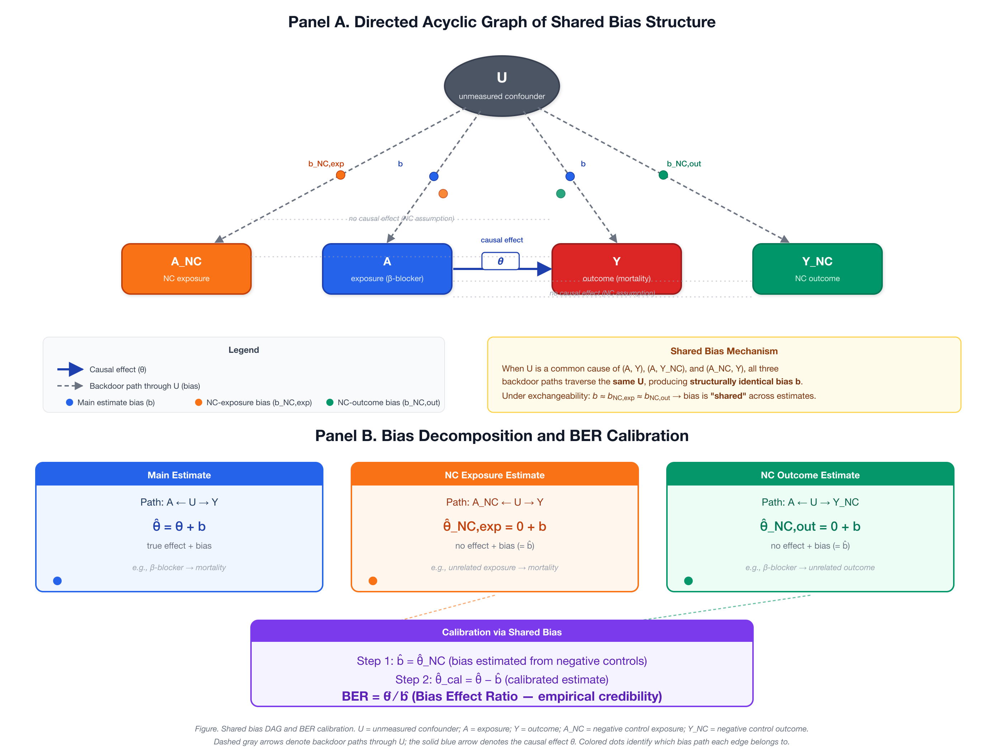
eFigure 1. Directed acyclic graph of shared bias structure and BF calibration. Panel A: U = unmeasured confounder; A = exposure (beta-blocker); Y = primary outcome (mortality); N_k = negative control outcomes. Solid arrows denote causal paths; dashed arrows denote bias paths shared between Y and N_k through U. Panel B: bias decomposition and the BF formula.

23. eFigure 2. Simulation classification accuracy heatmap
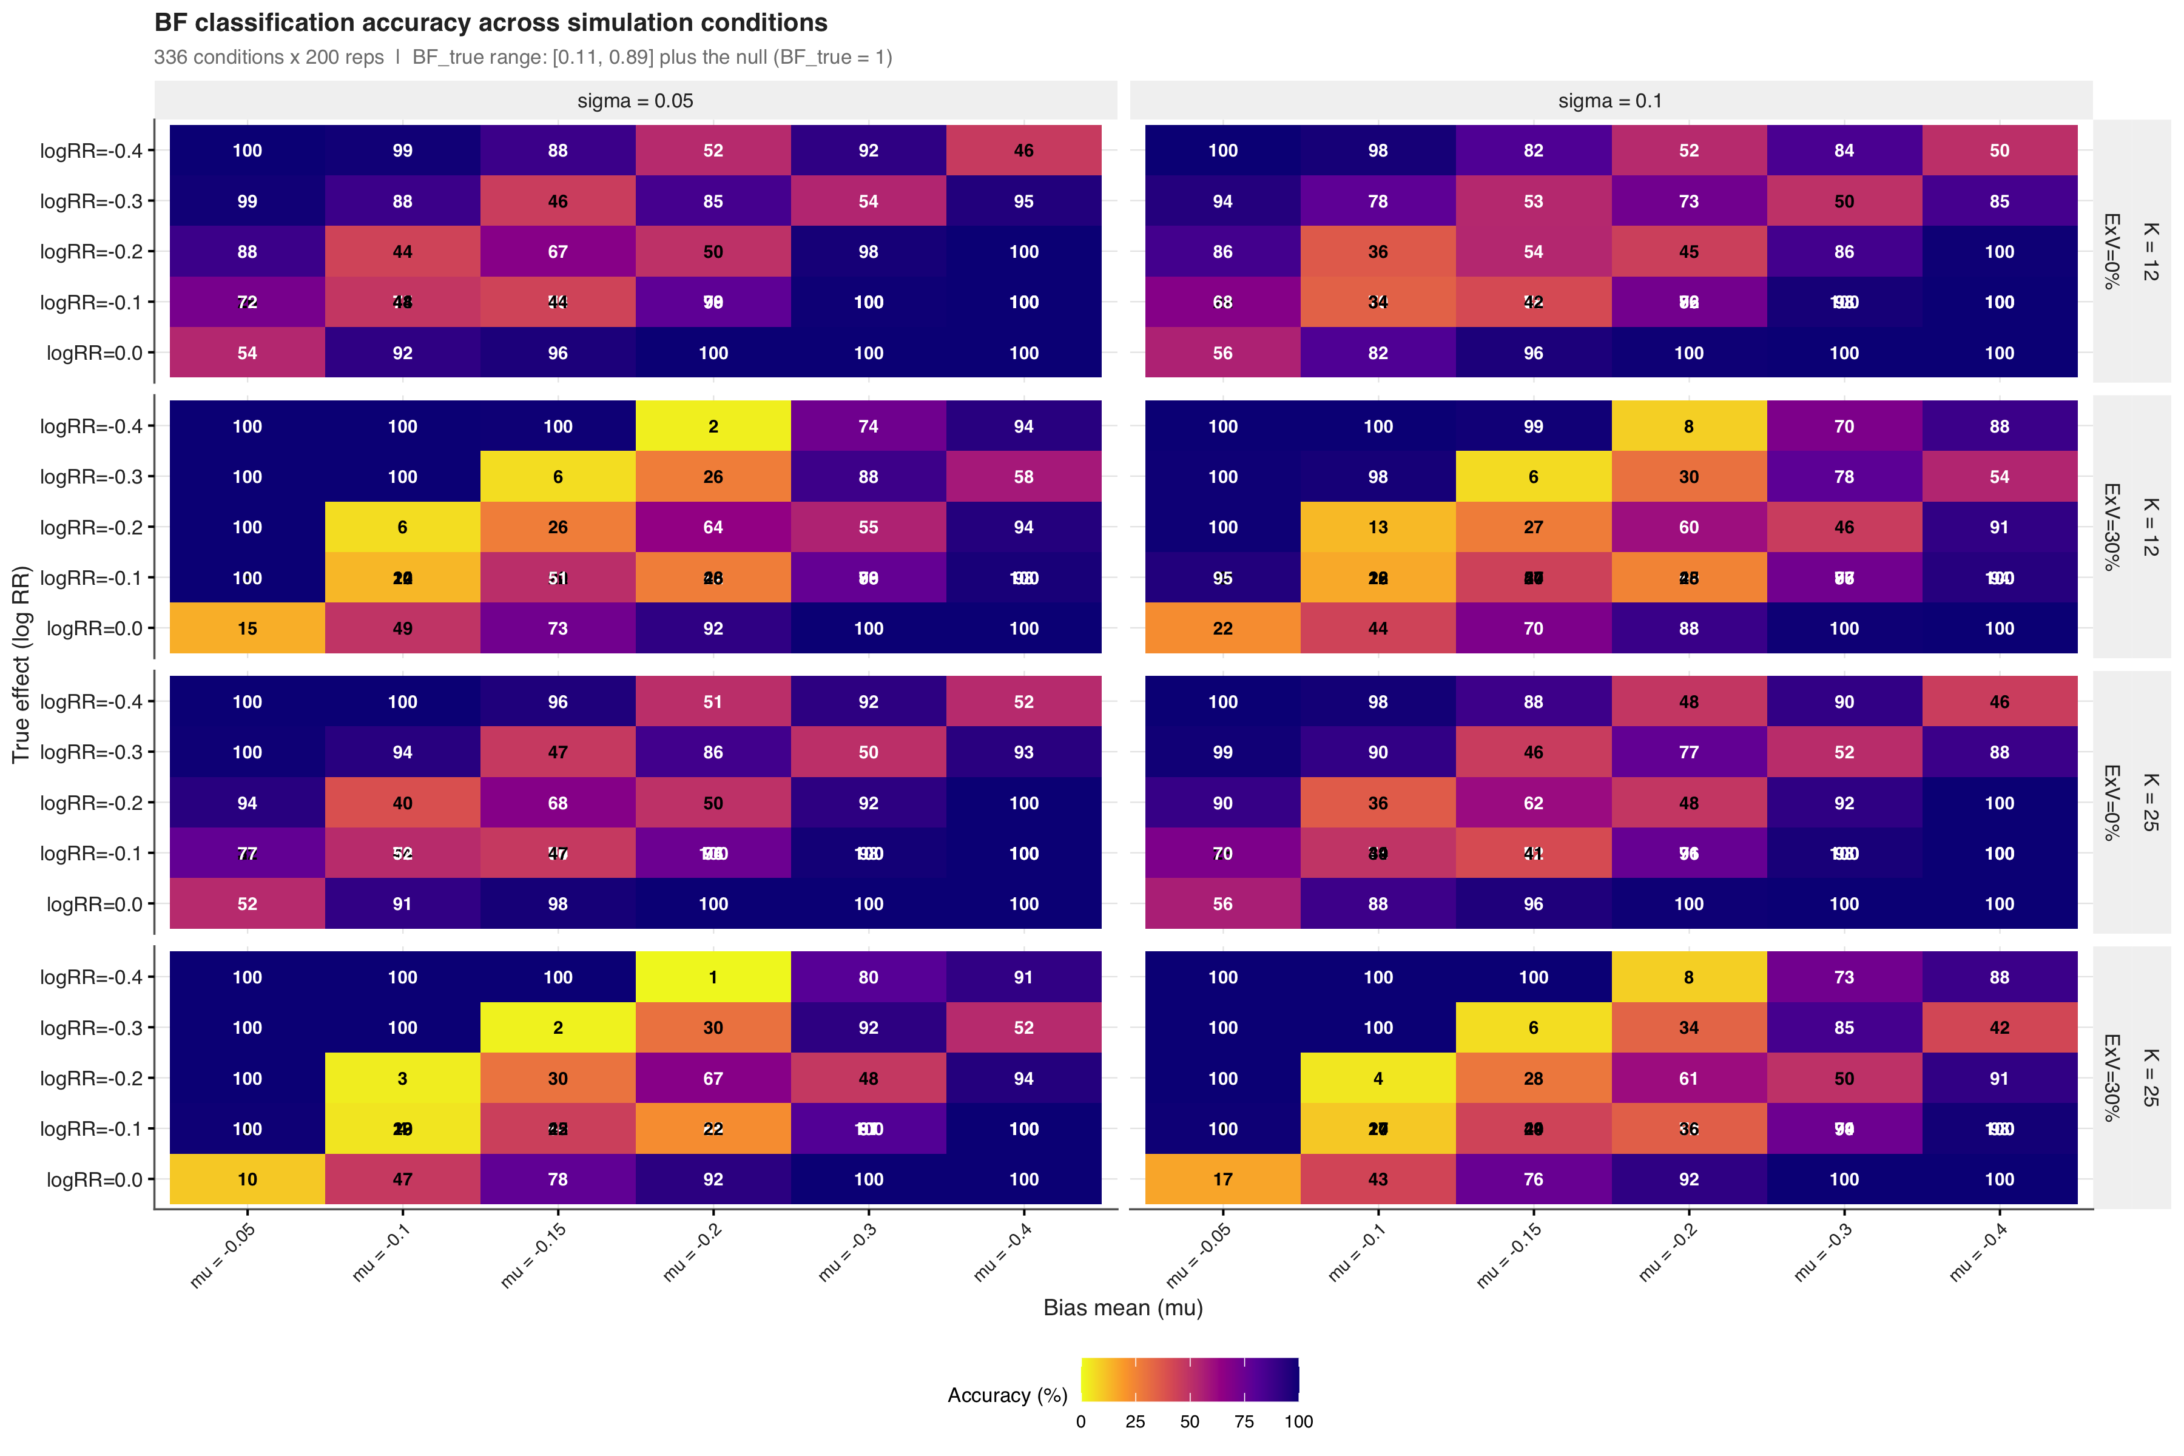
eFigure 2. Classification accuracy across 336 simulation conditions. Each cell shows the accuracy for one combination of true effect size (psi), systematic bias mean (mu_B), bias heterogeneity (sigma_B), negative control count (K), and exchangeability violation level. Darker colors indicate higher accuracy.

24. eFigure 3. Classification performance by zone
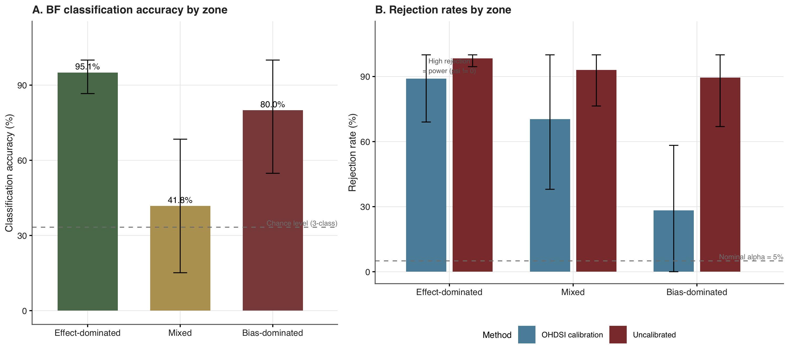
eFigure 3. Classification performance by zone. Panel A: BF classification accuracy by zone with the 33% chance-level reference line. Panel B: OHDSI calibrated p-value rejection rate and uncalibrated rejection rate by zone, with the 5% nominal alpha reference line.

25. eFigure 4. Leave-one-out sensitivity analysis
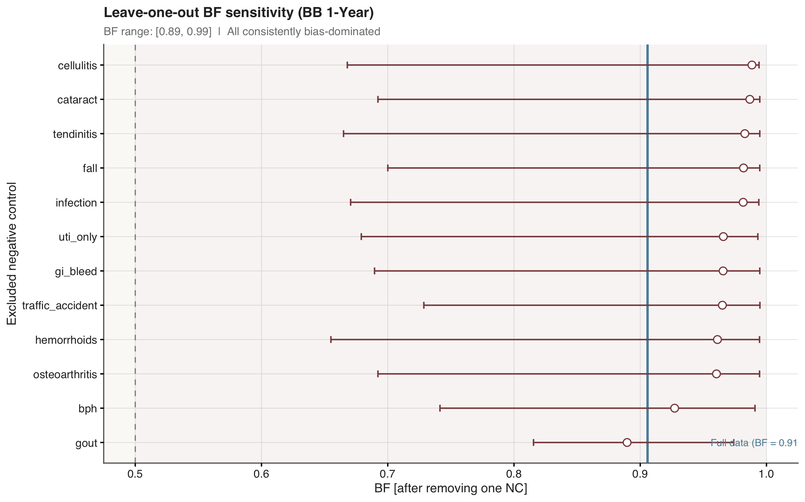
eFigure 4. Leave-one-out sensitivity analysis. Each point shows BF after excluding one negative control. The blue line indicates the full-data BF. All exclusions remained in the bias-dominated zone (BF > 0.5).

26. eFigure 5. Negative control diagnostics
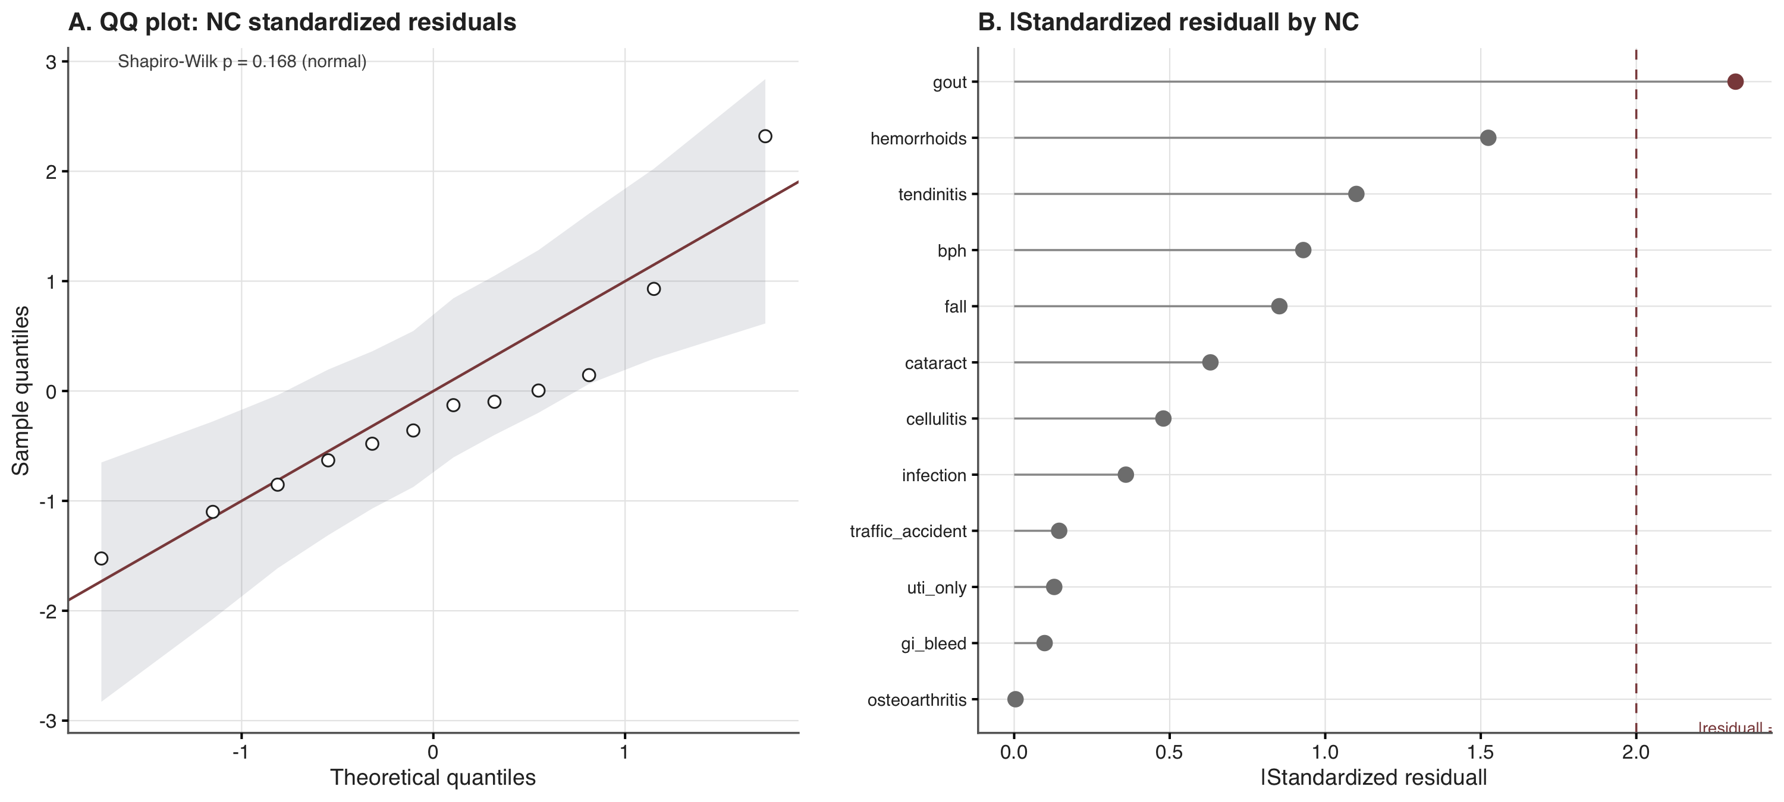
eFigure 5. Negative control diagnostics. Panel A: QQ plot of standardized residuals with simulated 95% confidence envelope. Panel B: lollipop chart of absolute standardized residuals by negative control outcome.

27. eFigure 6. Bootstrap distributions (BF scale)
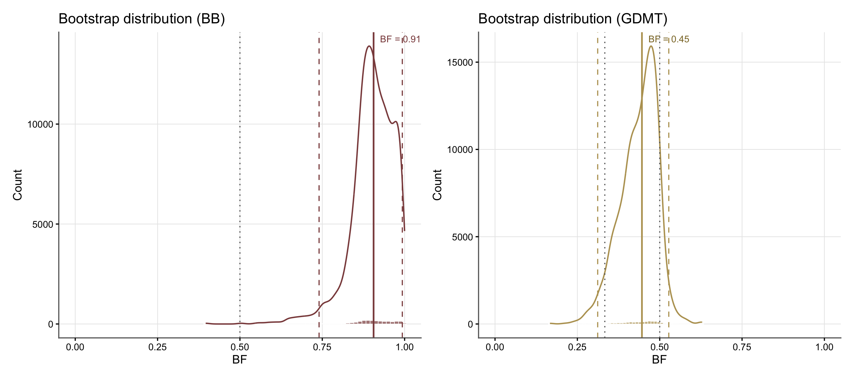
eFigure 6. Bootstrap distributions of BF for beta-blocker (left) and GDMT (right). Solid lines indicate point estimates (bootstrap medians); dashed lines indicate 95% bootstrap CI bounds. Dotted lines mark the zone boundaries at 1/3 and 0.5. The beta-blocker distribution concentrates near BF = 1; the GDMT distribution spans the effect-dominated and mixed zones.

28. eFigure 7. Participant flow diagram for the target trial emulation
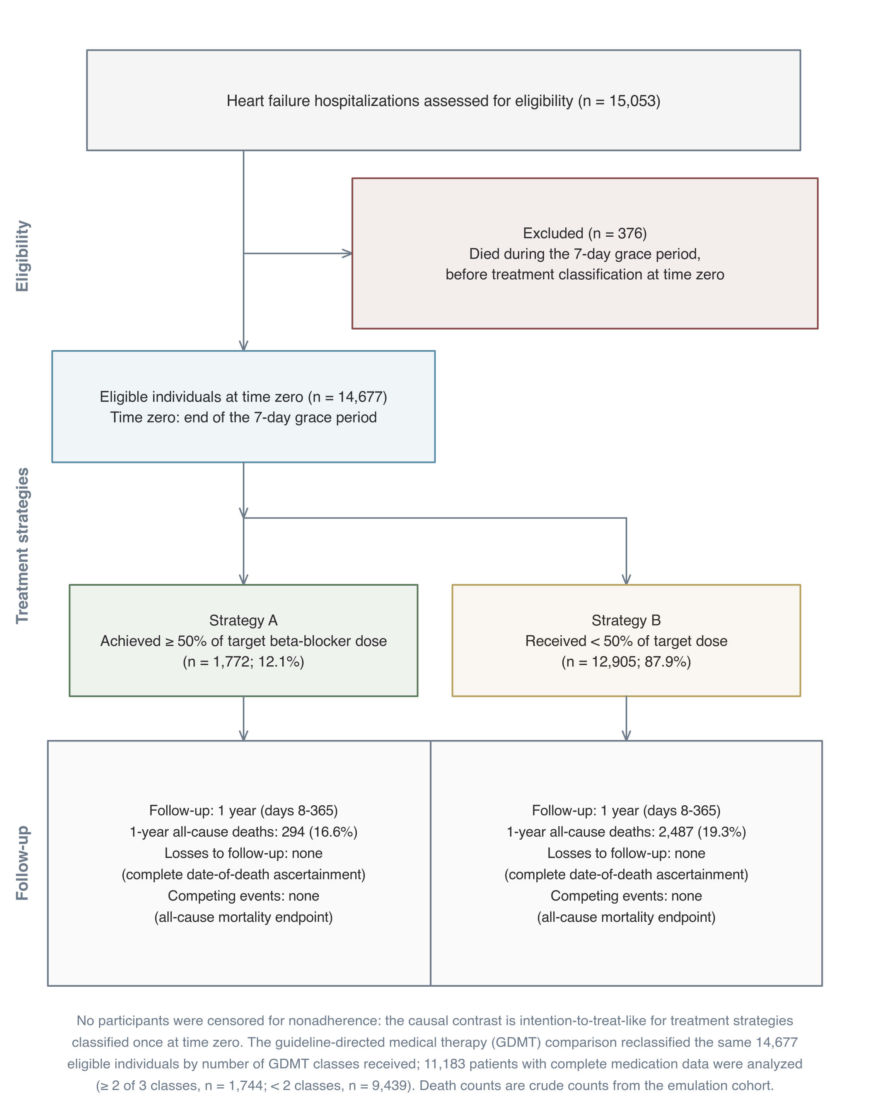
eFigure 7. Participant flow diagram for the target trial emulation, following the TARGET guideline flow diagram template for emulations with a unique time of eligibility and treatment strategies distinguishable at baseline [3]. Time zero is the end of the 7-day grace period. Follow-up covers days 8 to 365. No participants were censored for nonadherence because the causal contrast is intention-to-treat-like for treatment strategies classified once at time zero. The guideline-directed medical therapy (GDMT) comparison reclassified the same 14,677 eligible individuals by number of GDMT classes received; 11,183 patients with complete medication data were analyzed (>= 2 of 3 classes, n = 1,744; < 2 classes, n = 9,439). Death counts are crude counts from the emulation cohort.

29. eReferences
1. Fieller EC. Some problems in interval estimation. Journal of the Royal Statistical Society: Series B 1954; 16(2) pp. 175–185
2. Langan SM, Schmidt SAJ, Wing K, Ehrenstein V, Nicholls SG, Filion KB, et al. The reporting of studies conducted using observational routinely collected health data statement for pharmacoepidemiology (RECORD-PE). BMJ 2018; 363 p. k3532
3. Cashin AG, Hansford HJ, Hernán MA, Swanson SA, Lee H, Jones MD, et al. Transparent reporting of observational studies emulating a target trial: The TARGET statement. JAMA 2025; 334(12) pp. 1084–1093
4. Ren Y, Jia Y, Liu L, Lyv H, Tao L, Li Y, et al. Design and implementation of observational studies emulating a target trial. JAMA Network Open 2026; 9(2) p. e2558262
5. Lendle SD, Schwab J, Petersen ML, Laan MJ van der. ltmle: An R Package Implementing Targeted Minimum Loss-Based Estimation for Longitudinal Data. Journal of Statistical Software 2017; 81(1) pp. 1–21
6. Buuren S van, Groothuis-Oudshoorn K. mice: Multivariate Imputation by Chained Equations in R. Journal of Statistical Software 2011; 45(3) pp. 1–67
7. Laan MJ van der, Gruber S. Targeted minimum loss based estimation of causal effects of multiple time point interventions. The International Journal of Biostatistics 2012; 8(1)
8. Johnson AEW, Bulgarelli L, Shen L, Gayles A, Shammout A, Horng S, et al. MIMIC-IV, a freely accessible electronic health record dataset. Scientific Data 2023; 10(1) p. 1
9. Schuemie MJ, Ryan PB, DuMouchel W, Suchard MA, Madigan D. Interpreting observational studies: Why empirical calibration is needed to correct p-values. Statistics in Medicine 2014; 33(2) pp. 209–218

