Quantifying Bias in Causal Estimates Using Negative Controls: The Bias Attribution Fraction
Zeng Zhechun
Wang Jinwen
Zuo Huijuan
Shu Lixia
2026-08-27
¹ Beijing Anzhen Hospital, Capital Medical University, Beijing 100029, China
² National Clinical Research Center for Cardiovascular Diseases, Beijing, China
³ Beijing Institute of Heart, Lung and Blood Vessel Diseases, Beijing, China
Corresponding author: Zeng Zhechun, MD, MPH Beijing Anzhen Hospital, Capital Medical University; Beijing Institute of Heart, Lung and Blood Vessel Diseases, Tongzhou Campus, No. 225 Songzhuang South 1st Street, Tongzhou District, Beijing 101149, China Email: zengzhechun@icloud.com
Study Type: Original Investigation.
Keywords: Bias Attribution Fraction, Bias (Epidemiology), Target Trial Emulation, Observational Studies as Topic, Reproducibility of Results.

Key Points
Question: Can the Bias Attribution Fraction, a metric derived from negative control calibration, quantify the fraction of systematic bias in observational causal estimates?
Findings: In a 960,000-repetition simulation, Bland-Altman analysis showed moderate agreement of the BAF estimator with truth (mean difference -0.07; concordance 0.78, full grid); the calibrated P value, BAF, and its interval reduced the misuse rate from 36.0% to 2.9%. In the beta-blocker case study (14,677 patients), BAF returned two distinct determinations despite a TARGET-compliant design and doubly robust TMLE: the target-dose question was bias-dominated (BAF = 0.91, not usable as effect evidence) and the guideline-directed therapy question gave a competitive determination with no usable determination, with BAF = 0.51 marginally in the bias-dominated zone and its 95% credible interval spanning 0.5.
Meaning: BAF extends the binary calibrated P value into a three-part assessment: whether a signal exists, its size, and the fraction attributable to bias, at no additional data cost, making observational findings more interpretable and comparable within a common negative-control framework.

Abstract
Importance. Observational comparative effectiveness studies rely on the no-unmeasured-confounding assumption; only 30.8% of 237 target trial emulation (TTE) studies used statistical methods to assess it. Negative control calibration detects residual bias but returns only a calibrated P value, a binary pass-or-fail threshold, without quantifying the magnitude of bias relative to the surviving effect.
Objective. To develop and evaluate the Bias Attribution Fraction (BAF), a bounded credibility metric quantifying the fraction of systematic bias in a calibrated observational effect estimate.
Design, Setting, and Participants. A factorial simulation (960,000 repetitions) evaluated the BAF estimator by Bland-Altman agreement (primary) and, as a secondary outcome, by a two-layer decision rule, a calibrated P value followed by the BAF and its interval, calibrated against the known truth. The estimator was then applied in a beta-blocker case study under a TARGET-compliant TTE design with doubly robust targeted maximum likelihood estimation (TMLE) and 12 negative controls, comparing two treatment strategies with respect to 1-year mortality among 14,677 hospitalized heart failure patients (MIMIC-IV, 2008–2019).
Exposures. (1) Achieving at least 50% of guideline-recommended beta-blocker target dose within 7 days; (2) receiving guideline-directed medical therapy with at least two of three foundational drug classes.
Main Outcomes and Measures. The primary outcome was Bland-Altman agreement (mean bias, limits of agreement, Lin concordance); the two-layer decision rule and the case study BAF determinations were secondary.
Results. The primary Bland-Altman analysis showed mean bias -0.049 in the interior analysis (864,000 repetitions; concordance 0.82) and -0.069 across all 960,000 repetitions (93.8% within limits of agreement; concordance 0.78), with stronger proportional bias near BAF = 1. The two-layer rule cut the misuse rate (declared usable while truth was bias-dominated) from 36.0% to 2.9%. Across K = 12 to 50 negative controls, precision and safety improved monotonically with no plateau (median interval half-width 0.193 to 0.081; misuse 3.5% to 2.3%). In the case study, question 1 was bias-dominated (BAF = 0.91 [95% credible interval, 0.74-0.99]) despite the TARGET-compliant design and doubly robust TMLE; question 2 had a calibrated P value below .05. Its BAF point estimate 0.51 [95% credible interval, 0.36-0.60] placed it marginally in the bias-dominated zone, but the interval spanned 0.5 and the calibrated probability that bias dominates was 0.648, a level that supported a competitive determination with no usable determination.
Conclusions and Relevance. BAF quantifies the fraction of systematic bias in the calibrated signal, providing a bounded, continuous complement to the calibrated P value. Even a rigorously designed and analyzed case study showed the beta-blocker target-dose question to be bias-dominated, indicating that empirical bias diagnostics are necessary, not optional. This methodological demonstration does not constitute evidence of drug ineffectiveness.

Introduction
Target trial emulation¹ and targeted maximum likelihood estimation (TMLE)^{2,3} have narrowed the gap between observational and randomized evidence, yet cannot eliminate the threat of unmeasured confounding. A cross-sectional survey of 237 target trial emulation studies found that only 30.8% used statistical methods to assess it⁴. The healthy adherer effect, in which adherent patients fare better even on outcomes the therapy cannot plausibly affect, exemplifies the threat in pharmacoepidemiology^{5,6}. Sensitivity analyses such as the E-value and related tipping-point analyses⁷ quantify the minimum confounding strength required to overturn a result but do not estimate how much of the observed association is attributable to bias.
Explicit eligibility criteria, time-zero alignment, and doubly robust estimation remove bias that is visible in the measured covariates, but none constrains the bias that remains when a prognostic factor was never recorded. An estimate produced by the most careful available observational design can still be dominated by systematic error, and nothing in the conventional reporting of that estimate, an effect size, a confidence interval, and a P value, reveals that this has occurred.
The Observational Health Data Sciences and Informatics consortium addresses this problem by estimating an empirical null from negative controls (outcomes not causally affected by the treatment but sharing its confounding structure) and returns a calibrated P value⁸ and calibrated effect⁹. Existing calibration methods, however, answer only whether the calibrated P value rejects the null; they do not report how large the estimated bias is relative to the effect that survives calibration. A calibrated estimate near the null could reflect either a genuinely null treatment effect or an estimate overwhelmed by bias. We propose the Bias Attribution Fraction (BAF) = |${\hat{μ}}_{B}$| / (|${\hat{μ}}_{B}$| + |$\tilde{ψ}$|), a credibility metric that reports the fraction of the calibrated signal attributable to systematic bias on a bounded [0, 1] scale; it builds on, but is not part of, the OHDSI empirical calibration framework and its EmpiricalCalibration R package, and is computed from quantities that the pipeline already produces, requiring no additional data. We evaluate three questions. First, how accurately does the BAF estimator recover the true bias, assessed by Bland-Altman agreement as the primary outcome in a factorial simulation of 960,000 repetitions across 960 conditions. Second, whether adding BAF and its interval to the calibrated P value improves discrimination of bias-dominated estimates and reduces their misuse through a two-layer decision rule (secondary). Third, what BAF reveals in a real-world target trial emulation. We first define the metric, then evaluate it in simulation, and finally demonstrate it in a deliberately demanding case study: a target trial emulation designed in accordance with the TARGET guideline, estimated with doubly robust TMLE and calibrated with 12 negative controls, asking whether systematic bias persists even under a rigorous observational design.
Several existing approaches also probe unmeasured confounding, and BAF is designed to complement rather than replace them. Quantitative bias analysis asks the analyst to specify a bias model from external evidence, propagate it, and report a bias-adjusted estimate and interval^{10,11}; it is most informative when such external evidence exists, and least informative precisely when the bias is unknown, which is the situation BAF addresses. External-adjustment and bounding approaches follow the same logic, requiring an assumed magnitude for the unmeasured confounder and returning an adjusted estimate rather than a share of the observed association^{12,13}. Negative-control methods, including the empirical calibration we build on, ask whether an estimate is distinguishable from a distribution of bias estimated from the data themselves, but stop at a calibrated P value^{8,14}. BAF uses that same empirical null and reports the share of the calibrated signal attributable to bias on a scale bounded between 0 and 1. ## Methods
The credibility metric. Consider an observational study estimating the effect of a binary treatment $A$ on an outcome $Y$, with target estimand $ψ=log{RR}_{\text{true}}$. An estimator (eg, TMLE with Super Learner) yields ${\hat{ψ}}_{\text{obs}}$ with standard error ${\hat{σ}}_{\text{obs}}$. Suppose $K$ negative control outcomes $N_{1},…,N_{K}$ are available, each sharing the confounding structure of $Y$ but not causally affected by $A$; for each control the same estimator yields ${\hat{γ}}_{k}$ with standard error ${\hat{τ}}_{k}$.
The key assumption is bias exchangeability: conditional on the measured covariates, the distribution of residual bias affecting ${\hat{ψ}}_{\text{obs}}$ is approximately the same as that governing the negative control estimates ${\hat{γ}}_{1},…,{\hat{γ}}_{K}$. Like the no-unmeasured-confounding assumption it is meant to diagnose, this cannot be verified from the data; its plausibility rests on domain knowledge and sensitivity analyses.
Under bias exchangeability, $μ_{B}$ is estimated by fitting an empirical null to $\{({\hat{γ}}_{k},{\hat{τ}}_{k})\}_{k=1}^{K}$ with the fitNull function of the EmpiricalCalibration R package⁸, yielding ${\hat{μ}}_{B}$ and ${\hat{σ}}_{B}$. The bias-corrected estimate is $\tilde{ψ}={\hat{ψ}}_{\text{obs}}−{\hat{μ}}_{B}$, with calibrated standard error $\tilde{σ}=\sqrt{{\hat{σ}}_{\text{obs}}^{2}+{\hat{σ}}_{B}^{2}}$.
Building on this framework, we define the Bias Attribution Fraction as
$$BAF=\frac{|{\hat{μ}}_{B}|}{|{\hat{μ}}_{B}|+|\tilde{ψ}|}=\frac{|{\hat{μ}}_{B}|}{|{\hat{μ}}_{B}|+|{\hat{ψ}}_{\text{obs}}−{\hat{μ}}_{B}|}.$$
Absolute values keep BAF between 0 and 1 whatever the direction of either component. The metric is scale-invariant and bounded, in the spirit of how the E-value summarizes a sensitivity analysis in a single number⁷: it quantifies the magnitude of bias instead of merely testing for its presence, and because it uses absolute values it does not indicate whether the bias and the calibrated effect point in the same or opposite direction: one BAF is consistent with bias that inflates the effect, bias that shrinks it toward the null, or bias that reverses its sign, all of which call for different interpretation. Values near 0 mean the calibrated signal is mostly the estimated effect; values near 1 mean it is mostly bias. To make the continuous scale actionable, we define three regions by cut-points on BAF: bias-dominated when BAF exceeds 0.5, equivalently when the bias magnitude exceeds the effect it accompanies ($|μ_{B}|>|\tilde{ψ}|$); effect-dominated when BAF falls below 1/3, equivalently when the bias amounts to less than half the effect ($|μ_{B}|<|\tilde{ψ}|/2$); and mixed in between. Two boundary conventions apply. When $\tilde{ψ}$ = 0 the denominator reduces to $|{\hat{μ}}_{B}|$, so BAF = 1, meaning the calibrated signal is attributed entirely to bias; when both ${\hat{μ}}_{B}$ and $\tilde{ψ}$ are 0 the ratio is 0/0 and undefined, and we report BAF = 1 under that same convention while flagging the estimate as uninformative, because no calibrated effect remains to offset the bias. The cut-points are not thresholds chosen for their own sake: each is simply where the corresponding inequality between $|μ_{B}|$ and $|\tilde{ψ}|$ happens to fall on the BAF scale, so a classification by BAF reports how bias and effect compare in absolute size.
Interval estimation. BAF is a ratio whose denominator is itself the difference between two estimated quantities, so its uncertainty cannot be inherited from a standard error in the usual way. We therefore propagate uncertainty instead of approximating it: a set of draws of $μ_{B}$ is generated and each is passed through the same function, $BAF=|{\hat{μ}}_{B}|/(|{\hat{μ}}_{B}|+|{\hat{ψ}}_{obs}−{\hat{μ}}_{B}|)$, with ${\hat{ψ}}_{obs}$ held at its observed value; the interval is the 2.5th to 97.5th percentile of the resulting distribution of BAF, and the point estimate is the median of that same distribution, so an estimate always lies inside the interval reported for it. The point estimate is the posterior median of the propagated distribution, which differs from the plug-in value obtained by substituting the point estimates ${\hat{μ}}_{B}$ and ${\hat{ψ}}_{cal}$ into the BAF definition; the gap is largest when ${\hat{ψ}}_{cal}$ is near 0, where the ratio is strongly nonlinear, so the two can disagree substantially (for question 1 the plug-in value is about 0.97 whereas the posterior median is the BAF reported above). The draws come from the fitted systematic error model; the sampling schemes, the prior specification, and the reading of a bootstrap percentile distribution as an approximation to a posterior under an uninformative prior are given in eMethods in Supplement 1. We call the result a credible interval because it is a percentile range of a distribution for the quantity being estimated, not the output of a procedure constructed to cover the true value in 95% of repeated samples; no sampling distribution is inverted, so it carries no guarantee of frequentist coverage. The sampling scheme differs by setting and is stated explicitly. In the simulation the draws are M = 300 posterior draws from a Gibbs sampler (400 iterations, 100 discarded as warm-up; eMethods in Supplement 1). In the case study they are nonparametric bootstrap resamples of the negative control panel, with the empirical null refitted within each resample. The modest case-study resample count means the 2.5th and 97.5th percentiles carry Monte Carlo uncertainty, compounding the undercoverage from holding the observed effect estimate fixed (see Limitations). We summarize each interval by its half-width, $({\hat{BAF}}_{hi}−{\hat{BAF}}_{lo})/2$, and not by its two bounds: because BAF is bounded, the bounds convey where the estimate sits as well as how precise it is, whereas the half-width extracts precision alone, in the same units as the estimate.
Simulation. Because the true bias is unknown in any application, we cannot judge from data how accurate $\hat{BAF}$ is or how any rule based on it will perform. We therefore conducted a factorial simulation in which the truth is known by construction, covering both settings where bias exchangeability holds and settings where it is deliberately violated, so that the design examines the assumption’s failure instead of presupposing that it holds. Five factors were crossed following the ADEMP framework¹⁵ in 960 conditions × 1000 repetitions (960,000). Table 1 lists the five factors that define a condition and, separately, the three quantities redrawn in every repetition. Ranges of each factor were anchored to quantities measured in the case study described below and to published adherence-bias estimates⁵, with the justification for every level in eMethods in Supplement 1. Within a condition the truth, including ${BAF}_{true}$, is fixed, so its 1000 repetitions differ through the sampling variation. Each repetition refits the empirical null and records $\hat{BAF}$ and the calibrated P value. All simulations and analyses were implemented in R (version 4.4.1) using the biasratio (version 0.3.1), EmpiricalCalibration (version 3.1.4), and ltmle (version 1.3.0) packages, and the Monte Carlo grid was generated with a fixed random seed (43) for reproducibility.
Table 1. Simulation design.
Element | Levels | Values
Fixed within a condition (defines the 960 conditions)
True effect, $ψ$ | 10 | -0.40 to -0.01, equally spaced (RR, 0.67-0.99)
Systematic bias center, $μ_{B}$ | 8 | -0.40 to -0.05, in steps of 0.05 (RR, 0.67-0.95)
Standard error of the target estimate, $σ_{ψ}$ | 2 | 0.06, 0.10
Negative controls, $K$ | 3 | 12, 25, 50
Exchangeability violation | 2 | None; 30% of controls shifted by +0.15 (RR, 1.16)
Redrawn in each of the 1000 repetitions
Target estimate | 1 | ${\hat{ψ}}_{obs}=ψ+μ_{B}+ε$, with $ε∼N(0,σ_{ψ}^{2})$
Control estimates | $K$ | ${\hat{γ}}_{k}∼N(μ_{B},σ_{B}^{2})$, with $σ_{B}=0.05$
Control standard errors | $K$ | Uniform (0.03, 0.12)
The upper block lists the five crossed factors; every combination of their levels is one condition. The lower block lists the quantities redrawn independently in each repetition of a condition. Because the truth is held fixed within a condition, these three quantities are the only sources of variation across its repetitions. All effects are on the log relative-risk scale. The relative risks given in parentheses are the exponentials of the log-scale values beside them, included so that the magnitudes can be read on the scale clinicians use; for example, a log relative risk of -0.40 is a relative risk of 0.67, a 33% lower risk. Standard errors describe spread on the log scale rather than an effect, so they have no relative-risk equivalent and none is given. Justification for each level appears in eMethods in Supplement 1.
Performance measures. Two questions were put to the simulated repetitions in sequence. Step 1 asked how closely $\hat{BAF}$ tracks the truth. Agreement was assessed by Bland-Altman analysis¹⁶, with the signed difference $\hat{BAF}−{BAF}_{true}$ on the vertical axis. We used the classic formulation, plotting that difference against ${BAF}_{true}$ and not against the average of the two quantities, because in a simulation the truth is known by construction and is therefore the appropriate reference; averaging the two would mix the reference with the quantity being judged. The prespecified summaries were the mean signed difference, the SD of the difference, the 95% limits of agreement (mean difference ± 1.96 SD), and the Lin concordance correlation coefficient¹⁷. Proportional bias, meaning error that grows with the true value, was tested by regressing the signed difference on ${BAF}_{true}$ and testing the slope against zero. Because the least negative effect level (ψ = -0.01) drives ${BAF}_{true}$ toward its upper bound of 1, where the estimator is compressed against the boundary, we prespecified two analysis sets: the full grid, and an interior grid that excludes that single level. Because the excluded level is the one where ${BAF}_{true}$ approaches its upper bound of 1, the interior set most directly characterizes estimates in the middle of the BAF scale; the near-boundary compression that produces the highest-BAF case-study estimates (question 1, $\hat{BAF}$ ≈ 0.91) is captured by the full grid, and the interior conclusions should not be read as applying to estimates close to 1.
Step 2 asked whether a reporting rule built on $\hat{BAF}$ separates trustworthy from untrustworthy estimates. Layer 1 declares an estimate usable when its calibrated P value is below .05; layer 2 maps $\hat{BAF}$ jointly with its interval half-width through a lookup table (eTable 1 in Supplement 1), calibrated against the known truth. The table is built from the 960,000 simulated repetitions, sorted into 12 equal-quantile intervals of the BAF estimate; within each interval the empirical proportion that were in truth bias-dominated is computed separately for narrow and wide intervals (split at the median half-width), and the larger is taken as the conservative probability (eTable 2 in Supplement 1). Because the table and the rule evaluations in Table 2 are built on the same 960,000 repetitions, the reported rule performance reflects in-sample agreement; with at least 1,000 repetitions per cell and only 24 empirical proportions estimated, the optimism from this is expected to be small (with at least 1,000 repetitions per cell, the standard error of each cell’s empirical bias-dominated proportion is at most about 1.6 percentage points), though a held-out validation remains to be done. That conservative probability is mapped onto the probability that the repetition is truly bias-dominated, meaning that ${BAF}_{true}$ exceeds 0.5, and from that probability to one of four determinations, in ascending order of that probability: usable as effect evidence below a prespecified 15%, mixed and hypothesis-generating below a prespecified 45%, competitive determination with no usable determination below a prespecified 65%, and not usable as effect evidence at 65% or above. Two proportions summarize each rule: the proportion of repetitions it declared usable, meaning free enough of systematic error to be reported as evidence about the effect, and the proportion of those declared usable that were in fact dominated by bias, the misuse rate. Discrimination was compared across three predictors, the calibrated P value alone, $\hat{BAF}$ alone, and $\hat{BAF}$ with its interval half-width, by receiver operating characteristic analysis. Because the mixed zone is negative in both readings, the bias-dominated and effect-dominated views are not mirror images, so the analysis is reported from both: in the bias-dominated view a positive call is withheld and a positive truth is truly bias-dominated, and in the effect-dominated view a positive call is declared usable and a positive truth is truly effect-dominated; the area under the curve is the summary measure and nested predictors are compared by likelihood ratio test. Each rule is also plotted as an operating point in that space, where its vertical coordinate is its sensitivity and its horizontal coordinate one minus its specificity.
TTE Case study. The purpose of the case study was to illustrate how the BAF metric and its reporting rules are applied and interpreted in a real-world target trial emulation, where the truth is unknown. Two target trial emulations¹ were conducted in MIMIC-IV linked to MIMIC-IV-ECG^{18,19}, with every design decision checked item by item against the TARGET guideline²⁰. Both emulations shared the same patients (P) and outcome (O) and differed only in the treatment strategies compared. The patients were adults hospitalized for heart failure with reduced ejection fraction who were new users of beta-blockers, and the outcome was one-year all-cause mortality; the new-user restriction applies to question 1, whereas question 2 compares receipt versus non-receipt of guideline-directed medical therapy without a new-user requirement. Treatment strategies were ascertained over a 7-day grace period, and time zero was set at the end of that period so that follow-up and outcome ascertainment began on day 8, which avoids immortal time bias; because the strategies are defined over a single fixed baseline window and the primary analysis follows intention-to-treat without modeling time-varying treatment or censoring, the design avoids time-varying confounding, at the cost of estimating a baseline-strategy contrast rather than the effect of sustained adherence. Question 1 compared achievement of at least 50% of the guideline-recommended beta-blocker target dose (I) with failure to reach that target (C). Question 2 compared receipt of guideline-directed medical therapy, defined as at least two of the three foundational drug classes (beta-blocker, renin-angiotensin system inhibitor, mineralocorticoid receptor antagonist) at adequate dose (I), with not receiving such therapy (C). This three-class definition reflects the treatment era captured by the data, which predates the widespread use of sodium-glucose cotransporter 2 inhibitors in heart failure^{21,22}. The assigned strategy was the target regimen over 12 months; in the primary intention-to-treat analysis adherence was not enforced, and per-protocol and as-treated analyses were conducted as sensitivity checks.
One-year all-cause mortality was estimated by targeted maximum likelihood estimation (TMLE)³, a doubly robust, semiparametric efficient estimator targeting the log relative risk. For Question 1, the treatment mechanism was modeled with a Super Learner²³ of two candidate learners (main-term logistic regression and Lasso logistic regression), selected by cross-validated out-of-sample risk, and the outcome model with a main-term logistic regression; for Question 2, the same doubly robust TMLE was used with a main-term logistic regression outcome model and a main-term logistic regression treatment model (a single Super Learner library, SL.glm), the specification also used for the negative controls; because the treatment model is doubly robust, this simpler main-term specification remains consistent even if the outcome model is misspecified. The negative controls were carried on the same hospitalizations over the same one-year window, with the same 7-day grace-period exclusion (excluding day-0 outcome events), the same 10 baseline covariates, and the same single-point treatment node and estimator as the target estimates. They differ in the beta-blocker contrast that defines exposure: the panel was fitted with the exposure defined by the agent received, counting all beta-blocker agents (43.0% of hospitalizations at or above 50% of the target dose), whereas the target estimates reported here use the guideline-restricted definition, restricted to carvedilol, metoprolol succinate, or bisoprolol (11.8% at or above the target dose). The 12 negative controls were estimated under that single contrast and applied to both questions, so a single empirical null (mean systematic bias -0.190, SD 0.068) was fitted from them and used for both. Both were fit on the baseline covariates listed in Table 3. The 12 negative controls, prespecified before any case-study analysis and used to estimate residual systematic bias, were infection, gastrointestinal bleeding, falls without fracture, urinary tract infection, cellulitis, cataract, osteoarthritis, traffic accidents, hemorrhoids, benign prostatic hyperplasia, gout, and tendinitis, selected from the OHDSI standard panel for cardiovascular outcomes (see eTable 6 in Supplement 1 for the full list)^{9,24}. Each control was required to have no plausible causal effect of the study drugs and at least 50 observed events in the database, and the panel spanned six clinical domains; full code lists, event counts, and per-control estimates appear in eTable 6 in Supplement 1.
Data source and participants. The case study used MIMIC-IV (version 2.2) linked at the stay level to MIMIC-IV-ECG (version 1.0.1), covering intensive care unit admissions at Beth Israel Deaconess Medical Center between 2008 and 2019^{18,19}. Eligible adults were aged 18 years or older with a first intensive care unit stay, at least 24 hours of continuous monitoring, and a 12-lead electrocardiogram during the index stay; we excluded previous admissions for the index condition, discharge within 24 hours, and missing values in key covariates. Of 15,053 heart-failure hospitalizations assessed for eligibility, 376 did not survive the 7-day grace period to time zero and were excluded, leaving 14,677 in the analytic cohort. The deidentified data were approved by the Massachusetts Institute of Technology and Beth Israel Deaconess Medical Center institutional review boards with a waiver of informed consent.

Results
Simulation.
Bland-Altman agreement. The prespecified primary analysis set was the interior of the grid, which excludes the ψ = -0.01 boundary level where ${BAF}_{true}$ approaches 1; there $\hat{BAF}$ had mean difference -0.049 across 864,000 repetitions with Lin concordance 0.815. Across all 960,000 full grid repetitions, which retain that boundary level and are reported as a transparency analysis, the mean difference was -0.069 (SD of the differences, 0.139) with 95% limits of agreement -0.341 to 0.203, concordance 0.781, and 93.8% of repetitions within the limits of agreement; proportional bias was significant (slope -0.1814, 95% CI -0.1826 to -0.1802, t = -306.7, P < .001). $\hat{BAF}$ therefore systematically underestimates ${BAF}_{true}$, which motivates truth calibration; the larger full-grid bias than interior bias shows that the underestimation is concentrated at the boundary rather than spread uniformly across the scale, so the near-boundary compression that produces the highest case-study estimate (question 1, $\hat{BAF}$ ≈ 0.91) is captured by the full grid while the interior results describe the middle of the scale. Figure 1 shows the Bland-Altman agreement.
Discrimination. In receiver operating characteristic analysis read from the bias-dominated view (a positive call is withheld, a positive truth is truly bias-dominated), the calibrated P value alone reached an AUC of 0.787; adding $\hat{BAF}$ raised it to 0.918, and adding the interval half-width moved it by +0.0001 (0.918; likelihood ratio χ² = 70.3, df = 1, P < .001), a difference large enough to detect at this number of repetitions and far too small to change any classification. Read from the effect-dominated view (a positive call is declared usable, a positive truth is truly effect-dominated), the same three scores reached 0.721, 0.951 and 0.951: $\hat{BAF}$ is therefore more useful for ranking the effect-dominated view (AUC 0.95) than the bias-dominated view (AUC 0.92), the reverse of the calibrated P value (0.72 vs 0.79) is a finding that the two viewpoints together make visible. In either view, $\hat{BAF}$, not the width of its interval, carries the discriminatory information beyond the calibrated P value.
Reporting rule performance. Ranking and deciding are separate tasks: the curve averages over every possible cutoff, so it cannot show the gain a rule obtains by imposing a stricter condition, which is how R3 and R4 improve. Figure 2 overlays each reporting rule of Table 2 as an operating point in the same space, with sensitivity on the vertical axis and one minus specificity on the horizontal axis, so the nested rules can be read directly as the trade-off between catching bias-dominated repetitions and sparing effect-dominated ones. Table 2 shows the same trade-off in numbers: with each added component, fewer estimates are declared usable as evidence about the effect, but a smaller share of those declarations is wrong. Under the calibrated P value alone, 61.9% of repetitions were declared usable and 36.0% of those were in truth dominated by bias. Under the most stringent rule (R4), which additionally requires a calibrated probability of bias dominance below 15%, 21.5% were declared usable and only 2.9% of those were in truth dominated by bias. The number of negative controls was itself a design lever: across K = 12 to 50 (320,000 repetitions each), the median half-width of the $\hat{BAF}$ credible interval fell from 0.193 to 0.081 and the misuse rate among estimates declared usable fell from 3.5% to 2.3%, while the share declared usable was nearly unchanged (21.9% to 20.9%; eTable 3 in Supplement 1). Improvement was monotonic, with no plateau at K = 50, the largest value studied.
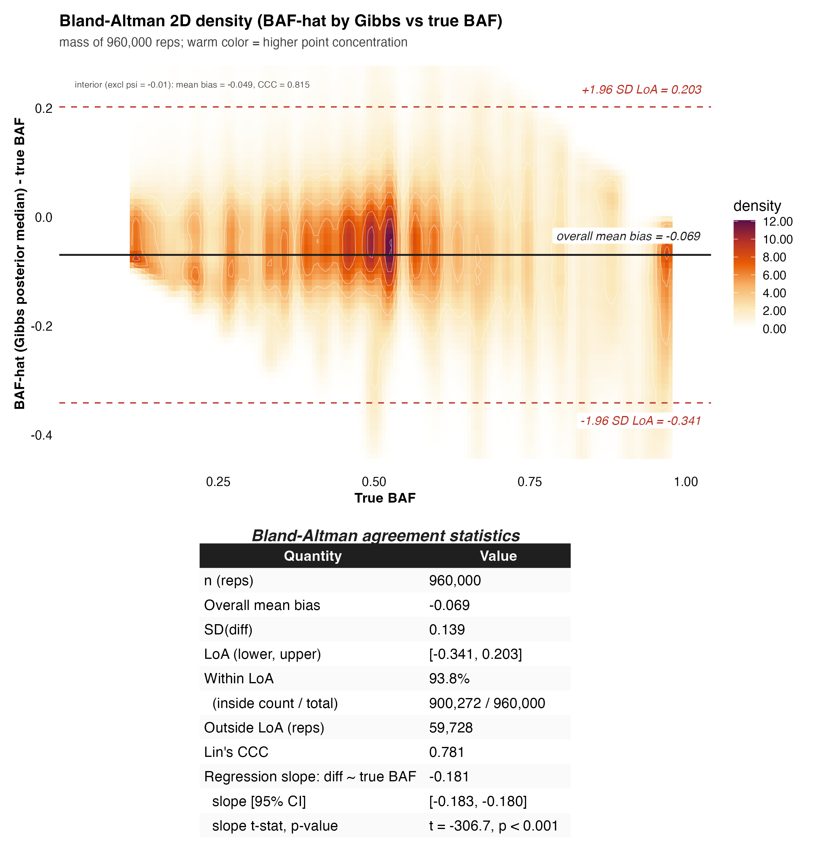

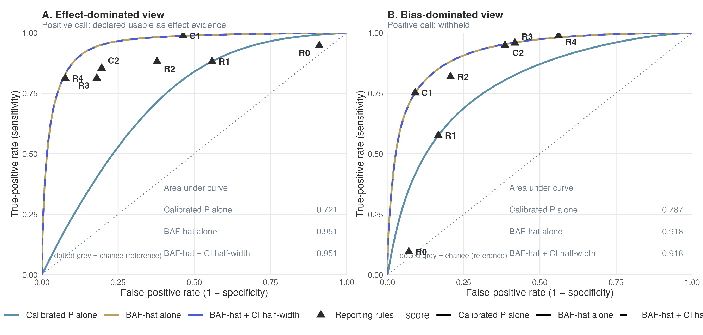
Table 2. Performance of the nested reporting rules across 960 000 simulated repetitions, read from two viewpoints. Every rule withholds a repetition unless all the conditions listed for it are met; only then is the repetition declared usable as effect evidence. A single rule has two readings at once. The effect-dominated view (columns under the left grey band) takes a positive call to be “declared usable” and a positive truth to be truly effect-dominated. The bias-dominated view (columns under the right grey band) takes a positive call to be “withheld” and a positive truth to be truly bias-dominated. In each view: Sens = share of truly positive repetitions the rule called positive; Spec = share of truly negative repetitions the rule called negative; PPV = share of repetitions the rule called positive that were truly positive; NPV = share the rule called negative that were truly negative. Truth has three levels (effect-dominated 18.8%, mixed 28.7%, bias-dominated 52.5%); the mixed zone is negative in both views, so the views are not mirror images. The rules are ordered by the positive-call rate of the bias-dominated view; within each group the stricter rule is below. Layer 1 is a calibrated P value below .05. R0 uses the uncalibrated P value. R1 is layer 1 alone; R2, R3 and R4 each add one requirement to it: R2, $\hat{BAF}$ below 0.5; R3, the whole 95% credible interval of $\hat{BAF}$ below 0.5, the bias-dominated threshold, so that the interval is clear of bias dominance; R4, a calibrated probability that the repetition is truly bias-dominated below 15%, read from eTable 1 in Supplement 1. C1 and C2 apply the two $\hat{BAF}$ requirements without layer 1, which is why they are listed apart.
 |  | Effect-dominated view |  |  |  | Bias-dominated view
Rule | Withholds unless | Sens (ED) | Spec (ED) | PPV (ED) | NPV (ED) | Sens (BD) | Spec (BD) | PPV (BD) | NPV (BD)
Nested rules, each adding one component
R0 | Uncalibrated P < .05 (no bias correction) | 94.6 | 9.0 | 19.4 | 87.9 | 9.5 | 93.0 | 59.9 | 48.2
R1 | Calibrated P < .05 (layer 1 only) | 88.1 | 44.2 | 26.7 | 94.2 | 57.5 | 83.3 | 79.2 | 64.0
R2 | Layer 1, plus BAF point estimate below 0.5, the bias-dominated threshold | 88.1 | 62.2 | 35.0 | 95.8 | 81.8 | 79.3 | 81.4 | 79.8
R3 | Layer 1, plus the whole credible interval of BAF below 0.5, the bias-dominated threshold | 81.2 | 82.0 | 51.0 | 95.0 | 95.8 | 58.2 | 71.7 | 92.6
R4 | Layer 1, plus probability of bias dominance below 15% | 81.2 | 92.3 | 70.9 | 95.5 | 98.8 | 43.9 | 66.0 | 97.1
Stand-alone comparators, no calibrated P value
C1 | BAF point estimate below 0.5, the bias-dominated threshold, no layer 1 | 98.7 | 53.6 | 32.9 | 99.5 | 75.2 | 90.9 | 90.1 | 76.8
C2 | The whole credible interval of BAF below 0.5, the bias-dominated threshold, no layer 1 | 85.3 | 80.4 | 50.1 | 96.0 | 94.8 | 61.4 | 73.1 | 91.4
Every rule is listed with the extra requirement it imposes on layer 1, so the rows are nested rather than duplicated: R1 is layer 1 alone, R2 adds the BAF point estimate, R3 additionally requires the whole 95% credible interval to lie below 0.5, and R4 replaces the interval requirement with a calibrated probability of bias dominance below 15%. Each added requirement lowers the share declared usable and lowers the misuse rate among those declared usable: 61.9% declared usable with misuse under R1, 47.2% and under R2, 29.9% and under R3, and 21.5% and under R4. The two requirements are not interchangeable: R3 constrains the interval and R4 the calibrated probability, and at these settings R4 is the stricter of the two.

TTE Case study. Baseline characteristics of the 14,677 eligible patients by beta-blocker target-dose strategy appear in Table 3. For question 2, baseline characteristics of the 14,677 eligible patients by guideline-directed medical therapy strategy appear in eTable 7 in Supplement 1; of 16 baseline variables, 4 exceeded the 0.10 imbalance threshold before weighting and 1 remained above it after IPTW adjustment.
Table 3. Baseline characteristics of the 14,677 eligible patients by treatment strategy (beta-blocker target-dose question). Values are mean (SD) for continuous variables and No. (%) for categorical variables. SMD is the absolute standardized mean difference between strategies. Of 16 baseline variables, 12 exceeded the conventional imbalance threshold of 0.10 (mean absolute SMD 0.123, maximum 0.199), indicating that the two strategies differed systematically at baseline even under the target trial framework.
 |  | Target-dose strategy |  | Standardized mean difference
Characteristic | Overall | Achieved ≥50% | Did not achieve 50% | Unadjusted | IPTW-adjusted
 | (N = 14,677) | (n = 1,772) | (n = 12,905)
Demographics
Age, mean (SD), y | 71.3 (13.6) | 70.0 (12.9) | 71.4 (13.6) | 0.106 | 0.004
Female, No. (%) | 6702 (45.7) | 702 (39.6) | 6000 (46.5) | 0.139 | -0.011
Age ≥75 y, No. (%) | 6679 (45.5) | 719 (40.6) | 5960 (46.2) | 0.113 | 0.012
Electrocardiographic
Heart rate, mean (SD), bpm | 79.9 (18.2) | 81.5 (17.9) | 79.7 (18.2) | 0.103 | 0.001
QRS duration, mean (SD), ms | 106.7 (25.6) | 108.9 (26.2) | 106.4 (25.5) | 0.096 | 0.011
QTc interval, mean (SD), ms | 458.7 (29.6) | 463.5 (28.2) | 458.1 (29.7) | 0.189 | 0.002
Atrial fibrillation, No. (%) | 4836 (32.9) | 684 (38.6) | 4152 (32.2) | 0.135 | 0.016
Left bundle branch block, No. (%) | 1060 (7.2) | 160 (9.0) | 900 (7.0) | 0.076 | 0.010
Prolonged QTc, No. (%) | 5660 (38.6) | 811 (45.8) | 4849 (37.6) | 0.167 | 0.010
Wide QRS (≥120 ms), No. (%) | 3806 (26.0) | 488 (27.6) | 3318 (25.7) | 0.041 | 0.007
Laboratory
Creatinine, mean (SD), mg/dL | 1.5 (1.4) | 1.7 (1.6) | 1.5 (1.4) | 0.142 | 0.011
eGFR, mean (SD), mL/min/1.73 m² | 59.9 (28.3) | 56.4 (28.0) | 60.4 (28.4) | 0.142 | -0.015
Hemoglobin, mean (SD), g/dL | 10.8 (1.9) | 11.1 (2.0) | 10.8 (1.9) | 0.199 | -0.010
Sodium, mean (SD), mEq/L | 112.0 (2.3) | 112.1 (2.4) | 112.0 (2.3) | 0.067 | 0.021
Potassium, mean (SD), mEq/L | 4.2 (0.6) | 4.3 (0.7) | 4.2 (0.6) | 0.142 | -0.007
eGFR <60 mL/min/1.73 m², No. (%) | 7156 (50.4) | 975 (55.4) | 6181 (49.7) | 0.114 | 0.027
Question 1 (beta-blocker target dose) failed layer 1 (the calibrated-P-below-.05 criterion); the bias fraction (BAF) was 0.907 (95% credible interval, 0.739 to 0.993). Under the TTE design and doubly robust TMLE estimation, the uncalibrated relative risk (RR) was 0.831 (95% CI, 0.745 to 0.928). Calibration against the empirical null, built from all 12 negative controls showing protective or null associations (uncalibrated RR range, 0.59 to 1.00) consistent with a pervasive healthy-adherer effect (${\hat{μ}}_{B}$ = -0.190, ${\hat{σ}}_{B}$ = 0.068), returned a calibrated P of 0.946 and a calibrated RR of 1.006 (95% CI, 0.847 to 1.195), so the apparent 17% mortality reduction was not distinguishable from the empirical null.
Question 2 (guideline-directed medical therapy) passed layer 1; the bias fraction (BAF) was 0.510 (95% credible interval, 0.356 to 0.603). Under the same design and estimator, the uncalibrated RR was 0.682 (95% CI, 0.597 to 0.779); calibration against the single empirical null fitted from the 12 negative controls (mean bias -0.190, SD 0.068), shared with question 1, returned a calibrated P of 0.0452 and a calibrated RR of 0.825 (95% CI, 0.684 to 0.996).
Bias fraction and determination. Layer 2 (BAF and its interval) maps each estimate to a probability of bias dominance (eTable 1 in Supplement 1).
Question 1 gave $\hat{BAF}$ = 0.907 (95% credible interval 0.739 to 0.993), returning a probability of being bias-dominated of 0.997, above the 0.65 threshold; the determination was not usable as effect evidence.
Question 2 gave $\hat{BAF}$ = 0.510 (95% credible interval 0.356 to 0.603), returning a probability of 0.648, between the 0.45 and 0.65 thresholds; the BAF point estimate 0.510 placed the estimate marginally in the bias-dominated zone (above 0.5), but its 95% credible interval (0.356 to 0.603) spanned the 0.5 threshold, so the lookup table returned a competitive determination with no usable determination.
Under the reporting rules of Table 2, question 1 was declared usable only by R0 (uncalibrated P < .05) and withheld by R1 through R4; question 2 was declared usable by R0 and R1 and withheld by R2 through R4. Complete output appears in eTable 5 in Supplement 1.
Robustness. The bias fraction for question 1 was estimated at 91%; none of the safeguards (TARGET-adherent design, doubly robust estimation, the full negative control panel) changed this central finding, because unmeasured confounding is not addressed by design or estimator sophistication. The determination was robust. Leave-one-out re-estimation across the 12 negative controls moved $\hat{BAF}$ only between 0.891 and 0.990, and removing the single most influential control, falls without fracture, gave $\hat{BAF}$ = 0.984; replacing the Super Learner library with each of three alternatives (main-term logistic regression, a generalized additive model, and gradient boosting; eTable 4 in Supplement 1, which also reports a Gaussian-process propensity-score perturbation) gave $\hat{BAF}$ = 0.901, 0.896, and 0.918. The sensitivity analyses above cover question 1 only. Question 2 was calibrated against the same panel, which was estimated under the question-1 contrast, so its determination demonstrates the reporting rule rather than constituting an independently validated finding, and question-2-specific robustness analyses were not performed.
Figure 3A shows the empirical null distribution; Figure 3B shows BAF for the two questions on the three-zone scale.
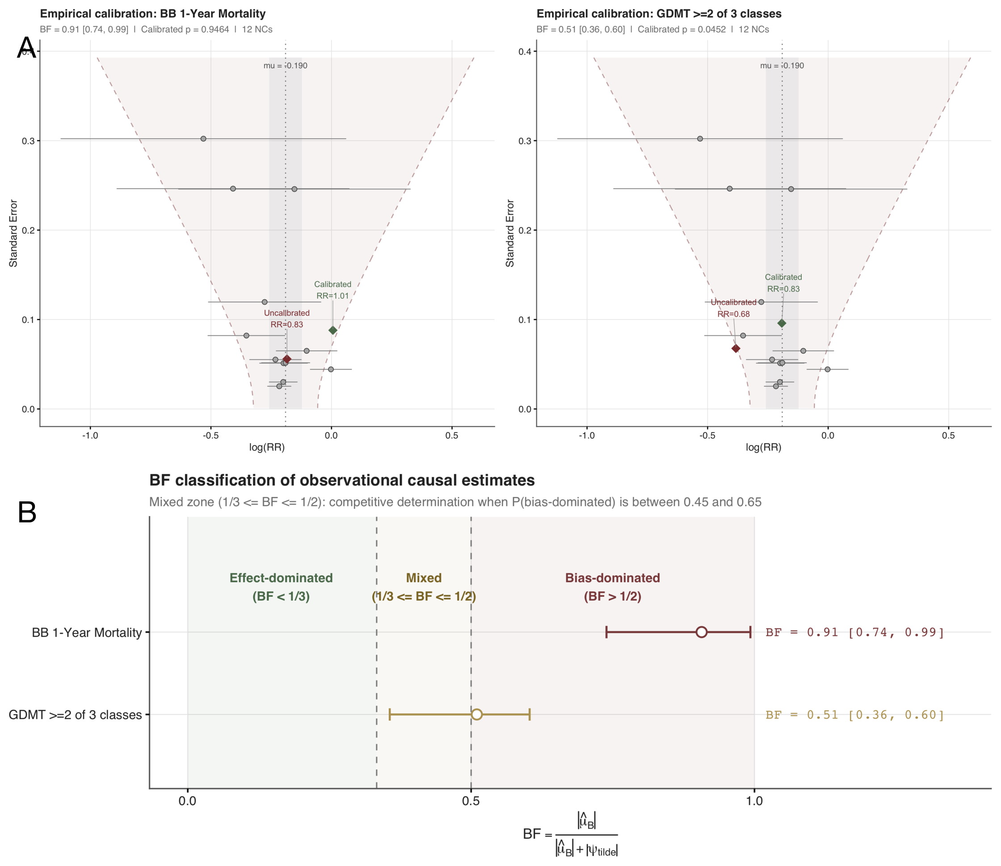

Discussion
Reporting the calibrated P value together with BAF and its interval converts a binary credibility judgment into three questions: whether a signal exists, how large it is, and what fraction is attributable to bias. The full rule is deliberately conservative: it declares few estimates usable because a usable determination requires positive evidence that bias does not dominate, not merely the absence of evidence that it does. Unlike sensitivity analyses such as the E-value⁷, which quantify the confounding needed to overturn a result, or OHDSI negative-control calibration⁹, which returns only a binary calibrated P value, BAF reports the fraction of the surviving signal attributable to bias on a bounded [0, 1] scale, so estimates with different outcomes or sample sizes can be compared directly.
The primary Bland-Altman evaluation showed moderate agreement between the estimator and truth: Lin concordance was 0.78 across the full grid and 0.82 in the interior, with mean difference -0.069 (full grid) and -0.049 (interior). The estimator systematically underestimates ${BAF}_{true}$ (proportional bias slope -0.1814, P < .001), and this underestimation is concentrated near ${BAF}_{true}$ = 1, where the estimator is compressed against its upper bound. A reported BAF near 1 is therefore a conservative lower bound on the true bias fraction, and the moderate concordance supports the use of BAF as a continuous diagnostic alongside the calibrated P value, not as a standalone estimator.
Adding $\hat{BAF}$ to the calibrated P value raised the area under the receiver operating characteristic curve from 0.787 to 0.918 in the bias-dominated view and from 0.721 to 0.951 in the effect-dominated view: $\hat{BAF}$ ranks effect-dominated estimates better, the reverse of the calibrated P value, so the two metrics are complementary, not interchangeable. Adding the interval half-width changed discrimination by +0.0001 in the bias-dominated view and by -0.0001 in the effect-dominated view, so the sign of its contribution is not consistent across the two views; in neither view does it add ranking information beyond $\hat{BAF}$, and it is retained because rule R3 requires the whole credible interval to fall below 0.5, clear of the bias-dominated zone. The nested rules traded yield for safety: under the calibrated P value alone, 61.9% of estimates were declared usable and 36.0% of those were truly bias-dominated; under R4, 21.5% were usable and only 2.9% were misused. Across K = 12 to 50 negative controls, precision and safety improved monotonically without plateau (median interval half-width 0.193 to 0.081; misuse 3.5% to 2.3%), so the number of negative controls is a design parameter rather than a fixed cost.
The case study was designed as a hard test of the diagnostic point and is methodological, not clinical: it makes no claim about beta-blocker therapy and mortality. Despite a TARGET-compliant target trial emulation, doubly robust TMLE, and calibration against 12 negative controls, for question 1, the two beta-blocker strategies differed systematically at baseline (Table 3; 12 of 16 variables exceeded the imbalance threshold before weighting and 0 of 16 after IPTW adjustment, maximum IPTW-adjusted SMD 0.027; the standardized difference is a diagnostic only, because the effect estimate itself comes from TMLE, not from weighting); for question 2, the two strategies also differed systematically at baseline, and unlike question 1 the imbalance was not resolved by weighting (eTable 7; 4 of 16 variables exceeded the threshold before weighting and 1 remained above it afterwards, with a maximum IPTW-adjusted standardized mean difference of 0.331; that residual imbalance is a diagnostic of the weighting, not of the TMLE estimate, which does not use the weights), and all 12 negative controls showed protective or null associations (empirical null center -0.19) consistent with a pervasive healthy-adherer effect. For question 1, the uncalibrated relative risk of 0.83 collapsed to 1.01 after calibration (calibrated P = 0.95), with $\hat{BAF}$ = 0.91 indicating that approximately 91% of the calibrated signal (the sum of bias and the surviving calibrated effect) was attributable to bias; given the estimator’s systematic underestimation established by the Bland-Altman analysis, the true bias fraction is likely even higher, strengthening the not-usable determination.
For question 2, the calibrated estimate (relative risk 0.83, calibrated P = 0.045) survived calibration but $\hat{BAF}$ = 0.51 placed it marginally in the bias-dominated zone, while its 95% credible interval spanned 0.5, so the calibrated probability that bias dominates (0.65) left a competitive determination with no usable finding. The question-1 determination was robust to these safeguards: leave-one-out re-estimation across the 12 negative controls moved question-1 $\hat{BAF}$ only between 0.891 and 0.990, removing the single most influential control gave 0.984, and three alternative Super Learner libraries gave 0.901, 0.896, and 0.918.
BAF is a property of the evidence, not of the treatment: it quantifies the fraction of the observed association attributable to systematic bias, not whether a true effect exists. A determination of not usable as effect evidence means this study cannot support an effect claim, because the residual signal is small relative to the estimated bias and rests on an unverifiable exchangeability assumption; it does not mean the effect is zero. Conversely, a calibrated P value below .05 establishes only that the calibrated estimate is distinguishable from the empirical null, which is consistent with a true effect but does not prove one, since the same pattern arises if the negative controls understate the bias affecting the target. These results carry three implications for practice. Rigorous design and advanced estimation address measured confounding but not unmeasured confounding, so quantifying what remains complements them instead of replacing them. Because BAF is computed from negative-control estimates that many observational studies already obtain, it could be appended to existing reports without new data collection, although whether doing so improves how observational findings are interpreted remains to be established. Finally, the number of negative controls is itself a design parameter: within the range studied each increase improved precision and safety monotonically without leveling off by K = 50, and because negative controls are drawn from outcome phenotypes already in the data source, enlarging K costs specification effort rather than new data collection.

Limitations
BAF inherits the negative control assumption that the controls are truly null and exchangeable with the target estimate. Like the no-unmeasured-confounding assumption it is meant to probe, this cannot be verified from data. Because both questions were calibrated against one empirical null fitted from the same 12 negative controls, which were estimated under the question-1 contrast, we additionally assume the residual confounding distribution is shared across the two treatment contrasts; if the two contrasts differed in their unmeasured confounding, Q2’s BAF and determination would be biased in an undetected direction. A violation in which the bias affecting the target lies outside the negative control distribution will distort BAF in a direction that cannot be detected internally. We probed this by adding a simulation arm that explicitly violates exchangeability: where the assumption held, 0.91% of estimates declared usable were in truth bias-dominated, whereas under a 30% violation that proportion rose to 4.08%, with the share declared usable rising from 15.9% to 27.0%. The resulting misuse rates are therefore conditional on that design, not universal constants, and they show how much of the apparent safety of the rules rests on the exchangeability assumption itself. Negative controls must also be specified before their own results are examined; post hoc selection would bias the empirical null. The 12 negative controls are all protective or null (uncalibrated relative risks 0.59 to 1.00), so the empirical null is fitted from a one-sided panel; with only 12 controls the Shapiro-Wilk test of normality has little power (P = 0.168 in the case study), and the sensitivity of the calibration to deviations from normality is not examined.
As defined in the Methods, the interval is a credible interval, not a confidence interval, obtained by propagating draws of ${\hat{μ}}_{B}$ while holding ${\hat{ψ}}_{obs}$ fixed, so it carries no frequentist coverage guarantee; in the simulation it contained ${BAF}_{true}$ in 71.1% of repetitions, below the nominal 95%. Two features of the construction contribute to this gap. First, the interval propagates uncertainty from the empirical null while holding the observed effect estimate fixed, omitting the sampling variability of the effect estimate. Second, the number of draws is modest (M = 300 in the simulation; a bootstrap of comparable size in the case study), so the 2.5th and 97.5th percentiles carry Monte Carlo uncertainty. Propagating the omitted term jointly restores coverage: adding the sampling variability of the calibrated estimate raised coverage from 78.8% to 97.7% across the conditions examined, at the cost of widening the median half-width from 0.132 to 0.222 and lowering the yield of the strictest interval rule from 24.3% to 13.2% of repetitions (eTable 9 in Supplement 1). Because the interval as reported is systematically narrower than its nominal coverage, the rules that consume its endpoints or half-width (R3, C2, and the narrow or wide split of the lookup table) are conservative in yield; widening the interval to nominal coverage would raise both their yield and the misuse rates they report, so the observed R3 and R4 misuse rates are lower bounds. Because BAF is a ratio, the interval is wide by construction near $\tilde{ψ}$ = 0; its half-width describes precision for the bias fraction estimate, not a test of it. The lookup table that maps BAF and interval half-width to a determination was built from the same 960,000 repetitions used to evaluate the rules, so its reported performance reflects in-sample agreement and is optimistically biased. Two held-out validations bound that optimism (eTable 8 in Supplement 1). Holding out 20% of repetitions within every condition left every rule’s misuse rate unchanged to two decimal places. Holding out 20% of the 960 conditions instead, which also tests grid cells that never contributed to the lookup, left the share declared usable essentially unchanged and raised the misuse rate of the strictest rule from 2.2% to 2.4%, the largest excursion across the five folds being 4.1%. Finally, the absolute misuse rate depends on the truth composition induced by the factorial design; in this simulation that composition was 18.8% effect-dominated, 28.7% mixed, and 52.5% bias-dominated, and a different composition would shift the absolute misuse rate even though the relative ordering of the rules would not.
Because the data-generating truth is fixed by the investigator, absolute misuse rates are illustrative and depend on the chosen ranges of the simulation factors. What is robust is the relative ordering of strategies, which held across the prespecified subgroups, including the exchangeability-violation level. The number of negative controls was examined only up to K = 50; where the gain eventually levels off, and whether the marginal improvement beyond that point justifies the further specification burden, is unknown.
The case study uses single-center critical care data restricted to patients with continuous monitoring and a recorded 12-lead electrocardiogram. This limits the generalizability of the empirical findings, but not of the metric, which depends only on estimates and their standard errors. Because the primary outcome is all-cause mortality, competing risks do not arise in the primary analysis; they would matter only for cause-specific or nonfatal endpoints, which here serve solely as negative controls. The GDMT strategy was defined by three foundational drug classes, not by contemporary four-drug therapy, because sodium-glucose cotransporter 2 inhibitors entered heart failure practice only after the period captured by these data, and incorporating them would introduce time-dependent confounding by indication. This limits the clinical currency of the GDMT estimate but not the demonstration of the metric, which applies to any prespecified treatment strategy. In question 2, 3,494 patients (23.8%) with a missing guideline-directed medical therapy score were classified as not optimized; if this missingness is related to the true exposure it is a nonrandom treatment misclassification that biases the question-2 estimate. We therefore re-estimated question 2 under four handling conventions (eTable 10 in Supplement 1): indeterminate treated as suboptimal, as published; complete-case; indeterminate treated as optimized; and multiple imputation from a logistic model of exposure on the baseline covariates. The uncalibrated relative risk moved from 0.68 to 0.91 across conventions, but no convention produced a calibratable signal, and none yielded a usable determination: the bias fraction rose from 0.51 under the published convention to between 0.51 and 0.66 under the others, and three of the four conventions placed question 2 in the least favourable determination of not usable as effect evidence. The published convention is thus the most favourable of the four, so the qualitative conclusion does not depend on it. The negative-control panel was fitted with the exposure contrast that counts all beta-blocker agents, whereas the target estimates use the guideline-restricted contrast. Refitting the panel to match the target contrast widens the empirical null (SD 0.113 versus 0.068) and raises the question-2 calibrated P value above .05 (0.103 versus 0.045), so the question-2 layer-1 pass is not robust to this choice, although its label as a competitive determination with no usable finding is; question 1 remains not usable as effect evidence under either panel (calibrated P 0.894).

Conclusions
Reporting the Bias Attribution Fraction (BAF) and its credible interval alongside the calibrated P value may give a more defensible credibility assessment than the P value alone: with no additional data, it describes whether a signal exists, its size, and the fraction attributable to bias. Across 960,000 simulated repetitions, BAF improved discrimination over the calibrated P value, and the nested rules R0 to R4 traded yield for safety. The case study demonstrates the metric and the rules in use: applied to two clinical questions, BAF and R0 to R4 returned two distinct determinations, one not usable as effect evidence and the other a competitive determination with no usable determination, with the guideline-directed therapy question’s BAF marginally in the bias-dominated zone and its 95% credible interval spanning 0.5. Rigorous design and advanced estimation are necessary but not sufficient, since neither can bound unmeasured confounding; empirical bias diagnostics may complement them but do not replace them.

References
1. Hernán MA, Robins JM. Using Big Data to Emulate a Target Trial When a Randomized Trial Is Not Available. Am J Epidemiol. 2016;183(8):758-764. doi:10.1093/aje/kwv254
2. Lendle SD, Schwab J, Petersen ML, van der Laan MJ. ltmle: An R Package Implementing Targeted Minimum Loss-Based Estimation for Longitudinal Data. J Stat Softw. 2017;81(1):1-21. doi:10.18637/jss.v081.i01
3. van der Laan MJ, Rose S. Targeted Learning: Causal Inference for Observational and Experimental Data. Springer; 2011. doi:10.1007/978-1-4419-9782-1
4. Ren Y, Jia Y, Liu L, et al. Design and implementation of observational studies emulating a target trial. JAMA Netw Open. 2026;9(2):e2558262. doi:10.1001/jamanetworkopen.2025.58262
5. Simpson SH, Eurich DT, Majumdar SR, et al. A meta-analysis of the association between adherence to drug therapy and mortality. BMJ. 2006;333(7557):15. doi:10.1136/bmj.38875.675486.55
6. Shrank WH, Patrick AR, Brookhart MA. Healthy user and related biases in observational studies of preventive interventions: A primer for physicians. J Gen Intern Med. 2011;26(5):546-550. doi:10.1007/s11606-010-1609-1
7. VanderWeele TJ, Ding P. Sensitivity Analysis in Observational Research: Introducing the E-Value. Ann Intern Med. 2017;167(4):268-274. doi:10.7326/M16-2607
8. Schuemie MJ, Ryan PB, DuMouchel W, Suchard MA, Madigan D. Interpreting observational studies: Why empirical calibration is needed to correct p-values. Stat Med. 2014;33(2):209-218. doi:10.1002/sim.5925
9. Schuemie MJ, Hripcsak G, Ryan PB, Madigan D, Suchard MA. Empirical confidence interval calibration for population-level effect estimation studies in observational healthcare data. Proc Natl Acad Sci U S A. 2018;115(11):2571-2577. doi:10.1073/pnas.1708282114
10. Lash TL, Fox MP, Fink AK. Applying Quantitative Bias Analysis to Epidemiologic Data. Springer; 2009.
11. Greenland S. Basic methods for sensitivity analysis of biases. Int J Epidemiol. 1996;25(6):1107-1116. doi:10.1093/ije/25.6.1107
12. Schneeweiss S. Sensitivity analysis and external adjustment for unmeasured confounders in epidemiologic database studies of therapeutics. Pharmacoepidemiol Drug Saf. 2006;15(5):291-303. doi:10.1002/pds.1200
13. MacLehose RF, Kaufman S, Kaufman JS, Poole C. Bounding causal effects under uncontrolled confounding using counterfactuals. Epidemiology. 2005;16(4):548-555. doi:10.1097/01.ede.0000165364.69366.36
14. Shi X, Miao W, Tchetgen Tchetgen EJ. A selective review of negative control methods in epidemiology. Curr Epidemiol Rep. 2020;7(4):190-202. doi:10.1007/s40471-020-00243-4
15. Morris TP, White IR, Crowther MJ. Using simulation studies to evaluate statistical methods. Stat Med. 2019;38(11):2074-2102. doi:10.1002/sim.8086
16. Bland JM, Altman DG. Statistical methods for assessing agreement between two methods of clinical measurement. Lancet. 1986;327(8476):307-310. doi:10.1016/S0140-6736(86)90837-8
17. Lin LIK. A concordance correlation coefficient to evaluate reproducibility. Biometrics. 1989;45(1):255-268. doi:10.2307/2532051
18. Johnson AEW, Bulgarelli L, Shen L, et al. MIMIC-IV, a freely accessible electronic health record dataset. Sci Data. 2023;10(1):1. doi:10.1038/s41597-022-01899-x
19. Gow B, Pollard T, Nathanson LA, et al. MIMIC-IV-ECG: Diagnostic electrocardiogram matched subset. PhysioNet. Published online 2023. doi:10.13026/4nqg-sb35
20. Cashin AG, Hansford HJ, Hernán MA, et al. Transparent reporting of observational studies emulating a target trial: The TARGET statement. BMJ. 2025;390:e087179. doi:10.1136/bmj-2025-087179
21. McMurray JJV, Solomon SD, Inzucchi SE, et al. Dapagliflozin in patients with heart failure and reduced ejection fraction. N Engl J Med. 2019;381(21):1995-2008. doi:10.1056/NEJMoa1911303
22. Packer M, Anker SD, Butler J, et al. Cardiovascular and renal outcomes with empagliflozin in heart failure. N Engl J Med. 2020;383(15):1413-1424. doi:10.1056/NEJMoa2022190
23. van der Laan MJ, Polley EC, Hubbard AE. Super Learner. Stat Appl Genet Mol Biol. 2007;6(1):Article 25. doi:10.2202/1544-6115.1309
24. Lipsitch M, Tchetgen Tchetgen E, Cohen T. Negative controls: A tool for detecting confounding and bias in observational studies. Epidemiology. 2010;21(3):383-388. doi:10.1097/EDE.0b013e3181d61eeb
25. Zeng Z. biasratio: Bias Fraction and Bias-Effect Ratio for Quantifying Residual Systematic Bias in Observational Studies (R package version 0.2.1). Published online 2026. https://github.com/zengzhechun/biasratio

Figure Legends
Figure 1. Bland-Altman agreement of the BAF estimator with the true BAF, full grid Monte Carlo simulation (n = 960 000 repetitions across 960 conditions); the empirical null fitted separately in each repetition was estimated by a conjugate Gibbs sampler. The x-axis is the true BAF of the simulated condition; the y-axis is the signed difference in each repetition BAF-hat minus BAF-true. The 2D density (warm ramp on white) summarizes all 960 000 repetitions. The solid horizontal line is the overall mean bias, the two dashed red lines are the 95% limits of agreement, and the inset table reports bias, SD, limits of agreement, Lin concordance correlation coefficient, and the proportional bias slope. The estimator systematically underestimates BAF-true.
Figure 2. Receiver operating characteristic analysis for the reporting rules of Table 2, read from two viewpoints. Curves: the calibrated P value alone, BAF-hat alone, and BAF-hat plus its interval half-width; the in-panel tables report the area under each curve in that panel. Triangles: the operating points of R0 through R4 and C1, C2 of Table 2. Panel A. Effect-dominated view. Reference standard: truly effect-dominated. Positive call: declared usable as effect evidence. Panel B. Bias-dominated view. Reference standard: truly bias-dominated. Positive call: withheld. Truth has three levels (effect-dominated, mixed, bias-dominated, 18.8% / 28.7% / 52.5%), and the mixed zone falls outside the positive group of both views, which is why the views are not mirror images and why the same curve has a different area in each panel. Adding BAF-hat, not the interval width, carries the discriminatory information beyond the calibrated P value; the rules of Table 2 are read here as a stress test of the curves, every rule being one cut of the underlying score.
Figure 3. Empirical null distribution and bias fraction for the two clinical questions. A, Empirical null distribution estimated from the negative control outcomes (left, beta-blocker question; right, guideline-directed medical therapy question). The fitted center (gray vertical dashed line at -0.190, with its 95% confidence band shown as a shaded gray strip) marks the estimated mean systematic bias; the 12 negative controls appear as filled circles with horizontal 95% confidence intervals on their own track. The funnel-shaped red dashed curves mark the 95% prediction interval of the empirical null model at each standard error, the region within which a true null estimate is expected to fall. The red diamond is the uncalibrated target estimate and the green diamond the calibrated estimate. B, Bias fraction (BAF) for the two clinical questions (BB, beta-blocker; GDMT, guideline-directed medical therapy), read as a continuous estimator of residual bias. Shaded zones indicate the three classification regions (effect-dominated, mixed, bias-dominated). Points show BAF estimates with 95% credible intervals; dashed lines at BAF = 1/3 and BAF = 0.5 denote zone boundaries.

Article Information
Study Type. Original Investigation.
Author Contributions. Dr Zeng had full access to all of the data in the study and takes responsibility for the integrity of the data and the accuracy of the data analysis. Dr Zeng conceived the study, designed the credibility metric, implemented the analysis code and the biasratio R package, conducted the simulation study, and drafted the manuscript. Dr Wang contributed to the methodological design and reviewed the statistical approach. Dr Zuo contributed to the clinical interpretation of the negative control selection and reviewed the manuscript. Dr Shu contributed to the study design and critically revised the manuscript for important intellectual content. All authors read and approved the final manuscript. Dr Zeng is the author and maintainer of the biasratio R package cited in this work.
Conflict of Interest Disclosures. All authors reported no conflict of interest disclosures.
Funding/Support. This research received no specific grant from any funding agency in the public, commercial, or not-for-profit sectors.
Role of the Funder/Sponsor. Not applicable.
Data Sharing Statement. The MIMIC-IV database (version 2.2) is available through PhysioNet (https://physionet.org/content/mimiciv/) and the MIMIC-IV-ECG extension (version 1.0.1) at https://physionet.org/content/mimic-iv-ecg/1.0.1/ to credentialed users. All analysis code, including the simulation pipeline, the case-study TMLE estimation pipeline, and the BAF computation proposed in this work, is available at https://github.com/zengzhechun/bias-fraction, together with an interactive graphical explainer of the metric, the simulation, and the two clinical questions. The methods proposed here are implemented in the companion biasratio R package (version 0.3.1; https://github.com/zengzhechun/biasratio)²⁵, released under the MIT license, which provides the BAF estimator with bootstrap and Fieller intervals, the two-layer screening rule, the full set of reporting rules evaluated in Table 2, leave-one-out sensitivity analysis, and negative control diagnostics, together with a unit-test suite covering the estimator, the interval procedures, and the classification thresholds; the version used for this manuscript is archived at commit 27c6a0f. The EmpiricalCalibration R package (Schuemie et al.), which supplies the empirical null machinery used here but does not include BAF, is available from CRAN.
Additional Contributions. The authors thank the MIMIC-IV team for making the database publicly available and the OHDSI/EmpiricalCalibration R package developers for the empirical calibration tools upon which this work builds.
Artificial Intelligence Use Disclosure. The authors used artificial intelligence tools (DeepSeek V4 Pro, Kimi K3, GLM 5.3, ChatGPT 5.5, and Tencent WorkBuddy) for code development, manuscript editing, and language polishing. All AI-assisted content was critically reviewed and revised by the authors, who take full responsibility for the content of this manuscript.
Word Count. 6,665 words of text (excluding abstract, references, tables, and figure legends).

