Quantifying Systematic Bias in Observational Causal Estimates: The Bias Attribution Fraction
Zeng Zhechun
Wang Jinwen
Zuo Huijuan
Shu Lixia
2026-08-27
¹ Beijing Anzhen Hospital, Capital Medical University, Beijing 100029, China
² National Clinical Research Center for Cardiovascular Diseases, Beijing, China
³ Beijing Institute of Heart, Lung and Blood Vessel Diseases, Beijing, China
Corresponding author: Zeng Zhechun, MD, MPH Beijing Anzhen Hospital, Capital Medical University; Beijing Institute of Heart, Lung and Blood Vessel Diseases, Tongzhou Campus, No. 225 Songzhuang South 1st Street, Tongzhou District, Beijing 101149, China Email: zengzhechun@icloud.com
Study Type: Original Investigation.
Keywords: Bias Attribution Fraction, Bias (Epidemiology), Target Trial Emulation, Observational Studies as Topic, Reproducibility of Results.

Key Points
Question: Can the Bias Attribution Fraction, derived from negative controls, quantify how much of an observational estimate is systematic bias?
Findings: In a 1,920,000-repetition simulation, BAF tracked the truth with moderate agreement and, added to the calibrated P value, cut misuse from 36.0% to 3.0%. In the beta-blocker case study (14,677 patients), BAF separated two questions the calibrated P value did not, one bias-dominated and one mixed.
Meaning: BAF adds to the calibrated P value the fraction of the surviving signal attributable to bias, at no additional data cost.

Abstract
Importance. Only 30.8% of 237 target trial emulation (TTE) studies assessed the no-unmeasured-confounding assumption statistically. Negative control calibration detects residual bias but returns only a calibrated P value, without quantifying bias relative to the surviving effect.
Objective. To develop and evaluate the Bias Attribution Fraction (BAF), a bounded metric quantifying the fraction of systematic bias in a calibrated effect estimate.
Design, Setting, and Participants. A factorial simulation (1,920,000 repetitions; a primary grid plus a sign-flipped companion grid of identical size, pooled throughout) evaluated the BAF estimator by Bland-Altman agreement (primary) and a two-layer decision rule (calibrated P value, then BAF and its interval). It was then applied in a beta-blocker case study under a TARGET-compliant TTE design with doubly robust targeted maximum likelihood estimation and 12 negative controls, in 14,677 patients with heart failure for 1-year mortality (MIMIC-IV, 2008–2019).
Exposures. (1) Achieving at least 50% of guideline-recommended beta-blocker target dose within 7 days; (2) receiving guideline-directed medical therapy with at least two of three foundational drug classes.
Main Outcomes and Measures. The primary outcome was Bland-Altman agreement; the decision rule and case-study determinations were secondary.
Results. Bland-Altman analysis showed mean bias -0.020 in the interior (1,728,000 repetitions; concordance 0.84) and -0.040 across all 1,920,000 repetitions (93.9% within limits of agreement), with stronger proportional bias near BAF = 1. The two-layer rule cut misuse (usable calls that were truly bias-dominated) from 36.0% to 3.0%, falling monotonically across K = 12 to 50 negative controls. In the case study, question 1 was bias-dominated (BAF = 0.87 [95% credible interval, 0.38-0.99]) despite the TARGET-compliant design and TMLE. Neither question passed the calibrated-P screen; question 2 had a BAF of 0.46 (95% credible interval, 0.19-0.62) in the mixed zone with the interval spanning both zone boundaries, a competitive determination with no usable finding.
Conclusions and Relevance. BAF quantifies the fraction of systematic bias in the calibrated signal, a bounded complement to the calibrated P value. A rigorously designed case study still showed the beta-blocker target-dose question to be bias-dominated, so empirical bias diagnostics are necessary; this demonstration is not evidence of drug ineffectiveness.

Introduction
Target trial emulation¹ and targeted maximum likelihood estimation^{2,3} cannot remove unmeasured confounding: of 237 target trial emulation studies surveyed, only 30.8% assessed it statistically⁴. The healthy adherer effect, in which adherence predicts better outcomes for events the therapy cannot plausibly affect, illustrates the threat^{5,6}, and the E-value⁷ quantifies the confounding needed to overturn a result, not how much of the association is bias.
Rigorous eligibility criteria, time-zero alignment, and doubly robust estimation remove bias visible in measured covariates, but none bounds the bias remaining when a prognostic factor was never recorded, and nothing in a reported effect size, confidence interval, and P value reveals when that bias dominates.
The Observational Health Data Sciences and Informatics (OHDSI) consortium estimates an empirical null from negative controls, outcomes not causally affected by the treatment but sharing its confounding structure, and returns a calibrated P value⁸ and calibrated effect⁹. Calibration answers only whether a signal exists, not how large the bias is relative to the surviving signal. We propose the Bias Attribution Fraction (BAF) = |${\hat{μ}}_{B}$| / (|${\hat{μ}}_{B}$| + |$\tilde{ψ}$|), the fraction of that signal attributable to systematic bias on a bounded [0, 1] scale. Existing bias analyses return an adjusted estimate rather than a share of the association^{10–13}, and negative-control methods stop at that P value^{8,14}. We assess how accurately BAF recovers the true bias in simulation and what it reveals in a TARGET-compliant emulation calibrated with 12 negative controls.

Methods
The credibility metric. Consider an observational study of a binary treatment $A$ and outcome $Y$ with target estimand $ψ=log{RR}_{\text{true}}$, estimated by TMLE as ${\hat{ψ}}_{\text{obs}}$ with standard error ${\hat{σ}}_{\text{obs}}$. Suppose $K$ negative control outcomes share the confounding structure of $Y$ but are not causally affected by $A$; each yields ${\hat{γ}}_{k}$ with standard error ${\hat{τ}}_{k}$.
The key assumption is bias exchangeability: conditional on measured covariates, the residual bias affecting ${\hat{ψ}}_{\text{obs}}$ is distributed as that governing the negative control estimates. Like the assumption it diagnoses, it cannot be verified from data.
Under bias exchangeability, $μ_{B}$ is estimated by fitting an empirical null to $\{({\hat{γ}}_{k},{\hat{τ}}_{k})\}_{k=1}^{K}$ with the fitNull function of the EmpiricalCalibration R package⁸, yielding ${\hat{μ}}_{B}$ and ${\hat{σ}}_{B}$. The bias-corrected estimate is $\tilde{ψ}={\hat{ψ}}_{\text{obs}}−{\hat{μ}}_{B}$, with calibrated standard error $\tilde{σ}=\sqrt{{\hat{σ}}_{\text{obs}}^{2}+{\hat{σ}}_{B}^{2}}$.
Building on this framework, we define the Bias Attribution Fraction as
$$BAF=\frac{|{\hat{μ}}_{B}|}{|{\hat{μ}}_{B}|+|\tilde{ψ}|}=\frac{|{\hat{μ}}_{B}|}{|{\hat{μ}}_{B}|+|{\hat{ψ}}_{\text{obs}}−{\hat{μ}}_{B}|}.$$
Absolute values keep BAF between 0 and 1 whatever the sign of either component, so the metric is scale-invariant and bounded⁷: one BAF is therefore consistent with bias that inflates the effect, shrinks it toward the null, or reverses its sign. We define three regions: bias-dominated when BAF exceeds 0.5 ($|μ_{B}|>|\tilde{ψ}|$), effect-dominated when BAF falls below 1/3 ($|μ_{B}|<|\tilde{ψ}|/2$), and mixed in between.
Interval estimation. BAF is a ratio whose denominator is itself a difference of estimates, so its uncertainty cannot be inherited from a standard error. We therefore propagate it: draws of $μ_{B}$ are passed through the BAF function with ${\hat{ψ}}_{obs}$ held fixed, and the interval is the 2.5th to 97.5th percentile of the resulting distribution, its point estimate the median. It is a credible interval, not a confidence interval. Sampling details and the half-width summary appear in eMethods in Supplement 1.
Simulation. Because the true bias is unknown in any application, we simulated a factorial design with the truth known by construction, including settings that violate bias exchangeability deliberately. Five factors were crossed following the ADEMP framework¹⁵ in the primary grid, 960 conditions × 1000 repetitions (960,000); a companion grid of the same size flips the sign of the true systematic bias, and pooling the two grids yields 1,920,000 repetitions across 1920 conditions, the base for every performance analysis reported below. Table 1 lists the factors with the bias center at both signs, and eMethods in Supplement 1 justifies each level⁵. Random seeds were fixed (43 for the primary grid and 100 043 for the companion grid, whose random number stream is disjoint from the primary one).
Performance measures. The repetitions answered two questions. The first asked how closely $\hat{BAF}$ tracks the truth, by Bland-Altman analysis¹⁶ with the signed difference $\hat{BAF}−{BAF}_{true}$ plotted against ${BAF}_{true}$; summaries were the mean signed difference, its SD, the 95% limits of agreement, and the Lin concordance correlation coefficient¹⁷, with proportional bias tested by regressing the difference on ${BAF}_{true}$. Because the least negative effect level (ψ = -0.01) drives ${BAF}_{true}$ against the estimator’s bound of 1, we prespecified the full pooled design and an interior set excluding it.
The second asked whether a reporting rule built on $\hat{BAF}$ separates trustworthy from untrustworthy estimates. Layer 1 declares an estimate usable when its calibrated P value is below .05; layer 2 maps $\hat{BAF}$ with its interval half-width, through a lookup table split at the median half-width (eTables 1 and 2 in Supplement 1), to a conservative probability that the estimate is bias-dominated, and then to one of four determinations: usable as effect evidence below 15%, mixed and hypothesis-generating below 45%, competitive below 65%, and not usable at 65% or above. Each rule is summarized by its share declared usable and its misuse rate; discrimination was compared across the calibrated P value alone, $\hat{BAF}$ alone, and $\hat{BAF}$ with its half-width. The mixed zone is negative in both views, so both are reported.
TTE case study. Two target trial emulations¹ were conducted in MIMIC-IV linked to MIMIC-IV-ECG^{18,19}, with every design decision checked against the TARGET guideline²⁰ (eTable 16 in Supplement 1). Participants were adults hospitalized for heart failure who were new users of beta-blockers, and the outcome was one-year all-cause mortality. Strategies were ascertained over a 7-day grace period with time zero at its end, so the design avoids immortal time bias and time-varying confounding but estimates a baseline-strategy contrast, not the effect of sustained adherence. Question 1 compared achieving at least 50% of the guideline-recommended beta-blocker target dose with failing to reach it; the qualifying agents, their target doses, and the derivation of the in-hospital daily dose are given in eMethods in Supplement 1. Question 2 compared guideline-directed medical therapy (at least two of three foundational drug classes at adequate dose) with not receiving it, a definition predating sodium-glucose cotransporter 2 inhibitors in heart failure^{21,22}.
One-year all-cause mortality was estimated by targeted maximum likelihood estimation (TMLE)³, a doubly robust, semiparametric efficient estimator of the log relative risk. For question 1 the treatment mechanism used a Super Learner²³ of two learners (main-term and Lasso logistic regression) with a main-term logistic outcome model; for question 2 and the negative controls both models were main-term logistic regressions (SL.glm). The negative controls shared the target estimates’ hospitalizations, window, exclusion, covariates, estimator, and exposure contrast, the last because the panel was fitted on the guideline-restricted cohort, in which exposure is defined as for question 1 by receipt of carvedilol, metoprolol succinate, or bisoprolol at or above 50% of the target dose, covering 12.1% of the analytic cohort. The resulting empirical null (mean bias -0.168, SD 0.113) was applied to both questions^{9,24}; the candidate list, the screening levels, and the per-control estimates appear in eMethods and eTable 6 in Supplement 1.
Data source and participants. The case study used MIMIC-IV (version 2.2) linked at the stay level to MIMIC-IV-ECG (version 1.0.1), covering intensive care unit admissions at Beth Israel Deaconess Medical Center between 2008 and 2019^{18,19}. Eligible adults had a first intensive care unit stay, at least 24 hours of continuous monitoring, and a 12-lead electrocardiogram during the index stay. Of 15,053 heart-failure hospitalizations assessed, 376 did not survive the 7-day grace period, leaving 14,677 (eFigure 2 in Supplement 1). The institutional review boards approved the study with a waiver of informed consent.
Statistical analysis. All hypothesis tests were 2-sided with an a priori significance level of .05. The log relative risk and its standard error were estimated by targeted maximum likelihood estimation (ltmle 1.3.0) and the empirical null by the fitNull function (EmpiricalCalibration 3.1.4); agreement was summarized by the Lin concordance correlation coefficient with 95% limits of agreement, and discrimination by likelihood ratio χ² tests. Analyses used R 4.4.1 (R Foundation for Statistical Computing, Vienna, Austria) with bafratio 0.4.0; code appears in Supplement 1.

Results
Simulation.
Bland-Altman agreement. The prespecified primary analysis set was the interior of the grid, excluding the ψ = -0.01 boundary level where ${BAF}_{true}$ approaches 1; there $\hat{BAF}$ had mean difference -0.020 across 1,728,000 repetitions with Lin concordance 0.838. Across all 1,920,000 repetitions of the full design the mean difference was -0.040 with 95% limits of agreement -0.301 to 0.221, concordance 0.810, and 93.9% within the limits; proportional bias was significant (slope -0.2106, P < .001). $\hat{BAF}$ therefore underestimates ${BAF}_{true}$, concentrated near the boundary (Figure 1).
Discrimination. In the bias-dominated view, the calibrated P value alone reached an AUC of 0.787; adding $\hat{BAF}$ raised it to 0.922, and adding the interval half-width moved it by +0.0010 (likelihood ratio χ² = 3835.1, df = 1, P < .001), too small to change any classification. In the effect-dominated view the same three scores reached 0.721, 0.950 and 0.950: $\hat{BAF}$ ranks effect-dominated estimates better than bias-dominated ones (0.95 vs 0.92), the reverse of the calibrated P value.
Reporting rule performance. Table 2 and Figure 2 show each rule as an operating point: each added component declares fewer estimates usable but a smaller share of those declarations is wrong. Under the calibrated P value alone, 61.8% of repetitions were declared usable and 36.0% of those were in truth bias-dominated; under the most stringent rule (R4), only 3.0% were. The number of negative controls was itself a design lever: across K = 12 to 50, the median interval half-width fell from 0.144 to 0.060 and the misuse rate from 3.5% to 2.6% (eTable 3 in Supplement 1).
TTE Case study. Baseline characteristics of the 14,677 eligible patients by beta-blocker target-dose strategy appear in eTable 15 in Supplement 1, and those of the 14,677 eligible patients by guideline-directed medical therapy strategy appear in eTable 7 in Supplement 1.
Question 1 (beta-blocker target dose) failed layer 1; the bias fraction (BAF) was 0.875 (95% credible interval, 0.385 to 0.992). The uncalibrated relative risk (RR) was 0.831 (95% CI, 0.745 to 0.928). Calibration against the empirical null from all 12 negative controls (${\hat{μ}}_{B}$ = -0.168, ${\hat{σ}}_{B}$ = 0.113) returned a calibrated P of .89 and a calibrated RR of 0.983 (95% CI, 0.768 to 1.259), so the apparent 17% mortality reduction was not distinguishable from the empirical null.
Question 2 (guideline-directed medical therapy) also failed layer 1; the bias fraction (BAF) was 0.460 (95% credible interval, 0.186 to 0.619). Under the same design and estimator, the uncalibrated RR was 0.682 (95% CI, 0.597 to 0.779); calibration against the shared empirical null returned a calibrated P of .10 and a calibrated RR of 0.807 (95% CI, 0.623 to 1.044).
The probability of being bias-dominated was 0.999, above the 0.65 threshold; the determination was not usable as effect evidence.
The probability of being bias-dominated was 0.588, between the 0.45 and 0.65 thresholds; the point estimate fell in the mixed zone and the interval spanned both zone boundaries, a competitive determination with no usable finding (eTable 1 in Supplement 1).
Under the reporting rules of Table 2, both questions failed layer 1 and were therefore declared usable only by R0 and withheld by R1 through R4, so the calibrated P value did not separate them; the separation came from the bias fraction and its interval (eTable 5 in Supplement 1).
Robustness. The bias fraction for question 1 was estimated at 87%; no safeguard (a TARGET-adherent design, doubly robust estimation, the full negative control panel) changed this finding, because unmeasured confounding is not addressed by design or estimator sophistication. Leave-one-out re-estimation moved $\hat{BAF}$ only between 0.815 and 0.955, and three alternative Super Learner libraries gave 0.871, 0.871, 0.876.
Figure 3A shows the empirical null distribution; Figure 3B shows BAF for the two questions on the three-zone scale.

Discussion
Reporting BAF and its interval alongside the calibrated P value converts a binary credibility judgment into three questions: whether a signal exists, how large it is, and what fraction is attributable to bias. The rule is deliberately conservative, declaring few estimates usable, because a usable determination requires positive evidence that bias does not dominate, not merely the absence of evidence that it does. Unlike the E-value⁷, which quantifies the confounding needed to overturn a result, or OHDSI calibration⁹, which returns only a calibrated P value, BAF reports the fraction of the surviving signal due to bias.
The primary Bland-Altman evaluation showed moderate agreement, with the estimator underestimating ${BAF}_{true}$ (slope -0.2106, P < .001) most near 1, so a reported BAF near 1 is a conservative lower bound. Adding $\hat{BAF}$ to the calibrated P value raised the AUC in both views, so the two metrics are complementary; the half-width added no ranking information and is retained only because R3 requires the whole interval to fall below 0.5. The nested rules traded yield for safety: the repetition-level shares are given in Table 2.
The case study is methodological, not clinical: it makes no claim about beta-blocker therapy and mortality, and its baseline imbalances (eTables 15 and 7 in Supplement 1) diagnose the weighting only, since the effect estimate comes from TMLE. Despite a TARGET-compliant design, doubly robust TMLE, and calibration against 12 negative controls, the uncalibrated relative risk of 0.83 collapsed to 0.98 with $\hat{BAF}$ = 0.87: about 87% of the calibrated signal was attributable to bias, the true fraction likely higher.
For question 2 the calibrated estimate (relative risk 0.81, calibrated P = .10) survived calibration, but $\hat{BAF}$ = 0.46 fell in the mixed zone, a competitive determination with no usable finding.
BAF is a property of the evidence, not of the treatment: it quantifies the fraction of the observed association attributable to systematic bias, not whether a true effect exists. A determination of not usable as effect evidence means the residual signal is small relative to the estimated bias and rests on an unverifiable exchangeability assumption, so the study cannot support an effect claim; it does not mean the effect is zero. Because negative-control estimates are already routine, BAF could be appended to existing reports without new data collection.

Limitations
BAF inherits the negative control assumption that the controls are truly null and exchangeable with the target estimate, and like the no-unmeasured-confounding assumption it probes, this cannot be verified from data. Because both questions were calibrated against one empirical null, fitted from the same 12 negative controls estimated under the question-1 contrast, we additionally assume the residual confounding distribution is shared across the two contrasts; if they differed, question 2’s BAF and determination would be biased undetectably. In simulation, where exchangeability held, 1.39% of estimates declared usable were in truth bias-dominated, rising to 4.36% under a 30% violation. Of the 12 negative controls, 10 have uncalibrated relative risks below the null and 2 above it, so the panel is predominantly but not exclusively protective.
The interval is a credible interval obtained by propagating draws of ${\hat{μ}}_{B}$ while holding ${\hat{ψ}}_{obs}$ fixed, so it carries no frequentist coverage guarantee: in the merged simulation pool it contained ${BAF}_{true}$ in 55.7% of repetitions (71.1% in the primary grid alone, where bias and effect share a sign). Being narrower than its nominal coverage affects the rules that consume its upper bound, and not in the direction usually assumed: R3, and its case-study analogue C2, declare an estimate usable only when the entire interval lies below 0.5, which a narrower interval satisfies more easily. Restoring nominal coverage therefore lowers their yield rather than raising it, and because the repetitions that drop out are those with the least evidence against bias dominance the misuse rate falls with it: jointly propagating the omitted term lowered the yield of R3 from 24.3% to 13.2% and its misuse rate from 5.1% to 0.6%, so the R3 misuse rate reported here is an upper bound at nominal coverage, not a lower bound. The lookup table used the same 1,920,000 repetitions as the rule evaluation, so its performance is in-sample; held-out validations bound that optimism (eTable 8 in Supplement 1).
Because the data-generating truth is fixed by the investigator, absolute misuse rates are illustrative; here the truth composition was 18.8% effect-dominated, 28.7% mixed, and 52.5% bias-dominated. A second restriction is directional: the case study belongs to the regime in which bias inflates the apparent effect. The performance numbers reported here pool the two half-grids, so they average over all four roles; the opposing roles were examined separately (eTable 13 and eTable 14 in Supplement 1): the point estimate holds across them, but the interval narrows and its coverage falls further, which, not any loss of accuracy, governs the yield of R3. What is robust is the relative ordering of strategies; the number of controls was examined only up to K = 50.
The case study uses single-center critical care data restricted to patients with continuous monitoring and a recorded 12-lead electrocardiogram, which limits the generalizability of the findings but not of the metric, which depends only on estimates and their standard errors. The GDMT strategy used three foundational drug classes rather than contemporary four-drug therapy. In question 2, 3,494 patients (23.8%) with a missing guideline-directed medical therapy score were classified as not optimized, and re-estimation under four handling conventions produced no usable determination under any convention (eTable 10 in Supplement 1). The negative-control panel was refitted on the guideline-restricted cohort, so every result here shares the exposure contrast of the target estimates; realigning it moved the question-2 calibrated P value from .05 to .10, so the layer-1 pass the earlier all-agent panel would have given question 2 did not survive, and with the realigned panel neither question passes layer 1 while both determinations are unchanged.

Conclusions
Reporting the Bias Attribution Fraction (BAF) and its credible interval alongside the calibrated P value may give a more defensible credibility assessment than the P value alone: with no additional data, it describes whether a signal exists, its size, and the fraction attributable to bias. Across 1,920,000 simulated repetitions, BAF improved discrimination over the calibrated P value, and in the case study the two questions returned distinct determinations. Rigorous design and advanced estimation are necessary but not sufficient, since neither can bound unmeasured confounding.

References
1. Hernán MA, Robins JM. Using Big Data to Emulate a Target Trial When a Randomized Trial Is Not Available. Am J Epidemiol. 2016;183(8):758-764. doi:10.1093/aje/kwv254
2. Lendle SD, Schwab J, Petersen ML, van der Laan MJ. ltmle: An R Package Implementing Targeted Minimum Loss-Based Estimation for Longitudinal Data. J Stat Softw. 2017;81(1):1-21. doi:10.18637/jss.v081.i01
3. van der Laan MJ, Rose S. Targeted Learning: Causal Inference for Observational and Experimental Data. Springer; 2011. doi:10.1007/978-1-4419-9782-1
4. Ren Y, Jia Y, Liu L, et al. Design and implementation of observational studies emulating a target trial. JAMA Netw Open. 2026;9(2):e2558262. doi:10.1001/jamanetworkopen.2025.58262
5. Simpson SH, Eurich DT, Majumdar SR, et al. A meta-analysis of the association between adherence to drug therapy and mortality. BMJ. 2006;333(7557):15. doi:10.1136/bmj.38875.675486.55
6. Shrank WH, Patrick AR, Brookhart MA. Healthy user and related biases in observational studies of preventive interventions: A primer for physicians. J Gen Intern Med. 2011;26(5):546-550. doi:10.1007/s11606-010-1609-1
7. VanderWeele TJ, Ding P. Sensitivity Analysis in Observational Research: Introducing the E-Value. Ann Intern Med. 2017;167(4):268-274. doi:10.7326/M16-2607
8. Schuemie MJ, Ryan PB, DuMouchel W, Suchard MA, Madigan D. Interpreting observational studies: Why empirical calibration is needed to correct p-values. Stat Med. 2014;33(2):209-218. doi:10.1002/sim.5925
9. Schuemie MJ, Hripcsak G, Ryan PB, Madigan D, Suchard MA. Empirical confidence interval calibration for population-level effect estimation studies in observational healthcare data. Proc Natl Acad Sci U S A. 2018;115(11):2571-2577. doi:10.1073/pnas.1708282114
10. Lash TL, Fox MP, Fink AK. Applying Quantitative Bias Analysis to Epidemiologic Data. Springer; 2009.
11. Greenland S. Basic methods for sensitivity analysis of biases. Int J Epidemiol. 1996;25(6):1107-1116. doi:10.1093/ije/25.6.1107
12. Schneeweiss S. Sensitivity analysis and external adjustment for unmeasured confounders in epidemiologic database studies of therapeutics. Pharmacoepidemiol Drug Saf. 2006;15(5):291-303. doi:10.1002/pds.1200
13. MacLehose RF, Kaufman S, Kaufman JS, Poole C. Bounding causal effects under uncontrolled confounding using counterfactuals. Epidemiology. 2005;16(4):548-555. doi:10.1097/01.ede.0000165364.69366.36
14. Shi X, Miao W, Tchetgen Tchetgen EJ. A selective review of negative control methods in epidemiology. Curr Epidemiol Rep. 2020;7(4):190-202. doi:10.1007/s40471-020-00243-4
15. Morris TP, White IR, Crowther MJ. Using simulation studies to evaluate statistical methods. Stat Med. 2019;38(11):2074-2102. doi:10.1002/sim.8086
16. Bland JM, Altman DG. Statistical methods for assessing agreement between two methods of clinical measurement. Lancet. 1986;327(8476):307-310. doi:10.1016/S0140-6736(86)90837-8
17. Lin LIK. A concordance correlation coefficient to evaluate reproducibility. Biometrics. 1989;45(1):255-268. doi:10.2307/2532051
18. Johnson AEW, Bulgarelli L, Shen L, et al. MIMIC-IV, a freely accessible electronic health record dataset. Sci Data. 2023;10(1):1. doi:10.1038/s41597-022-01899-x
19. Gow B, Pollard T, Nathanson LA, et al. MIMIC-IV-ECG: Diagnostic electrocardiogram matched subset. PhysioNet. Published online 2023. doi:10.13026/4nqg-sb35
20. Cashin AG, Hansford HJ, Hernán MA, et al. Transparent reporting of observational studies emulating a target trial: The TARGET statement. BMJ. 2025;390:e087179. doi:10.1136/bmj-2025-087179
21. McMurray JJV, Solomon SD, Inzucchi SE, et al. Dapagliflozin in patients with heart failure and reduced ejection fraction. N Engl J Med. 2019;381(21):1995-2008. doi:10.1056/NEJMoa1911303
22. Packer M, Anker SD, Butler J, et al. Cardiovascular and renal outcomes with empagliflozin in heart failure. N Engl J Med. 2020;383(15):1413-1424. doi:10.1056/NEJMoa2022190
23. van der Laan MJ, Polley EC, Hubbard AE. Super Learner. Stat Appl Genet Mol Biol. 2007;6(1):Article 25. doi:10.2202/1544-6115.1309
24. Lipsitch M, Tchetgen Tchetgen E, Cohen T. Negative controls: A tool for detecting confounding and bias in observational studies. Epidemiology. 2010;21(3):383-388. doi:10.1097/EDE.0b013e3181d61eeb

Figure Legends
Figure 1. Bland-Altman agreement of the BAF estimator with the true BAF, Monte Carlo simulation across two grids, a primary grid and a sign-flipped companion (n = 1 920 000 repetitions across 1920 conditions); the empirical null fitted separately in each repetition was estimated by a conjugate Gibbs sampler. The x-axis is the true BAF of the simulated condition; the y-axis is the signed difference in each repetition BAF-hat minus BAF-true. The 2D density (warm ramp on white) summarizes all 1 920 000 repetitions. The solid horizontal line is the overall mean bias, the two dashed red lines are the 95% limits of agreement, and the inset table reports bias, SD, limits of agreement, Lin concordance correlation coefficient, and the proportional bias slope. The estimator systematically underestimates BAF-true.
Figure 2. Receiver operating characteristic analysis for the reporting rules of Table 2, read from two viewpoints. Curves: the calibrated P value alone, BAF-hat alone, and BAF-hat plus its interval half-width; the in-panel tables report the area under each curve in that panel. Triangles: the operating points of R0 through R4 and C1, C2 of Table 2. Panel A. Effect-dominated view. Reference standard: truly effect-dominated. Positive call: declared usable as effect evidence. Panel B. Bias-dominated view. Reference standard: truly bias-dominated. Positive call: withheld. Truth has three levels (effect-dominated, mixed, bias-dominated, 18.8% / 28.7% / 52.5%), and the mixed zone falls outside the positive group of both views, which is why the views are not mirror images and why the same curve has a different area in each panel. Adding BAF-hat, not the interval width, carries the discriminatory information beyond the calibrated P value; the rules of Table 2 are read here as a stress test of the curves, every rule being one cut of the underlying score.
Figure 3. Empirical null distribution and bias fraction for the two clinical questions. A, Empirical null distribution estimated from the negative control outcomes (left, beta-blocker question; right, guideline-directed medical therapy question). The fitted center (gray vertical dashed line at -0.168, with its 95% confidence band shown as a shaded gray strip) marks the estimated mean systematic bias; the 12 negative controls appear as filled circles with horizontal 95% confidence intervals on their own track. The funnel-shaped red dashed curves mark the 95% prediction interval of the empirical null model at each standard error, the region within which a true null estimate is expected to fall. The red diamond is the uncalibrated target estimate and the green diamond the calibrated estimate. B, Bias fraction (BAF) for the two clinical questions (BB, beta-blocker; GDMT, guideline-directed medical therapy), read as a continuous estimator of residual bias. Shaded zones indicate the three classification regions (effect-dominated, mixed, bias-dominated). Points show BAF estimates with 95% credible intervals; dashed lines at BAF = 1/3 and BAF = 0.5 denote zone boundaries.

Tables
Table 1. Simulation design.
Element | Levels | Values
Fixed within a condition (defines the 1920 conditions)
True effect, $ψ$ | 10 | -0.40 to -0.01, equally spaced (RR, 0.67-0.99)
Systematic bias center, $μ_{B}$ | 16 | -0.40 to -0.05 and +0.05 to +0.40, in steps of 0.05 (RR, 0.67-0.95 and 1.05-1.49)
Standard error of the target estimate, $σ_{ψ}$ | 2 | 0.06, 0.10
Negative controls, $K$ | 3 | 12, 25, 50
Exchangeability violation | 2 | None; 30% of controls shifted by +0.15 (RR, 1.16)
Redrawn in each of the 1000 repetitions
Target estimate | 1 | ${\hat{ψ}}_{obs}=ψ+μ_{B}+ε$, with $ε∼N(0,σ_{ψ}^{2})$
Control estimates | $K$ | ${\hat{γ}}_{k}∼N(μ_{B},σ_{B}^{2})$, with $σ_{B}=0.05$
Control standard errors | $K$ | Uniform (0.03, 0.12)
The upper block lists the five crossed factors, every combination of which is one condition; the lower block lists the quantities redrawn within each repetition, the only sources of variation. Effects are on the log relative-risk scale; the relative risks in parentheses are their exponentials. Standard errors describe spread and have no relative-risk equivalent. In the 960 conditions where the bias center shares its sign, the bias inflates the apparent effect; in the 960 conditions where it opposes the effect, the bias shrinks it, cancels it exactly, or reverses its sign. The two half-grids are pooled for every performance analysis, and the opposing half is additionally analysed role by role (eTables 13 and 14 in Supplement 1). Justification for each level appears in eMethods in Supplement 1.

Table 2. Performance of the nested reporting rules across 1 920 000 simulated repetitions, read from two viewpoints. Every rule withholds a repetition unless all the conditions listed for it are met; only then is the repetition declared usable as effect evidence. A single rule has two readings at once. The effect-dominated view (columns under the left grey band) takes a positive call to be “declared usable” and a positive truth to be truly effect-dominated. The bias-dominated view (columns under the right grey band) takes a positive call to be “withheld” and a positive truth to be truly bias-dominated. In each view: Sens = share of truly positive repetitions the rule called positive; Spec = share of truly negative repetitions the rule called negative; PPV = share of repetitions the rule called positive that were truly positive; NPV = share the rule called negative that were truly negative. Truth has three levels (effect-dominated 18.8%, mixed 28.7%, bias-dominated 52.5%); the mixed zone is negative in both views, so the views are not mirror images. The rules are ordered by the positive-call rate of the bias-dominated view; within each group the stricter rule is below. Layer 1 is a calibrated P value below .05. R0 uses the uncalibrated P value. R1 is layer 1 alone; R2, R3 and R4 each add one requirement to it: R2, $\hat{BAF}$ below 0.5; R3, the whole 95% credible interval of $\hat{BAF}$ below 0.5, the bias-dominated threshold, so that the interval is clear of bias dominance; R4, a calibrated probability that the repetition is truly bias-dominated below 15%, read from eTable 1 in Supplement 1. C1 and C2 apply the two $\hat{BAF}$ requirements without layer 1, which is why they are listed apart.
 |  | Effect-dominated view |  |  |  | Bias-dominated view
Rule | Withholds unless | Sens (ED) | Spec (ED) | PPV (ED) | NPV (ED) | Sens (BD) | Spec (BD) | PPV (BD) | NPV (BD)
Nested rules, each adding one component
R0 | Uncalibrated P < .05 (no bias correction) | 82.3 | 35.7 | 22.8 | 89.7 | 31.1 | 66.4 | 50.5 | 46.6
R1 | Calibrated P < .05 (layer 1 only) | 88.1 | 44.2 | 26.7 | 94.2 | 57.6 | 83.3 | 79.2 | 64.0
R2 | Layer 1, plus BAF point estimate below 0.5, the bias-dominated threshold | 88.1 | 66.0 | 37.4 | 96.0 | 86.1 | 77.7 | 81.0 | 83.5
R3 | Layer 1, plus the whole credible interval of BAF below 0.5, the bias-dominated threshold | 84.6 | 75.9 | 44.7 | 95.5 | 93.1 | 67.1 | 75.8 | 89.8
R4 | Layer 1, plus probability of bias dominance below 15% | 82.1 | 91.8 | 69.7 | 95.7 | 98.7 | 45.1 | 66.5 | 97.0
Stand-alone comparators, no calibrated P value
C1 | BAF point estimate below 0.5, the bias-dominated threshold, no layer 1 | 98.3 | 59.6 | 35.9 | 99.3 | 81.7 | 87.8 | 88.1 | 81.3
C2 | The whole credible interval of BAF below 0.5, the bias-dominated threshold, no layer 1 | 91.0 | 73.4 | 44.1 | 97.2 | 91.9 | 72.4 | 78.6 | 89.0
Every rule is listed with the extra requirement it imposes on layer 1, so the rows are nested rather than duplicated: R1 is layer 1 alone, R2 adds the BAF point estimate, R3 additionally requires the whole 95% credible interval to lie below 0.5, and R4 replaces the interval requirement with a calibrated probability of bias dominance below 15%. Each added requirement lowers the share declared usable and lowers the misuse rate among those declared usable: 61.8% declared usable with misuse under R1, 44.2% and under R2, 35.5% and under R3, and 22.1% and under R4. The two requirements are not interchangeable: R3 constrains the interval and R4 the calibrated probability, and at these settings R4 is the stricter of the two.

Figures
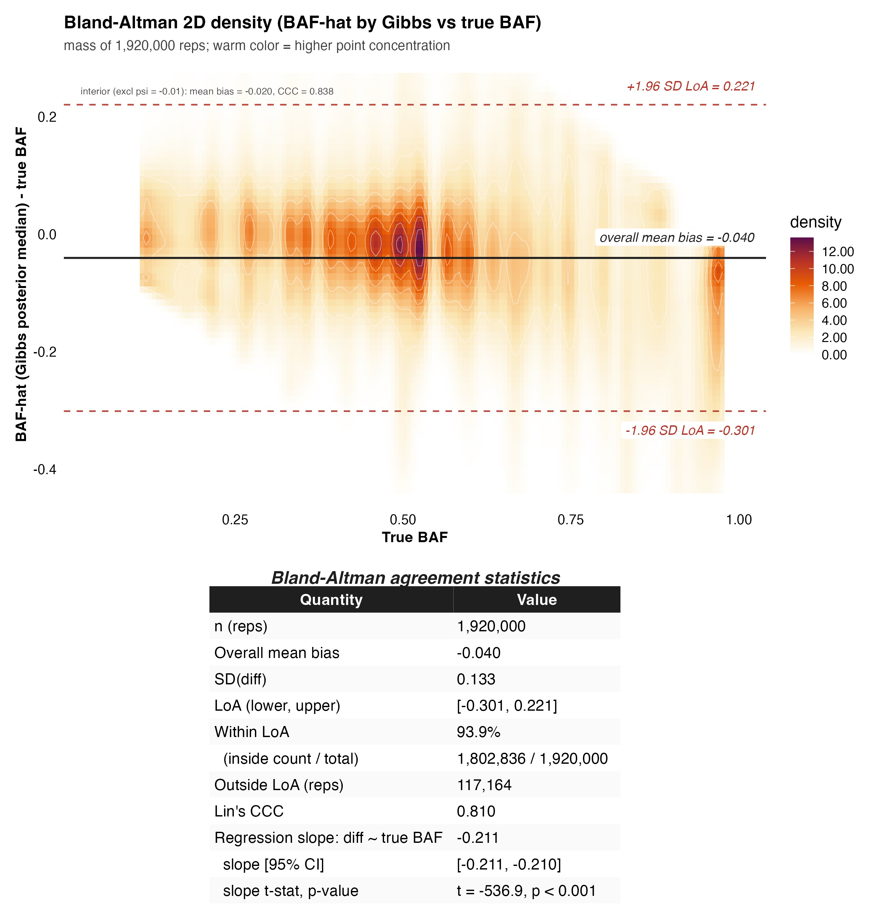
Figure 1. Bland-Altman agreement of the BAF estimator with the true BAF, Monte Carlo simulation across two grids, a primary grid and a sign-flipped companion (n = 1 920 000 repetitions across 1920 conditions); the empirical null fitted separately in each repetition was estimated by a conjugate Gibbs sampler. The x-axis is the true BAF of the simulated condition; the y-axis is the signed difference in each repetition BAF-hat minus BAF-true. The 2D density (warm ramp on white) summarizes all 1 920 000 repetitions. The solid horizontal line is the overall mean bias, the two dashed red lines are the 95% limits of agreement, and the inset table reports bias, SD, limits of agreement, Lin concordance correlation coefficient, and the proportional bias slope. The estimator systematically underestimates BAF-true.

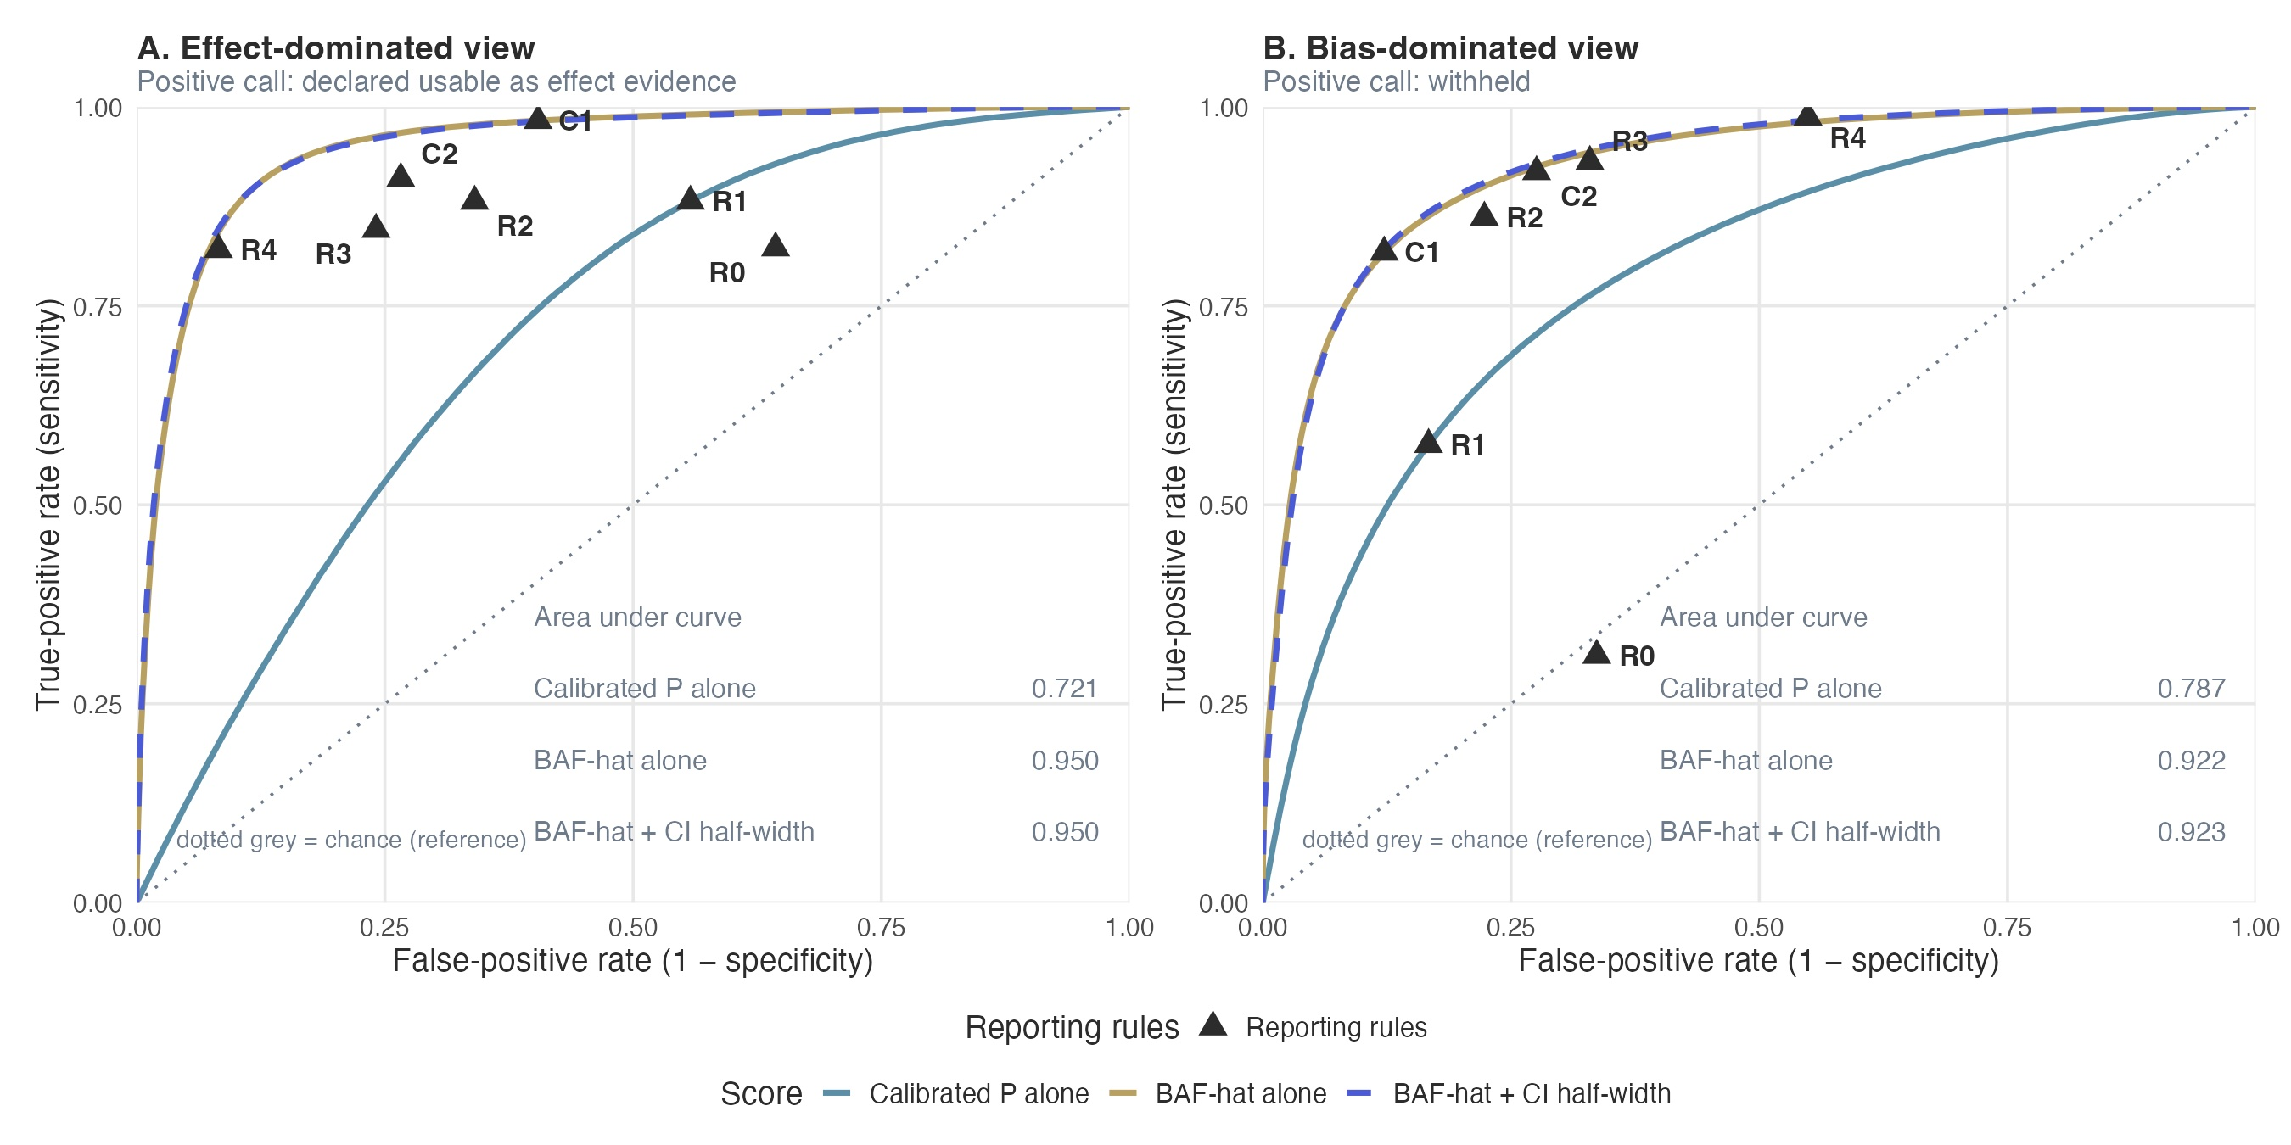
Figure 2. Receiver operating characteristic analysis for the reporting rules of Table 2, read from two viewpoints. Curves: the calibrated P value alone, BAF-hat alone, and BAF-hat plus its interval half-width; the in-panel tables report the area under each curve in that panel. Triangles: the operating points of R0 through R4 and C1, C2 of Table 2. Panel A. Effect-dominated view. Reference standard: truly effect-dominated. Positive call: declared usable as effect evidence. Panel B. Bias-dominated view. Reference standard: truly bias-dominated. Positive call: withheld. Truth has three levels (effect-dominated, mixed, bias-dominated, 18.8% / 28.7% / 52.5%), and the mixed zone falls outside the positive group of both views, which is why the views are not mirror images and why the same curve has a different area in each panel. Adding BAF-hat, not the interval width, carries the discriminatory information beyond the calibrated P value; the rules of Table 2 are read here as a stress test of the curves, every rule being one cut of the underlying score.

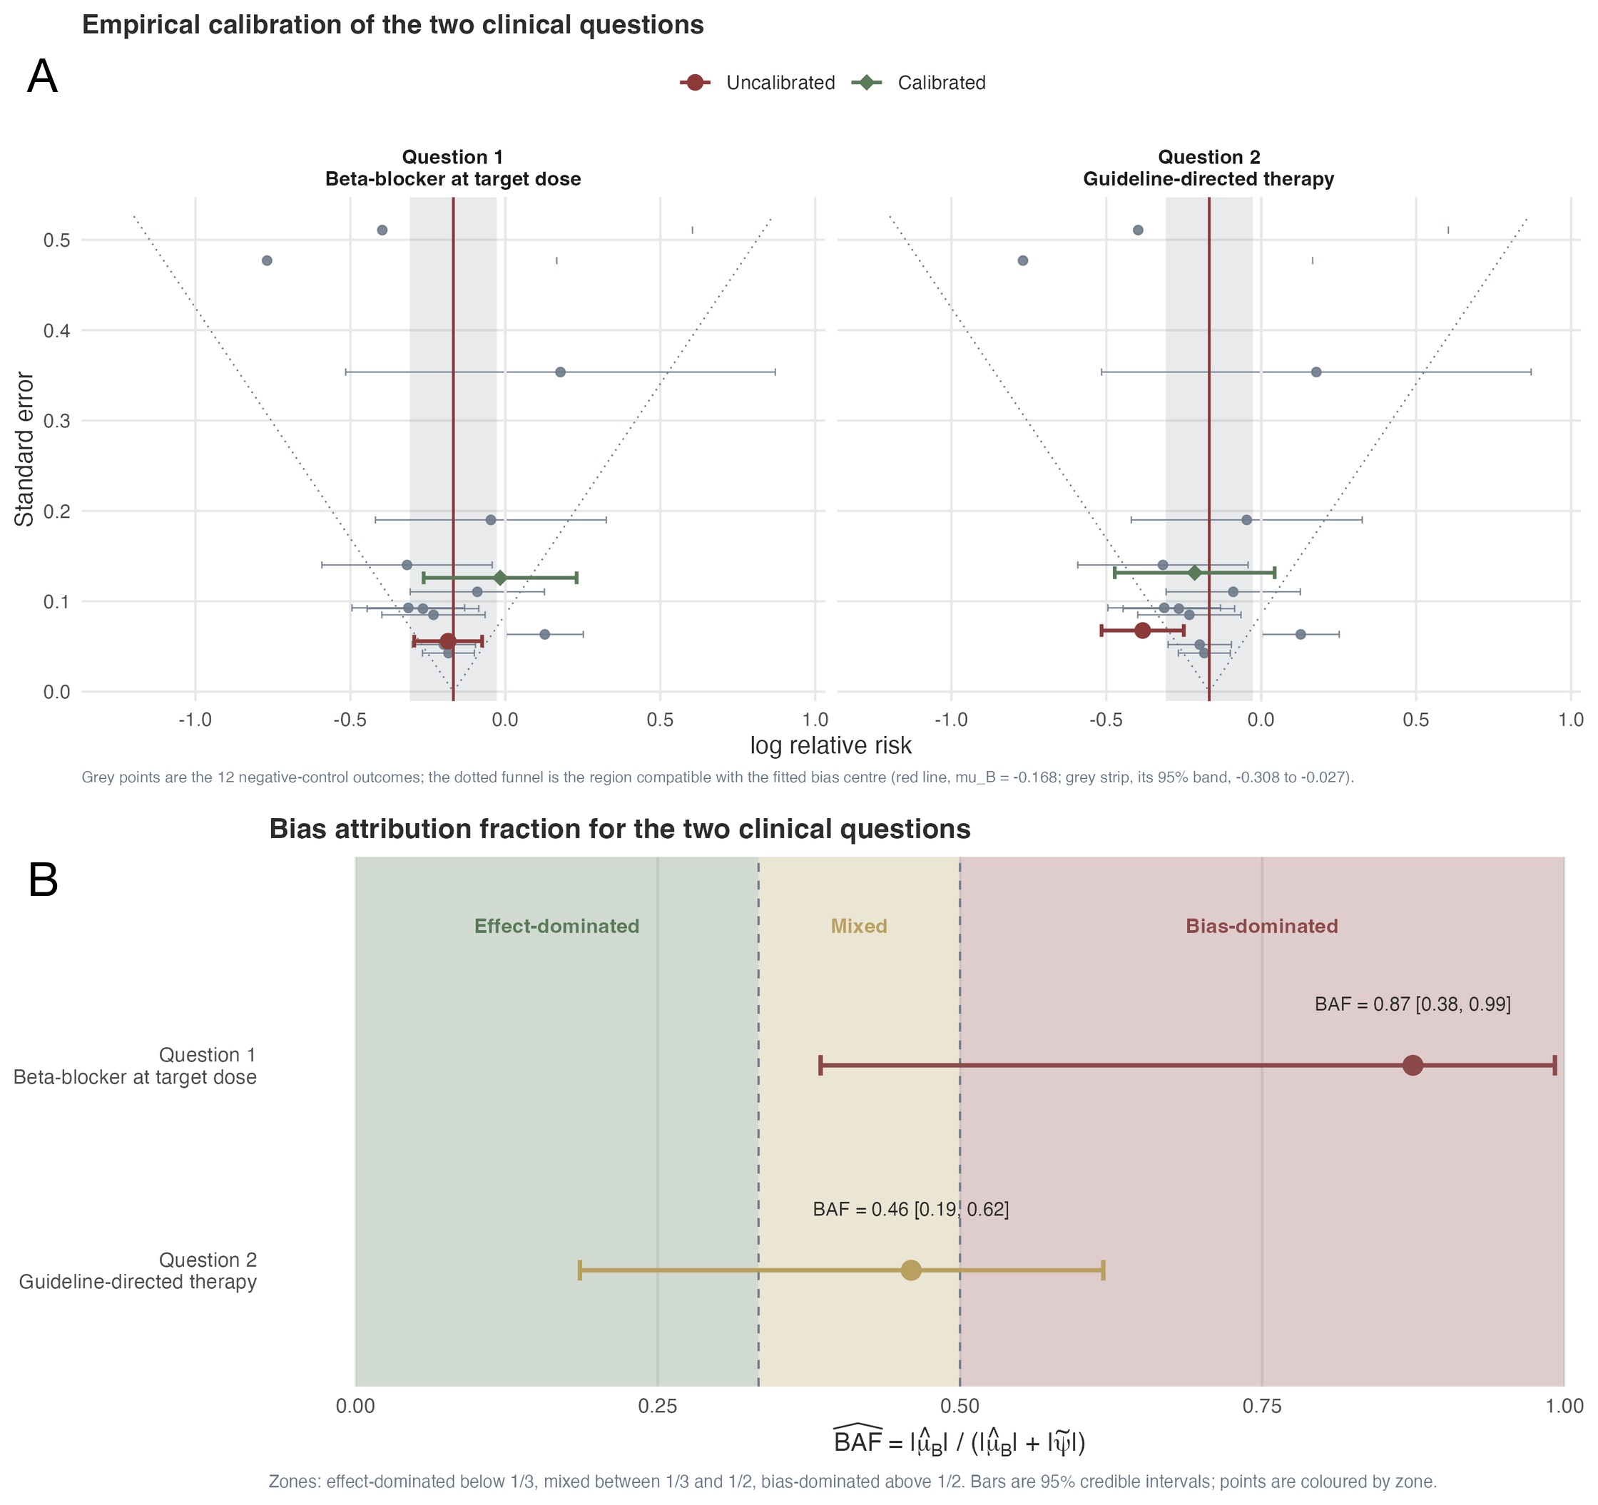
Figure 3. Empirical null distribution and bias fraction for the two clinical questions. A, Empirical null distribution estimated from the negative control outcomes (left, beta-blocker question; right, guideline-directed medical therapy question). The fitted center (gray vertical dashed line at -0.168, with its 95% confidence band shown as a shaded gray strip) marks the estimated mean systematic bias; the 12 negative controls appear as filled circles with horizontal 95% confidence intervals on their own track. The funnel-shaped red dashed curves mark the 95% prediction interval of the empirical null model at each standard error, the region within which a true null estimate is expected to fall. The red diamond is the uncalibrated target estimate and the green diamond the calibrated estimate. B, Bias fraction (BAF) for the two clinical questions (BB, beta-blocker; GDMT, guideline-directed medical therapy), read as a continuous estimator of residual bias. Shaded zones indicate the three classification regions (effect-dominated, mixed, bias-dominated). Points show BAF estimates with 95% credible intervals; dashed lines at BAF = 1/3 and BAF = 0.5 denote zone boundaries.

Article Information
Study Type. Original Investigation.
Author Contributions. Dr Zeng had full access to all of the data in the study and takes responsibility for the integrity of the data and the accuracy of the data analysis. Dr Zeng conceived the study, designed the credibility metric, implemented the analysis code and the bafratio R package, conducted the simulation study, and drafted the manuscript. Dr Wang contributed to the methodological design and reviewed the statistical approach. Dr Zuo contributed to the clinical interpretation of the negative control selection and reviewed the manuscript. Dr Shu contributed to the study design and critically revised the manuscript for important intellectual content. All authors read and approved the final manuscript. Dr Zeng is the author and maintainer of the bafratio R package used in this work.
Conflict of Interest Disclosures. All authors reported no conflict of interest disclosures.
Funding/Support. This research received no specific grant from any funding agency in the public, commercial, or not-for-profit sectors.
Role of the Funder/Sponsor. Not applicable.
Data Sharing Statement. The MIMIC-IV database (version 2.2) is available through PhysioNet (https://physionet.org/content/mimiciv/) and the MIMIC-IV-ECG extension (version 1.0.1) at https://physionet.org/content/mimic-iv-ecg/1.0.1/ to credentialed users. All analysis code, including the simulation pipeline, the case-study TMLE estimation pipeline, and the BAF computation proposed in this work, is available at https://github.com/zengzhechun/bias-fraction, together with an interactive graphical explainer of the metric, the simulation, and the two clinical questions. The methods proposed here are implemented in the companion bafratio R package (version 0.4.0; https://github.com/zengzhechun/bafratio), released under the MIT license, which provides the BAF estimator with bootstrap and Fieller intervals, the two-layer screening rule, the full set of reporting rules evaluated in Table 2, leave-one-out sensitivity analysis, and negative control diagnostics, together with a unit-test suite covering the estimator, the interval procedures, and the classification thresholds; the version used for this manuscript is archived at commit af47a0e. The EmpiricalCalibration R package (Schuemie et al.), which supplies the empirical null machinery used here but does not include BAF, is available from CRAN.
Additional Contributions. The authors thank the MIMIC-IV team for making the database publicly available and the OHDSI/EmpiricalCalibration R package developers for the empirical calibration tools upon which this work builds.
Artificial Intelligence Use Disclosure. Artificial intelligence tools were used to assist with code development, manuscript editing, and language polishing, each between July and September 2026: DeepSeek V4 Pro (DeepSeek AI), Kimi K3 (Moonshot AI), GLM 5.3 (Zhipu AI), ChatGPT 5.5 (OpenAI), and Tencent WorkBuddy (Tencent). All AI-assisted text and code were reviewed, tested, and revised by the authors, who take full responsibility for the integrity of the content of this manuscript. References were formatted with a standard citation processor rather than generated by AI.
Word Count. 2,996 words of text (excluding abstract, references, tables, and figure legends).

