KMID Deployment Document

Environment Pre-Requisites
- IIS
- .Net 8.0
- Domain SSL Certificate of Windows Server(if needed)
- KMID PACI Certificate

Install IIS
- search "Server Manager"
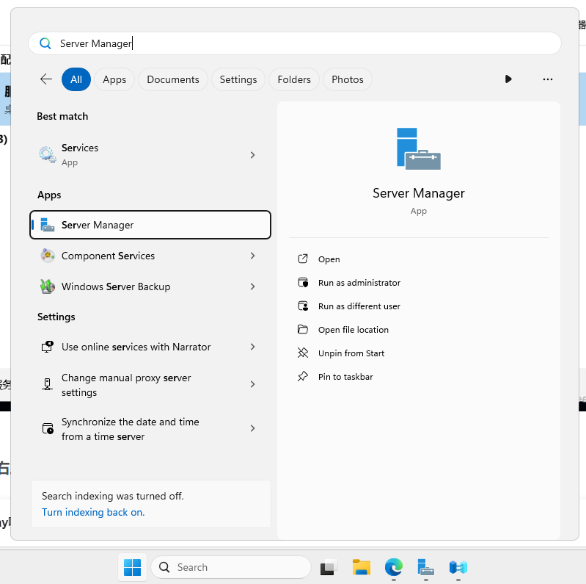

- click "Manage" -> "Add Roles and Features"
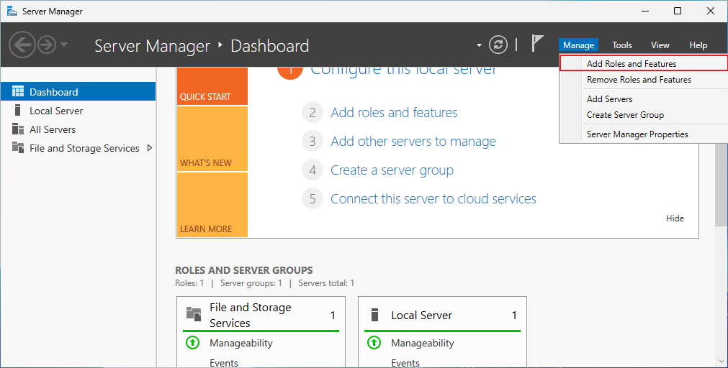

- Follow installing step like below
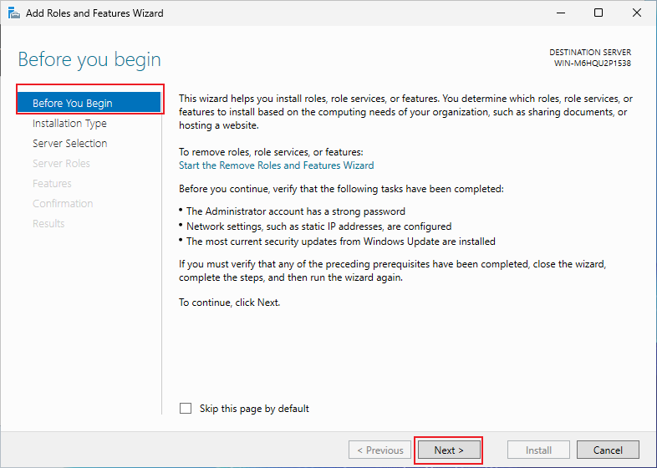

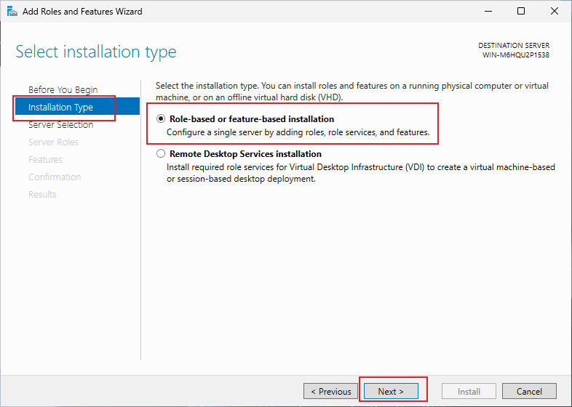

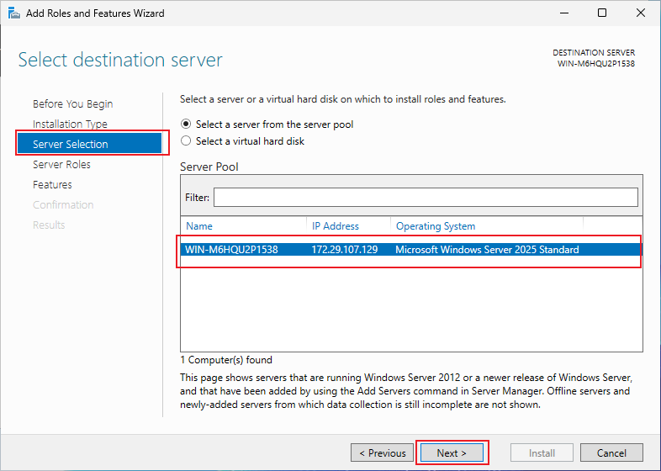

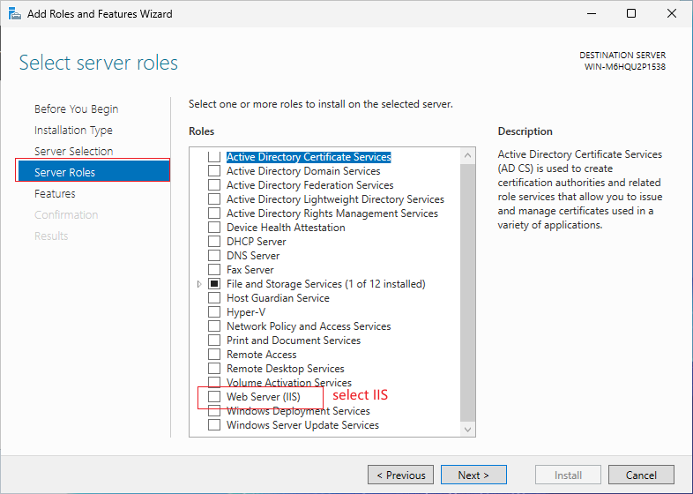

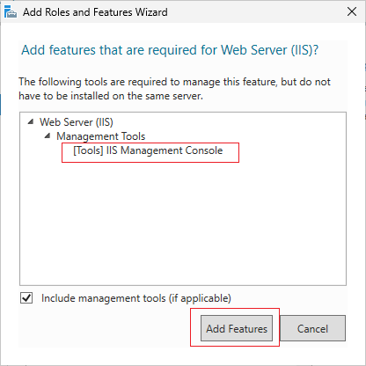

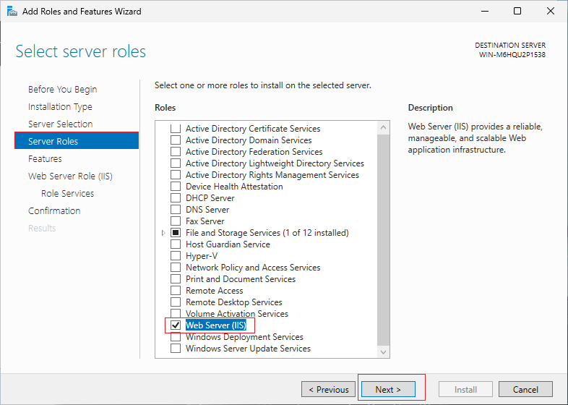

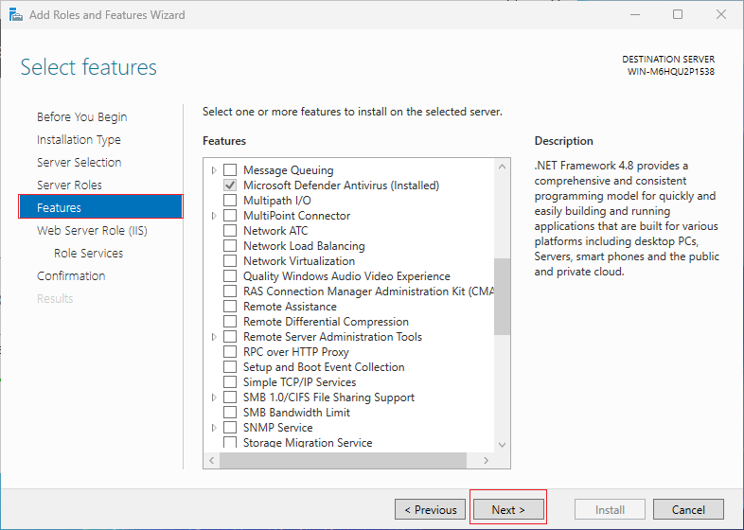

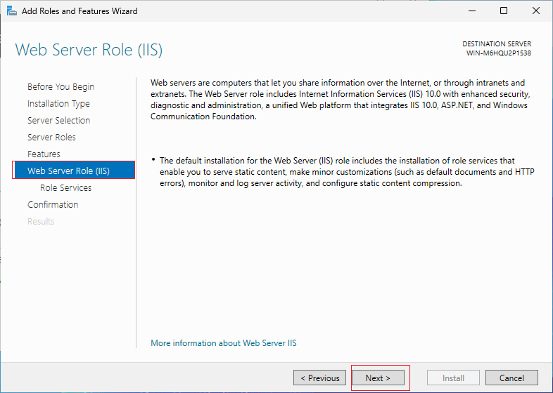

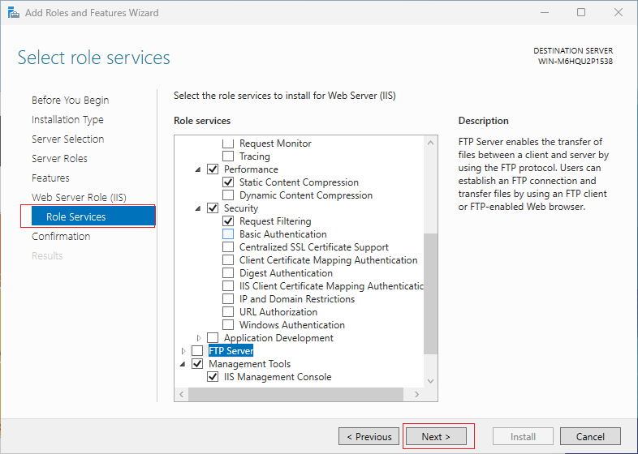

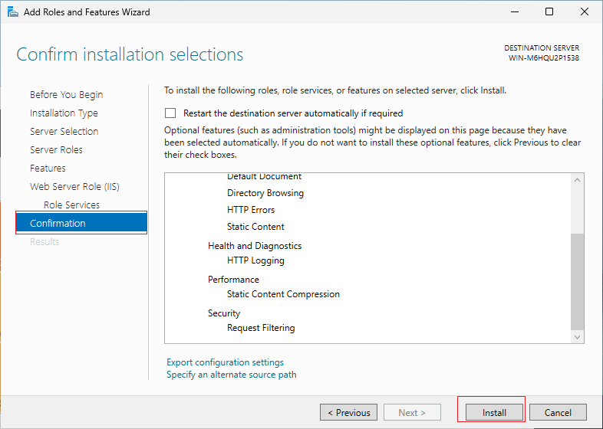
- Install Successfully
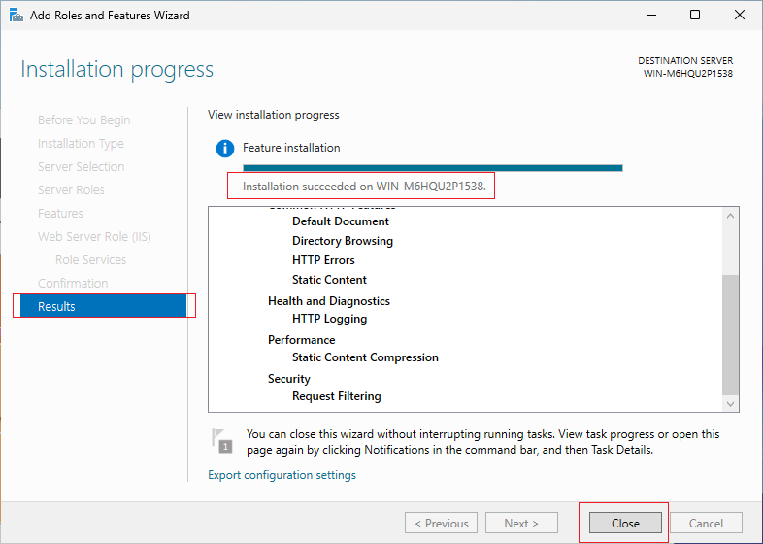

Install .Net 8.0
- Open Download .NET 8.0 (Linux, macOS, and Windows) | .NET
- Download .Net 8.0
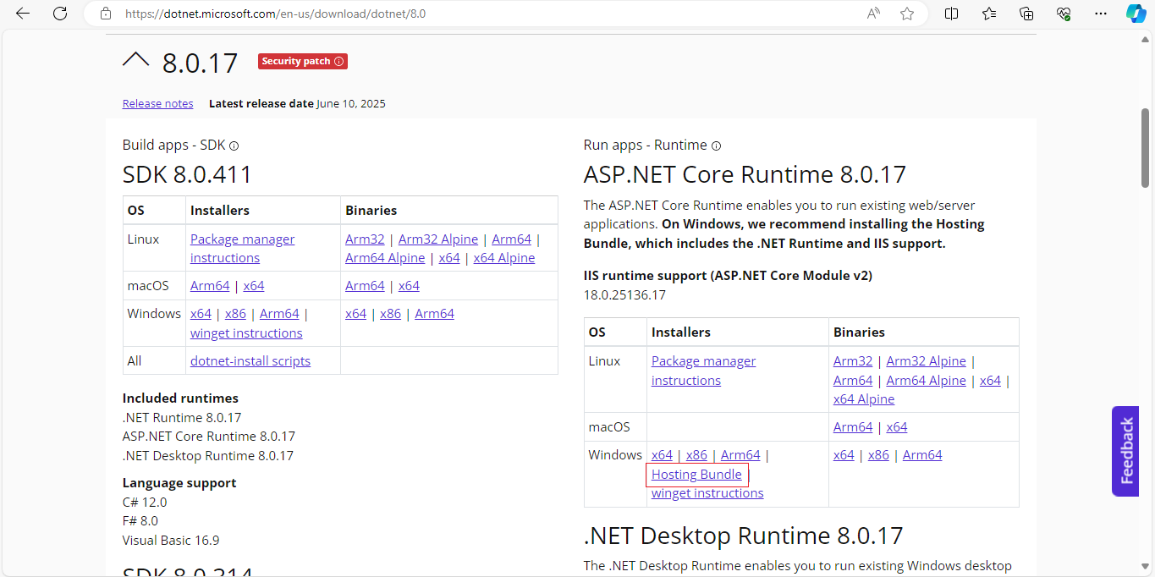

- Follow installing step like below
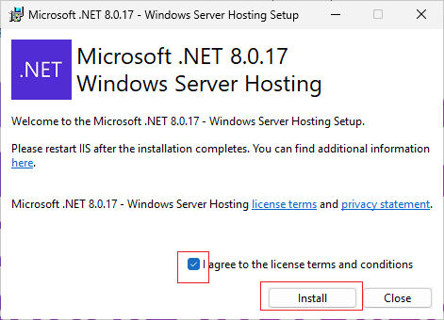

- Install Successfully
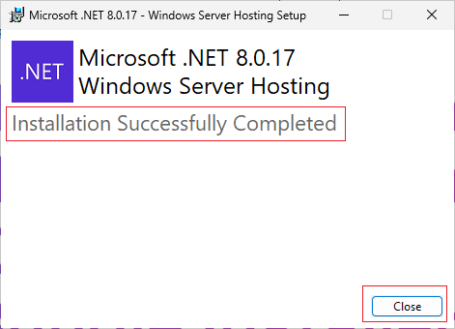

Install Domain SSL Certificate(if needed)

Install KMID PACI SSL Certificate
- Install Certificate to "Local Machine"(need provided by kmid first)
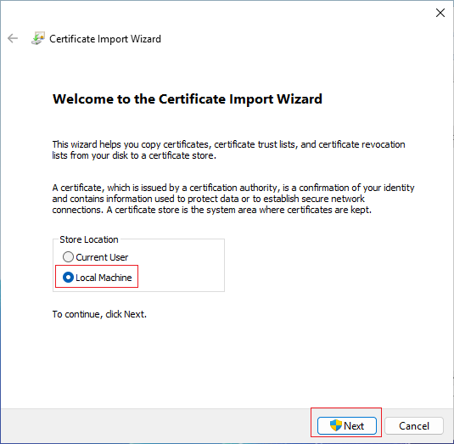

- Next step
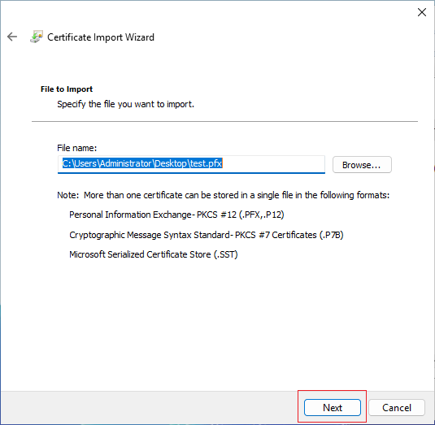

- Input password
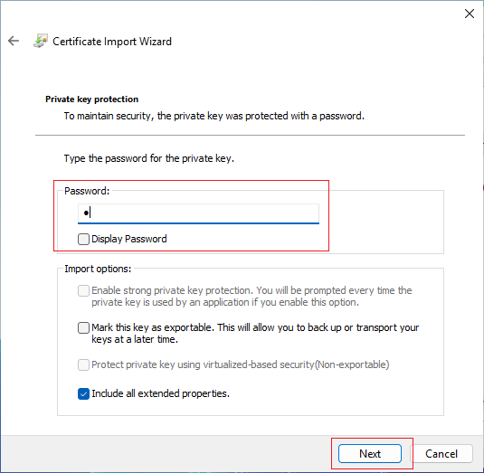

- Change certificate installation location
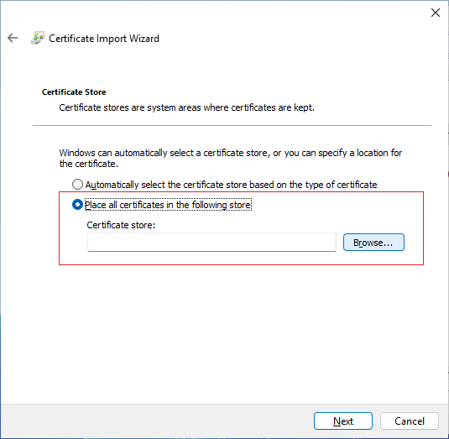

- Select "Personal"
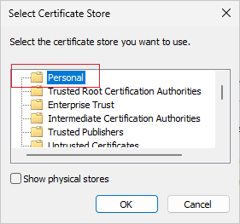

- Install successfully
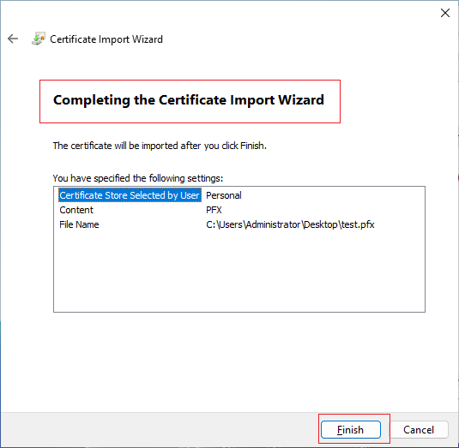

Deployment Flow
- Open IIS
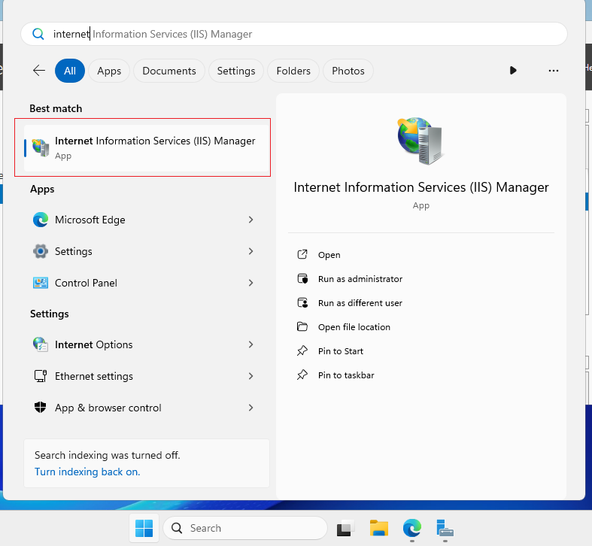

- Add website
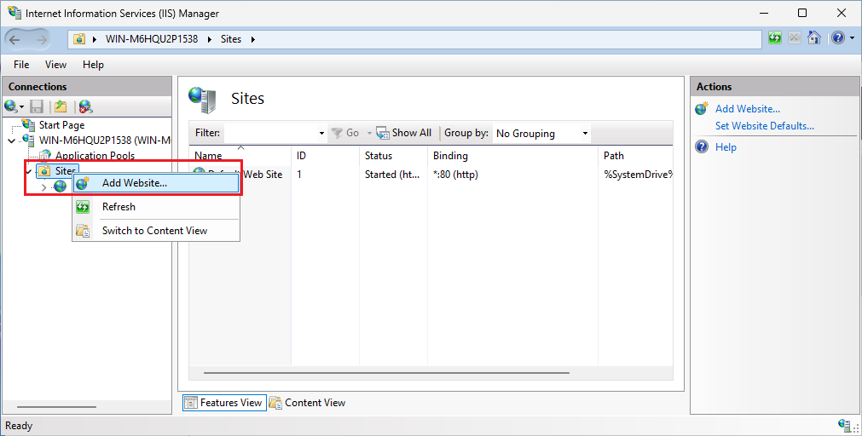

- Input website message
Site name: the name of website like MIDAuthWebService
Application pool: select or create a new application pool
Physical path: the deployment package path
Binding: if use https protol, that need to finished 1.3 Install Domain SSL Certificate first
Host name: the name of host like kwpreprodmobileid.tiqmopaymentkuwait.com
SSL certificate: installed by 1.3 Install Domain SSL Certificate
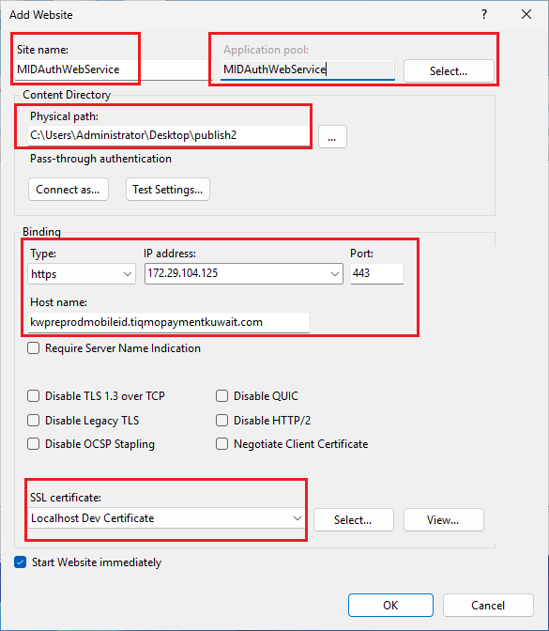

- Make sure the website is associated with an application pool that you want
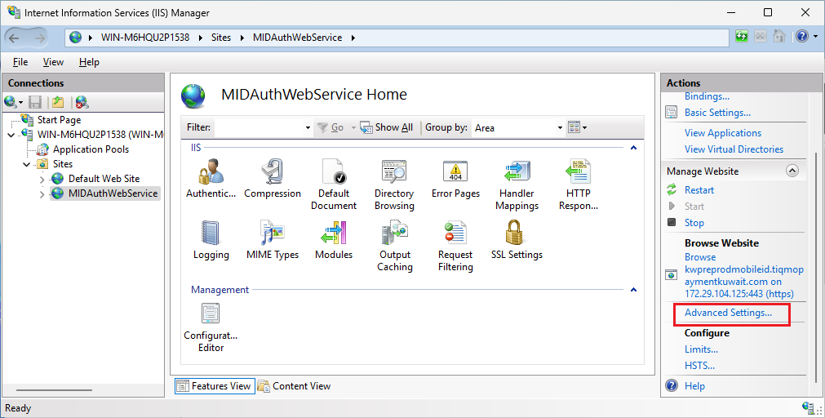

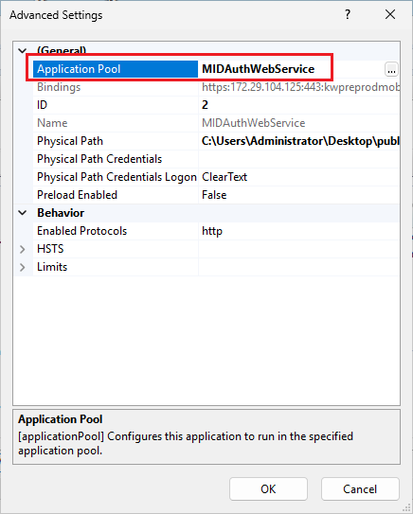

- Change the application pool ".Net CLR version" to "No Managed Code"
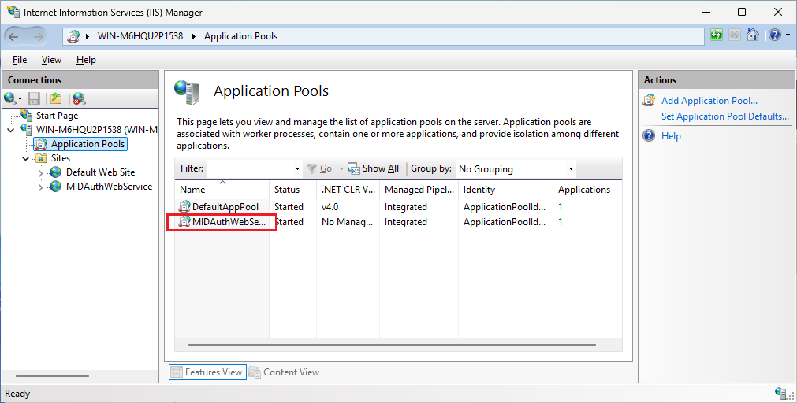

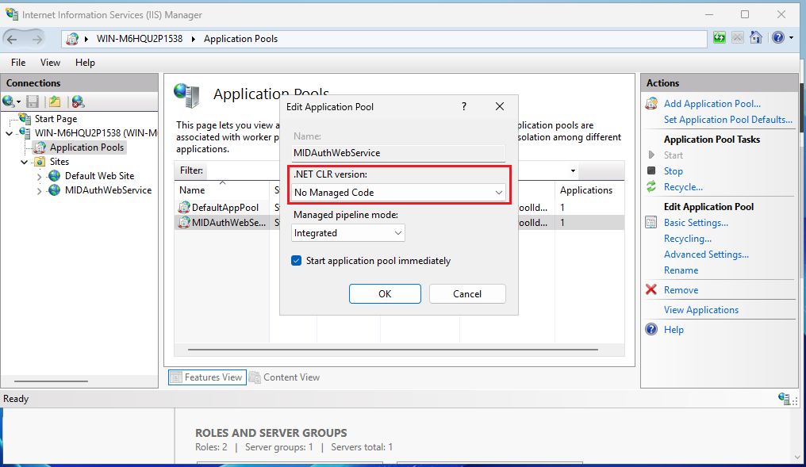

- Configure client SSL settings(if needed)
Default configuration is "ignore" which mean that client do not need to provide the ssl certificate.If server want to verify the client certificate, can check "Require SSL" option and then check "Require" option, after that client need to provide the ssl certificate with each api call.
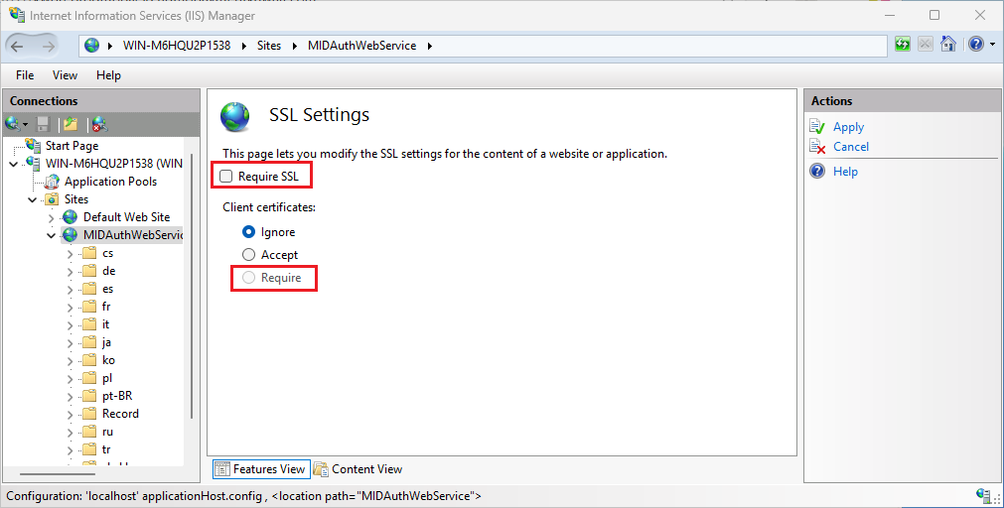

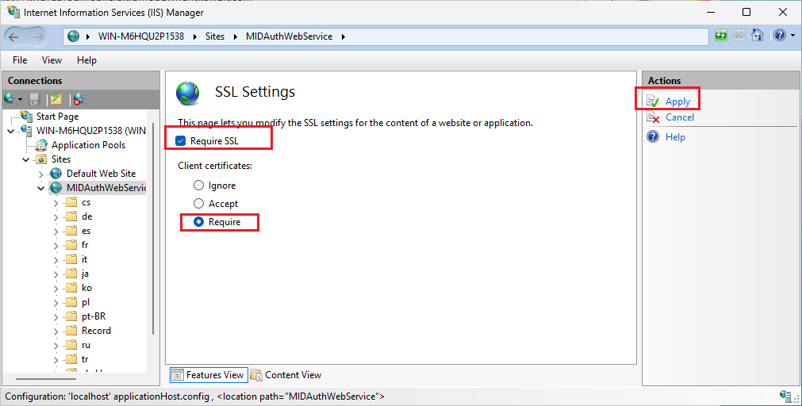

Authorize Flow
- Click "Browse Website"
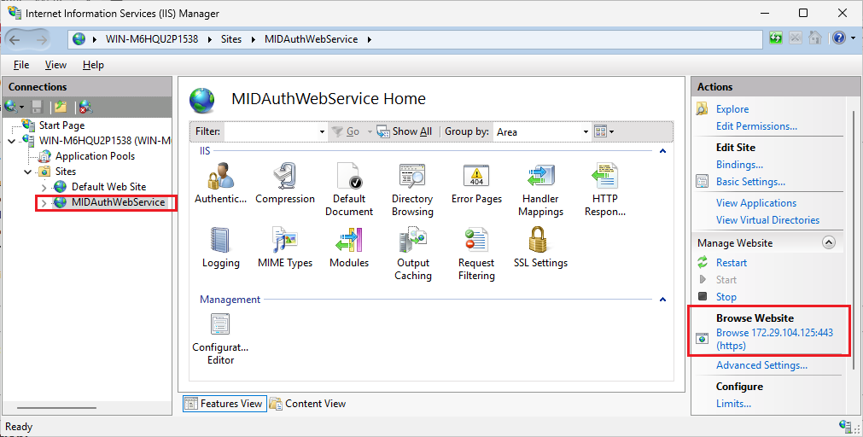

- HTTP Error 500.19 - Internal Server Error
it cases by website which does not have permission to read configuration
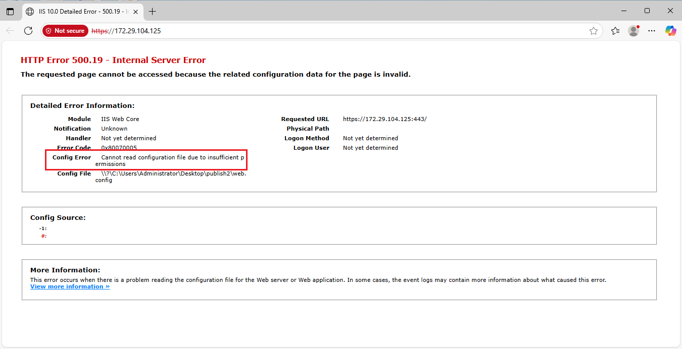

- Edit Permission
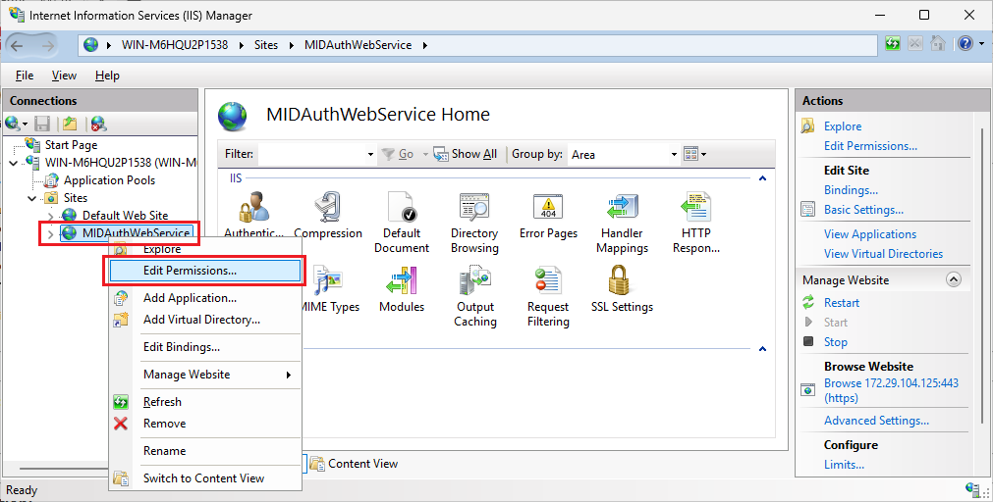

- "Security" -> "Edit"
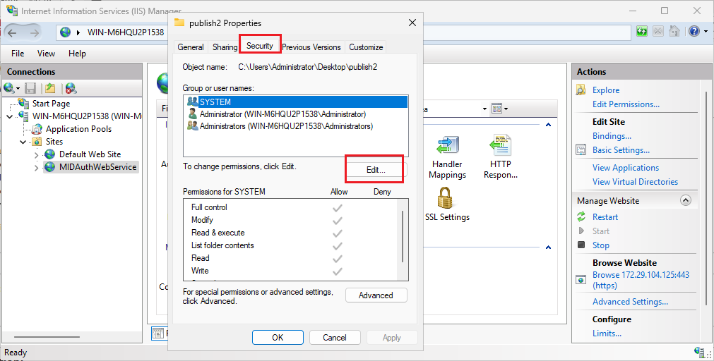

- "Add"
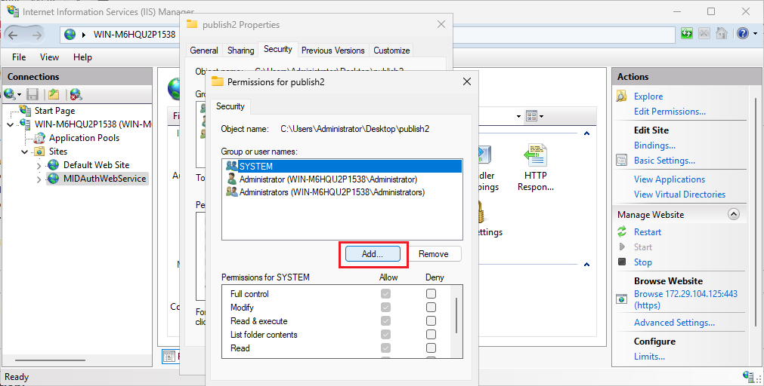

- "Advanced"
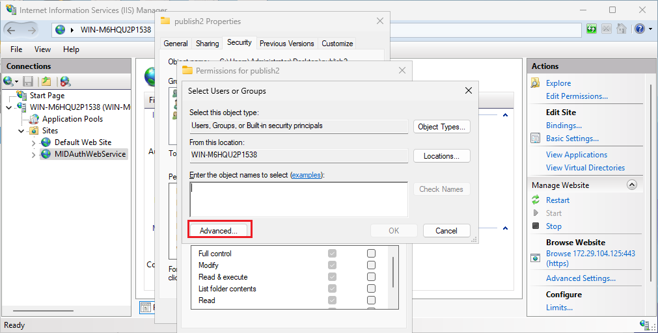

- "Find Now"
Select IIS_IUSRS group(created by IIS automatically), also you could select another or create a new group which satisfied with server running requirement.
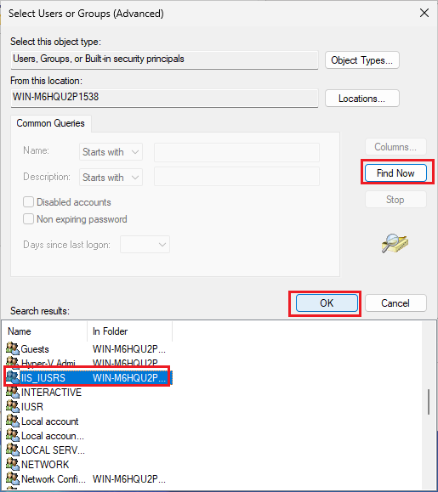

- Click "OK"
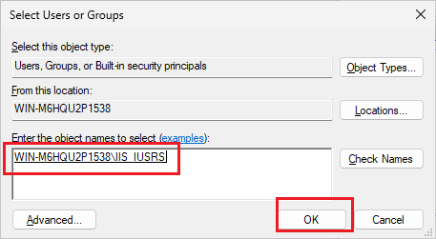

- Check "Modify" option
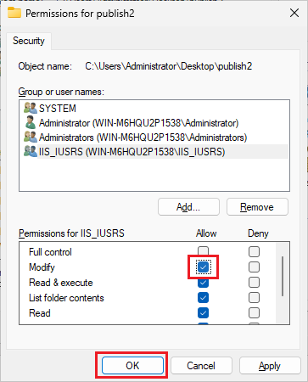

- Add Group Successfully
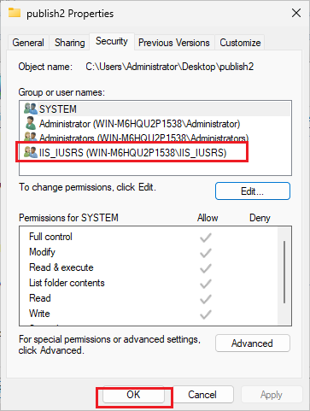

- Refresh Website
After above flow, refresh website could see the error page is disappeared. The 404 error page is normal dut to the server do not have any page.
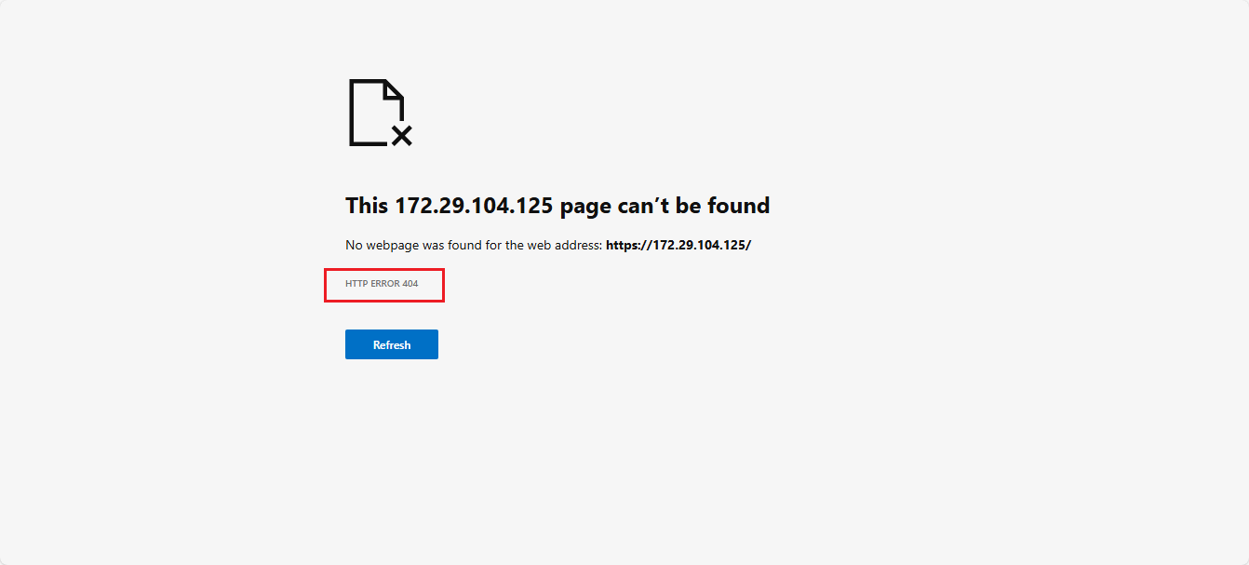

you could visit: website + /swagger/index.html, can view the swagger ui(will remove in production environment)
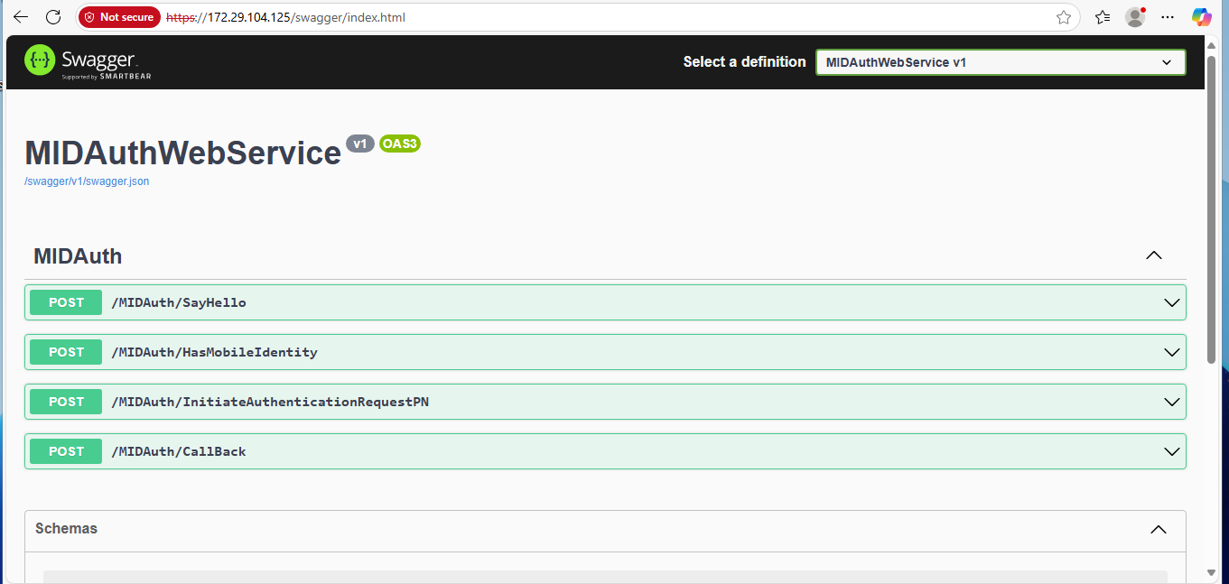

Environment Configuration
- Windows Firewall Policy
- ...

Checklist
- Domain Network Connectivity
- Domain Port Connectivity
- Service Availability

