**postgreSQL**

# Centos7安装postgreSql-10

参考博客：<https://blog.csdn.net/rudy5348/article/details/79299162>

<https://www.postgresql.org/download/linux/redhat/>

1,yum install <https://download.postgresql.org/pub/repos/yum/reporpms/EL-7-x86_64/pgdg-redhat-repo-latest.noarch.rpm>

2,yum install postgresql10

3,yum install postgresql10-server

4,/usr/pgsql-10/bin/postgresql-10-setup initdb

5,systemctl enable postgresql-10

6,systemctl start postgresql-10

# 登录

su - postgres

psql

如图表示成功：

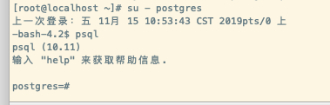

设置密码：ALTER USER postgres WITH PASSWORD '123456';

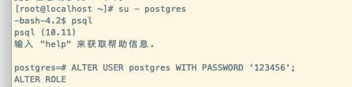

# 退出



# 设置远程访问

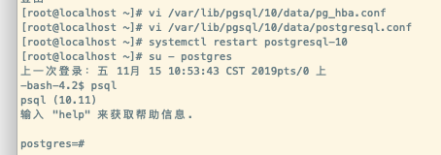

参考博客