**rocketmq**

# docker安装rocketmq

参考博客：<https://www.pianshen.com/article/79061070664/>

## 拉取镜像

docker pull rocketmqinc/rocketmq:4.4.0

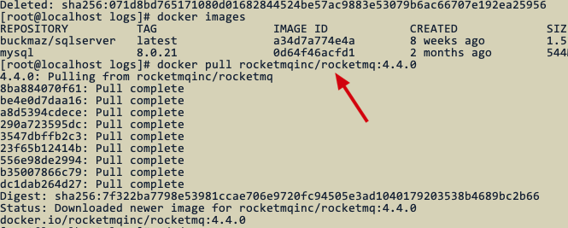

## 启动nameserver

|  |
| --- |
| docker run -d -p 9876:9876 -v {自己的路径}/data/namesrv/logs:/root/logs -v {RmHome}/data/namesrv/store:/root/store --name rmqnamesrv -e "MAX_POSSIBLE_HEAP=100000000" rocketmqinc/rocketmq:4.4.0 sh mqnamesrv |

自己的路径为： /root/mq

修改后的命令：

|  |
| --- |
| docker run -d -p 9876:9876 -v /root/mq/data/namesrv/logs:/root/logs -v /root/mq/data/namesrv/store:/root/store --name rmqnamesrv -e "MAX_POSSIBLE_HEAP=100000000" rocketmqinc/rocketmq:4.4.0 sh mqnamesrv |

运行后效果：

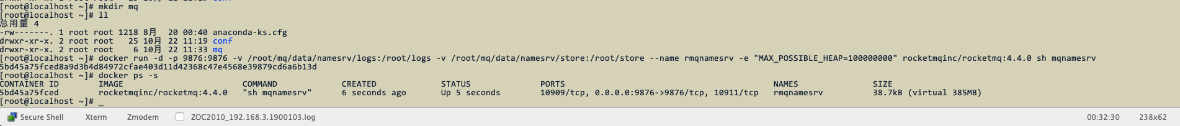

## 启动broker

编写broker.conf文件

|  |
| --- |
| brokerClusterName = DefaultCluster  brokerName = broker-a  brokerId = 0  deleteWhen = 04  fileReservedTime = 48  brokerRole = ASYNC_MASTER  flushDiskType = ASYNC_FLUSH  brokerIP1 = 192.168.3.190 |

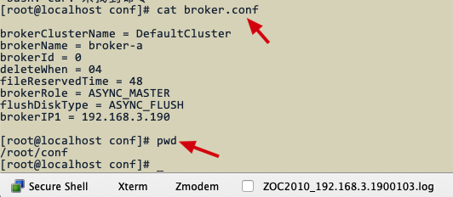

### 启动命令

|  |
| --- |
| docker run -d -p 10911:10911 -p 10909:10909 -v {自己的路径}/data/broker/logs:/root/logs -v {自己的路径}/rocketmq/data/broker/store:/root/store -v {自己的路径}/conf/broker.conf:/opt/rocketmq-4.4.0/conf/broker.conf --name rmqbroker --link rmqnamesrv:namesrv -e "NAMESRV_ADDR=namesrv:9876" -e "MAX_POSSIBLE_HEAP=200000000" rocketmqinc/rocketmq:4.4.0 sh mqbroker -c /opt/rocketmq-4.4.0/conf/broker.conf |

修改后的命令

|  |
| --- |
| docker run -d -p 10911:10911 -p 10909:10909 -v /root/mq/data/broker/logs:/root/logs -v /root/mq/rocketmq/data/broker/store:/root/store -v /root/conf/broker.conf:/opt/rocketmq-4.4.0/conf/broker.conf --name rmqbroker --link rmqnamesrv:namesrv -e "NAMESRV_ADDR=namesrv:9876" -e "MAX_POSSIBLE_HEAP=200000000" rocketmqinc/rocketmq:4.4.0 sh mqbroker -c /opt/rocketmq-4.4.0/conf/broker.conf |

运行后的效果：



## 控制台安装

### 拉取镜像

docker pull styletang/rocketmq-console-ng

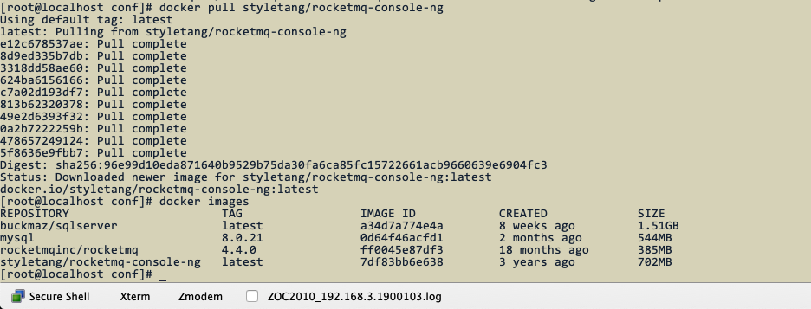

### 启动控制台

|  |
| --- |
| docker run -e "JAVA_OPTS=-Drocketmq.namesrv.addr=服务器公网ip:9876 -Dcom.rocketmq.sendMessageWithVIPChannel=false" -p 8080:8080 -t styletang/rocketmq-console-ng |

修改后命令：

|  |
| --- |
| docker run -e "JAVA_OPTS=-Drocketmq.namesrv.addr=192.168.3.190:9876 -Dcom.rocketmq.sendMessageWithVIPChannel=false" -p 8080:8080 -t styletang/rocketmq-console-ng |

运行后效果：

