**Shiro**

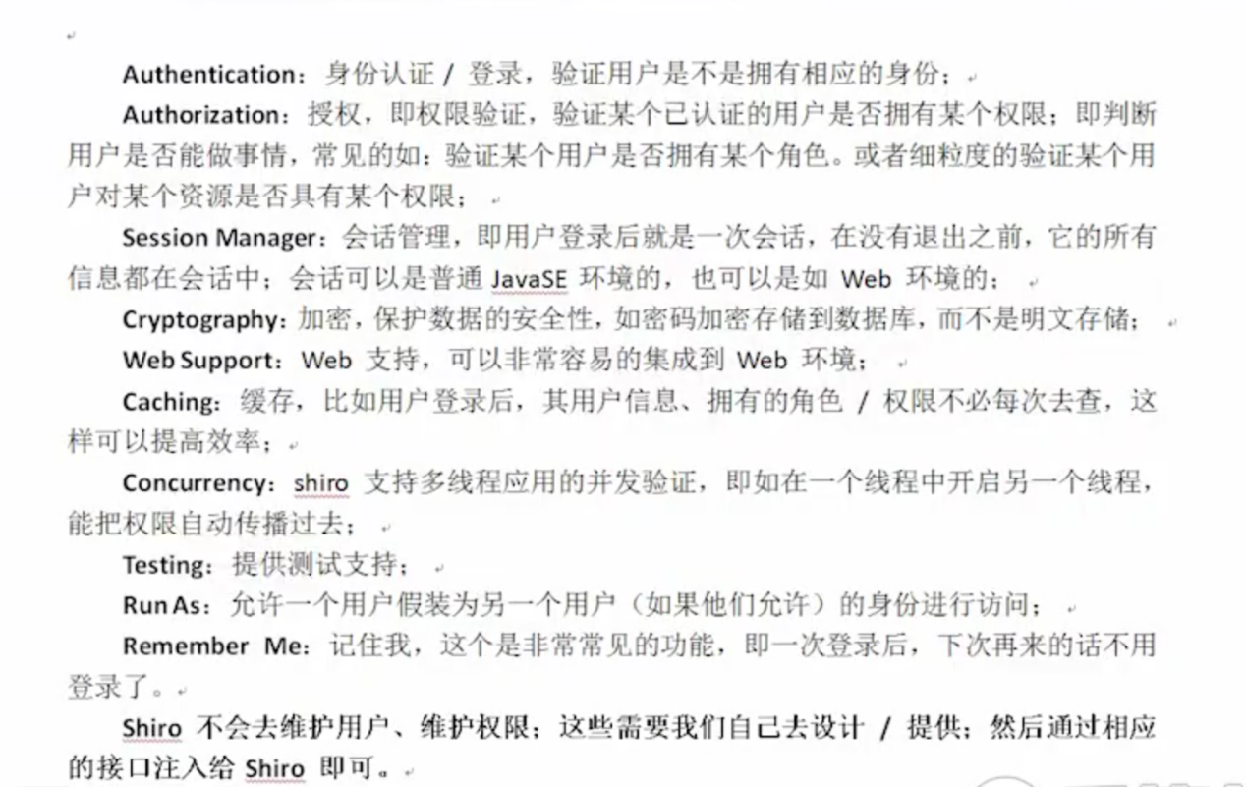

# 概念：subject、securityManager、Realm

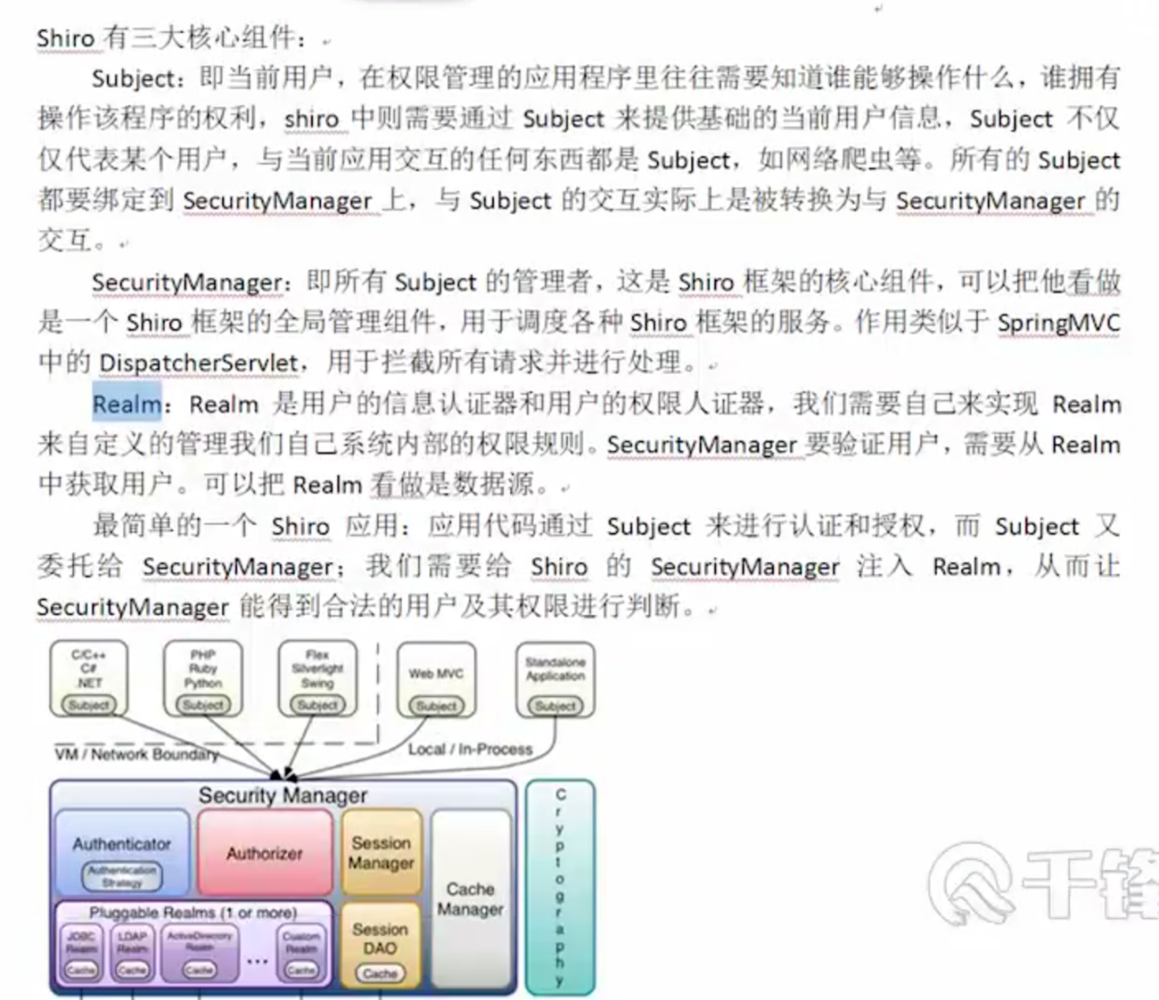

# 编码

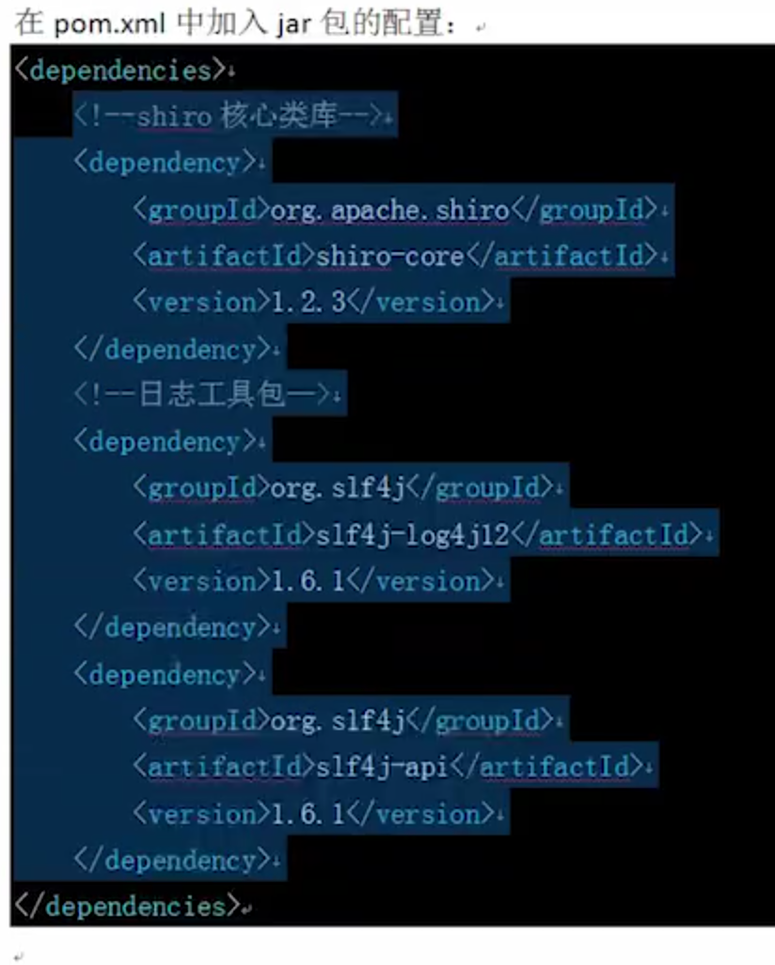

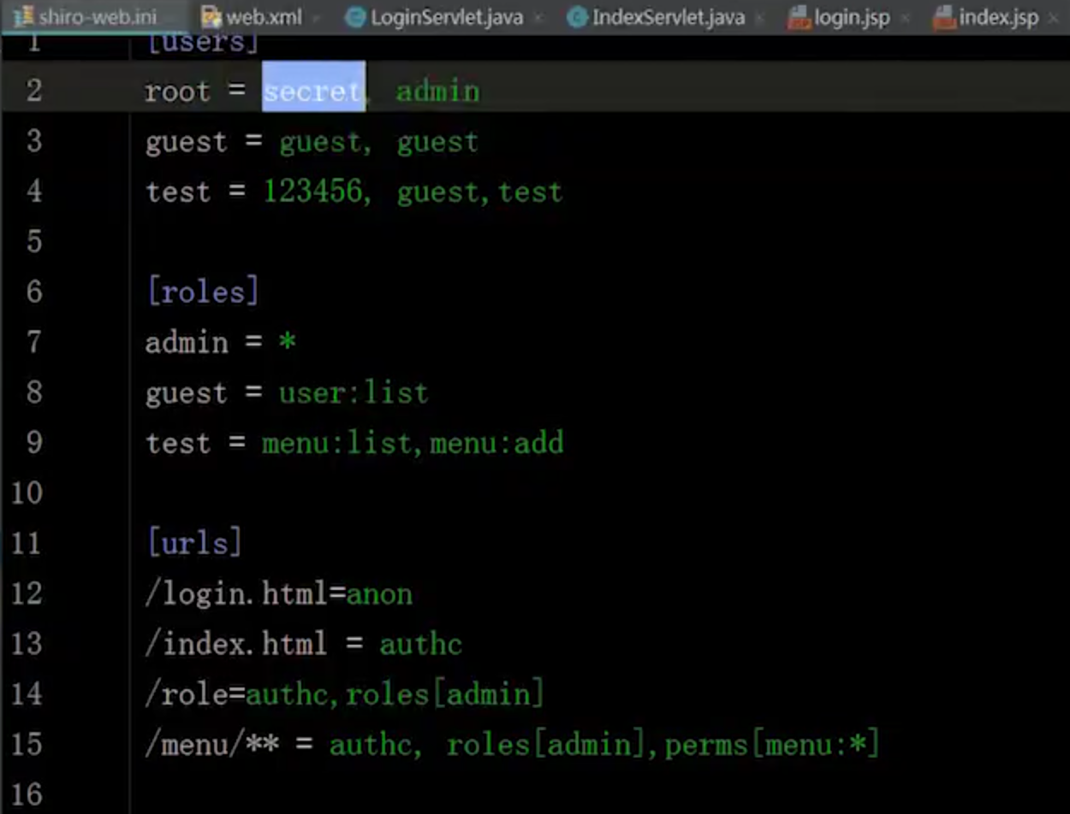

一些权限标签

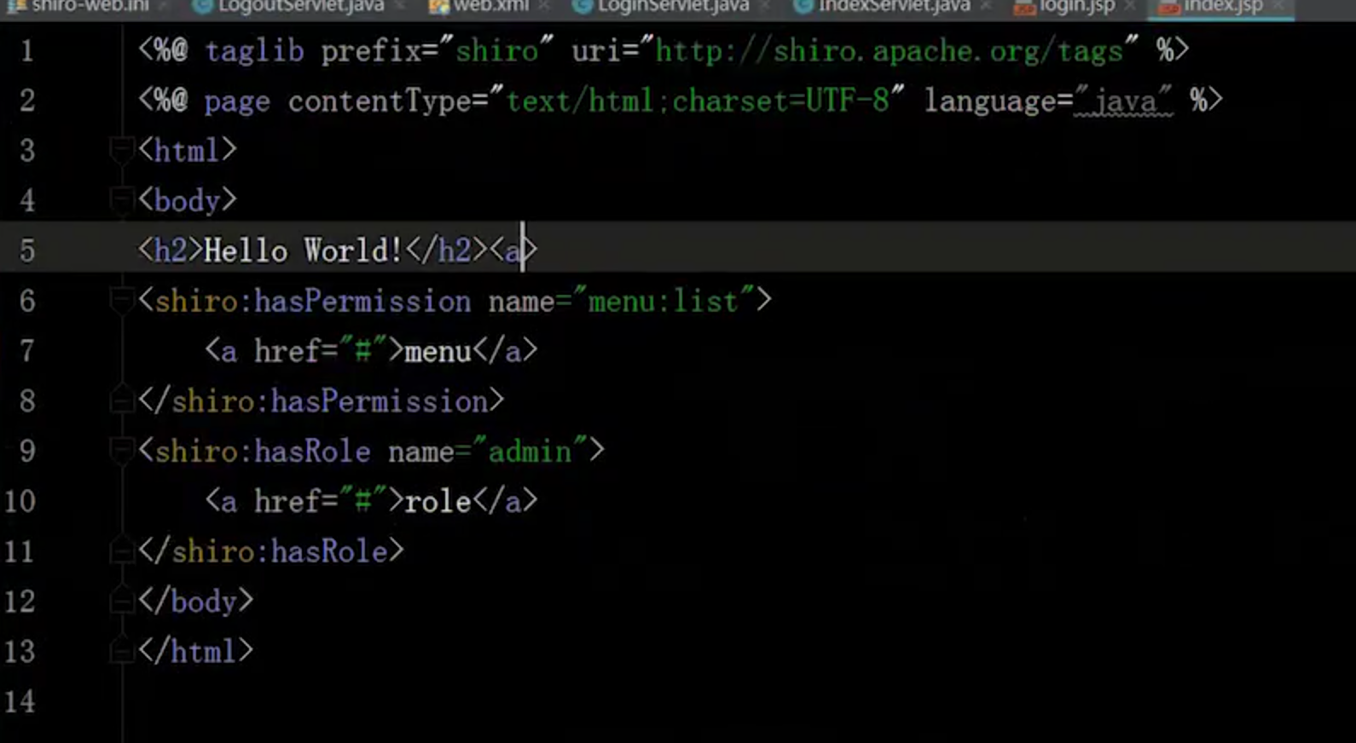

# ssm整合shiro

|  |
| --- |
| *<!-- https://mvnrepository.com/artifact/org.apache.shiro/shiro-core -->* <**dependency**>  <**groupId**>org.apache.shiro</**groupId**>  <**artifactId**>shiro-core</**artifactId**>  <**version**>1.4.1</**version**> </**dependency**> *<!-- https://mvnrepository.com/artifact/org.apache.shiro/shiro-web -->* <**dependency**>  <**groupId**>org.apache.shiro</**groupId**>  <**artifactId**>shiro-web</**artifactId**>  <**version**>1.4.1</**version**> </**dependency**> *<!-- https://mvnrepository.com/artifact/org.apache.shiro/shiro-spring -->* <**dependency**>  <**groupId**>org.apache.shiro</**groupId**>  <**artifactId**>shiro-spring</**artifactId**>  <**version**>1.4.1</**version**> </**dependency**> |