ws安装各个软件

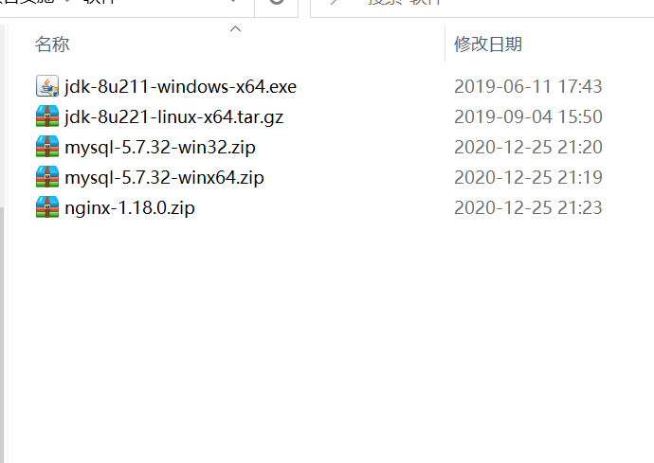

jdk:

参考博客：

<https://www.cnblogs.com/heqiyoujing/p/9502726.html>

<https://blog.csdn.net/qq_28189423/article/details/82378037>

MySQL

MySQL安装

以管理员身份运行cmd进行安装

<https://blog.csdn.net/weixin_40026797/article/details/84204207>

<https://www.cnblogs.com/zhangkanghui/p/9613844.html>

MySQL添加用户

<https://blog.csdn.net/gnd15732625435/article/details/80285296>

桌面化

<https://blog.csdn.net/weixin_40449300/article/details/84729652>

Redis：

<https://www.cnblogs.com/hunanzp/p/12304622.html>

Nginx

<https://blog.csdn.net/bitree1/article/details/100559530>

<https://blog.csdn.net/bitree1/article/details/100559530>

jar打包教程

<https://blog.csdn.net/weixin_40326608/article/details/100123178>

<https://www.jianshu.com/p/af90db4b54e3>