**拦截器**

# 使用

|  |
| --- |
| **package** com.zengqiang.utils.interceptor;  **import** org.apache.log4j.Logger; **import** org.springframework.web.servlet.HandlerInterceptor; **import** org.springframework.web.servlet.ModelAndView;  **import** javax.servlet.http.HttpServletRequest; **import** javax.servlet.http.HttpServletResponse;  */**  \** ***@Author:*** *iszengziqiang@163.com  \** ***@Date:*** *2019/1/5 10:32  \** ***@Version:*** *1.0  \** ***@Desc: TODO*** *\*\*/* **public class** ApiInterceptor **implements** HandlerInterceptor {   Logger **logger** = Logger.*getLogger*(ApiInterceptor.**class**);    */**  * 返回值：表示我们是否需要将当前的请求拦截下来  * 返回false:请求将被终止（controller里的方法不会执行，postHandle和afterCompletion不会执行）  * 返回true:请求会被继续运行  *  \** ***@param httpServletRequest*** *\** ***@param httpServletResponse*** *\** ***@param o*** *\** ***@return*** *\** ***@throws*** *Exception  */* @Override  **public boolean** preHandle(HttpServletRequest httpServletRequest, HttpServletResponse httpServletResponse, Object o) **throws** Exception {  **logger**.info(**"ApiInterceptor:----preHandle"**);  System.***out***.println(**"ApiInterceptor:----preHandle"**);  System.***out***.println(**"ApiInterceptor:----preHandle：----"** + o);  **return true**;  }   */**  * 可以在此方法中进行数据修改，拦截并视图修改等操作  *  \** ***@param httpServletRequest*** *\** ***@param httpServletResponse*** *\** ***@param o*** *\** ***@param modelAndView*** *\** ***@throws*** *Exception  */* @Override  **public void** postHandle(HttpServletRequest httpServletRequest, HttpServletResponse httpServletResponse, Object o, ModelAndView modelAndView) **throws** Exception {  **logger**.info(**"ApiInterceptor:----postHandle"**);  System.***out***.println(**"ApiInterceptor:----postHandle"**);  System.***out***.println(**"ApiInterceptor:----postHandle:----"** + o + **"===="** + modelAndView);   }   */**  * 处理资源销毁操作  *  \** ***@param httpServletRequest*** *\** ***@param httpServletResponse*** *\** ***@param o*** *\** ***@param e*** *\** ***@throws*** *Exception  */* @Override  **public void** afterCompletion(HttpServletRequest httpServletRequest, HttpServletResponse httpServletResponse, Object o, Exception e) **throws** Exception {  **logger**.info(**"ApiInterceptor:----afterCompletion"**);  System.***out***.println(**"ApiInterceptor:----afterCompletion"**);  System.***out***.println(**"ApiInterceptor:----afterCompletion:----"** + o);  } } |

# 配置

|  |
| --- |
| *<!--注册拦截器-->* <**mvc:interceptors**>  <**bean class="com.zengqiang.utils.interceptor.ApiInterceptor"**></**bean**> </**mvc:interceptors**> |

# 原理

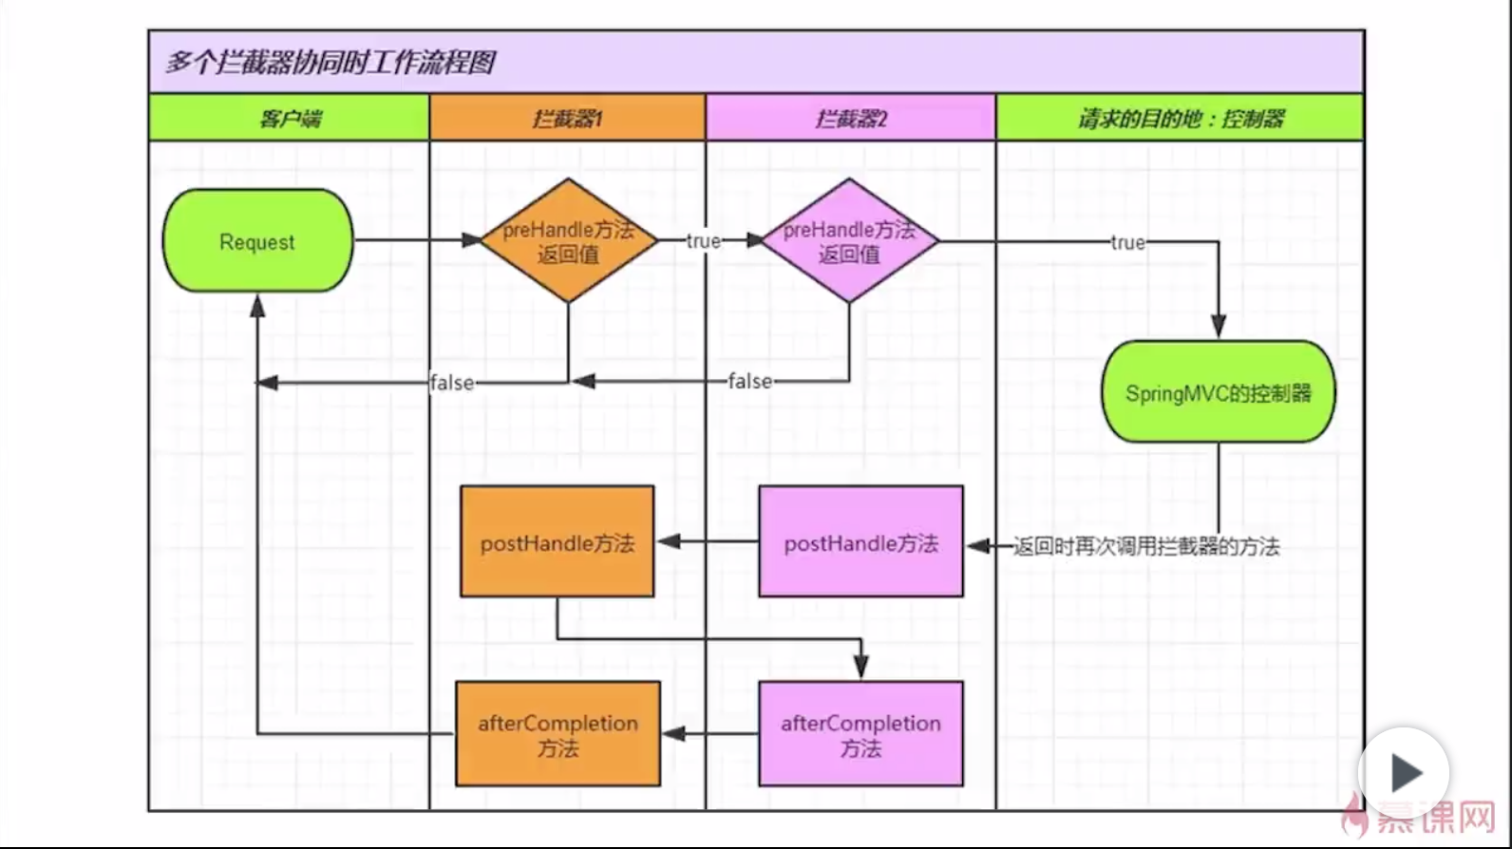

# 拦截器的其他实现方式【用的少】

