参考博客：<https://www.cnblogs.com/charlottepl/p/12661542.html>

<https://developer.aliyun.com/article/665693>

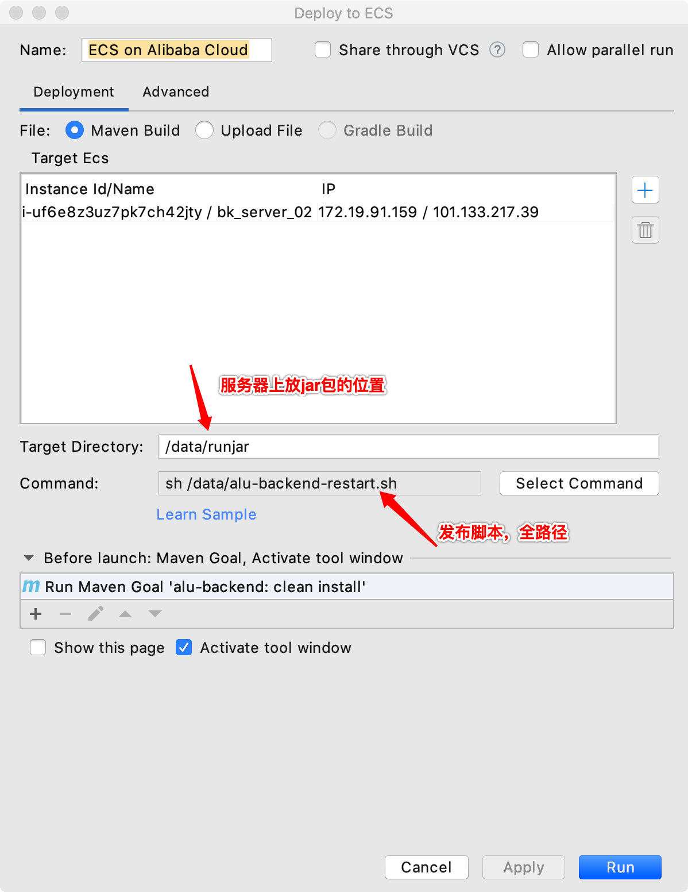

目录结构如下：

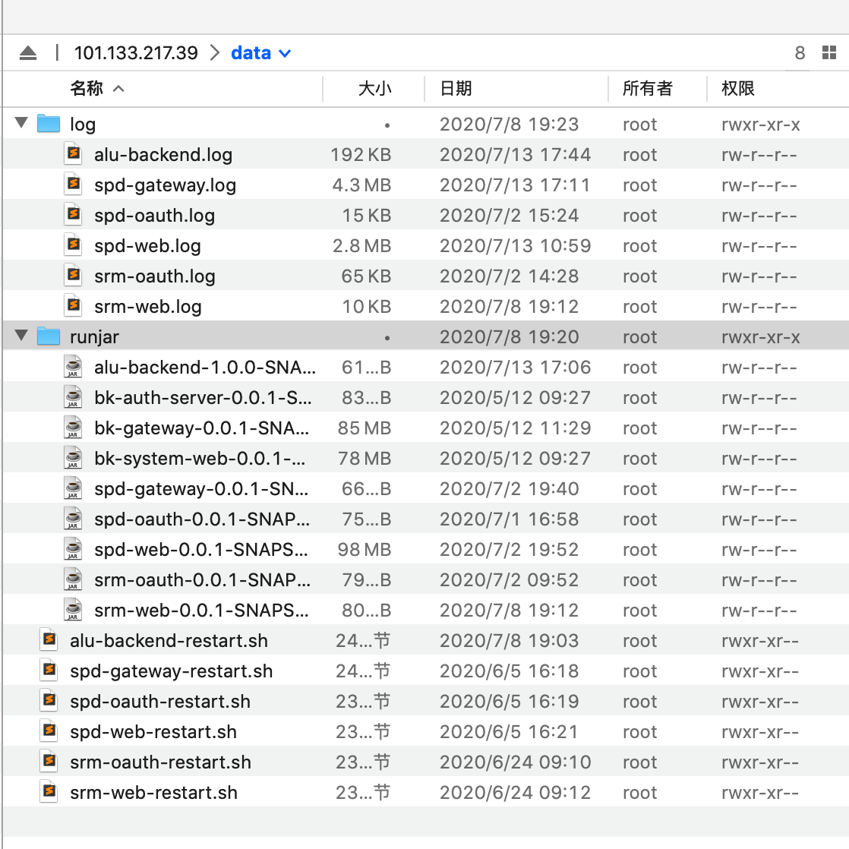

发布脚本：

|  |
| --- |
| source /etc/profile  netstat -anp|grep 8899|awk '{printf $7}'|cut -d/ -f1 |xargs kill -9 || true  nohup java -jar /data/runjar/alu-backend-1.0.0-SNAPSHOT.jar --spring.profiles.active=dev --server.port=8899 > /data/log/alu-backend.log 2>&1 & |

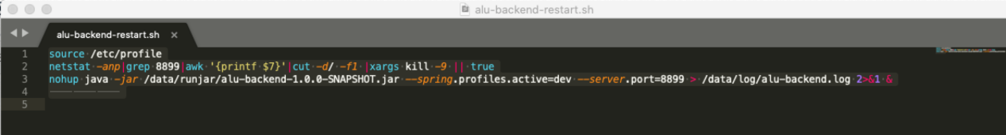

配置查看日志：

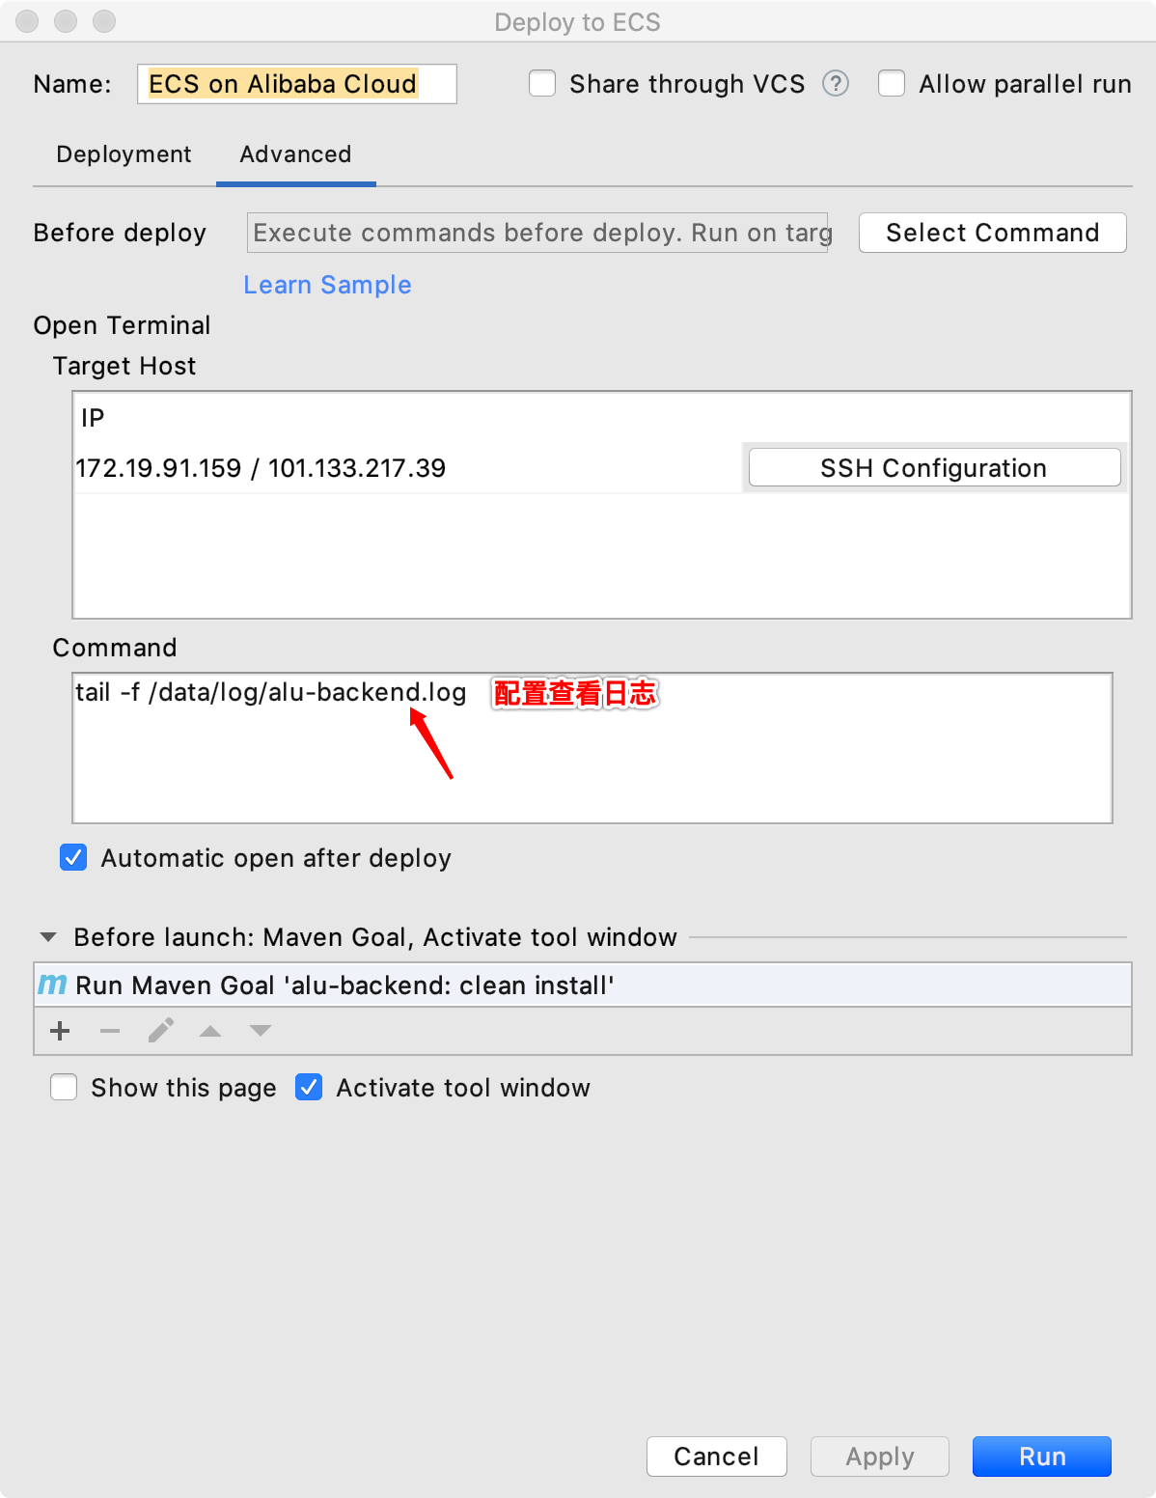

统一脚本，通过传参数发布

|  |
| --- |
| #!/bin/sh  export LC_ALL=zh_CN.UTF-8  SPB_OPTS="--spring.profiles.active=dev"  HEAP_OPTS="-Xmx1536m -Xms1536m -XX:NewSize=384m"  JAVA_OPTS="-server -XX:+PrintGCDetails -XX:+HeapDumpOnOutOfMemoryError -XX:HeapDumpPath=/data/log/gc.hprof $HEAP_OPTS"  case "$1" in  spd-stock)  ps aux | grep "spd-stock-0.0.1-SNAPSHOT.jar" |grep -v grep| cut -c 9-15 >/data/runjar/spd-stock.pid  kill -9 `cat /data/runjar/spd-stock.pid`  sleep 2  exec "nohup" java -jar /data/runjar/spd-stock-0.0.1-SNAPSHOT.jar $JAVA_OPTS --server.port=9007 >/data/log/spd-stock.log 2>&1 &  echo $1" starting..."  ;;  spd-gateway)  ps aux | grep "spd-gateway-0.0.1-SNAPSHOT.jar" |grep -v grep| cut -c 9-15 >/data/runjar/spd-gateway.pid  kill -9 `cat /data/runjar/spd-gateway.pid`  sleep 2  exec "nohup" java -jar /data/runjar/spd-gateway-0.0.1-SNAPSHOT.jar $JAVA_OPTS --server.port=9001 >/data/log/spd-gateway.log 2>&1 &  echo $1" starting..."  ;;  spd-oauth)  ps aux | grep "spd-oauth-0.0.1-SNAPSHOT.jar" |grep -v grep| cut -c 9-15 >/data/runjar/spd-oauth.pid  kill -9 `cat /data/runjar/spd-oauth.pid`  sleep 2  exec "nohup" java -jar /data/runjar/spd-oauth-0.0.1-SNAPSHOT.jar $JAVA_OPTS --server.port=9002 >/data/log/spd-oauth.log 2>&1 &  echo $1" starting..."  ;;    spd-web)  ps aux | grep "spd-web-0.0.1-SNAPSHOT.jar" |grep -v grep| cut -c 9-15 >/data/runjar/spd-web.pid  kill -9 `cat /data/runjar/spd-web.pid`  sleep 2  exec "nohup" java -jar /data/runjar/spd-web-0.0.1-SNAPSHOT.jar $JAVA_OPTS --server.port=9003 >/data/log/spd-web.log 2>&1 &  echo $1" starting..."  ;;    srm-oauth)  ps aux | grep "srm-oauth-0.0.1-SNAPSHOT.jar" |grep -v grep| cut -c 9-15 >/data/runjar/srm-oauth.pid  kill -9 `cat /data/runjar/srm-oauth.pid`  sleep 2  exec "nohup" java -jar /data/runjar/srm-oauth-0.0.1-SNAPSHOT.jar $JAVA_OPTS --server.port=7002 >/data/log/srm-oauth.log 2>&1 &  echo $1" starting..."  ;;    srm-web)  ps aux | grep "srm-web-0.0.1-SNAPSHOT.jar" |grep -v grep| cut -c 9-15 >/data/runjar/srm-web.pid  kill -9 `cat /data/runjar/srm-web.pid`  sleep 2  exec "nohup" java -jar /data/runjar/srm-web-0.0.1-SNAPSHOT.jar $JAVA_OPTS --server.port=7003 >/data/log/srm-web.log 2>&1 &  echo $1" starting..."  ;;    srm-gateway)  ps aux | grep "srm-gateway-0.0.1-SNAPSHOT.jar" |grep -v grep| cut -c 9-15 >/data/runjar/srm-gateway.pid  kill -9 `cat /data/runjar/srm-gateway.pid`  sleep 2  exec "nohup" java -jar /data/runjar/srm-gateway-0.0.1-SNAPSHOT.jar $JAVA_OPTS --server.port=7001 >/data/log/srm-gateway.log 2>&1 &  echo $1" starting..."  ;;  spd-openapi)  ps aux | grep "spd-openapi-0.0.1-SNAPSHOT.jar" |grep -v grep| cut -c 9-15 >/data/runjar/spd-openapi.pid  kill -9 `cat /data/runjar/spd-openapi.pid`  sleep 2  exec "nohup" java -jar /data/runjar/spd-openapi-0.0.1-SNAPSHOT.jar $JAVA_OPTS --server.port=9009 >/data/log/spd-openapi.log 2>&1 &  echo $1" starting..."  ;;    spd-activiti)  ps aux | grep "spd-activiti-0.0.1-SNAPSHOT.jar" |grep -v grep| cut -c 9-15 >/data/runjar/spd-activiti.pid  kill -9 `cat /data/runjar/spd-activiti.pid`  sleep 2  exec "nohup" java -jar /data/runjar/spd-activiti-0.0.1-SNAPSHOT.jar $JAVA_OPTS --server.port=9110 >/data/log/spd-activiti.log 2>&1 &  echo $1" starting..."  ;;  *)  echo "usage: {url|twitter}"  exit 1  esac |