增值服务系统设计文档1.0

1. 业务流程设计
2. 系统介绍

淘实惠增值服务“开放接入平台”对接了全国各地的生活充值缴费类的增值服务提供商，为中国广大县域农村提供了话费充值、缴电费、缴水费、缴煤气费、有线电视费、固话宽带、交通罚款等类型的充值缴费服务。能扩展更多的服务供应商加入。

淘实惠增值服务Open API目前仅提供HTTP API。对于第三方app的认证方法，采用了目前流行的oauth认证机制，保证了用户数据的安全性，也给开发者带来了便利。在获得用户的授权的前提下，淘实惠增值服务Open API为第三方开发者提供了对用户数据灵活、丰富的访问接口。

1. 系统业务流程

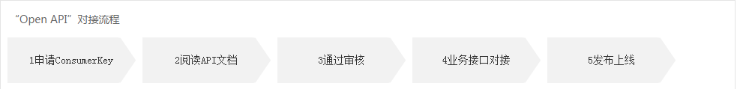

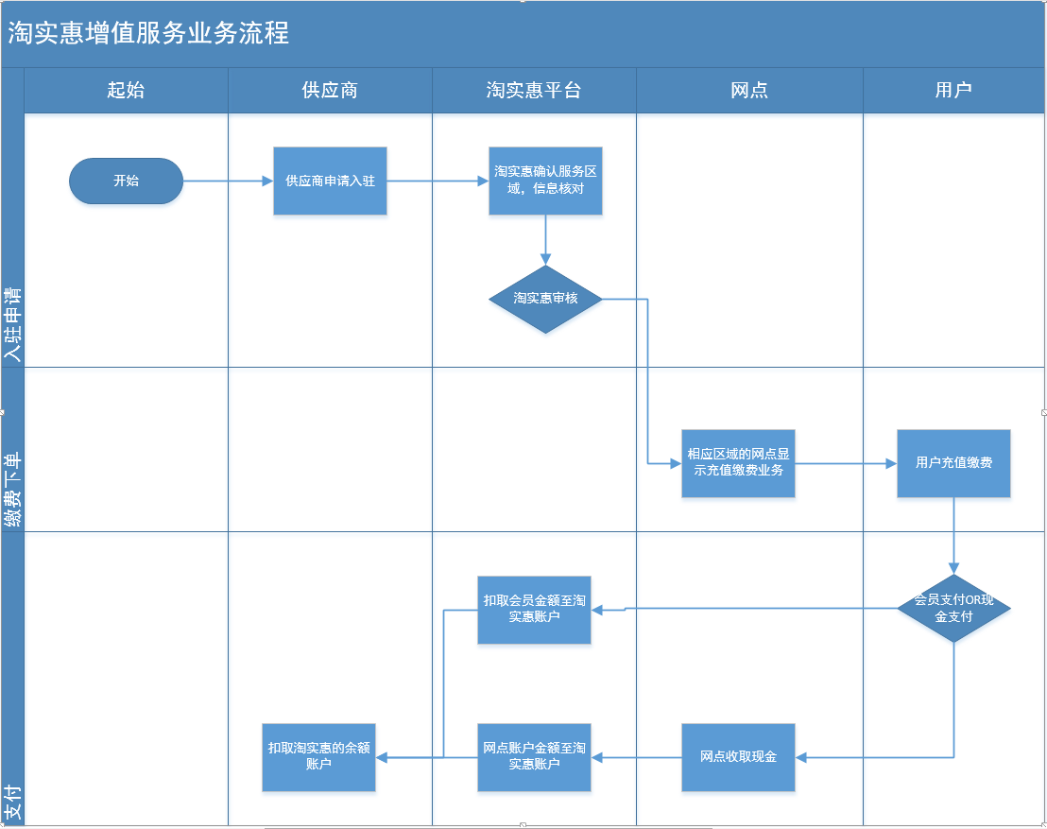

1. 使用者操作介绍

供应商：提供各种服务的商家，供应商有自己的充值平台，淘实惠需要使用其提供的业务接口进行业务操作，供应商提供的业务接口必须符合淘实惠的接口标准定义。

淘实惠平台：平台进行入驻审核，用户资金和供应商资金间的对接搭桥。平台的收支账户对账。

网点责任人：由网点的屏端提供用户充值入口，网点后台的增值服务订单列表和

状态查询。

用户：使用充值缴费。

1. 淘实惠内部系统关系

增值服务：供应商入驻，供应商管理，网点查询缴费单，用户充值入口。

资金账号系统：充值账户间资金的变动。

1. 开放接口业务场景
2. 系统设计
3. 整体系统结构设计

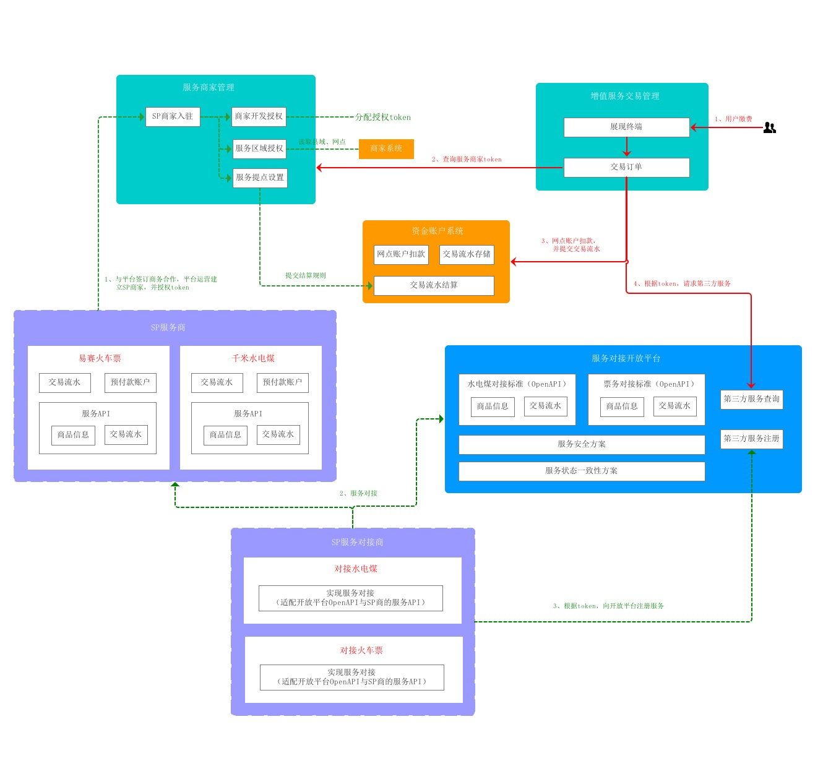

1. 开放平台对接系统方案

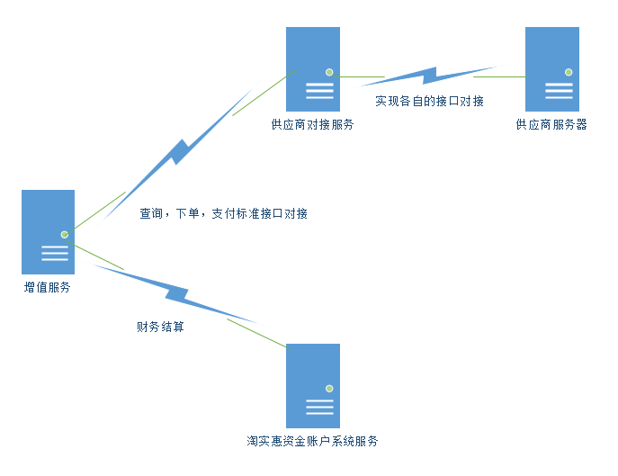

1. 角色关系图

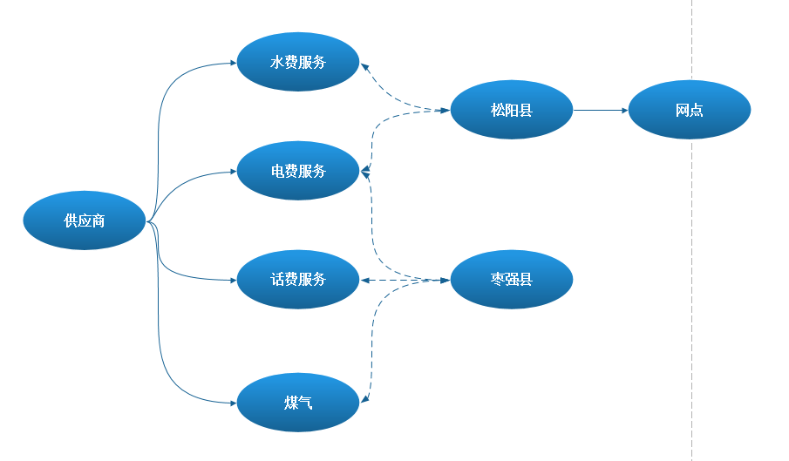

1. 数据库设计
2. 增值服务供应商管理和订单数据库

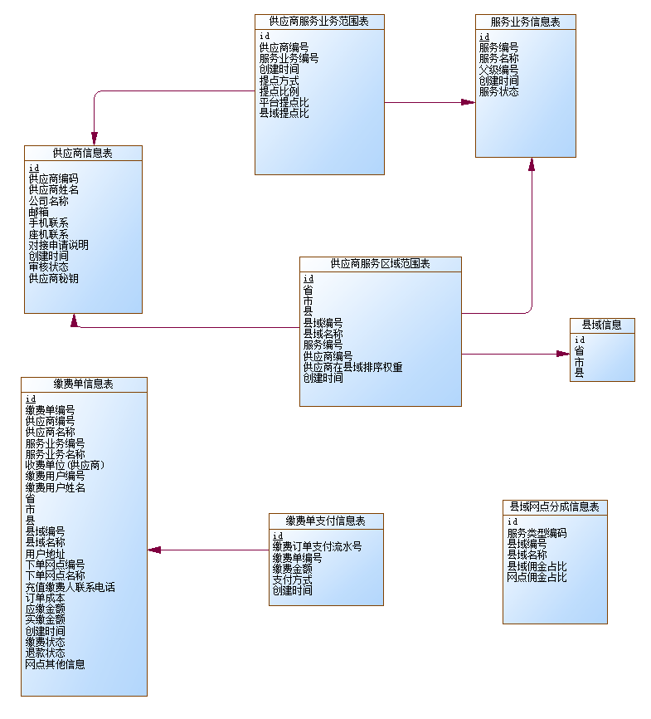

数据库主要包括供应商管理模块和用户缴费单模块

供应商模块：以供应商信息为主表。

用户缴费单模块：以缴费单为主表。

1. 接口设计

参数标准类：用来将供应商的接口数据符合淘实惠平台的数据格式。

请求过程：只是一个模板，使代码都按统一个格式请求。

供应商实现我们的接口，和参数模型。

以水电煤的为例，增值服务系统与供应商对接服务系统的接口定义：

1. 供应商入驻

|  |
| --- |
| 请求  {  "param": {  "applyExplain": "申请说明",  "businessCodes": [  "服务业务编号",  "DJDF"  ],  "company": "供应商名称",  "email": "供应商邮箱",  "mobile": "供应商联系电话",  "supplierName": "供应商姓名",  "supplier_token": "供应商秘钥",  "telphone": "供应商座机"  }  } |
| 返回  {  "applyExplain": "申请说明",  "checkStatus": "审核状态",  "checkTime": "审核时间",  "company": "供应商公司",  "createTime": "入驻申请时间",  "email": "供应商邮箱",  "id": "供应商id",  "mobile": "供应商联系电话",  "supplierCode": "供应商编码",  "supplierName": "供应商姓名",  "telphone": "供应商座机"  } |

1. 供应商审核列表

|  |
| --- |
| 请求  {  "param": {  "checkStatus": "审核状态",  "company": "供应商公司名称",  "page": "页数",  "pageSize": "每页大小"  }  } |
| 返回  {  "applyExplain": "申请说明",  "businessNames": "供应商对接业务,用|隔开，如话费充值|缴电费|缴水费",  "checkStatus": "审核状态",  "checkTime": "审核时间",  "company": "供应商公司",  "createTime": "入驻申请时间",  "email": "供应商邮箱",  "id": "供应商id",  "mobile": "供应商联系电话",  "supplierCode": "供应商编码",  "supplierName": "供应商姓名",  "telphone": "供应商座机",  "supplierAreaDesc":"供应商支持的地区"  } |

1. 查看供应商支持的地区列表

|  |
| --- |
| 请求  {  "param": {  "supplierCode": "供应商编号"  }  } |
| 返回  {  "area": [  {  "city": "市",  "country": "县",  "province": "省"  },  {  "city": "市",  "country": "县",  "province": "省"  }  ],  "supplierCode": "供应商编号",  "supplierName": "供应商名称"  } |

1. 查看供应商信息详情

|  |
| --- |
| 请求  {  "param": {  "supplierCode": "供应商编号"  }  } |
| 返回  {  "applyExplain": "申请说明",  "businessCodes": "供应商对接业务,用|隔开，如话费充值|缴电费|缴水费",  "checkStatus": "审核状态",  "checkTime": "审核时间",  "company": "供应商公司",  "createTime": "入驻申请时间",  "email": "供应商邮箱",  "id": "供应商id",  "mobile": "供应商联系电话",  "supplierArea": [  {  "city": "市",  "country": "县",  "province": "省"  },  {  "city": "市",  "country": "县",  "province": "省"  }  ],  "supplierCode": "供应商编码",  "supplierName": "供应商姓名",  "telphone": "供应商座机"  } |

1. 供应商信息编辑

|  |
| --- |
| 请求  {  "param": {  "businessNames": "供应商对接业务,用|隔开，如话费充值|缴电费|缴水费",  "company": "供应商公司",  "email": "供应商邮箱",  "mobile": "供应商联系电话",  "supplierCode": "供应商编码",  "supplierName": "供应商姓名",  "telphone": "供应商座机"  }  } |
| 返回  {  "applyExplain": "申请说明",  "businessNames": "供应商对接业务,用|隔开，如话费充值|缴电费|缴水费",  "checkStatus": "审核状态",  "checkTime": "审核时间",  "company": "供应商公司",  "createTime": "入驻申请时间",  "email": "供应商邮箱",  "id": "供应商id",  "mobile": "供应商联系电话",  "supplierCode": "供应商编码",  "supplierName": "供应商姓名",  "telphone": "供应商座机"  } |

1. 供应商服务地区设置

|  |
| --- |
| 请求  {  "businessCode": "服务业务编号",  "businessName": "服务业务名称",  "supplierArea": [  {  "city": "市",  "country": "县",  "province": "省"  },  {  "city": "市",  "country": "县",  "province": "省"  }  ],  "supplierCode": "供应商编号",  "supplierName": "供应商姓名"  } |
| 返回  {  "Code": "返回成功码"  } |

1. 审核和终止服务，删除

|  |
| --- |
| 请求  {  "checkStatus": "审核状态",  "supplierCode": "供应商编号"  } |
| 返回  {  "Code": "返回成功码"  } |

1. 排序权重设置

|  |
| --- |
| 请求  {  "businessCode": "增值服务类型",  "city": "市",  "country": "县",  "province": "省",  "rank_order": [  {  "supplierCode": "增值服务供应商编码",  "supplierName": "增值服务供应商名称",  "supplierOrder": "供应商排序"  },  {  "supplierCode": "增值服务供应商编码",  "supplierName": "增值服务供应商名称",  "supplierOrder": "供应商排序"  }  ]  } |
| 返回  {  "Code": "返回成功码"  } |

1. 利润分成提点设置

|  |
| --- |
| 请求  {  "param": {  "area_share_ratio": "县域分成百分比率",  "business_code": "服务业务编码",  "plateform_share_ratio": "平台分成百分比率",  "share_way": "是否可利润分成 1.不可分成 2.全额分成 ，3.差额分成",  "supplier_code": " 供应商编号",  "total_share_ratio": "总利润分成百分比率"  }  } |
| 返回  {  "area_share_ratio": "县域分成百分比率",  "business_code": "服务业务编码",  "plateform_share_ratio": "平台分成百分比率",  "share_way": "是否可利润分成 1.不可分成 2.全额分成 ，3.差额分成",  "supplier_code": " 供应商编号",  "total_share_ratio": "总利润分成百分比率"  } |

1. 增值服务订单报表

|  |
| --- |
| 请求  {  "param": {  "businessCode": "服务业务类型编码",  "chargeCreateTimeEnd": "下单查询结束时间",  "chargeCreateTimeStart": "下单查询开始时间",  "charge_code": "缴费订单编号",  "city": "订单所属城市",  "country": "定单所属县",  "mobile": "充值缴费联系人电话",  "parentBusinessCode": "大服务业务类型编码",  "payStatus": "订单支付状态",  "province": "订单所属省",  "rechargeUserCode": "缴费用户账号",  "rechargeUserName": "付费用户姓名",  "supplierName": "供应商姓名"  }  } |
| 返回  {  "areaShareRatio": "县域分成比例",  "businessCode": "服务业务类型编码",  "chargeCreateTime": "下单查询结束时间",  "charge_code": "缴费订单编号",  "costingAmount": "成本价",  "mobile": "充值缴费联系人电话",  "parentBusinessCode": "大服务业务类型编码",  "payStatus": "订单支付状态",  "plateformShareAmount": "平台佣金",  "plateformShareRatio": "平台分成比例",  "realAmount": "实缴金额",  "rechargeUserCode": "缴费用户账号",  "rechargeUserName": "付费用户姓名",  "refundAmount": "退款金额",  "refundStatus": "退款状态",  "serialNumber": "支付流水号",  "shareWay": "提点分成方式，1.不可分成 2.全额分成 ，3.差额分成",  "storeCode": "下单网点编号",  "storeName": "下单网点姓名",  "storeShareRatio": "网点分成比例",  "supplierCode": "服务供应商编号",  "supplierName": "服务供应商名称",  "totalShareRatio": "总分成"  } |

1. 县域分成比例设置

|  |
| --- |
| 请求  {  "param": {  "businessCode": "服务业务编号",  "businessName": "服务业务名称",  "city": "市",  "country": "县",  "countryShareRatio": "县域分成比例",  "province": "省",  "storeShareRatio": "网点分成比例",  "supplier_code": "供应商编号",  "supplier_name": "供应商姓名"  }  } |
| 返回  {  "businessCode": "服务业务编号",  "businessName": "服务业务名称",  "city": "市",  "country": "县",  "countryShareRatio": "县域分成比例",  "province": "省",  "storeShareRatio": "网点分成比例",  "supplier_code": "供应商编号",  "supplier_name": "供应商姓名"  } |

1. 水电煤缴费下单接口

|  |
| --- |
| 请求  {  "param": {  "businessCode": "服务业务编号",  "chargeOrg": "收费机构名称",  "mobile": "充值缴费手机号码",  "originalAmount": "应缴金额",  "realAmount": "实付金额",  "rechargeUserCode": "付费用户账户",  "rechargeUserName": "付费用户名称",  "storeCode": "网点编号",  "supplierCode": "供应商编号"  }  } |
| 返回  {  "Code": "返回成功码"  } |

1. 水电煤下单调用账号接口

|  |
| --- |
| 请求  {  "param": {  "addTag": "加减标识：1,扣减金额-订单支付 ; 2，增加金额-订单退款.",  "bizId": "所属账户的商业ID",  "bizIntro": "业务简述.",  "bizOrderNo": "业务单编号，缴费订单编号",  "bizType": "所属账户的商业类型.",  "operateUserId": "请求操作用户Id.",  "orderId": "订单id",  "ticketId": "令牌id.",  "totalMoney": "待支付/待退回总额（不包括优惠金额,单位是分）."  }  } |
| 返回  {  "Code": "返回成功码"  } |