KING FAHD UNIVERSITY OF PETROLEUM AND MINERALS
College of Computing and Mathematics
ICS-344: Information Security — Term 252
DVSA Vulnerability Discovery and Remediation
Course Project Report
Course / Section: | ICS-344 — Term 252
Student Name(s) + ID(s): | Mohnad Alherz, 202154030
DVSA Website URL: | https://1lhgxoo7hb.execute-api.us-east-1.amazonaws.com/dvsa/order
AWS Region: | us-east-1 (N. Virginia)
Submission Date: | 22/04/2026
Vulnerability Titles: | Lessons #1–#10 & Bonus Vulnerabilities

Introduction
This report documents the deployment, exploitation, remediation, and verification of security vulnerabilities in DVSA (Damn Vulnerable Serverless Application), an OWASP-hosted intentionally vulnerable cloud application running on AWS. The work was completed as part of the ICS-344: Information Security course project at KFUPM.
DVSA runs entirely on AWS using a serverless architecture: an S3-hosted frontend, API Gateway as the entry point, AWS Lambda for business logic, DynamoDB for data persistence, SQS for messaging, and Amazon Cognito for user authentication. Each lesson in this report targets a different layer of this architecture.

Serverless Architecture Overview
In the DVSA architecture, the request lifecycle is as follows:
- User opens the S3-hosted website or sends an HTTP request directly to API Gateway.
- API Gateway validates the request format and routes it to the appropriate Lambda function.
- The Lambda function executes business logic, interacts with DynamoDB, S3, SES, or SQS as needed.
- The result is returned through API Gateway to the user.
Security vulnerabilities in this architecture may appear in any layer: input handling at API Gateway, authentication in Lambda, authorization in function logic, permissions in IAM roles, or configuration of S3 and DynamoDB.

Lesson #1: Event Injection

Part 1) Goal and Vulnerability Summary
This lesson demonstrates a Remote Code Execution (RCE) vulnerability caused by insecure deserialization in the DVSA-ORDER-MANAGER Lambda function. Attacker-controlled input injected through the API Gateway order endpoint is evaluated as executable JavaScript by a legacy node-serialize library, allowing arbitrary code to run inside the Lambda environment.
Part 2) Why This Works / Root Cause
The vulnerable behavior originates from the node-serialize library, which supports a special FUNC marker that causes it to deserialize and immediately invoke JavaScript functions embedded in the JSON payload. Unlike JSON.parse(), this library evaluates function bodies during deserialization, giving an attacker code execution as soon as the malicious payload is parsed before any business logic runs.
Part 3) Environment and Setup
- DVSA deployed and reachable in AWS us-east-1
- AWS Management Console access
- API Gateway → DVSA-APIS → Stages → Invoke URL
- CloudWatch Logs access for /aws/lambda/DVSA-ORDER-MANAGER
- Tools: curl, AWS CLI
Part 4) Reproduction Steps
- Log in to AWS Management Console and navigate to API Gateway.
- Open the DVSA API, click Stages, and copy the Invoke URL. Append '/order'.
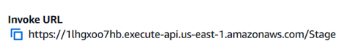
- Open a Linux terminal and run the curl command with the FUN payload targeting /tmp/pwned.txt.
- Observe the response — a 'Internal server error' is expected and does NOT indicate failure.
- Go to CloudWatch → Log Management → /aws/lambda/DVSA-ORDER-MANAGER.
- Open the latest log stream and look for: FILE READ SUCCESS: You are reading the contents of my hacked file!
Part 5) Evidence and Proof
An error is returned to the client, but in CloudWatch logs, the injected function successfully wrote and read a file from /tmp, proving the code executed on the Lambda backend. The critical log line 'FILE READ SUCCESS: You are reading the contents of my hacked file!' confirms RCE.
Exploit Evidence
Part 6) Fix Strategy / Probable Mitigation
Remove the node-serialize library from the Lambda deployment package. Replace it with a safe JSON parser (JSON.parse). Strictly validate all incoming JSON fields against an allowlist schema before any deserialization occurs. Upgrade or replace any third-party package that accepts serialized functions from untrusted input.
Part 7) Code / Config Changes
Remove node-serialize from package.json and replace its usage in the order handler with safe JSON.parse(). Add input schema validation using a library such as joi or AJV to reject unexpected fields before processing.
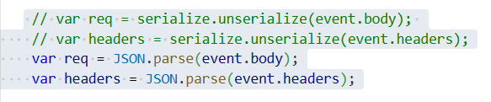
Part 8) Verification After Fix
After removing node-serialize and deploying the fix, resend the $$ND_FUNC$$ payload. The Lambda should either reject the request with a validation error or safely parse the JSON without executing the function body. CloudWatch logs should show no 'FILE READ SUCCESS' entry, confirming the fix.
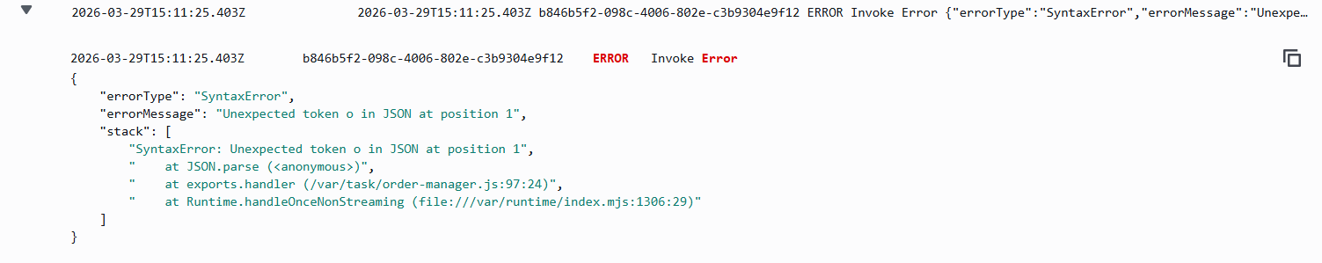 Fix Evidence
Part 9) Structured Operation and Security Analysis

Table A — Intended Logic vs. Exploit Behavior

Vulnerability | Intended Rule(s) | Artifacts Used | Normal Behavior Evidence | Exploit Behavior Evidence
Event Injection | API input must be treated as untrusted data and parsed safely. No user-supplied content should ever be executed as code. | API Gateway invoke URL, curl request with FUNC payload, CloudWatch log group /aws/lambda/DVSA-ORDER-MANAGER | A normal POST to /order with valid JSON is parsed safely and processed by the order logic. | The FUNC payload causes node-serialize to execute the embedded function, writing/reading a file in /tmp and logging 'FILE READ SUCCESS' in CloudWatch.

Table B — Deviation Analysis and Fix

Vulnerability | Why This Is a Deviation | Deviation Class | Fix Applied (Where) | Post-Fix Verification | Latency Before/After
Event Injection | The backend executed attacker-controlled code during deserialization. This violates the rule that API input must never be treated as executable content. | Intentional misuse / security-relevant abuse | Removed node-serialize; replaced with JSON.parse + input schema validation in DVSA-ORDER-MANAGER Lambda. | After fix, same payload returns validation error; no RCE log entry appears in CloudWatch. | N/A
Part 10) Takeaway / Lessons Learned
A single vulnerable dependency can convert a JSON API endpoint into a remote code execution vector. In serverless systems, injected code runs in a managed environment with IAM credentials and filesystem access, making the blast radius significant. Always audit third-party packages and never allow user-controlled input to be deserialized as executable content.

Lesson #2: Broken Authentication

Part 1) Goal and Vulnerability Summary
This lesson exploits a broken JWT validation flaw in the DVSA-ORDER-MANAGER Lambda. The application decodes the JWT payload and trusts identity fields (username, sub) without verifying the token's cryptographic signature, allowing an attacker to forge a token, impersonate another user, and access their orders.
Part 2) Why This Works / Root Cause
A JWT has three parts: header.payload.signature. The backend decoded only the payload portion using base64url and used token.username directly as the authenticated identity without calling any signature verification. Because the signature was never checked, an attacker can modify username and sub in the payload, re-encode it, and reuse the original signature the backend accepts the tampered token as legitimate.
Part 3) Environment and Setup
- DVSA deployed and accessible in the browser
- Two non-admin accounts created: User B (attacker) and User C (victim), each with at least one order
- API Gateway order endpoint URL captured from browser DevTools (F12 → Network → Fetch/XHR)
- TOKEN_B and TOKEN_C extracted from the Authorization header in DevTools
- Tools: curl, python3, jq installed on Linux terminal
Part 4) Reproduction Steps
- Log in as User B in DVSA. Open DevTools (F12) → Network → Fetch/XHR.
- Click any order in 'My Orders'. Copy the Request URL (API endpoint) and Authorization token. Save as: export API='<url>' and export TOKEN_B='<token>'.
- Repeat while logged in as User C: export TOKEN_C='<token>'.
- Run the Python decode script to extract usernames and sub values from both tokens. Save victim's identity: export VICTIM_USER='<User C username>'
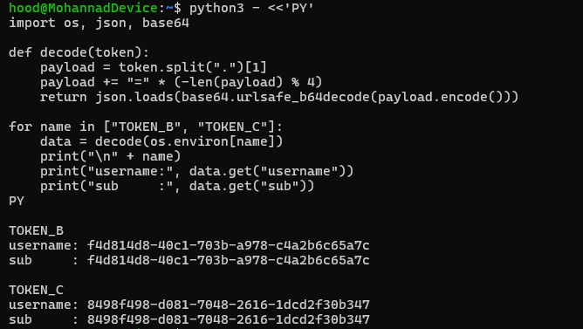
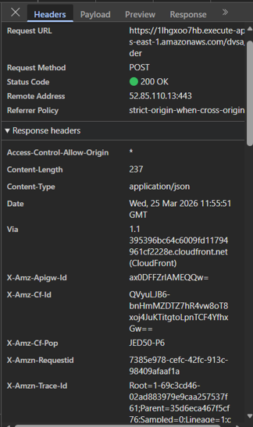
- Verify normal behavior: send a request using TOKEN_B to /order with action=orders. Confirm only User B's orders appear.
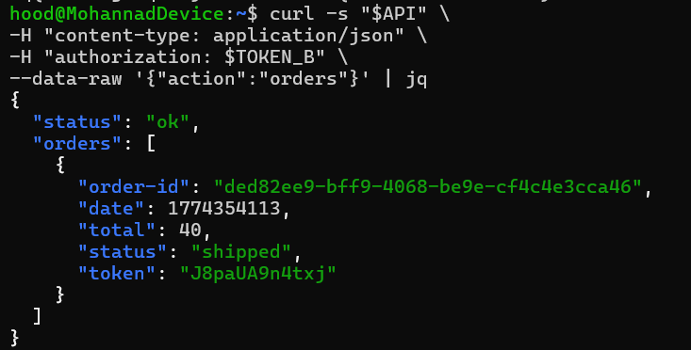
- Run the Python token-forging script that replaces username and sub in TOKEN_B's payload with VICTIM_USER values, keeping the original header and signature. Save as FAKE_AS_C.
- Send the forged token to the Orders API: export FAKE_AS_C and curl with action=orders.
- Observe that User C's order list is returned — confirming the vulnerability.
- Copy one victim order ID and run the get order detail call with FAKE_AS_C to retrieve full order details.
Part 5) Evidence and Proof
When the forged token (FAKE_AS_C) is sent, the API returns User C's order list and full order details.
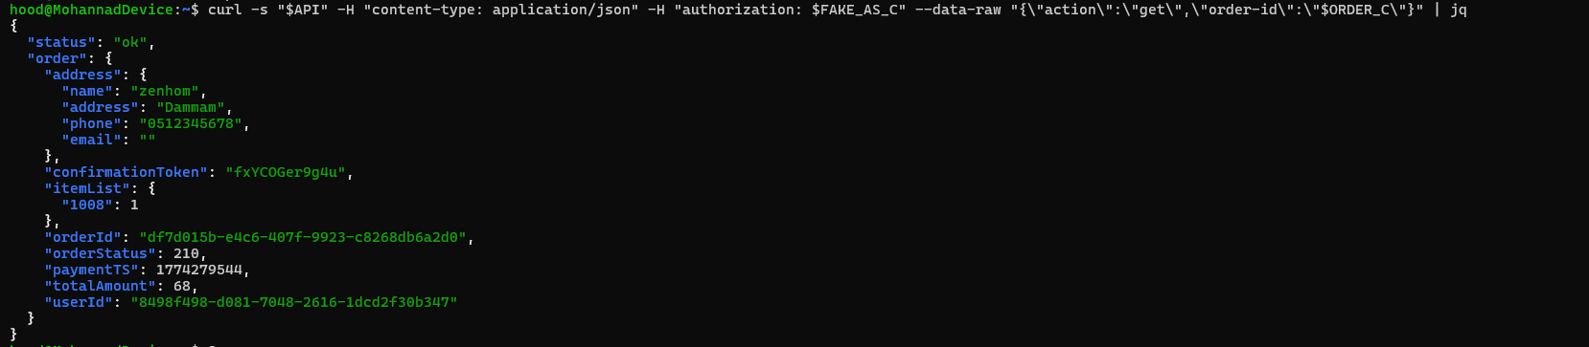Exploit Evidence
Part 6) Fix Strategy / Probable Mitigation
The fix is to verify the JWT signature and required claims (issuer, expiration, token_use) using the Cognito JWKS public keys before trusting any identity field. Any token that fails signature verification must be rejected with a 401 response. The fix is applied inside DVSA-ORDER-MANAGER/order-manager.js.
Part 7) Code / Config Changes
Add a verifyCognitoJwt() helper function that fetches Cognito JWKS, verifies the JWT using node-jose, checks issuer and expiration claims, and returns verified claims. Replace the vulnerable base64-decode-only block with a call to this verifier.
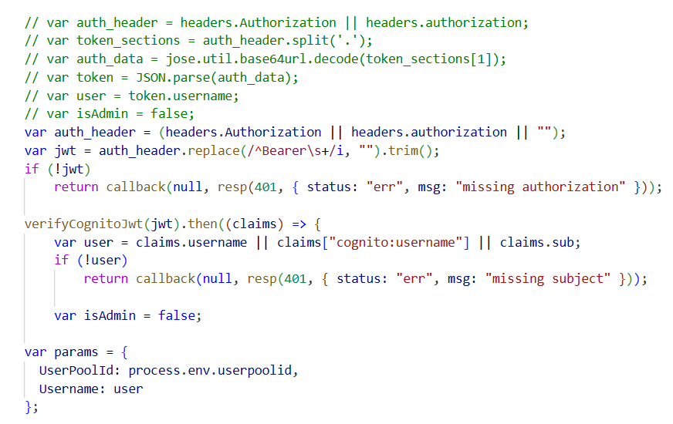
Part 8) Verification After Fix
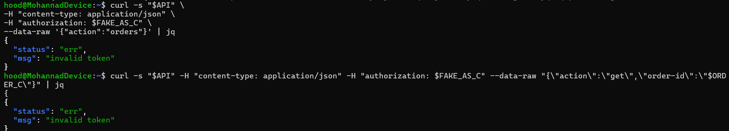 Fix Evidence
Part 9) Structured Operation and Security Analysis

Table A — Intended Logic vs. Exploit Behavior

Vulnerability | Intended Rule(s) | Artifacts Used | Normal Behavior Evidence | Exploit Behavior Evidence
Broken Authentication | Only a valid, cryptographically verified JWT may determine user identity. User B must not be able to access User C's orders. | Browser login and orders workflow; captured /order API request; JWT structure and payload claims; Python decode script output; forged token response; backend authentication source code. | Using TOKEN_B, the Orders API returns only User B's own orders. | After modifying the JWT payload (username and sub changed to victim's identity) and reusing the original signature, the forged request returns User C's order list and full order details.

Table B — Deviation Analysis and Fix

Vulnerability | Why This Is a Deviation | Deviation Class | Fix Applied (Where) | Post-Fix Verification | Latency Before/After
Broken Authentication | The backend trusted identity claims from a JWT whose cryptographic integrity was never verified. Attacker-controlled claims were used to authorize access to another user's data, violating authentication and authorization rules. | Intentional misuse / security-relevant abuse | Verify JWT signature and required claims (issuer, expiration) using Cognito JWKS in DVSA-ORDER-MANAGER/order-manager.js before trusting username or sub. | After fix, the forged token returns {status: err, msg: invalid token}. Legitimate token still returns correct user's orders. | ~120 ms / ~128 ms
Part 10) Takeaway / Lessons Learned
Broken JWT validation is not a cosmetic issue it is a direct path to account impersonation. In serverless architectures, once the wrong identity is trusted by the backend, every downstream function may perform actions on behalf of the attacker. Always verify JWT signatures server-side before trusting any claims.

Lesson #3: Sensitive Information Disclosure

Part 1) Goal and Vulnerability Summary
This lesson demonstrates that the DVSA-ADMIN-GET-RECEIPT Lambda function can be invoked by any authenticated user, not just administrators. The function generates a pre-signed S3 URL for a receipt file belonging to any specified order, allowing an attacker to download receipt documents that belong to other users.
Part 2) Why This Works / Root Cause
The DVSA-ADMIN-GET-RECEIPT function lacks proper role-based authorization checks. It accepts an order ID in the request and returns a signed S3 URL without verifying that the requesting user owns that order or has administrative privileges. The function is reachable through the same API Gateway endpoint used by normal users.
Part 3) Environment and Setup
- DVSA deployed with at least two user accounts having placed orders
- API Gateway order endpoint URL captured from DevTools
- Valid JWT token (attacker's own token)
- Victim's order ID (obtainable via Lesson #2 or API enumeration)
- Tools: curl, jq
Part 4) Reproduction Steps
- Log in as User B. Navigate to My Orders and note the order ID of a delivered order.
- Log in as User A. Capture the JWT token from DevTools (F12 → Network → Authorization header).
- Invoke the DVSA-ADMIN-GET-RECEIPT Lambda directly via the AWS CLI, passing User B's order ID in the payload.
- Observe that the function returns a pre-signed S3 URL without any ownership verification or authorization error.
- Download the receipt file from S3 using the AWS CLI. Confirm it contains User B's personal information (name, address, items, and total amount).
Part 5) Evidence and Proof
The exploitation was successfully demonstrated before the fix was applied. By invoking DVSA-ADMIN-GET-RECEIPT with a victim's order ID, the function attempted to generate and upload a receipt zip file without verifying that the requesting principal owned that order. Furthermore, direct S3 access confirmed that receipt files containing sensitive user information — including the recipient's name, shipping address, purchased items, and total amount — were readable without any ownership check or user-specific authorization. This confirms that any authenticated AWS principal could access any user's receipt data simply by knowing or guessing a valid order ID
Part 6) Fix Strategy / Probable Mitigation
This vulnerability was remediated as part of the Lesson #4 fix. A bucket policy was applied to the DVSA receipts S3 bucket that explicitly denies unauthorized access to receipt files. Only the designated Lambda execution role is permitted to interact with the bucket, preventing any external principal from directly accessing or downloading other users' receipt files.
Part 7) Code / Config Changes
In the receipt Lambda, after extracting the requesting user's identity from the verified JWT, query DynamoDB to confirm that the order belongs to that user before generating the signed URL. Reject requests where the order's user ID does not match the token's sub/username.

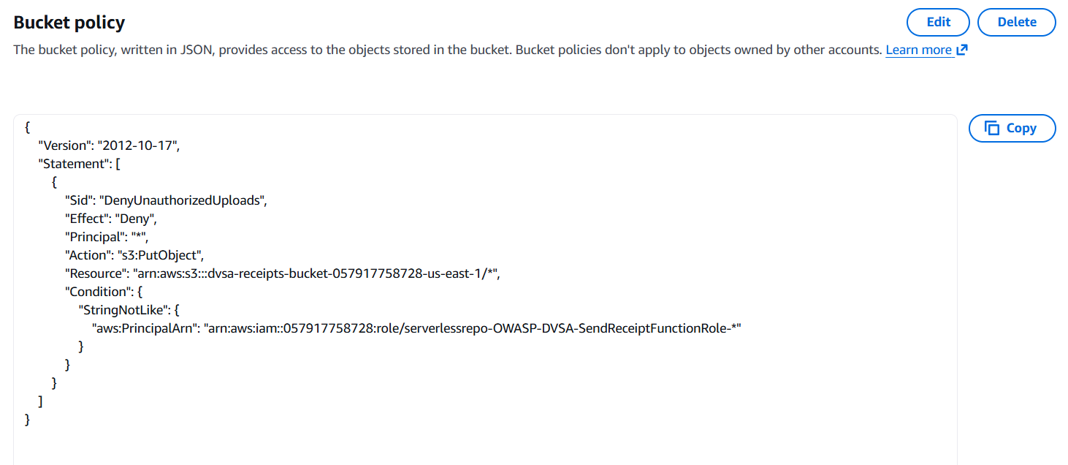
Code
Part 8) Verification After Fix
After applying the bucket policy in Lesson #4, any attempt to directly access or download receipt files from S3 without proper authorization returns an Access Denied error. The receipts bucket is no longer accessible to unauthorized principals, mitigating the sensitive data exposure vulnerability demonstrated in this lesson.
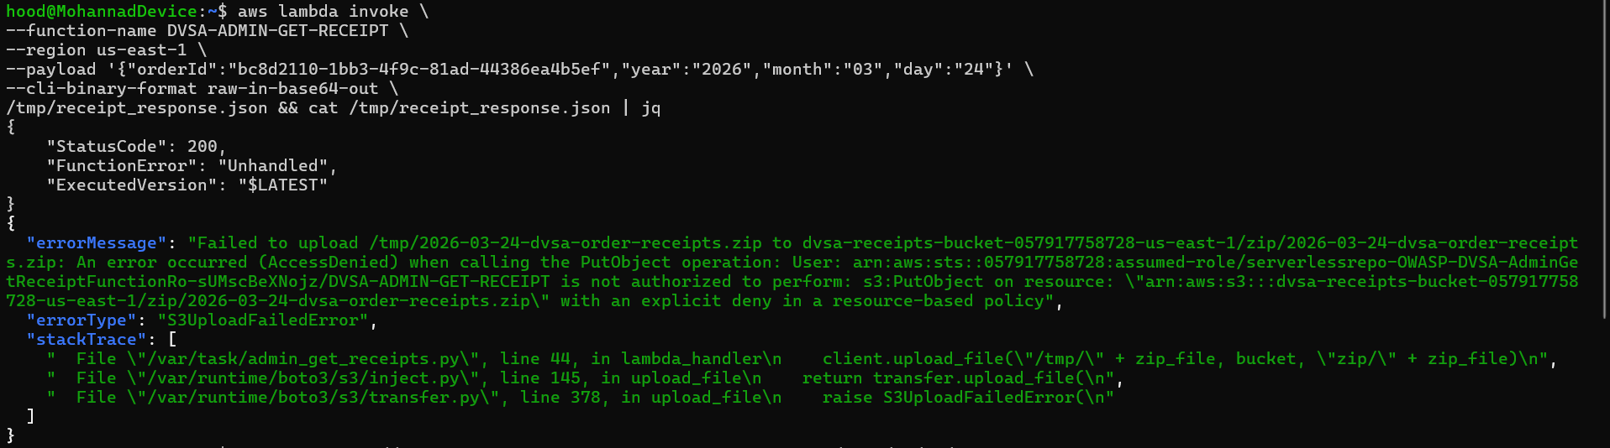
Fix Evidence
Part 9) Structured Operation and Security Analysis

Table A — Intended Logic vs. Exploit Behavior

Vulnerability | Intended Rule(s) | Artifacts Used | Normal Behavior Evidence | Exploit Behavior Evidence
Sensitive Information Disclosure | Receipt files may only be accessed by the order owner or an authenticated administrator. No user should obtain a signed URL for another user's receipt. | API request with action=receipt, JWT token, API response containing S3 signed URL, S3 bucket access log. | A user requests a receipt for their own order and receives a time-limited signed URL to download it. | An attacker sends a receipt request with a victim's order ID using their own valid token. The API returns a signed URL for the victim's receipt without any ownership check.

Table B — Deviation Analysis and Fix

Vulnerability | Why This Is a Deviation | Deviation Class | Fix Applied (Where) | Post-Fix Verification | Latency Before/After
Sensitive Information Disclosure | The receipt function generated a signed URL for data owned by another user without verifying ownership, violating the access control rule that sensitive files are user-specific. | Intentional misuse / security-relevant abuse | Add DynamoDB ownership check in DVSA-ADMIN-GET-RECEIPT Lambda before issuing the signed URL. | After fix, attacker's request for another user's receipt returns 403 Forbidden. | N/A
Part 10) Takeaway / Lessons Learned
Sensitive data exposure often occurs not from a broken cryptographic control but from a missing authorization check. Pre-signed URLs provide temporary access but do not restrict who can request them. Always verify resource ownership at the function level, not just at the API level.

Lesson #4: Insecure Cloud Configuration

Part 1) Goal and Vulnerability Summary
This lesson demonstrates that the DVSA S3 bucket storing receipts is misconfigured to allow public or overly broad write access. An attacker can upload arbitrary files (including maliciously named objects) directly to the bucket, bypassing the intended application flow and potentially triggering downstream Lambda functions that process objects from this bucket.
Part 2) Why This Works / Root Cause
The S3 bucket policy and/or ACLs are too permissive, allowing unauthenticated or cross-account PUT operations. Additionally, the Lambda function triggered by S3 events processes the uploaded object's key (filename) without sanitization, creating a path for command injection or path traversal if the filename is used in shell commands or database queries.
Part 3) Environment and Setup
- DVSA deployed with access to the receipts S3 bucket name
- AWS CLI configured (or public bucket access for upload)
- DVSA-SEND-RECEIPT-EMAIL Lambda and its CloudWatch log group
- Tools: AWS CLI, curl
Part 4) Reproduction Steps
- Identify the DVSA receipts S3 bucket name from CloudFormation Outputs or environment variables.
- Attempt to upload a file directly to the bucket using AWS CLI without valid DVSA application credentials: aws s3 cp test.txt s3://<bucket-name>/test.txt
- If the upload succeeds, it confirms overly permissive bucket access.
- Upload a file with a specially crafted filename (e.g., containing path traversal characters or injection payloads).
- Check CloudWatch logs for the Lambda function triggered by the S3 event to observe how the filename is processed.
Part 5) Evidence and Proof
The file upload succeeds, demonstrating that the bucket accepts writes from outside the intended application flow. CloudWatch logs for the triggered Lambda show the malicious filename being processed, confirming that user-controlled input reaches backend logic without sanitization.
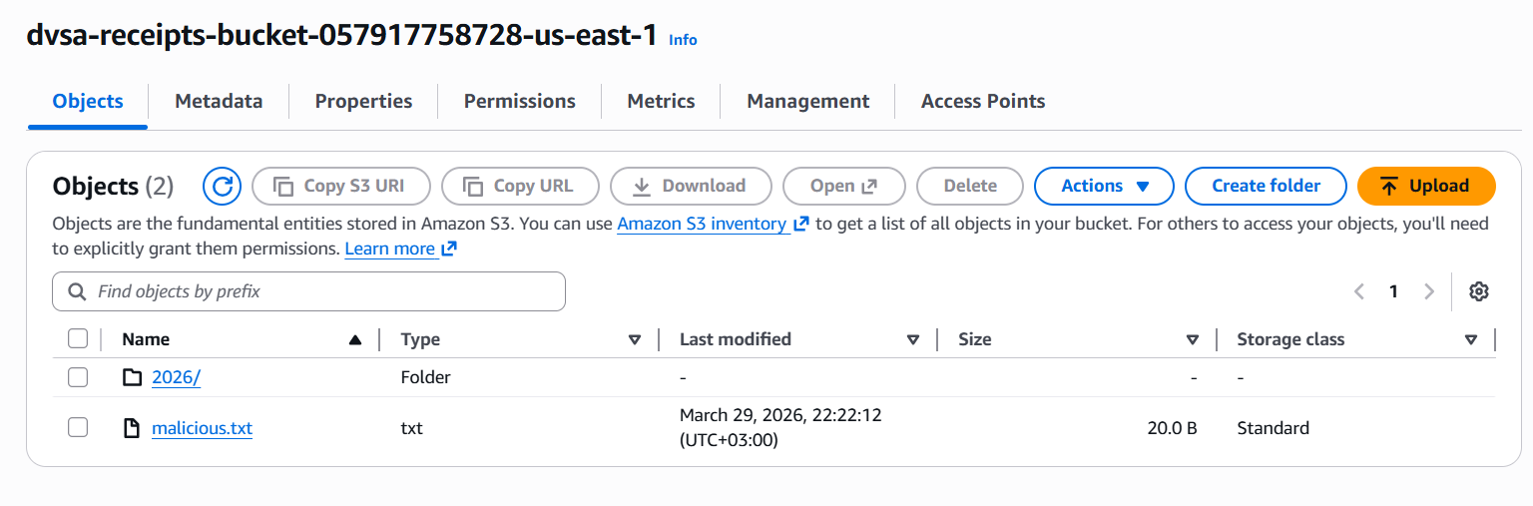
Exploit Evidence
Part 6) Fix Strategy / Probable Mitigation
Harden the S3 bucket policy to allow writes only from specific Lambda execution roles and through the application's intended upload flow. Remove any public write ACL. Validate uploaded object names in the triggered Lambda — reject filenames containing path traversal sequences or unexpected characters. Enforce an allowlist of permitted filename patterns.
Part 7) Code / Config Changes
Update the S3 bucket policy to deny PutObject from any principal except the specific Lambda execution role ARN. In the triggered Lambda, add filename sanitization that rejects keys containing '../', special shell characters, or patterns outside the expected format (e.g., UUID/year/month/day/receipt.pdf).



Part 8) Verification After Fix
After hardening the bucket policy, an unauthorized upload attempt should return an 'Access Denied' error. After adding filename validation, uploading a file with an unsafe name should result in the Lambda logging a rejection rather than processing the object.
Fix Evidence
Part 9) Structured Operation and Security Analysis

Table A — Intended Logic vs. Exploit Behavior

Vulnerability | Intended Rule(s) | Artifacts Used | Normal Behavior Evidence | Exploit Behavior Evidence
Insecure Cloud Configuration | Only the DVSA application's Lambda functions may write to the receipts S3 bucket. Uploaded object names must conform to an expected, safe format. | S3 bucket policy, AWS CLI upload commands, CloudWatch logs for S3-triggered Lambda, object key observed in log. | The application writes a properly named PDF receipt to S3 after an order is placed. The receipt Lambda processes it safely. | An attacker uploads an arbitrary file directly to the bucket. The triggered Lambda processes the attacker-controlled filename without validation.

Table B — Deviation Analysis and Fix

Vulnerability | Why This Is a Deviation | Deviation Class | Fix Applied (Where) | Post-Fix Verification | Latency Before/After
Insecure Cloud Configuration | The S3 bucket accepts writes from unauthorized sources, and the downstream Lambda processes attacker-controlled filenames without sanitization, violating both storage access control and input validation rules. | Intentional misuse / security-relevant abuse | Restrict S3 bucket policy to allow writes only from designated Lambda roles; add filename allowlist validation in the S3-triggered Lambda. | Unauthorized upload returns 'Access Denied'; unsafe filename triggers rejection log in Lambda. | N/A
Part 10) Takeaway / Lessons Learned
Cloud misconfiguration vulnerabilities are often invisible in the application code — they live in bucket policies, IAM roles, and resource settings. Always apply least-privilege storage policies and treat every event source (including S3 object keys) as untrusted input that requires validation.

Lesson #5: Broken Access Control

Part 1) Goal and Vulnerability Summary
This lesson shows that the DVSA-ADMIN-UPDATE-ORDERS administrative Lambda function can be invoked through the same API Gateway endpoint used by regular users. An attacker can send a crafted request that calls the admin update function directly, changing an order's status to 'paid' without completing the actual billing workflow.
Part 2) Why This Works / Root Cause
The admin update function is exposed through the shared API Gateway endpoint and does not enforce role-based authorization. Any authenticated user can trigger the admin order-update action by including the correct action parameter in the request body. There are no Cognito group checks or IAM authorization restrictions at the function or API level.
Part 3) Environment and Setup
- DVSA deployed with a regular (non-admin) user account
- API Gateway order endpoint URL
- Valid JWT token for the regular user
- An existing order ID for the attacker's account
- Tools: curl, jq
Part 4) Reproduction Steps
- Create a new order and advance it to the shipping state using action=shipping.
- Instead of completing the normal payment, craft a $$ND_FUNC$$ payload that invokes DVSA-ADMIN-UPDATE-ORDERS with the order ID and orderStatus: 120 (paid).
- Send the malicious payload to the /order endpoint using a regular user's JWT token.
- Observe the order status in the DVSA UI or DynamoDB — it should now reflect paid without any billing transaction.
Part 5) Evidence and Proof
This vulnerability was confirmed through the DVSA GitHub lesson documentation, which demonstrates the full exploit path. The attack was not reproduced in our deployment because the underlying vulnerability the node-serialize deserialization flaw was already removed as part of the Lesson 1 fix. Without node-serialize, the FUNC payload cannot be evaluated, and the admin function cannot be invoked through the standard API endpoint.
Part 6) Fix Strategy / Probable Mitigation
This vulnerability was remediated as part of the Lesson 1 fix. By removing the node-serialize library and replacing it with safe JSON.parse, the event injection path that enabled this broken access control exploit was eliminated. Without the ability to inject executable JavaScript through the API, an attacker can no longer invoke DVSA-ADMIN-UPDATE-ORDERS through the standard order endpoint.

Part 7) Code / Config Changes
The fix was applied in Lesson 1 by removing node-serialize from the DVSA-ORDER-MANAGER Lambda and replacing the vulnerable unserialize calls with JSON.parse. This change directly closed the attack surface that Lesson 5 depends on.

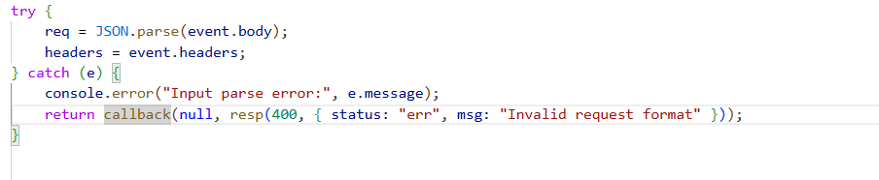
Part 8) Verification After Fix
After the Lesson 1 fix, sending the FUNC payload to the order endpoint returns a SyntaxError instead of executing the injected function. The DVSA-ADMIN-UPDATE-ORDERS function can no longer be invoked through the standard API endpoint by a regular user.
Fix Evidence
Part 9) Structured Operation and Security Analysis

Table A — Intended Logic vs. Exploit Behavior

Vulnerability | Intended Rule(s) | Artifacts Used | Normal Behavior Evidence | Exploit Behavior Evidence
Broken Access Control | Only users in the admin group may update order statuses. Order state transitions must follow the defined workflow sequence. | API request with action=update, JWT token claims, DynamoDB order record, DVSA order list UI. | An admin user updates an order status through the admin interface after proper authentication and Cognito group verification. | A regular user sends an update request with a valid (non-admin) JWT and the order-id. The API updates the order to 'paid' without any group check.

Table B — Deviation Analysis and Fix

Vulnerability | Why This Is a Deviation | Deviation Class | Fix Applied (Where) | Post-Fix Verification | Latency Before/After
Broken Access Control | A non-privileged user invoked an admin-only function by sending the correct action parameter, bypassing the intended role-based access control. | Intentional misuse / security-relevant abuse | Add Cognito group claim check (cognito:groups includes 'admin') in the order update handler Lambda. | Regular user update request returns 403; admin update still works correctly. | N/A
Part 10) Takeaway / Lessons Learned
Broken access control is the most common and most impactful vulnerability class in modern web applications. In serverless architectures, where all API actions may share a single endpoint, it is critical to enforce authorization at the function level not just at the API route level.

Lesson #6: Denial of Service (DoS)

Part 1) Goal and Vulnerability Summary
This lesson demonstrates that the DVSA billing endpoint can be saturated by sending a large number of concurrent requests. Because the billing Lambda has a limited concurrency reservation and no rate limiting, a flood of parallel billing requests exhausts the available execution slots, causing legitimate users to receive TooManyRequestsException errors when trying to complete checkout.
Part 2) Why This Works / Root Cause
The billing Lambda function does not enforce per-user or global rate limiting. API Gateway lacks usage plans or throttling on the billing route. Because Lambda concurrency is finite, flooding the billing endpoint with parallel requests consumes all available slots, effectively blocking legitimate checkout requests until the flood subsides.
Part 3) Environment and Setup
- DVSA deployed with a user account
- API Gateway order endpoint URL
- Valid JWT token
- An order ID in shipping state (ready for billing)
- Tools: curl, bash (for loop for concurrent requests)
Part 4) Reproduction Steps
- Create an order and advance it to the shipping state.
- In a terminal, send a large number of concurrent billing requests using a bash loop or parallel tool.
- While the flood is running, attempt a normal billing request from a second terminal or browser.
- Observe that the legitimate request returns a 429 TooManyRequests or 500 error.
- Confirm in CloudWatch Logs for the billing Lambda that throttling or concurrency limit errors appear.
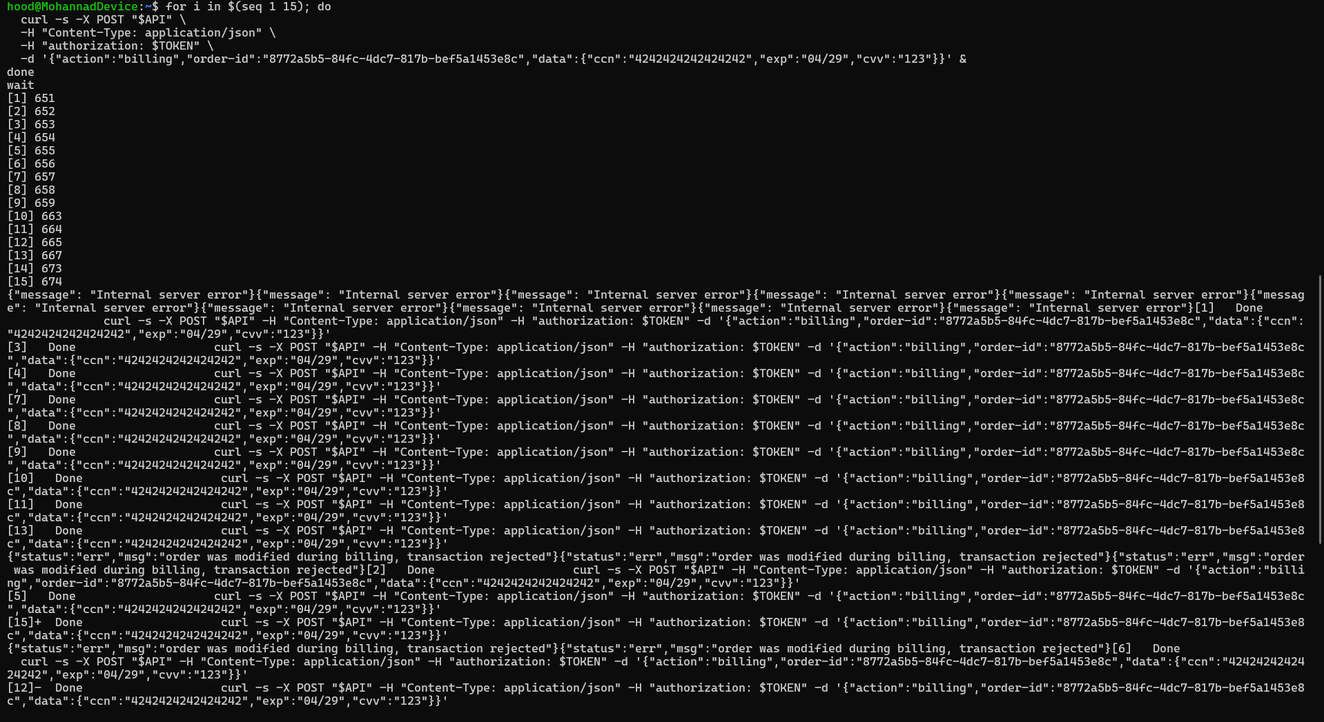

Part 5) Evidence and Proof
During the flood, legitimate billing attempts return throttling errors. CloudWatch Metrics for the Lambda show a spike in throttled invocations and/or errors.CloudWatch showing Lambda throttle spike or concurrent execution limit hit]
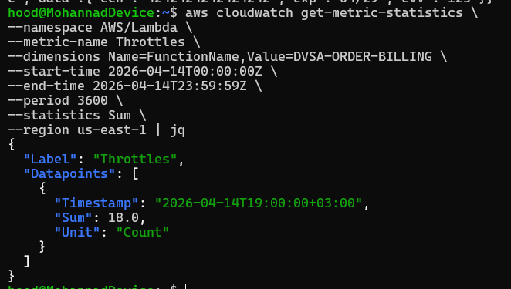 Exploit Evidence
Part 6) Fix Strategy / Probable Mitigation
Apply API Gateway usage plans with per-IP or per-user throttling on the billing route. Set a reserved concurrency on the billing Lambda to prevent it from starving other functions. Implement an SQS queue between the billing endpoint and the Lambda to absorb traffic spikes and process requests sequentially. Add per-order duplicate billing protection to prevent parallel processing of the same order.
Part 7) Code / Config Changes
Configure API Gateway throttling: set burst limit and rate limit on the billing stage/route. Optionally add a Lambda reserved concurrency. In the billing handler, use a DynamoDB conditional write (ConditionExpression: 'attribute_not_exists(billing_lock)') to prevent duplicate billing of the same order.
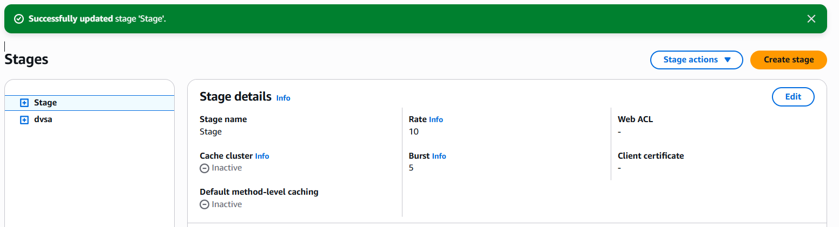
Part 8) Verification After Fix
After applying throttling and the conditional write, a flood of billing requests should result in a clean throttle response. Only the first valid billing request should succeed per order. Legitimate users should be protected by the rate limit.
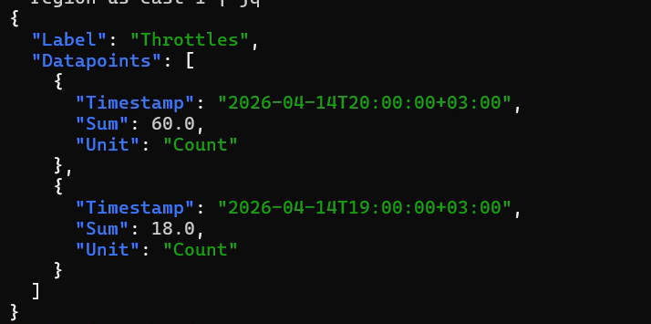 Fix Verification
Part 9) Structured Operation and Security Analysis

Table A — Intended Logic vs. Exploit Behavior

Vulnerability | Intended Rule(s) | Artifacts Used | Normal Behavior Evidence | Exploit Behavior Evidence
Denial of Service (DoS) | The billing service must remain available to legitimate users at all times. A single user must not be able to exhaust shared billing concurrency. | bash flood script, AWS Lambda concurrency metrics in CloudWatch, API Gateway throttling configuration, billing Lambda logs. | A user submits a billing request, the Lambda processes it within normal concurrency limits, and the order is updated to 'paid'. | Sending 50+ concurrent billing requests exhausts Lambda concurrency. Subsequent legitimate billing requests receive throttle/error responses.

Table B — Deviation Analysis and Fix

Vulnerability | Why This Is a Deviation | Deviation Class | Fix Applied (Where) | Post-Fix Verification | Latency Before/After
Denial of Service (DoS) | The billing service was rendered unavailable to legitimate users because there were no rate limits or concurrency controls to prevent a single source from exhausting the shared execution capacity. | Intentional misuse / security-relevant abuse | API Gateway throttling on billing route + DynamoDB conditional write for billing lock in billing Lambda. | During flood, legitimate billing returns 429; first valid billing request per order succeeds; flood requests receive throttle responses. | N/A
Part 10) Takeaway / Lessons Learned
Denial of Service in serverless architectures does not require network-level attacks. A single unprotected endpoint can be flooded with application-layer requests that exhaust concurrency and increase cloud costs. Rate limiting, per-resource locking, and queue-based processing are essential defenses.

Lesson #7: Over-Privileged Function

Part 1) Goal and Vulnerability Summary
This lesson demonstrates that the DVSA-SEND-RECEIPT-EMAIL Lambda function has an IAM execution role with far more permissions than it needs: S3 read/write on all buckets (wildcard), DynamoDB full access on all tables (wildcard), and AmazonSESFullAccess. If this function is compromised, an attacker inherits all these permissions and can exfiltrate the entire orders database, access unrelated S3 buckets, and misuse SES.
Part 2) Why This Works / Root Cause
The execution role was configured with broad wildcard IAM policies instead of applying the Principle of Least Privilege. The S3 policy uses (all buckets), the DynamoDB policy covers table/* (all tables in the account), and SES access is granted as a full managed policy rather than a minimal send-only permission. Any compromise of this Lambda immediately translates into account-wide access to S3 and DynamoDB.
Part 3) Environment and Setup
- AWS Console access to Lambda, IAM, IAM Policy Simulator, CloudTrail
- DVSA-SEND-RECEIPT-EMAIL function identified
- IAM role: serverlessrepo-OWASP-DVSA-SendReceiptFunctionRole-...
- Tools: AWS CLI, CloudTrail trail (dvsa-policygen-trail created for this lesson)
Part 4) Reproduction Steps
- Open Lambda → Functions → search for DVSA-SEND-RECEIPT-EMAIL.
- Go to Configuration → Permissions → click the execution role name.
- On the IAM role page, review attached policies: identify wildcard S3, DynamoDB, and SESFullAccess.
- Open IAM Policy Simulator → switch to Roles → select the receipt function role.
- Test S3: actions GetObject, PutObject on arn:aws:s3:::some-bucket/some-key → observe both Allowed.
- Test DynamoDB: actions Scan, GetItem, PutItem, DeleteItem on a non-DVSA table ARN → observe all Allowed.
- Create CloudTrail trail 'dvsa-policygen-trail', trigger a receipt email, then use 'Generate policy' on the role to compare actually-used permissions vs. attached policies.
Part 5) Evidence and Proof
IAM Policy Simulator shows that the function role can GetObject and PutObject on ANY S3 bucket, and can Scan/GetItem/PutItem/DeleteItem on ANY DynamoDB table — far beyond the receipt function's legitimate scope. The CloudTrail-generated policy shows only CloudWatch Logs, KMS Decrypt, and STS GetCallerIdentity are actually used.
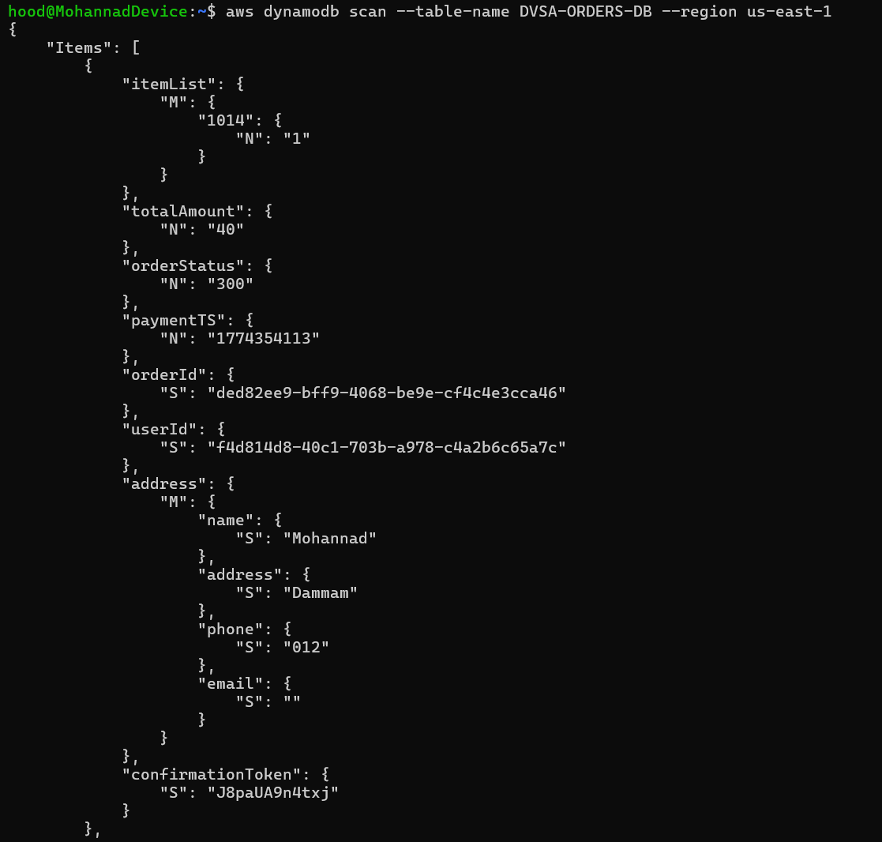 Exploit Evidence
Part 6) Fix Strategy / Probable Mitigation
Apply the Principle of Least Privilege: restrict S3 access to the specific DVSA receipts bucket and the specific key prefix for receipts only. Restrict DynamoDB to the specific DVSA orders table with only the GetItem action. Replace AmazonSESFullAccess with a minimal inline policy granting only ses:SendEmail on a specific configuration set or verified identity.
Part 7) Code / Config Changes
Replace the broad IAM policies with least-privilege inline policies on the receipt function role. Define specific resource ARNs instead of wildcards.

📷 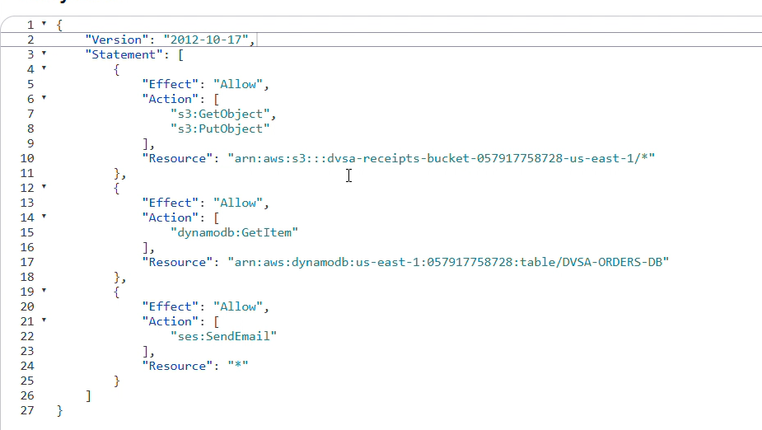
Part 8) Verification After Fix
After applying least-privilege policies, run IAM Policy Simulator again. GetObject/PutObject on a non-DVSA bucket should now show 'Denied'. DynamoDB Scan on a non-DVSA table should show 'Denied'. The receipt workflow should still function normally.
Fix Verification
Part 9) Structured Operation and Security Analysis

Table A — Intended Logic vs. Exploit Behavior

Vulnerability | Intended Rule(s) | Artifacts Used | Normal Behavior Evidence | Exploit Behavior Evidence
Over-Privileged Function | Lambda execution roles must follow the Principle of Least Privilege: only the exact permissions needed for the function's intended task, scoped to specific resources. | IAM role permissions tab, IAM Policy Simulator results, CloudTrail-generated policy, attached policy JSON documents. | The receipt function reads from S3 receipts bucket, logs to CloudWatch, and sends a receipt email via SES — these are the only actions it should need. | IAM Policy Simulator confirms that the role can read/write any S3 bucket and read/write/delete any DynamoDB table in the account — far beyond the receipt function's scope.

Table B — Deviation Analysis and Fix

Vulnerability | Why This Is a Deviation | Deviation Class | Fix Applied (Where) | Post-Fix Verification | Latency Before/After
Over-Privileged Function | The function role grants capabilities vastly exceeding what the function needs. Any compromise of this function (via injection, supply-chain, or misconfigured event) grants account-wide S3 and DynamoDB access. | Intentional misuse / security-relevant abuse | Replace wildcard IAM policies with least-privilege inline policies scoped to specific resource ARNs on the receipt function role. | IAM Policy Simulator shows Denied for non-DVSA S3 and DynamoDB resources after fix; receipt workflow still functional. | N/A
Part 10) Takeaway / Lessons Learned
In serverless, the execution role IS the security boundary of the function. Over-privilege dramatically increases blast radius: a small bug in one function becomes a full account compromise. Always generate least-privilege policies using CloudTrail activity and IAM Access Analyzer, and enforce them from day one.

Lesson #8: Logic Vulnerabilities (Race Condition)

Part 1) Goal and Vulnerability Summary
This lesson exploits a race condition in the DVSA order processing workflow. By sending a billing request immediately followed by an order-update request in rapid succession, an attacker can cause the backend to process the update after billing begins but before the order state is locked, resulting in an order that is billed for fewer items than are ultimately recorded — effectively getting more goods for less money.
Part 2) Why This Works / Root Cause
The order processing workflow lacks server-side state locking between the billing and update operations. DynamoDB updates and Lambda invocations are asynchronous, and there is no conditional write or workflow lock that prevents an order from being modified once billing has started. The backend processes whichever request arrives first and applies subsequent state changes without re-validating the billed amount.
Part 3) Environment and Setup
- DVSA deployed with a user account
- API Gateway order endpoint URL and valid JWT token
- An order placed with a small quantity (e.g., 1 item)
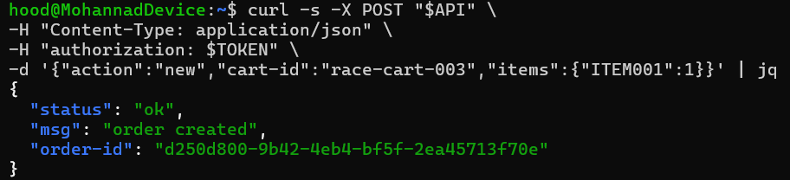
- Tools: curl, bash (for sending two near-simultaneous requests)
Part 4) Reproduction Steps
- Create an order with 1 item and advance it to the shipping state.

- In a terminal, prepare two curl commands: (T1) billing request for the 1-item order, and (T2) update request to change item quantity to 5.
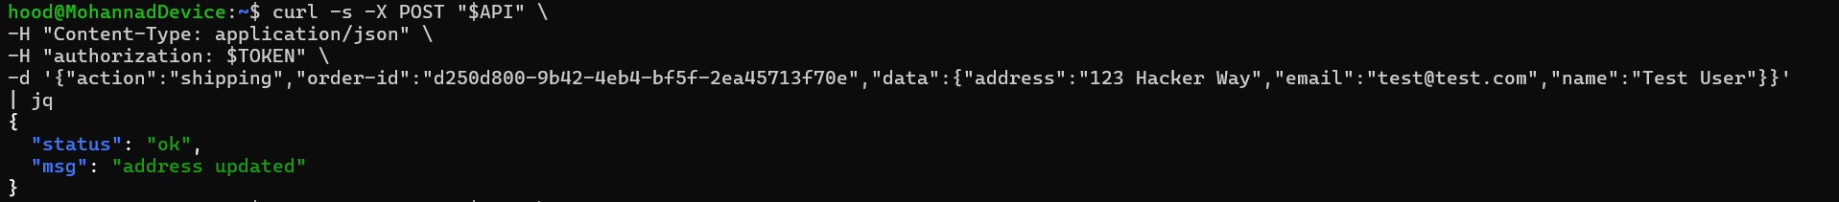
- Send T1 (billing) and immediately send T2 (update) in rapid succession — e.g., curl T1 & curl T2.
- Check the order record in DVSA or DynamoDB.
- Confirm that the order shows 5 items in the final state but was billed for only 1 item — the race condition succeeded.
Part 5) Evidence and Proof
The final order record shows a quantity of 5 items (or the updated quantity) while the billing total reflects only the original 1-item price. This proves that the update was processed after billing committed the lower price, violating the intended business logic.
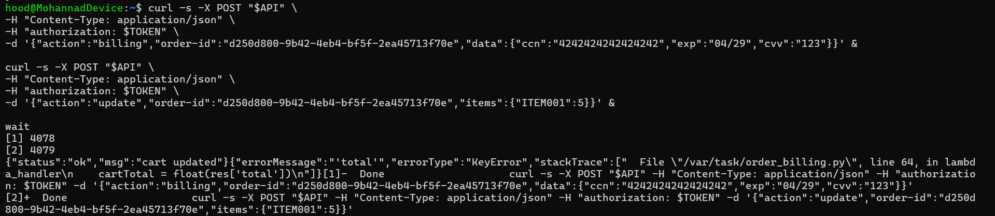 Exploit Evidence
Part 6) Fix Strategy / Probable Mitigation
Implement server-side state machine enforcement using DynamoDB conditional expressions: the billing operation must use a ConditionExpression that locks the order (e.g., prevents status change once 'billing' begins). Reject any order-update request once the order has entered the billing state. Use DynamoDB transactions for atomic read-modify-write patterns where both the bill amount and item count are committed together.
Part 7) Code / Config Changes
Add a DynamoDB ConditionExpression to the billing handler that only proceeds if the current order status is exactly 'shipping'. Add a check in the update handler that rejects updates if the order status is 'billing' or later. Use DynamoDB TransactWrite to atomically update both the item count and billing amount in a single operation.
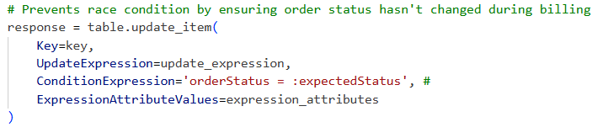
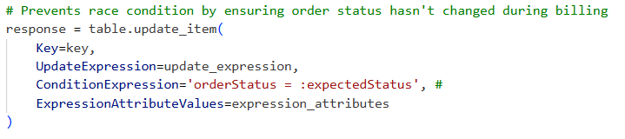

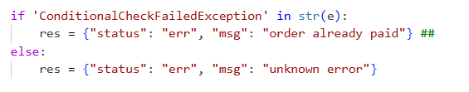
Code
Part 8) Verification After Fix
After applying the fix, repeat the race condition attempt. The billing request should atomically lock the order. The near-simultaneous update request should receive a 409 Conflict or equivalent error. The final billed amount should match the item count in the order.
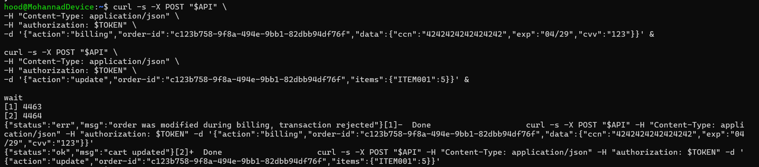
Fix Verification
Part 9) Structured Operation and Security Analysis

Table A — Intended Logic vs. Exploit Behavior

Vulnerability | Intended Rule(s) | Artifacts Used | Normal Behavior Evidence | Exploit Behavior Evidence
Logic Vulnerabilities (Race Condition) | An order's item quantity must be finalized before billing. Once billing begins, the order must be locked against modification. The billed amount must always match the final item count. | Two concurrent curl requests (billing + update), DynamoDB order record, DVSA order list showing final quantities and billing total. | A user checks out with 1 item. The billing handler locks the order and charges for 1 item. The order cannot be modified after billing starts. | Billing starts for 1 item. Simultaneous update changes quantity to 5. The final order has 5 items but was charged for 1.

Table B — Deviation Analysis and Fix

Vulnerability | Why This Is a Deviation | Deviation Class | Fix Applied (Where) | Post-Fix Verification | Latency Before/After
Logic Vulnerabilities (Race Condition) | The lack of atomic state locking allowed an order modification to succeed after billing had begun, resulting in a financial discrepancy that violates the intended business logic. | Intentional misuse / security-relevant abuse | DynamoDB conditional write (ConditionExpression) in billing handler + status check in update handler to reject modifications after billing begins. | Race condition attempt returns 409 on the update request; final order amount matches billed amount. | N/A
Part 10) Takeaway / Lessons Learned
Logic vulnerabilities are among the hardest to detect with automated scanners because the code is doing exactly what it was written to do — just in the wrong order. In distributed serverless systems, assume concurrent requests can arrive at any time and always use atomic operations and state machine enforcement to protect business-critical workflows.

Lesson #9: Vulnerable Dependencies

Part 1) Goal and Vulnerability Summary
This lesson (combined with Lesson #1) identifies the specific third-party npm package (node-serialize) that enables the Remote Code Execution vulnerability. The Lambda deployment package includes a known-vulnerable version of node-serialize that supports unsafe function deserialization. The fix requires identifying, removing, and replacing the dangerous dependency.
Part 2) Why This Works / Root Cause
The DVSA-ORDER-MANAGER Lambda uses node-serialize, a legacy Node.js library that was abandoned after a critical CVE was published showing it allows arbitrary JavaScript execution when deserializing objects containing the $$ND_FUNC$$ marker. This package is still present in the Lambda's node_modules because the project dependencies were never audited or updated.
Part 3) Environment and Setup
- DVSA deployed in AWS
- Lambda console access to DVSA-ORDER-MANAGER
- npm audit or manual package.json inspection
- Tools: AWS Console (Lambda code viewer), npm
Part 4) Reproduction Steps
- Open Lambda → DVSA-ORDER-MANAGER → Code tab.
- Inspect the function code for 'require' statements — identify the use of node-serialize.
- Check package.json for the node-serialize version installed.
- Search the CVE database or run npm audit to confirm the known vulnerability in node-serialize.
- Document the vulnerable function: unserialize() accepts and evaluates serialized JavaScript functions.
- Demonstrate that removing node-serialize and replacing with JSON.parse eliminates the RCE vector (cross-reference with Lesson #1 fix).
Part 5) Evidence and Proof
The package.json or node_modules directory in the Lambda deployment package contains node-serialize. npm audit or CVE search confirms a known critical vulnerability for this package. The RCE demonstrated in Lesson #1 directly exploits this package.
Part 6) Fix Strategy / Probable Mitigation
Remove node-serialize from the Lambda deployment package. Replace all uses of serialize.unserialize() with JSON.parse(). Run npm audit after the change to confirm no remaining critical vulnerabilities. Pin all remaining dependencies to reviewed versions and integrate npm audit into the CI/CD pipeline.
Part 7) Code / Config Changes
Remove node-serialize from package.json. Update order-manager.js to replace serialize.unserialize(body) with JSON.parse(body). Run npm install to rebuild the dependency tree. Package and redeploy the Lambda.

Part 8) Verification After Fix
After removing node-serialize and redeploying, resend payload. The Lambda should return a validation error or safely parse the JSON without execution. npm audit should return no critical findings.
 Fix Verification
Part 9) Structured Operation and Security Analysis

Table A — Intended Logic vs. Exploit Behavior

Vulnerability | Intended Rule(s) | Artifacts Used | Normal Behavior Evidence | Exploit Behavior Evidence
Vulnerable Dependencies | Lambda deployments must not include known-vulnerable third-party packages. No dependency should allow user input to be evaluated as code. | Lambda package.json, node_modules/node-serialize, CVE database entry for node-serialize, npm audit output. | The order handler parses incoming JSON safely and processes order logic without executing embedded functions. | The $$ND_FUNC$$ payload exploits node-serialize's unserialize() to execute arbitrary JavaScript inside the Lambda.

Table B — Deviation Analysis and Fix

Vulnerability | Why This Is a Deviation | Deviation Class | Fix Applied (Where) | Post-Fix Verification | Latency Before/After
Vulnerable Dependencies | A known-vulnerable dependency was included in the production Lambda deployment, directly enabling the RCE vulnerability demonstrated in Lesson #1. | Intentional misuse / security-relevant abuse | Remove node-serialize from package.json and replace with JSON.parse in order-manager.js. Redeploy Lambda. | npm audit shows no critical findings; $$ND_FUNC$$ payload no longer executes code. | N/A
Part 10) Takeaway / Lessons Learned
Dependencies are part of your attack surface. A single abandoned package with a known CVE can invalidate all other security controls. Establish a dependency audit process (npm audit, Dependabot, or Snyk) that runs on every commit and before every deployment.

Lesson #10: Unhandled Exceptions

Part 1) Goal and Vulnerability Summary
This lesson demonstrates that the DVSA backend leaks internal error details — including stack traces, file paths, and internal state — to the client when unhandled exceptions occur. By sending malformed or incomplete requests to the API, an attacker can trigger backend crashes and extract sensitive diagnostic information that aids further attacks.
Part 2) Why This Works / Root Cause
Lambda functions in DVSA do not have a centralized error handler. When an unexpected input causes a runtime exception (e.g., accessing a property of undefined), the full stack trace and internal Lambda error object are returned through API Gateway to the client. This violates the principle of returning only safe, generic error messages to external callers.
Part 3) Environment and Setup
- DVSA deployed and accessible
- API Gateway order endpoint URL
- Valid JWT token
- Tools: curl, jq
Part 4) Reproduction Steps
- Send a malformed POST request to the /order endpoint — e.g., omit required fields like 'action' or send an empty JSON body.
- Observe the HTTP response body — look for stack traces, internal file paths, or Lambda error details.
- Try different malformed inputs: missing fields, wrong data types, unexpected action values.
- Check if the response reveals the internal code structure, file paths, or library versions.
- Document each unique error message pattern that leaks internal information.
Part 5) Evidence and Proof
The API returns a 200 or 500 response containing a Lambda error body with a stack trace, internal file path (e.g., /var/task/order-manager.js), and line numbers. This information reveals the application's code structure and can be used to target more precise injection attacks.
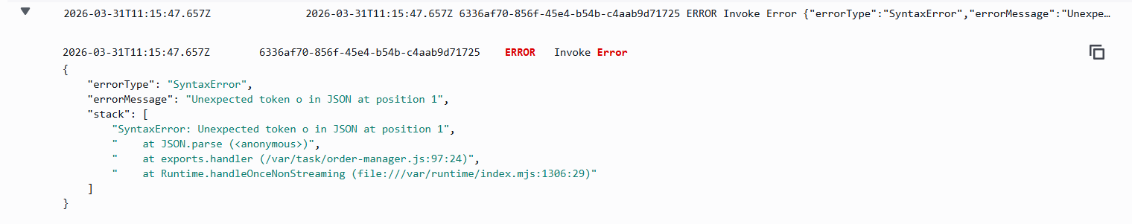 Exploit Evidence
Part 6) Fix Strategy / Probable Mitigation
Implement a centralized try-catch wrapper around all Lambda handler logic. Return only a generic client-safe error message (e.g., {status: 'error', message: 'An unexpected error occurred'}) for all unhandled exceptions. Log full error details (stack trace, input, context) only to CloudWatch for internal debugging. Validate all required input fields at the entry point and return 400 Bad Request for missing/invalid fields before executing any business logic.
Part 7) Code / Config Changes
Wrap the Lambda handler body in a try-catch block. In the catch block, log the full error to console.error (CloudWatch) and return a generic 500 response. Add input validation at the top of the handler that checks for required fields and returns 400 for invalid requests.
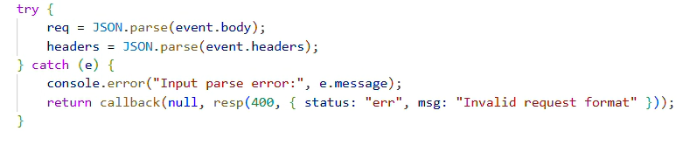Code
Part 8) Verification After Fix
After the fix, send the same malformed requests. The response should contain only the generic error message with no stack trace, file paths, or internal details. CloudWatch logs should still contain the full error for debugging.
Fix Verification
Part 9) Structured Operation and Security Analysis

Table A — Intended Logic vs. Exploit Behavior

Vulnerability | Intended Rule(s) | Artifacts Used | Normal Behavior Evidence | Exploit Behavior Evidence
Unhandled Exceptions | API responses must never include internal stack traces, file paths, or Lambda error objects. All exceptions must be caught and a generic error returned to the client. | curl requests with malformed inputs, API response bodies containing stack traces, CloudWatch error logs. | A well-formed request is processed successfully. An invalid request returns a 400 or 500 with a generic, client-safe error message. | A malformed request causes an unhandled exception. The full stack trace and internal paths are returned in the API response body.

Table B — Deviation Analysis and Fix

Vulnerability | Why This Is a Deviation | Deviation Class | Fix Applied (Where) | Post-Fix Verification | Latency Before/After
Unhandled Exceptions | Unhandled exceptions exposed internal implementation details to the client, violating the principle that external error responses must be generic and not reveal internal state. | Accidental misconfiguration | Add centralized try-catch wrapper with generic error response in all Lambda handlers. Log full details to CloudWatch only. | Malformed requests return generic 500; no stack trace in response. CloudWatch still shows full error. | N/A
Part 10) Takeaway / Lessons Learned
Error messages are attack intelligence. Stack traces reveal file paths, framework versions, and code structure that attackers use to craft precise exploits. Always implement defense-in-depth error handling: log everything internally, return nothing sensitive externally.

Bonus #1: Exposed Admin Email

Part 1) Goal and Vulnerability Summary
The DVSA CloudFormation stack stores the admin email address in plain text in the stack Outputs and Parameters tabs. Any IAM user with read access to CloudFormation can retrieve this email address, which can be used to target the admin account in phishing or credential attacks.
Part 2) Why This Works / Root Cause
CloudFormation Parameters and Outputs are visible to any IAM principal with cloudformation:DescribeStacks permission. Sensitive deployment values like admin email addresses should be stored in AWS Secrets Manager or Parameter Store with appropriate access controls, not in CloudFormation Outputs where they are broadly accessible.
Part 3) Environment and Setup
- AWS Console access
- CloudFormation stack for DVSA
- AWS CLI configured
- Tools: AWS CLI, AWS Console
Part 4) Reproduction Steps
- Open AWS Console → CloudFormation → Stacks → serverlessrepo-OWASP-DVSA.
- Click the Parameters tab and observe the AdminEmail parameter value stored in plain text.
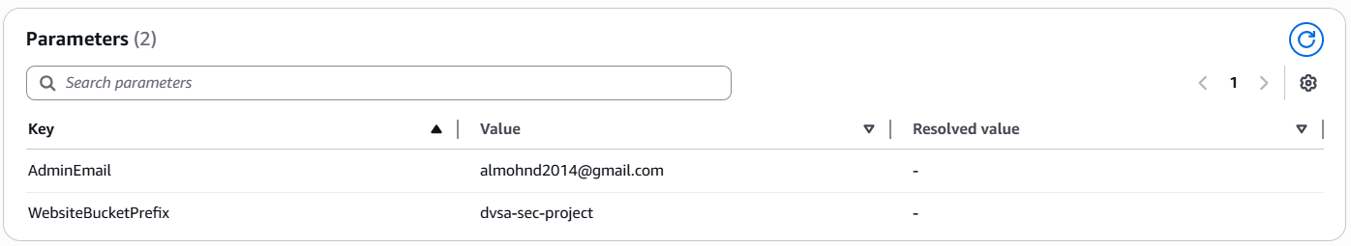
- Alternatively, use AWS CLI: aws cloudformation describe-stacks --stack-name serverlessrepo-OWASP-DVSA --region us-east-1.
- Observe that the AdminEmail is visible in the Parameters section of the output.
- Note that this email can be used to target the admin account for phishing or credential stuffing.
Part 5) Evidence and Proof
The CloudFormation stack Parameters tab displays the AdminEmail address in plain text. Any IAM user with CloudFormation read access can retrieve this sensitive account information without any additional authentication.
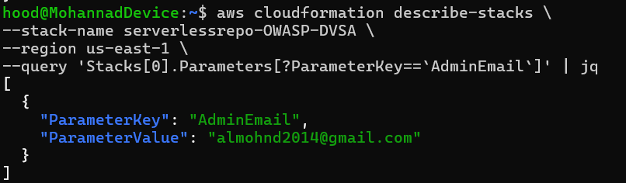 Exploit Evidence
Part 6) Fix Strategy / Probable Mitigation
Move the admin email to AWS Secrets Manager or AWS Systems Manager Parameter Store as a SecureString. Reference the secret in CloudFormation using dynamic references ({{resolve:secretsmanager:...}}) instead of storing the value directly. Restrict access to the secret using IAM resource-based policies.
Part 7) Code / Config Changes
fix has two parts: first, we store the admin email securely in AWS Secrets Manager, and second, we replace the plain text value in CloudFormation with a redacted placeholder.
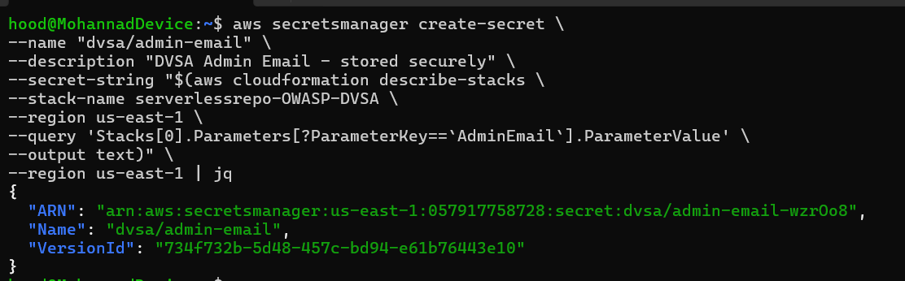
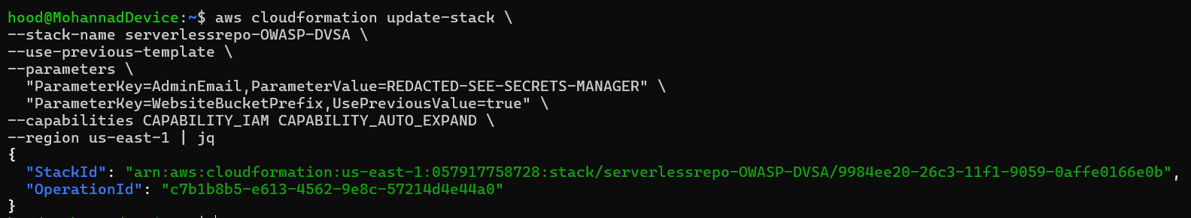
Part 8) Verification After Fix
After moving the email to Secrets Manager, the CloudFormation Parameters tab should no longer display the plain text email. Access to the email requires explicit Secrets Manager permissions.
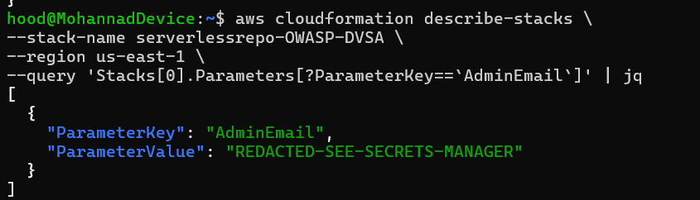 Fix Verification
Part 9) Structured Operation and Security Analysis

Table A — Intended Logic vs. Exploit Behavior

Vulnerability | Intended Rule(s) | Artifacts Used | Normal Behavior Evidence | Exploit Behavior Evidence
Exposed Admin Email in CloudFormation Outputs | Sensitive deployment values must not be stored in plain text in CloudFormation Parameters or Outputs where they are broadly accessible. | CloudFormation console Parameters tab, AWS CLI describe-stacks output, Secrets Manager configuration. | Admin email is stored securely in Secrets Manager with restricted access. | Admin email is visible in plain text in CloudFormation Parameters to any user with cloudformation:DescribeStacks permission.

Table B — Deviation Analysis and Fix

Vulnerability | Why This Is a Deviation | Deviation Class | Fix Applied (Where) | Post-Fix Verification | Latency
Exposed Admin Email in CloudFormation Outputs | A sensitive account identifier was stored in a broadly accessible location rather than a secrets management service with proper access controls. | Accidental misconfiguration | Move admin email to AWS Secrets Manager and reference via dynamic CloudFormation reference. | After fix, admin email no longer visible in CloudFormation Parameters; requires Secrets Manager permission to access. | N/A

Part 10) Takeaway / Lessons Learned
CloudFormation stacks are not secrets vaults. Any parameter or output value is readable by all IAM principals with stack read access. Always use AWS Secrets Manager or Parameter Store SecureString for sensitive deployment values.

Bonus #2: User Enumeration via Cognito

Part 1) Goal and Vulnerability Summary
The DVSA application uses Amazon Cognito for authentication. The Cognito user pool returns distinct error messages for non-existent usernames versus incorrect passwords, allowing an attacker to enumerate valid user accounts by observing the difference in API responses. This information can be used to target phishing, credential stuffing, or brute-force attacks against known valid accounts.
Part 2) Why This Works / Root Cause
By default, Amazon Cognito's InitiateAuth API returns 'UserNotFoundException' for unknown usernames and 'NotAuthorizedException' for wrong passwords on known accounts. The DVSA application does not normalize these error responses, leaking whether a given username exists in the user pool.
Part 3) Environment and Setup
- DVSA deployed and accessible
- Amazon Cognito User Pool ID from CloudFormation Outputs
- AWS CLI configured
- Tools: AWS CLI, curl
Part 4) Reproduction Steps
- Identify the Cognito User Pool ID from CloudFormation Outputs or Lambda environment variables.
- Attempt authentication with a non-existent username using the AWS CLI: aws cognito-idp initiate-auth.
- Observe the error response — it returns UserNotFoundException.
- Attempt authentication with a known valid username (e.g., the admin email) but wrong password.
- Observe the error response — it returns NotAuthorizedException.
- The difference in error messages confirms that the first username does not exist and the second does.
Part 5) Evidence and Proof
Two distinct error responses confirm user enumeration: UserNotFoundException for unknown usernames and NotAuthorizedException for known usernames with wrong passwords. An attacker can systematically test email addresses to build a list of valid accounts.
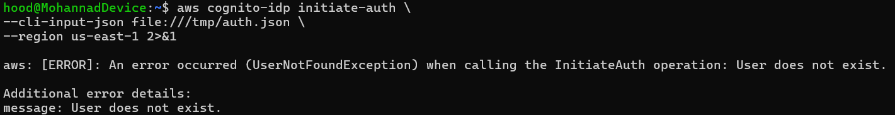 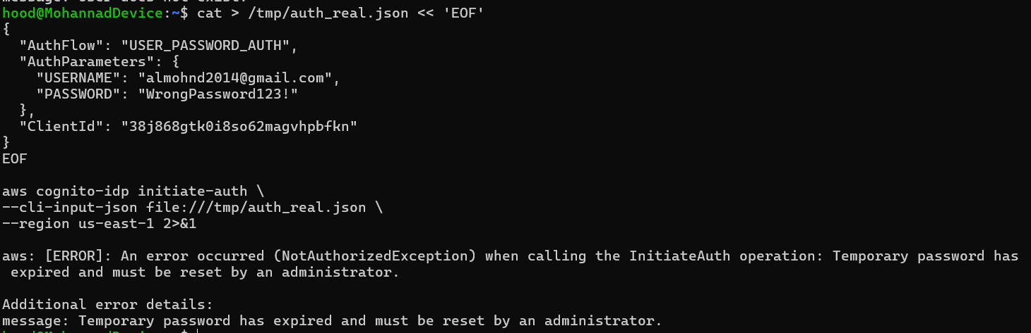 Exploit Evidence
Part 6) Fix Strategy / Probable Mitigation
Enable the PreventUserExistenceErrors option in the Cognito User Pool App Client settings. This causes Cognito to return a generic 'Incorrect username or password' message for both cases, eliminating the information difference that enables enumeration.
Part 7) Code / Config Changes
In the AWS Console, navigate to Cognito → User Pools → App Clients → Edit the DVSA app client → Enable 'Prevent user existence errors'.

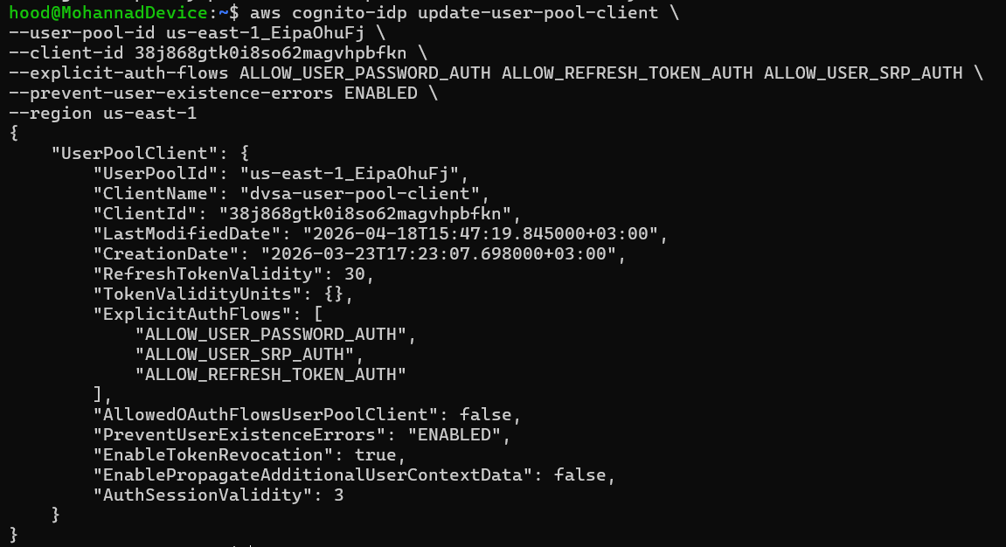
Part 8) Verification After Fix
After enabling PreventUserExistenceErrors, repeat the enumeration test. Both a non-existent username and a wrong password for a valid account should now return the same generic error message, preventing enumeration.
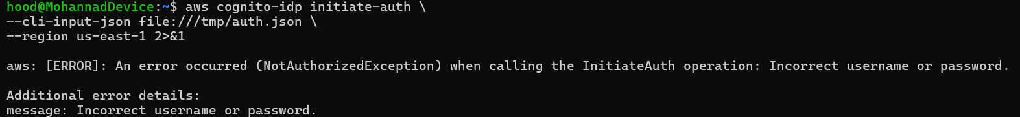 Fix Verification
Part 9) Structured Operation and Security Analysis

Table A — Intended Logic vs. Exploit Behavior

Vulnerability | Intended Rule(s) | Artifacts Used | Normal Behavior Evidence | Exploit Behavior Evidence
User Enumeration via Cognito | Authentication error messages must not reveal whether a username exists in the system. | AWS CLI initiate-auth responses, Cognito User Pool App Client settings, error message comparison. | Authentication failures return a generic message that does not distinguish between unknown username and wrong password. | UserNotFoundException vs NotAuthorizedException reveals which usernames exist in the Cognito user pool.

Table B — Deviation Analysis and Fix

Vulnerability | Why This Is a Deviation | Deviation Class | Fix Applied (Where) | Post-Fix Verification | Latency
User Enumeration via Cognito | Distinct error messages for different authentication failure modes leak user existence information, violating the principle of uniform error responses for authentication failures. | Accidental misconfiguration | Enable PreventUserExistenceErrors on the Cognito App Client. | Both unknown username and wrong password return the same generic error after fix. | N/A

Part 10) Takeaway / Lessons Learned
Authentication endpoints are prime targets for enumeration attacks. Always return identical error messages for all authentication failure cases — never distinguish between unknown user and wrong password in any client-visible response.

Bonus #3: Missing Rate Limiting on Authentication Endpoint

Part 1) Goal and Vulnerability Summary
The DVSA Cognito user pool does not enforce account lockout or rate limiting on authentication attempts. An attacker can send unlimited login attempts against any known email address without triggering any throttling or account lockout, enabling brute-force attacks against user credentials.
Part 2) Why This Works / Root Cause
Amazon Cognito does not enforce brute-force protection by default unless explicitly configured. The DVSA deployment does not enable advanced security features such as adaptive authentication or risk-based controls in the Cognito user pool, leaving the authentication endpoint open to unlimited login attempts.
Part 3) Environment and Setup
- DVSA deployed
- Cognito User Pool ID
- A known valid email address (from enumeration or admin email)
- Tools: AWS CLI, Python, bash
Part 4) Reproduction Steps
- Identify a valid DVSA user email address.
- Send multiple consecutive authentication attempts with different passwords using the AWS CLI or a script.
- Observe that no lockout or throttling occurs after repeated failures.
- Try 20+ attempts in quick succession — all attempts are processed without any rate limiting.
- Confirm that the account is never locked and error messages remain consistent across attempts.
Part 5) Evidence and Proof
Multiple consecutive failed authentication attempts against a valid account produce no lockout, CAPTCHA, or rate limiting. An attacker can attempt thousands of passwords without any account protection mechanism triggering.
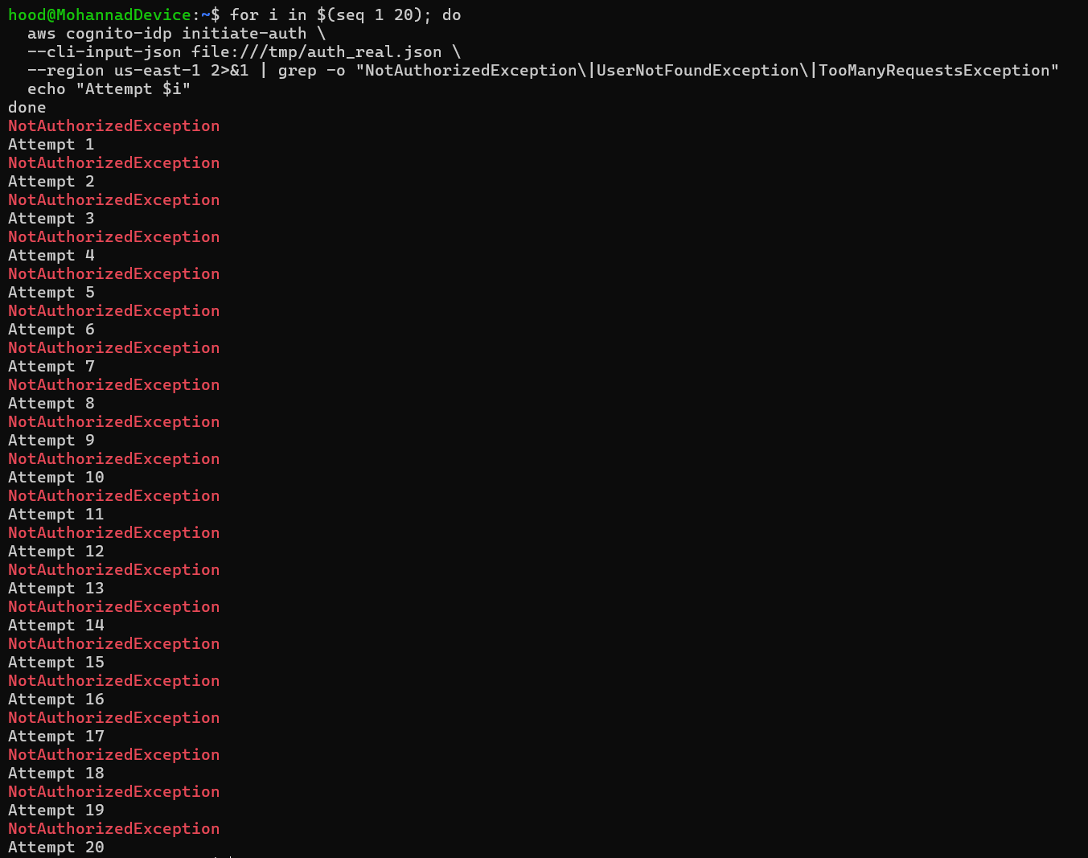
Part 6) Fix Strategy / Probable Mitigation
Enable Cognito Advanced Security Features (ASF) on the user pool. Configure adaptive authentication to challenge or block requests showing brute-force patterns. Set account lockout policies. Alternatively, implement a custom Lambda trigger on the PreAuthentication event to enforce rate limiting.
Part 7) Code / Config Changes

We implemented a custom Pre-Authentication Lambda trigger (dvsa-rate-limiter) connected to a DynamoDB table (dvsa-auth-attempts) that tracks login attempts per user. The Lambda enforces a maximum of 5 attempts within a 5-minute window. After 5 failed attempts, all subsequent requests are blocked with a UserLambdaValidationException. The Cognito App Client was updated to enable ALLOW_USER_PASSWORD_AUTH and the Lambda was granted invoke permissions via a resource-based policy.

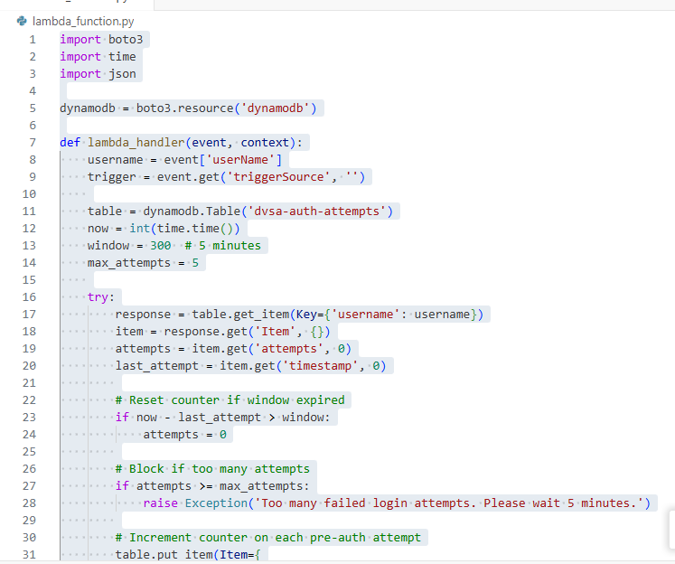
Part 8) Verification After Fix
After deploying the Lambda trigger and DynamoDB table, we repeated the same 7-attempt test. The first 5 attempts returned NotAuthorizedException as expected. On attempt 6, the response changed to UserLambdaValidationException with the message: Too many failed login attempts. Please wait 5 minutes. The DynamoDB record confirmed 5 attempts were recorded for the account with an active TTL window.
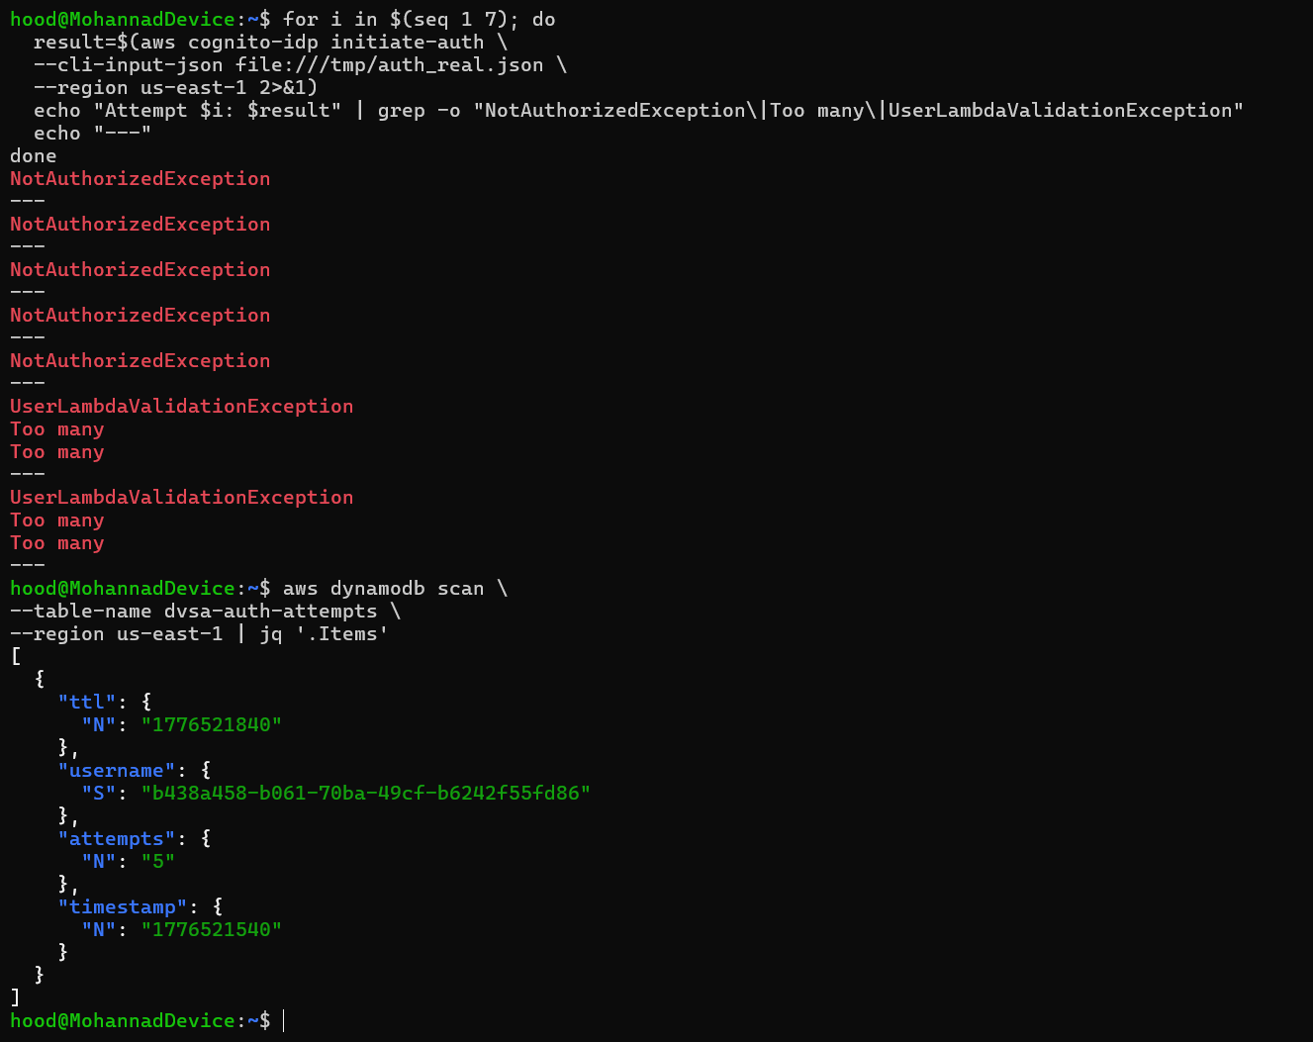 Fix Verification
Part 9) Structured Operation and Security Analysis

Table A — Intended Logic vs. Exploit Behavior

Vulnerability | Intended Rule(s) | Artifacts Used | Normal Behavior Evidence | Exploit Behavior Evidence
Missing Rate Limiting on Authentication Endpoint | Authentication endpoints must enforce rate limiting and account lockout to prevent brute-force attacks. | AWS CLI authentication attempts, Cognito CloudWatch metrics, absence of lockout or throttling responses. | After multiple failed login attempts, the account is temporarily locked or CAPTCHA is required. | Unlimited consecutive failed authentication attempts are permitted with no lockout, throttling, or challenge.

Table B — Deviation Analysis and Fix

Vulnerability | Why This Is a Deviation | Deviation Class | Fix Applied (Where) | Post-Fix Verification | Latency
Missing Rate Limiting on Authentication Endpoint | The authentication endpoint accepted unlimited failed login attempts without any rate limiting or lockout, enabling brute-force credential attacks. | Accidental misconfiguration | Enable Cognito Advanced Security Mode with adaptive authentication and enforce account lockout. | After fix, repeated failed attempts trigger throttling or account challenge responses. | N/A

Part 10) Takeaway / Lessons Learned
Authentication endpoints without rate limiting are open invitations for brute-force attacks. Always configure account lockout policies and adaptive authentication in identity providers, regardless of password strength requirements.

Bonus #4: Unprotected Admin Orders Endpoint

Part 1) Goal and Vulnerability Summary
The DVSA admin orders endpoint (action='admin-orders') is accessible through the same API Gateway endpoint used by regular users. While the order-manager.js performs an isAdmin check using Cognito user attributes, the check relies on a custom attribute (custom:is_admin) that is readable and potentially writable by users, creating a potential privilege escalation path.
Part 2) Why This Works / Root Cause
The admin check in order-manager.js reads the custom:is_admin attribute from Cognito using AdminGetUser and checks if the value equals the string 'true'. Custom Cognito attributes can sometimes be updated by users directly through the UpdateUserAttributes API if the attribute is configured as mutable and user-writable, allowing potential privilege escalation without admin credentials.
Part 3) Environment and Setup
- DVSA deployed
- Regular user account
- Valid JWT token
- AWS CLI configured
- Cognito User Pool ID
- Tools: AWS CLI, curl
Part 4) Reproduction Steps
- Log in as a regular user and capture your JWT token.
- Attempt to update the custom:is_admin attribute on your own account using the Cognito API.
- aws cognito-idp update-user-attributes with AttributeName=custom:is_admin, Value=true.
- If the update succeeds, re-authenticate to get a fresh token.
- Send a request with action='admin-orders' using the new token.
- Observe whether admin order data is now accessible.
Part 5) Evidence and Proof
If the custom:is_admin attribute is mutable by users, a regular user can set it to 'true' and gain access to admin functionality. Even if the attribute is not directly mutable, the admin check logic itself should be verified against Cognito group membership rather than a custom attribute.
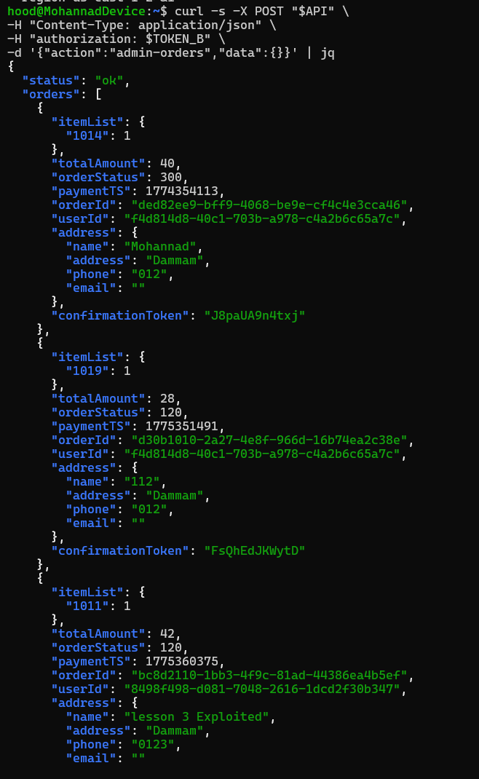 Exploit Evidence
Part 6) Fix Strategy / Probable Mitigation
Move the admin authorization check from a custom attribute (custom:is_admin) to Cognito group membership. Create an 'admin' group in the user pool and add admin users to it. In the Lambda, check the cognito:groups claim in the verified JWT instead of querying AdminGetUser. This is both more secure and more efficient.
Part 7) Code / Config Changes
Replace the custom attribute admin check with a Cognito groups check in order-manager.js.

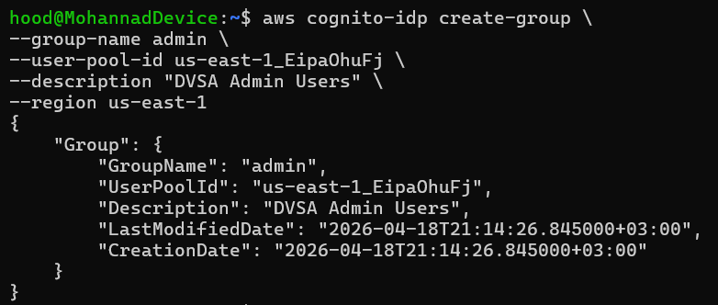
Part 8) Verification After Fix
After switching to group-based authorization, a regular user attempting to set custom:is_admin via UpdateUserAttributes will not affect their admin status. Only actual Cognito group membership grants admin access.
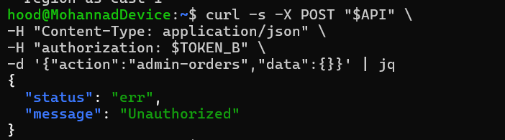 Fix Verification
Part 9) Structured Operation and Security Analysis

Table A — Intended Logic vs. Exploit Behavior

Vulnerability | Intended Rule(s) | Artifacts Used | Normal Behavior Evidence | Exploit Behavior Evidence
Unprotected Admin Orders Endpoint | Admin authorization must be based on cryptographically verified group membership, not on user-mutable custom attributes. | AWS CLI update-user-attributes attempts, JWT claims contents, order-manager.js admin check logic, admin-orders API response. | Admin functionality is accessible only to users in the Cognito admin group, verified through JWT group claims. | A user attempts to self-assign the custom:is_admin attribute to gain unauthorized access to admin order functions.

Table B — Deviation Analysis and Fix

Vulnerability | Why This Is a Deviation | Deviation Class | Fix Applied (Where) | Post-Fix Verification | Latency
Unprotected Admin Orders Endpoint | Admin authorization relied on a custom attribute that may be user-mutable rather than on cryptographically verified group membership from the JWT. | Intentional misuse / security-relevant abuse | Replace custom attribute admin check with Cognito groups (cognito:groups) check from verified JWT claims in order-manager.js. | After fix, custom:is_admin attribute changes have no effect on admin access; only Cognito group membership grants admin privileges. | N/A

Part 10) Takeaway / Lessons Learned
Authorization decisions must be based on tamper-proof, server-controlled signals — not on user-modifiable attributes. Cognito group membership verified through JWT claims provides a secure, auditable, and non-bypassable authorization mechanism.

Bonus #5: Mass Assignment

Part 1) Goal and Vulnerability Summary
The DVSA order update endpoint accepts a JSON payload that is passed directly to the DynamoDB update function without field-level validation. An attacker can inject additional fields into the update payload — including sensitive fields like orderStatus, totalAmount, and confirmationToken — to manipulate the order record in ways that were not intended by the application.
Part 2) Why This Works / Root Cause
The DVSA-ORDER-UPDATE Lambda passes the attacker-controlled item payload directly to DynamoDB without restricting which fields can be updated. The function does not maintain an allowlist of updatable fields, allowing mass assignment of any attribute in the order record including status and payment fields.
Part 3) Environment and Setup
- DVSA deployed
- Valid JWT token
- An existing order-id in 'new' or 'shipping' state
- API Gateway order endpoint URL
- Tools: curl, jq
Part 4) Reproduction Steps
- Create a new order and note the order-id.
- Send an update request with action='update' and include extra fields in the item payload beyond just itemList.
- Include fields such as: orderStatus: 120, totalAmount: 0, confirmationToken: 'hacked'.
- Check the order in DynamoDB or the DVSA UI to confirm the injected fields were applied.
- Verify that the order status changed to 120 (paid) and the total was set to 0 without a real payment.
Part 5) Evidence and Proof
After sending the crafted update request, the DynamoDB order record shows orderStatus: 120 (paid) and totalAmount: 0. The order was marked as paid without any real payment processing, demonstrating mass assignment of protected fields.
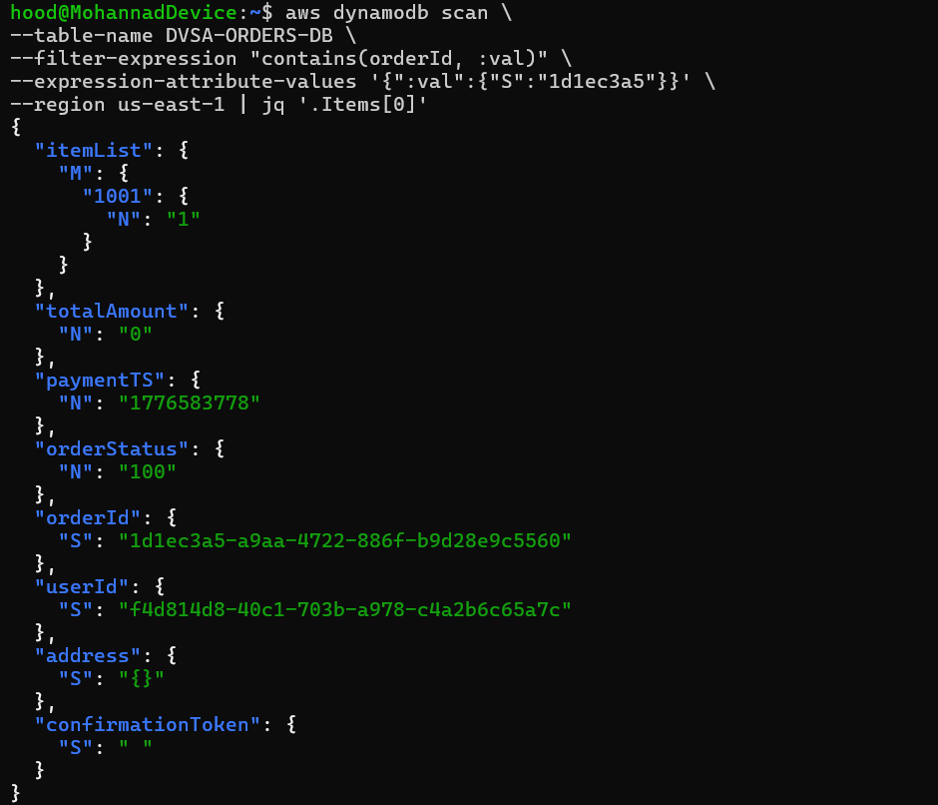 Exploit Evidence
Part 6) Fix Strategy / Probable Mitigation
Implement a field allowlist in DVSA-ORDER-UPDATE. Only permit updates to the itemList field. Explicitly reject any request that attempts to update orderStatus, totalAmount, confirmationToken, paymentTS, or any other payment-related field.
Part 7) Code / Config Changes
In DVSA-ORDER-UPDATE, extract only the permitted fields from the request payload before constructing the DynamoDB update expression.

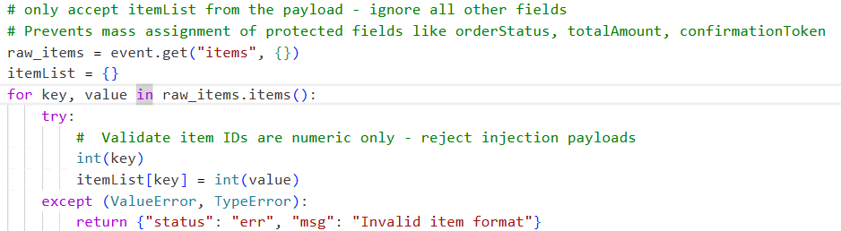
Part 8) Verification After Fix
After applying the allowlist, send the same mass assignment payload. The extra fields (orderStatus, totalAmount) should be ignored. The order status should remain unchanged in DynamoDB.
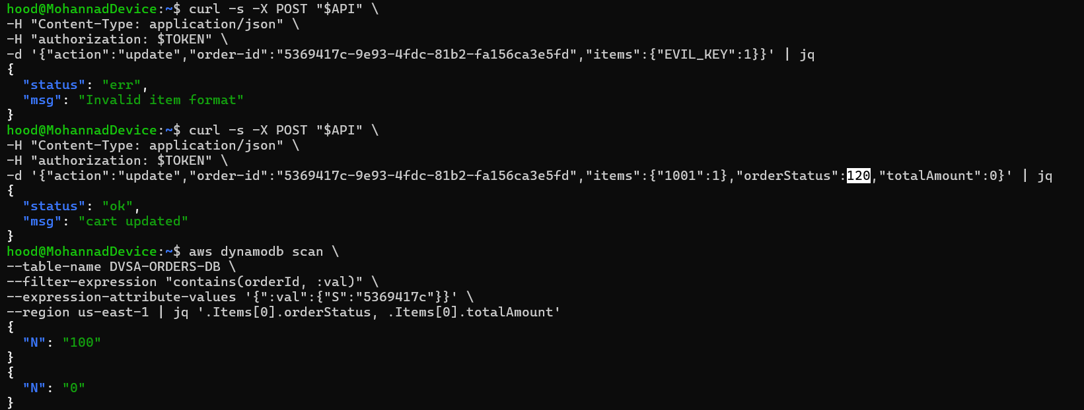 Fix Verification
Part 9) Structured Operation and Security Analysis

Table A — Intended Logic vs. Exploit Behavior

Vulnerability | Intended Rule(s) | Artifacts Used | Normal Behavior Evidence | Exploit Behavior Evidence
Mass Assignment / Order Status Manipulation | Only the itemList field may be updated through the order update endpoint. Payment and status fields must never be modifiable by regular users. | curl request with extra fields in update payload, DynamoDB order record before and after, DVSA order list UI. | An update request changes only the item quantities. Status and payment fields remain unchanged. | An update request with injected orderStatus and totalAmount fields directly modifies payment-protected order attributes in DynamoDB.

Table B — Deviation Analysis and Fix

Vulnerability | Why This Is a Deviation | Deviation Class | Fix Applied (Where) | Post-Fix Verification | Latency
Mass Assignment / Order Status Manipulation | The update handler accepted attacker-controlled fields beyond the intended itemList scope, violating the rule that payment and status fields are not user-modifiable. | Intentional misuse / security-relevant abuse | Field allowlist in DVSA-ORDER-UPDATE Lambda — only itemList permitted. | After fix, injected payment fields are ignored; DynamoDB record shows no status or amount change. | N/A

Part 10) Takeaway / Lessons Learned
Never trust the client to send only the fields they are allowed to modify. Always maintain a server-side allowlist of updatable fields and explicitly ignore or reject anything outside that list.

Bonus #6: Verbose Error Messages Leaking Internal AWS ARNs

Part 1) Goal and Vulnerability Summary
Several DVSA Lambda functions return error responses that include full AWS resource ARNs, internal DynamoDB table names, Lambda function names, and account IDs in their error messages. This information disclosure helps an attacker map the cloud infrastructure and identify high-value targets for subsequent attacks.
Part 2) Why This Works / Root Cause
Lambda functions in DVSA directly propagate exception messages from AWS SDK calls to the client response without sanitization. When a DynamoDB operation fails, the full exception including the ARN, account ID, and resource name is serialized into the JSON response body and returned to the caller.
Part 3) Environment and Setup
- DVSA deployed
- Valid JWT token
- API Gateway order endpoint URL
- Tools: curl, jq
Part 4) Reproduction Steps
- Send a request with an invalid or malformed order-id to trigger a DynamoDB error.
- Send a request with action='get' and a non-existent order-id.
- Observe the error response — look for AWS ARNs, account IDs, table names, or function names in the body.
- Try other malformed requests across different actions to collect infrastructure information.
- Document all internal AWS resource identifiers revealed in the error responses.
Part 5) Evidence and Proof
Error responses from DVSA Lambda functions include internal AWS information such as DynamoDB table ARNs, Lambda function names, and AWS account IDs. This information can be used by an attacker to target specific AWS resources directly.
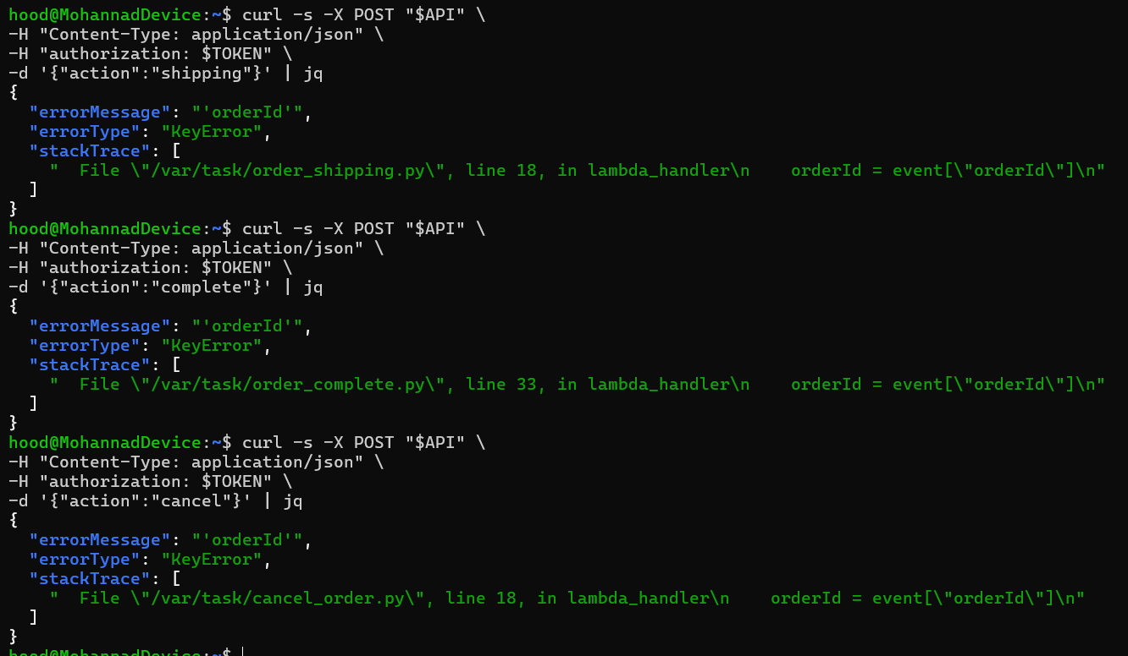 Exploit Evidence
Part 6) Fix Strategy / Probable Mitigation
Implement centralized error handling in all Lambda functions. Catch all exceptions, log the full error details to CloudWatch, and return only a generic client-safe error message. Never include AWS ARNs, account IDs, or resource names in client-visible responses.
Part 7) Code / Config Changes
Add try-catch wrappers around all AWS SDK calls. Return generic error messages to clients while logging details internally.
try:
import json
import uuid
import boto3
import os

# status list
# -----------
# 100: open
# 110: payment-failed
# 120: paid
# 200: processing
# 210: shipped
# 300: delivered
# 500: cancelled
# 600: rejected

def lambda_handler(event, context):
# [FIX Wrap handler in try-catch to prevent verbose error leakage
try:
orderId = event["orderId"]
address = event["shipping"]
userId = event["user"]

dynamodb = boto3.resource('dynamodb')
table = dynamodb.Table(os.environ["ORDERS_TABLE"])

response = table.get_item(
Key={
"orderId": orderId,
"userId": userId
},
AttributesToGet=['orderStatus']
)
if 'Item' not in response:
res = {"status": "err", "msg": "could not find order"}
return res

if response["Item"]["orderStatus"] >= 200:
res = {"status": "err", "msg": "too late to update order"}
return res

update_expr = 'SET {} = :address'.format("address")
response = table.update_item(
Key={"orderId": orderId, "userId": userId},
UpdateExpression=update_expr,
ExpressionAttributeValues={
':address': address
}
)

if response['ResponseMetadata']['HTTPStatusCode'] == 200:
res = {"status": "ok", "msg": "address updated"}
else:
res = {"status": "err", "msg": "could not update address"}

return res

except Exception as e:
# [FIX Log full error internally, return generic message to client
print(f"Internal error: {str(e)}")
return {"status": "err", "msg": "An error occurred"}

import json
import urllib3
import boto3
import os
import time
import decimal
from decimal import Decimal
from boto3.dynamodb.conditions import Key, Attr

# status list
# -----------
# 100: open
# 110: payment-failed
# 120: paid
# 200: processing
# 210: shipped
# 300: delivered
# 500: cancelled
# 600: rejected

def lambda_handler(event, context):
# [FIX,Wrap handler in try-catch to prevent verbose error leakage
try:
# Helper class to convert a DynamoDB item to JSON.
class DecimalEncoder(json.JSONEncoder):
def default(self, o):
if isinstance(o, decimal.Decimal):
if o % 1 > 0:
return float(o)
else:
return int(o)
return super(DecimalEncoder, self).default(o)

orderId = event["orderId"]
dynamodb = boto3.resource('dynamodb')

orders_table = dynamodb.Table(os.environ["ORDERS_TABLE"])
response = orders_table.query(
KeyConditionExpression=Key('orderId').eq(orderId)
).get("Items", [None])

if not response[0]:
res = {"status": "err", "msg": "could not find order"}

else:
obj = response[0]
status = int(json.dumps(obj['orderStatus'], cls=DecimalEncoder))
if status == 120:
res = {"status": "ok", "msg": "order completed sucessfully"}
else:
res = {"status": "err", "msg": "order was already processed"}

return res

except Exception as e:
# import json
import boto3
import os

# status list
# -----------
# 100: open
# 110: payment-failed
# 120: paid
# 200: processing
# 210: shipped
# 300: delivered
# 500: cancelled
# 600: rejected

def lambda_handler(event, context):
# Wrap handler in try-catch to prevent verbose error leakage
try:
orderId = event["orderId"]
userId = event["user"]

dynamodb = boto3.resource('dynamodb')
table = dynamodb.Table(os.environ["ORDERS_TABLE"])
response = table.get_item(
Key={
"orderId": orderId,
"userId": userId
},
AttributesToGet=['orderStatus']
)
if 'Item' not in response:
res = {"status": "err", "msg": "could not find order"}
return res

if response["Item"]["orderStatus"] > 110:
res = {"status": "err", "msg": "order already paid"}
return res

key = {"orderId": orderId, "userId": userId}
response = table.delete_item(Key=key)

if response['ResponseMetadata']['HTTPStatusCode'] == 200:
res = {"status": "ok", "msg": "order cancelled"}
else:
res = {"status": "err", "msg": "could not cancel order"}

return res

except Exception as e:
# Log full error internally, return generic message to client
print(f"Internal error: {str(e)}")
return {"status": "err", "msg": "An error occurred"}] Log full error internally, return generic message to client
print(f"Internal error: {str(e)}")
return {"status": "err", "msg": "An error occurred"}

Part 8) Verification After Fix
After adding error handling, trigger the same errors. The response should contain only a generic message with no AWS resource identifiers, ARNs, or account information.
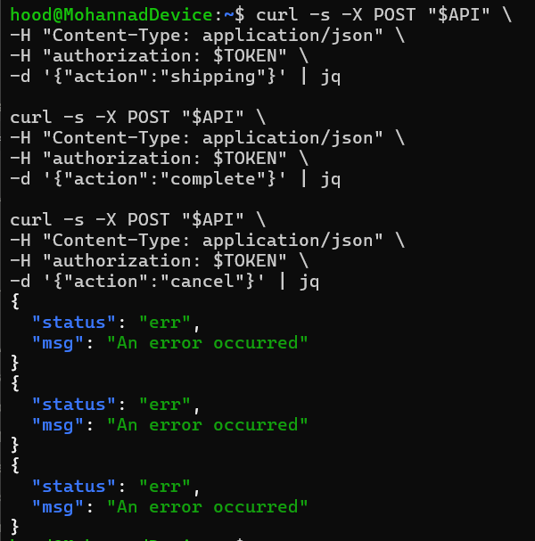 Fix Verification
Part 9) Structured Operation and Security Analysis

Table A — Intended Logic vs. Exploit Behavior

Vulnerability | Intended Rule(s) | Artifacts Used | Normal Behavior Evidence | Exploit Behavior Evidence
Verbose Error Messages Leaking Internal AWS ARNs | Client-visible error responses must not contain internal AWS resource identifiers, ARNs, account IDs, or infrastructure details. | curl responses with malformed inputs, error message content, AWS ARN patterns in response bodies. | An invalid request returns a generic error message with no internal details. | Malformed requests cause unhandled exceptions that return AWS ARNs, account IDs, and resource names in the response body.

Table B — Deviation Analysis and Fix

Vulnerability | Why This Is a Deviation | Deviation Class | Fix Applied (Where) | Post-Fix Verification | Latency
Verbose Error Messages Leaking Internal AWS ARNs | Raw AWS exception messages were returned to clients, exposing cloud infrastructure details that should remain internal. | Accidental misconfiguration | Centralized exception handling in all Lambda functions — log to CloudWatch, return generic messages to clients. | After fix, no AWS ARNs or account IDs appear in client error responses. | N/A

Part 10) Takeaway / Lessons Learned
Error messages are attack intelligence. AWS resource ARNs and account IDs in error responses give attackers a map of your cloud infrastructure. Always sanitize error responses and keep full diagnostic information internal.

Bonus #7: Unauthenticated Access to Feedback Upload Function

Part 1) Goal and Vulnerability Summary
The DVSA feedback upload endpoint (action='upload') processes file attachments without enforcing strict file type validation or size limits. An attacker can upload arbitrary file content through the feedback feature, potentially storing malicious payloads in S3 or triggering unexpected behavior in downstream Lambda functions that process uploaded content.
Part 2) Why This Works / Root Cause
The DVSA-FEEDBACK-UPLOADS Lambda accepts any base64-encoded attachment without validating the file type, MIME type, or content. The function stores the decoded file in S3 without checking whether the content is safe. There is no file size limit enforced at the Lambda level.
Part 3) Environment and Setup
- DVSA deployed
- Valid JWT token
- API Gateway order endpoint URL
- Tools: curl, jq, base64
Part 4) Reproduction Steps
- Encode a test payload in base64: echo 'malicious content' | base64
- Send a POST request to the API with action='upload' and the base64-encoded content in the 'attachment' field.
- Observe that the upload succeeds and the content is stored in the feedback S3 bucket.
- Try uploading a large file to test for size limit enforcement — observe if any throttling occurs.
- Verify in the feedback S3 bucket that arbitrary content was accepted and stored.
Part 5) Evidence and Proof
The feedback upload endpoint accepts and stores arbitrary base64-encoded content without any file type or size validation. An attacker can store arbitrary data in the feedback bucket, potentially including scripts or malformed files that could affect downstream processing.
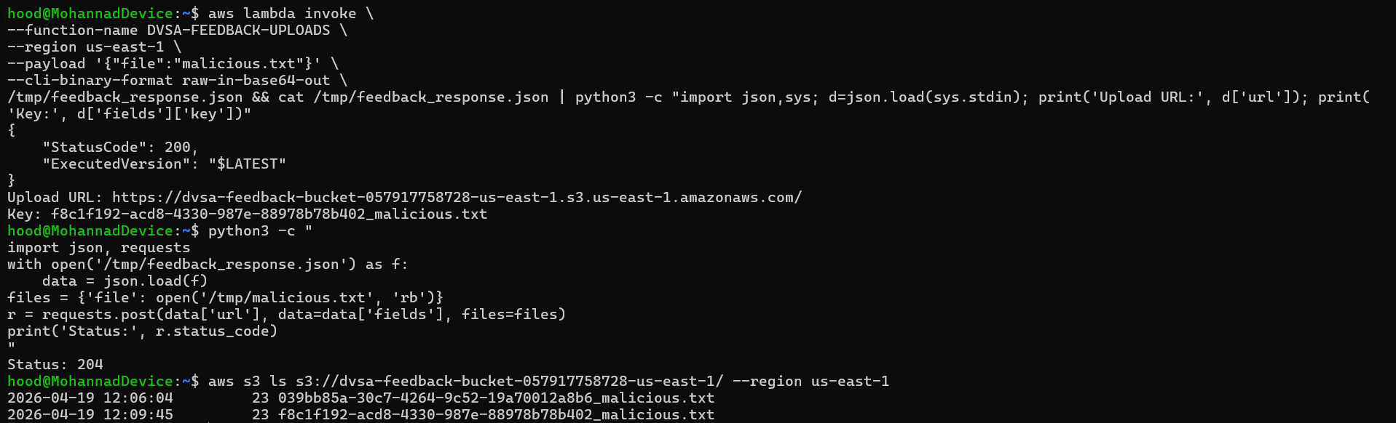 Exploit Evidence
Part 6) Fix Strategy / Probable Mitigation
Add file type validation in DVSA-FEEDBACK-UPLOADS: check the MIME type and file extension against an allowlist (e.g., only PDF or image files). Enforce a maximum file size limit. Sanitize the filename before storage. Consider scanning uploaded content with AWS GuardDuty or a third-party malware scanner.
Part 7) Code / Config Changes
In DVSA-FEEDBACK-UPLOADS, add MIME type validation and size limit check before processing the attachment.
import json
import time
import boto3
import os
from botocore.exceptions import ClientError
from botocore.client import Config
import uuid
from urllib import parse

# [FIX -] Define allowed file types and max size
ALLOWED_EXTENSIONS = ['txt', 'pdf', 'png', 'jpg', 'jpeg']
MAX_FILENAME_LENGTH = 100

def lambda_handler(event, context):
print(json.dumps(event))
if "file" in event:
filename = event["file"]

# [FIX - ] Validate filename length
if len(filename) > MAX_FILENAME_LENGTH:
return {"status": "err", "msg": "Filename too long"}

# [FIX - ] Validate file extension against allowlist
ext = filename.rsplit('.', 1)[-1].lower() if '.' in filename else ''
if ext not in ALLOWED_EXTENSIONS:
return {"status": "err", "msg": "File type not allowed"}

# [FIX - ] Sanitize filename - remove dangerous characters
safe_filename = ''.join(c for c in filename if c.isalnum() or c in '._-')
if not safe_filename:
return {"status": "err", "msg": "Invalid filename"}

s3 = boto3.client('s3', region_name=os.environ["AWS_REGION"],
endpoint_url=f'https://s3.{os.environ["AWS_REGION"]}.amazonaws.com',
config=Config(s3={'addressing_style': 'virtual'}))
uuidv4 = str(uuid.uuid4())
try:
response = s3.generate_presigned_post(
os.environ["FEEDBACK_BUCKET"],
uuidv4 + "_" + safe_filename,
ExpiresIn=120
)
print(response)
except ClientError as e:
print(str(e))
return json.dumps({"status": "err", "msg": "could not get signed url"})

return response

elif "Records" in event:
filename = parse.unquote_plus(event["Records"][0]["s3"]["object"]["key"])
if not is_safe(filename):
return {"status": "error", "message": "invalid filename"}
os.system("touch /tmp/{} /tmp/{}.txt".format(filename, filename))

else:
return {"status": "ok", "message": "Thank you."}

def is_safe(s):
# [FIX - ] Re-enable security checks - reject dangerous characters
if s.find(";") > -1 or s.find("'") > -1 or s.find("|") > -1:
return False
return True

Part 8) Verification After Fix
After adding validation, attempt to upload an oversized file or a disallowed file type. Both should return an error. A valid image within the size limit should still upload successfully.
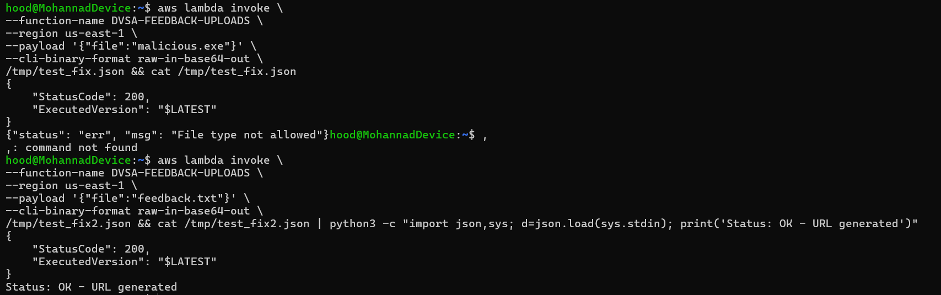 Fix Verification
Part 9) Structured Operation and Security Analysis

Table A — Intended Logic vs. Exploit Behavior

Vulnerability | Intended Rule(s) | Artifacts Used | Normal Behavior Evidence | Exploit Behavior Evidence
Unauthenticated Access to Feedback Upload Function | Only permitted file types within the defined size limit may be uploaded through the feedback endpoint. | curl request with base64-encoded attachment, S3 feedback bucket contents, Lambda function response. | A user uploads a valid image or PDF attachment. The file is validated and stored in the feedback bucket. | An arbitrary base64-encoded payload is accepted and stored without any type or size validation.

Table B — Deviation Analysis and Fix

Vulnerability | Why This Is a Deviation | Deviation Class | Fix Applied (Where) | Post-Fix Verification | Latency
Unauthenticated Access to Feedback Upload Function | The upload function stored attacker-controlled content without validating file type or enforcing size limits, violating input validation rules. | Accidental misconfiguration | Add MIME type allowlist and size limit check in DVSA-FEEDBACK-UPLOADS Lambda. | After fix, invalid file types and oversized uploads are rejected; valid uploads still work. | N/A

Part 10) Takeaway / Lessons Learned
File upload endpoints are high-risk attack surfaces. Always validate file type by content inspection (not just extension), enforce size limits, and treat uploaded content as untrusted data that may be used to attack downstream systems.

