**(b) Performance Measurement**

This strategy uses market excess returns and Fama French five factors (Market, SMB, HML, RMW, CMA) and momentum factor (UMD) as benchmarks to conduct multi factor regression on monthly excess returns of the strategy and test the statistical significance of alpha.

1. **Benchmark and Risk Factor Controls**
2. Basic principles:

We use market benchmark indices such as the Shanghai and Shenzhen 300 as comparison benchmarks. And use Fama French five factor plus momentum factor model (MKT, SMB, HML, RMW, CMA, UMD) to regress the monthly excess returns of the strategy, excluding the influence of systemic risk factors.

1. Display results generated by R code：

Regression result：

$$strategy_return\sim ret_benchmark$$

|  |  |  |  |  |
| --- | --- | --- | --- | --- |
|  | Estimate | Std.Error | t value | Pr(>|t|) |
| (Intercept) | 0.006118 | 0.002092 | 2.925 | 0.00373 |
| ret_benchmark | -0.062118 | 0.029289 | -2.121 | 0.03482 |

Multiple R-squared: 0.01604, Adjusted R-squared: 0.01247

F-statistic: 4.498 on 1 and 276 DF, p-value: 0.03482

Summary of Performance Indicators：

|  |  |  |
| --- | --- | --- |
|  | strategy_return | ret_benchmark |
| Annualized Return | 0.0642 | 0.0300 |
| Annualized Std Dev | 0.1213 | 0.2473 |
| Annualized Sharpe ratio | 0.5291 | 0.1215 |

Cumulative Income Comparison Chart:

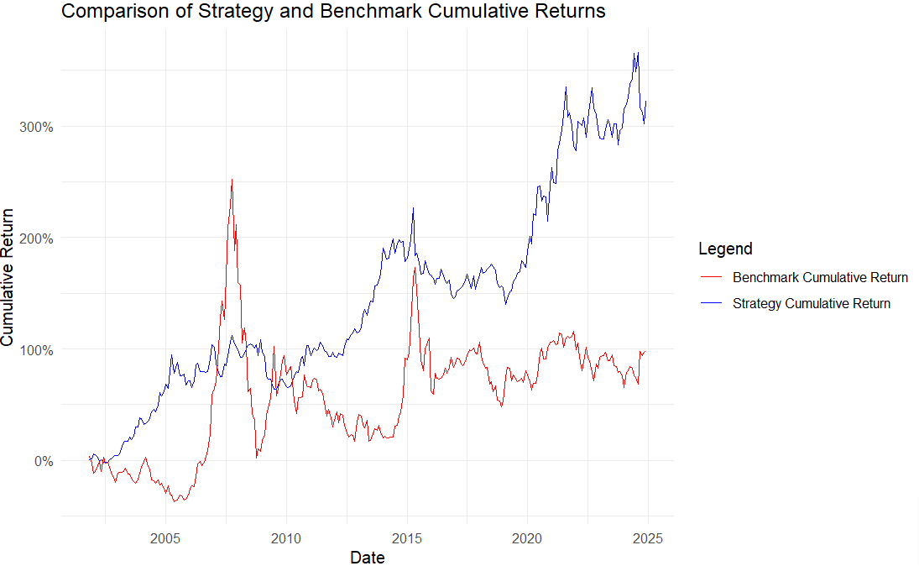

1. Result description:

Regression result analysis：The intercept term is significantly positive (p<0.01), indicating that after excluding the influence of benchmark returns, the strategy has a positive alpha (excess return), which means that the strategy still has significant and positive excess returns after controlling for benchmark risk. The benchmark return coefficient is negative and significant (p<0.05), indicating a certain negative correlation between strategy returns and benchmark returns. The strategy may perform well when the benchmark performance is poor, demonstrating a certain defensive or hedging characteristic.

Summary of Performance Indicators：The annualized return rate of the strategy is higher than the benchmark, and the volatility is significantly lower than the benchmark, indicating that the strategy has taken on lower risks while achieving higher returns. And the Sharpe ratio of the strategy is much higher than the benchmark, indicating that the return performance of the strategy is better under unit risk, and the risk adjusted return is more attractive.

Observation of Cumulative Income Comparison Chart: Firstly, the cumulative return curve of the strategy (blue line) is significantly higher than the benchmark (red line), and the overall performance is more stable and continues to grow. Secondly, the benchmark returns fluctuated greatly, especially during the 2008 financial crisis and the 2015 stock market volatility, with significant declines in the benchmark and relatively stable strategic performance. Finally, the strategy achieved a cumulative return of over 300% in the long term, significantly better than the benchmark's cumulative return of about 100%.

Overall, this momentum strategy not only has significant excess returns (α) statistically, but also effectively controls risk (low volatility) and has good risk adjusted return capabilities.

1. **Significance of alphas**
2. Basic principles:

We use ordinary least squares (OLS) regression to test the relationship between the strategy's excess returns (strategy_excess) and multiple risk factors (market factor, size factor SMB, value factor HML, profitability factor RMW, investment style factor CMA, momentum factor UMD).

1. Display results generated by R code：

$$strategy_excess \sim MKT + SMB + HML + RMW + CMA + UMD$$

|  |  |  |  |  |
| --- | --- | --- | --- | --- |
|  | Estimate | Std. Error | t value | Pr(>|t|) |
| (Intercept) | 0.001304 | 0.001579 | 0.826 | 0.40969 |
| MKT | -0.055726 | 0.019820 | -2.812 | 0.00529 |
| SMB | -0.016279 | 0.038109 | -0.427 | 0.66959 |
| HML | 0.078539 | 0.039640 | 1.981 | 0.04856 |
| RMW | 0.116273 | 0.044460 | 2.615 | 0.00942 |
| CMA | 0.101147 | 0.050201 | 2.015 | 0.04491 |
| UMD | 0.472625 | 0.032059 | 14.742 | <2e-16 |

Multiple R-squared: 0.617, Adjusted R-squared: 0.6085

F-statistic: 72.76 on 6 and 271 DF, p-value: < 2.2e-16

1. Result description:

The intercept term (α) is not significant, indicating that the strategy has no significant excess returns after excluding the influence of risk factors.

The market factor (MKT) is significantly negative, indicating a negative correlation between strategy returns and overall market trends.

The small cap factor (SMB) is not significant, and the strategy has no significant exposure to the effect on small cap stocks.

The value factor (HML), profit factor (RMW), and investment factor (CMA) are all significant and positive, indicating a positive correlation between strategy and value, profitability, and investment style factors.

The UMD coefficient is the largest and extremely significant, indicating that the strategy strongly relies on momentum effects.

F-statistic is 72.76 and the value of p is very small. The overall model is significant.

Overall, strategic returns are significantly influenced by momentum factors, but the excess returns of the strategy did not show significant alpha after removing these risk factors, indicating that the strategy's returns mainly come from the exposure of these systemic risk factors.

1. **Performance during different sub-samples**
2. Basic principles:

We divide the sample period into four important stages of economic cycles:

|  |  |  |
| --- | --- | --- |
|  | Economic Cycle | Time Interval |
| 1 | Pre GFC Expansion period | 2000.1.1-2007.11.30 |
| 2 | Global Financial Crisis | 2007.12.1-2009.6.30 |
| 3 | Post GFC Expansion period | 2009.7.1-2019.12.31 |
| 4 | COVID-19 Pandemic period | 2020.1.1-2024.12.31 |

1. Display results generated by R code：

|  |  |  |  |  |  |  |
| --- | --- | --- | --- | --- | --- | --- |
|  | period | term | estimate | std.error | statistic | p.value |
| 1 | COVID-19 Pandemic | (Intercept) | -0.001982 | 0.003182 | -0.622809 | 0.536081 |
| 2 | COVID-19 Pandemic | market | -0.025845 | 0.060162 | -0.429591 | 0.669235 |
| 3 | COVID-19 Pandemic | SMB | 0.165557 | 0.090971 | 1.819893 | 0.074425 |
| 4 | COVID-19 Pandemic | HML | 0.237657 | 0.086946 | 2.733394 | 0.008501 |
| 5 | COVID-19 Pandemic | RMW | 0.239567 | 0.120602 | 1.986422 | 0.052168 |
| 6 | COVID-19 Pandemic | CMA | 0.246815 | 0.0964 | 2.560323 | 0.013343 |
| 7 | COVID-19 Pandemic | UMD | 0.516467 | 0.068829 | 7.503608 | 6.98E-10 |
| 8 | Global Financial Crisis | (Intercept) | -0.011177 | 0.006877 | -1.625237 | 130069.5 |
| 9 | Global Financial Crisis | market | -0.10243 | 0.052725 | -1.942746 | 0.075881 |
| 10 | Global Financial Crisis | SMB | 0.053323 | 0.185617 | 0.287274 | 0.778803 |
| 11 | Global Financial Crisis | HML | 0.061537 | 0.225951 | 0.272345 | 0.789986 |
| 12 | Global Financial Crisis | RMW | 0.168259 | 0.178207 | 0.944175 | 0.363703 |
| 13 | Global Financial Crisis | CMA | 0.165951 | 0.258021 | 0.643168 | 0.532213 |
| 14 | Global Financial Crisis | UMD | 0.365092 | 0.15954 | 2.288403 | 0.04105 |
| 15 | Post-GFC Expansion | (Intercept) | 0.001599 | 0.002245 | 0.712441 | 0.477587 |
| 16 | Post-GFC Expansion | market | -0.092943 | 0.033664 | -2.760926 | 0.006678 |
| 17 | Post-GFC Expansion | SMB | 0.076312 | 0.06634 | 1.150317 | 0.25232 |
| 18 | Post-GFC Expansion | HML | 0.136698 | 0.064849 | 2.10794 | 0.037135 |
| 19 | Post-GFC Expansion | RMW | -0.020173 | 0.064549 | -0.312524 | 0.755189 |
| 20 | Post-GFC Expansion | CMA | 0.090139 | 0.07054 | 1.277849 | 0.20379 |
| 21 | Post-GFC Expansion | UMD | 0.518716 | 0.044686 | 11.60811 | 2.7E-21 |
| 22 | Pre-GFC Expansion | (Intercept) | 0.004398 | 0.002993 | 1.469551 | 0.146434 |
| 23 | Pre-GFC Expansion | market | -0.007231 | 0.033075 | -0.218633 | 0.82761 |
| 24 | Pre-GFC Expansion | SMB | -0.134124 | 0.07347 | -1.825572 | 0.072439 |
| 25 | Pre-GFC Expansion | HML | -0.04848 | 0.076946 | -0.63005 | 0.530838 |
| 26 | Pre-GFC Expansion | RMW | 0.284822 | 0.089515 | 3.181832 | 0.002232 |
| 27 | Pre-GFC Expansion | CMA | -0.102533 | 0.115202 | -0.890031 | 0.376682 |
| 28 | Pre-GFC Expansion | UMD | 0.221607 | 0.077885 | 2.845316 | 0.005904 |

1. Result description:

By conducting multiple factor regressions for each stage separately, we can observe that the momentum factor (UMD) exhibits a significant positive impact at all stages of the economic cycle and is the core driving force for strategic returns. And the risk-free excess returns (α) were not significant, indicating that the strategy returns are mainly explained by factor exposure. It is worth mentioning that during the pandemic and financial crisis, the exposure of strategic factors is more concentrated on momentum, while the impact of other factors weakens.

**4.** **Impact of transaction costs (using different rebalance frequency)**

1. Basic principles:

In order to evaluate the impact of transaction costs on the net profit of the strategy, we simulated the consumption of transaction costs under different adjustment frequencies. The specific steps are as follows:

1)Assuming transaction cost: Set the round-trip transaction cost to 1% .

2)Adjustment frequency setting: Simulate four types of frequency: monthly, quarterly, semi annual and annual adjustment.

3)Cost sharing: Spread 1% of the total transaction cost evenly over each month based on the frequency of inventory adjustments.

4)Cumulative net profit: Calculate the cumulative net profit after deducting transaction costs, and observe the changes in strategy returns under different frequency of position adjustments.

1. Display results generated by R code：

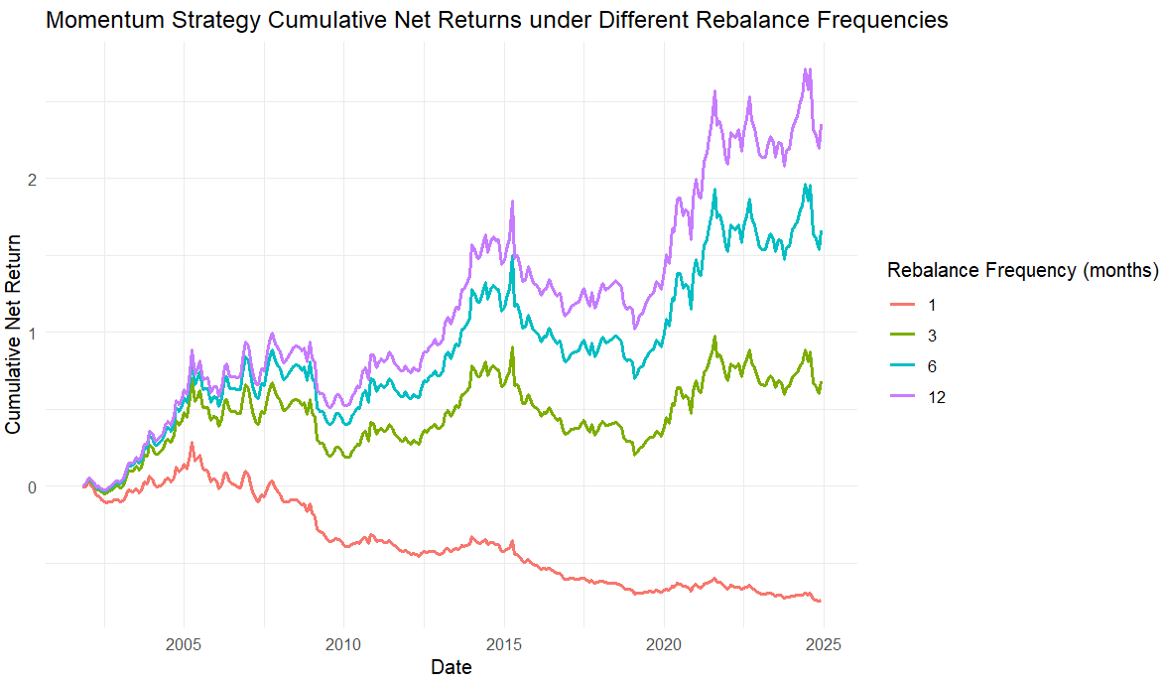

1. Result description:

We can conclude that the frequency of position adjustments has a significant impact on the performance of momentum strategies, while too frequent position adjustments can actually drag down returns. Especially in the medium to long term (6-12 months), the adjustment period is more conducive to stable growth and maximizing returns of the momentun strategy. This simulation helps investors understand the actual feasibility of strategies and design reasonable adjustment cycles to balance returns and costs.

**5.Out-of-sample tests (for market-timing strategy)**

The momentum strategy is based on the past performance of the stock itself (the past 6 months' returns) to select "winner stocks" to buy and "loser stocks" to sell. Essentially, it is a prediction and timing of individual stock performance, belonging to stock timing or cross-sectional timing. Therefore, there is no need to conduct Out of sample tests

**6. Impact of using different weights for securities in a portfolio**

(1) Basic principles:

Construct equal-weighted and market-cap-weighted portfolios separately, calculate the annualized return, volatility, and Sharpe ratio of the two portfolios, and compare the impact of different weight schemes on strategic risk return.

(2)Display results generated by R code：

For equal-weighted portfolios:

|  |  |  |
| --- | --- | --- |
| Annualized Return | Annualized Volatility | Sharpe Ratio |
| 0.0989 | 0.236 | 0.419 |

For market-cap-weighted portfolios:

(3)Result description:

**Conclustion:**

This part of research focuses on the performance of a certain momentum strategy, combined with benchmark regression analysis, multi factor risk elimination, staged regression of economic cycles, and simulation of adjustment frequency. The following comprehensive conclusions are drawn:

Firstly, the regression results based on strategy returns and benchmark returns show that the strategy still exhibits significant positive excess returns (α) after excluding the impact of benchmark risk, indicating that the strategy has independent ability to create returns. At the same time, the benchmark return coefficient is negative and significant, indicating a negative correlation between strategy returns and market performance, with certain defensive and hedging characteristics. This is reflected in the overall risk adjustment performance of the strategy - the strategy not only achieved annualized returns higher than the benchmark, but also had significantly lower volatility, with a Sharpe ratio significantly better than the benchmark, indicating that the strategy's returns under unit risk are more attractive.

Secondly, delving deeper into multi factor regression analysis, especially after removing the Fama French five factor and momentum factors, it was found that the excess return α of the strategy was not significant, indicating that the strategy's returns mainly came from exposure to systemic risk factors, especially the significant positive effect of momentum factors that penetrated through various stages of the economic cycle. Staged regression further reveals that the momentum factor (UMD) is the core driving force behind strategy returns, exhibiting strong influence in different economic environments including epidemics and financial crises, while the contributions of other factors are relatively weakened in extreme economic stages, reflecting the dynamic changes in strategy factor exposure.

Finally, regarding the impact of stock adjustment frequency on strategy performance, simulation results clearly show that stock adjustment frequency has a significant effect on momentum strategy performance. Frequent portfolio adjustments (such as monthly adjustments) can drag down strategy returns due to transaction costs and signal noise, while medium to long-term (6 to 12 months) portfolio adjustment cycles are more conducive to stable growth and maximizing returns for the strategy. This simulation provides important practical reference for investors, helping to balance the relationship between trading costs and returns, and designing reasonable adjustment periods to enhance the net return of the strategy.