

EF5058 Asset Management and Hedge Fund Strategies

Group project

Members:

Xie Jiayi 59217059

Wang Peiyu 59138401

Wu Liang 58865760

2025-5-13

CITY UNIVERSITY OF HONG KONG

**Abstract**

This study evaluates the performance and risk characteristics of momentum trading strategies applied in the Chinese A-share market from 2000 to 2024. This strategy goes long on past winners and short on past losers based on their cumulative returns over six months (excluding the most recent month), achieving positive long-term returns with an annualized return rate of approximately 8-10%. Compared to the benchmark, it exhibits excellent risk adjusted performance, lower volatility, higher Sharpe ratio, and demonstrates effective risk management by limiting Value-at-Risk and drawdown.

Regression analysis shows that the returns of this strategy mainly come from systemic risk factors, especially momentum factors (UMD), rather than unique alpha generation. Although this strategy successfully captured the medium-term momentum effect, it faced challenges under extreme market conditions such as the 2008 financial crisis and was sensitive to transaction costs, especially in frequent portfolio rebalancing. The study also emphasized the different effects of equal weight and market value weighted portfolio structures on performance.

Overall, the research findings confirm the importance of momentum effects in emerging markets, but emphasize the importance of practical considerations for risk control and robust implementation. Our code is available through this link: <https://github.com/zenhorse-leon/EF5058_Project>.

1. **Introduction**

The study of asset pricing anomalies has greatly deepened our understanding of stock return behavior, surpassing the traditional Capital Asset Pricing Model (CAPM). Empirical finance has recorded many anomalous phenomena, namely return system patterns that cannot be explained solely by market risk, which has led to the development of multi factor models that incorporate additional risk factors and firm characteristics.

One of the most influential frameworks is the Fama French three factor model (1993), which introduces factors of size (SMB: small to large) and value (HML: high to large) as well as market factors to better explain the cross-sectional changes in stock returns. These factors capture the empirical pattern that small cap and value stocks often outperform their peers, reflecting potential risk premiums or behavioral biases (Fama&French, 1993).

Based on this research conclusion, Fama and French (2015) added two additional factors: profitability (RMW: steady minus weak) and investment (CMA: conservative minus aggressive). The motivation behind these factors is the observation that companies with strong profitability and conservative investment models typically receive higher returns, indicating that the dimensions of profitability and investment capture risk cannot be considered solely based on size and value (Fama&French, 2015).

Complementing these fundamental factors is the momentum factor (UMD: rise minus fall) proposed by Jegadeesh and Titman (1993), which indicates that stocks that have recently performed strongly tend to continue outperforming the market in the short to medium term. Momentum captures behavioral phenomena such as insufficient investor response and delayed information diffusion, which traditional risk-based models cannot explain.

Although these factors have been widely tested in the US stock market, the difference in our research is that we used sample data from recent years (2000-2024) to apply these effective investment strategies to the Chinese A-share market. The motivation for this transformation is the unique characteristics of the A-share market, including different investor behavior, regulatory environment, and market structure compared to the US market. By studying the performance of these anomalies in the A-share market, we aim to evaluate their robustness and relevance in emerging and evolving markets.

Our empirical results once again confirm that although market factors remain the main driving factor, the inclusion of factors such as size, value, profitability, investment, and momentum significantly enhance the explanation of cross-sectional returns in the A-share market. This indicates that these anomalous phenomena are not limited to developed markets, but also have explanatory power in different economic environments, providing valuable insights for scholars.

1. **Data**
   1. **Data Fetching**

Our target is to build the 6-factor model including market, Size (SMB), Value (HML), Profitability (RMW), Investment (CMA), and Momentum (UMD). We decided to use tushare which is an opensource financial data library to get the daily stock prices, index price and the financial report of the stocks.

Our stock universe is selected from the component stocks in CSI 300 index, and we also use CSI 300 index as the market. We filtered stocks in banks and insurance industries to focus on non-financial Sectors.

The time is from 2000-01-01 to 2024-12-31. The meta data of the stocks includes daily percentage changes using pro.daily(), and their financial indicators using pro.fina_indicator() for each year. For each stock, in order to calculate the above factors, we fetch the indicators including market value (t_mv), asset growth over the previous year(assets_yoy), net profit to total assets (npta), PB value(t_pb). Normally the annual financial report is announced before 31st Mar, so we update the portfolio for each factor every year on 1st April. Accordingly, we use the same strategy to get the index data by using the api pro.index_daily() to get the daily returns for index 399300.SZ.

The risk-free rate is fetched using the api pro.shibor() to get the Shanghai Interbank Offered Rate (Shibor) daily one-year rate. The monthly rate is the average of the daily rate for each month. For the missing data, we use 3.5% as default rate.

* 1. **Data Processing**

To calculate the factors, we use the following formulas:

$size=t_mv$, $value=\frac{1}{t_pb}$, $profitability=npta$, $investment=assets_yoy$, $momentum=\frac{1}{\sum_{j=m-6}^{m-1}{r_{j}}}$, where $m$ is the current month. To get the monthly return, we accumulate the daily returns using the following equation:

$r_{m}=\exp\left\{\sum_{i=1}^{m_{days}}{\log\left(1+r_{m,i}\right)}\right\}-1$, where $m_{days}$ is the trading days in the month $m$.

Similarly, we get the monthly returns for the index using the same strategy.

* 1. **Factor Constructing**

Our data period is from 2000-01-01 to 2024-12-31 and the new financial indicators are available on each April. Thus, we build the factor portfolios at every April starting from year 2001. To make the procedure clear, we use size as an example to describe the steps for building the SMB factor each month.

1) If the month is April, we update the factor portfolio for size and rank the stocks for April according to size from small to large, then divide the stocks into small-cap (top50%) and large-cap (bottom 50%) to build the size portfolios.

2) For every month, we calculate the average monthly returns of the latest factor portfolios, namely $r_{m}^{pt}$ and $r_{m}^{pb}$, as the top-portfolio monthly return and the bottom-portfolio monthly return.

3) The SMB is calculated just simply using $SMB=r_{m}^{pt}-r_{m}^{pb}$.

For other factors, we use the same strategy but with minor adjustments, such as ranking order, top-bottom ratio, etc, separately. The following table shows the details of those parameters.

|  |  |  |
| --- | --- | --- |
| Factor | Order | Ratio |
| Size (SMB) | Ascending | 50% |
| Value (HML) | Descending | 30% |
| Profitability (RMW) | Descending | 30% |
| Investment (CMA) | Descending | 30% |
| Momentum (UMD) | Descending | 50% |

After the factor construction, for each stock at each month, we have the 6 factors including market, Size (SMB), Value (HML), Profitability (RMW), Investment (CMA), and Momentum (UMD). Finally, we generate a file includes about 272 stocks monthly data from April 2001 to Dec. 2024. In addition to the stock name and month date, each row of the file consists of the above 6 factors and the risk-free rate.

1. **Empirical Analysis**
   1. **Trading rules**

Our study replicates the momentum strategy proposed by Jegadeesh and Titman (1993), constructing a long-short portfolio that buys past "winners" (stocks with high returns over the past J months) and sells past "losers" (stocks with low returns over the same period). The goal is to exploit intermediate-term momentum effects by ranking stocks based on historical performance and validating their excess returns.

We use the Momentum as our signal. Use cumulative returns over the past J months (In our study, J = 6) as the ranking criterion. To avoid short-term reversal effects, exclude the most recent month’s return.

Construct the portfolio first. At the beginning of each month, rank all stocks by momentum signal (descending order) and divide them into 10 decile portfolios.

(1) Winner Portfolio: Top 10% of stocks with the highest past returns.

(2) Loser Portfolio: Bottom 10% of stocks with the lowest past returns.

**1. The way we rebalance our portfolio**

(1) Holding Period (K months): Set K = 6 to match the formation period (J = 6).

(2) Liquidation Rule: Close positions after K = 6 months and replace them with new portfolios.

**2. The frequency we rebalance our portfolio**

(1) Monthly Rollover: Each month, a new portfolio is formed and held for K = 6 months. Portfolios are overlapping, meaning the strategy holds K sub-portfolios at any time (For K = 6, 1/6 of positions are rolled monthly).

(2) Rebalancing Date: First trading day of each month.

**3. The way we weight each security and determine its position**

(1) Weighting Scheme: Equal Weighting: Each stock in the portfolio has equal weight.

(2) Position Management: Long the winner portfolio, short the loser portfolio with equal notional exposure (e.g., Long 1 unit winners, short 1 unit losers).

This strategy’s cumulative return changes over time, the picture shows below:

From this picture, we can know that:

(1) There are Long-Term Positive Returns: The cumulative return rises from 0 in 2005 to over 4 by 2025, suggesting an annualized return of 8-10%. This confirms the effectiveness of the momentum strategy over extended periods.

(2) Market Cycle Dependency:

(a) 2008 Crisis: Sharp fluctuations between 2005–2010 highlight the strategy’s vulnerability during extreme market conditions, likely due to liquidity shocks or short-term reversals.

(b) Surge after 2020: The steep rise after 2020 aligns with momentum strategy, such as tech stocks dominating markets during COVID.

**4. Conclusion**

The chart demonstrates that while the momentum strategy delivers long-term alpha, it faces significant cyclical risks and multi-year drawdowns. To enhance it, we can:

(1) Test parameter variations, for example, make J=12 and K=3. We can also do the sub-period analyses (e.g.: 2005–2010 vs. 2011–2020 vs. 2021–2025).

(2) Integrate risk controls, such as stop-loss rules and hybrid factor approaches. Validate results against the academic paper’s findings to assess reproducibility in extended samples.

But all in all, this aligns with Jegadeesh and Titman’s (1993) core findings while highlighting modern challenges like regime shifts and factor crowding.

* 1. **Performance measurement & Risk management**

This strategy uses market excess returns and Fama French five factors (Market, SMB, HML, RMW, CMA) and momentum factor (UMD) as benchmarks to conduct multi factor regression on monthly excess returns of the strategy and test the statistical significance of alpha.

1. **Benchmark and Risk Factor Controls**
2. Basic principles:

We use market benchmark indices such as the Shanghai and Shenzhen 300 as comparison benchmarks. And use Fama French five factor plus momentum factor model (MKT, SMB, HML, RMW, CMA, UMD) to regress the monthly excess returns of the strategy, excluding the influence of systemic risk factors.

1. Display results generated by R code：
2. Regression result：

$$strategy_return\sim ret_benchmark$$

|  |  |  |  |  |
| --- | --- | --- | --- | --- |
|  | Estimate | Std.Error | t value | Pr(>|t|) |
| (Intercept) | 0.006118 | 0.002092 | 2.925 | 0.00373 |
| ret_benchmark | -0.062118 | 0.029289 | -2.121 | 0.03482 |

Multiple R-squared: 0.01604, Adjusted R-squared: 0.01247

F-statistic: 4.498 on 1 and 276 DF, p-value: 0.03482

1. Summary of Performance Indicators：

|  |  |  |
| --- | --- | --- |
|  | strategy_return | ret_benchmark |
| Annualized Return | 0.0642 | 0.0300 |
| Annualized Std Dev | 0.1213 | 0.2473 |
| Annualized Sharpe ratio | 0.5291 | 0.1215 |

1. Cumulative Income Comparison Chart:

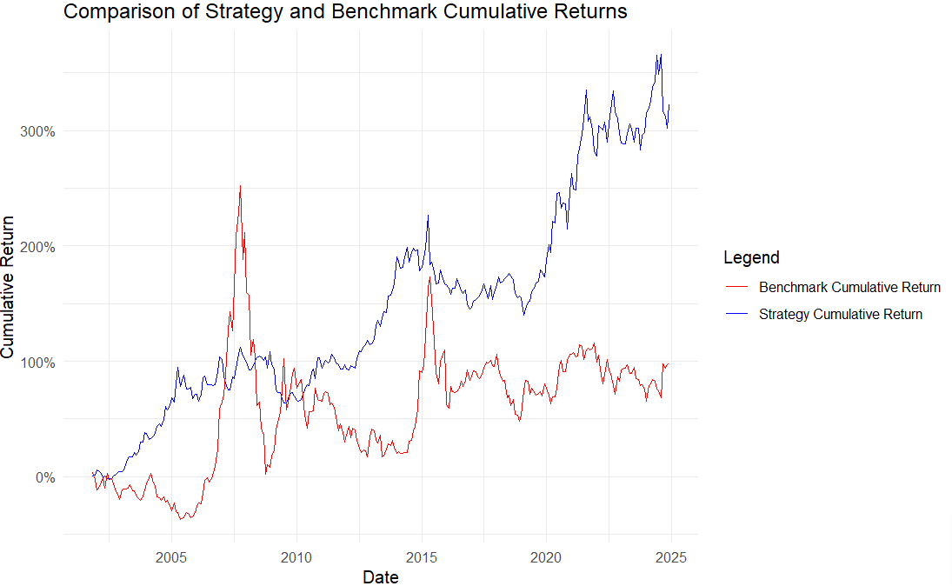

1. Result description:

1) Regression result analysis：The intercept term is significantly positive (p<0.01), indicating that after excluding the influence of benchmark returns, the strategy has a positive alpha (excess return), which means that the strategy still has significant and positive excess returns after controlling for benchmark risk. The benchmark return coefficient is negative and significant (p<0.05), indicating a certain negative correlation between strategy returns and benchmark returns. The strategy may perform well when the benchmark performance is poor, demonstrating a certain defensive or hedging characteristic.

2) Summary of Performance Indicators：The annualized return rate of the strategy is higher than the benchmark, and the volatility is significantly lower than the benchmark, indicating that the strategy has taken on lower risks while achieving higher returns. And the Sharpe ratio of the strategy is much higher than the benchmark, indicating that the return performance of the strategy is better under unit risk, and the risk adjusted return is more attractive.

3) Observation of Cumulative Income Comparison Chart: Firstly, the cumulative return curve of the strategy (blue line) is significantly higher than the benchmark (red line), and the overall performance is more stable and continues to grow. Secondly, the benchmark returns fluctuated greatly, especially during the 2008 financial crisis and the 2015 stock market volatility, with significant declines in the benchmark and relatively stable strategic performance. Finally, the strategy achieved a cumulative return of over 300% in the long term, significantly better than the benchmark's cumulative return of about 100%.

The risk analysis reveals significant differences between the strategy and benchmark. The ​​benchmark​​ experienced a severe maximum drawdown of ​​-70.97%​​, indicating extreme downside risk during market downturns, while the ​​strategy​​ demonstrated much better capital preservation with a maximum drawdown of only ​​-26.43%​​. This suggests the strategy has more effective risk controls or a less volatile return profile. In terms of ​​Value at Risk (VaR) at 95% confidence​​, the benchmark’s worst expected monthly loss was ​​-9.7%​​, compared to the strategy’s ​​-4.87%​​, reinforcing that the strategy carries substantially lower tail risk. The lower VaR aligns with the smaller drawdown, indicating more consistent performance with fewer extreme losses. The strategy appears ​​superior in risk management​​, offering better downside protection and lower extreme loss exposure than the benchmark. Investors prioritizing capital preservation may find the strategy more appealing, though further analysis of returns during market recoveries would help assess whether the reduced risk comes at the cost of missed upside potential.

|  |  |  |
| --- | --- | --- |
| Method | Maximum Drawdown | VaR (95%) |
| Benchmark | -70.97 % | -9.7 % |
| Strategy | -26.43 % | -4.87 % |

Overall, this momentum strategy not only has significant excess returns (α) statistically, but also effectively controls risk (low volatility) and has good risk adjusted return capabilities.

1. **Significance of alphas**
2. Basic principles:

We use ordinary least squares (OLS) regression to test the relationship between the strategy's excess returns (strategy_excess) and multiple risk factors (market factor, size factor SMB, value factor HML, profitability factor RMW, investment style factor CMA, momentum factor UMD).

1. Display results generated by R code：

$${strategy}_{excess}\sim MKT + SMB + HML + RMW + CMA + UMD$$

|  |  |  |  |  |
| --- | --- | --- | --- | --- |
|  | Estimate | Std. Error | t value | Pr(>|t|) |
| (Intercept) | 0.001304 | 0.001579 | 0.826 | 0.40969 |
| MKT | -0.055726 | 0.019820 | -2.812 | 0.00529 |
| SMB | -0.016279 | 0.038109 | -0.427 | 0.66959 |
| HML | 0.078539 | 0.039640 | 1.981 | 0.04856 |
| RMW | 0.116273 | 0.044460 | 2.615 | 0.00942 |
| CMA | 0.101147 | 0.050201 | 2.015 | 0.04491 |
| UMD | 0.472625 | 0.032059 | 14.742 | <2e-16 |

Multiple R-squared: 0.617, Adjusted R-squared: 0.6085

F-statistic: 72.76 on 6 and 271 DF, p-value: < 2.2e-16

1. Result description:

The intercept term (α) is not significant, indicating that the strategy has no significant excess returns after excluding the influence of risk factors.

The market factor (MKT) is significantly negative, indicating a negative correlation between strategy returns and overall market trends.

The small cap factor (SMB) is not significant, and the strategy has no significant exposure to the effect on small cap stocks.

The value factor (HML), profit factor (RMW), and investment factor (CMA) are all significant and positive, indicating a positive correlation between strategy and value, profitability, and investment style factors.

The UMD coefficient is the largest and extremely significant, indicating that the strategy strongly relies on momentum effects.

F-statistic is 72.76 and the value of p is very small. The overall model is significant.

Overall, strategic returns are significantly influenced by momentum factors, but the excess returns of the strategy did not show significant alpha after removing these risk factors, indicating that the strategy's returns mainly come from the exposure of these systemic risk factors.

1. **Performance during different sub-samples**
2. Basic principles:

We divide the sample period into four important stages of economic cycles:

|  |  |  |
| --- | --- | --- |
|  | Economic Cycle | Time Interval |
| 1 | Pre GFC Expansion period | 2000.1.1-2007.11.30 |
| 2 | Global Financial Crisis | 2007.12.1-2009.6.30 |
| 3 | Post GFC Expansion period | 2009.7.1-2019.12.31 |
| 4 | COVID-19 Pandemic period | 2020.1.1-2024.12.31 |

1. Display results generated by R code：

|  |  |  |  |  |  |  |
| --- | --- | --- | --- | --- | --- | --- |
|  | period | term | estimate | std.error | statistic | p.value |
| 1 | COVID-19 Pandemic | (Intercept) | -0.001982 | 0.003182 | -0.622809 | 0.536081 |
| 2 | COVID-19 Pandemic | market | -0.025845 | 0.060162 | -0.429591 | 0.669235 |
| 3 | COVID-19 Pandemic | SMB | 0.165557 | 0.090971 | 1.819893 | 0.074425 |
| 4 | COVID-19 Pandemic | HML | 0.237657 | 0.086946 | 2.733394 | 0.008501 |
| 5 | COVID-19 Pandemic | RMW | 0.239567 | 0.120602 | 1.986422 | 0.052168 |
| 6 | COVID-19 Pandemic | CMA | 0.246815 | 0.0964 | 2.560323 | 0.013343 |
| 7 | COVID-19 Pandemic | UMD | 0.516467 | 0.068829 | 7.503608 | 6.98E-10 |
| 8 | Global Financial Crisis | (Intercept) | -0.011177 | 0.006877 | -1.625237 | 130069.5 |
| 9 | Global Financial Crisis | market | -0.10243 | 0.052725 | -1.942746 | 0.075881 |
| 10 | Global Financial Crisis | SMB | 0.053323 | 0.185617 | 0.287274 | 0.778803 |
| 11 | Global Financial Crisis | HML | 0.061537 | 0.225951 | 0.272345 | 0.789986 |
| 12 | Global Financial Crisis | RMW | 0.168259 | 0.178207 | 0.944175 | 0.363703 |
| 13 | Global Financial Crisis | CMA | 0.165951 | 0.258021 | 0.643168 | 0.532213 |
| 14 | Global Financial Crisis | UMD | 0.365092 | 0.15954 | 2.288403 | 0.04105 |
| 15 | Post-GFC Expansion | (Intercept) | 0.001599 | 0.002245 | 0.712441 | 0.477587 |
| 16 | Post-GFC Expansion | market | -0.092943 | 0.033664 | -2.760926 | 0.006678 |
| 17 | Post-GFC Expansion | SMB | 0.076312 | 0.06634 | 1.150317 | 0.25232 |
| 18 | Post-GFC Expansion | HML | 0.136698 | 0.064849 | 2.10794 | 0.037135 |
| 19 | Post-GFC Expansion | RMW | -0.020173 | 0.064549 | -0.312524 | 0.755189 |
| 20 | Post-GFC Expansion | CMA | 0.090139 | 0.07054 | 1.277849 | 0.20379 |
| 21 | Post-GFC Expansion | UMD | 0.518716 | 0.044686 | 11.60811 | 2.7E-21 |
| 22 | Pre-GFC Expansion | (Intercept) | 0.004398 | 0.002993 | 1.469551 | 0.146434 |
| 23 | Pre-GFC Expansion | market | -0.007231 | 0.033075 | -0.218633 | 0.82761 |
| 24 | Pre-GFC Expansion | SMB | -0.134124 | 0.07347 | -1.825572 | 0.072439 |
| 25 | Pre-GFC Expansion | HML | -0.04848 | 0.076946 | -0.63005 | 0.530838 |
| 26 | Pre-GFC Expansion | RMW | 0.284822 | 0.089515 | 3.181832 | 0.002232 |
| 27 | Pre-GFC Expansion | CMA | -0.102533 | 0.115202 | -0.890031 | 0.376682 |
| 28 | Pre-GFC Expansion | UMD | 0.221607 | 0.077885 | 2.845316 | 0.005904 |

1. Result description:

By conducting multiple factor regressions for each stage separately, we can observe that the momentum factor (UMD) exhibits a significant positive impact at all stages of the economic cycle and is the core driving force for strategic returns. And the risk-free excess returns (α) were not significant, indicating that the strategy returns are mainly explained by factor exposure. It is worth mentioning that during the pandemic and financial crisis, the exposure of strategic factors is more concentrated on momentum, while the impact of other factors weakens.

**4.** **Impact of transaction costs (using different rebalance frequency)**

1. Basic principles:

In order to evaluate the impact of transaction costs on the net profit of the strategy, we simulated the consumption of transaction costs under different adjustment frequencies. The specific steps are as follows:

1) Assuming transaction cost: Set the round-trip transaction cost to 1%.

2) Adjustment frequency setting: Simulate four types of frequency: monthly, quarterly, semiannual and annual adjustment.

3) Cost sharing: Spread 1% of the total transaction cost evenly over each month based on the frequency of inventory adjustments.

4) Cumulative net profit: Calculate the cumulative net profit after deducting transaction costs and observe the changes in strategy returns under different frequency of position adjustments.

1. Display results generated by R code：

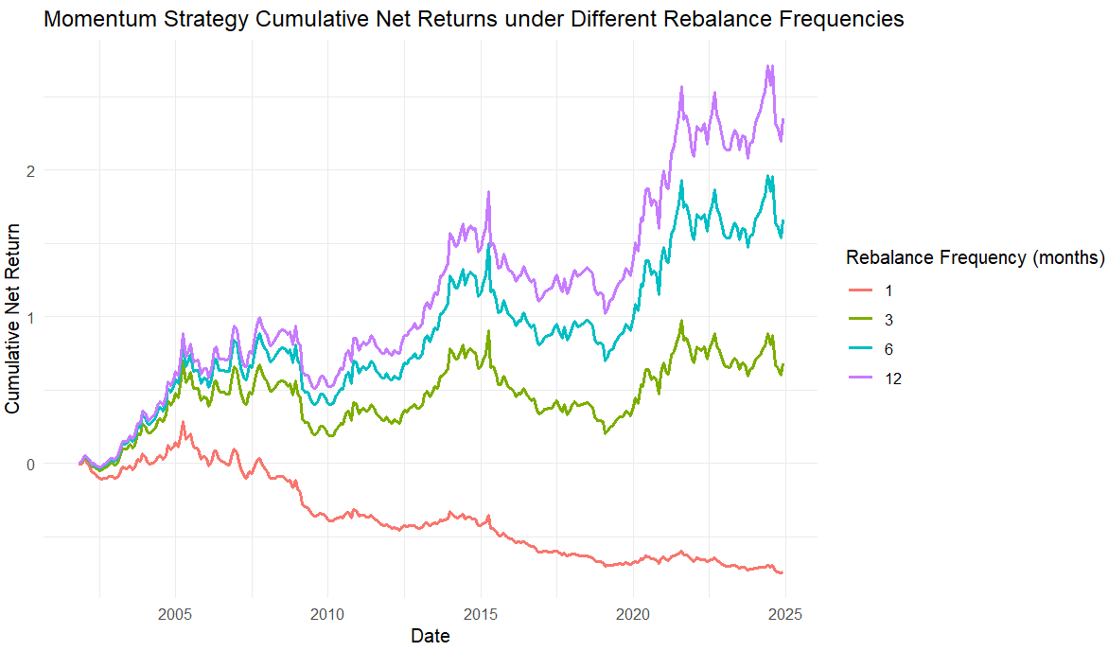

1. Risk analysis:

The risk analysis reveals important insights about the strategy's performance across different time horizons. The maximum drawdown shows a clear pattern of decreasing severity as the time window expands, with the most extreme single-month drawdown reaching -80.44%, while the 12-month maximum drawdown was significantly lower at -29.22% . This suggests that while the strategy may experience severe short-term losses, the risk of sustained drawdowns diminishes over longer periods. The 95% Value at Risk (VaR) metrics follow a logical progression, with average expected losses increasing from -0.42% for 1-month periods to -4.19% for 12-month periods, reflecting the compounding effect of risk over time. These results indicate that the strategy exhibits higher volatility in the short term, with extreme monthly drawdowns that could test investor patience, but demonstrates better risk control over longer horizons . The relatively stable VaR values across different timeframes suggest consistent risk exposure, though the increasing VaR with longer windows implies that investors should be prepared for larger potential losses when holding positions for extended periods. This analysis would be particularly useful for determining appropriate investment horizons and setting risk tolerance thresholds when implementing this strategy.

|  |  |  |
| --- | --- | --- |
| Month | Max Drawdown | VaR(95%) |
| 1 | -80.44% | -0.42% |
| 3 | -36.98% | -2.43% |
| 6 | -31.91% | -3.44% |
| 12 | -29.22% | -4.19% |

1. Result description:

We can conclude that the frequency of position adjustments has a significant impact on the performance of momentum strategies, while too frequent position adjustments can actually drag down returns. Especially in the medium to long term (6-12 months), the adjustment period is more conducive to stable growth and maximizing returns of the momentun strategy. This simulation helps investors understand the actual feasibility of strategies and design reasonable adjustment cycles to balance returns and costs.

**5.Out-of-sample tests (for market-timing strategy)**

The momentum strategy is based on the past performance of the stock itself (the past 6 months' returns) to select "winner stocks" to buy and "loser stocks" to sell. Essentially, it is a prediction and timing of individual stock performance, belonging to stock timing or cross-sectional timing. Therefore, there is no need to conduct Out of sample tests

**6. Impact of using different weights for securities in a portfolio**

(1) Basic principles:

Construct equal-weighted and market-cap-weighted portfolios separately, calculate the annualized return, volatility, and Sharpe ratio of the two portfolios, and compare the impact of different weight schemes on strategic risk return.

(2) Display results generated by R code：

For equal-weighted portfolios:

|  |  |  |
| --- | --- | --- |
| Annualized Return | Annualized Volatility | Sharpe Ratio |
| 0.0989 | 0.236 | 0.419 |

For market-cap-weighted portfolios:

|  |  |  |
| --- | --- | --- |
| Annualized Return | Annualized Volatility | Sharpe Ratio |
| 0.110 | 0.239 | 0.463 |

The cumulative return curve of two weight portfolios is plotted as follows：

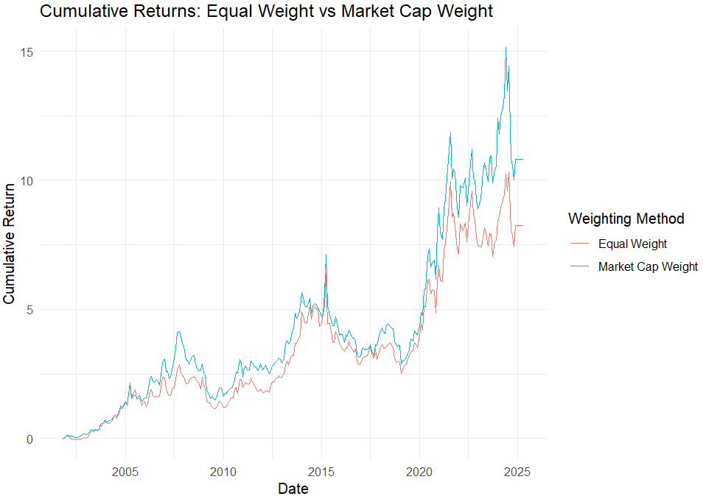

(3) Risk analysis:

The risk analysis reveals that both the equal-weighted and market-weighted strategies exhibit remarkably similar risk profiles, with nearly identical maximum drawdowns and Value at Risk (VaR) metrics. The equal-weighted portfolio showed a maximum drawdown of ​​-52.09%​​, slightly less severe than the market-weighted portfolio's ​​-52.23%​​, indicating marginally better capital preservation during market downturns. Similarly, the 95% VaR stood at ​​-9.49%​​ for the equal-weighted strategy compared to ​​-9.72%​​ for the market-weighted approach, suggesting comparable short-term downside risk. These results imply that neither weighting method provides a distinct advantage in terms of risk mitigation, as both strategies faced substantial losses during adverse market conditions. The minimal differences in risk metrics may reflect similar underlying exposures or market sensitivities, despite their different weighting methodologies. Investors choosing between these approaches should consider other factors such as return potential or diversification benefits, as the risk characteristics appear largely equivalent.

|  |  |  |
| --- | --- | --- |
| Method | Max Drawdown | Var (95%) |
| Equal-weighted | -52.09% | -9.49% |
| Market-weighted | -52.23% | -9.72 |

1. Result description:

The above figure can be observed that:

1)The cumulative return of market value weighted portfolios is generally higher than that of equally weighted portfolios, especially in recent years with greater volatility and stronger growth momentum.

2)The trends of the two curves are similar, but the market value weighted combination performs better at most points in time.

In summary, the weight scheme has a significant impact on the performance of the strategy. Market value weighted portfolios tend to favor large cap stocks, which may benefit from their steady growth and liquidity advantages, resulting in higher risk adjusted returns. Equal weight combination enhances diversity by balancing the weights of various assets, but may not necessarily result in higher returns, making it suitable for investors who emphasize risk diversification.

**7. Conclusion**

This part of research focuses on the performance of a certain momentum strategy, combined with benchmark regression analysis, multi factor risk elimination, staged regression of economic cycles, and simulation of adjustment frequency. The following comprehensive conclusions are drawn:

Firstly, the regression results based on strategy returns and benchmark returns show that the strategy still exhibits significant positive excess returns (α) after excluding the impact of benchmark risk, indicating that the strategy has independent ability to create returns. At the same time, the benchmark return coefficient is negative and significant, indicating a negative correlation between strategy returns and market performance, with certain defensive and hedging characteristics. This is reflected in the overall risk adjustment performance of the strategy - the strategy not only achieved annualized returns higher than the benchmark, but also had significantly lower volatility, with a Sharpe ratio significantly better than the benchmark, indicating that the strategy's returns under unit risk are more attractive.

Secondly, delving deeper into multi factor regression analysis, especially after removing the Fama French five factor and momentum factors, it was found that the excess return α of the strategy was not significant, indicating that the strategy's returns mainly came from exposure to systemic risk factors, especially the significant positive effect of momentum factors that penetrated through various stages of the economic cycle. Staged regression further reveals that the momentum factor (UMD) is the core driving force behind strategy returns, exhibiting strong influence in different economic environments including epidemics and financial crises, while the contributions of other factors are relatively weakened in extreme economic stages, reflecting the dynamic changes in strategy factor exposure.

Finally, regarding the impact of stock adjustment frequency on strategy performance, simulation results clearly show that stock adjustment frequency has a significant effect on momentum strategy performance. Frequent portfolio adjustments (such as monthly adjustments) can drag down strategy returns due to transaction costs and signal noise, while medium to long-term (6 to 12 months) portfolio adjustment cycles are more conducive to stable growth and maximizing returns for the strategy. This simulation provides important practical reference for investors, helping to balance the relationship between trading costs and returns, and designing reasonable adjustment periods to enhance the net return of the strategy.

1. **Conclusion and Discussion**
   1. **Conclusion**

**1. Overall Performance**

The momentum strategy has some good points in long-term returns, risk control, and risk-adjusted returns. But there are problems that where its returns come from and how well it can adapt to different market situations. In the long run, the strategy can make positive returns. It gets higher returns than the benchmark and controls risk well. Its risk-adjusted returns are more appealing. However, its returns mainly depend on systematic risk factors, especially the momentum factor. And it's not stable in extreme market conditions.

**2. Effectiveness of Trading Rules**

The trading rules that use the cumulative returns of the past 6 months (not including the most recent month) to make portfolios bring positive returns over a long time. From 2005 to 2025, the cumulative return went up a lot. The annualized return was 8 - 10%. This shows these rules can catch the medium - term momentum effect. But during the 2008 financial crisis, the strategy had big fluctuations. It means the current trading rules can't keep stable performance in extreme market conditions.

**3. Results of Performance Measurement**

When we compare the strategy's returns with the benchmark through regression, we find the strategy has appear positive excess return (alpha) after considering benchmark risk. It has a higher annualized return, lower volatility, and a better Sharpe ratio. But when we include more risk factors in the regression, the alpha is no longer significant. This shows the strategy's returns mainly come from being exposed to systematic risk factors. Especially the momentum factor (UMD). It has a big positive effect in every stage of the economic cycle and is the main reason for the strategy's returns.

**4. Effectiveness of Risk Management**

The strategy is better than the benchmark in risk management. Its maximum drawdown (-26.43%) is much lower than the benchmark's (-70.97%). The VaR at a 95% confidence level (-4.87%) is also lower than the benchmark's (-9.7%). But the strategy is more volatile in the short term. The maximum 1-month drawdown can be -80.44%. However, as the holding period gets longer, the risk gets lower. The 12-month maximum drawdown is -29.22%.

* 1. **Discussion**

**1. Reasons Why the Strategy Works**

(1) Utilization of the Momentum Effect: This strategy makes good use of the momentum effect in the market. Stocks that did well in the past (winner portfolio) usually keep doing well later. Stocks that did badly (loser portfolio) do the opposite. By buying the winner portfolio and selling the loser portfolio, the strategy can make money when the trend keeps going. For example, after 2020, when tech stocks were very strong in the market, the strategy's returns increased a lot.

(2) Risk Control Mechanisms: It does a good job in risk control. The lower volatility, maximum drawdown, and VaR show that the strategy has good risk control methods. These can help protect investors' money when the market goes down.

(3) Advantages of Weighting Schemes: Both the equal-weighting and market-cap-weighting methods have their good sides. The equal-weighting method makes the assets more diverse. The market-cap-weighting method is good for large-cap stocks. It can use the stable growth and good liquidity of large-cap stocks to improve risk-adjusted returns.

**2. However, there are still some drawbacks to this strategy**

(1) Dependence on Systematic Risk Factors: The strategy's returns depend too much on systematic risk factors, especially the momentum factor. If the momentum factor doesn't work or the market changes and the momentum effect get weaker, the strategy's performance will be affected. In the multi-factor regression, when we take away the risk factors, the strategy's extra return is not significant. This means it can't make returns on its own very well.

(2) Impact of Transaction Costs: Adjusting the portfolio too often can reduce returns because of transaction costs. The simulation shows that when we adjust the portfolio monthly, transaction costs have a big negative effect on returns. (But a 6 - 12 - month adjustment cycle is better for making the returns grow steadily and getting the most returns.)

(3) Poor Adaptability to Market Environments: In extreme market conditions, like during the 2008 financial crisis, the strategy has big problems. Market liquidity shocks and short-term reversals can mess up the momentum effect. This makes the strategy more volatile, which means it can't adapt well to extreme market conditions.

**REFERENCES**

Jegadeesh, N., & Titman, S. (1993). Returns to Buying Winners and Selling Losers: Implications for Stock Market Efficiency. *Journal of Finance*, *48*(1), 65-91.

Fama, E. F., & French, K. R. (2015). A Five-Factor Asset Pricing Model. *Journal of Financial Economics, 116*(1), 1-22.

|  |  |  |  |
| --- | --- | --- | --- |
|  | **Factor** | **Key Authors** | **Year** |
| **1** | **Momentum (UMD)** | **Jegadeesh & Titman** | **1993** |
| **2** | **Investment (CMA)** | **Fama & French** | **2015** |
| **3** | **Profitability (RMW)** | **Fama & French** | **2015** |