

Computer Networks Lab

SUBMITTED TO: MA’AM HURMAT HIDAYAT



Submitted by: Muhammad Ahmed Raza

ROLL NO: 19P-0070

SUBMITTED TO: MA’AM HURMAT HIDAYAT

# **Task # 1**

a) Connect two PC’s together with Cross Over wire as both are same devices. Next part is to configure IP addresses to both of the PC’s which we can see in below image.

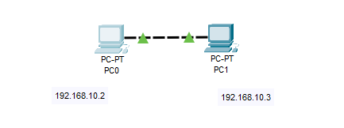

To configure IP address, follow the steps below:

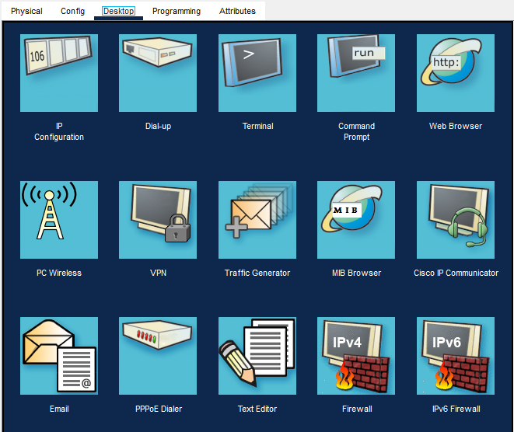

1. Click on the PC and go to Desktop Tab.
2. There click on IP configuration which is highlighted

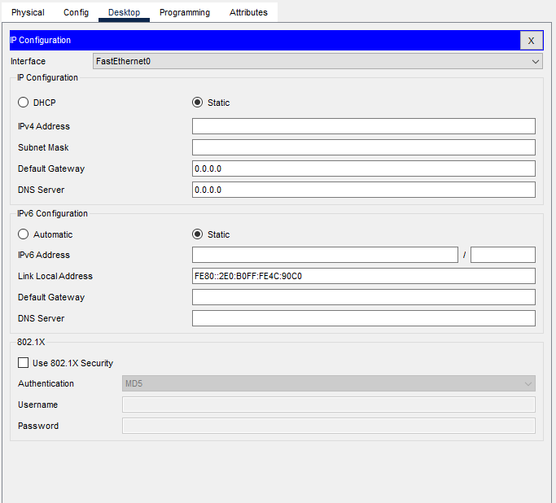

This Window will show up as shown in above figure.

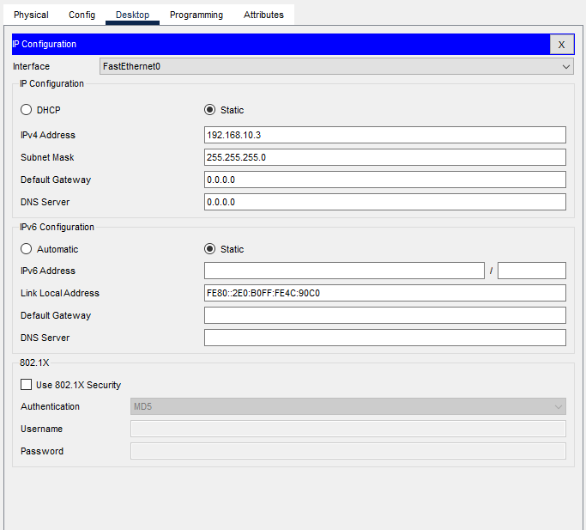

1. Enter any desired IP address in the IPv4 Address
2. Simply click on subnet mask field, it should fill with the default subnet mask

Next do the same with other PC and we are done with the IP configuration.

Test whether connection is established

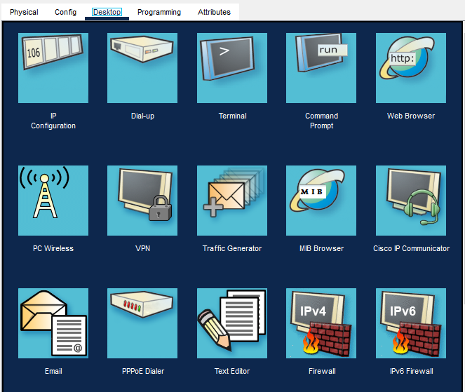

Click on a PC and go to desktop like before. This time Click on command prompt

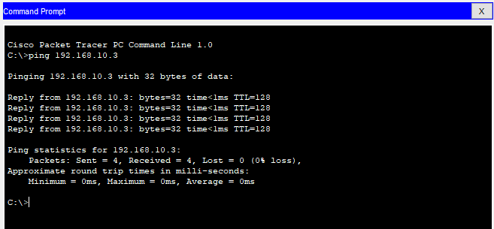

Enter **Ping** command following by the IP address of other PC.

You should see first PC pinging another PC by sending 32 bytes. Second PC should send the response back. A total of 4 packets of 8 bytes should be sent and returned. With 0% packet loss.

b) Lets test what happens with the connection if we have IP addresses with different network ID’s

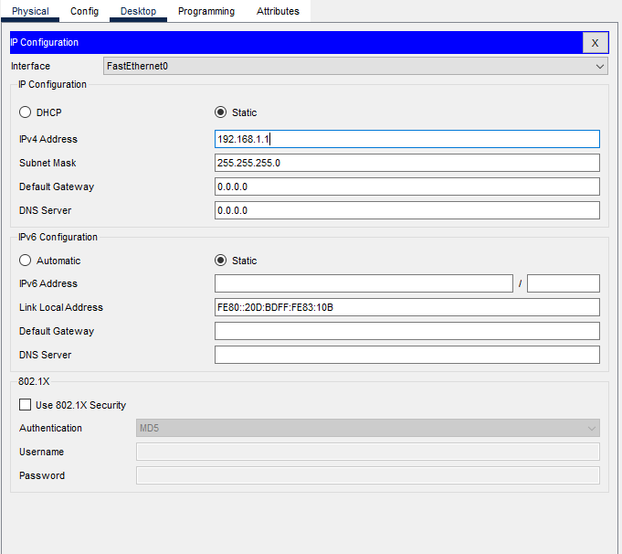

* Set the Ipv4 address of first PC to 192.168.1.1
* Set the subnet mask to 255.255.255.0

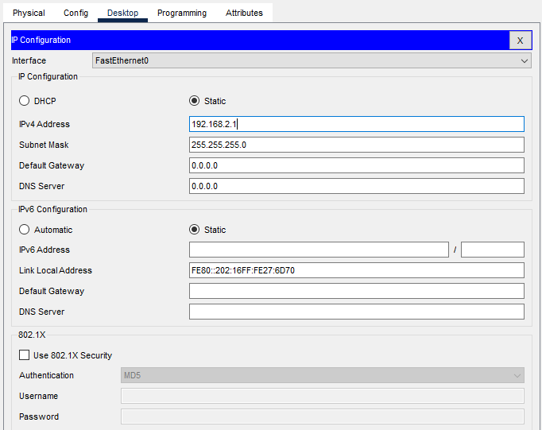

* Set the Ipv4 address of first PC to 192.168.2.1
* Set the subnet mask to 255.255.255.0

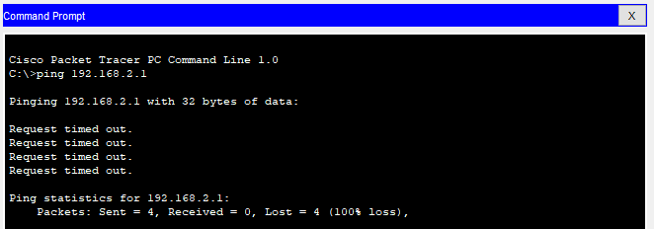

## Analysis:

We can observer through the subnet mask that both PC’s has different networks. We can figure that out by looking up the subnet mask. Since subnet masks for both PC’s are same i.e. 255.255.255.0. Therefore, the Network ID for PC-1 is 192.168.1.0 and for PC-2 is 192.168.2.0.

For a local connection without any external assistance like router or any other means of connection, it’s necessary for all the devices to have the same Network, that is same Network part followed by different Host ID for each device to establish the connection.

Due to this reason, connection is not established as the network is different for both PC’s. We can observe a 100% packet lost and Request Timeout.

c) Lest test if we can solve connection issue with same IP addresses.

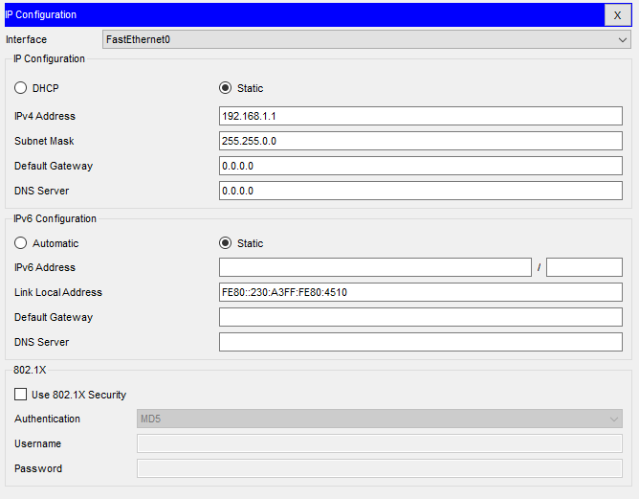

* Keep the Ipv4 address of first PC same as 192.168.1.1
* Change the subnet mask to 255.255.0.0

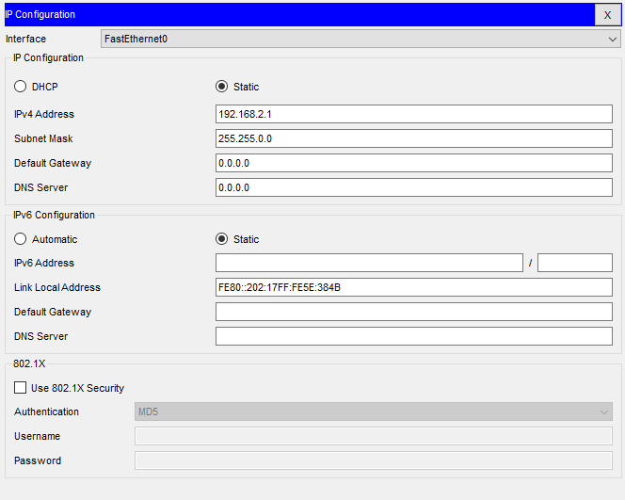

* Keep the Ipv4 address of first PC same as 192.168.2.1
* Change the subnet mask to 255.255.0.0

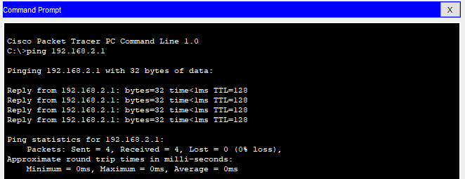

## Analysis:

In the last part, we noticed connection didn’t establish due to different network. We can fix that, by changing the subnet mask to 255.255.0.0. This enables us to have same Network for both PC’s. Now the network ID’s for both PC’s is 192.168.0.0. The latter two parts of the IP addresses, are considered Host ID. Therefore, we can see the connection establish and get our response back.

# **Task # 2**

To establish a connection between more than two PC’s, a hub is required. Multiple devices or PC’s are connected to hub via straight-through cable. Hub receives a request from a PC, it then broadcast it to all the connected devices.

Drawbacks of using Hub:

* Security, as hub broadcasts the data / messages to all the connected devices.
* Higher Traffic over the network
* Higher bandwidth

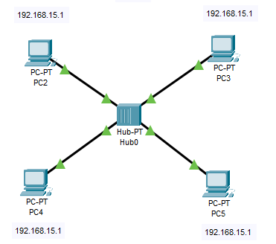

Let’s say PC-2 wants to connect to PC-4, it sends a request to hub first. As you can see in Figure 1.2 and Figure 2

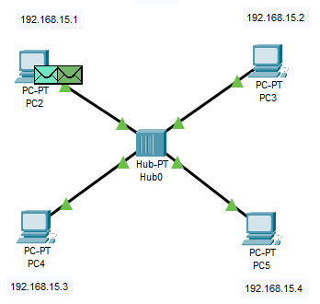

Figure 1.2

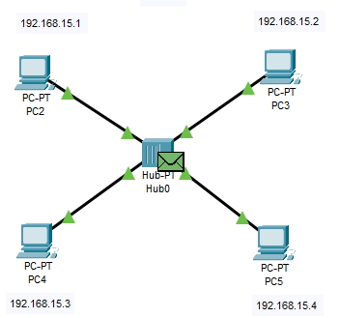

Figure 2

Hub then broadcast to all the connected PC’s. All the PC’s other than PC-2 rejects the request, as it was not intended for them. PC-4 will accept the request. As you can see in figure 3

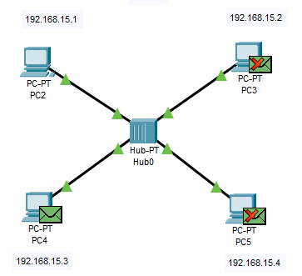

Figure 3

PC-4 will send back a response to hub. Hub will broadcast the response to all the connected PC’s again. All the PC’s will reject the response except PC-2. As you can see in figure 4 and figure 5

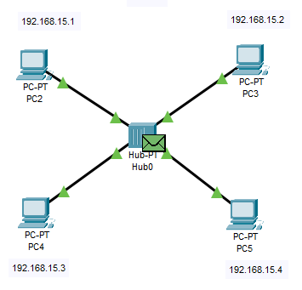

Figure 4

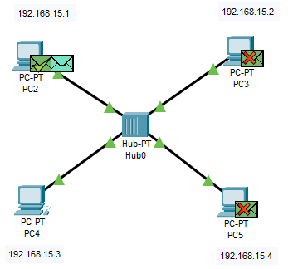

Figure 5

# **Task # 3**

To avoid all the drawbacks of the hub. We use switches. Switches are “smart hubs” in a way. What makes switches smart is that, switches contain a table in which it stores the MAC addresses of all the connected devices.

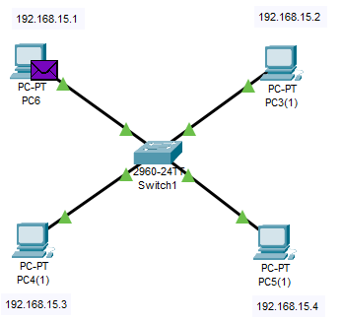

Switches broadcast a request from a certain connected PC to all the other connected PC’s for the first time. It then stores the MAC addresses of the PC that sent a request. So the response that comes from the other PC is just sent to the PC that sent the request instead of broadcasting to all the devices like Hub does. This resolves the issues that previously we faced using hub.

In the simulation, we can’t see the first broadcast. PC-6 wants to ping PC4(1). First the request goes to switch. Switch then forwards it to PC4(1) as you can see in figure 6 and figure 7.

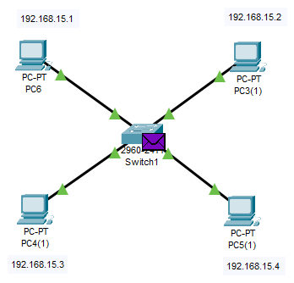

Figure 6

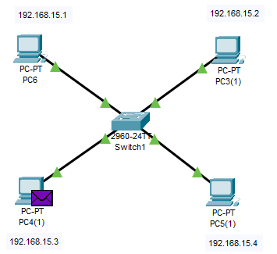

Figure 7

PC-4(1) then accepts the request and sends back the response to switch. Which hub then forward back to PC-6. As you can see in figure 8 and figure 9.

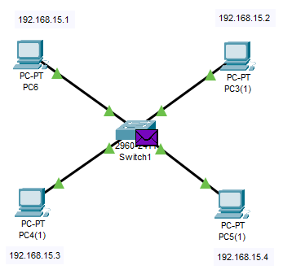

Figure 8

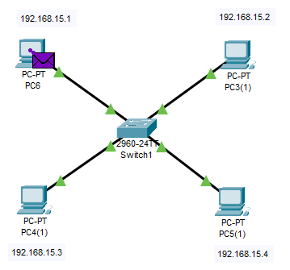

Figure 9