acousticsim
Underwater Acoustic Ray-Tracing Simulator
Technical Documentation • v0.1.0
March 2026

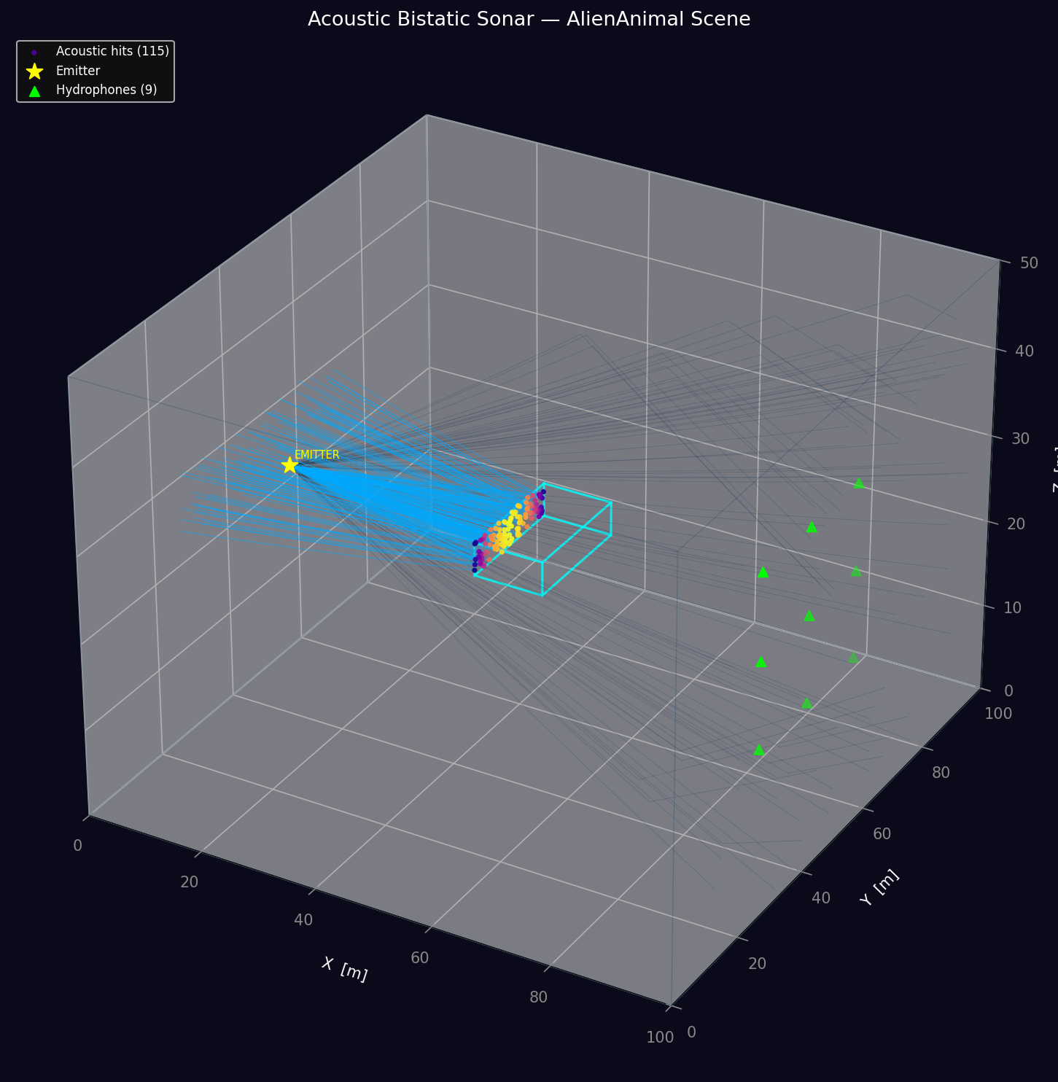
Figure 1 — AlienAnimal bistatic sonar demo: 3D scene overview

Table of Contents
1 Overview
2 System Architecture
3 Coordinate System
4 Physics Engine
4.1 Acoustic Wave Fundamentals
4.2 Sound Speed — Mackenzie Equation
4.3 Absorption — Thorp Equation
4.4 Ray Theory
4.5 Reflection Physics
4.6 Refraction and Snell's Law
4.7 Phase and Interference
4.8 Multipath Propagation
5 Module Reference
5.1 Water
5.2 Ray
5.3 WaveEmitter
5.4 Hydrophone
5.5 Object3D, Surface, Seabed
5.6 Simulation
5.7 MeshImporter & ImportedObject3D
5.8 NoiseModel
5.9 Feature Extractor
5.10 DatasetGenerator & AcousticDataset
5.11 SklearnDetector & PyTorchDetector
5.12 AcousticDetector (inference)
6 AlienAnimal Demo Walkthrough
7 Data Persistence — Save & Load
7.1 File Format Overview
7.2 Training Dataset (.npz)
7.3 sklearn Detector (.pkl)
7.4 PyTorch Detector (.pt)
7.5 Full File Lifecycle
7.6 Inspecting a Dataset Without acousticsim
8 Machine Learning Pipeline
9 Quick Usage Guide
10 Installation

1. Overview
acousticsim is a Python package for 3-D underwater acoustic ray-tracing simulation. It models the propagation of high-frequency sound (30 – 200 kHz) through a stratified water column with realistic physics: depth- and temperature-dependent sound speed, frequency-dependent absorption, angle-dependent reflection and refraction, multipath arrival detection at hydrophone arrays, and full per-bounce metadata for building acoustic point clouds.
Beyond raw simulation the package includes a complete machine-learning pipeline: 3-D mesh import (STL / OBJ / GLTF), randomised dataset generation, sklearn RandomForest baseline and a PyTorch multi-task MLP for simultaneous object classification and 6-DoF pose estimation.

Key Capabilities
- Physics-accurate 3-D ray tracing (Mackenzie sound speed, Thorp absorption)
- AABB slab-method intersection (fast) and Möller–Trumbore triangle mesh intersection (accurate)
- Spherical and cone beam emission; continuous-wave and chirp waveforms
- Per-hydrophone multipath detection with SNR-aware noise floor
- Object-tagged reflection points — acoustic point cloud output
- 3-D mesh import from STL, OBJ, GLTF/GLB via trimesh
- Four underwater noise models: white, thermal, ambient (Wenz), shipping
- ML dataset generation → sklearn RF → PyTorch MLP (class + 6-DoF pose)
- Full PyPI-ready packaging (pyproject.toml, PEP 517)

2. System Architecture
The package is organised as a single importable namespace acousticsim with twelve sub-modules. The dependency graph flows from environment (Water) through emitter → rays → objects → hydrophones → simulation, and then optionally into the ML stack.

Package Structure
acousticsim/
├── __init__.py # public API, re-exports all symbols
├── water.py # Water environment — sound speed, absorption
├── ray.py # Ray — propagation state, per-bounce metadata
├── emitter.py # WaveEmitter — spherical / cone beam, chirp
├── hydrophone.py # Hydrophone — multipath detection, noise injection
├── object3d.py # Object3D, Surface, Seabed — AABB primitives
├── simulation.py # Simulation — ray-trace engine, BVH loop
├── mesh_importer.py # MeshImporter — STL/OBJ/GLTF loader via trimesh
├── imported_object3d.py # ImportedObject3D — AABB or Möller-Trumbore mesh
├── noise.py # NoiseModel — white/thermal/ambient/shipping
├── feature_extractor.py # extract_features() — hydrophone → ML vector
├── dataset_generator.py # DatasetGenerator — randomised simulation runs
├── train_detector.py # SklearnDetector, PyTorchDetector, AcousticMLP
└── inference.py # AcousticDetector — deploy / infer from mesh

Data Flow
Water (environment)
│
▼
WaveEmitter ──emits──► [Ray, Ray, ...]
│
Simulation._trace_ray()
│ intersect every Object3D / ImportedObject3D
│ ray.reflect(object_name=...) ← logs hit
│ ray.refract() / propagation step
▼
Ray arrives near Hydrophone
│ detect_ray() → arrival dict stored
▼
get_multipath_signal(noise_model=...) → signal array
get_amplitudes(noise_model=...) → amplitude list
│
feature_extractor.extract_features() → 1-D float32 vector
│
DatasetGenerator → AcousticDataset (.npz)
│
train_sklearn / train_pytorch → detector checkpoint
│
AcousticDetector.detect_from_hydrophones() → prediction

3. Coordinate System
All positions and dimensions are in metres. The simulator uses a right-handed 3-D Cartesian coordinate system with the following convention:
X-axis: Width — left to right
Y-axis: Length — front to back
Z-axis: Depth — positive downward (oceanographic convention)
Origin: Front-left corner of the water volume, at the surface (Z = 0)

Y (Length)
↑
|
|________→ X (Width)
/
↓
Z (Depth, positive = deeper)

Z = 0 → Water surface
Z = 25 → 25 m below surface
Z = 50 → Seabed (for a 50 m deep environment)

Object positions refer to the geometric centre of the bounding box. A block placed at [30, 50, 10] with size [4, 6, 3] spans X: 28–32, Y: 47–53, Z: 8.5–11.5 m.

Direction Vectors
Normalised unit vectors describe ray and beam directions:
[1, 0, 0] → +X direction (right)
[-1, 0, 0] → -X direction (left)
[0, 1, 0] → +Y direction (forward)
[0, 0, 1] → +Z direction (downward)
[0.577, 0.577, 0.577] → diagonal (normalise before use)

4. Physics Engine

4.1 Acoustic Wave Fundamentals
Sound in water is a longitudinal pressure wave. The simulator models acoustic energy propagation in the 30 – 200 kHz sonar band.
Core relationships:
λ = c / f wavelength [m] = sound speed [m/s] / frequency [Hz]
T = 1 / f period [s]
φ = 2π × d / λ phase shift [rad] over distance d [m]
E ∝ A² energy proportional to amplitude squared

Amplitude is tracked linearly throughout propagation. dB values are used only at the emitter source level and in the noise floor comparison:
A = 10^(SL_dB / 20) linear amplitude from source level dB
dB = 20 × log10(A / A_ref)

4.2 Sound Speed — Mackenzie Equation
The Mackenzie (1981) nine-term equation gives sound speed as a function of temperature T (°C), depth D (m) and salinity S (ppt):
c = 1448.96
+ 4.591 T
- 5.304e-2 T²
+ 2.374e-4 T³
+ 1.340 (S - 35)
+ 1.630e-2 D
+ 1.675e-7 D²
- 1.025e-2 T (S - 35)
- 7.139e-13 T D³ [m/s]
Temperature is modelled as a linear vertical gradient between the user-supplied surface and bottom temperatures. A horizontal sound-speed gradient is computed numerically for refraction calculations.
Typical values for this simulator's default environment (T_surf=18°C, T_bottom=8°C, S=35 ppt):
Surface (Z=0, T=18°C): c ≈ 1516 m/s
Mid (Z=25, T=13°C): c ≈ 1505 m/s
Bottom (Z=50, T=8°C): c ≈ 1496 m/s

4.3 Absorption — Thorp Equation
Acoustic energy is absorbed by the water column according to the Thorp model, valid across 30 – 200 kHz:
α(f) = 0.11 f² / (1 + f²) ← ionic relaxation
+ 44 f² / (4100 + f²) ← MgSO₄ relaxation
+ 2.75×10⁻⁴ f² ← viscosity
+ 0.003 ← structural

Result in dB/km, where f is in kHz.
Worked examples:
f = 30 kHz → α ≈ 8.7 dB/km
f = 85 kHz → α ≈ 27.6 dB/km
f = 200 kHz → α ≈ 54.8 dB/km
Absorption loss is applied to the ray amplitude every simulation step: A_new = A × 10^(−α × Δd / 20 000) where Δd is the step distance in metres.

4.4 Ray Theory
Ray theory is valid when the acoustic wavelength is much smaller than object dimensions (λ << L). For the 30–200 kHz band, λ = 7.5 mm – 50 mm, which satisfies ray conditions for objects larger than ~5 cm.
Each Ray object carries:
position current 3-D location [m]
direction unit vector of travel
amplitude linear pressure amplitude
phase accumulated phase [rad]
path_length total distance travelled [m]
frequency_khz carrier frequency
bounces number of reflections so far
reflection_points list of (x,y,z) hit locations
reflection_objects parallel list of object names hit
reflection_amplitudes incident amplitude at each bounce
Geometric spreading is not applied as an explicit 1/r² factor between steps; instead, each emitter fires N rays and the total source power is distributed uniformly: A_per_ray = A_source / √N. Cylindrical spreading from the ray to a hydrophone is applied at detection time.

4.5 Reflection Physics
When a ray strikes an Object3D or ImportedObject3D surface:
1. The incident amplitude before energy loss is captured.
2. Effective reflection coefficient is computed from the base coefficient and optional frequency-dependent absorption tables.
3. The reflected amplitude is applied:
A_reflected = A_incident × R_eff

where R_eff ∈ [0, 1] (1 = perfect reflection, 0 = full absorption)
4. The reflected direction is computed using the geometric law of reflection:
d_reflected = d_incident - 2 (d_incident · n̂) n̂

where n̂ is the outward surface normal.
5. Optional phase inversion (rigid boundary): φ += π
6. The hit point, object name and incident amplitude are appended to the ray's parallel metadata lists.
Typical reflection coefficients:
Steel / aluminium hull : 0.95 – 0.98
Rock seabed : 0.85 – 0.92
Sandy seabed : 0.70 – 0.85
Soft tissue / flesh : 0.30 – 0.60
Open water surface : 0.90 – 0.99 (angle-dependent)

4.6 Refraction and Snell's Law
When the sound speed changes with depth, rays bend according to Snell's law. The simulator applies a small incremental refraction correction at each step by projecting the local sound-speed gradient perpendicular to the ray direction:
∇c = (∂c/∂x, ∂c/∂y, ∂c/∂z) [computed numerically, Δ=0.1 m]

Bending correction per step Δd:
d_new = d + (∇c - (∇c · d̂) d̂) × (Δd / c)
d_new = d_new / |d_new| [re-normalize]
For the default linear temperature gradient, the dominant component is ∂c/∂z ≈ −0.2 m/s per metre of depth, causing rays to bend toward the deeper, slower region (downward refraction for the warm-surface case).

4.7 Phase and Interference
Phase accumulates continuously along each ray:
Δφ = 2π × Δd / λ per step Δd
λ = c_local / f

Additionally:
+π phase shift on reflection from a rigid boundary (optional)
+2π×(r_perp / λ) extra phase when spreading to hydrophone position
Constructive interference occurs when two arrivals satisfy |Δφ| = 2πk (k integer). Destructive interference occurs at |Δφ| = (2k+1)π. get_multipath_signal() superposes all arrivals coherently.

4.8 Multipath Propagation
Multiple ray paths connect the emitter to a hydrophone: direct path, surface-reflected, seabed-reflected, object-reflected, and combinations. Each path arrives at a different time and amplitude, creating the characteristic spread of arrivals measured in real sonar:
ToA_i = path_length_i / c_avg + r_perp_i / c_avg [seconds]

The multipath signal is:
s(t) = Σ_i A_i × sin(2π f (t - ToA_i) + φ_i)
The Delay Spread (std of ToA values) and Time-of-Arrival Differences (TDOA) between hydrophone pairs are the primary spatial features used by the ML detector.

5. Module Reference

5.1 Water
Defines the water volume and its physical properties.
Water(
size = (lx, ly, lz), # volume dimensions [m]
temperature_surface = 20.0, # surface temperature [°C]
temperature_bottom = 10.0, # bottom temperature [°C]
salinity = 35.0, # salinity [ppt]
ambient_noise_level = 50.0, # dB re 1 μPa
)

Key Methods
sound_speed_at(x, y, z): Returns c [m/s] via Mackenzie equation at position
absorption_thorp(frequency_khz): Returns α [dB/km] via Thorp model
temperature_at(x, y, z): Linear interpolated temperature [°C]
sound_speed_gradient(x, y, z): Numerical ∇c for refraction [m/s per m]
is_inside(x, y, z): True if point is within the water volume

5.2 Ray
Tracks a single acoustic ray: position, direction, amplitude, phase, bounce history and object-tagged reflection metadata.
Ray(
position, # (x, y, z) starting point
direction, # (dx, dy, dz) unit vector
frequency_khz = 85.0,
amplitude = 1.0,
wave_type = 'continuous', # or 'chirp'
frequency_range = (f_min, f_max),
)

Key Methods
propagate(distance, water): Move the ray, apply absorption and refraction
reflect(normal, R, phase_inversion, object_name): Bounce off a surface; records hit to metadata lists
get_reflection_points(object_name=None): All bounce hit points, optionally filtered by object name
get_reflection_objects(): List of object names struck at each bounce
get_reflection_amplitudes(): Incident amplitude at each bounce (before loss)

5.3 WaveEmitter
Generates a list of Ray objects according to the selected beam pattern.
WaveEmitter(
position,
frequency_khz = 85.0,
beam_pattern = 'spherical', # or 'cone'
beam_direction = [1, 0, 0],
beam_angle = 30.0, # half-angle [deg] for cone
power_db = 180.0, # source level [dB re 1 μPa @ 1 m]
wave_type = 'continuous', # or 'chirp'
frequency_range = None, # (f_min, f_max) kHz for chirp
chirp_duration = 0.01, # seconds
)

emitter.emit_rays(num_rays=1000) → list[Ray]
Spherical pattern: Fibonacci lattice ensures uniform solid-angle coverage. Cone pattern: uniform distribution within a specified half-angle using the cos(α) = Uniform(cos(θ_max), 1) inverse-CDF method.

5.4 Hydrophone
A point sensor that detects acoustic arrivals from nearby rays.
Hydrophone(
position,
name = None,
sensitivity_db = -170.0, # [dB re 1V/μPa]
)

# Key attributes
hydrophone.min_amplitude = 1e-7 # noise floor
hydrophone.max_detection_distance = 50.0 # perpendicular detection radius [m]

Key Methods
detect_ray(ray, sound_speed): Test one Ray; stores arrival if amplitude > min_amplitude
get_time_of_arrivals(): List of ToA values [s]
get_amplitudes(noise_model=None): List of amplitudes; optional NoiseModel perturbs each value
get_multipath_signal(time_samples, duration, noise_model, sample_rate): Construct coherent multipath waveform; optional NoiseModel adds shaped background noise
inject_arrivals(noise_model, n, frequency_khz, time_range): (via NoiseModel) Inject synthetic noise arrivals
get_first_arrival() / get_strongest_arrival(): Convenience accessors
Detection model: cylindrical spreading from the ray path to the sensor. Amplitude at hydrophone = ray.amplitude × 1/√(max(1, r_perp)). Time of arrival = (path_length + r_perp) / c.

5.5 Object3D, Surface, Seabed
AABB (Axis-Aligned Bounding Box) primitives for walls, reflectors and the environment boundary.
Object3D(
name, position, size,
reflection_coefficient = 0.9,
is_rigid = True,
frequency_absorption = {(30,50): 0.8, (50,80): 0.5},
)

Surface(water) # water–air interface at Z=0 (R ≈ 0.99)
Seabed(water, reflection_coefficient=0.85) # bottom boundary
Intersection: slab method — six half-space tests. O(1) per ray per object.
Surface normal is determined by which AABB face is hit; direction sign is chosen so the normal points toward the incoming ray.

5.6 Simulation
The main ray-tracing engine. Manages the world of objects, emitters and hydrophones and drives the propagation loop.
sim = Simulation(water)
sim.max_bounces = 8
sim.step_size = 0.5 # m per propagation step

sim.add_object(object3d)
sim.add_emitter(emitter)
sim.add_hydrophone(hydrophone)

results = sim.run(num_rays=1000)

# After run():
sim.get_reflection_points(object_name='AlienAnimal') # filtered hit list
sim.rays # all Ray objects

Trace Loop (per ray)
For each step, the engine:
1. ray.propagate(step_size, water) ← move, absorb, refract
2. For every Object3D: test ray_intersect()
3. Pick nearest hit within the step
4. If hit: ray.reflect(..., object_name=name)
ray.position = hit_point + ε × normal ← push off surface
5. Test all Hydrophones: detect_ray()
6. Stop if ray.amplitude < threshold or
ray.bounces > max_bounces or
ray outside water volume

5.7 MeshImporter & ImportedObject3D
Load arbitrary 3-D meshes and use them as acoustic reflectors.
from acousticsim import MeshImporter, ImportedObject3D

mesh = MeshImporter.load('AlienAnimal.obj', scale=1.0)
# mesh.vertices, mesh.faces, mesh.normals, mesh.bounds

obj = ImportedObject3D(
mesh_data = mesh,
position = [50, 50, 25],
rotation_deg = (0, 0, 0), # roll, pitch, yaw
scale = 1.0,
intersection_mode = 'aabb', # or 'mesh'
reflection_coefficient = 0.80,
name = 'AlienAnimal',
)

Two intersection modes:
'aabb' — axis-aligned bounding box slab test.
Very fast; suitable for physics pass with many rays.

'mesh' — vectorised Möller–Trumbore algorithm against every triangle.
Exact per-facet hit; suitable for small ray counts or
high-fidelity surface mapping.
ImportedObject3D.get_pose() returns a (6,) array: [x, y, z, roll°, pitch°, yaw°].

5.8 NoiseModel
Generates spectrally-shaped underwater ambient noise for signal corruption or arrival injection.
from acousticsim import NoiseModel, add_noise_to_signal

nm = NoiseModel(
noise_type = 'ambient', # 'white' | 'thermal' | 'ambient' | 'shipping'
snr_db = 15.0, # dB SNR relative to input signal; or None
noise_amplitude = 1e-6, # absolute RMS when snr_db is None
seed = 42, # reproducibility
)

# Add to a signal array
noisy = add_noise_to_signal(clean_signal, nm, sample_rate=250_000)

# Use via Hydrophone
t, noisy_sig = hydrophone.get_multipath_signal(noise_model=nm)
noisy_amps = hydrophone.get_amplitudes(noise_model=nm)

# Inject fake noise arrivals into arrival list
nm.inject_arrivals(hydrophone, n_noise_arrivals=5)

Noise Spectra
'white' flat Gaussian, all frequencies equal power.
'thermal' rises ∝ √f above 1 kHz — models hydrophone electronics.
'ambient' Wenz model: 1/f below 300 Hz, flat above — ocean background.
'shipping' steep low-frequency content below 200 Hz — shipping / industrial.
When snr_db is provided and a reference_signal is passed to generate(), the noise amplitude is scaled so that SNR = snr_db dB relative to the RMS of that reference signal.

5.9 Feature Extractor
Converts raw hydrophone arrival lists into a fixed-size float32 ML feature vector.
from acousticsim import extract_features

vec, names = extract_features(hydrophones, sound_speed=1500.0)
# vec.shape = (H*8 + C(H,2),) e.g. H=9 → 72+36 = 108 features

Feature Layout
Per hydrophone h (×8):
h_n_arrivals total arrivals
h_first_time_ms earliest ToA [ms]
h_last_time_ms latest ToA [ms]
h_delay_spread_ms std of ToA values
h_max_amplitude peak amplitude
h_total_energy Σ A²
h_amplitude_mean mean amplitude
h_amplitude_std std of amplitudes

Cross-hydrophone TDOA pairs i<j (×C(H,2)):
tdoa_ij_ms = first_time[i] - first_time[j]

5.10 DatasetGenerator & AcousticDataset
Runs many simulation episodes with randomised object positions and rotations to build a labelled training dataset.
from acousticsim import DatasetGenerator, DatasetConfig

config = DatasetConfig(
num_samples = 500,
num_rays = 300,
num_hydrophones= 5,
frequency_khz = 85.0,
noise_model = None, # optional NoiseModel
)

gen = DatasetGenerator(mesh_dict={'target': mesh_data}, config=config)
dataset = gen.generate()

dataset.save('training_data.npz')
dataset = AcousticDataset.load('training_data.npz')
# dataset.X — feature matrix (N × F)
# dataset.y_class — class labels (N,)
# dataset.y_pose — pose labels (N, 6)

5.11 SklearnDetector & PyTorchDetector
Two ready-to-train detector backends.
from acousticsim import SklearnDetector, PyTorchDetector
from acousticsim import train_sklearn, train_pytorch, evaluate

# sklearn Random Forest
sk_det = train_sklearn(dataset)
metrics = evaluate(sk_det, test_dataset)

# PyTorch multi-task MLP
pt_det = train_pytorch(
dataset,
hidden_dims = [256, 128, 64],
lr = 1e-3,
epochs = 100,
patience = 10,
)

AcousticMLP Architecture
Input layer (F features)
│
▼
Shared backbone: Linear → BatchNorm → ReLU → Dropout (×N layers)
│
├──► Classification head → softmax → class probabilities
│
└──► Pose regression head → linear → (x,y,z,roll,pitch,yaw)

Loss = CrossEntropy(class) + λ × MSE(pose) [λ default = 0.1]

5.12 AcousticDetector (Inference)
High-level deployment wrapper for either backend.
from acousticsim import AcousticDetector

det = AcousticDetector.from_sklearn(sk_det, class_names=['target'])
# or
det = AcousticDetector.from_pytorch(pt_det, class_names=['target'])

# Simulate from mesh file and predict
pred = det.simulate_and_detect(
mesh_filepath = 'AlienAnimal.obj',
position = [50, 50, 25],
rotation_deg = [0, 0, 15],
)
print(pred['class'], pred['pose_xyz'], pred['confidence'])

# Predict from already-populated hydrophones
pred = det.detect_from_hydrophones(hydrophones)

# Batch mode
preds = det.detect_batch(mesh_filepaths, positions)

6. AlienAnimal Demo Walkthrough
alien_demo.py demonstrates a bistatic sonar configuration where an emitter fires acoustic rays at the AlienAnimal.obj mesh and a hydrophone array on the opposite side captures reflections. The demo produces two output images and prints detailed statistics.

6.1 Scene Configuration
Water volume : 100 × 100 × 50 m (coastal bay)
AlienAnimal.obj : trimesh import, scale=1.0
extents ≈ 17.9 × 19.6 × 39.3 m
position [50, 50, 25]

Emitter : [5, 50, 25] (left wall)
85 kHz 185 dB cone beam ± 25° pointing +X
1 200 rays

Hydrophone array : 3 × 3 grid at X=95 (right wall)
Y: 35, 50, 65 m
Z: 15, 25, 35 m
max_detection_distance = 18.0 m

Simulation : step_size=0.5 m, max_bounces=8

6.2 Pipeline Steps
1. MeshImporter.load('AlienAnimal.obj', scale=1.0)
→ trimesh mesh with 25 695 vertices, 46 588 faces

2. ImportedObject3D(mesh_data, mode='aabb', R=0.80, name='AlienAnimal')
Added to Simulation alongside Surface and Seabed.

3. sim.run(num_rays=1200)
→ rays traced; reflection metadata stored per bounce

4. collect_alien_hits(sim, 'AlienAnimal')
→ filter reflection_points where object_name == 'AlienAnimal'
→ 870 AABB acoustic hit points

5. trimesh_surface_hits(mesh_data, alien_obj, num_rays=8000)
→ 8000 directions sampled from hit points toward object centre
→ BVH RayMeshIntersector fires each ray
→ 3197 exact triangle surface intersection points
→ incidence angle computed for colour mapping

6. plot_scene() — saves two PNG images

6.3 Output — Scene Overview
Figure 2 — Full 3D scene: emitter (green star), AABB hit cloud (cyan), hydrophone array (yellow), water volume bounding box

The scene plot shows: the 3-D water volume wireframe, the emitter position, the 9-hydrophone array, AABB acoustic reflection hits on the AlienAnimal coloured by reflected amplitude, and the object bounding box.

6.4 Output — Surface Point Cloud
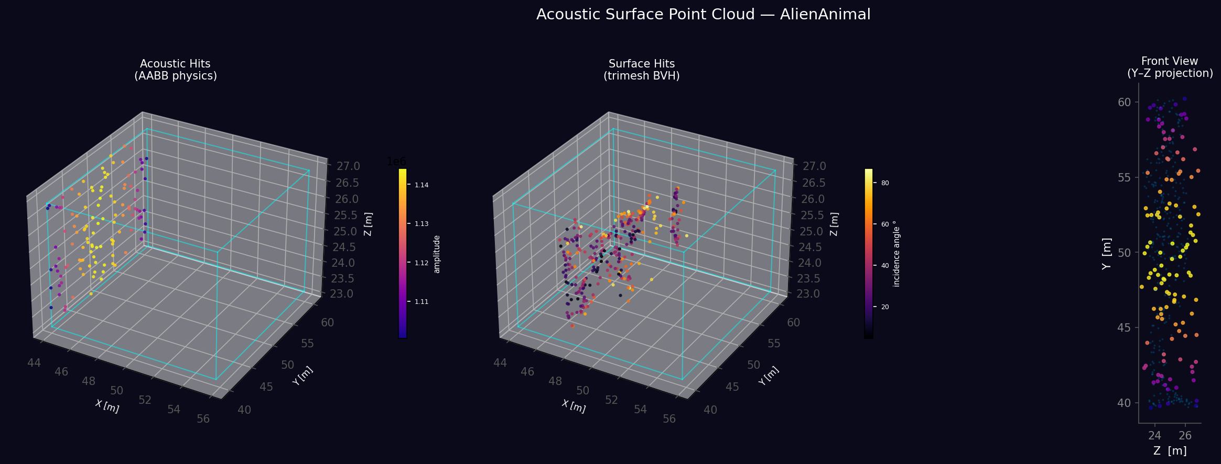
Figure 3 — Acoustic surface point cloud: exact trimesh BVH hits coloured by incidence angle (blue = glancing, yellow = normal)

The surface point cloud uses trimesh's BVH RayMeshIntersector for exact per-triangle hit locations. Points are coloured by incidence angle: blue = glancing (large angle from normal), yellow = near-normal incidence (strongest return). This gives a acoustic "image" of the object's visible surface from the emitter side.

6.5 Running the Demo
# From the repo root:
python alien_demo.py

# Or double-click:
run_demo.bat

# Expected terminal output:
Loading AlienAnimal.obj ...
vertices : 25695
faces : 46588
extents : 17.94 × 19.56 × 39.30 m scale=1.0
Running simulation (1200 rays) ...
AABB acoustic hits on AlienAnimal : 870
Running trimesh BVH surface mapping (8000 rays) ...
Exact surface hits : 3197
Total hydrophone arrivals : 10893
Saving alien_pointcloud_scene.png
Saving alien_pointcloud_surface.png
Done.

7. Data Persistence — Save & Load
acousticsim uses three different file formats depending on what is being persisted: the generated training dataset, the sklearn model, and the PyTorch model checkpoint. Each format is self-contained — you can close Python, share the file with a colleague, and resume without any re-simulation.

7.1 File Format Overview
dataset.npz ← NumPy compressed archive (AcousticDataset)
sklearn_det.pkl ← Python pickle (SklearnDetector + StandardScaler)
pytorch_det.pt ← PyTorch checkpoint dict (weights + normalization stats)

7.2 Training Dataset — .npz (NumPy Compressed Archive)
AcousticDataset.save() calls numpy.savez_compressed(), which stores all arrays in a single zipped .npz file. This is cross-platform, readable without acousticsim installed, and typically 5–20× smaller than the uncompressed equivalent.

What is stored
┌─────────────────┬──────────────────────────────┬──────────────────────────┐
│ Key │ Shape / dtype │ Description │
├─────────────────┼──────────────────────────────┼──────────────────────────┤
│ X │ (N, F) float32 │ Feature matrix │
│ │ e.g. (1000, 108) for H=9 │ one row per simulation │
│ y_class │ (N,) int32 │ Class ID per sample │
│ y_pose │ (N, 6) float32 │ x, y, z, roll, pitch, │
│ │ │ yaw in metres / degrees │
│ class_names │ (C,) object (str) │ Name for each class ID │
│ feature_names │ (F,) object (str) │ Name for each column │
└─────────────────┴──────────────────────────────┴──────────────────────────┘

N = number of simulation runs
F = H×8 + C(H,2) (H = number of hydrophones)
C = number of object classes

Feature matrix layout (X)
Each row is the output of extract_features() for one simulation run. Columns are arranged as follows for H hydrophones:
Columns 0 … H×8-1 — per-hydrophone statistics (8 per sensor)
[ n_arrivals, first_time_ms, last_time_ms,
delay_spread_ms, max_amplitude, total_energy,
amplitude_mean, amplitude_std ]

Columns H×8 … F-1 — cross-hydrophone TDOA pairs, all i<j ordered
tdoa_ij = first_arrival_time[i] - first_arrival_time[j]
In milliseconds.

Save & load
# Save
dataset.save('my_dataset.npz')
# Prints: Dataset saved: my_dataset.npz (1000 samples, 108 features)

# Load — returns AcousticDataset (config field will be None)
from acousticsim import AcousticDataset
dataset = AcousticDataset.load('my_dataset.npz')

print(dataset.X.shape) # (1000, 108)
print(dataset.y_class[:5]) # [0 1 0 0 1]
print(dataset.class_names) # ['alien', 'submarine']
print(dataset.class_distribution()) # {'alien': 512, 'submarine': 488}

# Read directly with NumPy (no acousticsim needed)
import numpy as np
raw = np.load('my_dataset.npz', allow_pickle=True)
print(list(raw.keys())) # ['X', 'y_class', 'y_pose', 'class_names', 'feature_names']
print(raw['X'].shape) # (1000, 108)

7.3 sklearn Detector — .pkl (Python Pickle)
SklearnDetector.save() serialises the entire object — including the fitted RandomForestClassifier, MultiOutputRegressor, and StandardScaler — into a single .pkl file using Python's standard pickle module. The scaler's fitted mean and std are embedded inside the same object, so no separate normalisation file is needed.

What is stored
SklearnDetector object containing:
.classifier RandomForestClassifier (n_estimators trees, all node data)
.regressor MultiOutputRegressor wrapping 6 RandomForestRegressors
.scaler StandardScaler (.mean_, .var_, .scale_)
.class_names list of str
.n_estimators int
.n_jobs int

Save & load
# Save
sklearn_det.save('sklearn_det.pkl')

# Load
from acousticsim.train_detector import SklearnDetector
sklearn_det = SklearnDetector.load('sklearn_det.pkl')

# Predict immediately — scaler is embedded
pred_class, pred_pose = sklearn_det.predict(X_new)
result = sklearn_det.predict_single(feature_vector)
# → {'class_id': 0, 'class_name': 'alien', 'x': 49.3, 'y': 51.2, ...}
Warning: pickle files are Python-version and library-version sensitive. Use the same major version of scikit-learn to load a saved file. For long-term storage prefer re-training from the .npz dataset.

7.4 PyTorch Detector — .pt (Torch Checkpoint)
PyTorchDetector.save() calls torch.save() on a plain Python dict that contains the model's state_dict plus all normalisation statistics. This is the standard PyTorch checkpoint pattern and is more robust than pickling the whole object.

What is stored inside the .pt file
{
'model_state' : OrderedDict — all layer weights & biases
'class_names' : list[str]
'feature_means' : (F,) float32 — per-feature training mean
'feature_stds' : (F,) float32 — per-feature training std
'pose_mean' : (6,) float32 — per-DoF training mean
'pose_std' : (6,) float32 — per-DoF training std
'pose_loss_weight' : float
}
During training, both the feature vectors (X) and pose targets (y_pose) are normalised to zero-mean unit-variance before being passed to the network. At inference, the same statistics are applied to incoming feature vectors and the pose output is denormalised back to physical units before returning.

Normalisation flow
TRAINING:
X_norm = (X − feature_means) / feature_stds → fed to network
yp_norm = (yp − pose_mean) / pose_std → target for pose head

INFERENCE:
X_norm = (X_new − feature_means) / feature_stds → network input
pose_raw = network(X_norm).pose_head → network output (normalised)
pose_out = pose_raw × pose_std + pose_mean → physical [m, deg]

Save & load
# Save
pytorch_det.save('pytorch_det.pt')

# Load — must supply architecture parameters
from acousticsim.train_detector import PyTorchDetector
pytorch_det = PyTorchDetector.load(
'pytorch_det.pt',
input_dim = 108, # must match saved model
num_classes = 2,
hidden_dims = (256, 128, 64),
dropout = 0.3,
)

# Predict
pred_class, pred_pose = pytorch_det.predict(X_new)
result = pytorch_det.predict_single(feature_vector)
# → {'class_id': 0, 'class_name': 'alien',
# 'x': 49.7, 'y': 50.8, 'z': 24.1,
# 'roll_deg': 0.2, 'pitch_deg': -1.4, 'yaw_deg': 178.3,
# 'class_proba': {'alien': 0.94, 'submarine': 0.06}}

7.5 Full File Lifecycle
[Meshes] AlienAnimal.obj, submarine.stl
│
▼ MeshImporter.load()
[MeshData objects in memory]
│
▼ DatasetGenerator.generate(num_samples=1000)
│ runs 1000 simulations, extracts feature vectors
▼
[AcousticDataset in memory]
│
├──► dataset.save('dataset.npz') ← persist raw training data
│ (arrays only, no Python objects)
▼
├── train_sklearn(dataset)
│ SklearnDetector.save('sklearn_det.pkl') ← RF trees + scaler
│
└── train_pytorch(dataset)
PyTorchDetector.save('pytorch_det.pt') ← weights + norm stats

─────────── Later / different machine ───────────────────────────────────

AcousticDataset.load('dataset.npz') ← reload to re-train or inspect
SklearnDetector.load('sklearn_det.pkl') ← deploy sklearn model
PyTorchDetector.load('pytorch_det.pt', ← deploy pytorch model
input_dim=108, num_classes=2)
│
▼ AcousticDetector.from_sklearn() / .from_pytorch()
.simulate_and_detect('AlienAnimal.obj', [50,50,25], [0,0,0])
.detect_from_hydrophones(hydrophones)
.detect_batch(filepaths, positions)

7.6 Inspecting a Saved Dataset Without acousticsim
import numpy as np

raw = np.load('dataset.npz', allow_pickle=True)

# Arrays
X = raw['X'] # (N, F) float32
y_class = raw['y_class'] # (N,) int32
y_pose = raw['y_pose'] # (N, 6) float32
class_names = list(raw['class_names']) # ['alien', ...]
feature_names= list(raw['feature_names']) # ['h0_n_arrivals', ...]

# Inspect
print(f"Samples : {len(X)}")
print(f"Features : {X.shape[1]}")
print(f"Classes : {class_names}")

for i, name in enumerate(class_names):
count = (y_class == i).sum()
print(f" {name}: {count} samples")

print(f"Pose range: x={y_pose[:,0].min():.1f}–{y_pose[:,0].max():.1f} m")

8. Machine Learning Pipeline
The ML pipeline converts acoustic simulation data into a trained detector that predicts object class and 6-DoF pose from live hydrophone arrays.

8.1 End-to-End Workflow
from acousticsim import (
MeshImporter, DatasetGenerator, DatasetConfig,
NoiseModel, train_pytorch, AcousticDetector
)

# 1. Load meshes
meshes = {
'alien' : MeshImporter.load('AlienAnimal.obj'),
'submarine' : MeshImporter.load('sub.stl'),
}

# 2. Configure and generate dataset
nm = NoiseModel('ambient', snr_db=15, seed=0)
cfg = DatasetConfig(
num_samples = 1000,
num_rays = 400,
num_hydrophones = 9,
frequency_khz = 85.0,
noise_model = nm,
)
dataset = DatasetGenerator(meshes, cfg).generate()
dataset.save('dataset.npz')

# 3. Train
detector = train_pytorch(dataset, epochs=150, patience=15)

# 4. Deploy
det = AcousticDetector.from_pytorch(detector,
class_names=['alien','submarine'])
pred = det.simulate_and_detect('AlienAnimal.obj', [50,50,25], [0,0,0])
print(pred) # → {'class': 'alien', 'confidence': 0.94, 'pose_xyz': [...]}

8.2 Feature Vector Size
For a 9-hydrophone array (3×3 grid):
Per-hydrophone features : 9 × 8 = 72
TDOA pairs : C(9,2) = 36 (all unique sensor pairs)
Total features : 108

8.3 Model Outputs
Classification → softmax probability over N object classes
Pose regression → [x, y, z, roll°, pitch°, yaw°] 6-DoF continuous values

Loss function:
L = CrossEntropy(ŷ_class, y_class) + 0.1 × MSE(ŷ_pose, y_pose)

9. Quick Usage Guide

9.1 Minimal Simulation
from acousticsim import Water, WaveEmitter, Hydrophone, Simulation, Surface, Seabed

water = Water(size=(100,100,50), temperature_surface=18, temperature_bottom=8)
sim = Simulation(water)
sim.add_object(Surface(water))
sim.add_object(Seabed(water))

emitter = WaveEmitter([5,50,25], frequency_khz=85, beam_pattern='cone',
beam_direction=[1,0,0], beam_angle=30, power_db=185)
sim.add_emitter(emitter)

hydro = Hydrophone([95,50,25], name='H1')
sim.add_hydrophone(hydro)

sim.run(num_rays=500)

print('Arrivals:', hydro.get_arrival_count())
t, sig = hydro.get_multipath_signal()

9.2 Import a 3-D Mesh Object
from acousticsim import MeshImporter, ImportedObject3D, Simulation

mesh = MeshImporter.load('my_object.obj', scale=0.5)
obj = ImportedObject3D(mesh, position=[50,50,25],
intersection_mode='mesh',
reflection_coefficient=0.85,
name='target')
sim.add_object(obj)

9.3 Add Noise to Signals
from acousticsim import NoiseModel

nm = NoiseModel('ambient', snr_db=12, seed=42)

# Noisy waveform
t, noisy = hydrophone.get_multipath_signal(noise_model=nm)

# Noisy amplitudes (for feature extraction)
amps = hydrophone.get_amplitudes(noise_model=nm)

# Inject fake arrivals (simulates reverberation tail / bio noise)
nm.inject_arrivals(hydrophone, n_noise_arrivals=6)

9.4 Get Acoustic Point Cloud
# After sim.run():
all_hits = sim.get_reflection_points() # all objects
alien_hits = sim.get_reflection_points(object_name='AlienAnimal') # filtered
alien_amps = [r for r, o in zip(all_amps, all_objects) if o == 'AlienAnimal']

# Per-ray access
for ray in sim.rays:
pts = ray.get_reflection_points(object_name='AlienAnimal')
names = ray.get_reflection_objects()
amps = ray.get_reflection_amplitudes()

9.5 Chirp Waveform
emitter = WaveEmitter(
position = [5, 50, 25],
wave_type = 'chirp',
frequency_range= (70, 100), # kHz
chirp_duration = 0.005, # 5 ms
power_db = 185,
)

10. Installation

10.1 From Source (development)
git clone https://github.com/yourname/acousticsim.git
cd acousticsim
pip install -e .[all]

10.2 From PyPI (once published)
pip install acousticsim # core physics only
pip install acousticsim[mesh] # + trimesh mesh import
pip install acousticsim[ml] # + scikit-learn + torch
pip install acousticsim[all] # everything

10.3 Optional Dependencies
trimesh[easy] >= 3.23 # STL, OBJ, GLTF import + BVH raycasting
scikit-learn >= 1.3 # Random Forest detector
torch >= 2.0 # PyTorch MLP detector
aiohttp >= 3.8 # real-time WebSocket server (future)
matplotlib >= 3.7 # visualisation

10.4 Running the Demo
# Ensure AlienAnimal.obj is in the repo root, then:
python alien_demo.py
# or
run_demo.bat

# Outputs:
# alien_pointcloud_scene.png
# alien_pointcloud_surface.png

acousticsim v0.1.0 — MIT License — Generated March 01, 2026

