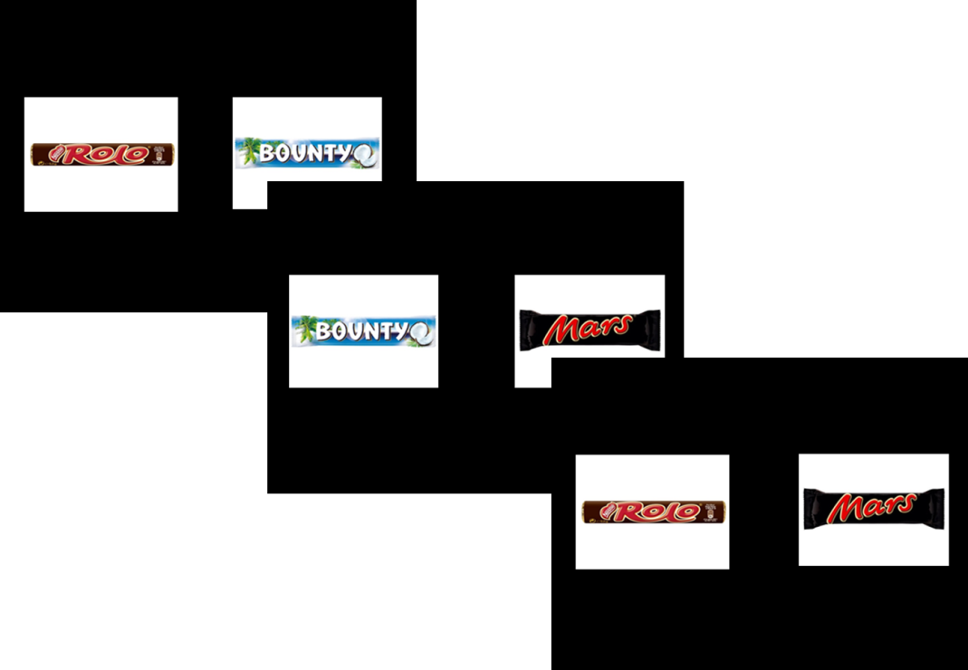

**Fig. 1**. Three trials of the binary choice experiment. Subject indicated their preferred candy bar on each trial. Stimulus presentation and choice was self-paced, with a maximum length of 5 seconds.

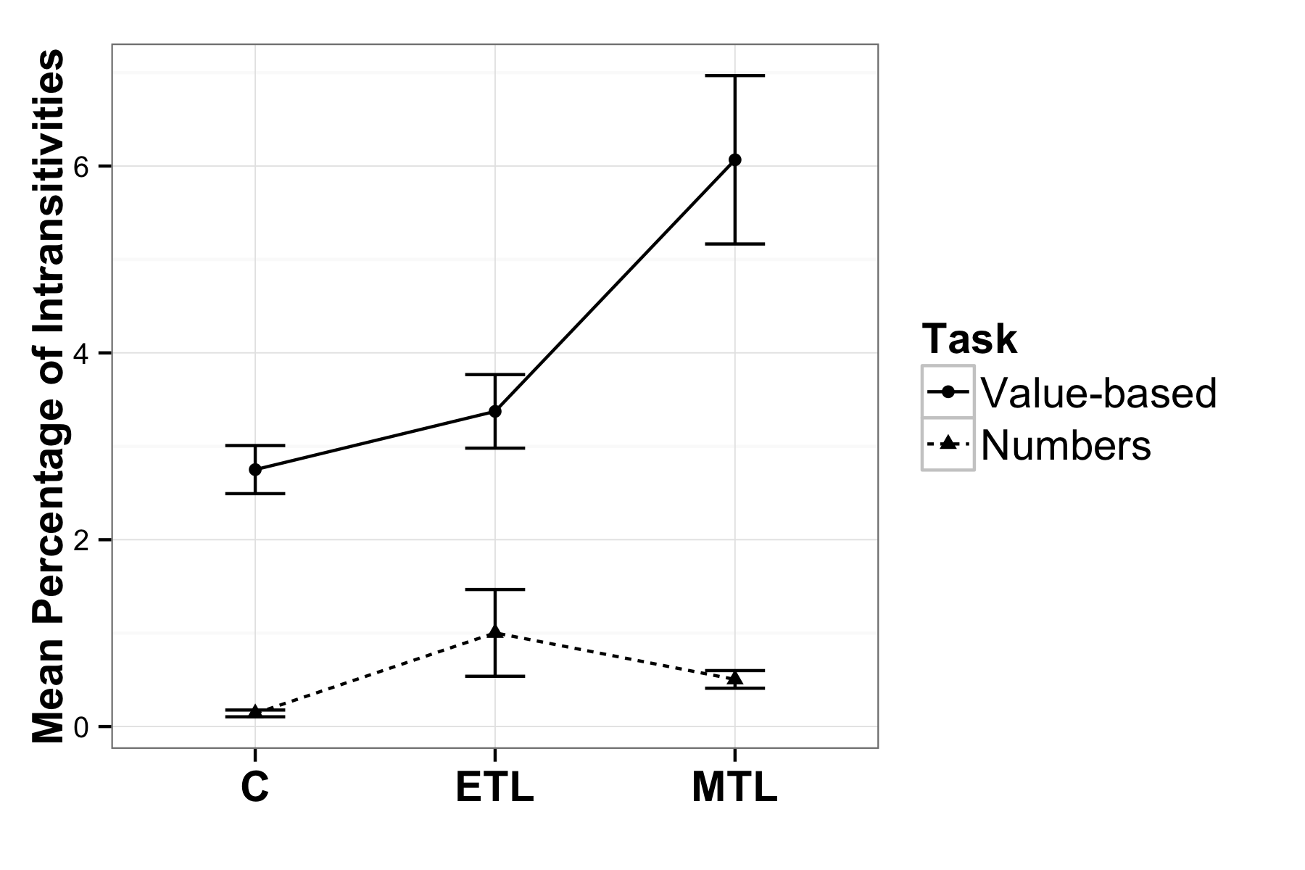

**Fig. 2**. Mean percentage of intransitive choices per group in each task (nMTL = 31, nC = 30, nETL = 30). Error bars represent SEM.

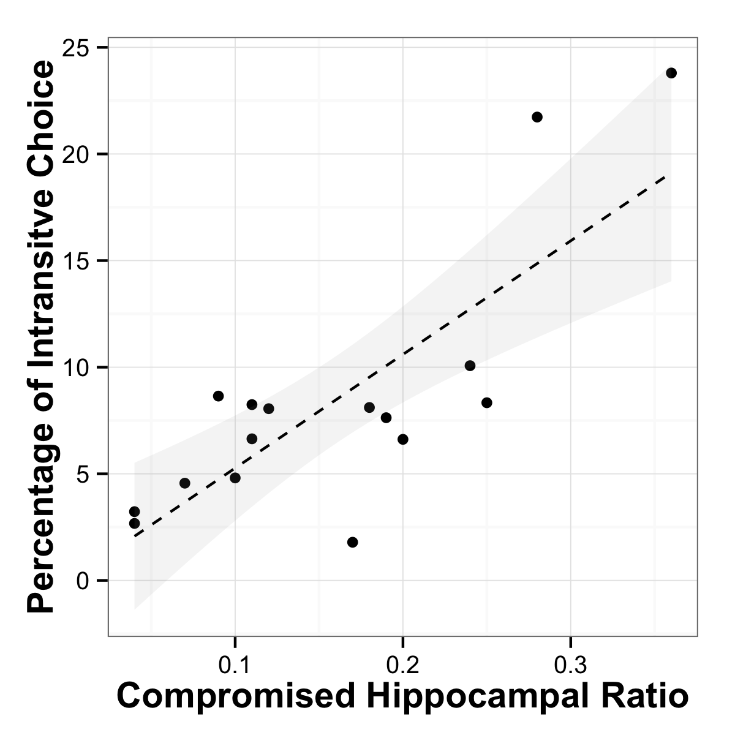

**Fig. 3**. Relationship between hippocampal lesion volume and intransitive choices. Scatterplot of compromised hippocampal volume (as a ratio of total volume) against percentage of intransitive choices, with a regression line with 95% CI for a linear regression. The observed robust nonparametric rank order correlation rho=0.676, p=0.004.

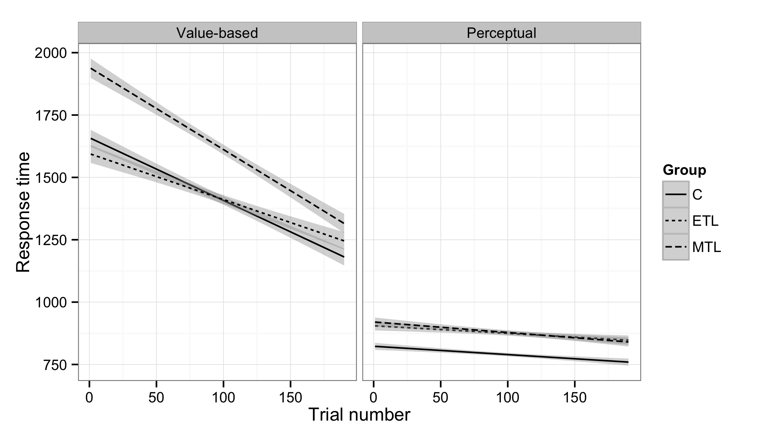

*Figure S1: Response times (RT) for each task and group. RT’s decreased as the task progressed for all groups in both trials. The MTL group was consistently slower in the choice task. All groups were faster in the control task, particularly the healthy controls.*

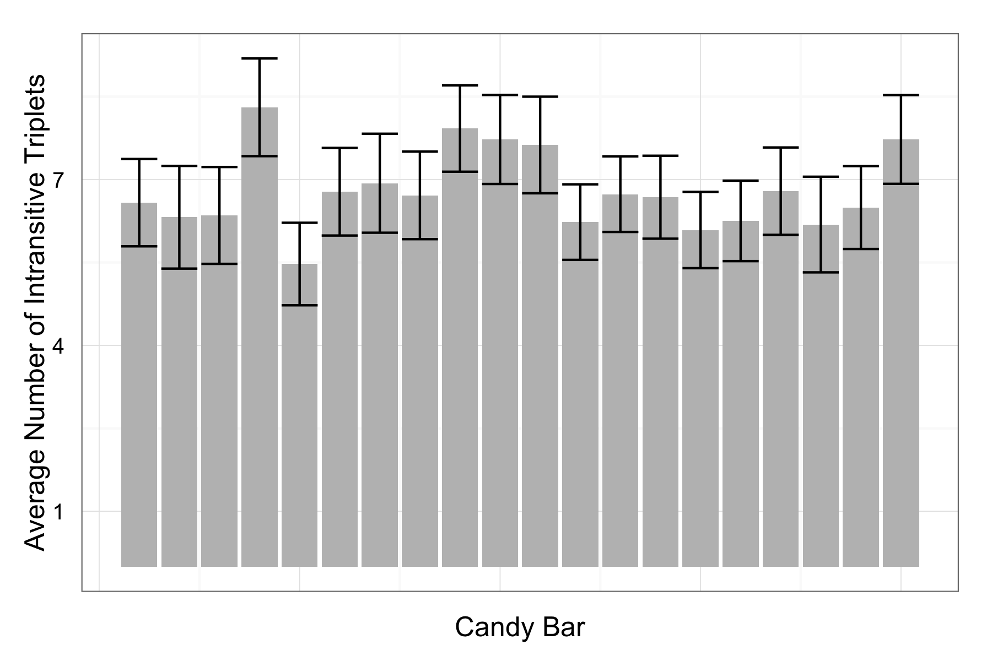

***Figure S2****. Average number of intransitive triplets each stimulus was involved in for the preference task. There were no idiosyncratic differences between the stimuli (F(1, 18) = 0.003, p = 0.959).*

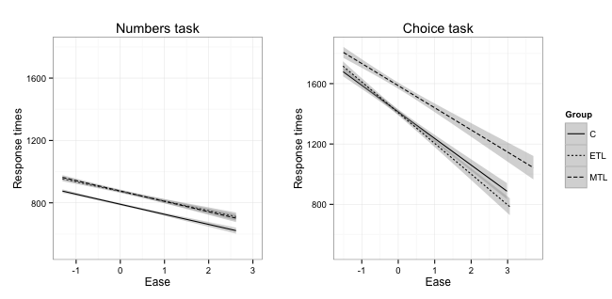

***Figure S3****. Response times as a function of decision difficulty. As decisions become easier in both tasks all groups respond faster. The MTL group is slower, however, to react to change in difficulty for the choice task, while this is not true for the control task.*

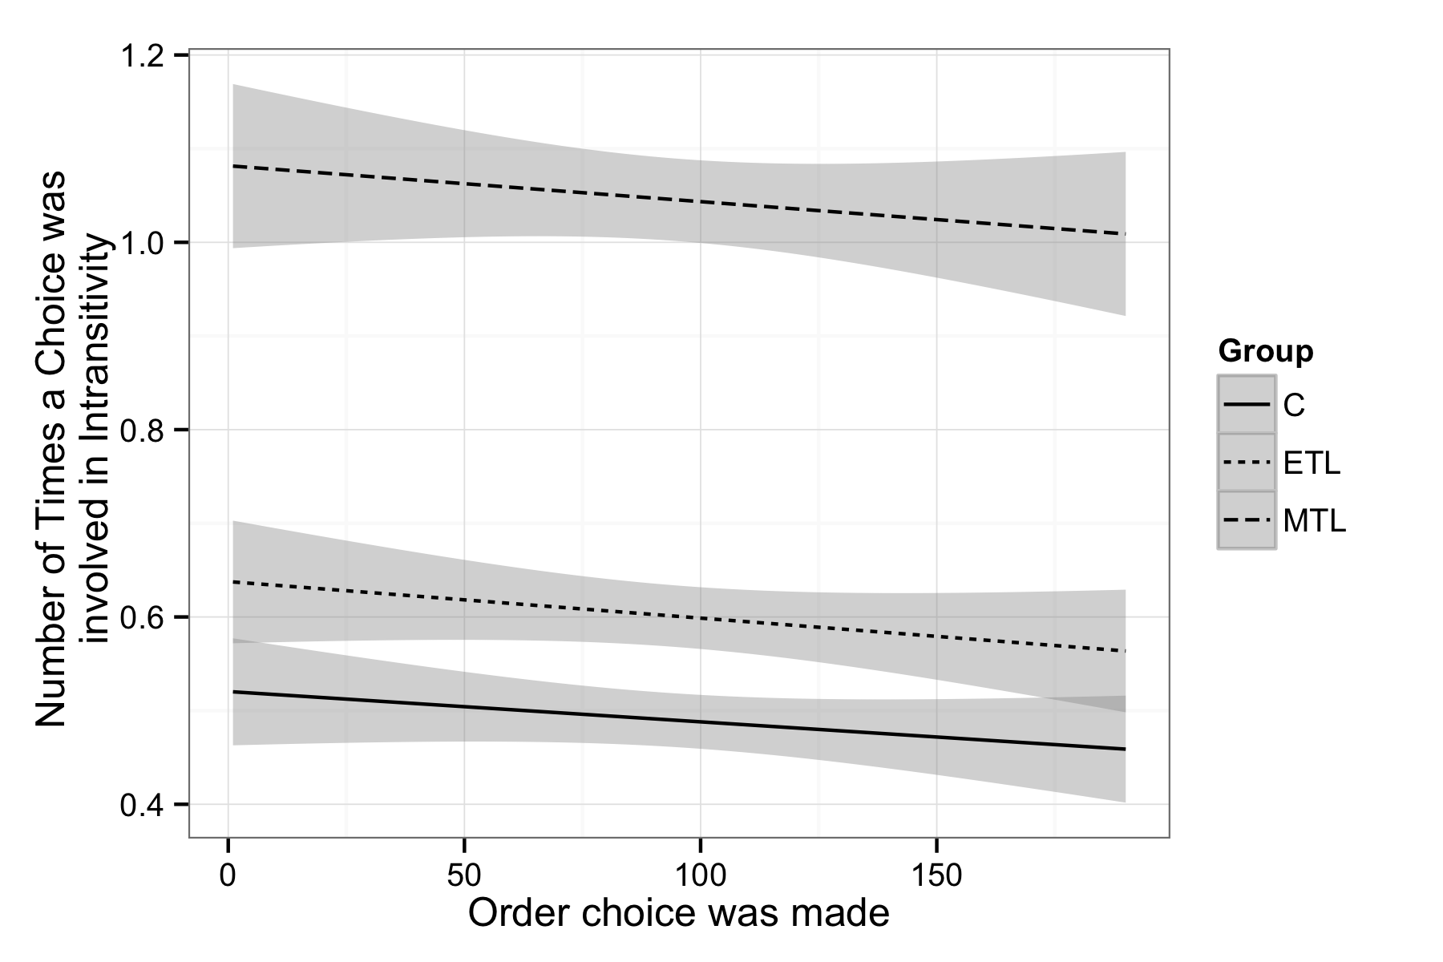

*Figure S4: Number of intransitivities throughout the task for each group. The probability of intransitivity remains constant across trials.*

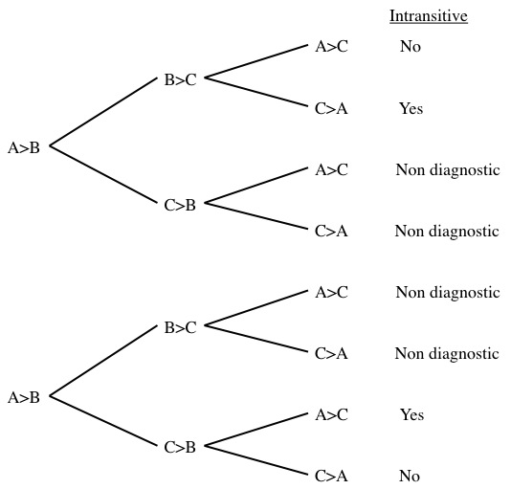

*Figure S5: Tree diagram indicating possible intransitive paths from three binary choices*

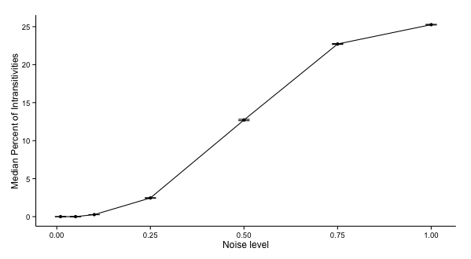

*Figure S6: Median percentage of intransitivities at different noise levels, based on 1000 simulations. Error bars indicate standard errors of the simulation means.*