**Preference consistency relies on hippocampal function: Evidence from mediotemporal lobe epilepsy**

B. Weber1,2, I. Zweyer1,2, J. Wagner1, C.E. Elger1,2, E. U. Weber3, E. J. Johnson3,

1Department of Epileptology, University Hospital Bonn. 2Center for Economics and Neuroscience, University of Bonn. 3Center for Decision Science, Columbia University

*Correspondence at: bernd.weber@ukb.uni-bonn.de

**Introduction**

The notion that our preferences draw on past experience and hence memory should not be controversial. Memory representations of past choices and their consequences allow organisms to learn what sources of food provide optimal nourishment and which predators and other dangers to avoid, ensuring our survival and well-being by informing future preferences. To the extent that such information has great generality over time, it even gets incorporated into a species’ genetic blueprint, its collective memory record, resulting for example in hardwired fear of snakes in chimpanzees and humans.

The field of economics has treated preferences as a primitive in its influential axiomatic models of choice (e.g., von Neumann & Morgenstern, 1952). Perhaps as a result, the connection between properties of memory and judgment and choice has historically been ignored, with only a few exceptions (Weber, Goldstein, & Barlas, 1995). More recently, memory considerations have played a more prominent role in explanations of JDM phenomena attempting to leverage what we know about memory to provide insight into the processes underlying known decision phenomena (Reyna et al 2003; Schneider 2003).

Memory processes provide entry points for psychological models of judgment and choice, in addition to the important role of attentional and perceptual processes that have resulted in models such as prospect theory (Kahneman & Tversky, 1979). As reviewed by Weber & Johnson (2009), both memory encoding and retrieval processes influence judgment and choice in multiple ways. If preferences are often constructed (see Lichtenstein & Slovic, 2006), an insight that may arguably be psychology’s most successful export to economics, then memory processes can be expected to play a major role in this construction (Weber & Johnson, 2006). Query theory (Johnson et al, 2007; Weber et al., 2007) suggests that decision-makers consult their memory (or external sources) with automatic and implicit queries about the choice alternatives, in particular arguments for choosing one or the other, i.e., their merits or liabilities. Past experiences and other associations provide the basis for such evaluation.

One way to show that memory for past events plays a role in choice is to show that important choice characteristics are impaired in individuals who are known to have memory encoding or retrieval deficiencies. Memory of past experiences and imagining future experiences activate a common set of brain regions that include the hippocampus (Schacter & Addis, 2007), and these functions are impaired in patients with hippocampal damage (Klein et al., 2002). Thus patients with hippocampal sclerosis may be expected to show impaired preference construction.

To examine this, we employ a simple paradigm, binary choices among simple food products. Our basic measure is choice transitivity, whether or not choices among these options are consistent across choices. For example if a person chooses A over B, and B over C, transitivity implies that they must pick A over C (Samuelson, 1938). Transitivity has been a central measure in early work in decision-making (Tversky, 1969), and recent work examining preferences in neuroscience (Camille, Griffiths, Vo, Fellows, & Kable, 2011; Fellows, 2006; Fellows & Farah, 2007; Kalenscher, Tobler, Huijbers, Daselaar, & Pennartz, 2010) and consumer choice (Lee, Amir, & Ariely, 2009). One reason for focusing on transitivity is that it is the central as the General Axiom of Revealed Preference and is necessary and sufficient for value maximization(Houthakker, 1950). Without GARP, one cannot be truly maximizing value. Transitivity of preferences is embraced by most individuals as a desirable choice attribute, i.e., most people will change intransitive choice patterns to transitive ones, when their inconsistency in choice at different points in time is pointed out to them (Birnbaum & Guitierrez, 2007).

Prior research has used patients with ventromedial frontal lobe damage, areas known to be involved in the expression of value, to the frequency of intransitivities both for gambles (Camille et al., 2011) and preferences for food, colors, and people (Fellows & Farah, 2007). The latter work included an important control: An increase in intransitivity was not observed for perceptual judgments, suggesting that preferential tasks are uniquely affected.

Our task examines binary choices among pairs of 20 commonly available candy bars, a product that would be familiar and interesting to participants. We include a control judgment, asking respondents which number was bigger.

**Methods**

Thirty-one patients with clinically diagnosed hippocampal sclerosis from the presurgical program at the Department of Epileptology in Bonn were included in the study (MTL). As control groups, thirty patients with extratemporal lobe epilepsy (ETL) and thirty healthy control subjects (CON) were comprised. The study was approved by the local ethics committee of the University of Bonn and all subjects gave their written informed consent. The three groups did not differ with respect to age or gender (see Table X for details).

*Behavioral experiment*

Each subject made a series of binary choices on a computer between pairs of candy bars drawn randomly out of twenty, with each combination presented once, resulting in 190 choices. This procedure was adapted from Lee et al. (JCR, 2009). A choice was counted as inconsistent, if chocolate bar “A” was preferred over “B” and “B” over” C”, but “C” over “A”. We performed an additional control task in which subjects were presented with numbers from one to twenty and had to perform a judgment on which number was larger. Subjects received the choice of one random trial as additional payment to a participation fee of 10 €.

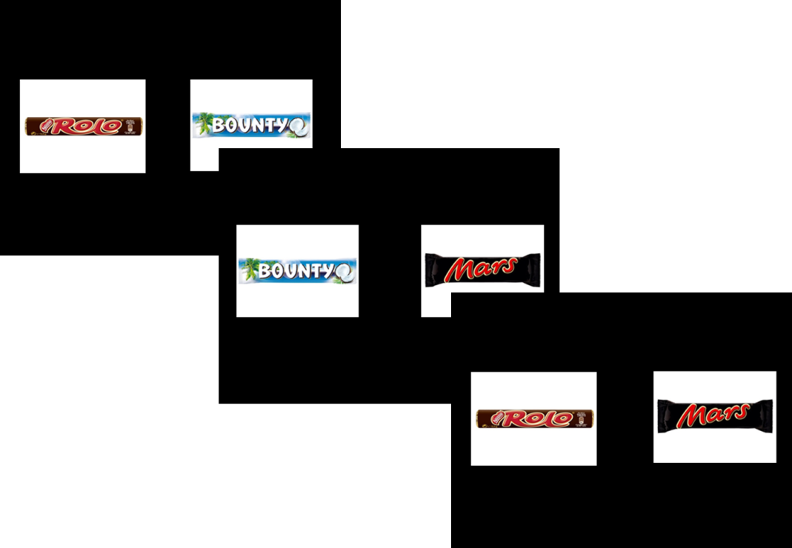

Fig 1. Three example trials of the binary choice experiment. Subject performed a choice of their preferred chocholate bar in each trial. The timing of the stimulus presentation and choice was self-paced.

*MR sequence and analysis*

For a subgroup of the patients with hippocampal sclerosis, a 3D-T1 weighted high-resolution data-set (MP-RAGE, voxel size 1x1x1mm, repetition time 1570ms, echo time 3.42ms, flip angle 15°, field of view 256mm x 256mm) was available for volumetric measurement of the hippocampus. This was done in a fully automated manner by means of the FreeSurfer image analysis suite (Version 5.1.0, Martinos Center, Harvard University, Boston, MA, U.S.A.) (Fischl *et al.*, 2002; Fischl *et al.*, 2004), which is documented and freely available for download online (<http://surfer.nmr.mgh.harvard.edu/>).. Because of the high variance in hippocampal volume between individuals, we used a laterality index of hippocampal volume as a proxy for unilateral hippocampal damage (*abs((Hippovol-Left – Hippovol-Right)/(Hippovol-L+Hippovol-R)*). Only subjects with unilateral hippocampal sclerosis were included in this analysis, because bilateral atrophy cannot be quantified by this measure.

*Statistical analysis*

Statistical analyses were performed using SPSS Statistics 21.0 for Windows (IBM, Armonk, NY, U.S.A.). All values throughout this report are given as mean unless otherwise stated. A probability (p) value ≤ 0.05 was regarded as statistically significant using two-tailed tests. Statistically significant differences in the figures and tables are marked with asterisks: *p ≤ 0.05, **p ≤ 0.01, and ***p ≤ 0.001.

**Results**

Patients with hippocampal sclerosis showed an increased number of inconsistent choices compared to the two control groups (Fig. 2; MTL: 6.45%; ETL: 3.67%; CON: 2.77%; Kruskal-Wallis-Test of independent groups p<0.001).

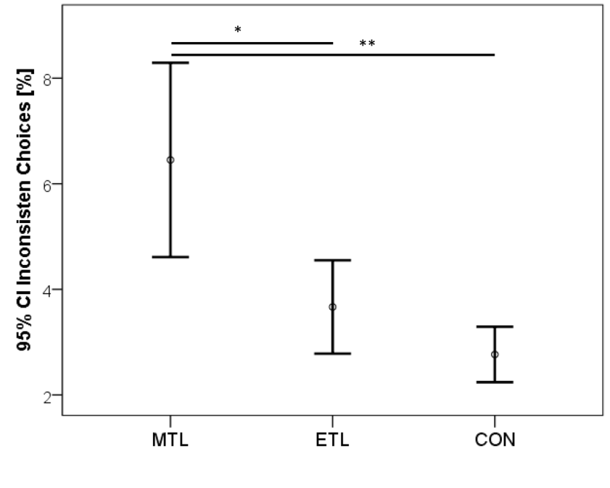

Fig. 2. Mean and 95%CI of the percentage of inconsistent choices for the three subject groups. * p<0.05; **p<0.01

The ratio of compromised hippocampal volume to total volume was significantly correlated with the amount of inconsistencies (Fig.3; spearman-rho = 0.761; p<0.001; n=16).

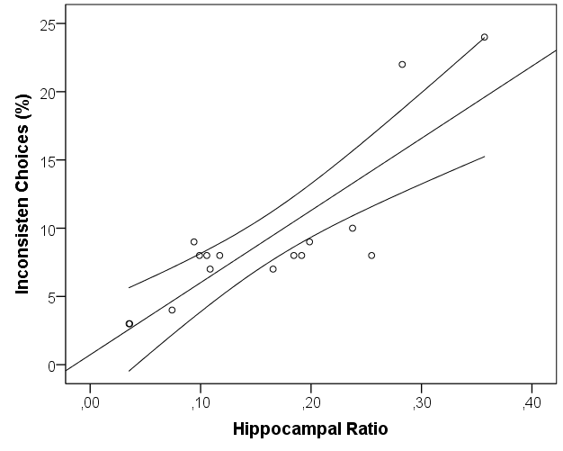

Fig 2. Correlation of hippocampal asymmetry (as a marker for unilateral atrophy) and percentage of inconsistent choices with 95% CI of the mean. rho=0.761, p<0.001

In the control task all groups did very well but the ETL group was significantly worse than the control group (percentage of errors: MTL: 0.81%; ETL: 1.17%; CON:0.07%; p<0.001 Kruskal-Wallis test for independent groups; MTL vs. ETL n.sign.; MTL vs. CON n.sign; ETL vs. CON p<0.05) with ETL patients exhibiting a much higher variance in this task.

How do we account for the strikingly similar pattern that we observe in MTL patients with that observed in VMPFC patients? Obviously, they both may have independent functions in choice. Fellows (Fellows, 2006) has demonstrated that VMPFC lesioned patients show difference in external information search that could be attributed to diminished planning capacity. Whether that diminished planning capacity affects search of memory is an interesting topic of further research.

**References**

Michael H. Birnbaum *, Roman J. Gutierrez (2007). Testing for intransitivity of preferences predicted by a lexicographic semi-order. Organizational Behavior and Human Decision Processes 104 (2007) 96–112

Grether, David M & Plott, Charles R, 1979. "[**Economic Theory of Choice and the Preference Reversal Phenomenon**](http://ideas.repec.org/a/aea/aecrev/v69y1979i4p623-38.html)," [American Economic Review](http://ideas.repec.org/s/aea/aecrev.html), 69, 623-38.

Klein SB, Loftus J, Kihlstrom JF (2002) Memory and temporal experience: the effects of episodic memory loss on an amnesic patient’s ability to remember the past and imagine the future. Social Cognition 20:353–379.

Lee, L., Amir, O., Ariely, D. (2009). In search of homo economicus: Cognitive noise and the role of emotions in preference construction. *Journal of Consumer Research, 36*, 173-187.

Lichtenstein, S. & Slovic, P., (Eds.), The Construction of Preference. New York NY: Cambridge University Press.

Schacter DL, Addis DR (2007) The cognitive neuroscience of constructive memory: remembering the past and imagining the future. Philos Trans R Soc Lond B Biol Sci 362:773–786.

Weber, E. U., Goldstein, W. M., & Barlas, S. (1995). [And let us not forget memory: The role of memory processes and techniques in the study of judgment and choice.](https://docs.google.com/a/decisionsciences.columbia.edu/viewer?a=v&pid=sites&srcid=ZGVjaXNpb25zY2llbmNlcy5jb2x1bWJpYS5lZHV8Y2RzLXdpa2l8Z3g6NmU3MWNhNTI5ZmVhNjkwMg) In J. R. Busemeyer, R. Hastie, D. L. Medin (Eds.) The Psychology of Learning and Motivation, Volume 32. Decision Making from a Cognitive Perspective. (pp. 33-82). San Diego: Academic Press.

Weber, E. U. & Johnson, E. J. (2006). [Constructing preferences from memory.](https://vlab2.gsb.columbia.edu/decisionsciences.columbia.edu/uploads/File/Articles/PAM.slovicbookclean.pdf) In: Lichtenstein, S. & Slovic, P., (Eds.), The Construction of Preference (pp. 397-410). New York NY: Cambridge University Press.

Weber, E. U. & Johnson, E. J. (2009). [Mindful judgment and decision making.](https://vlab2.gsb.columbia.edu/decisionsciences.columbia.edu/uploads/File/Articles/MindfulJudgment.PDF) Annual Review of Psychology, 60, 53-86.

Camille, N., Griffiths, C. A., Vo, K., Fellows, L. K., & Kable, J. W. (2011). Ventromedial frontal lobe damage disrupts value maximization in humans. *Journal of Neuroscience*, *31*(20), 7527–7532. doi:10.1523/JNEUROSCI.6527-10.2011

Fellows, L. K. (2006). Deciding how to decide: ventromedial frontal lobe damage affects information acquisition in multi-attribute decision making. *Brain*, *129*(4), 944–952. doi:10.1093/brain/awl017

Fellows, L. K., & Farah, M. J. (2007). The role of ventromedial prefrontal cortex in decision making: judgment under uncertainty or judgment per se? *Cerebral Cortex*, *17*(11), 2669–2674.

Houthakker, H. S. (1950). Revealed preference and the utility function. *Economica*, *17*(66), 159–174.

Kalenscher, T., Tobler, P. N., Huijbers, W., Daselaar, S. M., & Pennartz, C. M. (2010). Neural signatures of intransitive preferences. *Frontiers in human neuroscience*, *4*. doi:10.3389/fnhum.2010.00049

Lee, L., Amir, O., & Ariely, D. (2009). In Search of Homo Economicus: Cognitive Noise and the Role of Emotion in Preference Consistency. *Journal Of Consumer Research*, *36*(2), 173–187. doi:10.1086/597160

Samuelson, P. A. (1938). A note on the pure theory of consumer's behaviour. *Economica*.

Tversky, A. (1969). Intransitivity of preferences. *Psychological Review*, *76*(1), 31–48. doi:10.1037/h0026750