Preference consistency relies on hippocampal function:

Evidence from mediotemporal lobe epilepsy

B. Weber1,2, I. Zweyer1,2, J. Wagner1, C.E. Elger1,2, E. U. Weber3, E. J. Johnson3,

1Department of Epileptology, University Hospital Bonn. 2Center for Economics and Neuroscience, University of Bonn. 3Center for Decision Science, Columbia University

*Correspondence at: bernd.weber@ukb.uni-bonn.de

# Introduction

The notion that our preferences rely on past experience and hence memory should not be controversial. Memory representations of past choices and their consequences allow organisms to learn what sources of food provide optimal nourishment and which predators and other dangers to avoid, ensuring our survival and well-being. Confronted with the choice of a snack food item from a vending machine, we look at the labels, but use them to retrieve stored representations of past experiences to construct an estimate of their reward value.

However, economics has treated preferences as a primitive in its influential axiomatic models of choice (Von Neumann & Morgenstern, 1944). As a result, the connection between properties of memory and judgment and choice has historically been ignored, with only a few exceptions (Elke U. Weber, Goldstein, & Barlas, 1995). More recently, memory considerations have played a more prominent role in explanations of judgment and decision-making (JDM) phenomena attempting to leverage what we know about memory to provide insight into the processes underlying known decision phenomena (Dougherty, Gettys, & Ogden, 1999; Reyna, Lloyd, & Brainerd, 2003).

Memory processes provide entry points for psychological models of judgment and choice, in addition to the important role of attentional and perceptual processes that have resulted in models such as prospect theory (Kahneman & Tversky, 1979). Both memory encoding and retrieval processes influence judgment and choice in multiple ways (see Weber & Johnson, 2009 for a review). If preferences are often constructed (see Lichtenstein & Slovic, 2006), an insight that may arguably be psychology’s most successful export to economics, then memory processes can be expected to play a major role in this construction (Elke U. Weber & Johnson, 2006). Query theory (Johnson, Häubl, & Keinan, 2007; E U Weber et al., 2007) suggests that decision-makers consult their memory (or external sources) with automatic and implicit queries about the choice alternatives, in particular arguments for choosing one or the other, i.e., their merits or liabilities. Past experiences and other associations provide the basis for such evaluation. Parallel concerns in Neuroscience have emerged with a focus on the Prospective Memory network. Here it has been shown that future episodic imagery, i.e. the mental construction of specific future events, influences intertemporal choices. Stronger activity in this prospective memory network, including the MTL, related to a decrease of temporal discounting of monetary rewards (Benoit, Gilbert, & Burgess, 2011; Peters & Büchel, 2010). A recent study highlighted the involvement of the MTL in preference based choices. When preferences for novel food items had to be explicitly constructed from two familiar, previously uncombined tastes, the hippocampus as well as the medial prefrontal cortex provided value information (Barron, Dolan, & Behrens, 2013).

One way of demonstrating that memory the past plays a role in choice is to show that important choice characteristics are impaired in individuals who are known to have memory encoding or retrieval deficiencies. Memory of past experiences and imagining future experiences activate a common set of brain regions that include the hippocampus (Schacter & Addis, 2007), and these functions are impaired in patients with hippocampal damage (Klein & Loftus, 2002). Thus patients with hippocampal sclerosis may be expected to show impaired preference construction.

To examine this, we employ a simple paradigm, binary choices among simple food products. Our basic measure is choice transitivity, whether or not choices among these options are consistent across choices. For example if a person chooses A over B, and B over C, transitivity implies that they must pick A over C (Samuelson, 1938). Transitivity has been a central measure in early work in decision-making (Tversky, 1969), and recent work examining preferences in neuroscience (Camille, Griffiths, Vo, Fellows, & Kable, 2011; Fellows & Farah, 2007; Fellows, 2006; Kalenscher, Tobler, Huijbers, Daselaar, & Pennartz, 2010) and consumer choice (Lee, Amir, & Ariely, 2009). One reason for focusing on transitivity is that it is the central as the General Axiom of Revealed Preference and is necessary and sufficient for value maximization (Houthakker, 1950). Without GARP, one cannot be truly maximizing value. Transitivity of preferences is embraced by most individuals as a desirable property of a choice process:, Most people will change intransitive choice patterns to transitive ones, when their inconsistencies are pointed out to them (Birnbaum & Gutierrez, 2007).

Prior research has used patients with ventromedial frontal lobe damage, areas known to be involved in the expression of value, to the frequency of intransitivities both for gambles (Camille et al., 2011) and preferences for food, colors, and people (Fellows & Farah, 2007). The latter work included an important control: An increase in intransitivity was not observed for perceptual judgments, suggesting that preferential tasks are uniquely affected.

Our task examines binary choices among pairs of 20 commonly available candy bars, a product that would be familiar and interesting to participants. We include a control judgment, asking respondents which number was bigger.

# Methods

Thirty-one patients with clinically diagnosed hippocampal sclerosis from the presurgical program at the Department of Epileptology in Bonn were included in the study (MTL). As control groups, thirty patients with extratemporal lobe epilepsy (ETL) and thirty healthy control subjects (CON) were comprised. The study was approved by the local ethics committee of the University of Bonn and all subjects gave their written informed consent. The three groups did not differ with respect to age or gender (see Table X for details).

# Behavioral experiment

Each subject made a series of binary choices on a computer between pairs of candy bars drawn randomly out of twenty, with each combination presented once, resulting in 190 choices. This procedure was similar to that used to examine the effect of ventromedial frontal lobe damage in Camille et al., 2011; Fellows & Farah, 2007; Fellows, 2006, and used familiar candy bars as the choice objects (see also Lee et al., 2009). A choice was counted as inconsistent, if chocolate bar “A” was preferred over “B” and “B” over” C”, but “C” over “A”. We performed an additional control task in which subjects were presented with numbers from one to twenty and had to perform a judgment on which number was larger. Subjects received their choice from one randomly selected trial in addition to a participation fee of 10 €.

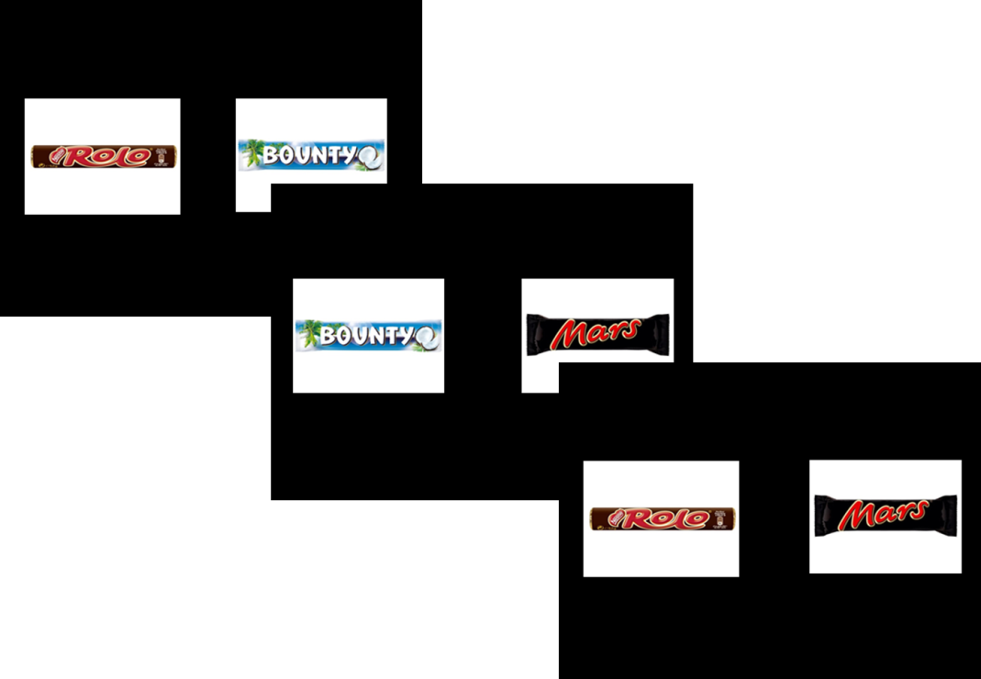

Fig 1. Three example trials of the binary choice experiment. Subject performed a choice of their preferred chocolate bar in each trial. The timing of the stimulus presentation and choice was self-paced with time constraint of 5 seconds.

# MR sequence and analysis

For a subgroup of the patients with hippocampal sclerosis, a 3D-T1 weighted high-resolution data set (MP-RAGE, voxel size 1x1x1mm, repetition time 1570ms, echo time 3.42ms, flip angle 15°, field of view 256mm x 256mm) was available for volumetric measurement of the hippocampus. This was done in a fully automated manner by means of the FreeSurfer image analysis suite (Version 5.1.0, Martinos Center, Harvard University, Boston, MA, U.S.A.) (Fischl et al., 2002, 2004), which is documented and freely available for download online (<http://surfer.nmr.mgh.harvard.edu/>). Because of the high variance in hippocampal volume between individuals, we used a laterality index of hippocampal volume as a proxy for unilateral hippocampal damage

$$LI=abs \frac{V_{Hippo_L}-V_{Hippo_R} }{V_{Hippo_L}+V_{Hippo_R}}$$

Only subjects with unilateral hippocampal sclerosis were included in this analysis, because bilateral atrophy cannot be quantified by this measure.

# Statistical analysis

Statistical analyses were performed using SPSS Statistics 21.0 for Windows (IBM, Armonk, NY, U.S.A.) and R (Version 3.0.2) for Mac. All values throughout this report are given as mean unless otherwise stated. A probability (p) value ≤ 0.05 was regarded as statistically significant using two-tailed tests. Statistically significant differences in the figures and tables are marked with asterisks: *p ≤ 0.05, **p ≤ 0.01, and ***p ≤ 0.001.

## Tallying intransitivities

The binary choices each subject made were transformed in to a matrix of triplets because the detection of intransitivity requires three trials. Each matrix consisted of 1140 representing all possible combinations of 3 of 20 bars. A triplet was marked as indicating intransitivity either if A was chosen over B and B was chosen over C yet C was chosen over A or if B was chose A and C was chosen over B yet A was chosen over C.

$$A ≳B and B≳C and C$$ $$≳A$$

or

$$B ≳A and C≳B and A≳C$$

This provided the central dependent measure, the proportion of intransitive choices by dividing the number of intransitive triples by the total number of triples.

# Results

Patients with hippocampal sclerosis showed an increased number of intransitive choices compared to the two control groups (Fig. 2; mean percentages: MTL: 6.80%; ETL: 4.45%; CON: 2.81%; median percentages: MTL: 4.91%; ETL 3.25%; CON: 3.03%; Kruskal-Wallis-Test of independent groups p<0.001). The two controls group did not differ significantly from each other (Wilcoxon rank sum test p = 0.193).[1]



Fig 1. Median percentage of intransitive choices of 1140 triples for each group. Bootstrapped standard errors calculated from 1000 samples.

The ratio of compromised hippocampal volume to total volume was significantly correlated with the amount of inconsistencies (Fig.3; spearman-rho = 0.761; p<0.001; n=16).

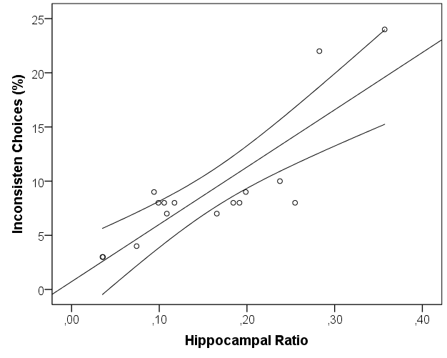

Fig 2. Correlation of hippocampal asymmetry (as a marker for unilateral atrophy) and percentage of inconsistent choices with 95% CI of the mean. rho=0.761, p<0.001

In the control task, respondents identified which number was larger. All groups did well but the ETL group was significantly worse than the control group (percentage of errors: MTL: 0.81%; ETL: 1.17%; CON:0.07%; p<0.001 Kruskal-Wallis test for independent groups; MTL vs. ETL n.sign.; MTL vs. CON n.sign; ETL vs. CON p<0.05) and ETL patients exhibited a much higher variance in this task. However, the absence of differences in this task and the presence of differences in the choice task underlines the specificity of the involvement of hippocampal function in preference based choices and not more general attentional effects.

We examined if these patterns were stable across the course of the experiment. Although each pair of options is seen once, prior choices involving one of the pairs might influence subsequent choices where options were previously seen. It would be of particular concern if these effects occur differentially across groups. The MTL group might have less ability to benefit from past retrievals of an option on earlier trials, producing an alternative explanation for the observed differences. We examined how intransitivities occurred across time by computing how many times a trial was a member of an intransitive triplet. This served as the dependent measure in a multilevel model. This model contained a random effect representing individuals nested in groups and fixed effects of the centered trial number, its centered quadratic term, and factors indicating groups and their interactions. Intransitivities did not vary over trials (t = – 0.41) nor with the quadratic term (t = 0.91), nor were any interaction significant.

We also examined response latencies of the choices. There were no significant differences between the groups (MTL = 1587 msec, ETL = 1408 msec, CON = 1413 msec, p = 0.12). While respondents, as expected, became faster in later trials. (t = – 27.79), there was no relationship between latency and the number of intransitivies (p = 0.81).

Were particular options responsible for intransitivies? We regressed the number of times each trial was involved in an intransitive choice onto indicator variable representing the identify of each chocolate bar as well a factor representing group.. None of these variables survived a post-hoc test of significance..

# Discussion

There is increasing interest in how value representations are constructed. In this paper we demonstrate that hippocampal lesions are associated with intransitive preferences and that the degree of intransitivity is related to severity of the damage to the hippocampus. A control task not involving preference based choices does not show these effects, nor do respondents who have lesions outside of the temporal lobe. These results implicate the hippocampal areas in preference construction and produce results that are strikingly similar to those observed in VMPFC patients.

What is the relationship between these results? One initial idea is impressions and memories stored in the hippocampus are inputs to value calculation occurring elsewhere (Barron et al., 2013).The hippocampus is one of the most highly interconnected brain areas, including a direct monosynaptic connection to the prefrontal cortex (Cole, Pathak, & Schneider, 2010; Godsil, Kiss, Spedding, & Jay, 2013; Ongür & Price, 2000). Ranganath and Ritchey (2012) proposed a distinction of the MTL into two systems for memory guided behavior: the anterior (AT) and posterior-medial (PM) system. The AT, which is comprised of the peri-rhinal cortex and anterior parts of the hippocampus and amygdala has strong interconnections with the frontal cortex and argued to be involved in familiarity based cognition, social behavior and saliency. The authors state “the AT system could facilitate the construction of knowledge about people, so that past experiences can be used to inform inferences about the personality and intentions of others, irrespective of their behaviour in a particular context”. Our data suggests that this connection to the ventromedial prefrontal cortex may also serve the construction of preferences. This is supported by the results of Fellows (Fellows, 2006) who has demonstrated that VMPFC lesioned patients show differences in external information search that could be attributed to diminished planning capacity. Perhaps retrieval of experiences from memory is also inhibited in VMPFC patients but this is an interesting topic of further research.

What is the status of the intransitivities that we observe?   Much research has used the existence of particular intransitive preferences as evidence of particular alternatives to value maximization (Tversky, 1969), but those demonstrations have been criticized (Regenwetter) potentially being due to changing preferences and indifference.  In our work, we use intransitivities in a simpler way, as evidence that a stable preference is less strong in those whose MTL regions have been impaired, that and the degree of that weakness is a function of the degree of damage.

Because this work parallels similar work implicating the VMPFC in value representation, it suggests a critical role for the hippocampus as the carrier of critical components needed to construct those values. We would argue that most decision require the construction of value based upon past experience: Even an experienced option, like a favorite dish in a familiar restaurant requires us to compare that option to specials that are newly available and to consider our the last experience with our favorite option. Thus it is likely that memory will have a large role in our growing understanding of how the brain calculates value.

# References

Barron, H. C., Dolan, R. J., & Behrens, T. E. J. (2013). Online evaluation of novel choices by simultaneous representation of multiple memories. *Nature Neuroscience*, *16*(10), 1492–8. doi:10.1038/nn.3515

Benoit, R. G., Gilbert, S. J., & Burgess, P. W. (2011). A neural mechanism mediating the impact of episodic prospection on farsighted decisions. *The Journal of Neuroscience : The Official Journal of the Society for Neuroscience*, *31*(18), 6771–9. doi:10.1523/JNEUROSCI.6559-10.2011

Birnbaum, M. H., & Gutierrez, R. J. (2007). Testing for intransitivity of preferences predicted by a lexicographic semi-order. *Organizational Behavior and Human Decision Processes*, *104*(1), 96–112. doi:10.1016/j.obhdp.2007.02.001

Camille, N., Griffiths, C. a, Vo, K., Fellows, L. K., & Kable, J. W. (2011). Ventromedial frontal lobe damage disrupts value maximization in humans. *The Journal of Neuroscience : The Official Journal of the Society for Neuroscience*, *31*(20), 7527–32. doi:10.1523/JNEUROSCI.6527-10.2011

Cole, M. W., Pathak, S., & Schneider, W. (2010). Identifying the brain’s most globally connected regions. *NeuroImage*, *49*(4), 3132–48. doi:10.1016/j.neuroimage.2009.11.001

Dougherty, M. R. P., Gettys, C. F., & Ogden, E. E. (1999). MINERVA-DM : A Memory Processes Model for Judgments of Likelihood. *Psychological Review*, *106*(1), 180–209.

Fellows, L. K. (2006). Deciding how to decide: ventromedial frontal lobe damage affects information acquisition in multi-attribute decision making. *Brain : A Journal of Neurology*, *129*(Pt 4), 944–52. doi:10.1093/brain/awl017

Fellows, L. K., & Farah, M. J. (2007). The role of ventromedial prefrontal cortex in decision making: judgment under uncertainty or judgment per se? *Cerebral Cortex (New York, N.Y. : 1991)*, *17*(11), 2669–74. doi:10.1093/cercor/bhl176

Fischl, B., Salat, D. H., Busa, E., Albert, M., Dieterich, M., Haselgrove, C., … Dale, A. M. (2002). Whole brain segmentation: Automated labeling of neuroanatomical structures in the human brain. *Neuron*, *33*, 341–355. doi:10.1016/S0896-6273(02)00569-X

Fischl, B., van der Kouwe, A., Destrieux, C., Halgren, E., Ségonne, F., Salat, D. H., … Dale, A. M. (2004). Automatically parcellating the human cerebral cortex. *Cerebral Cortex (New York, N.Y. : 1991)*, *14*, 11–22. doi:10.1093/cercor/bhg087

Godsil, B. P., Kiss, J. P., Spedding, M., & Jay, T. M. (2013). The hippocampal-prefrontal pathway: the weak link in psychiatric disorders? *European Neuropsychopharmacology : The Journal of the European College of Neuropsychopharmacology*, *23*(10), 1165–81. doi:10.1016/j.euroneuro.2012.10.018

Houthakker, H. S. (1950). Revealed Preference and the Utility Function. *Economica*, *17*(66), 159–174.

Johnson, E. J., Häubl, G., & Keinan, A. (2007). Aspects of endowment: a query theory of value construction. *Journal of Experimental Psychology. Learning, Memory, and Cognition*, *33*, 461–474. doi:10.1037/0278-7393.33.3.461

Kahneman, D., & Tversky, A. (1979). Prospect Theory: An analysis of decision under risk. *Econometrica: Journal of Econometric Society*, *47*(2), 263–292.

Kalenscher, T., Tobler, P. N., Huijbers, W., Daselaar, S. M., & Pennartz, C. M. a. (2010). Neural signatures of intransitive preferences. *Frontiers in Human Neuroscience*, *4*(June), 1–14. doi:10.3389/fnhum.2010.00049

Klein, S. B., & Loftus, J. (2002). Memory and temporal experience : The effects of episodic memory loss on an amnesic patient’s ability to remember the past and imagine the future. *Social Cognition*, *20*(5), 353–379.

Lee, L., Amir, O., & Ariely, D. (2009). In Search of Homo Economicus: Cognitive Noise and the Role of Emotion in Preference Consistency. *Journal of Consumer Research*, *36*(2), 173–187. doi:10.1086/597160

Lichtenstein, S., & Slovic, P. (Eds.). (2006). *The Construction of Preference*. New York: Cambridge University Press.

Ongür, D., & Price, J. L. (2000). The organization of networks within the orbital and medial prefrontal cortex of rats, monkeys and humans. *Cerebral Cortex (New York, N.Y. : 1991)*, *10*(3), 206–19. Retrieved from http://www.ncbi.nlm.nih.gov/pubmed/10731217

Peters, J., & Büchel, C. (2010). Episodic future thinking reduces reward delay discounting through an enhancement of prefrontal-mediotemporal interactions. *Neuron*, *66*(1), 138–48. doi:10.1016/j.neuron.2010.03.026

Ranganath, C., & Ritchey, M. (2012). Two cortical systems for memory-guided behaviour. *Nature Reviews. Neuroscience*, *13*(10), 713–26. doi:10.1038/nrn3338

Reyna, V. F., Lloyd, F. J., & Brainerd, C. J. (2003). Memory, Development, and Rationality: An Integrative Theory of Judgement and Decision Making. In *Emerging Perspectives on Judgement and Decision Research* (pp. 201–245).

Samuelson, P. A. (1938). A Note on the Pure Theory of Behaviour Consumer ’s Bheavior. *Economica*, *5*(17), 61–71.

Schacter, D. L., & Addis, D. R. (2007). The cognitive neuroscience of constructive memory: remembering the past and imagining the future. *Philosophical Transactions of the Royal Society of London. Series B, Biological Sciences*, *362*(1481), 773–86. doi:10.1098/rstb.2007.2087

Tversky, A. (1969). Intransitivity of preferences. *Psychological Review*, *76*(1), 31–48. doi:10.1037/h0026750

Von Neumann, J., & Morgenstern, O. (1944). *Theory of Games and Economic Behavior*. *Princeton University Press* (Vol. 2, p. 625). doi:10.1177/1468795X06065810

Weber, E. U., Goldstein, W. M., & Barlas, S. (1995). And let us not Forget Memory: The Role of Memory Processes and Techniques in the Study of Judgment and Choice. In *The Psychology of Learning and Motivation* (Vol. 32, pp. 33–81). doi:10.1016/S0079-7421(08)60307-2

Weber, E. U., & Johnson, E. J. (2006). Constructing Preferences from Memory. *SSRN Electronic Journal*. doi:10.2139/ssrn.1301075

Weber, E. U., & Johnson, E. J. (2009). Mindful judgment and decision making. *Annual Review of Psychology*, *60*, 53–85. doi:10.1146/annurev.psych.60.110707.163633

Weber, E. U., Johnson, E. J., Milch, K. F., Chang, H., Brodscholl, J. C., & Goldstein, D. G. (2007). Asymmetric discounting in intertemporal choice: a query-theory account. *Psychological Science : A Journal of the American Psychological Society / APS*, *18*, 516–523. doi:10.1111/j.1467-9280.2007.01932.x

1. Some trials timed out before subjects could indicate a clear preference. We recalculated these statistics and tests excluding the trials and triplets containing a timed-out choice. All behavioral results are similar.