Preference consistency relies on hippocampal function:

Evidence from mediotemporal lobe epilepsy

B. Weber1,2, I. Zweyer1,2, J. Wagner1, C.E. Elger1,2, A. Z. Enkavi3 ,E. U. Weber3, E. J. Johnson3,

1Department of Epileptology, University Hospital Bonn. 2Center for Economics and Neuroscience, University of Bonn. 3Center for Decision Science, Columbia University

*Correspondence at: bernd.weber@ukb.uni-bonn.de

# Introduction

It seems obvious that our preferences draw on past experience and hence memory. Memory representation of past choices and their consequences allow us to learn what sources of food provide optimal nourishment and which predators and other dangers should be avoided, ensuring our survival and well-being. Confronted with a choice of snack food items at a vending machine, we examine the wrappers of the candy bars, primarily as memory cues to retrieve past experiences with them as a way to construct an estimate of their reward value.

Economics, in contrast, treats preferences as a primitive in its influential axiomatic models of risky choice (Von Neumann & Morgenstern, 1944). As a result, the connection between properties of memory and judgment and choice has historically been ignored, with only a few exceptions (Elke U. Weber, Goldstein, & Barlas, 1995). More recently, memory processes and constraints have played a more prominent role in explanations of judgment and decision-making (JDM) phenomena, in an attempt to leverage what we know about memory to explain well-known decision phenomena (Dougherty, Gettys, & Ogden, 1999; Reyna, Lloyd, & Brainerd, 2003; Schneider & Shanteau, 2003; Elke U Weber & Johnson, 2009).

Memory processes provide entry points for psychological models of judgment and choice that have the potential to more accurately describe observed judgments and decisions. Consideration of memory processes is a logical next step in field where previous incorporation of attentional and perceptual processes has resulted in models such as prospect theory (Kahneman & Tversky, 1979; Tversky & Kahneman, 1992) that have succeeded to account for response patterns considered anomalies by rational choice models such as expected utility theory, resulting in the Nobel Prize for Economic Science being awarded to Daniel Kahneman in 2002.

If preferences are often constructed (see Lichtenstein & Slovic, 2006), an insight that may arguably be psychology’s most successful export to economics, then memory processes can be expected to play a major role in this construction. Both memory encoding and retrieval processes influence judgment and choice in multiple ways (see Weber & Johnson, 2009 for a review). Query theory (Johnson, Häubl, & Keinan, 2007; E U Weber et al., 2007) suggests that decision-makers consult their memory (or external sources) with automatic and implicit queries about the choice alternatives, in particular arguments for choosing one or the other, i.e., their merits or liabilities. Past experiences and other associations provide the basis for such evaluation.

Parallel lines of investigation in neuroscience have focused on the Prospective Memory network. Here it has been shown that future-oriented episodic imagery, i.e. the mental construction of specific future events based on past experience, influences intertemporal choices. Stronger activity in this prospective memory network, including the medial temporal lobe (MTL), is associated with decreased temporal discounting of monetary rewards (Benoit, Gilbert, & Burgess, 2011; Peters & Büchel, 2010). Wimmer and Shohamy (2012) showed that the MTL is also involved in the transfer of value of rewarded stimuli by associative learning and how these memory mechanisms bias decisions. A recent study highlighted the involvement of the MTL in preference-based choices. When preferences for novel food items had to be explicitly constructed from two familiar, previously uncombined tastes, the hippocampus as well as the medial prefrontal cortex provided value information (Barron, Dolan, & Behrens, 2013).

One way of demonstrating that memory representations of past experience play a role in choice is to show that choice is impaired in individuals who are known to have memory encoding or retrieval deficiencies. Memory of past experiences and imagining future experiences activate a common set of brain regions that include the hippocampus (Schacter & Addis, 2007), and these functions are impaired in patients with hippocampal damage (Klein & Loftus, 2002). Thus patients with hippocampal sclerosis may be expected to show impaired preference construction.

To test this hypothesis, we employ a simple paradigm, a series of binary choices among simple food products. Our measure of choice quality is the transitivity of preference, i.e., whether or not preferences for different options are consistent across choice pairings. For example if a person chooses A over B, and B over C, transitivity requires that they must pick A over C (Samuelson, 1938). Transitivity has been a central measure in early work in decision-making (Tversky, 1969), and recent work examining preferences in neuroscience (Camille, Griffiths, Vo, Fellows, & Kable, 2011; Fellows & Farah, 2007; Fellows, 2006; Kalenscher, Tobler, Huijbers, Daselaar, & Pennartz, 2010) and consumer choice (Lee, Amir, & Ariely, 2009). One reason for focusing on transitivity is that it is central to the General Axiom of Revealed Preference and is necessary and sufficient for value maximization (Houthakker, 1950). Transitivity of preferences is embraced by most individuals as a desirable property of a choice process. Most people will change intransitive choice patterns to transitive ones, when their inconsistencies are pointed out to them (Birnbaum & Gutierrez, 2007).

Research using patients with lesions in the ventromedial frontal lobe, in areas known to be involved in the expression of value, showed greater frequency of intransitivities for choices between gambles (Camille et al., 2011) and for preferences for food, colors, and people (Fellows & Farah, 2007). The latter study included an important control: An increase in intransitivity was not observed for perceptual judgments, suggesting that preferential tasks were uniquely affected.

We adapt the paradigm but examine the effect of damage to the hippocampus, an area not know to be involve in the expression of value but, according to our hypothesis, involved in the generation of input to any value calculation. In particular, our task examines binary choices among pairs of 20 commonly available candy bars, a product we could expect to be familiar and interesting to participants. We also included a control judgment, asking respondents to judge which of two numbers was bigger. In both cases our dependent measure was the transitivity of (preference or magnitude) judgments.

# Methods

Thirty-one patients with clinically diagnosed hippocampal sclerosis from the presurgical program at the Department of Epileptology in Bonn were included in the study (MTL). Two control groups consisted of thirty patients with extratemporal lobe epilepsy (ETL) and thirty healthy control subjects (CON), respectively. The study was approved by the local ethics committee of the University of Bonn and all subjects gave their written informed consent. The three groups did not differ with respect to age or gender (see Table X for details).

# Behavioral experiment

Each subject made a series of binary choices on a computer between pairs of candy bars, each represented pictorially as shown in Fig.1, drawn randomly out of a set of twenty, with each combination presented once, resulting in 190 choices. This procedure was similar to that used to examine the effect of ventromedial frontal lobe damage on choice used by Camille et al. (2011), Fellows & Farah (2007) and Fellows (2006), and used familiar candy bars as the choice objects (see also Lee et al., 2009). A choice triplet was counted as inconsistent, if chocolate bar “A” was preferred over “B” and “B” over” C”, but “C” was preferred over “A”. In a control task, subjects were presented with numbers from one to twenty and had to judge which number was larger. In this task, judgment inconsistency in triplets of magnitude judgments was similarly assessed. Subjects knew that they would receive their choice from one randomly selected candy bar choice trial, in addition to a participation fee of 10 €.

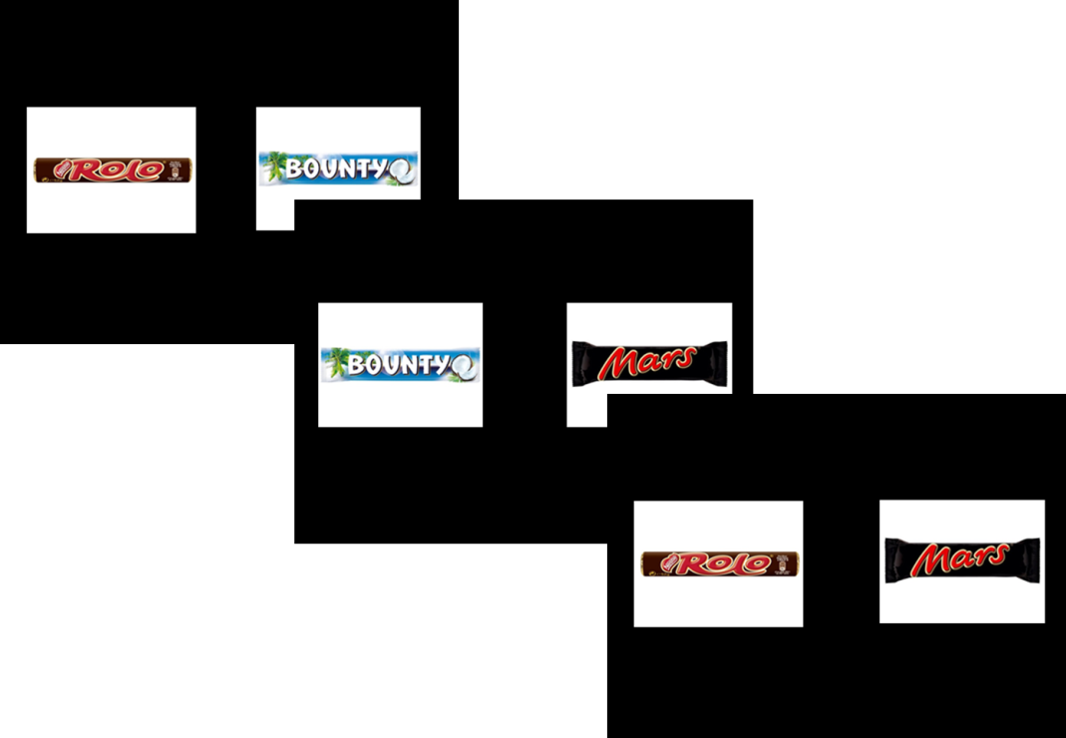

Fig 1. Three trials of the binary choice experiment. Subject indicated their preferred candy bar on each trial. The timing of the stimulus presentation and choice was self-paced, with a maximal length of 5 seconds.

# MR sequence and analysis

For a subgroup of the patients with hippocampal sclerosis, a 3D-T1 weighted high-resolution data set (MP-RAGE, voxel size 1x1x1mm, repetition time 1570ms, echo time 3.42ms, flip angle 15°, field of view 256mm x 256mm) was available for volumetric measurement of the hippocampus. This was done in a fully automated manner by means of the FreeSurfer image analysis suite (Version 5.1.0, Martinos Center, Harvard University, Boston, MA, U.S.A.) (Fischl et al., 2002, 2004), which is documented and freely available for download online (<http://surfer.nmr.mgh.harvard.edu/>). Because of the high variance in hippocampal volume between individuals, we used a lateral damage index of hippocampal volume to express the extent of unilateral hippocampal damage in our MTL group:

$$LDI=abs \frac{V_{Hippo_L}-V_{Hippo_R} }{V_{Hippo_L}+V_{Hippo_R}}$$

This lateral damage index can obviously by only assessed for subjects with unilateral hippocampal sclerosis.

# Statistical analysis

Statistical analyses were performed using SPSS Statistics 21.0 for Windows (IBM, Armonk, NY, U.S.A.) and R (Version 3.0.2) for Mac. We use a two-tailed p-value of 0.05 as our criterion for statistical significance and mark significant differences in the figures and tables with asterisks: *p ≤ 0.05, **p ≤ 0.01, and ***p ≤ 0.001.

## Tallying intransitivities

The binary choices made by each subject were transformed into a matrix of triplets, as the detection of intransitivity requires three choice pairs. Each matrix consisted of 1140 rows, representing all possible combinations of 3 of 20 bars. A triplet was marked as indicating intransitivity either if A was chosen over B and B was chosen over C yet C was chosen over A or if B was chose A and C was chosen over B yet A was chosen over C:

$$A ≳B and B≳C and C≳A$$

or

$$B ≳A and C≳B and A≳C$$

The proportion of intransitive choices was obtained by dividing the number of intransitive triples by the total number of triples. This provided the central dependent measure.

# Results

Patients with hippocampal sclerosis showed an increased number of intransitive choices compared to the two control groups (Fig. 2; mean percentages: MTL: 6.80%; ETL: 4.45%; CON: 2.81%; median percentages: MTL: 4.91%; ETL 3.25%; CON: 3.03%; Kruskal-Wallis-Test of independent groups p<0.001). The two controls group did not differ significantly in intransitivity from each other (Wilcoxon rank sum test p = 0.193).[1]



Fig 2. Median percentage of intransitive choices of 1140 triples for each group. Bootstrapped standard errors calculated from 1000 samples.

Consistent with our hypothesis that hippocampal retrieval of candy bar associations acquired over respondents’ prior life was used in preference construction and choice, we found that the ratio of compromised hippocampal volume to total volume was significantly correlated with the amount of choice inconsistencies (Fig.3; spearman-rho = 0.761; p<0.001; n=16).

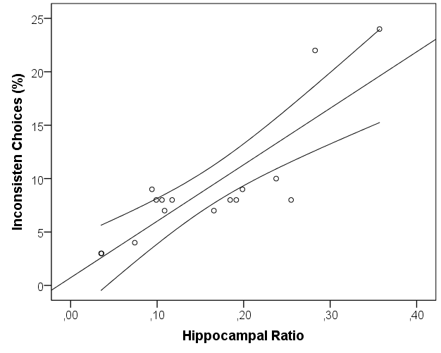

Fig 3. Correlation of hippocampal asymmetry (as a marker for unilateral atrophy) and percentage of inconsistent choices with 95% CI of the mean. rho=0.761, p<0.001

To rule out alternative explanations, in particular the possibility that subjects may have explicitly remembered their previous choices within this study, using this information to avoid intransitivities, and that it is this ability that may be impaired in patients with hippocampal damage, we examined if the observed group differences in choice inconsistencies were stable across the course of the study session. Although each pair of options is seen only once, prior choices involving one of the two candy bars might influence subsequent choices, and memory for these choices might differ across groups, with the MTL group being less able to retrieve their choices on earlier trials. This alternative explanation for the observed group differences in transitivity suggests that more intransitivities should occur later in the session. We examined how intransitivities occurred across time by looking at the number of times each trial was involved in an intransitivity. Alternative explanations involving memory would expect a change in this proportion with trial number (i. e. when the pair is seen during the session). The number of times each trial was involved in an intransitivity served as the dependent measure in a hierarchical regression allowing for different intercepts for each subject nested in groups and fixed effects of the centered trial number and its centered quadratic term (to detect non-linear effects), as well as factors indicating groups and their interactions. Expectedly, each trial was involved in more intransitivities for the MTL group (t = 3.863) followed by the ETL group (t = 1.904) compared to the healthy controls but this pattern did changed neither linearly (t = 0.766) nor quadratically (t = 0.514) for any of the groups. All trial across the experiment for each subject were equally likely to be involved in an intransitive triplet ruling out explanations based on memory to explain the group differences in total number of intransitivies.

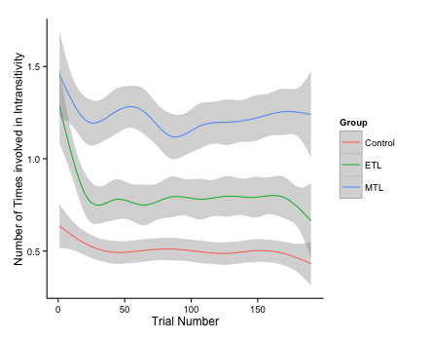

We also examined response latencies of the choices On trial level all participants get faster as they progress in the task. The MTL group has the highest average reaction time for a trial significantly differing from the control and ETL groups, while the latter two do not differ from each. How quickly each group speeds up across trials also differs significantly. The slope of speeding up in later trials is steepest for the MTL group, followed by the control group and flattest for the ETL group. These differences are tested for using a hierarchical model that account for the repeated measures aspect of this data, using the R lmer function of the lme4 package (Version 1.0-5). The model includes as predictors (fixed effects) the trial number, group and their interaction and a random-effects participant term nested in the three groups. This random effect captures the repeated-measures aspect of the data and individual differences, if they exist. The significant fixed effect for trial number (β = –2.537, t = – 18.139) indicates that all subjects decrease their reaction times later with each trial. The significant fixed effect for the MTL group (t = 2.615) and the lack thereof for the ETL group (β = –58.623, t = – 0.563) show that the MTL group was significantly slower (272.115 ms on average) than the control group. The significant interactions with each group (β = 0.644, t = 3.253 for MTL and β = –0.845, t = – 4.260 for ETP) imply that the slopes for this decrease in reaction times differ across groups.

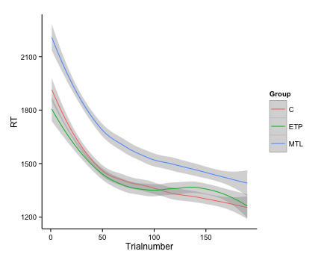

Given the group differences in reaction times (RTs) on trial level analysis we also explored whether they had an effect on the number of intransitivities each trial was involved in. A multilevel model with fixed effects for centered RTs and centered quadratic term for RTs, as well as, groups and random intercepts for each participant confirmed that trials where participants took longer were involved in more intransitivites with an RT fixed effect (β = 0.0008, t = 12.586). This translates to roughly one more intransitivity per trial for every two second a participant spends on it, especially after the first second. Intransitivities happen even when participants work harder and spend more time. Additionally this model confirmed the MTL group making significantly more intransitivities per trial (β = 0.611, t = 3.288) and captured the non-linear effects as seen in Figure S2 (β = –1.085*10–7, t = –7.554). There were no significant interactions. Notably this model is also significantly better in predicting the number of intransitivites a trial is involved in compared to one only with a fixed effect with group and random intercepts for subjects (χ2(4) = 479.69; p <0.001) accounting for variation captured by the previously significant intercept in the simpler model and not changing the effect of the MTL group markedly (β = 0.686, t = 3.853).

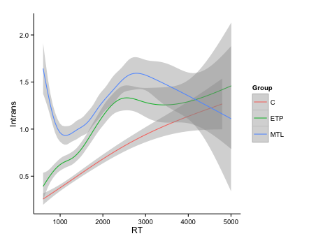

We also examined whether particular options were responsible for intransitivies. We regressed the number of times each trial was involved in an intransitive choice onto indicator variable representing the identify of each chocolate bar as well a factor representing group. None of these variables survived a post-hoc test of significance.

Another way of ruling out alternative explanations for our observed pattern of differential choice inconsistency across groups is to examine the consistency in judgments in our control task across the three groups. Our hypothesis predicts that the observed increase in inconsistency for the MTLgroup should be restricted to the preference judgments. In the control task, respondents identified which of two numbers was larger. All groups did well, though the ETL group was significantly worse than the control group (percentage of errors: MTL: 0.81%; ETL: 1.09%; CON:0.07%; p<0.001 Kruskal-Wallis test for independent groups; MTL vs. ETL n.s.; MTL vs. CON n.s; ETL vs. CON p<0.05) and ETL patients exhibited a much higher variance in this task. The absence of a difference in inconsistency between the MTL and the control groups in this task and the presence of a differences in choice inconsistency supports the involvement of hippocampal function in preference based choices and not more general attentional effects.

# Discussion

There is increasing interest in how value representations are constructed. In this paper we provide support for the role of memory in preference construction, by showing that hippocampal lesions are associated with an increase in intransitive preferences and that the degree of intransitivity is related to magnitude of the damage to the hippocampus. A control task not involving preference-based choices does not show these effects, nor do respondents who have lesions outside of the medial temporal lobe. These results implicate the hippocampal areas in preference construction.

Our hippocampal patients produce patterns of intransitivity of preference that are strikingly similar to those observed in VMPFC patients, suggesting that the associations and memories stored in the hippocampus may serve are inputs to value calculation occurring elsewhere (Barron et al., 2013). The hippocampus is one of the most highly interconnected brain areas, including a direct monosynaptic connection to the prefrontal cortex (Cole, Pathak, & Schneider, 2010; Godsil, Kiss, Spedding, & Jay, 2013; Ongür & Price, 2000). Ranganath and Ritchey (2012) proposed a division of the MTL into two systems for memory-guided behavior: the anterior (AT) and posterior-medial (PM) system. The AT, which is comprised of the peri-rhinal cortex and anterior parts of the hippocampus and amygdala has strong interconnections with the frontal cortex, has been argued to be involved in familiarity-based cognition, social behavior and saliency. Ranganath & Ritchey (2012) suggest that “the AT system could facilitate the construction of knowledge about people, so that past experiences can be used to inform inferences about the personality and intentions of others, irrespective of their behavior in a particular context.” Our results suggests that this connection to the ventromedial prefrontal cortex may also serve the construction of preferences. Fellows (2006) showed that VMPFC lesioned patients differ from normal controls in their external information search, in ways that could be attributed to diminished planning capacity. Perhaps retrieval of experiences from memory is also inhibited in VMPFC patients, but this is an interesting topic for future research.

Some early judgment and decision making research used the existence of specific forms of intransitive preferences as evidence for choice rules that differ from value maximization (Tversky, 1969), with some recent criticisms (Regenwetter, Dana, Davis-Stober, & Guo, 2011) that argue that deviations of choice patterns from value maximization may be due to simpler reasons, including changing preferences and indifference.  Our work uses intransitivities in a much simpler way, namely as evidence that preferences are less stable in decision makers whose MTL regions have been impaired. We also show that the degree of preference instability is a function of the degree of hippocampal damage.

Our results suggest a critical role for the hippocampus as the carrier of input into the construction of the value of choice options. Most decisions require the construction of value based on past experience: Even a previously experienced option, like a favorite dish in a familiar restaurant, requires us to compare that option to newly available options (dinner specials). Combining what we know about internal and external inputs to preference construction processes and about information aggregation and comparison will allow us to better understanding how the brain calculates value and makes wise choices.

# References

Barron, H. C., Dolan, R. J., & Behrens, T. E. J. (2013). Online evaluation of novel choices by simultaneous representation of multiple memories. *Nature Neuroscience*, *16*(10), 1492–8. doi:10.1038/nn.3515

Benoit, R. G., Gilbert, S. J., & Burgess, P. W. (2011). A neural mechanism mediating the impact of episodic prospection on farsighted decisions. *The Journal of Neuroscience : The Official Journal of the Society for Neuroscience*, *31*(18), 6771–9. doi:10.1523/JNEUROSCI.6559-10.2011

Birnbaum, M. H., & Gutierrez, R. J. (2007). Testing for intransitivity of preferences predicted by a lexicographic semi-order. *Organizational Behavior and Human Decision Processes*, *104*(1), 96–112. doi:10.1016/j.obhdp.2007.02.001

Camille, N., Griffiths, C. a, Vo, K., Fellows, L. K., & Kable, J. W. (2011). Ventromedial frontal lobe damage disrupts value maximization in humans. *The Journal of Neuroscience : The Official Journal of the Society for Neuroscience*, *31*(20), 7527–32. doi:10.1523/JNEUROSCI.6527-10.2011

Cole, M. W., Pathak, S., & Schneider, W. (2010). Identifying the brain’s most globally connected regions. *NeuroImage*, *49*(4), 3132–48. doi:10.1016/j.neuroimage.2009.11.001

Dougherty, M. R. P., Gettys, C. F., & Ogden, E. E. (1999). MINERVA-DM : A Memory Processes Model for Judgments of Likelihood. *Psychological Review*, *106*(1), 180–209.

Fellows, L. K. (2006). Deciding how to decide: ventromedial frontal lobe damage affects information acquisition in multi-attribute decision making. *Brain : A Journal of Neurology*, *129*(Pt 4), 944–52. doi:10.1093/brain/awl017

Fellows, L. K., & Farah, M. J. (2007). The role of ventromedial prefrontal cortex in decision making: judgment under uncertainty or judgment per se? *Cerebral Cortex (New York, N.Y. : 1991)*, *17*(11), 2669–74. doi:10.1093/cercor/bhl176

Fischl, B., Salat, D. H., Busa, E., Albert, M., Dieterich, M., Haselgrove, C., … Dale, A. M. (2002). Whole brain segmentation: Automated labeling of neuroanatomical structures in the human brain. *Neuron*, *33*, 341–355. doi:10.1016/S0896-6273(02)00569-X

Fischl, B., van der Kouwe, A., Destrieux, C., Halgren, E., Ségonne, F., Salat, D. H., … Dale, A. M. (2004). Automatically parcellating the human cerebral cortex. *Cerebral Cortex (New York, N.Y. : 1991)*, *14*, 11–22. doi:10.1093/cercor/bhg087

Godsil, B. P., Kiss, J. P., Spedding, M., & Jay, T. M. (2013). The hippocampal-prefrontal pathway: the weak link in psychiatric disorders? *European Neuropsychopharmacology : The Journal of the European College of Neuropsychopharmacology*, *23*(10), 1165–81. doi:10.1016/j.euroneuro.2012.10.018

Houthakker, H. S. (1950). Revealed Preference and the Utility Function. *Economica*, *17*(66), 159–174.

Johnson, E. J., Häubl, G., & Keinan, A. (2007). Aspects of endowment: a query theory of value construction. *Journal of Experimental Psychology. Learning, Memory, and Cognition*, *33*, 461–474. doi:10.1037/0278-7393.33.3.461

Kahneman, D., & Tversky, A. (1979). Prospect Theory: An analysis of decision under risk. *Econometrica: Journal of Econometric Society*, *47*(2), 263–292.

Kalenscher, T., Tobler, P. N., Huijbers, W., Daselaar, S. M., & Pennartz, C. M. a. (2010). Neural signatures of intransitive preferences. *Frontiers in Human Neuroscience*, *4*(June), 1–14. doi:10.3389/fnhum.2010.00049

Klein, S. B., & Loftus, J. (2002). Memory and temporal experience : The effects of episodic memory loss on an amnesic patient’s ability to remember the past and imagine the future. *Social Cognition*, *20*(5), 353–379.

Lee, L., Amir, O., & Ariely, D. (2009). In Search of Homo Economicus: Cognitive Noise and the Role of Emotion in Preference Consistency. *Journal of Consumer Research*, *36*(2), 173–187. doi:10.1086/597160

Lichtenstein, S., & Slovic, P. (Eds.). (2006). *The Construction of Preference*. New York: Cambridge University Press.

Ongür, D., & Price, J. L. (2000). The organization of networks within the orbital and medial prefrontal cortex of rats, monkeys and humans. *Cerebral Cortex (New York, N.Y. : 1991)*, *10*(3), 206–19. Retrieved from http://www.ncbi.nlm.nih.gov/pubmed/10731217

Peters, J., & Büchel, C. (2010). Episodic future thinking reduces reward delay discounting through an enhancement of prefrontal-mediotemporal interactions. *Neuron*, *66*(1), 138–48. doi:10.1016/j.neuron.2010.03.026

Ranganath, C., & Ritchey, M. (2012). Two cortical systems for memory-guided behaviour. *Nature Reviews. Neuroscience*, *13*(10), 713–26. doi:10.1038/nrn3338

Regenwetter, M., Dana, J., Davis-Stober, C. P., & Guo, Y. (2011). Parsimonious testing of transitive or intransitive preferences: Reply to Birnbaum (2011). *Psychological Review*, *118*(4), 684–688. doi:10.1037/a0025291

Reyna, V. F., Lloyd, F. J., & Brainerd, C. J. (2003). Memory, Development, and Rationality: An Integrative Theory of Judgement and Decision Making. In *Emerging Perspectives on Judgement and Decision Research* (pp. 201–245).

Samuelson, P. A. (1938). A Note on the Pure Theory of Behaviour Consumer ’s Bheavior. *Economica*, *5*(17), 61–71.

Schacter, D. L., & Addis, D. R. (2007). The cognitive neuroscience of constructive memory: remembering the past and imagining the future. *Philosophical Transactions of the Royal Society of London. Series B, Biological Sciences*, *362*(1481), 773–86. doi:10.1098/rstb.2007.2087

Schneider, S. L., & Shanteau, J. (2003). *Emerging Perspectives on Judgment and Decision Research* (p. 736). Cambridge University Press.

Tversky, A. (1969). Intransitivity of preferences. *Psychological Review*, *76*(1), 31–48. doi:10.1037/h0026750

Tversky, A., & Kahneman, D. (1992). Advances in prospect theory: Cumulative representation of uncertainty. *Journal of Risk and Uncertainty*, *5*(4), 297–323. doi:10.1007/BF00122574

Von Neumann, J., & Morgenstern, O. (1944). *Theory of Games and Economic Behavior*. *Princeton University Press* (Vol. 2, p. 625). doi:10.1177/1468795X06065810

Weber, E. U., Goldstein, W. M., & Barlas, S. (1995). And let us not Forget Memory: The Role of Memory Processes and Techniques in the Study of Judgment and Choice. In *The Psychology of Learning and Motivation* (Vol. 32, pp. 33–81). doi:10.1016/S0079-7421(08)60307-2

Weber, E. U., & Johnson, E. J. (2009). Mindful judgment and decision making. *Annual Review of Psychology*, *60*, 53–85. doi:10.1146/annurev.psych.60.110707.163633

Weber, E. U., Johnson, E. J., Milch, K. F., Chang, H., Brodscholl, J. C., & Goldstein, D. G. (2007). Asymmetric discounting in intertemporal choice: a query-theory account. *Psychological Science : A Journal of the American Psychological Society / APS*, *18*, 516–523. doi:10.1111/j.1467-9280.2007.01932.x

1. Some trials (1.2 % of all trials) timed out before subjects could indicate a clear preference. We repeated all statistics tests while excluding the trials and triplets containing a timed-out choice, and obtained very similar results.