Preference consistency relies on hippocampal function:

Evidence from mediotemporal lobe epilepsy

B. Weber1,2, A. Z. Enkavi3,I. Zweyer1,2, J. Wagner1, C.E. Elger1,2, ,E. U. Weber3, E. J. Johnson3,

1Department of Epileptology, University Hospital Bonn. 2Center for Economics and Neuroscience, University of Bonn. 3Center for Decision Science, Columbia University

*Correspondence at: bernd.weber@ukb.uni-bonn.de

# Introduction

It seems obvious that our preferences draw on past experience and hence memory. Memory representation of past choices and their consequences allow us to learn what sources of food provide optimal nourishment and which predators and other dangers should be avoided, ensuring our survival and well-being. Confronted with a choice of snack food items at a vending machine, we use the packaging as memory cues to retrieve past experiences with the options to construct an estimate of their reward value.

In contrast, economics treats preferences as a primitive in axiomatic models of risky choice (Von Neumann & Morgenstern, 1944). As a result, the connection between properties of memory and judgment and choice has historically been neglected, with only a few exceptions (Elke U. Weber, Goldstein, & Barlas, 1995). More recently, memory processes and their accompanying constraints have played a more prominent role in explanations of decision-making phenomena, in an attempt to leverage what we know about memory to explain well-known decision phenomena (Dougherty, Gettys, & Ogden, 1999; Reyna, Lloyd, & Brainerd, 2003; Schneider & Shanteau, 2003; Elke U Weber & Johnson, 2009).

Previously, incorporating attentional and perceptual processes resulted in models such as prospect theory (Kahneman & Tversky, 1979; Tversky & Kahneman, 1992) that have succeeded to account for response patterns considered anomalies by rational choice models such as expected utility theory. Similarly, m

If preferences are often constructed (see Lichtenstein & Slovic, 2006), an insight that might be psychology’s most successful export to economics, then memory processes must play a major role in this construction. Both memory encoding and retrieval processes influence judgment and choice in multiple ways (see Weber & Johnson, 2009 for a review). Query theory (Johnson, Häubl, & Keinan, 2007; E U Weber et al., 2007) suggests that decision-makers consult their memory (or external sources) with automatic and implicit queries about the choice alternatives, in particular arguments for choosing one or the other, i.e., their merits or liabilities. Past experiences and other associations provide the basis for such evaluation.

There have been parallel lines in neuroscience focusing on the Prospective Memory network. Here, future-oriented episodic imagery, i.e. the mental construction of specific future events based on past experience, has been shown to influence intertemporal choices. Stronger activity in this prospective memory network, including the hippocampus, is associated with decreased temporal discounting of monetary rewards (Benoit, Gilbert, & Burgess, 2011; Peters & Büchel, 2010). Wimmer & Shohamy (2012) showed that the MTL is also involved in the transfer of value of rewarded stimuli by associative learning and how these memory mechanisms bias decisions. A recent study (Barron, Dolan, & Behrens, 2013)highlighted the involvement of the MTL in preference. When constructing preferences for novel food items based on two familiar, previously uncombined tastes, the hippocampus as well as the medial prefrontal cortex were related to value.

One demonstration of the role of memory representations of past experience in choice is to show that choice is impaired in individuals who are known to have memory encoding or retrieval deficiencies. Memory of past experiences and imagining future experiences activate a common set of brain regions that include the hippocampus (Schacter & Addis, 2007), and these functions are impaired in patients with hippocampal damage (Hassabis, Kumaran, Vann, & Maguire, 2007)(Klein & Loftus, 2002). Thus we ask if patients with hippocampal sclerosis show impaired preference construction.

To test this hypothesis, we employ a simple paradigm, a series of binary choices among simple commonly consumed and familiar food products. Our measure of choice quality is the preference transistivity, that is seeing if preferences for different options are consistent across choice pairs. For example if a person chooses A over B, and B over C, transitivity requires that they must pick A over C (Samuelson, 1938). Transitivity has been a central in early empirical work in decision-making (Tversky, 1969), and recent prefence research in neuroscience (Camille, Griffiths, Vo, Fellows, & Kable, 2011; Fellows & Farah, 2007; Fellows, 2006; Kalenscher, Tobler, Huijbers, Daselaar, & Pennartz, 2010) and consumer choice (Lee, Amir, & Ariely, 2009). One reason for focusing on transitivity is that it is central to the General Axiom of Revealed Preference and is a necessary and sufficient condition for value maximization (Houthakker, 1950). Transitivity of preferences is embraced by most individuals as a desirable property of a choice process: Most people will change intransitive choice patterns to transitive ones, when confronted with their instransitive choices (Birnbaum & Gutierrez, 2007).

Research using patients with lesions in the ventromedial frontal lobe, in areas known to be involved in the expression of value, has shown a greater frequency of intransitivities for choices between gambles (Camille et al., 2011) and for preferences for food, colors, and people (Fellows & Farah, 2007). The latter study included an important control: An increase in intransitivity was not observed for perceptual judgments, suggesting that preferential tasks were uniquely affected.

We adopt this paradigm but examine the effect of damage to the hippocampus, an area that is not a focus of much research in value representation, but, according to our hypothesis, an essential input to some kinds of value calculation. In particular, our task examines binary choices among pairs of 20 common candy bars, a product familiar and interesting to participants. We also included a control judgment, asking respondents to judge which of two numbers was bigger. In both cases our dependent measure was the transitivity of (preference or magnitude) judgments.

# Methods

Thirty-one patients suffering from mesial temporal lobe epilepsy with clinically diagnosed uni (left:n=14;right:n=8) - or bilateral (n=9) hippocampal sclerosis from the presurgical program at the Department of Epileptology in Bonn were included in the study (MTL). Two control groups consisted of thirty patients with extratemporal lobe epilepsy (ETL) and thirty healthy control subjects (CON), respectively. The study was approved by the local ethics committee of the University of Bonn and the Institutional Review Board at Columbia University (IRB-AAAB1301) and all subjects gave their written informed consent. The three groups did not differ with respect to age or gender (see Table S1 for details).

# Behavioral experiment

Each subject made a series of binary choices on a computer between pairs of candy bars, each represented pictorially as shown in Fig.1, drawn randomly out of a set of twenty, with each combination presented once, resulting in 190 choices, with a different random order for each participant. This procedure was similar to that used to examine the effect of ventromedial frontal lobe damage on choice used by Camille et al. (2011), Fellows & Farah (2007) and Fellows (2006), see also Lee et al., 2009). n a control task, subjects were presented with numbers from one to twenty and had to judge which number was larger. Judgment inconsistency in triplets of magnitude was computed identically. Subjects knew that they would receive their choice from one randomly selected candy bar choice trial, in addition to a participation fee of 10 €.

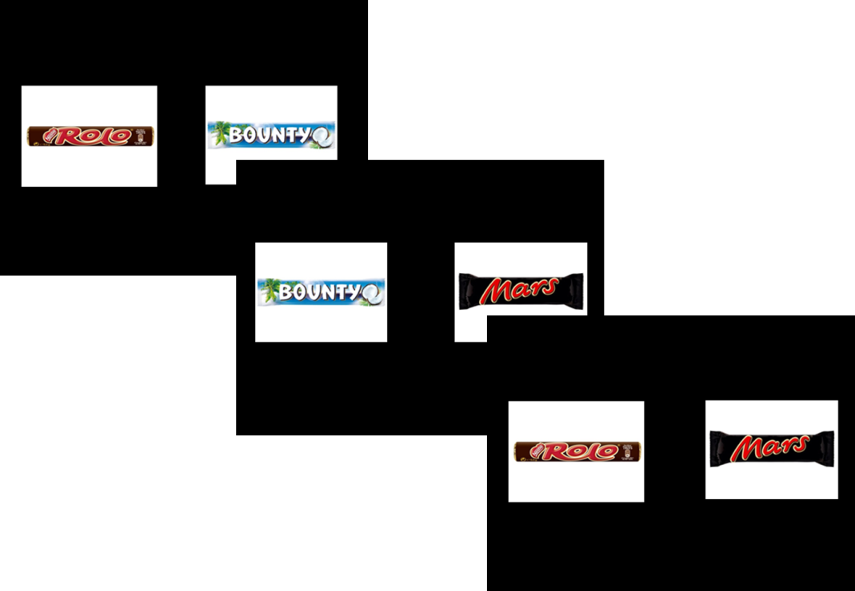

Fig 1. Three trials of the binary choice experiment. Subject indicated their preferred candy bar on each trial. The timing of the stimulus presentation and choice was self-paced, with a maximum length of 5 seconds.

# MR sequence and analysis

For a subgroup of the patients with unilateral hippocampal sclerosis (n=16), a 3D-T1 weighted high-resolution data set (MP-RAGE, voxel size 1x1x1mm, repetition time 1570ms, echo time 3.42ms, flip angle 15°, field of view 256mm x 256mm) was available for volumetric measurement of the hippocampus. This was done in a fully automated manner by means of the FreeSurfer image analysis suite (Version 5.1.0, Martinos Center, Harvard University, Boston, MA, U.S.A.) (Fischl et al., 2002, 2004), which is documented and freely available for download online (<http://surfer.nmr.mgh.harvard.edu/>). Because of the high variance in hippocampal volume between individuals, we used a lateral damage index of hippocampal volume to express the extent of unilateral hippocampal damage in our MTL group:

This lateral damage index can obviously by only assessed for subjects with unilateral hippocampal sclerosis.

# Statistical analysis

Statistical analyses were performed using SPSS Statistics 21.0 for Windows (IBM, Armonk, NY, U.S.A.) and R (Version 3.0.2) for Mac. We use a two-tailed p-value of 0.05 as our criterion for statistical significance and mark significant differences in the figures and tables with asterisks: *p ≤ 0.05, **p ≤ 0.01, and ***p ≤ 0.001.

## Tallying intransitivities

The binary choices made by each subject were transformed into a matrix of triplets, as the detection of intransitivity requires three choice pairs. Each matrix consisted of 1140 rows, representing all possible combinations of 3 of 20 bars. A triplet was marked as indicating intransitivity either if A was chosen over B and B was chosen over C yet C was chosen over A or if B was chosen over A and C was chosen over B yet A was chosen over C:

or

The proportion of intransitive choices was obtained by dividing the number of intransitive triples by the total number of triples. This provided the central dependent measure. In the supplementary materials, we show that the maximum proportion of instransitivities possible, in a random responder would be 25%, and that this varies non-linearly with the amount of error in the valuation of choice pairs.

# Results

Patients with hippocampal sclerosis showed an increased number of intransitive choices compared to the two control groups (Fig. 2; mean percentages: MTL: 6.21%; ETL: 3.47%; CON: 2.75%; median percentages: MTL: 4.56%; ETL 2.81%; CON: 2.94%) Kruskal-Wallis-Test of independent groups p<0.001). The two controls group did not differ significantly in intransitivity from each other (Wilcoxon rank sum test p = 0.78), but both groups differed significantly from the MTL group (MTL vs ETL p = 0.02, MTL vs CON p <.001, Bonferroni adjusted). Very similar results are provided by an Analysis of Variance with post-hoc comparisons (p < .001).

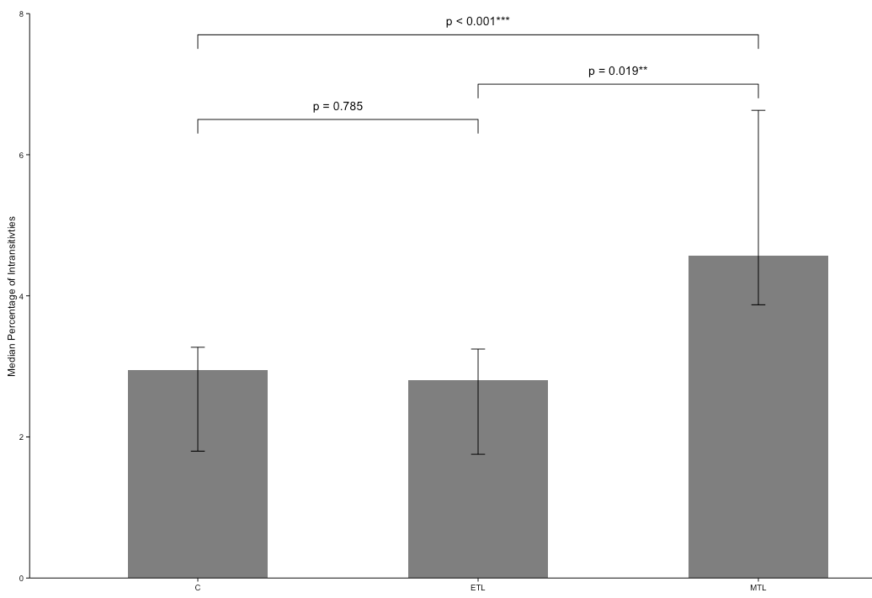

Fig 2.Median percentage of intransitives per group. Group comparisons computed Wilcoxon rank sum test and 95% confidence intervals calculated from bootstrapped medians from 2500 samples.

Consistent with our hypothesis that hippocampal retrieval of candy bar associations acquired over respondents’ prior life was used in preference construction and choice, we found that the ratio of compromised hippocampal volume to total volume was significantly correlated with the amount of choice inconsistencies (Fig.3; spearman-rho = 0.761; p<0.001; n=16).

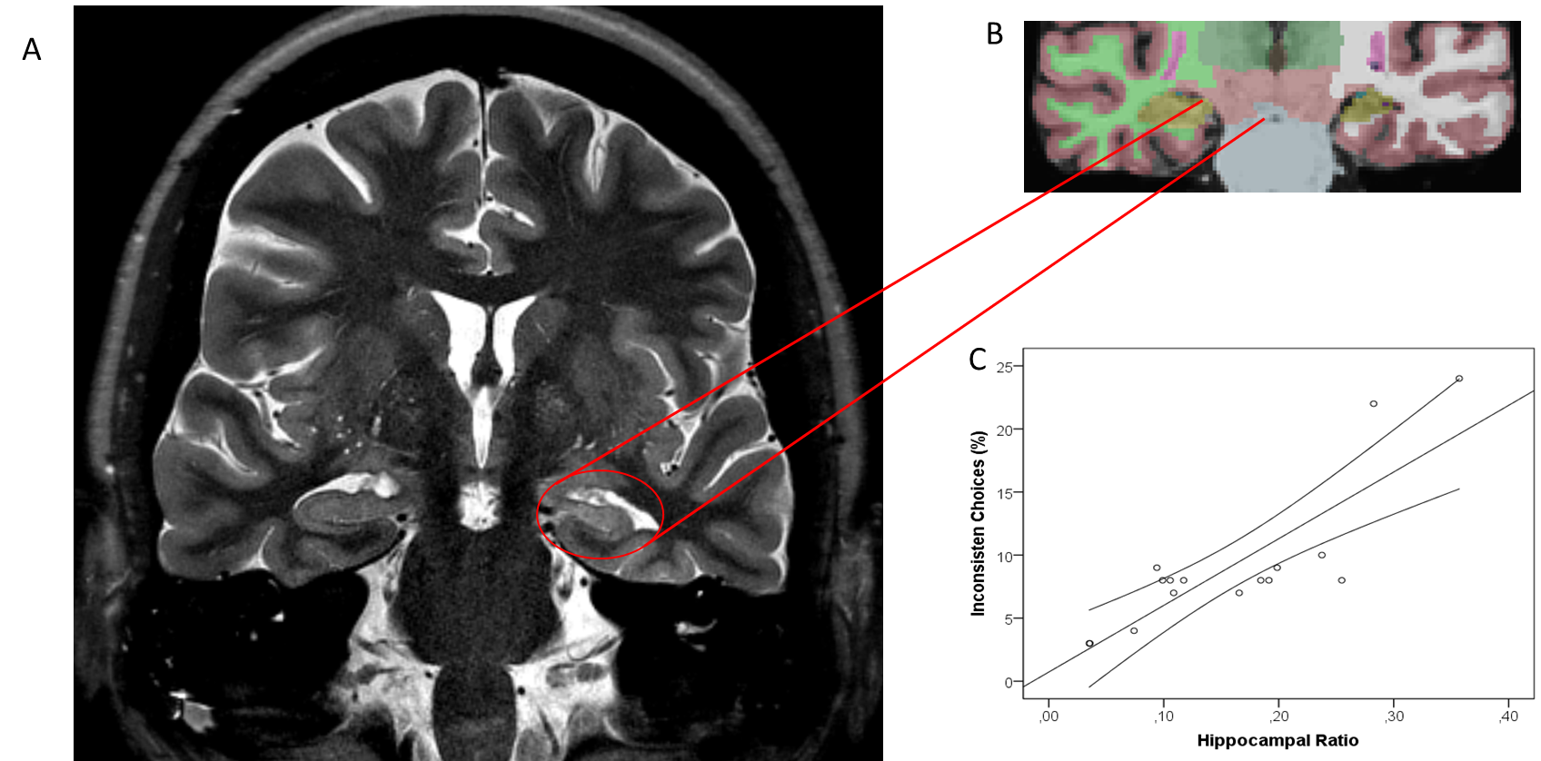

Fig 3. Example of a typical hippocampal sclerosis on a T2-weighted image (A), automated hippocampal volumetry (B) and correlation of hippocampal asymmetry (as a marker for unilateral atrophy) and percentage of inconsistent choices with 95% CI of the mean. rho=0.761, p<0.001

We ruled out the possibility that subjects may have explicitly remembered their previous choices within this study, and used this information to avoid intransitivities, by examining if the observed group differences in choice inconsistencies were stable across the course of the study session. Although each pair of options is seen only once, prior choices involving one of the two candy bars might facilitate recall and influence subsequent choices, and this facilitation might differ across groups, particularly for the MTL group. This alternative explanation for the observed group differences in transitivity suggests that relatively more intransitivities should occur later in the session, for the MTL group. We tested this hypothesis by examining for differences in the effects of trial on the frequency of intransitivities across groups. As detailed in the SOM, no differences were found.

To examine the possibility of a speed-accuracy tradeoff, we examined response latencies of the choices, and the relationship between responses latencies and intransitivities. We found that slower trials were most likely to be involved in intransitive triplets, and that the MTL group has a significantly slower average response time per trial. Together, these results suggest that intransitive triplets accompany more careful, longer responding, eliminating the possibility of a speed-accuracy tradeoff.

We also examined whether particular options were responsible for intransitivies. We regressed the number of times each option was involved in an intransitive choice onto indicator variable representing the identity of each chocolate bar as well a factor representing group. None of these variables survived a post-hoc (Bonferroni) test of significance. Furthermore we calculated the utilities of each bar for each subject and checked whether the difference in utilities predicted how often a pair was involved in an intransitivity. Expectedly those that were closer in value were more likely to lead to intransitivity.

To ensure that the intransitives we observe are associated with reporting preferences, we examined performance in the control task. In the control task, respondents identified which of two numbers was larger. All groups did well, though the ETL group was significantly worse than the control group (percentage of errors: MTL: 0.81%; ETL: 1.09%; CON: 0.07%; p<0.001 Kruskal-Wallis test for independent groups; MTL vs. ETL n.s.; MTL vs. CON n.s; ETL vs. CON p<0.05) and ETL patients exhibited a much higher variance in this task. The absence of a difference in inconsistency between the MTL and the control groups in this task and the presence of a differences in choice inconsistency supports the involvement of hippocampal function in preferential choice but not in more general attentional effects.

# Discussion

There is increasing interest in how value representations are constructed. In this paper we provide support for the role of memory in preference construction, by showing that hippocampal lesions are associated with an increase in intransitive preferences and that the degree of intransitivity is related to magnitude of the damage to the hippocampus. A control task not involving preference-based choices does not show these effects, nor do respondents who have lesions outside of the medial temporal lobe. These results implicate the hippocampal areas in preference construction.

Our hippocampal patients produce patterns of intransitivity of preference that are strikingly similar to those observed in ventromedial prefrontal cortex (vmPFC) patients, suggesting that the associations and memories stored in the hippocampus may serve as inputs to value calculation occurring elsewhere (Barron et al., 2013). The hippocampus is one of the most highly interconnected brain areas, including a direct monosynaptic connection to the prefrontal cortex (Cole, Pathak, & Schneider, 2010; Godsil, Kiss, Spedding, & Jay, 2013; Ongür & Price, 2000). Ranganath and Ritchey (2012) proposed a division of the MTL into two systems for memory-guided behavior: the anterior (AT) and posterior-medial (PM) system. The AT, which is comprised of the peri-rhinal cortex and anterior parts of the hippocampus and amygdala has strong interconnections with the frontal cortex, has been argued to be involved in familiarity-based cognition, social behavior and saliency. Ranganath & Ritchey (2012) suggest that “the AT system could facilitate the construction of knowledge about people, so that past experiences can be used to inform inferences about the personality and intentions of others, irrespective of their behavior in a particular context.” Our results suggest that this connection to the ventromedial prefrontal cortex may also serve the construction of preferences. Fellows (2006) showed that vmPFC lesioned patients differ from normal controls in their external information search, in ways that could be attributed to diminished planning capacity. Perhaps retrieval of experiences from memory is also inhibited in vmPFC patients, and this is an interesting topic for future research.

Some early judgment and decision making research used the existence of specific forms of intransitive preferences as evidence for choice rules that differ from value maximization (Tversky, 1969), with some recent criticisms (Regenwetter, Dana, Davis-Stober, & Guo, 2011) that argue that deviations of choice patterns from value maximization may be due to simpler reasons, including changing preferences and indifference.  Our work uses intransitivities in a much simpler way, namely as evidence that preferences are less stable in decision makers whose MTL regions have been impaired. We also show that the degree of preference instability is a function of the degree of hippocampal damage.

We do not take a specific stance on the mechanism producing these effects but speculate that they are consistent with retrieval in the MTL group produces value inputs that are more errorful, either because of failures of retrieval or because different inputs are retrieved on each occasion. Simulating the effect of noise on the level of intransitivity shows that the observed inconsistency levels correspond to a value signal containing approximately 25% noise compared to a noiseless representation which would produce a completely transitive set of preferences (see SOM for details).

This research provides a basis for future research may provoked by these observations:

First,the hippocampus is just one part in a larger network of relevant brain areas involved in the retrieval and processing of choice values. A recent review of Shohame and Turk-Browne nicely reviews the evidence of hippocampal involvement in a variety of cognitive functions outside of the domain of declarative memory. It suggests two different hypotheses of hippocampal function; the memory modulation hypothesis proposes that representations within the hippocampus may transiently bias other cognitive functions such as value computations in the present task. The adaptive function hypothesis on the other hand highlights the hippocampus as a central processing unit with specific computations carried out in the hippocampal networks, depending on the task at hand (Shohamy & Turk-Browne, 2013). Both models of hippocampal functions, could be involved in producing instransitive preferences.

Second, are there compensation mechanisms in patients with chronic hippocampal lesions.?It is well known that chronic brain lesions may lead to compensatory shifts in neural processes, e.g. in the domain of language processing(Kipervasser et al., 2008; Weber et al., 2006). The application of neuroimaging methods, like functional MRI, during a value-based decision task in these patients could be used to investigate compensation mechanisms in future research.

Third, although patients with temporal lobe epilepsy and hippocampal sclerosis do show neuropsychological deficits especially in the domain of declarative memory, the amount to which these deficits occur varies strongly between patients and they hardly show amnesic behavior(Hoppe, Elger, & Helmstaedter, 2007). Future research combining in-depth neuropsychological testing together with value-based choice tasks may shed light on the specific cognitive components relating to the observed decision deficits.

Our results suggest a critical role for the hippocampus as the carrier of input into the construction of the value of choice options. Most decisions require the construction of value based on past experience: Even a previously experienced option, like a favorite dish in a familiar restaurant, requires us to compare that option to newly available options such as tonight’s specials). Combining what we know about internal and external inputs to preference construction processes and about information aggregation and comparison will allow us to better understanding how the brain calculates value and makes wise choices.

# References

Barron, H. C., Dolan, R. J., & Behrens, T. E. J. (2013). Online evaluation of novel choices by simultaneous representation of multiple memories. *Nature Neuroscience*, *16*(10), 1492–8. doi:10.1038/nn.3515

Benoit, R. G., Gilbert, S. J., & Burgess, P. W. (2011). A neural mechanism mediating the impact of episodic prospection on farsighted decisions. *The Journal of Neuroscience : The Official Journal of the Society for Neuroscience*, *31*(18), 6771–9. doi:10.1523/JNEUROSCI.6559-10.2011

Birnbaum, M. H., & Gutierrez, R. J. (2007). Testing for intransitivity of preferences predicted by a lexicographic semi-order. *Organizational Behavior and Human Decision Processes*, *104*(1), 96–112. doi:10.1016/j.obhdp.2007.02.001

Camille, N., Griffiths, C. a, Vo, K., Fellows, L. K., & Kable, J. W. (2011). Ventromedial frontal lobe damage disrupts value maximization in humans. *The Journal of Neuroscience : The Official Journal of the Society for Neuroscience*, *31*(20), 7527–32. doi:10.1523/JNEUROSCI.6527-10.2011

Cole, M. W., Pathak, S., & Schneider, W. (2010). Identifying the brain’s most globally connected regions. *NeuroImage*, *49*(4), 3132–48. doi:10.1016/j.neuroimage.2009.11.001

Dougherty, M. R. P., Gettys, C. F., & Ogden, E. E. (1999). MINERVA-DM : A Memory Processes Model for Judgments of Likelihood. *Psychological Review*, *106*(1), 180–209.

Fellows, L. K. (2006). Deciding how to decide: ventromedial frontal lobe damage affects information acquisition in multi-attribute decision making. *Brain : A Journal of Neurology*, *129*(Pt 4), 944–52. doi:10.1093/brain/awl017

Fellows, L. K., & Farah, M. J. (2007). The role of ventromedial prefrontal cortex in decision making: judgment under uncertainty or judgment per se? *Cerebral Cortex (New York, N.Y. : 1991)*, *17*(11), 2669–74. doi:10.1093/cercor/bhl176

Fischl, B., Salat, D. H., Busa, E., Albert, M., Dieterich, M., Haselgrove, C., … Dale, A. M. (2002). Whole brain segmentation: Automated labeling of neuroanatomical structures in the human brain. *Neuron*, *33*, 341–355. doi:10.1016/S0896-6273(02)00569-X

Fischl, B., van der Kouwe, A., Destrieux, C., Halgren, E., Ségonne, F., Salat, D. H., … Dale, A. M. (2004). Automatically parcellating the human cerebral cortex. *Cerebral Cortex (New York, N.Y. : 1991)*, *14*, 11–22. doi:10.1093/cercor/bhg087

Godsil, B. P., Kiss, J. P., Spedding, M., & Jay, T. M. (2013). The hippocampal-prefrontal pathway: the weak link in psychiatric disorders? *European Neuropsychopharmacology : The Journal of the European College of Neuropsychopharmacology*, *23*(10), 1165–81. doi:10.1016/j.euroneuro.2012.10.018

Houthakker, H. S. (1950). Revealed Preference and the Utility Function. *Economica*, *17*(66), 159–174.

Johnson, E. J., Häubl, G., & Keinan, A. (2007). Aspects of endowment: a query theory of value construction. *Journal of Experimental Psychology. Learning, Memory, and Cognition*, *33*, 461–474. doi:10.1037/0278-7393.33.3.461

Kahneman, D., & Tversky, A. (1979). Prospect Theory: An analysis of decision under risk. *Econometrica: Journal of Econometric Society*, *47*(2), 263–292.

Kalenscher, T., Tobler, P. N., Huijbers, W., Daselaar, S. M., & Pennartz, C. M. a. (2010). Neural signatures of intransitive preferences. *Frontiers in Human Neuroscience*, *4*(June), 1–14. doi:10.3389/fnhum.2010.00049

Klein, S. B., & Loftus, J. (2002). Memory and temporal experience : The effects of episodic memory loss on an amnesic patient’s ability to remember the past and imagine the future. *Social Cognition*, *20*(5), 353–379.

Lee, L., Amir, O., & Ariely, D. (2009). In Search of Homo Economicus: Cognitive Noise and the Role of Emotion in Preference Consistency. *Journal of Consumer Research*, *36*(2), 173–187. doi:10.1086/597160

Lichtenstein, S., & Slovic, P. (Eds.). (2006). *The Construction of Preference*. New York: Cambridge University Press.

Ongür, D., & Price, J. L. (2000). The organization of networks within the orbital and medial prefrontal cortex of rats, monkeys and humans. *Cerebral Cortex (New York, N.Y. : 1991)*, *10*(3), 206–19. Retrieved from http://www.ncbi.nlm.nih.gov/pubmed/10731217

Peters, J., & Büchel, C. (2010). Episodic future thinking reduces reward delay discounting through an enhancement of prefrontal-mediotemporal interactions. *Neuron*, *66*(1), 138–48. doi:10.1016/j.neuron.2010.03.026

Ranganath, C., & Ritchey, M. (2012). Two cortical systems for memory-guided behaviour. *Nature Reviews. Neuroscience*, *13*(10), 713–26. doi:10.1038/nrn3338

Regenwetter, M., Dana, J., Davis-Stober, C. P., & Guo, Y. (2011). Parsimonious testing of transitive or intransitive preferences: Reply to Birnbaum (2011). *Psychological Review*, *118*(4), 684–688. doi:10.1037/a0025291

Reyna, V. F., Lloyd, F. J., & Brainerd, C. J. (2003). Memory, Development, and Rationality: An Integrative Theory of Judgement and Decision Making. In *Emerging Perspectives on Judgement and Decision Research* (pp. 201–245).

Samuelson, P. A. (1938). A Note on the Pure Theory of Behaviour Consumer ’s Bheavior. *Economica*, *5*(17), 61–71.

Schacter, D. L., & Addis, D. R. (2007). The cognitive neuroscience of constructive memory: remembering the past and imagining the future. *Philosophical Transactions of the Royal Society of London. Series B, Biological Sciences*, *362*(1481), 773–86. doi:10.1098/rstb.2007.2087

Schneider, S. L., & Shanteau, J. (2003). *Emerging Perspectives on Judgment and Decision Research* (p. 736). Cambridge University Press.

Shohamy, D., & Turk-Browne, N. B. (2013). Mechanisms for widespread hippocampal involvement in cognition. *Journal of Experimental Psychology. General*, *142*(4), 1159–70. doi:10.1037/a0034461

Tversky, A. (1969). Intransitivity of preferences. *Psychological Review*, *76*(1), 31–48. doi:10.1037/h0026750

Tversky, A., & Kahneman, D. (1992). Advances in prospect theory: Cumulative representation of uncertainty. *Journal of Risk and Uncertainty*, *5*(4), 297–323. doi:10.1007/BF00122574

Von Neumann, J., & Morgenstern, O. (1944). *Theory of Games and Economic Behavior*. *Princeton University Press* (Vol. 2, p. 625). doi:10.1177/1468795X06065810

Weber, E. U., Goldstein, W. M., & Barlas, S. (1995). And let us not Forget Memory: The Role of Memory Processes and Techniques in the Study of Judgment and Choice. In *The Psychology of Learning and Motivation* (Vol. 32, pp. 33–81). doi:10.1016/S0079-7421(08)60307-2

Weber, E. U., & Johnson, E. J. (2009). Mindful judgment and decision making. *Annual Review of Psychology*, *60*, 53–85. doi:10.1146/annurev.psych.60.110707.163633

Weber, E. U., Johnson, E. J., Milch, K. F., Chang, H., Brodscholl, J. C., & Goldstein, D. G. (2007). Asymmetric discounting in intertemporal choice: a query-theory account. *Psychological Science : A Journal of the American Psychological Society / APS*, *18*, 516–523. doi:10.1111/j.1467-9280.2007.01932.x

Wimmer, G. E., & Shohamy, D. (2012). Preference by association: how memory mechanisms in the hippocampus bias decisions. *Science (New York, N.Y.)*, *338*(6104), 270–3. doi:10.1126/science.1223252

Hassabis, Demis, Kumaran, Dharshan, Vann, Seralynne D., & Maguire, Eleanor A. (2007). Patients with hippocampal amnesia cannot imagine new experiences. *Proceedings of the National Academy of Sciences, 104*(5), 1726-1731. doi: 10.1073/pnas.0610561104

Hoppe, Christian, Elger, Christian E, & Helmstaedter, Christoph. (2007). Long‐term memory impairment in patients with focal epilepsy. *Epilepsia, 48*(s9), 26-29.

Kipervasser, S, Palti, D, Neufeld, MY, Ben Shachar, M, Andelman, F, Fried, I, . . . Hendler, T. (2008). Possible remote functional reorganization in left temporal lobe epilepsy. *Acta Neurologica Scandinavica, 117*(5), 324-331.

Weber, B., Wellmer, J., Reuber, M., Mormann, F., Weis, S., Urbach, H., . . . Fernandez, G. (2006). Left hippocampal pathology is associated with atypical language lateralization in patients with focal epilepsy. *Brain, 129*(Pt 2), 346-351. doi: 10.1093/brain/awh694

Hassabis, Demis, Kumaran, Dharshan, Vann, Seralynne D., & Maguire, Eleanor A. (2007). Patients with hippocampal amnesia cannot imagine new experiences. *Proceedings of the National Academy of Sciences, 104*(5), 1726-1731. doi: 10.1073/pnas.0610561104

Kipervasser, S, Palti, D, Neufeld, MY, Ben Shachar, M, Andelman, F, Fried, I, . . . Hendler, T. (2008). Possible remote functional reorganization in left temporal lobe epilepsy. *Acta Neurologica Scandinavica, 117*(5), 324-331.

Weber, B., Wellmer, J., Reuber, M., Mormann, F., Weis, S., Urbach, H., . . . Fernandez, G. (2006). Left hippocampal pathology is associated with atypical language lateralization in patients with focal epilepsy. *Brain, 129*(Pt 2), 346-351. doi: 10.1093/brain/awh694

Hassabis, Demis, Kumaran, Dharshan, Vann, Seralynne D., & Maguire, Eleanor A. (2007). Patients with hippocampal amnesia cannot imagine new experiences. *Proceedings of the National Academy of Sciences, 104*(5), 1726-1731. doi: 10.1073/pnas.0610561104

Kipervasser, S, Palti, D, Neufeld, MY, Ben Shachar, M, Andelman, F, Fried, I, . . . Hendler, T. (2008). Possible remote functional reorganization in left temporal lobe epilepsy. *Acta Neurologica Scandinavica, 117*(5), 324-331.

Hassabis, Demis, Kumaran, Dharshan, Vann, Seralynne D., & Maguire, Eleanor A. (2007). Patients with hippocampal amnesia cannot imagine new experiences. *Proceedings of the National Academy of Sciences, 104*(5), 1726-1731. doi: 10.1073/pnas.0610561104