Preference consistency relies on hippocampal function:

Evidence from mediotemporal lobe epilepsy

B. Weber1,2, A. Z. Enkavi3,I. Zweyer1,2, J. Wagner1, C.E. Elger1,2, ,E. U. Weber4, E. J. Johnson4,

1Department of Epileptology, Sigmund-Freud-Str.25, University Hospital Bonn, 53127 Bonn, Germany

2Center for Economics and Neuroscience, Nachtigallenweg 86, University of Bonn. 53127 Bonn, Germany

3Department of Psychology, Stanford University, 450 Serra Mall, 420-01, Stanford, CA 94305

4Center for Decision Science, Uris Hall 716, 3022 Broadway, New York, NY 10027-6902, Columbia University, US

*Correspondence at: [bernd.weber@ukb.uni-bonn.de](mailto:bernd.weber@ukb.uni-bonn.de)

Abstract

Making consistent decisions is both intuitively desirable and theoretically important for utility maximization. Despite strides in neuroeconomics describing neurobiological bases of value representations, brain regions necessary to originate and correctly categorize these signals remains an open question. The constructed preferences tradition within judgment and decision making research, on the other hand, emphasizes a critical role for cognitive processes relying on correct recall and associations. This calls for an investigation of the role of the hippocampus in making consistent decisions. We investigated 31 patients with mediotemporal lobe (MTL) epilepsy and hippocampal lesions, 30 patients with extratemporal lobe epilepsy, and 30 healthy controls, in their binary choices between candy bars and a number-comparison control task. Our results show an increase in intransitive choices in the MTL-group compared to the other groups for the value-based but not number task, suggesting a critical involvement of the MTL in preference construction and value-based choices.

# Introduction

Imagine that you are slightly hungry late in the afternoon, and wander to a vending machine to select a snack. You are faced with an array of over 20 possibilities. How do you select among them? In the last decade, decision neuroscience has made significant progress in identifying neurobiological correlates of value representations using paradigms similar to this scenario (Plassman, O’Doherty, Rangel, 2007, Hare et al., 2008, Hare et al., 2009, Plassman et al. 2010, Hare et al., 2011, Hutcherson et al., 2012, Rangel, 2013). Specifically, a value network involving a fronto-striatal circuit including the ventral striatum (VS) and the ventromedial prefrontal cortex (vmPFC), as well as posterior cingulate cortex (PCC) has been proposed (Kable and Glimcher, 2009; Haber and Knutson, 2009; Bartra et al. 2013, van den Bos and McClure, 2013; Pessiglione and Lebreton, 2015). An unsolved question, however, is where these value signals come from, particularly for more complex stimuli.

An independent tradition in the judgment and decision-making research suggests that preferences are often constructed as needed (Lichtenstein and Slovic, 2006). Opposing standard theories of rational choice that assume stable utility functions and preexisting values of options, a long stream of research explains many of the well-known inconsistencies in choice by suggesting that preferences are calculated on the fly and affected by factors such as the way options are posed and the content of the choice set. This construction can be thought of as involving multiple cognitive steps: retrieval of relevant experiences with stimuli in the choice set, evaluation of current state, comparison of relevant attributes as facilitated by the decision mode, integrating the pros and cons of the options with the current state, imagining future consequences of potential choices to name a few. Cognitive psychologists study some of these steps under memory processes. Psychological insights on memory processes and their accompanying opportunities and constraints inspired several theories and frameworks to explain multiple decision phenomena deviating from normative standards (Dougherty, Gettys, & Ogden, 1999; Reyna, Lloyd, & Brainerd, 2003; Schneider & Shanteau, 2003; Weber & Johnson, 2009).

A long line of work in cognitive neuroscience, on the other hand, implicates the medial temporal lobe (MTL) in relation to these memory processes (Squire et al., 2004). The involvement and interaction of the MTL (or more specifically one of its subcomponents, the hippocampus) with the value network, however, has only recently attracted attention. Several studies now provide evidence for the involvement of the hippocampus in value-related decisions, particularly when decisions involve novel options. Wimmer and Shohamy (2012), for example, show the involvement of the MTL in the transfer of value of rewarded stimuli by associative learning that biases later decisions on non-rewarded stimuli. Another recent study highlighted the involvement of the MTL in preference by showing activity in the hippocampus, in addition to medial prefrontal cortex, when subjects were asked to indicate preferences for novel food items based on two familiar, but previously uncombined tastes (Barron, Dolan, & Behrens, 2013). Other work motivated by the hippocampus’ involvement in imagining future experiences in addition to past ones (Schacter and Addis, 2007, Hassabis, Kumaran, Vann, & Maguire, 2007; Klein & Loftus, 2002) investigated its role in value-related decisions across time: When participants were asked to imagine future events stronger activity in a set of brain regions including the hippocampus was associated with more patient choices (Benoit et al., 2011, Peters and Büchel, 2010). More recently, it has also been shown that hippocampal activity increases specifically for preference for future outcomes that require simulation of consequences and degeneration of these pathways in patients with Alzheimers is associated with increased preference for options requiring less simulation (Lebreton et al., 2013).

Though these studies suggest the involvement of the hippocampus and memory processes in value-related decision-making they do not provide conclusive evidence on the necessity of these regions and related cognitive processes. Such evidence requires comparing value-related decision-making abilities in the absence or impairment of relevant brain regions. Differences in these abilities would substantiate both psychological models of decision-making involving memory processes and extend our understanding of the value network in the brain by providing hints on where the value signals for complex options are coming from. In fact, such evidence established most firmly the necessity of ventromedial frontal regions, now considered a key region in the value network, in representing value: Patients with damage in these areas performed poorly selectively in value-related decisions compared both to healthy controls, as well as patients with lesions elsewhere in the frontal cortex (Fellows and Farah, 2007; Camille et al. 2012). In light of these findings we ask whether patients with hippocampal sclerosis are impaired in making consistent value-based decisions.

We test this hypothesis with a simple paradigm, a series of binary choices among simple commonly consumed and familiar food products. Our measure of choice quality is transitivity, the degree to which choices for different options are consistent. If a person chooses A over B, and B over C, transitivity requires that they pick A over C (Samuelson, 1938). Violations of transitivity have been investigated in early empirical work in decision-making (Tversky, 1969), recent decision neuroscience (Camille, Griffiths, Vo, Fellows, & Kable, 2011; Fellows & Farah, 2007; Fellows, 2006; Kalenscher, Tobler, Huijbers, Daselaar, & Pennartz, 2010) and consumer choice (Lee, Amir, & Ariely, 2009). Transitivity of choices is embraced by most individuals as a desirable property of a choice process; that is, most people will change intransitive choice patterns to transitive ones when confronted with their intransitive choices (Birnbaum & Gutierrez, 2007).Our task examines binary choices among 20 common candy bars, a product familiar and interesting to participants. We also included a control judgment, presenting respondents with pairs of numbers and asking them to judge which of the two is bigger. In both cases our dependent measure was the transitivity of (value-based or magnitude-based) choices. This is very similar to the protocols used to establish the necessary role of the vmPFC in value-related decisions (Fellows & Farah, 2007). Thus, selective differences in patients with MTL damage in value-based choices compared to numerical decisions should provide strong evidence for the involvement of the hippocampus, and thereby mnemonic processes in value-based decision-making as well.

Two conceptual clarifications should be noted at this point. The first concerns the quantification of our dependent measure. Earlier work using choice intransitivity as a dependent measure has aimed to highlight specific choice heuristics incompatible with utility maximization (Tversky, 1969). This stirred a debate on the correct probabilistic model of transitivity that would account for errors in experimental data that by design result from a sampling process as opposed to the algebraic concept of transitivity (Birnbaum and Gutierrez, 2007, Regenwetter and Davis-Strober 2008, Regenwetter, Dana, Davis-Stober, & Guo, 2011, Muller-trede, Sher McKenzie, 2015). Our use of the term “transitivity” is not mathematically rigid as proposed in these frameworks and our design with two alternatives per choice not suited to compare alternative models of transitivity. We use intransitivity simply as a proxy that reflects the inability of decision makers to produce a stable representation of the value for the options as has been done with other patient groups (Fellows and Farah, 2007; Camille et al. 2011).

Second, the term “transitivity” might lead our task be misconstrued as one measuring transitive inference. Transitive inference tasks have been instrumental in establishing the role of the hippocampus in representing organizations of stimulus relations (Eichenbaum and Cohen, 2001). While animal lesion studies established the necessity of hippocampus for transitive inference (Bunsey and Eichenbaum, 1996, Dusek and Eichenbaum, 1997) the involvement of this region in humans has also been confirmed with PET (Nagode and Pardo, 2002) and fMRI (Heckers et al., 2004) studies. However transitive inference paradigms differ from ours critically in that the bases of the judgments in our design are preferences, not given premises, and the intransitive preferences are *inferred* from the respondents’ choices. We do not present participants with transitive relations and ask them to reason following this rule. We simply ask for their preference between two candy bars. How participants are rewarded does not depend on whether they comply with a specific rule in their preferences. We do not hypothesize that if a participant chooses Snickers over Mars and Mars over Bounty they would also choose Snickers over Bounty because they are instructed that that these choices must follow a given transitive relationship but because they genuinely enjoy Snickers more. That is, while a transitive inference task implies a strict ordinal relationship between stimuli thereby recruiting working memory, transitivity of choice, as measured by our design, relies on values that have been learned over time and presumably relies on associative facilities (Halford, 2005 pp. 545). Thus, our investigation of a role for the hippocampus in value-related decision-making as measured by preference transitivity maintains its novelty.

# Methods

A total of 91 respondents participated. Thirty-one patients suffering from mesial temporal lobe epilepsy with clinically diagnosed uni- (left:n=14;right:n=8) or bilateral (n=9) hippocampal sclerosis from the presurgical program at the Department of Epileptology in Bonn were included in the study (MTL). Two control groups consisted of thirty patients with extratemporal lobe epilepsy (ETL) and thirty healthy control subjects (CON), respectively. The three groups did not differ with respect to age or gender (see Table S1 for details).

# Experiment

Each respondent made a series of binary choices on a computer between pairs of candy bars, presented pictorially as shown in Fig.1, drawn randomly out of a set of twenty. Each combination was presented once, resulting in 190 choices, with a different random order for each participant. In a control task, subjects were presented with pairs of numbers, randomly drawn from the range of one to twenty, and had to judge which number was larger. Judgment inconsistency in triplets of magnitude was computed identically for the two tasks. Subjects 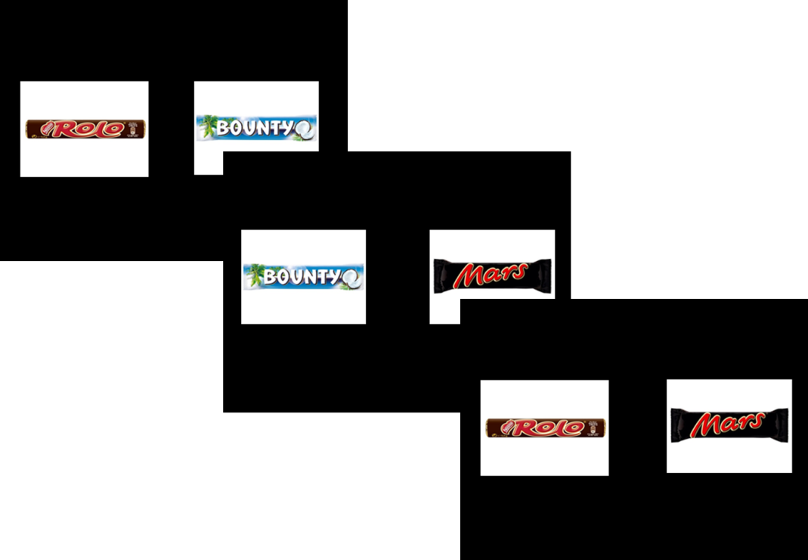knew that they would receive their choice from one randomly selected candy bar choice trial, in addition to a participation fee of 10 €.

**Figure 1**. Three trials of the binary choice experiment. Subject indicated their preferred candy bar on each trial. The timing of the stimulus presentation and choice was self-paced, with a maximum length of 5 seconds.

A triplet was marked as indicating intransitivity either if A was chosen over B and B was chosen over C yet C was chosen over A or if B was chosen over A and C was chosen over B yet A was chosen over C.

# Results

Patients with hippocampal sclerosis showed an increased percentage of intransitive choices compared to the two control groups in the preference task compared to the control task (Fig. 2; mean percentages for the preference task: MTL: 6.07%; ETL: 3.37%; CON: 2.75%; median percentages: MTL: 4.56%; ETL 2.72%; CON: 2.94%; mean percentages for the control task: MTL: 0.50 %; ETL: 1.00%; CON: 0.14%, median percentages: MTL: 0.36%; ETL: 0.00%; CON: 0.04% ; linear mixed model with orthogonal contrasts group task interaction b = – 0.06, t(91) = –2.98, p = 0.004). The difference between degree of intransitivity between the preference and control task did not differ significantly between the two control groups (linear mixed model with orthogonal contrasts group task interaction b = – 0.04, t(91) = 0.97, p = 0.333).

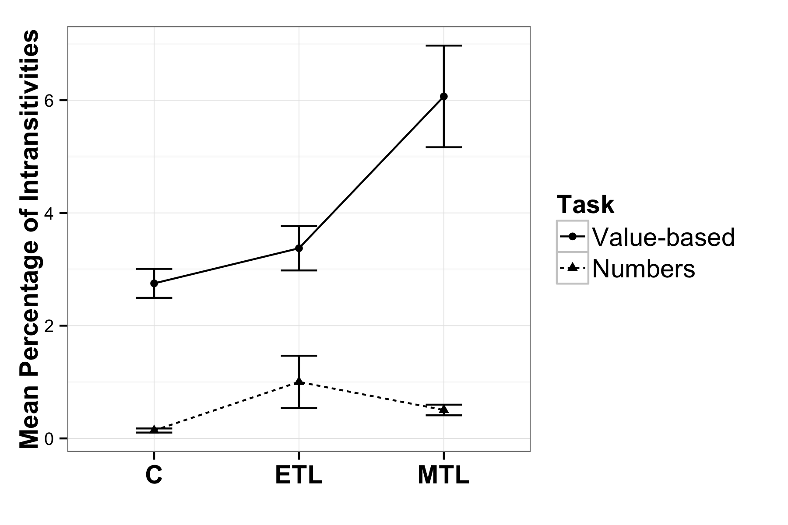**Figure 2**. Mean percentage of intransitive choices per group in each task (nMTL = 31, nC = 30, nETL = 30). Error bars represent SEM.

For a random group of participants (see SOM for details) we correlated the ratio of compromised hippocampal volume to total volume with the percentage of intransitive choices using a non-parametric correlation coefficient that is insensitive to outliers, and found a strong and significant relationship (Fig.3; spearman-rho = 0.676; F(1, 14) = 11.78, p=0.004; n=16). In other words, the larger the lesion, the less consistent were the value-based choices.

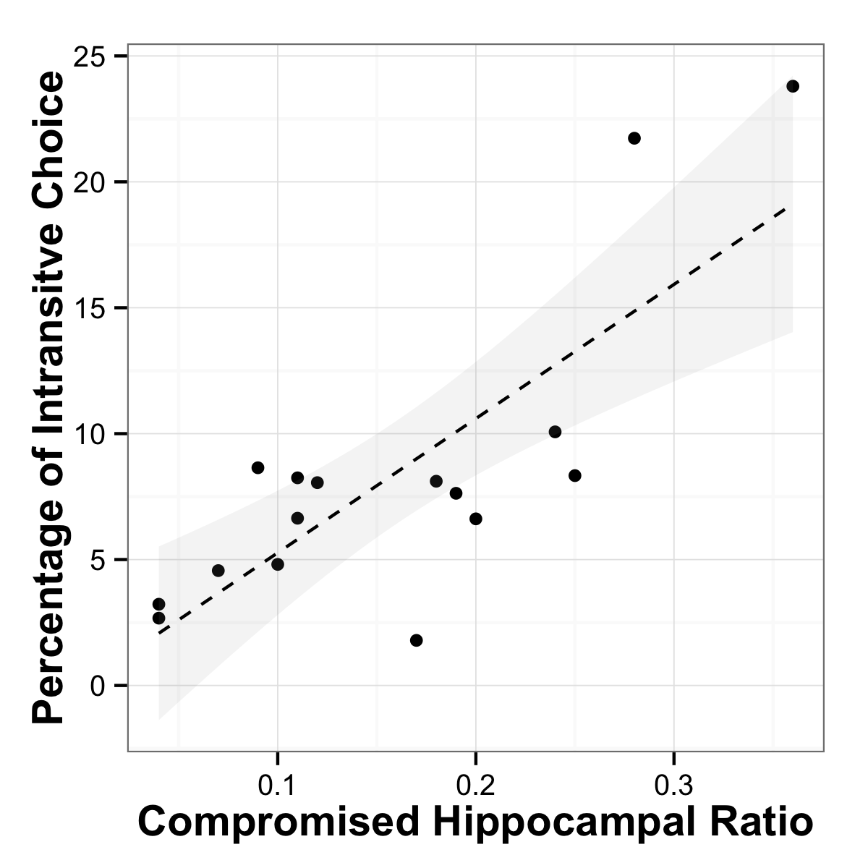

**Figure 3**. Relation of hippocampal ratio and intransitive choices. **a**) Example of a typical hippocampal sclerosis on a T2-weighted image highlighting both hippocampi which were used for the laterality index calculation. **b)** Scatterplot that maps hippocampal asymmetry (as a marker for unilateral atrophy) against percentage of intransitive choices, providing a regression line with 95% CI for the observed correlation of rho=0.676, p=0.004.

To contextualize the observed frequency of intransitivity, we conducted a series of simulations that used a random utility model with a stochastic term added to the utility of the options, such that the probability of choosing option A ($p(A)$) in a decision between A and B was:

$$p\left(A\right)=$$ $$\frac{1}{{1+e}^{\left(\left(1-α\right)u\left(B\right)+ αε\right)- \left(\left(1-α\right)u\left(A\right)+ αε\right) }}$$

where $α$ represents the proportion of the observed utility due to random, which was varied error between 0 and 1, $u\left(A\right)$ and $u(B)$ represent the utilities of each option and $ε$ is random noise. It can be shown analytically that the maximum proportion of intransitive triples would be .25 (see SOM, also noted in the discussion section of Tversky, 1969), but the interesting question is how the proportion increases as error in utilities increases. The effect is non-linear, but the observed intransitivities in the MTL group correspond to the level expected if the error represented approximately 30 percent of the utility in equation 1.

Several alternative explanations can be analyzed with these data. One possible alternative explanation is that non-MTL respondents had better memory for their choices made earlier in the task, and that this prevented intransitive choices. This would suggest that the rate of intransitivities declines over time differentially for the MTL and non-MTL groups. We tested this hypothesis and saw no differences in slopes (see SOM for details).

To examine the possibility of a speed-accuracy tradeoff, we examined response latencies of the choices, and the relationship between responses latencies and intransitivities. We found that slower trials were most likely to be involved in intransitive triplets, and that the MTL group had a significantly slower average response time per trial. Together, these results suggest that intransitive triplets accompany more effortful, longer responding, eliminating the possibility of a speed-accuracy tradeoff.

We also examined whether particular candy bars were more responsible for intransitivities. We regressed the number of times each candy bar was involved in an intransitive choice onto indicator variables representing the identity of each chocolate bar as well as on a factor representing group. None of these variables survived a post-hoc (Bonferroni) test of significance. Difficulty of a decision, as measured by the ordinal value difference between the bars in a trial, however, did have an impact on intransitivity. Expectedly more difficult trials were involved in more intransitive triplets for all groups, but less so for the MTL group. This was not the case for the control trial on numerical judgments, supporting further that differences in performance are due to processing of value.

# Discussion

In this paper we provide support for a critical role of brain regions associated with memory-related processes in value-based decision-making, by showing that hippocampal lesions are associated with an increase in intransitive value-based choices and that the degree of intransitivity is related to magnitude of the damage to the hippocampus. A control task not involving value-based choice does not show these effects, nor do respondents who have lesions outside of the medial temporal lobe. These results implicate the hippocampal areas in preference construction.

Though such data provide strong evidence for the involvement of a brain region in consistent value-based decisions the delineation of specific cognitive and neural mechanisms provide multiple avenues for future research.

First, the hippocampus is just one part in a larger network of relevant brain areas involved in the retrieval and processing of choice values. A recent review by Shohamy and Turk-Browne (2013) suggests hippocampal involvement in a variety of cognitive functions outside of the domain of declarative memory. It provides two different hypotheses of hippocampal function. The memory modulation hypothesis proposes that representations within the hippocampus may transiently bias other cognitive functions such as value computations in our task. The adaptive function hypothesis, in contrast, highlights the hippocampus as a central processing unit with specific computations carried out in the hippocampal networks, depending on the task at hand.

Our hippocampal patients produce patterns of intransitivity of value-based choice that are similar to those observed in ventromedial prefrontal cortex (vmPFC) patients, suggesting that the associations and memories stored in the hippocampus may serve as inputs to value calculation occurring elsewhere (Barron et al., 2013) potentially in line with the memory modulation hypothesis. The hippocampus is one of the most highly interconnected brain areas (Cole, Pathak, & Schneider, 2010; Godsil, Kiss, Spedding, & Jay, 2013). In addition to being directly and monosynaptically connected to the prefrontal cortex animal work suggests topographically specific hippocampal projections map on functionally distinct prefrontal regions (Barlas and Blatt, 1995, Ongür & Price, 2000).

This possibility calls for a nuanced investigation of the interactions between hippocampal and prefrontal regions in value-based decision-making. For example, Ranganath and Ritchey (2012) propose a division of the MTL into two systems for memory-guided behavior: the anterior (AT) and posterior-medial (PM) system. The AT, which is comprised of the perirhinal cortex and anterior parts of the hippocampus and amygdala has strong interconnections with the frontal cortex, has been argued to be involved in familiarity-based cognition, social behavior and saliency. Ranganath & Ritchey (2012) suggest that the AT system could facilitate the use of past experiences to inform inferences about the personality and intentions of others. Our results suggest such inferential abilities specific to distinct regions in the MTL along with the connection to the ventromedial prefrontal cortex may also play a role in value-based decisions.

On the other hand, more in line with an adaptive function hypothesis, deficits in consistent choices might be due to hippocampus-specific computations. For example, Fellows (2006) showed that vmPFC lesioned patients differ from normal controls in their external information search, in ways that could be attributed to diminished planning capacity. Perhaps this planning capacity relies on hippocampus-specific computations. An interesting topic of research would be whether vmPFC patients exhibit deficits in different types mnemonic processes.

A second future research topic is potential compensation mechanisms in patients with chronic hippocampal lesions. It is well-known that chronic brain lesions may lead to compensatory shifts in neural processes, e.g. in the domain of language processing (Kipervasser et al., 2008; Weber et al., 2006).The application of neuroimaging methods, like functional MRI, during a value-based decision task in these patients could provide answers to this question.

Third, although patients with temporal lobe epilepsy and hippocampal sclerosis do show neuropsychological deficits especially in the domain of declarative memory, the amount to which these deficits occur varies strongly between patients (Hoppe, Elger, & Helmstaedter, 2007). Future research combining in-depth neuropsychological testing together with value-based choice tasks may shed light on the specific cognitive components underlying the observed decision deficits.

Our results suggest a critical role for the hippocampus in the construction of the value of choice options. Most decisions require the construction of value based on past experience. Even a previously experienced option, like a favorite dish in a familiar restaurant, requires us to compare that option to newly available options such as tonight’s specials. A better understanding of both internal and external inputs to preference construction processes and their aggregation and comparison will allow us to comprehend and model how the brain calculates value and makes wise and consistent choices.

# Acknowledgements

BW is funded by a Heisenberg-Grant of the German Research Council (WE 4427/3-1) and EUW and EJJ by NIA Grant 5R01AG027934.

# Author contribution statements

BW, EJJ and EUW designed the experiment and wrote the manuscript, EJJ and AZE analyzed the data and wrote the manuscript, IZ performed experiments, JW analyzed the data. CEE provided clinical data of the patients.

# References

Barron, H. C., Dolan, R. J., & Behrens, T. E. J. (2013). Online evaluation of novel choices by simultaneous representation of multiple memories. *Nature Neuroscience*, *16*(10), 1492–8. doi:10.1038/nn.3515

Benoit, R. G., Gilbert, S. J., & Burgess, P. W. (2011). A neural mechanism mediating the impact of episodic prospection on farsighted decisions. *The Journal of Neuroscience : The Official Journal of the Society for Neuroscience*, *31*(18), 6771–9. doi:10.1523/JNEUROSCI.6559-10.2011

Birnbaum, M. H., & Gutierrez, R. J. (2007). Testing for intransitivity of preferences predicted by a lexicographic semi-order. *Organizational Behavior and Human Decision Processes*, *104*(1), 96–112. doi:10.1016/j.obhdp.2007.02.001

Camille, N., Griffiths, C. a, Vo, K., Fellows, L. K., & Kable, J. W. (2011). Ventromedial frontal lobe damage disrupts value maximization in humans. *The Journal of Neuroscience : The Official Journal of the Society for Neuroscience*, *31*(20), 7527–32. doi:10.1523/JNEUROSCI.6527-10.2011

Cole, M. W., Pathak, S., & Schneider, W. (2010). Identifying the brain’s most globally connected regions. *NeuroImage*, *49*(4), 3132–48. doi:10.1016/j.neuroimage.2009.11.001

Dougherty, M. R. P., Gettys, C. F., & Ogden, E. E. (1999). MINERVA-DM : A Memory Processes Model for Judgments of Likelihood. *Psychological Review*, *106*(1), 180–209.

Fellows, L. K. (2006). Deciding how to decide: ventromedial frontal lobe damage affects information acquisition in multi-attribute decision making. *Brain : A Journal of Neurology*, *129*(Pt 4), 944–52. doi:10.1093/brain/awl017

Fellows, L. K., & Farah, M. J. (2007). The role of ventromedial prefrontal cortex in decision making: judgment under uncertainty or judgment per se? *Cerebral Cortex (New York, N.Y. : 1991)*, *17*(11), 2669–74. doi:10.1093/cercor/bhl176

Fischl, B., Salat, D. H., Busa, E., Albert, M., Dieterich, M., Haselgrove, C., … Dale, A. M. (2002). Whole brain segmentation: Automated labeling of neuroanatomical structures in the human brain. *Neuron*, *33*, 341–355. doi:10.1016/S0896-6273(02)00569-X

Fischl, B., van der Kouwe, A., Destrieux, C., Halgren, E., Ségonne, F., Salat, D. H., … Dale, A. M. (2004). Automatically parcellating the human cerebral cortex. *Cerebral Cortex (New York, N.Y. : 1991)*, *14*, 11–22. doi:10.1093/cercor/bhg087

Godsil, B. P., Kiss, J. P., Spedding, M., & Jay, T. M. (2013). The hippocampal-prefrontal pathway: the weak link in psychiatric disorders? *European Neuropsychopharmacology : The Journal of the European College of Neuropsychopharmacology*, *23*(10), 1165–81. doi:10.1016/j.euroneuro.2012.10.018

Hassabis, D., Kumaran, D., Vann, S. D., & Maguire, E. a. (2007). Patients with hippocampal amnesia cannot imagine new experiences. *Proceedings of the National Academy of Sciences of the United States of America*, *104*(5), 1726–31. doi:10.1073/pnas.0610561104

Hoppe, C., Elger, C. E., & Helmstaedter, C. (2007). Long-term memory impairment in patients with focal epilepsy. *Epilepsia*, *48 Suppl 9*, 26–9. doi:10.1111/j.1528-1167.2007.01397.x

Houthakker, H. S. (1950). Revealed Preference and the Utility Function. *Economica*, *17*(66), 159–174.

Johnson, E. J., Häubl, G., & Keinan, A. (2007). Aspects of endowment: a query theory of value construction. *Journal of Experimental Psychology. Learning, Memory, and Cognition*, *33*, 461–474. doi:10.1037/0278-7393.33.3.461

Kalenscher, T., Tobler, P. N., Huijbers, W., Daselaar, S. M., & Pennartz, C. M. a. (2010). Neural signatures of intransitive preferences. *Frontiers in Human Neuroscience*, *4*(June), 1–14. doi:10.3389/fnhum.2010.00049

Kipervasser, S., Palti, D., Neufeld, M. Y., Ben Shachar, M., Andelman, F., Fried, I., … Hendler, T. (2008). Possible remote functional reorganization in left temporal lobe epilepsy. *Acta Neurologica Scandinavica*, *117*(5), 324–31. doi:10.1111/j.1600-0404.2007.00948.x

Klein, S. B., & Loftus, J. (2002). Memory and temporal experience : The effects of episodic memory loss on an amnesic patient’s ability to remember the past and imagine the future. *Social Cognition*, *20*(5), 353–379.

Lee, L., Amir, O., & Ariely, D. (2009). In Search of Homo Economicus: Cognitive Noise and the Role of Emotion in Preference Consistency. *Journal of Consumer Research*, *36*(2), 173–187. doi:10.1086/597160

Lichtenstein, S., & Slovic, P. (Eds.). (2006). *The Construction of Preference*. New York: Cambridge University Press.

Ongür, D., & Price, J. L. (2000). The organization of networks within the orbital and medial prefrontal cortex of rats, monkeys and humans. *Cerebral Cortex (New York, N.Y. : 1991)*, *10*(3), 206–19. Retrieved from http://www.ncbi.nlm.nih.gov/pubmed/10731217

Peters, J., & Büchel, C. (2010). Episodic future thinking reduces reward delay discounting through an enhancement of prefrontal-mediotemporal interactions. *Neuron*, *66*(1), 138–48. doi:10.1016/j.neuron.2010.03.026

Ranganath, C., & Ritchey, M. (2012). Two cortical systems for memory-guided behaviour. *Nature Reviews. Neuroscience*, *13*(10), 713–26. doi:10.1038/nrn3338

Regenwetter, M., Dana, J., Davis-Stober, C. P., & Guo, Y. (2011). Parsimonious testing of transitive or intransitive preferences: Reply to Birnbaum (2011). *Psychological Review*, *118*(4), 684–688. doi:10.1037/a0025291

Reyna, V. F., Lloyd, F. J., & Brainerd, C. J. (2003). Memory, Development, and Rationality: An Integrative Theory of Judgement and Decision Making. In *Emerging Perspectives on Judgement and Decision Research* (pp. 201–245).

Samuelson, P. A. (1938). A Note on the Pure Theory of Behaviour Consumer ’s Bheavior. *Economica*, *5*(17), 61–71.

Schacter, D. L., & Addis, D. R. (2007). The cognitive neuroscience of constructive memory: remembering the past and imagining the future. *Philosophical Transactions of the Royal Society of London. Series B, Biological Sciences*, *362*(1481), 773–86. doi:10.1098/rstb.2007.2087

Schneider, S. L., & Shanteau, J. (2003). *Emerging Perspectives on Judgment and Decision Research* (p. 736). Cambridge University Press.

Shohamy, D., & Turk-Browne, N. B. (2013). Mechanisms for widespread hippocampal involvement in cognition. *Journal of Experimental Psychology. General*, *142*(4), 1159–70. doi:10.1037/a0034461

Tversky, A. (1969). Intransitivity of preferences. *Psychological Review*, *76*(1), 31–48. doi:10.1037/h0026750

Von Neumann, J., & Morgenstern, O. (1944). *Theory of Games and Economic Behavior*. *Princeton University Press* (Vol. 2, p. 625). doi:10.1177/1468795X06065810

Weber, B., Wellmer, J., Reuber, M., Mormann, F., Weis, S., Urbach, H., … Fernández, G. (2006). Left hippocampal pathology is associated with atypical language lateralization in patients with focal epilepsy. *Brain : A Journal of Neurology*, *129*(Pt 2), 346–51. doi:10.1093/brain/awh694

Weber, E. U., Goldstein, W. M., & Barlas, S. (1995). And let us not Forget Memory: The Role of Memory Processes and Techniques in the Study of Judgment and Choice. In *The Psychology of Learning and Motivation* (Vol. 32, pp. 33–81). doi:10.1016/S0079-7421(08)60307-2

Weber, E. U., & Johnson, E. J. (2009). Mindful judgment and decision making. *Annual Review of Psychology*, *60*, 53–85. doi:10.1146/annurev.psych.60.110707.163633

Weber, E. U., Johnson, E. J., Milch, K. F., Chang, H., Brodscholl, J. C., & Goldstein, D. G. (2007). Asymmetric discounting in intertemporal choice: a query-theory account. *Psychological Science : A Journal of the American Psychological Society / APS*, *18*, 516–523. doi:10.1111/j.1467-9280.2007.01932.x

Wimmer, G. E., & Shohamy, D. (2012). Preference by association: how memory mechanisms in the hippocampus bias decisions. *Science (New York, N.Y.)*, *338*(6104), 270–3. doi:10.1126/science.1223252