**SUPPLEMENTAL ONLINE MATERIALS**

Preference consistency relies on hippocampal function:

Evidence from mediotemporal lobe epilepsy

B. Weber1,2, A. Z. Enkavi3 ,I. Zweyer1,2, J. Wagner1, C.E. Elger1,2, E. U. Weber3, E. J. Johnson3,

1Department of Epileptology, University Hospital Bonn. 2Center for Economics and Neuroscience, University of Bonn. 3Center for Decision Science, Columbia University

Professor Dr. Bernd Weber (corresponding author)  
Heisenberg Professor  
Department of Epileptology  
Head - NeuroCognition | Imaging  
Life&Brain Center   
Sigmund-Freud-Str. 25  
53127 Bonn  
Tel.: [++49 228 6885-262](tel:%2B%2B49%20228%206885-262" \t "_blank)  
Fax: [++49 228 6885-261](tel:%2B%2B49%20228%206885-261" \t "_blank)

e-mail: bweber@lifeandbrain.com

**METHODS AND MATERIALS**

*Table S1. Demographic and clinical characteristics of the included subjects*

|  |  |  |  |  |  |
| --- | --- | --- | --- | --- | --- |
|  | *Age* | *Gender (m/f)* | *Handedness (left/right/ambi)* | *First seizure (age yrs.)* | *Seizure frequency (n/month)* |
| *MTL* | *47.74 (2.56)* | *16/15* | *6/24/1* | *18.73 (2.89)* | *5 (8.1)* |
| *ETL* | *43.10(2.60)* | *16/14* | *2/26/2* | *20.17 (3.15)* | *2 (7.6)* |
| *CON* | *51.40(2.60)* | *15/15* | *1/29/0* | *---* | *---* |
|  | *n.sign.* | *n. sign.* | *n.sign.* | *n. sign.* | *n.sign.* |

*Participants*

*MR sequence and analysis*

*Choice task*

*Control task*

*Procedure*

*Reimbursement*

**… ACCOUNTS AND THEIR PREDICTIONS**

**DATA ANALYSIS**

*Data cleaning*

Participants were instructed to indicate their preferences within 5 seconds and pressing “1” (for left) or “4” (for right). There were trials where participants either failed to respond in the time limit or responded using another button. We call the first type of error “timeout trials” and the second “mispress trials.” Since we cannot determine participants’ preferences in these trials with certainty these trials were cleaned as described below.

57 (63 %) subjects (16 in the control group, 16 in the ETL group and 25 in the MTL group) timed out of at least one trial. One participant in the MTL group, timed out of 66 trials. This participant alone is responsible for 32 % of all the timed out trials and we cannot determine the participant’s preferences for 34.7 % of their trials. Ignoring these trials affects 93.7% of this participant’s intransitive choices. Therefore this participant was excluded from the remainder of the analyses. Despite the exclusion of this participant the MTL group still timed out of 2.4 trials on average, which was significantly more than the control group (pairwise t-test with Bonferroni correction p = 0.01) but not the ETL group (p = 0.319), which timed out of 1.5 trials on average.

9 subjects (2 in the control group, 3 in the ETL group and 4 in the MTL group) pressed indicated their preferences using the wrong buttons at least once. One participant in the ETL group mispressed in 65 trials. This participant alone is responsible for 63.1% and we cannot determine the participant’s preferences for 34.2% of their trials. Ignoring these trials affects 90.9% of this participant’s intransitive choices. Therefore this participant was also excluded from the remainder of the analyses. With this exclusion there were no significant differences in the number of mispressed trials between the groups. All groups mispressed less than one trial on average.

After these cleaning procedures … subjects (.. in the control group, .. in the ETL group and the .. in the MTL group) were used for the remainder of the analyses and all trials involving either error ( .. % timeout and .. % mispress) were excluded.

*Durations*

Excluding all other trials that timed out for other participants as well (<1 %) subjects took on average 1.5 seconds on each trial (SD = 720 ms) and 4.5 minutes to complete the whole task (range: 2.2 – 8 minutes, SD = 1.23 minutes). There were no significant group differences in total task completion time (*F*(2, 87) = 2.101, *p* = 0.128).

*Intransitvities by groups*

As the definition of intransitivity requires three pairs of trials we created a matrix with 1140 rows representing the possible combinations of 3 out of 20 candy bars for each participant. These “triplets” were marked as intransitive if

$$A ≳B and B≳C and C≳A$$

or

$$B ≳A and C≳B and A≳C$$

Triplet level counts were collapsed to trial and subject level by summing the number of intransitive triplets. The number of trials one trial was involved in an intransitivity ranged from 0 to 17 with a mean of 0.827 and standard deviation of 1.53 while the total number of intransitivities a subject committed ranged from 1 to 267 with a mean of 49.18 (median = 37, SD = 46.24).

To test if groups differed in respect to the number of intransitive choices they made we used a Kruskal-Wallis one-way analysis of variance by ranks, which is a non-parametric testing whether multiple samples are drawn from the same distribution since the distribution of the residuals of intransitivies cannot be assumed to be normal and therefore is treated as ordinal. Like a one-way ANOVA this test identifies that the means are not equal but requires contrasts, the Wilcoxon signed-rank test to explore differences in ranks. A one-way ANOVA yielded comparable results to the Kruskall-Wallis test (F(2,88) = 8.24, p<0.001).

On average the control subjects had 32 intransitive triplets (median = 34.5, SD = 16.4), the ETL group had 50.8 intransitive triplets (median = 37, SD = 44.4) and the MTL group had 77.5 intransitive triplets (median = 56.0, SD = 59.3), which translates to 2.8 %, 4.5 % and 6.8 % respectively. The Kruskal-Wallis one-way analysis of variance confirmed significant group difference (H(2) = 20, p < 0.001). The MTL group had more intransitive triplets compared to both the control group (pairwise Wilcoxon test p <0.001) and the ETL group (p = 0.029). The ETL and control groups did not differ from each other significantly (p = 0.193).

*Intransitivities and timed out trials*

As explained in the analysis of reaction times there were trials in which subjects timed out of the 5 second limit and therefore include uncertainty as to whether they indicated their true preference. Excluding even one trial from the transitivity count, however, would affect at least 18 triplets and completely throw off the calculation. To make sure that the group differences in the number of intransitive choices were not due to possible errors we marked all triplets that involved a timed out trial and replicated the analysis with triplets that did not involve timed out trials instead of cutting down the matrix for each subject. This was particularly important because the MTL group was slower on average and timed out of significantly more trials as described above.

For example if a participant timed out of 2 trials (1.05 %) of trials and if we had counted 25 (2.2%) intransitive triplets assuming that all 1140 were “clean” we would not be accounting for 35 triplets (3.07 %) that these 2 trials could be affecting. If, for example, 4 of the intransitive triplets that we had counted previously include these trials then 16 % of our counts might be erroneous by not reflecting true preferences. Hence we can’t claim intransitivity for any of the “affected” triplets. Therefore, for each subject, we calculated the number of “clean” triplets by subtracting the number of triplets that included one or more timed out trials. We also calculated the “clean” intransitivities by subtracting the number of intransitivities that involved a timed out trial from our initial count of intransitivities.

We used these two new values to check the new percentages: On average the control subjects had 31.1 intransitive triplets (median = 32.5, SD = 15.8), the ETL group had 46.0 intransitive triplets (median = 34.5, SD = 43.6) and the MTL group had 69.8 intransitive triplets (median = 50.0, SD = 59.6), which translates to 2.8 %, 4.1 % and 6.4 % respectively. The Kruskal-Wallis one-way analysis of variance confirmed significant group difference (H(2) = 13.5, p = 0.001). The MTL group still had significantly more intransitive triplets compared to the control group (pairwise Wilcoxon test p <0.001) and marginally more compared to the ETL group (p = 0.077). The ETL and control groups did not differ from each other significantly (p = 0.473).

*Other incidental factors (side or type of bar)*

We checked for other incidental variables to make sure that choices did not reflect an idiosyncratic pattern. One of these was to see if participants always chose one side of the screen. Overall the left side was chosen 49.1 % of the time. The control group picked the left option 51% of the time, the ETL group 49.1 % of the time and the MTL group 47.2 % of the time. A one-way ANOVA confirmed that the groups did not differ from each other in how often they chose left (F(2, 88) = 2.43, p = 0.094). A paired t-test showed that participants overall did not choose the left side significantly less than 50 % (p = 0.087) and this possibly marginal effect is due only to the MTL group choosing the left side significantly less than half of the time (p = 0.003). This is explained by the timed out trials as well since all but one of the timed out trials was chosen right and this group had the most timed out trials. Excluding these trials the percent of time the left option is chosen by the MTL group increases to 48.4, which is no longer significantly different than 50% (p = 0.086).

Another potential confounder we checked was for clear preference for any specific candy bars. Though some bars were chosen more often than other running pairwise t-tests on the frequency of how often each bar was chosen did not yield any clear “winning” bars.

*Transitivity across trials (memory and intransitivities)*

As noted in the main text one alternative for the differences observed in groups is not the influence of hippocampal damage on the construction of value estimates, but rather the idea that respondents with MTL damage simply did not recall their prior answers in the choice task. We examined how intransitivities occurred across time by looking at the number of times each trial was involved in intransitivity. Alternative explanations involving memory would expect a change in this proportion with trial number (i. e. when the pair is seen during the session). The number of times each trial was involved in an intransitivity served as the dependent measure in a hierarchical regression allowing for different intercepts for each subject nested in groups and fixed effects of the centered trial number and its centered quadratic term (to detect non-linear effects), as well as factors indicating groups and their interactions. Expectedly, each trial was involved in more intransitivities for the MTL group (t = 3.863) followed by the ETL group (t = 1.904) compared to the healthy controls. Each trial was involved in 0.5 intransitivities for the control group, 0.8 for the ETL group and 1.2 for MTL group but this pattern showed neither a linear (t = 0.766) or quadratic (t = 0.514) trend for any of the groups as the interactions between trial number and groups showed (t = 1.41 for ETL group and – 0.61 for MTL group). All trial across the experiment for each subject were equally likely to be involved in an intransitive triplet ruling out explanations based on memory to explain the group differences in total number of intransitivies.

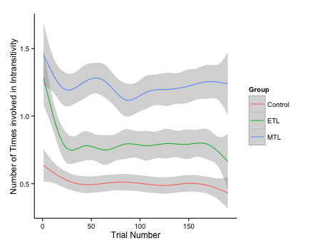

*Fig. S1: Number of intransitivities a trial is involved in based on when it is seen during the task broken down by groups.*

*Intransitivities and reaction times*

On trial level all participants get faster as they progress in the task. The MTL group has the highest average reaction time for a trial significantly differing from the control and ETL groups, while the latter two do not differ from each. How quickly each group speeds up across trials also differs significantly. The slope of speeding up in later trials is steepest for the MTL group, followed by the control group and flattest for the ETL group. These differences are tested for using a hierarchical model that account for the repeated measures aspect of this data, using the R lmer function of the lme4 package (Version 1.0-5). The model includes as predictors (fixed effects) the trial number, group and their interaction and a random-effects participant term nested in the three groups. This random effect captures the repeated-measures aspect of the data and individual differences, if they exist. The significant fixed effect for trial number (β = –2.537, t = – 18.139) indicates that all subjects decrease their reaction times later with each trial. The significant fixed effect for the MTL group (t = 2.615) and the lack thereof for the ETL group (β = –58.623, t = – 0.563) show that the MTL group was significantly slower (272.115 ms on average) than the control group. The significant interactions with each group (β = 0.644, t = 3.253 for MTL and β = –0.845, t = – 4.260 for ETP) imply that the slopes for this decrease in reaction times differ across groups.

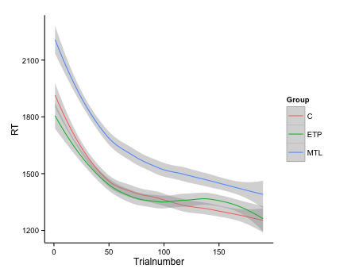

*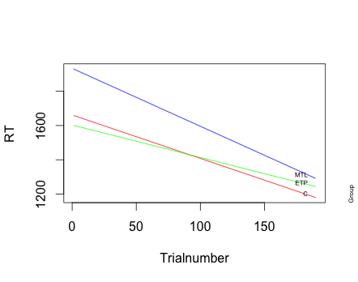*

*Fig. S2: Change in reaction times based depending on how far subjects are in the task broken down by groups. Top panel is drawn from raw data and smoothed with loess curves. Bottom panel is based on multilevel model fit.*

We examined whether reaction times (RTs) on trial level analysis had an effect on the number of intransitivities. A multilevel model with fixed effects for centered RTs and centered quadratic term for RTs, as well as, groups and random intercepts for each participant confirmed that trials where participants took longer were involved in more intransitivites with an RT fixed effect (β = 0.0008, t = 12.586). This translates to roughly one more intransitivity per trial for every two second a participant spends on it, especially after the first second. Intransitivities happen even when participants work harder and spend more time. Additionally this model confirmed the MTL group making significantly more intransitivities per trial (β = 0.611, t = 3.288) and captured the non-linear effects as seen in Figure S2 (β = –1.085\*10–7, t = –7.554). There were no significant interactions. Notably this model is also significantly better in predicting the number of intransitivites a trial is involved in compared to one only with a fixed effect with group and random intercepts for subjects (χ2(4) = 479.69; p <0.001) accounting for variation captured by the previously significant intercept in the simpler model and not changing the effect of the MTL group markedly (β = 0.686, t = 3.853). To make sure that the reaction time was not affected by the timed out trials these trials, along with the participant who timed out of most trials and trials faster than 600 ms and longer than 5500 ms were excluded from these models. These accounted for 0.08 %, 1.10 %, 1.4 % and 0.01 % percent of all trials.

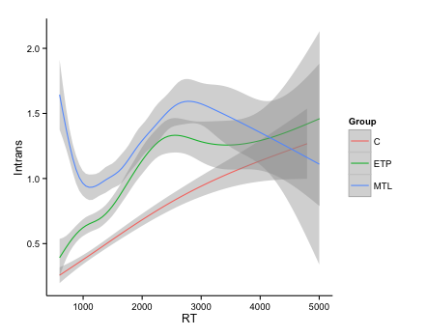

*Fig. S3: Number of intransitivites each trial was involved in as a function of reaction times.*