**SUPPLEMENTAL ONLINE MATERIALS**

Preference consistency relies on hippocampal function:

Evidence from mediotemporal lobe epilepsy

B. Weber1,2, A. Z. Enkavi3 ,I. Zweyer1,2, J. Wagner1, C.E. Elger1,2, E. U. Weber3, E. J. Johnson3,

1Department of Epileptology, University Hospital Bonn. 2Center for Economics and Neuroscience, University of Bonn. 3Center for Decision Science, Columbia University

Professor Dr. Bernd Weber (corresponding author)  
Heisenberg Professor  
Department of Epileptology  
Head - NeuroCognition | Imaging  
Life&Brain Center   
Sigmund-Freud-Str. 25  
53127 Bonn  
Tel.: [++49 228 6885-262](tel:%2B%2B49%20228%206885-262" \t "_blank)  
Fax: [++49 228 6885-261](tel:%2B%2B49%20228%206885-261" \t "_blank)

e-mail: bweber@lifeandbrain.com

**METHODS AND MATERIALS**

*Table S1. Demographic and clinical characteristics of the included subjects*

|  |  |  |  |  |  |
| --- | --- | --- | --- | --- | --- |
|  | *Age* | *Gender (m/f)* | *Handedness (left/right/ambi)* | *First seizure (age yrs.)* | *Seizure frequency (n/month)* |
| *MTL* | *47.74 (2.56)* | *16/15* | *6/24/1* | *18.73 (2.89)* | *5 (8.1)* |
| *ETL* | *43.10(2.60)* | *16/14* | *2/26/2* | *20.17 (3.15)* | *2 (7.6)* |
| *CON* | *51.40(2.60)* | *15/15* | *1/29/0* | *---* | *---* |
|  | *n.sign.* | *n. sign.* | *n.sign.* | *n. sign.* | *n.sign.* |

*Participants*

*MR sequence and analysis*

*Choice task*

*Control task*

*Procedure*

*Reimbursement*

**… ACCOUNTS AND THEIR PREDICTIONS**

**DATA ANALYSIS**

*Data cleaning*

Participants were instructed to indicate their preferences within 5 seconds and pressing “1” (for left) or “4” (for right). There were trials where participants either failed to respond in the time limit or responded using another button. We call the first type of error “timeout trials” and the second “mispress trials.” Since we cannot determine participants’ preferences in these trials with certainty these trials were cleaned as described below.

57 (63 %) subjects (16 in the control group, 16 in the ETL group and 25 in the MTL group) timed out of at least one trial. One participant in the MTL group, timed out of 66 trials. This participant alone is responsible for 32 % of all the timed out trials and we cannot determine the participant’s preferences for 34.7 % of their trials. Ignoring these trials affects 93.7% of this participant’s intransitive choices. Therefore this participant was excluded from the remainder of the analyses. Despite the exclusion of this participant the MTL group still timed out of 2.4 trials on average, which was significantly more than the control group (pairwise t-test with Bonferroni correction p = 0.01) but not the ETL group (p = 0.319), which timed out of 1.5 trials on average.

9 subjects (2 in the control group, 3 in the ETL group and 4 in the MTL group) pressed indicated their preferences using the wrong buttons at least once. One participant in the ETL group mispressed in 65 trials. This participant alone is responsible for 63.1% and we cannot determine the participant’s preferences for 34.2% of their trials. Ignoring these trials affects 90.9% of this participant’s intransitive choices. Therefore this participant was also excluded from the remainder of the analyses. With this exclusion there were no significant differences in the number of mispressed trials between the groups. All groups mispressed less than one trial on average.

After these cleaning procedures 89 subjects (30 in the control group, 29 in the ETL group and the 30 in the MTL group) were used for the remainder of the analyses and all trials involving either error for the rest of the subjects (0.2% timeout and 0.8% mispress) were excluded.

*Durations*

Subjects took on average 1480 miliseconds on each trial (SD = 710 ms) and 4.63 minutes to complete the whole task (range: 2.18 – 8.04 minutes, SD = 1.22 minutes). There were no significant group differences in total task completion time (*F*(2, 86) = 2.17, *p* = 0.12).

*Intransitvities by groups*

As the definition of intransitivity requires three pairs of trials we created a matrix with 1140 rows representing the possible combinations of 3 out of 20 candy bars for each participant. These “triplets” were marked as intransitive if

$$A ≳B and B≳C and C≳A$$

or

$$B ≳A and C≳B and A≳C$$

Triplet level counts were collapsed to trial and subject level by summing the number of intransitive triplets.

As explained in the data cleaning procedures there were trials in which subjects timed out of the 5 second limit or pressed the wrong button and therefore contain uncertainty as to whether they indicated their true preference. Excluding even one trial from the transitivity count, however, would affect at least 18 triplets and completely throw off the calculation. To make sure that the group differences in the number of intransitive choices were not due to possible errors we marked all triplets that involved a trial with either error and used only the clean triplets in the analyses. This was particularly important because the MTL timed out of significantly more trials as described above.

For example if a participant timed out of 2 trials (1.05 %) of trials and if we had counted 25 (2.2%) intransitive triplets assuming that all 1140 were “clean” we would not be accounting for 35 triplets (3.07 %) that these 2 trials could be affecting. If, for example, 4 of the intransitive triplets that we had counted previously include these trials then 16 % of our counts might be erroneous by not reflecting true preferences. Hence we cannot claim transitivity or intransitivity for any of the “affected” triplets. Therefore, for each subject, we calculated the number of “clean” triplets by subtracting the number of triplets that included one or more trials that included any errors. We also calculated the “clean” intransitivities by subtracting the number of intransitivities that involved a timed out trial from our initial count of intransitivities.

The number of times one trial was involved in an intransitivity ranged from 0 to 17 with a mean of 0.774 and standard deviation of 1.458 while the total number of intransitivities a subject committed ranged from 1 to 267 with a mean of 44.714 (median = 37, SD = 39.374).

To test if groups differed in respect to the number of intransitive choices they made we used a Kruskal-Wallis one-way analysis of variance by ranks, which is a non-parametric testing whether multiple samples are drawn from the same distribution since the distribution of the residuals of intransitivies cannot be assumed to be normal and therefore is treated as ordinal. Like a one-way ANOVA this test identifies that the means are not equal but requires contrasts, the Wilcoxon signed-rank test to explore differences in ranks. A one-way ANOVA yielded comparable results to the Kruskall-Wallis test (F(2,86) = 9.31, p<0.001).

On average the control subjects had 30.90 intransitive triplets (median = 32.5, SD = 15.79), the ETL group had 38.38 intransitive triplets (median = 32, SD = 23.824) and the MTL group had 67.33 intransitive triplets (median = 49, SD = 55.99), which translates to 2.75 %, 3.47 % and 6.21 % respectively. The Kruskal-Wallis one-way analysis of variance confirmed significant group difference (H(2) = 15.82, p < 0.001). The MTL group had more intransitive triplets compared to both the control group (pairwise Wilcoxon test p <0.001) and the ETL group (p = 0.019). The ETL and control groups did not differ from each other significantly (p = 0.785).

*Other incidental factors (side or type of bar)*

We checked for other incidental variables to make sure that choices did not reflect an idiosyncratic pattern. One of these was to see if participants always chose one side of the screen. Overall the left side was chosen 50.2 % of the time. The control group picked the left option 51.21% of the time, the ETL group 50.85.1 % of the time and the MTL group 48.55 % of the time. A one-way ANOVA indicated that the groups differed from each other in how often they chose left (F(2, 16729) = 4.65, p < 0.01) with the MTL choosing left less often than both the control (p = 0.015) and the ETL groups (p = 0.047). Paired t-tests showed that only the MTL group chose the left side significantly less than 50% (p = 0.03). We checked whether what side was chosen had an effect on how often a trial was involved in an intransitivity running a multi-level regression with fixed effects for groups, side of bar and their interaction, as well as, random intercepts for each participant. Crucially the interaction term between the MTL group and the side of bar was not significant (β = – 0.034, t = – 0.67).

Another potential confounder we checked was for clear preference for any specific candy bars. Though some bars were chosen more often than other running pairwise t-tests on the frequency of how often each bar was chosen did not yield any clear “winning” bars. Despite the lack of clear overall preferences for specific candy bars we calculated the utilities of each candy bar for each subject by fitting Bradley-Terry-Luce models. We tested whether pairs that are close in value for a subject were more likely to be involved in an intransitivity. Indeed, a multilevel model allowing for random intercepts for each subject nested in groups and fixed effects of the difference in utilities, as well as groups and their interactions confirmed that pairs where the difference was small were involved in more intransitive triplets (t = – 16.28).

*Transitivity across trials (memory and intransitivities)*

As noted in the main text one alternative for the differences observed in groups is not the influence of hippocampal damage on the construction of value estimates, but rather the idea that respondents with MTL damage simply did not recall their prior answers in the choice task. We examined how intransitivities occurred across time by looking at the number of times each trial was involved in intransitivity. Alternative explanations involving memory would expect a change in this proportion with trial number (i. e. when the pair is seen during the session). The number of times each trial was involved in an intransitivity served as the dependent measure in a hierarchical regression allowing for different intercepts for each subject nested in groups and fixed effects of the centered trial number and its centered quadratic term (to detect non-linear effects), as well as factors indicating groups and their interactions. Expectedly, each trial was involved in more intransitivities for the MTL group (t = 3.61). Each trial was involved in 0.52 intransitivities for the control group, 0.65 for the ETL group and 1.16 for MTL group but this pattern showed neither a linear (t = 0.80) nor a quadratic (t = 0.42) trend for any of the groups neither did the interactions between trial number and groups (t = 0.64 for ETL group and – 0.75 for MTL group). All trial across the experiment for each subject were equally likely to be involved in an intransitive triplet ruling out explanations based on memory to explain the group differences in total number of intransitivies.

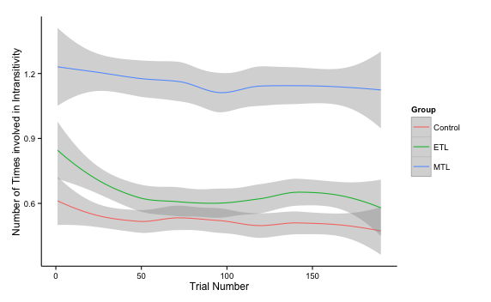

*Fig. S1: Number of intransitivities a trial is involved in based on when it is seen during the task broken down by groups.*

*Intransitivities and reaction times*

On trial level all participants get faster as they progress in the task. The MTL group has the longest average reaction time (1608 ms) for a trial followed by the control (1418 ms) and ETL (1408 ms) groups. How quickly each group speeds up across trials also differs significantly. The slope of speeding up in later trials is steepest for the MTL group, followed by the control group and flattest for the ETL group. These differences are tested for using a hierarchical model that account for the repeated measures aspect of this data, using the R lmer function of the lme4 package (Version 1.0-5). The model includes as predictors (fixed effects) the trial number, group and their interaction and a random-effects participant term nested in the three groups. This random effect captures the repeated-measures aspect of the data and individual differences, if they exist. The significant fixed effect for trial number (β = –2.54, t = – 18.17) indicates that all subjects decrease their reaction times later with each trial. The significant fixed effect for the MTL group (t = 2.62) and the lack thereof for the ETL group (β = –74.59, t = – 0.71) show that the MTL group was significantly slower (273.46 ms on average) than the control group. The significant interactions with each group (β = 0.71, t = 3.57 for ETL and β = –0.872, t = – 4.40 for MTL) imply that the slopes for this decrease in reaction times differ across groups.

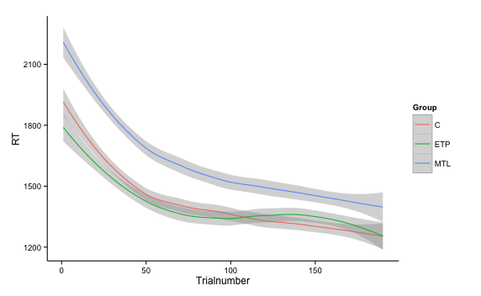

*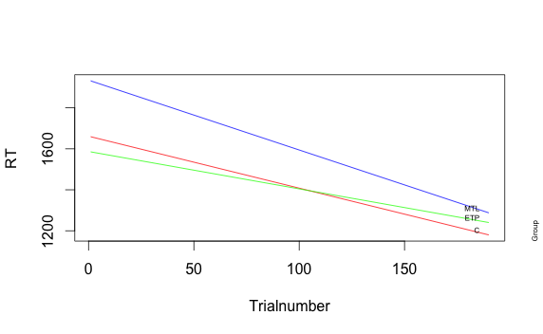*

*Fig. S2: Change in reaction times based depending on how far subjects are in the task broken down by groups. Top panel is drawn from raw data and smoothed with loess curves. Bottom panel is based on multilevel model fit.*

We examined whether reaction times (RTs) on trial level analysis had an effect on the number of intransitivities. A multilevel model with fixed effects for centered RTs and centered quadratic term for RTs, as well as, groups and random intercepts for each participant confirmed that trials where participants took longer were involved in more intransitivites with an RT fixed effect (β = 0.0007, t = 12.52). This translates to roughly one more intransitivity per trial for every two seconds a participant spends on it, especially after the first second. Intransitivities happen even when participants work harder and spend more time. Additionally this model confirmed the MTL group making significantly more intransitivities per trial (β = 0.56, t = 3.47) and captured the non-linear effects as seen in Figure S3 (β = –8.65\*10–8, t = – 6.91). There were no significant interactions. Notably this model is also significantly better in predicting the number of intransitivites a trial is involved in compared to one only with a fixed effect with group and random intercepts for subjects (χ2(4) = 488; p <0.001) accounting for variation captured by the previously significant intercept in the simpler model and not changing the effect of the MTL group on number of intransitivities markedly.

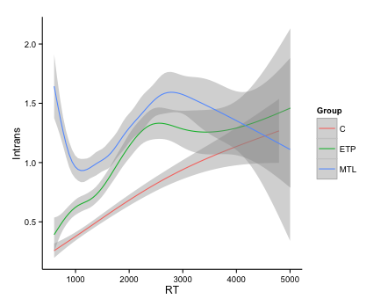

*Fig. S3: Number of intransitivites each trial was involved in as a function of reaction times.*

*Interpreting the number of intransitive choices (simulations)*

One question that may rise is how to interpret the size of these effects. To answer this question we simulated a logistic choice process with different amounts of noise and computed the number of intransitivities. One must note that if choices were completely random the percentage of intransitivities should be 25% given the definition of the term (p(A $≳$ B and B $≳$ C and C $≳$ A) = 2\*(0.5)^3). Therefore intransitivities are only detectable in this range and completely random noise in our simulations should approach this maximum value. Utilities for each bar were chosen from a standard normal distribution and noise from the same distribution was added to each choice to calculate choice probabilities. The mean level of intransitivities ranged from 0.003% at 1% noise to 25% at 100% noise in 1000 simulations.

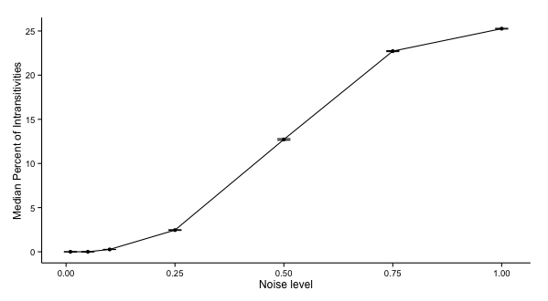

*Fig. S4: Median Percentage of intransitivities at different noise levels from 1000 simlations. Error bars indicate standard errors of the simulation means.*