**SUPPLEMENTAL ONLINE MATERIALS**

Preference consistency relies on hippocampal function:

Evidence from mediotemporal lobe epilepsy

B. Weber1,2, A. Z. Enkavi3 ,I. Zweyer1,2, J. Wagner1, C.E. Elger1,2, E. U. Weber3, E. J. Johnson3,

1Department of Epileptology, University Hospital Bonn. 2Center for Economics and Neuroscience, University of Bonn. 3Center for Decision Science, Columbia University

Professor Dr. Bernd Weber (corresponding author)  
Heisenberg Professor  
Department of Epileptology  
Head - NeuroCognition | Imaging  
Life&Brain Center   
Sigmund-Freud-Str. 25  
53127 Bonn  
Tel.: [++49 228 6885-262](tel:%2B%2B49%20228%206885-262" \t "_blank)  
Fax: [++49 228 6885-261](tel:%2B%2B49%20228%206885-261" \t "_blank)

e-mail: bernd.weber@ukb.uni-bonn.de

**METHODS AND MATERIALS**

*Table S1. Demographic and clinical characteristics of the included subjects*

|  |  |  |  |  |  |
| --- | --- | --- | --- | --- | --- |
|  | *Age* | *Gender (m/f)* | *Handedness (left/right/ambi)* | *First seizure (age yrs.)* | *Seizure frequency (n/month)* |
| *MTL* | *47.74 (2.56)* | *16/15* | *6/24/1* | *18.73 (2.89)* | *5 (8.1)* |
| *ETL* | *43.10(2.60)* | *16/14* | *2/26/2* | *20.17 (3.15)* | *2 (7.6)* |
| *CON* | *51.40(2.60)* | *15/15* | *1/29/0* | *---* | *---* |
|  | *n.sign.* | *n. sign.* | *n.sign.* | *n. sign.* | *n.sign.* |

**DATA ANALYSIS**

*Data cleaning*

Participants were instructed to indicate their preferences within 5 seconds by pressing “1” (for left) or “4” (for right) on the computer keyboard. There were trials where participants either failed to respond within the time limit or responded using another button. We call the first type of error “timeout trials” and the second “mispress trials.” Since we cannot determine participants’ preferences in these trials with certainty these trials were cleaned as described below.

*Timed out trials*

57 (63%) subjects (16 in the control group, 16 in the ETL group and 25 in the MTL group) timed out of at least one trial. One participant in the MTL group, timed out of 66 trials. This participant alone is responsible for 32% of all the timed out trials and we cannot determine the participant’s preferences for 34.7% of trials. Ignoring these trials affects 93.7% of this participant’s intransitive choices. Therefore this participant was excluded from the remainder of the analyses. Despite the exclusion of this participant, the MTL group still timed out of 2.4 trials on average, which was significantly more than the control group (pairwise t-test with Bonferroni correction p = 0.01) but not the ETL group (p = 0.319), which timed out of 1.5 trials on average.

*Misspress trials*

9 subjects (2 in the control group, 3 in the ETL group and 4 in the MTL group) indicated their preferences using the wrong buttons at least once. One participant in the ETL group mispressed in 65 trials. This participant alone is responsible for 63.1% and we cannot determine the participant’s preferences for 34.2% of trials. Ignoring these trials affects 90.9% of this participant’s intransitive choices. Therefore this participant was also excluded from the remainder of the analyses. With this exclusion there were no significant differences in the number of mispressed trials between the groups. All groups mispressed less than one trial on average.

After these cleaning procedures 89 subjects (30 in the control group, 29 in the ETL group and the 30 in the MTL group) were used for the remainder of the analyses and all trials involving either error (0.2% timeout and 0.8% mispress) were excluded.

To make sure that the group differences in the number of intransitive choices were not due to missing data due to timeout or mispress, we used only triplets that did not involve any of these pairs in the analyses. This was particularly important because the MTL timed out of significantly more trials as described above. Because of this, the reported percentage of intransitivities for the MTL group is most likely a conservative estimate.

SUPPLEMENTARY RESULTS

*Response times*

Subjects took on average 1480 miliseconds on each trial (SD = 710 ms) and 4.63 minutes to complete the whole task (range: 2.18 – 8.04 minutes, SD = 1.22 minutes). There were no significant group differences in total task completion time (*F*(2, 86) = 2.17, *p* = 0.12).

*Intransitivities by groups*

As the definition of intransitivity requires three pairs of trials, we created a matrix with 1140 rows representing the possible combinations of 3 pairwise choices for the 20 candy bars for each participant. These “triplets” were marked as intransitive if

$$A ≳B and B≳C and C≳A$$

or

$$B ≳A and C≳B and A≳C$$

Triplet level counts were collapsed to trial (i.e. choice pairs that participants saw) and subject level by summing the number of intransitive triplets.

The number of times one trial was involved in an intransitivity ranged from 0 to 17 with a mean of 0.8 and standard deviation of 1.5 while the total number of intransitivities a subject committed ranged from 1 to 267 with a mean of 44.7 (median = 37, SD = 39.4).

To test if groups differed in their number of intransitive choices we used a Kruskal-Wallis one-way analysis of variance by ranks, which is a non-parametric testing on whether multiple samples are drawn from the same distribution. A one-way ANOVA yielded comparable results to the Kruskall-Wallis test (F(2,86) = 9.31, p<0.001).

On average the control respondents showed 30.9 intransitive triplets (median = 32.5, SD = 15.8), the ETL group showed 38.4 intransitive triplets (median = 32, SD = 23.8) and the MTL group showed 67.3 intransitive triplets (median = 49, SD = 55.9), which translates to 2.75%, 3.47% and 6.21% respectively. The Kruskal-Wallis one-way analysis of variance confirmed significant group difference (H(2) = 15.82, p < 0.001). The MTL group showed more intransitive triplets compared to both the control group (pairwise Wilcoxon test p <0.001) and the ETL group (p = 0.019). The ETL and control groups did not differ from each other significantly (p = 0.785).

*Preference for side of computer screen*

We checked for whether an incidental factor, in particular the side of the screen on which a candy bars was displayed, affected choice. Overall the left side was chosen 50.2 % of the time. The control group picked the left option 51.21% of the time, the ETL group 50.85.1 % of the time and the MTL group 48.55 % of the time. A one-way ANOVA indicated that the groups differed from each other in how often they chose left (F(2, 16729) = 4.65, p < 0.01) with the MTL choosing left less often than both the control (p = 0.015) and the ETL groups (p = 0.047). Paired t-tests showed that only the MTL group chose the left side significantly less than 50% (p = 0.03). We checked whether what side was chosen had an effect on how often a trial was involved in an intransitivity running a multi-level regression with fixed effects for groups, side of chosen bar and their interaction, as well as, random intercepts for each participant. Crucially the interaction term between the MTL group and the side of chosen bar was not significant (β = – 0.034, t = – 0.67, p = 0.50).

*Utilities of candy bars and intransitivities*

We calculated the utilities of each candy bar for each subject by fitting a Bradley-Terry-Luce model to the choices of each respondent. To validate our assumption that intransitive choice patterns are the result of the presence of random error in people’s preference construction for each choice option, we tested whether pairs that are close in value for a subject (and thus more likely to be reversed in rank order by the presence of a constant level of random error) were more likely to be involved in an intransitivity. Indeed, a multilevel model allowing for random intercepts for each subject nested in groups and fixed effects of the difference in utilities, as well as groups and their interactions confirmed that pairs where the difference was small were involved in more intransitive triplets (t = – 16.28, p < 0.001).

*Alternative explanations of (in)transitivity across trials*

As noted in the main text, one alternative explanation for the observed group differences in intransitive choice patterns is not the influence of hippocampal damage on the construction of value estimates, but rather the idea that respondents with MTL damage simply did not recall their prior answers in the choice task as well as the other groups, who could use this information to increase their consistency in choices. We examined this alternative explanation by looking at the number of times each trial (i.e., choices made at different times of the test) was involved in intransitivity. The alternative explanation hypothesizing explicit memory recall of prior answers would expect a change in this proportion with trial number (i.e., the time point at which a choice pair is seen during the session). In particular, the alternative explanation would predict a decrease in intransitivities across trials, and less of a decrease in intransivities for the MTL group relative to the other two groups. The number of times each trial was involved in an intransitivity served as the dependent measure in a hierarchical regression allowing for different intercepts for each subject nested in groups and fixed effects of the centered trial number and its centered quadratic term (to detect non-linear effects), as well as factors indicating groups and their interactions. Consistent with previous analyses, each trial was involved in more intransitivities for the MTL group (t = 4.07, p < 0.001). Each trial was involved in 0.52 intransitivities for the control group, 0.65 for the ETL group and 1.16 for MTL group but this pattern showed neither a linear (t = 0.80, p = 0.43) nor a quadratic (t = 0.42, p = 0.68) trend for any of the groups neither did the interactions between trial number and groups (t = 0.64, p = 0.52 for ETL group and t = – 0.75, p = 0.45 for MTL group). All trials across the experiment for each subject were equally likely to be involved in an intransitive triplet ruling out an explanation based on explicit memory of prior choices within the experiment to explain the observed intransitivities as well as group differences in their frequency.

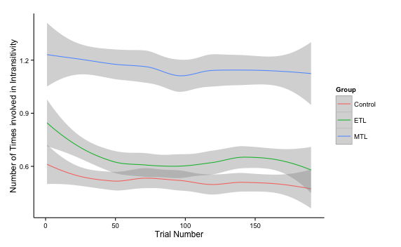

*Fig. S1: Number of intransitivities a trial is involved in based on when it is seen during the task broken down by groups.*

*Intransitivities and response times*

All participants got faster as they progressed with the choice task. The MTL group has the longest average response time (1608 ms) per choice, followed by the control (1418 ms) and ETL (1408 ms) groups. How quickly each group sped up across trials also differed significantly. The slope of speeding up on later trials was steepest for the MTL group, followed by the control group and flattest for the ETL group. These differences were tested for using a hierarchical model that accounts for the repeated measures aspect of this data, using the R lmer function of the lme4 package (Version 1.0-5). The model includes as predictors (fixed effects) the trial number, group and their interaction and a random-effects participant term nested in the three groups. This random effect captures the repeated-measures aspect of the data and individual differences, if they exist. The significant fixed effect for trial number (β = –2.54, t = – 18.17, p < 0.001) indicates that all subjects decreased their response times across trials. The significant fixed effect for the MTL group (t = 2.62, p = 0.01) and the lack thereof for the ETL group (β = –74.59, t = – 0.71, p = 0.48) show that the MTL group was significantly slower (273.46 ms on average) than the control group. The significant interactions with each group (β = 0.71, t = 3.57, p < 0.001 for ETL and β = –0.872, t = – 4.40, p < 0.001 for MTL) imply that the slopes for this decrease in reaction times differ across groups.

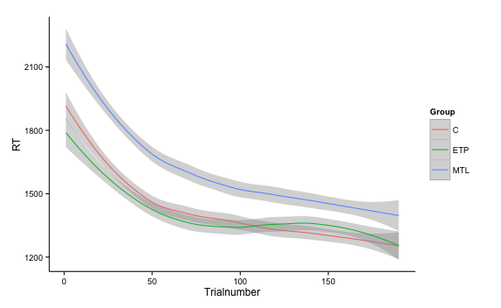

*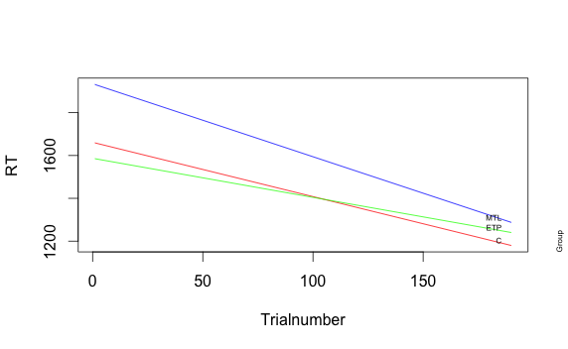*

*Fig. S2: Change in response times (RT) based depending on how far subjects are in the task broken down by groups. Top panel is drawn from raw data and smoothed with loess curves. Bottom panel is based on multilevel model fit.*

We examined whether response times (RTs) at the trial level had an effect on the number of intransitivities. A multilevel model with fixed effects for centered RTs and centered quadratic term for RTs, as well as groups and random intercepts for each participant showed that choices for which participants took longer were involved in more intransitivites, with an RT fixed effect (β = 0.0007, t = 12.52, p < 0.001). This translates to roughly one more intransitivity per choice for every extra two seconds a participant spends on it, especially after the first second. Additionally this model confirmed the MTL group making significantly more intransitivities per trial (β = 0.56, t = 3.47, p < 0.001) and captured the non-linear effects as seen in Figure S3 (β = –8.65\*10–8, t = – 6.91, p <0.001). There were no significant interactions. Notably this model is also significantly better in predicting the number of intransitivities a trial is involved in compared to one with only a fixed effect with group and random intercepts for subjects (χ2(4) = 488; p <0.001) accounting for variation captured by the previously significant intercept in the simpler model and not changing the effect of the MTL group on number of intransitivities markedly. Since the MTL group is both the slowest group and the one with most intransitivities this eliminates the possibility of the speed-accuracy tradeoff.

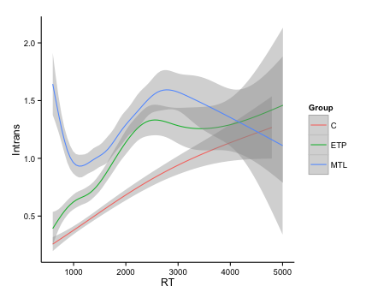

*Fig. S3: Number of intransitivites each trial was involved in as a function of reaction times.*

*Simulations to interpret the observed number of intransitive choices*

One question that may rise is how to interpret the size of the observed group differences in intransitivity. To answer this question we simulated a logistic choice process with different amounts of noise and computed the expected number of intransitivities. If choices were completely random, the percentage of intransitivities should be 25% given the definition of the term (p(A $≳$ B and B $≳$ C and C $≳$ A) = 2\*(0.5)^3). Therefore 25% forms the upper level of intransitivities that can be expected in our analyses. We used simulations to see how the percentage of intransitive choice triplets changed with the amount of random error or noise in people’s subjective preference judgments for each candy bar (from noise=0 for perfect utility judgments to noise=1 for completely random choices). Utilities for each bar were chosen from a standard normal distribution and noise from the same distribution was added to each choice to calculate choice probabilities. The mean level of intransitivities ranged from 0.003% at 1% noise to 25% at 100% noise in 1000 simulations.

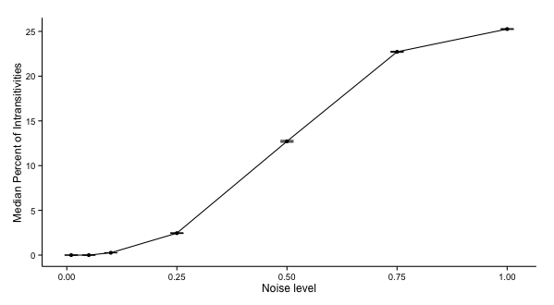

*Fig. S4: Median percentage of intransitivities at different noise levels, based on 1000 simulations. Error bars indicate standard errors of the simulation means.*