**SUPPLEMENTAL ONLINE MATERIALS**

Preference consistency relies on hippocampal function:

Evidence from mediotemporal lobe epilepsy

B. Weber1,2, A. Z. Enkavi3,I. Zweyer1,2, J. Wagner1, C.E. Elger1,2, ,E. U. Weber4, E. J. Johnson4,

1Department of Epileptology, Sigmund-Freud-Str.25, University Hospital Bonn, 53127 Bonn, Germany

2Center for Economics and Neuroscience, Nachtigallenweg 86, University of Bonn. 53127 Bonn, Germany

3Department of Psychology, Stanford University, 450 Serra Mall, 420-01, Stanford, CA 94305

4Center for Decision Science, Uris Hall 716, 3022 Broadway, New York, NY 10027-6902, Columbia University, US

Professor Dr. Bernd Weber (corresponding author)  
Heisenberg Professor  
Department of Epileptology  
Head - NeuroCognition | Imaging  
Life&Brain Center   
Sigmund-Freud-Str. 25  
53127 Bonn  
Tel.: [++49 228 6885-262](tel:%2B%2B49%20228%206885-262" \t "_blank)  
Fax: [++49 228 6885-261](tel:%2B%2B49%20228%206885-261" \t "_blank)

e-mail: bernd.weber@ukb.uni-bonn.de

**METHODS AND MATERIALS**

*Table S1. Demographic and clinical characteristics of the included subjects*

|  |  |  |  |  |  |
| --- | --- | --- | --- | --- | --- |
|  | *Age* | *Gender (m/f)* | *Handedness (left/right/ambi)* | *First seizure (age yrs.)* | *Seizure frequency (n/month)* |
| *MTL* | *47.74 (2.56)* | *16/15* | *6/24/1* | *18.73 (2.89)* | *5 (8.1)* |
| *ETL* | *43.10(2.60)* | *16/14* | *2/26/2* | *20.17 (3.15)* | *2 (7.6)* |
| *CON* | *51.40(2.60)* | *15/15* | *1/29/0* | *---* | *---* |
|  | *n.sign.* | *n. sign.* | *n.sign.* | *n. sign.* | *n.sign.* |

The study was approved by the local ethics committee of the University of Bonn and the Institutional Review Board at Columbia University (IRB-AAAB1301) and all subjects gave their written informed consent.

*MR sequence and analysis*

For a random subgroup of the patients with unilateral hippocampal sclerosis (n=16), a 3D-T1 weighted high-resolution data set (MP-RAGE, voxel size 1x1x1mm, repetition time 1570ms, echo time 3.42ms, flip angle 15°, field of view 256mm x 256mm) was available for volumetric measurement of the hippocampus. This was done in a fully automated manner by means of the FreeSurfer image analysis suite (Version 5.1.0, Martinos Center, Harvard University, Boston, MA, U.S.A.) (Fischl et al., 2002, 2004). Because of the high variance in hippocampal volume between individuals, we used a lateral damage index of hippocampal volume to express the extent of unilateral hippocampal damage in our MTL group:

$$LDI=abs\left(\frac{V_{Hippo_L}-V_{Hippo_R} }{V_{Hippo_L}+V_{Hippo_R}}\right)$$

This lateral damage index can obviously be only assessed for subjects with unilateral hippocampal sclerosis.

*Statistical analysis*

Statistical analyses were performed using SPSS Statistics 21.0 for Windows (IBM, Armonk, NY, U.S.A.) and R (Version 3.2.2) for Mac. We use a two-tailed p-value of 0.05 as our criterion for statistical significance and mark significant differences in the figures and tables with asterisks: \*p ≤ 0.05, \*\*p ≤ 0.01, and \*\*\*p ≤ 0.001.

*Tallying intransitivities*

The binary choices made by each respondent were transformed into a matrix of choice-triplets, as the detection of intransitivity requires three choice pairs. Each matrix consisted of 1140 rows, representing all possible combinations of 3 choice pairs, out of the 190 paired comparisons of the 20 chocolate bars, that are relevant to determine transitivity.

The proportion of intransitive choices was obtained by dividing the number of intransitive triples by the total number of triples. This provided the central dependent measure. Analytically, it can be shown that the maximum level of intransitivities (those produced by a random responder) is 25% of all triplets. Below we report the results of simulations that demonstrate the non-linear relationship between number of intransitive choices and response error.

**DATA ANALYSIS**

SUPPLEMENTARY RESULTS

*Response times*

Subjects took on average 1488 milliseconds on each trial (SD = 720 ms) on the choice task and 849 milliseconds (SD = 335 ms) on the control task. There were significant group and task differences in reaction times. All groups were faster in the control task than in the preference task (β = -0.972, t(34225) = -70.30, p < 0.001) and they got faster as the task progressed, though this trend was much more prominent for the choice task (task – trial number interaction β = 0.186, t(34225) = 13.44, p < 0.001). The MTL group was consistently slower than the control groups in the choice task but this was not true for the control task where the control group was consistently faster than both lesion groups. These patterns in the reaction times indicate that the choice task was more difficult for the MTL group while the control task was much easier for all groups, especially the healthy controls.

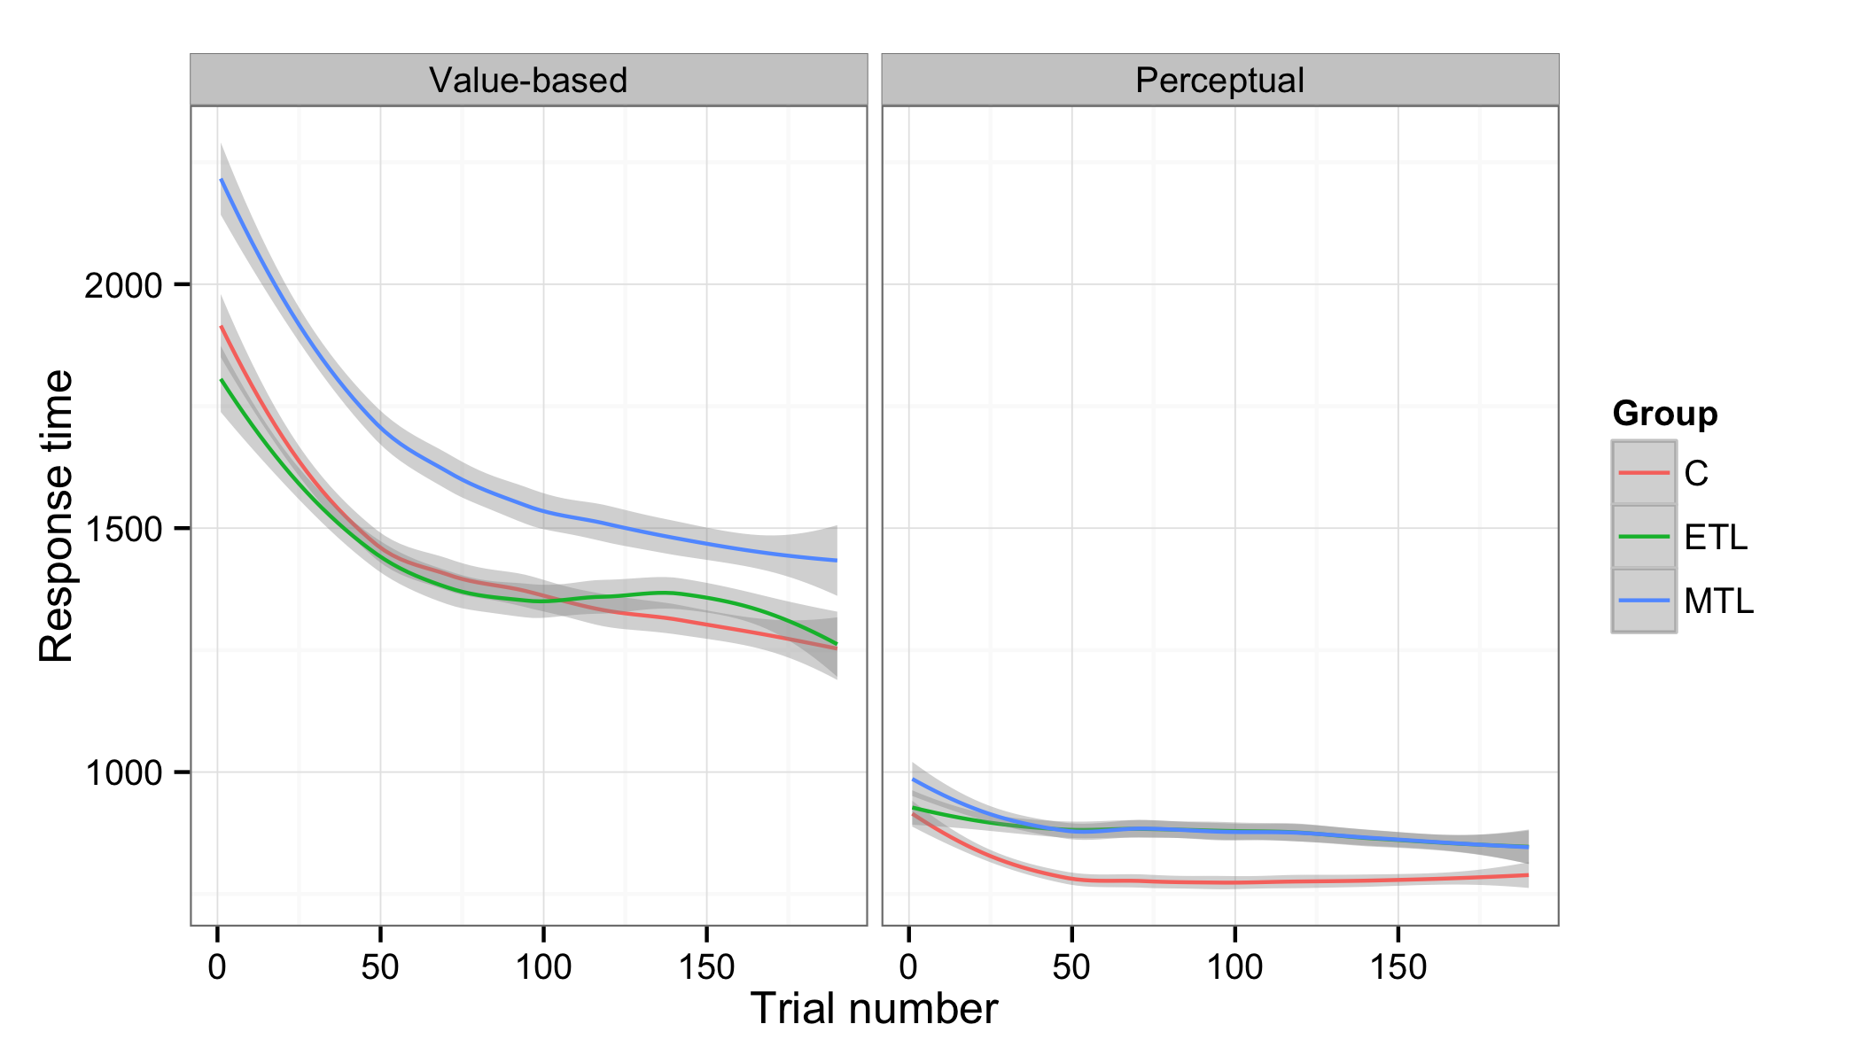

*Fig. S1: Response times (RT) for each task and group. RT’s decreased as the task progressed for all groups in both trials. The MTL group was consistently slower in the choice task. All groups were faster in the control task, particularly the healthy controls.*

*Intransitivities by groups*

As the definition of intransitivity requires three pairs of trials, we created a matrix with 1140 rows representing the possible combinations of 3 pairwise choices for the 20 candy bars for each participant. These “triplets” were marked as intransitive if

$$A ≳B and B≳C and C≳A$$

or

$$B ≳A and C≳B and A≳C$$

Triplet level counts were collapsed to trial (i.e. choice pairs that participants saw) and subject level by summing the number of intransitive triplets.

The number of times one trial was involved in an intransitivity ranged from 0 to 17 with a mean of 0.715 and standard deviation of 1.414 while the total number of intransitivities a subject committed ranged from 1 to 267 with a mean of 44.7 (median = 37, SD = 39.374).

To test if groups differed in their number of intransitive choices we used a linear mixed model with orthogonal contrasts for group and task type (choice or control). This was significantly better than a model without random intercept for subjects (χ2(7) = 4.39, p = 0.036). The percentage of intransitive choices was log transformed to ensure that the difference in variances was independent of task type (Bartlett’s Κ2(1) = 3.354, p = 0.067). Orthogonalization of contrasts allowed for direct comparison of the difference in intransitivity levels between the tasks for the MTL group compared to both control groups.

*Preference for side of computer screen*

We checked for whether an incidental factor, in particular the side of the screen on which a candy bars was displayed, affected choice. Overall the left side was chosen 50.2 % of the time. The control group picked the left option 51.21% of the time, the ETL group 50.7 % of the time and the MTL group 48.82 % of the time. A one-way ANOVA indicated that the groups differed from each other in how often they chose left (F(2, 17080) = 3.65, p < 0.026) with the MTL choosing left less often than the control (p = 0.033) but not the ETL groups (p = 0.122). We checked whether what side was chosen had an effect on how often a trial was involved in an intransitivity running a multi-level regression with fixed effects for groups, side of chosen bar and their interaction, as well as, random intercepts for each participant. Crucially the interaction term between the MTL group and the side of chosen bar was not significant (b = – 0.046, t(1700) = – 0.95, p = 0.340).

*Values of candy bars and intransitivities*

We calculated the ordinal values of each candy bar for each subject by counting how often it was chosen in the 19 times it was presented. To verify our assumption that intransitive choice patterns are the result of the presence of random error in people’s preference construction for each choice option, we tested whether pairs that are close in value for a subject (and thus more likely to be reversed in rank order by the presence of a constant level of random error) were more likely to be involved in an intransitivity. Indeed, a multilevel model allowing for random intercepts for each subject and fixed effects of the difference in utilities, as well as groups and their interactions confirmed that pairs where the difference was small were involved in more intransitive triplets (β = – 0.36, t(17280) = – 29.301, p < 0.001). How decision difficulty (i.e. difference in ordinal values) affected the probability of an intransitivity differed, however, by group. Specifically, hard decisions were less likely to be involved in an intransitive triplet for the MTL group compared to the two control groups, implying differences in how these differences in value were interpreted by this group (β = 0.110, t(17280) = – 6.249, p < 0.001).

*Alternative explanations of (in)transitivity*

As noted in the main text, one alternative explanation for the observed group differences in intransitive choice patterns is not the influence of hippocampal damage on the construction of value estimates, but rather the idea that respondents with MTL damage simply did not recall their prior answers in the choice task as well as the other groups, who could use this information to increase their consistency in choices. We examined this alternative explanation by looking at the number of times each choice was involved in intransitivity. The alternative explanation hypothesizing explicit memory recall of prior answers would expect a change in this proportion with trial number (i.e., the time point at which a choice pair is seen during the session). In particular, the alternative explanation would predict a decrease in intransitivities across trials, and less of a decrease in intransitivities for the MTL group relative to the other two groups. Consistent with previous analyses, each trial was involved in more intransitivities for the MTL group (b = 0.56, t(94) = 3.72, p < 0.001). As explained above the number of times one trial was involved in an intransitivity ranged from 0 to 17 with a mean of 0.715 and standard deviation of 1.414. As the mean implies most of the 190 choice pairs for each participant were not involved in intransitivies. Therefore, as Figure S2 depicts each trial was involved in 0.49 intransitivities on average for the control group, 0.60 for the ETL group and 1.05 for MTL group but this pattern showed neither a linear (b = 7.155 × 10-3, t(17200) = 0.297, p = 0.766) nor a quadratic (b = 7.727 × 10-3, t(17200) = 0.458, p = 0.647) trend throughout the task for any of the groups neither did the interactions between trial number and groups. All trials across the experiment for each subject were equally likely to be involved in an intransitive triplet ruling out an explanation based on explicit memory of prior choices within the experiment to explain the observed intransitivities as well as group differences in their frequency.

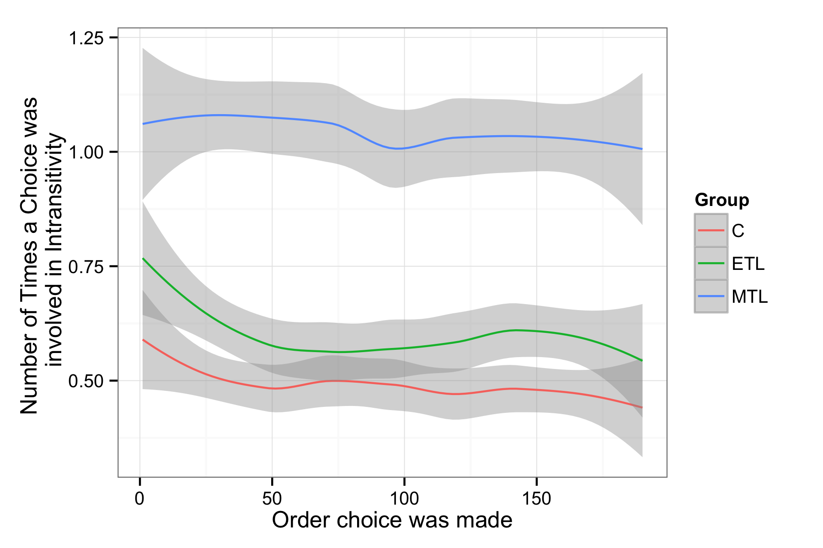

*Fig. S2: Number of intransitivities throughout the task for each group. The probability of intransitivity remains constant across trials.*

*Intransitivities and response times*

We examined whether response times (RTs) at the trial level had an effect on the number of intransitivities. A multilevel model with fixed effects for centered RTs and centered quadratic term for RTs, as well as groups and random intercepts for each participant showed that choices for which participants took longer were involved in more intransitivites, with an RT fixed effect (b = 0.275, t(17180) = 12.601, p < 0.001). This translates to roughly one more intransitivity per choice for every extra two seconds a participant spends on it, especially after the first second. There were no significant interactions. Notably this model is also significantly better in predicting the number of intransitivities a trial is involved in compared to one with only a fixed effect with group and random intercepts for subjects (χ2(3) = 449.58; p <0.001) accounting for variation captured by the previously significant intercept in the simpler model and not changing the effect of the MTL group on number of intransitivities markedly. Since the MTL group is both the slowest group and the one with most intransitivities, this eliminates the possibility of the increase in intransitivities being the result of a speed-accuracy tradeoff.

*Simulations to interpret the observed number of intransitive choices*

One question that may rise is how to interpret the size of the observed group differences in intransitivity. To answer this question we simulated a logistic choice process with different amounts of noise and computed the expected number of intransitivities. If choices were completely random, the percentage of intransitivities should be 25% given the definition of the term (p(A $≳$ B and B $≳$ C and C $≳$ A) = 2\*(0.5)^3). Therefore 25% forms the upper level of intransitivities that can be expected in our analyses.

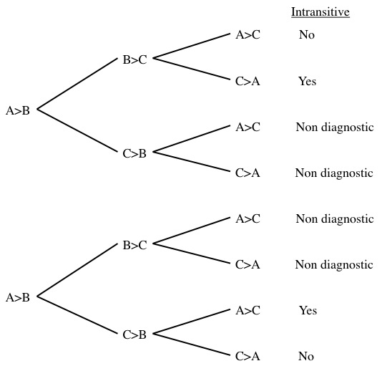

*Fig. S4: Tree diagram indicating possible intransitive paths from three binary choices*

We used simulations to see how the percentage of intransitive choice triplets changed with the amount of random error or noise in people’s subjective preference judgments for each candy bar (from noise=0 for perfect utility judgments to noise=1 for completely random choices). Utilities for each bar were chosen from a standard normal distribution and normally-distributed noise was added to each utility to calculate choice probabilities. The mean level of intransitivities ranged from 0.003% at 1% noise to 25% at 100% noise in 1000 simulations.

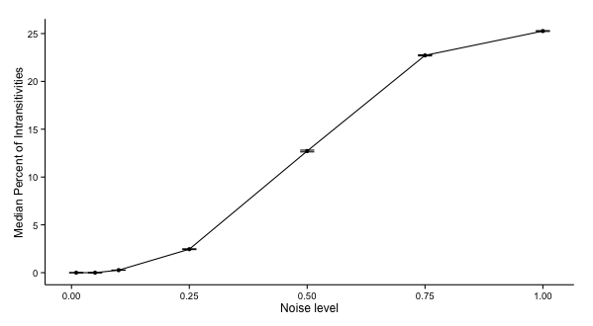

*Fig. S5: Median percentage of intransitivities at different noise levels, based on 1000 simulations. Error bars indicate standard errors of the simulation means.*

*Data cleaning*

Participants were instructed to indicate their preferences within 5 seconds by pressing “1” (for left) or “4” (for right) on the computer keyboard. There were trials where participants either failed to respond within the time limit or responded using another button. We call the first type of error “timeout trials” and the second “mispress trials.” Mispress trials were recoded as 1 if participants mistakenly pressed 2 repeatedly and as 4 if participants mistakenly pressed 3 or 5 repeatedly. 9 subjects (2 in the control group, 3 in the ETL group and 4 in the MTL group) indicated their preferences using the wrong buttons at least once. 57 subjects (16 in the control group, 16 in the ETL group and 25 in the MTL group) timed out of at least one trial. A single timeout trial, where preference cannot be determined with certainty, affects 19 triplets in the counting intransitivities. Percentage of intransitivities was therefore calculated as the ratio of non-affected intransitive triplets out of total non-affected triplets. 95.61 % of all triplets were immune to these problems (median: 98.25 %).