Forgot what you like? Evidence for a hippocampal role in value-based decisions
Abbreviated title: Hippocampal role in value-based decisions
A. Z. Enkavi*¹ B. Weber*^{2,3}, I. Zweyer^{2,3}, J. Wagner², C.E. Elger^{2,3}, ,E. U. Weber⁴, E. J. Johnson⁵
* Equally contributing first authors, listed in alphabetical order
¹ Department of Psychology, Stanford University, 450 Serra Mall, 420-01, Stanford, CA 94305
² Department of Epileptology, Sigmund-Freud-Str.25, University Hospital Bonn, 53127 Bonn, Germany
³ Center for Economics and Neuroscience, Nachtigallenweg 86, University of Bonn. 53127 Bonn, Germany
⁴ Corresponding author: ,
⁵ Center for Decision Science, Columbia University, Uris Hall, 3022 Broadway, New York, NY 10027-6902,

Number of pages: …
Number of figures, tables, multimedia and 3D models: … Figures, … Tables
Number of words: Abstract: …, Introduction: … , Discussion: …

Acknowledgements
BW is funded by a Heisenberg-Grant of the German Research Council (WE 4427/3-2) and EUW and EJJ by NIA Grant 5R01AG027934. The authors declare no competing financial interests.

Abstract
Consistent decisions are intuitively desirable and theoretically important for utility maximization. Neuroeconomics has established the neurobiological substrate of value representation, but the identity of the brain regions that provide inputs to the value-processing network is an open question. The constructed-preference tradition within behavioral decision research emphasizes a critical role for cognitive processes relying on associations, suggesting a role for the hippocampus in making consistent decisions. We compared the performance of 31 patients with mediotemporal lobe (MTL) epilepsy and hippocampal lesions, 30 patients with extratemporal lobe epilepsy, and 30 healthy controls on two tasks: binary choices between candy bars based on their preferences and a number-comparison control task where the larger number is chosen. MTL patients make more inconsistent choices than the other two groups for the value-based choice but not the number-comparison task, and their inconsistencies increase with their volume of compromised hippocampal tissue. These results suggest a critical involvement of the MTL in preference construction and value-based choices.
Significance
Our days are full of choices based on our underlying preferences. While economics lays out models on how to optimally make these decisions, neuroeconomics has identified a value-processing network in which activity correlates with constructs in economic models. How these signals are formed and what regions might be necessary for computations involving value maximization, however, remains an open question. Inspired by cognitive models calling on associative processes in value-based decisions this paper establishes the necessity of the MTL in making consistent choices indicating preferences and further informs our understanding of the value-processing network.
Keywords
Value representation, intransitive preferences, neuroeconomics, hippocampus
Introduction
Recently decision neuroscience made significant progress in identifying neurobiological correlates of value representations using paradigms involving simple choices between two stimuli based on underlying preferences (Hare, Camerer, & Rangel, 2009; Plassmann, O’Doherty, & Rangel, 2007). A value network involving a fronto-striatal circuit including the ventral striatum (VS) and the ventromedial prefrontal cortex (vmPFC), as well as posterior cingulate cortex (PCC) has been proposed (Bartra, McGuire, & Kable, 2013; Haber & Knutson, 2010). An unsolved question is where the value signals processed by this network come from, particularly for complex stimuli.
One influential conceptualization of preference construction proposes multiple steps including retrieval of relevant experiences with stimuli in the choice set, comparison of relevant attributes to reach a decision value, imagining future consequences of potential choices among others, that can be categorized as memory related processes (retrospective or prospective) (Rangel, Camerer, & Montague, 2008)
A long line of work in cognitive neuroscience implicates the medial temporal lobe (MTL) in relation to these memory processes (Squire, Stark, & Clark, 2004). The involvement and interaction of the MTL with the value network, has only recently attracted attention. Several studies provide evidence for the involvement of the hippocampus in value-related decisions. Wimmer and Shohamy (2012) show MTL involvement in the value transfer of rewarded stimuli by associative learning that biases later decisions on non-rewarded stimuli. Barron, Dolan, and Behrens (2013) show activity in the hippocampus, in addition to medial prefrontal cortex, when subjects were asked to indicate preferences for novel food items based on familiar, but previously uncombined tastes. Gluth et al. (2015) show that choices are limited by memory constraints, which is associated with functional connectivity between the hippocampus and vmPFC (Gluth, Sommer, Rieskamp, & Büchel, 2015). Work motivated by the hippocampus’ involvement in imagining future experiences (Hassabis, Kumaran, Vann, & Maguire, 2007; Schacter, Addis, & Buckner, 2007) investigated its role in value-related decisions across time: When participants were asked to imagine future events, stronger activity in a set of brain regions including the hippocampus was associated with more patient choices (Peters & Büchel, 2010).
Though these studies suggest the involvement of the hippocampus and memory processes in value-related decision-making, they do not provide conclusive evidence for their necessity. Such evidence requires comparing value-related decision-making abilities in the absence or impairment of relevant brain regions. Such differences would substantiate psychological models of decision-making involving memory processes and extend our understanding of the value network in the brain by providing clues to the origins of value signals for complex options. The necessity of ventromedial frontal regions, now considered crucial in the value network, in representing value was indeed established in this way: Patients with damage in these areas performed poorly in value-related decisions compared both to healthy controls, as well as patients with lesions elsewhere in the frontal cortex (Camille, Griffiths, Vo, Fellows, & Kable, 2011; Fellows & Farah, 2007).
Given these findings, we ask whether patients with hippocampal sclerosis are impaired in making consistent value-based decisions. We test this with a series of binary choices among commonly consumed, familiar food products. Our measure of choice quality is transitivity, the degree to which preferences are internally consistent. If a person chooses A over B, and B over C, transitivity requires they pick A over C (Samuelson, 1938). Decision neuroscience has used this metric to quantify choice quality (Camille et al., 2011; Fellows & Farah, 2007; Fellows, 2006a; Kalenscher, Tobler, Huijbers, Daselaar, & Pennartz, 2010). We included, as a control, a pairwise judgment task, presenting respondents with pairs of numbers and asking them to judge which of the two is bigger. This is similar to the protocols used to establish the necessary role of the vmPFC in value-related decisions (Fellows & Farah, 2007). Thus, selective differences in patients with MTL damage in value-based choices compared to numerical decisions should provide strong evidence for the involvement of the hippocampus, and thereby mnemonic processes in value-based decision-making.

Methods
A total of 91 respondents participated (see Supplementary Materials for a power analysis in determining the sample size). Thirty-one patients suffering from mesial temporal lobe epilepsy with clinically diagnosed uni-lateral (left:n=14;right:n=8) or bilateral (n=9) hippocampal sclerosis from the presurgical program at the Department of Epileptology in Bonn were included in the study (MTL). Different from patients with lesions in the vmPFC (Fellows & Farrah, 2007), the lesion locations in MTL patients are very similar. This makes lesion volume a better individual difference marker, as described below. Two control groups consisted of thirty patients with extratemporal lobe epilepsy (ETL) and thirty healthy control subjects (CON), respectively. The three groups did not differ with respect to age or gender (see Table S1 for details).
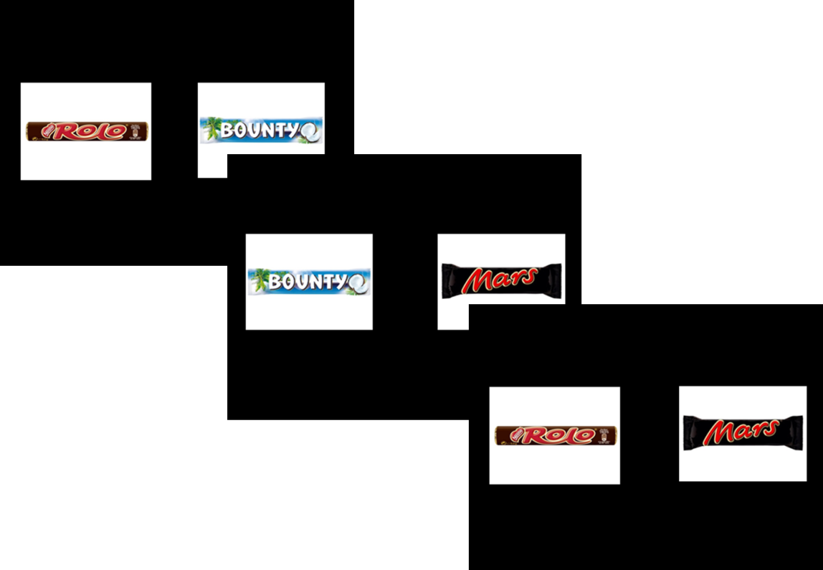
Fig. 1. Three trials of the binary choice experiment. Subject indicated their preferred candy bar on each trial. Stimulus presentation and choice was self-paced, with a maximum length of 5 seconds.

Each respondent made a series of choices between pairs of 20 candy bars, presented pictorially on a computer as in Figure 1. Each pairwise combination was presented once, resulting in (20x19)/2 = 190 choices for each participant, with a different random order for each participant. In a control task, subjects were presented with pairs of numbers, drawn from the range of one to twenty, and had to judge which number was larger. We computed judgment inconsistency across triplets of comparison identically for the two tasks. Subjects knew that they would receive their candy bar of choice from one randomly selected choice trial, in addition to a participation fee of 10 €.
A triplet was marked as indicating intransitivity if (i) A was chosen over B and B was chosen over C, yet C was chosen over A or (ii) if B was chosen over A and C was chosen over B, yet A was chosen over C.

Results
As shown in Figure 2, MTL patients showed a greater percentage of intransitive choices compared to the two control groups in the preference task compared to the control task (mean percentages for the preference task: MTL: 6.07%; ETL: 3.37%; CON: 2.75%; median percentages: MTL: 4.56%; ETL 2.72%; CON: 2.94%; mean percentages for the control task: MTL: 0.50 %; ETL: 1.00%; CON: 0.14%, median percentages: MTL: 0.36%; ETL: 0.00%; CON: 0.04% ; linear mixed model with orthogonal contrasts group task interaction b = – 0.06, t(91) = –2.98, p = 0.004). The difference between degree of intransitivity between the preference and control task did not differ significantly between the two control groups (linear mixed model with orthogonal contrasts group task interaction b = – 0.04, t(91) = 0.97, p = 0.333).
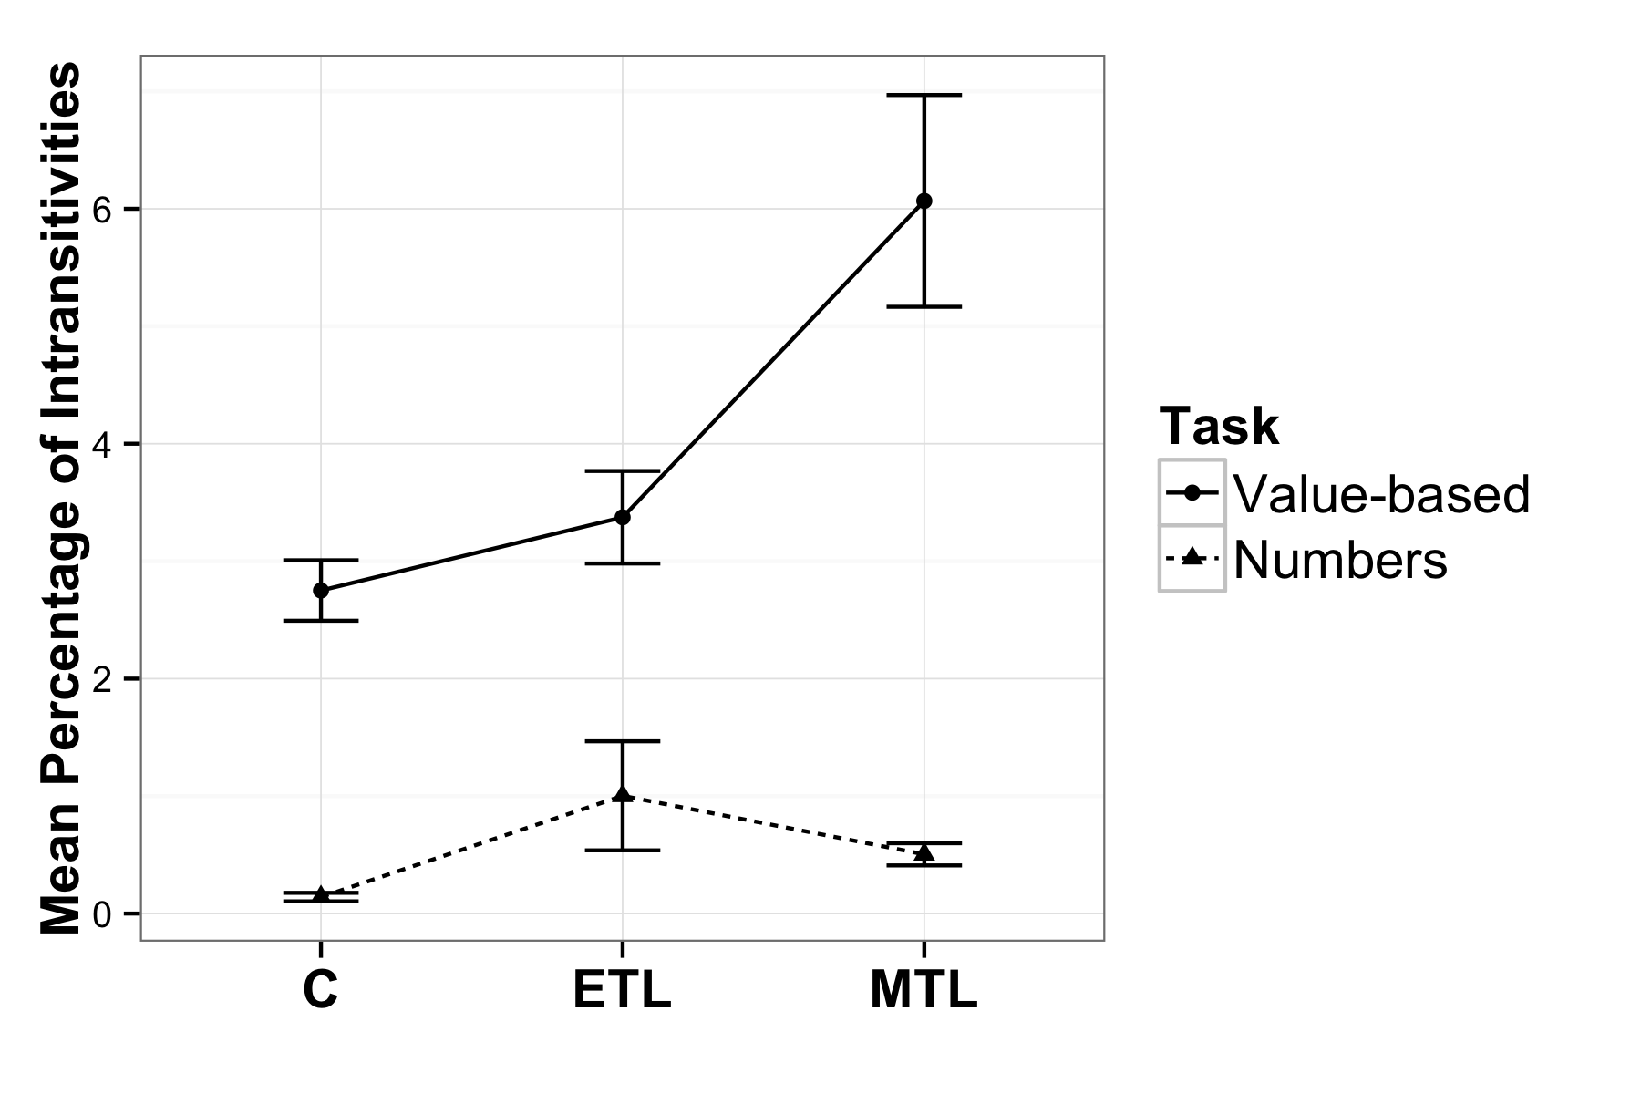
Fig. 2. Mean percentage of intransitive choices per group in each task (n_{MTL} = 31, n_{C} = 30, n_{ETL} = 30). Error bars represent SEM.

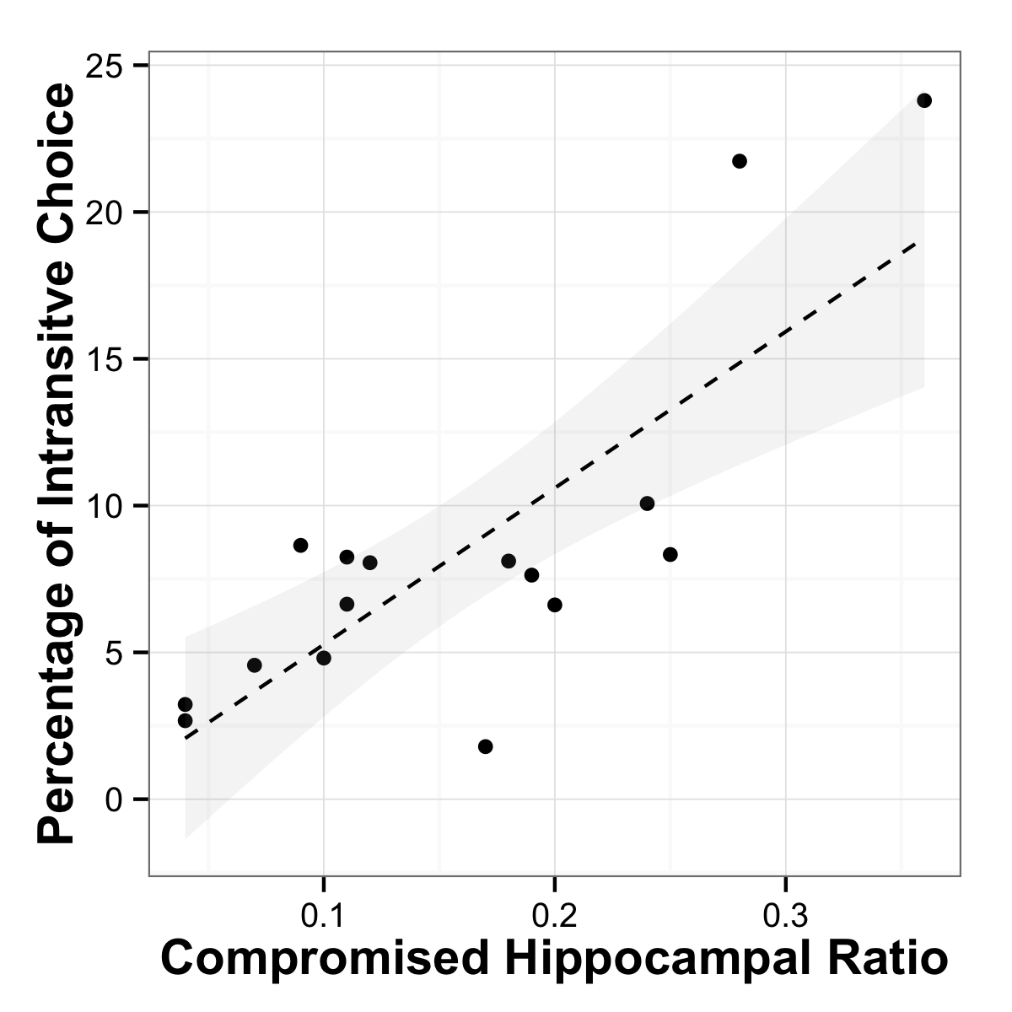
Fig. 3. Relationship between hippocampal lesion volume and intransitive choices. Scatterplot of compromised hippocampal volume (as a ratio of total volume) against percentage of intransitive choices, with a regression line with 95% CI for a linear regression. The observed robust nonparametric rank order correlation rho=0.676, p=0.004.

Since an MRI was not available for all subjects, we performed the following analysis in a subset of participants (see SOM for details). We determined the ratio of compromised hippocampal volume to total volume and correlated this individual difference variable with the percentage of intransitive choices observed for these participants, using a non-parametric correlation coefficient that is insensitive to outliers because it it calculated using rank order. We found a strong and significant relationship between these two variables, as shown in Figure 3 (Spearman-rho = 0.676; F(1, 14) = 11.78, p=0.004; n=16), such that the larger the lesion volume, the less consistent were the value-based choices.
To provide context for interpreting the observed frequencies of intransitivity, we conducted a series of simulations that use a random utility model with a stochastic term added to the utility of the options, such that the probability of choosing option A (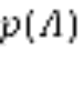) in a decision between A and B is:
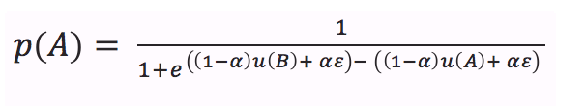Equation 1
where 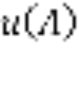 and 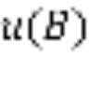 represent the utilities of option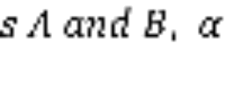 represents the proportion (between 0 and 1) of the observed utility due to random error, and is the random error. It can be shown analytically that the maximum proportion of intransitive triples is .25 (see SOM Figure S5, also noted in the discussion section of Tversky, 1969). The question of interest to us, given our hypothesis that the degree of MTL patients’ hippocampal sclerosis increases , the proportion of random error in option value construction, is how the proportion of intransitive triples increases as error in utilities increases. The effect is non-linear (see SOM Figure S6), and the observed intransitivities in the MTL group correspond to an of .3, i.e., the level expected if random error represented approximately 30 percent of the utility values in Equation 1.
Several explanations alternative to our account of random error in value construction can be tested with our data. One possible alternative explanation involves explicit episodic memory of previous value comparisons, rather than value construction for the two options of each pairwise choice. Under this account, non-MTL respondents may have better memory for their choices made earlier in the task, and this better episodic memory prevents intransitive choices. This account would suggest that the rate of intransitivities declines over time, as previous choices are remembered and used to avoid intransitive later choices, and this decline in intransitivities over choice trials would differ for the MTL and non-MTL groups. We tested this hypothesis and saw neither a significant decrease in intransitivities over choice trials (linear trend b = 7.155 × 10⁻³, t(17200) = 0.297, p = 0.766, quadratic trend b = 7.727 × 10⁻³, t(17200) = 0.458, p = 0.647), nor any difference in slopes for MTL vs. non-MTL groups (linear trend MTL group interaction b = - 0.003, t(88) = -0.955, p = 0.339).
Another alternative explanation involves group differences in speed-accuracy tradeoff. To test this, we examined response latencies of the choices, and the relationship between responses latencies and intransitivities for MTL and non-MTL groups. Contrary to a speed-accuracy tradeoff, we found that slower (rather than faster) trials were more likely to be involved in intransitive triplets (b = 0.241, t(17240) = 21.192, p < 0.001) for all groups, and that this did not differ for the MTL group (i.e., no interaction with this group: b = -.0009, t(17240) = -1.276, p = .202). Moreover, the MTL group actually had a significantly slower average response time per trial (b = 0.301, t(88) = 2.11, p = 0.038). Together, these results suggest that intransitive triplets accompany more effortful and longer responding, eliminating the possibility of a speed-accuracy tradeoff.
Lastly, we examined whether there were any idiosyncratic effects on preference intransitivity associated with specific stimuli (candy bars). We found no significant differences in the average number of intransitive triplets each bar was involved in (Figure S2 in SOM, F(1, 18) = 0.003, p = 0.959). To further quantify the value of each candy bar we fit the Bradley-Terry-Luce (BTL) model (Firth & Turner, 2012) to aggregate paired comparison data of each group. This confirmed poorer fits for the MTL group (AIC = 851.39) compared to the control (AIC = 840.42) and ETL group (AIC = 818.55).
In combination, these analyses suggest that the observed increase in transitivity violations for respondents with MTL lesions in the preference task but not number-comparison task, in a way that is related to the volume of hippocampal lesions, suggests a failure in associative abilities in this group.

Discussion
We provide support for a critical role of brain regions associated with memory-related processes in value-based decision-making, by showing that hippocampal lesions are associated with an increase in intransitive value-based choices and that the degree of intransitivity is related to magnitude of the damage to the hippocampus. A control task not involving value-based choice does not show these effects, nor do respondents who have lesions outside of the medial temporal lobe. These dissociation results implicate a crucial role for the hippocampal areas in preference construction (Lichtenstein & Slovic, 2006), a conceptualization in behavioral decision research in contrast to standard theories of rational choice that implicitly assume stable utility functions and choice options with preexisting values.
Two conceptual clarifications are in order. Our central dependent measure, the frequency of intransitive preferences has been used before to examine the inability of decision makers to produce a stable representation of the value of choice options, with other patient groups (Camille et al., 2011; Fellows & Farah, 2007). Earlier work, however, using choice intransitivity as a dependent measure did so to identify choice heuristics incompatible with utility maximization (Tversky, 1969). This resulted in a debate on the correct probabilistic model of transitivity that would account for errors in experimental data and whether that was evidence for a particular mechanism (Birnbaum & Gutierrez, 2007; Regenwetter, Dana, Davis-Stober, & Guo, 2011; Regenwetter & Davis-Stober, 2008). Our use of the term pairwise “transitivity” is not based on these frameworks and our design with two alternatives per choice not suited for such model comparison. We use intransitivity counts, instead, to examine error associated with the construction of value representations.
Second, our use of the term “transitivity” is only marginally related to the extensive literature measuring transitive inference, where a set of premises are learned in the experiment and participants are asked to generalize these learned rules to novel contexts and combinations of stimuli. Transitive inference tasks have been instrumental in establishing the role of the hippocampus in representing organizations of stimulus relations (Eichenbaum & Cohen, 2001). Animal lesion studies established the necessity of the hippocampus for transitive inference (Bunsey & Eichenbaum, 1996; Dusek & Eichenbaum, 1997), and data from humans has confirmed the involvement of this region (Heckers, Zalesak, Weiss, Ditman, & Titone, 2004; Nagode & Pardo, 2002). However transitive inference paradigms differ from ours critically because the bases of the judgments in our design are preferences, not learned premises. We do not present participants with transitive relations and ask them to reason following this rule. We ask for their preference between two candy bars. We do not hypothesize that if a participant chooses Snickers over Mars and Mars over Bounty they would also choose Snickers over Bounty because they are instructed that these choices must follow a given transitive relationship. Instead, their transitive choice reflects an anticipation that they will enjoy Snickers more. That is, while a transitive inference task implies a strict ordinal relationship between stimuli thereby recruiting working memory, transitivity of choice as measured by our design relies on values learned over time and presumably relies on the recruitment of associative facilities (Halford, 2005).
Despite the evidence for the involvement of the hippocampus in consistent value-based decisions, the delineation of specific cognitive and neural mechanisms provide multiple avenues for future research.
First, the hippocampus is just one part in a larger network of relevant brain areas involved in the retrieval and processing of choice values. A recent review (Shohamy & Turk-Browne, 2013) suggests hippocampal involvement in a variety of cognitive functions outside of the domain of declarative memory providing two different hypotheses of hippocampal function: The memory modulation hypothesis proposes that representations within the hippocampus may transiently bias other cognitive functions e.g. value computations in our task. The adaptive function hypothesis, in contrast, highlights the hippocampus as a central processing unit with specific computations carried out in the hippocampal networks, depending on the task at hand.
Our hippocampal patients produce patterns of intransitivity of value-based choice that are similar to those observed in ventromedial prefrontal cortex (vmPFC) patients, suggesting that the associations and memories stored in the hippocampus may serve as inputs to value calculation occurring elsewhere (Barron et al., 2013), potentially in line with the memory modulation hypothesis. The hippocampus is one of the most highly interconnected brain areas (Cole, Pathak, & Schneider, 2010; Godsil, Kiss, Spedding, & Jay, 2013). In addition to being directly and monosynaptically connected to the prefrontal cortex, animal work suggests a topographically specific hippocampal projections map on functionally distinct prefrontal regions (Cole et al., 2010; Godsil et al., 2013).
This possibility calls for a nuanced investigation of the interactions between hippocampal and prefrontal regions in value-based decision-making. For example, Ranganath and Ritchey (2012) propose a division of the MTL into two systems for memory-guided behavior: the anterior (AT) and posterior-medial (PM) system. The AT, which is comprised of the perirhinal cortex and anterior parts of the hippocampus and amygdala has strong interconnections with the frontal cortex, has been argued to be involved in familiarity-based cognition, social behavior and saliency. This is also the part of the hippocampus which is most affected in patients with hippocampal sclerosis (Woermann, Barker, Birnie, Meencke, & Duncan, 1998). Ranganath & Ritchey (2012) suggest that the AT system could facilitate the use of past experiences to inform inferences about the personality and intentions of others. Our results suggest such inferential abilities specific to distinct regions in the MTL along with the connection to the ventromedial prefrontal cortex may play a role in value-based decisions.
On the other hand, in line with an adaptive function hypothesis, deficits in consistent choices might be due to hippocampus-specific computations. For example, Fellows, (2006b) showed that vmPFC lesioned patients differ from normal controls in their external information search, in ways that could be attributed to diminished planning capacity. Perhaps this planning capacity relies on hippocampus-specific computations. An interesting topic of research would be whether vmPFC patients exhibit deficits in different mnemonic processes.
A second future research topic are potential compensation mechanisms in patients with chronic hippocampal lesions. It is well-known that chronic brain lesions may lead to compensatory shifts in neural processes, e.g. in the domain of language processing (B. Weber et al., 2006). The application of neuroimaging methods during a value-based decision task in these patients could provide answers to this question.
Third, although patients with temporal lobe epilepsy and hippocampal sclerosis do show neuropsychological deficits especially in the domain of declarative memory, the amount to which these deficits occur varies strongly between patients (Hoppe, Elger, & Helmstaedter, 2007). Future research combining in-depth neuropsychological testing together with value-based choice tasks may shed light on the specific cognitive components underlying the observed range of decision deficits.
Our results suggest a critical role for the hippocampus in the construction of the value of choice options. Most decisions require the construction of value based on past experience. Even a previously experienced option, like a favorite dish in a familiar restaurant, requires us to compare recollections of the value of that option to newly available options such as tonight’s specials. A better understanding of both internal and external inputs to preference construction processes and their aggregation and comparison will allow us to comprehend and model how the brain calculates value and makes consistent choices.

Author contribution statements
BW, EJJ and EUW designed the experiment and wrote the manuscript, EJJ and AZE analyzed the behavioral data and wrote the manuscript, IZ performed experiments, JW analyzed the MRI data. CEE provided clinical data of the patients. All authors approved the final version of the manuscript for submission.

References
Barron, H. C., Dolan, R. J., & Behrens, T. E. J. (2013). Online evaluation of novel choices by simultaneous representation of multiple memories. Nature Neuroscience, 16(10), 1492–8. doi:10.1038/nn.3515
Bartra, O., McGuire, J. T., & Kable, J. W. (2013). The valuation system: A coordinate-based meta-analysis of BOLD fMRI experiments examining neural correlates of subjective value. NeuroImage, 76, 412–427. doi:10.1016/j.neuroimage.2013.02.063
Birnbaum, M. H., & Gutierrez, R. J. (2007). Testing for intransitivity of preferences predicted by a lexicographic semi-order. Organizational Behavior and Human Decision Processes, 104(1), 96–112. doi:10.1016/j.obhdp.2007.02.001
Bunsey, M., & Eichenbaum, H. (1996). Conservation of hippocampal memory function in rats and humans. Nature.
Camille, N., Griffiths, C. a, Vo, K., Fellows, L. K., & Kable, J. W. (2011). Ventromedial frontal lobe damage disrupts value maximization in humans. The Journal of Neuroscience : The Official Journal of the Society for Neuroscience, 31(20), 7527–32. doi:10.1523/JNEUROSCI.6527-10.2011
Cole, M. W., Pathak, S., & Schneider, W. (2010). Identifying the brain’s most globally connected regions. NeuroImage, 49(4), 3132–48. doi:10.1016/j.neuroimage.2009.11.001
Dougherty, M. R. P., Gettys, C. F., & Ogden, E. E. (1999). MINERVA-DM : A Memory Processes Model for Judgments of Likelihood. Psychological Review, 106(1), 180–209.
Dusek, J. A., & Eichenbaum, H. (1997). The hippocampus and memory for orderly stimulus relations. Proceedings of the National Academy of Sciences of the United States of America, 94(13), 7109–7114. doi:10.1073/pnas.94.13.7109
Eichenbaum, H., & Cohen, N. J. (2001). From Conditioning to Conscious Recollection: Memory Systems of the Brain. Group (Vol. 4). doi:10.1093/acprof:oso/9780195178043.001.0001
Fellows, L. K. (2006a). Deciding how to decide: ventromedial frontal lobe damage affects information acquisition in multi-attribute decision making. Brain : A Journal of Neurology, 129(Pt 4), 944–52. doi:10.1093/brain/awl017
Fellows, L. K. (2006b). Deciding how to decide: ventromedial frontal lobe damage affects information acquisition in multi-attribute decision making. Brain : A Journal of Neurology, 129(Pt 4), 944–52. doi:10.1093/brain/awl017
Fellows, L. K., & Farah, M. J. (2007). The role of ventromedial prefrontal cortex in decision making: judgment under uncertainty or judgment per se? Cerebral Cortex (New York, N.Y. : 1991), 17(11), 2669–74. doi:10.1093/cercor/bhl176
Firth, D., & Turner, H. L. (2012). Bradley-Terry models in R : the BradleyTerry2 package. Development, (2002), 1–10. Retrieved from http://www.jstatsoft.org/search
Gluth, S., Sommer, T., Rieskamp, J., & Büchel, C. (2015). Effective Connectivity between Hippocampus and Ventromedial Prefrontal Cortex Controls Preferential Choices from Memory. Neuron, 86(4), 1078–1090. doi:10.1016/j.neuron.2015.04.023
Godsil, B. P., Kiss, J. P., Spedding, M., & Jay, T. M. (2013). The hippocampal-prefrontal pathway: the weak link in psychiatric disorders? European Neuropsychopharmacology : The Journal of the European College of Neuropsychopharmacology, 23(10), 1165–81. doi:10.1016/j.euroneuro.2012.10.018
Haber, S. N., & Knutson, B. (2010). The reward circuit: linking primate anatomy and human imaging. Neuropsychopharmacology : Official Publication of the American College of Neuropsychopharmacology, 35(1), 4–26. doi:10.1038/npp.2009.129
Halford, G. S. (2005). Development of thinking. In K. J. Holyoak & R. G. Morrison (Eds.), The Cambridge Handbook of Thinking and Reasoning (pp. 529–558). New York: Cambridge University Press.
Hare, T. a, Camerer, C. F., & Rangel, A. (2009). Self-Control in Decision-Making Involves Modulation of the vmPFC Valuation System. Science, 324(May), 646–648.
Hassabis, D., Kumaran, D., Vann, S. D., & Maguire, E. a. (2007). Patients with hippocampal amnesia cannot imagine new experiences. Proceedings of the National Academy of Sciences of the United States of America, 104(5), 1726–31. doi:10.1073/pnas.0610561104
Heckers, S., Zalesak, M., Weiss, A. P., Ditman, T., & Titone, D. (2004). Hippocampal activation during transitive inference in humans. Hippocampus, 14(2), 153–62. doi:10.1002/hipo.10189
Hoppe, C., Elger, C. E., & Helmstaedter, C. (2007). Long-term memory impairment in patients with focal epilepsy. Epilepsia, 48 Suppl 9, 26–9. doi:10.1111/j.1528-1167.2007.01397.x
Kalenscher, T., Tobler, P. N., Huijbers, W., Daselaar, S. M., & Pennartz, C. M. a. (2010). Neural signatures of intransitive preferences. Frontiers in Human Neuroscience, 4(June), 1–14. doi:10.3389/fnhum.2010.00049
Lee, L., Amir, O., & Ariely, D. (2009). In Search of Homo Economicus: Cognitive Noise and the Role of Emotion in Preference Consistency. Journal of Consumer Research, 36(2), 173–187. doi:10.1086/597160
Lichtenstein, S., & Slovic, P. (Eds.). (2006). The Construction of Preference. New York: Cambridge University Press.
Nagode, J. C., & Pardo, J. V. (2002). Human hippocampal activation during transitive inference. Neuroreport, 13(7), 939–44.
Peters, J., & Büchel, C. (2010). Episodic future thinking reduces reward delay discounting through an enhancement of prefrontal-mediotemporal interactions. Neuron, 66(1), 138–48. doi:10.1016/j.neuron.2010.03.026
Plassmann, H., O’Doherty, J., & Rangel, A. (2007). Orbitofrontal cortex encodes willingness to pay in everyday economic transactions. The Journal of Neuroscience : The Official Journal of the Society for Neuroscience, 27(37), 9984–9988. doi:10.1523/JNEUROSCI.2131-07.2007
Ranganath, C., & Ritchey, M. (2012). Two cortical systems for memory-guided behaviour. Nature Reviews. Neuroscience, 13(10), 713–26. doi:10.1038/nrn3338
Rangel, A., Camerer, C., & Montague, P. R. (2008). A framework for studying the neurobiology of value-based decision making. Nature Reviews Neuroscience, 9(7), 545–556. doi:10.1038/nrn2357
Regenwetter, M., Dana, J., Davis-Stober, C. P., & Guo, Y. (2011). Parsimonious testing of transitive or intransitive preferences: Reply to Birnbaum (2011). Psychological Review, 118(4), 684–688. doi:10.1037/a0025291
Regenwetter, M., & Davis-Stober, C. P. (2008). There are many models of transitive preference: a tutorial review and current perspective. Decision Modeling and Behavior in Complex and Uncertain Environments, 21, 99–124.
Samuelson, P. A. (1938). A Note on the Pure Theory of Behaviour Consumer ’s Behavior. Economica, 5(17), 61–71.
Schacter, D. L., Addis, D. R., & Buckner, R. L. (2007). Remembering the past to imagine the future: the prospective brain. Nature Reviews. Neuroscience, 8(9), 657–661. doi:10.1080/08995600802554748
Shohamy, D., & Turk-Browne, N. B. (2013). Mechanisms for widespread hippocampal involvement in cognition. Journal of Experimental Psychology. General, 142(4), 1159–70. doi:10.1037/a0034461
Squire, L. R., Stark, C. E. L., & Clark, R. E. (2004). The medial temporal lobe. Annual Review of Neuroscience, 27, 279–306. doi:10.1146/annurev.neuro.27.070203.144130
Tversky, A. (1969). Intransitivity of preferences. Psychological Review, 76(1), 31–48. doi:10.1037/h0026750
Weber, B., Wellmer, J., Reuber, M., Mormann, F., Weis, S., Urbach, H., … Fernández, G. (2006). Left hippocampal pathology is associated with atypical language lateralization in patients with focal epilepsy. Brain : A Journal of Neurology, 129(Pt 2), 346–51. doi:10.1093/brain/awh694
Weber, E. U., & Johnson, E. J. (2009). Mindful judgment and decision making. Annual Review of Psychology, 60, 53–85. doi:10.1146/annurev.psych.60.110707.163633
Wimmer, G. E., & Shohamy, D. (2012). Preference by association: how memory mechanisms in the hippocampus bias decisions. Science (New York, N.Y.), 338(6104), 270–3. doi:10.1126/science.1223252
Woermann, F. G., Barker, G. J., Birnie, K. D., Meencke, H. J., & Duncan, J. S. (1998). Regional changes in hippocampal T2 relaxation and volume: a quantitative magnetic resonance imaging study of hippocampal sclerosis. Journal of Neurology, Neurosurgery & Psychiatry, 65(5), 656–664. doi:10.1136/jnnp.65.5.656

