SUPPLEMENTAL ONLINE MATERIALS

Forgot what you like?
Evidence for a hippocampal role in value-based decisions

A. Z. Enkavi*¹ B. Weber*^{2,3}, I. Zweyer^{2,3}, J. Wagner², C.E. Elger^{2,3}, ,E. U. Weber^{4,5}, E. J. Johnson⁴

* Equally contributing first authors, listed in alphabetical order
¹ Department of Psychology, Stanford University, 450 Serra Mall, 420-01, Stanford, CA 94305
² Department of Epileptology, Sigmund-Freud-Str.25, University Hospital Bonn, 53127 Bonn, Germany
³ Center for Economics and Neuroscience, Nachtigallenweg 86, University of Bonn. 53127 Bonn, Germany
⁴ Center for Decision Science, Columbia University, Uris Hall, 3022 Broadway, New York, NY 10027-6902, ,
⁵ Corresponding author: 716 Uris Hall, Columbia University, 3022 Broadway, New York, NY 10027-6902, euw2@columbia.edu

METHODS AND MATERIALS
Table S1. Demographic and clinical characteristics of the included subjects
 | Age | Gender (m/f) | Handedness (left/right/ambi) | First seizure (age yrs.) | Seizure frequency (n/month)
MTL | 47.74 (2.56) | 16/15 | 6/24/1 | 18.73 (2.89) | 5 (8.1)
ETL | 43.10(2.60) | 16/14 | 2/26/2 | 20.17 (3.15) | 2 (7.6)
CON | 51.40(2.60) | 15/15 | 1/29/0 | --- | ---
 | n.sign. | n. sign. | n.sign. | n. sign. | n.sign.

The study was approved by the local ethics committee of the University of Bonn and the Institutional Review Board at Columbia University (IRB-AAAB1301) and all subjects gave their written informed consent.
Sample size was constrained by the availability of MTL patients with the appropriate lesion. However, to assess the probability of finding differences, we did an approximate power analysis with n=30, our estimate of sample accrual in a year, and a base proportion of intransitvities of .05, a large (and therefore conservative) estimate based on prior studies (Lee, Amir, & Ariely, 2009). This showed that the power of the comparison between groups, based on the individual proportions, with expected differences of .02 exceeded .9. This analysis is approximate and conservative because it (1) does not account for dependencies in preferences among stimuli, nor the bounded and non-normal distribution of the distribution of transitivities (see Simulations to interpret the observed number of intransitive choices).

MR sequence and analysis
For a random subgroup of the patients with unilateral hippocampal sclerosis (n=16), a 3D-T1 weighted high-resolution data set (MP-RAGE, voxel size 1x1x1mm, repetition time 1570ms, echo time 3.42ms, flip angle 15°, field of view 256mm x 256mm) was available for volumetric measurement of the hippocampus. This was done in a fully automated manner by means of the FreeSurfer image analysis suite (Version 5.1.0, Martinos Center, Harvard University, Boston, MA, U.S.A.) (Fischl et al., 2002, 2004). Because of the high variance in hippocampal volume between individuals, we used a lateral damage index of hippocampal volume to express the extent of unilateral hippocampal damage in our MTL group:
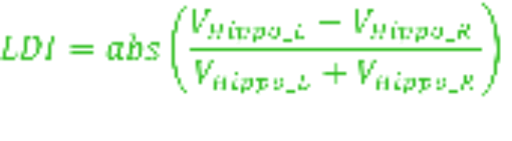

This lateral damage index can obviously be only assessed for subjects with unilateral hippocampal sclerosis.
Statistical analysis
Statistical analyses were performed using R (Version 3.2.2) for Mac. We use a two-tailed p-value of 0.05 as our criterion for statistical significance and mark significant differences in the figures and tables with asterisks: *p ≤ 0.05, **p ≤ 0.01, and ***p ≤ 0.001.
Tallying intransitivities
The binary choices made by each respondent were transformed into a matrix of choice-triplets, as the detection of intransitivity requires three choice pairs. Each matrix consisted of 1140 rows, representing all possible combinations of 3 choice pairs, out of the 190 paired comparisons of the 20 chocolate bars, that are relevant to determine transitivity.
The proportion of intransitive choices was obtained by dividing the number of intransitive triples by the total number of triples. This provided the central dependent measure. Analytically, it can be shown that the maximum level of intransitivities (those produced by a random responder) is 25% of all triplets. Below we report the results of simulations that demonstrate the non-linear relationship between number of intransitive choices and response error.
DATA ANALYSIS
SUPPLEMENTARY RESULTS
Response times
Subjects took on average 1488 milliseconds on each trial (SD = 720 ms) on the choice task and 849 milliseconds (SD = 335 ms) on the control task. There were significant group and task differences in reaction times. All groups were faster in the control task than in the preference task (β = -0.972, t(34225) = -70.30, p < 0.001) and they got faster as the task progressed, though this trend was much more prominent for the choice task (task – trial number interaction β = 0.186, t(34225) = 13.44, p < 0.001). The MTL group was consistently slower than the control groups in the choice task but this was not true for the control task where the control group was consistently faster than both lesion groups. These patterns in the reaction times indicate that the choice task was more difficult for the MTL group while the control task was much easier for all groups, especially the healthy controls.
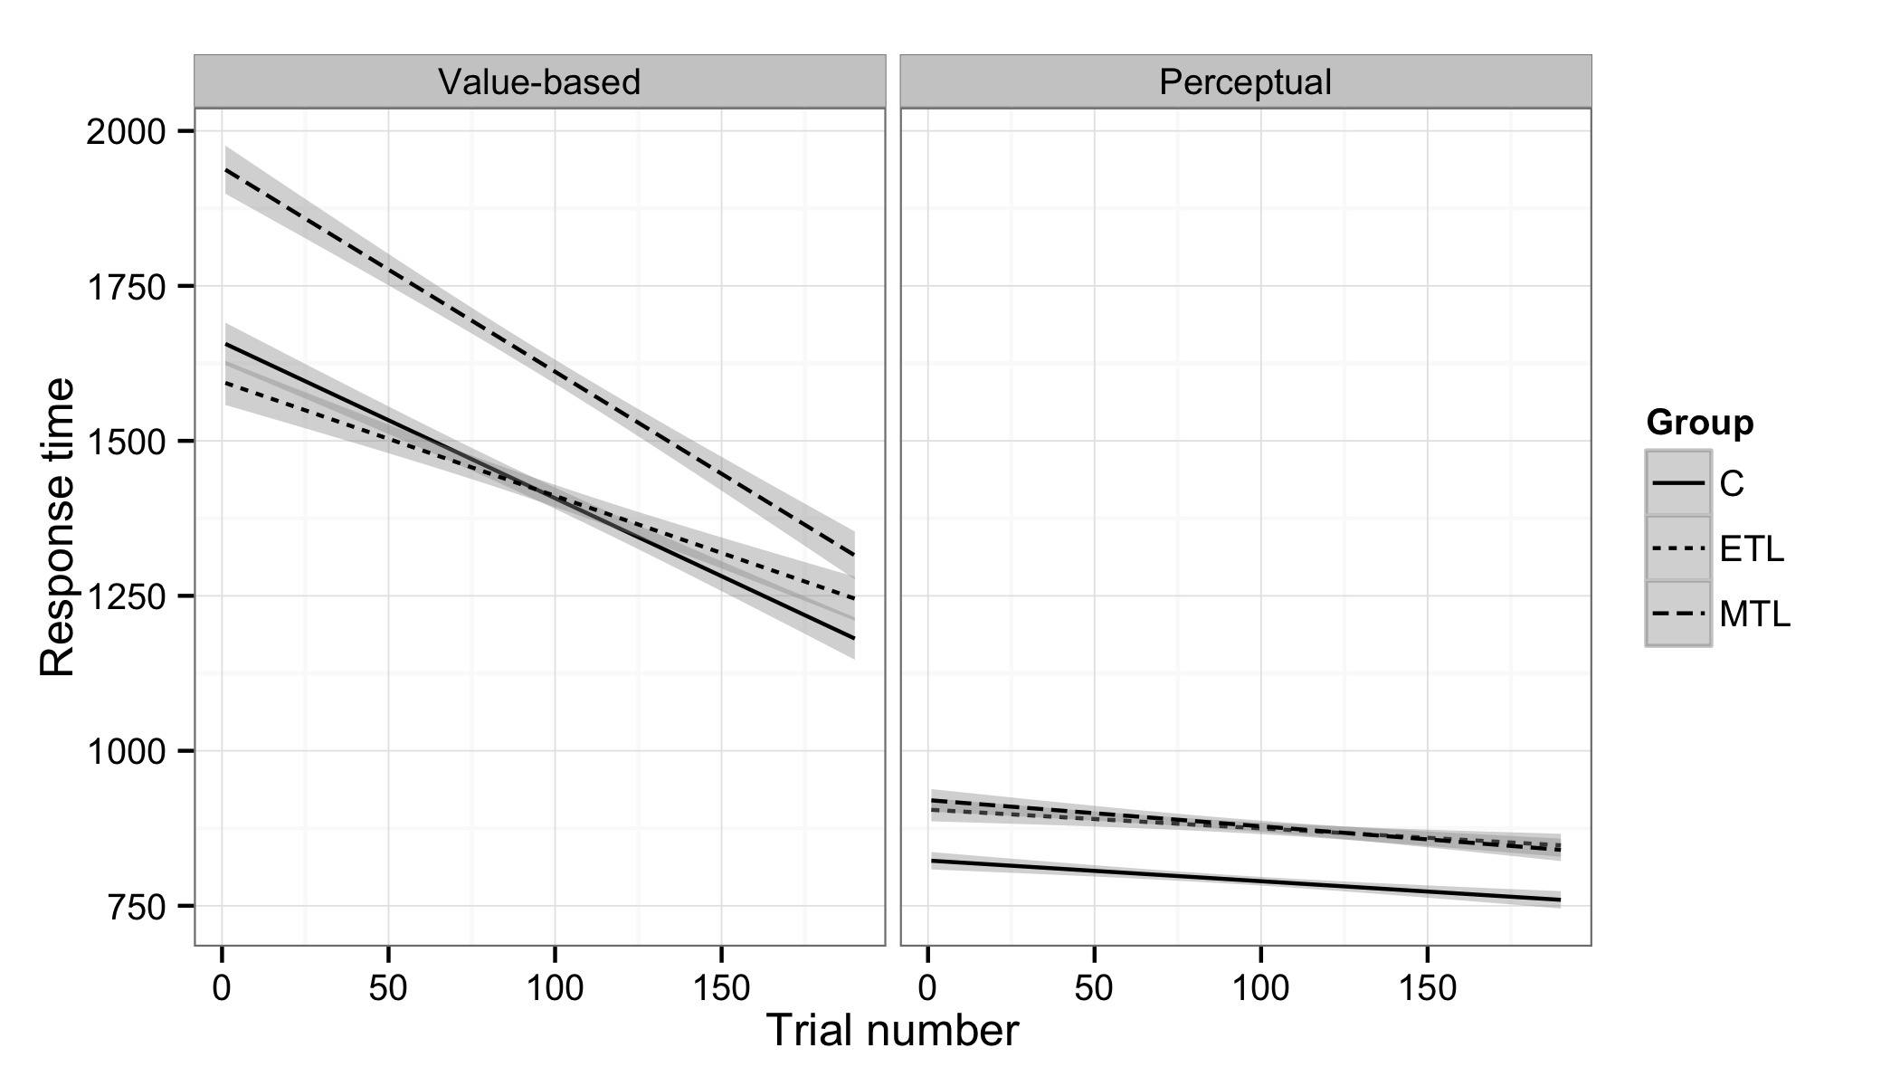
Figure S1: Response times (RT) for each task and group. RT’s decreased as the task progressed for all groups in both trials. The MTL group was consistently slower in the choice task. All groups were faster in the control task, particularly the healthy controls.

Intransitivities by groups
As the definition of intransitivity requires three pairs of trials, we created a matrix with 1140 rows representing the possible combinations of 3 pairwise choices for the 20 candy bars for each participant. These “triplets” were marked as intransitive if
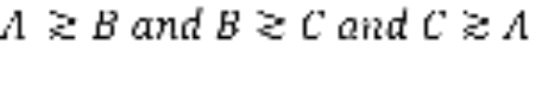
or
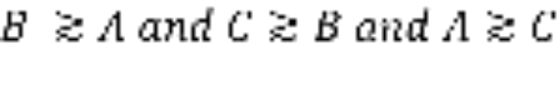
Triplet level counts were collapsed to trial (i.e. choice pairs that participants saw) and subject level by summing the number of intransitive triplets.
The number of times one trial was involved in an intransitivity ranged from 0 to 17 with a mean of 0.715 and standard deviation of 1.414 while the total number of intransitivities a subject committed ranged from 1 to 267 with a mean of 44.7 (median = 37, SD = 39.374).
To test if groups differed in their number of intransitive choices we used a linear mixed model with orthogonal contrasts for group and task type (choice or control). This was significantly better than a model without random intercept for subjects (χ²(7) = 4.39, p = 0.036). The percentage of intransitive choices was log transformed to ensure that the difference in variances was independent of task type (Bartlett’s Κ²(1) = 3.354, p = 0.067). Orthogonalization of contrasts allowed for direct comparison of the difference in intransitivity levels between the tasks for the MTL group compared to both control groups.

Preference for side of computer screen
We checked for whether an incidental factor, in particular the side of the screen on which a candy bars was displayed, affected choice. Overall the left side was chosen 50.2 % of the time. The control group picked the left option 51.21% of the time, the ETL group 50.7 % of the time and the MTL group 48.82 % of the time. A one-way ANOVA indicated that the groups differed from each other in how often they chose left (F(2, 17080) = 3.65, p < 0.026) with the MTL choosing left less often than the control (p = 0.033) but not the ETL groups (p = 0.122). We checked whether what side was chosen had an effect on how often a trial was involved in an intransitivity running a multi-level regression with fixed effects for groups, side of chosen bar and their interaction, as well as, random intercepts for each participant. Crucially the interaction term between the MTL group and the side of chosen bar was not significant (b = – 0.046, t(1700) = – 0.95, p = 0.340).
Values of candy bars and intransitivities
To make sure that differences in intransitivities were not driven by specific candy bars we checked on aggregate how often each bar was involved in an intransitive triplet. There were no significant differences between the bars as seen in Figure S2 below.
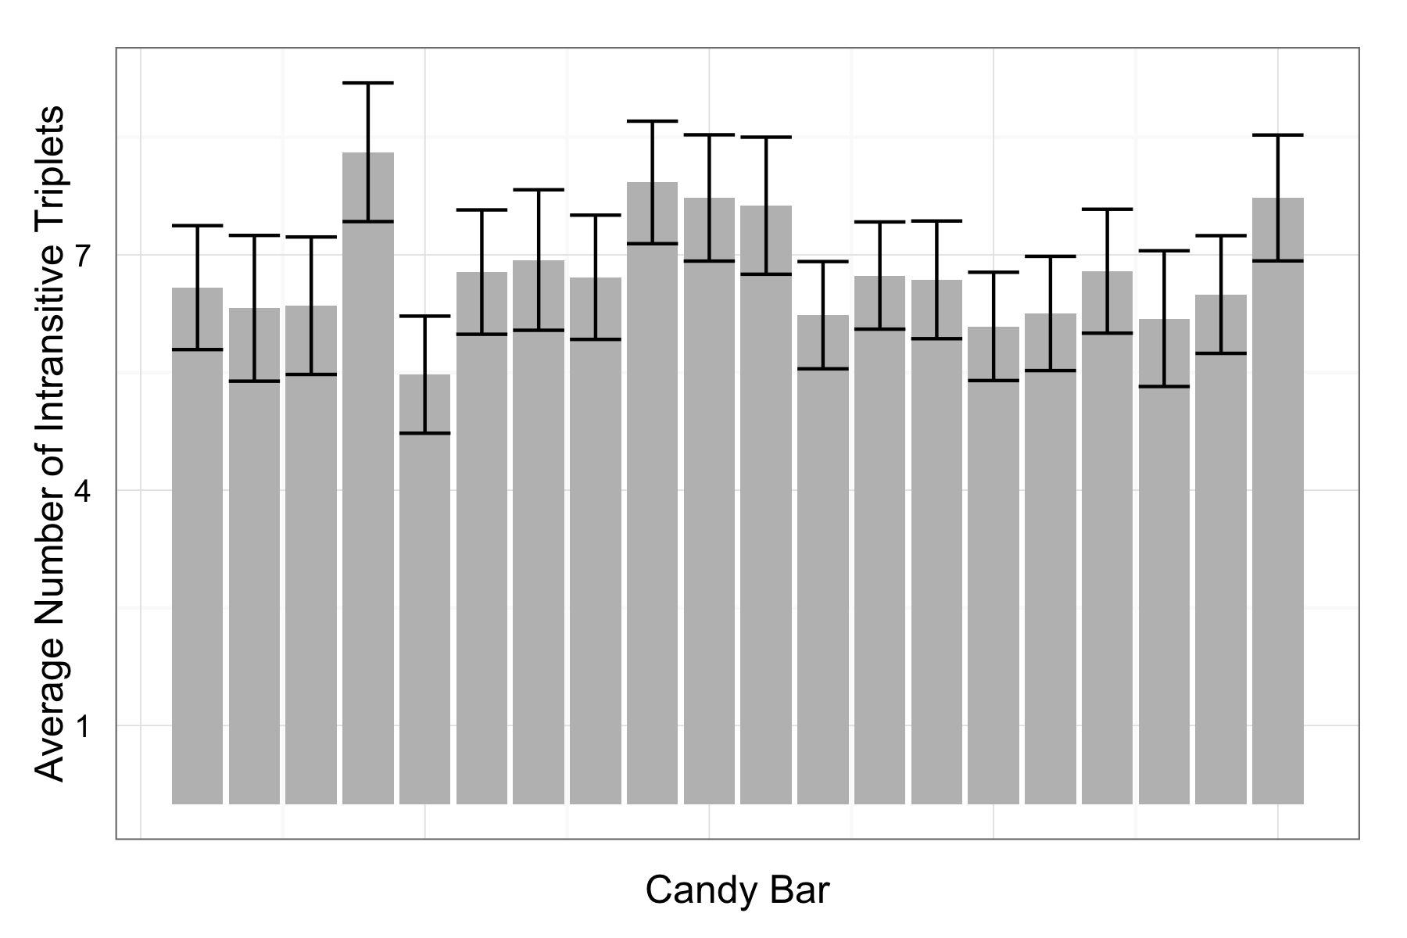
Figure S2. Average number of intransitive triplets each stimulus was involved in for the preference task. There were no idiosyncratic differences between the stimuli (F(1, 18) = 0.003, p = 0.959).

These aggregate level analyses mask, however, potential individual differences in preferences for the candy bars. To address this, we rank-ordered the candy bars depending on how often each bar was chosen out of the 19 potential times it could have been chosen. A candy bar that was chosen 16 times, for instance, would be assigned a rank-order value of 16. This also allowed us to ask whether decision difficulty might be processed differently between the groups. Decision difficulty was quantified as the difference between these rank-order values for the two candy bars in a given trial. As a result of higher intransitivity in the MTL group (and consistent with the group differences in the BTL model fits) the mean of the rank-order value differences was lower for the MTL group (b = -0.144, t(88) = -3.491, p<0.001). This can be explained by higher noise in value representations: Higher noise can lead to an underestimation of the value of most preferred candy bars and an overestimation of that of least preferred ones in pairwise counts of choices. Thus, in some sense all decisions are more difficult for the MTL group, consistent with their overall slower response times.
More interestingly, however, the three groups respond differently to decreasing difficulty. Expectedly, all groups were faster for easier trials in both tasks (numbers task: b = -0.19, t(1720) = -33.257, p <0.001, choice task: b = -0.24, t(1720) = -38.171, p < 0.001). Yet the MTL group was not only slower in general (b = 0.08, t(88) = 2.098, p = 0.039) but also slower to respond to decreasing difficulty in the choice task (b = 0.02, t(1720) = 4.461, p < 0.001). This pattern was not observed in the control task of number comparisons (b = -0.003, t(1720) = -0.865, p = 0.387). Although we cannot rule out alternative explanations for this response time pattern in the choice task due to other potential limitations posed by MTL lesions due to lack of additional neuropsychological data it still corroborates the necessary role for the MTL in stable value representations.
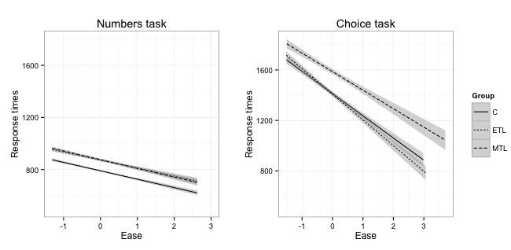
Figure S3. Response times as a function of decision difficulty. As decisions become easier in both tasks all groups respond faster. The MTL group is slower, however, to react to change in difficulty for the choice task, while this is not true for the control task.

Alternative explanations of (in)transitivity
As noted in the main text, one alternative explanation for the observed group differences in intransitive choice patterns is not the influence of hippocampal damage on the construction of value estimates, but rather the idea that respondents with MTL damage simply did not recall their prior answers in the choice task as well as the other groups, who could use this information to increase their consistency in choices. We examined this alternative explanation by looking at the number of times each choice was involved in intransitivity. The alternative explanation hypothesizing explicit memory recall of prior answers would expect a change in this proportion with trial number (i.e., the time point at which a choice pair is seen during the session). In particular, the alternative explanation would predict a decrease in intransitivities across trials, and less of a decrease in intransitivities for the MTL group relative to the other two groups. Consistent with previous analyses, each trial was involved in more intransitivities for the MTL group (b = 0.56, t(94) = 3.72, p < 0.001). As explained above the number of times one trial was involved in an intransitivity ranged from 0 to 17 with a mean of 0.715 and standard deviation of 1.414. As the mean implies most of the 190 choice pairs for each participant were not involved in intransitivies. Therefore, as Figure S4 depicts each trial was involved in 0.49 intransitivities on average for the control group, 0.60 for the ETL group and 1.05 for MTL group but this pattern showed neither a linear (b = 7.155 × 10⁻³, t(17200) = 0.297, p = 0.766) nor a quadratic (b = 7.727 × 10⁻³, t(17200) = 0.458, p = 0.647) trend throughout the task for any of the groups neither did the interactions between trial number and groups. All trials across the experiment for each subject were equally likely to be involved in an intransitive triplet ruling out an explanation based on explicit memory of prior choices within the experiment to explain the observed intransitivities as well as group differences in their frequency.
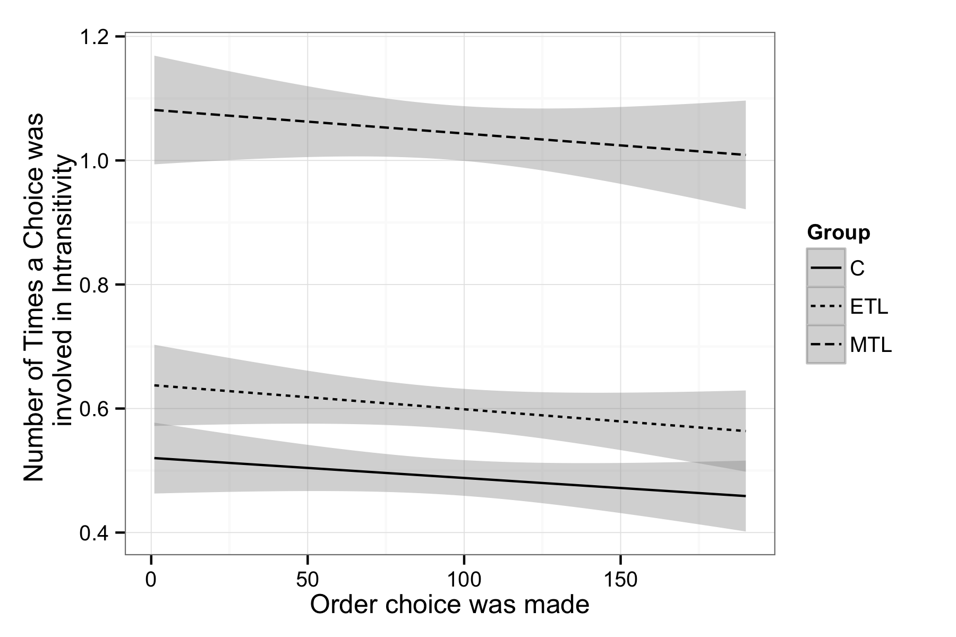
Figure S4: Number of intransitivities throughout the task for each group. The probability of intransitivity remains constant across trials.

Intransitivities and response times
We examined whether response times (RTs) at the trial level had an effect on the number of intransitivities. A multilevel model with fixed effects for centered RTs and centered quadratic term for RTs, as well as groups and random intercepts for each participant showed that choices for which participants took longer were involved in more intransitivites, with an RT fixed effect (b = 0.275, t(17180) = 12.601, p < 0.001). This translates to roughly one more intransitivity per choice for every extra two seconds a participant spends on it, especially after the first second. There were no significant interactions. Notably this model is also significantly better in predicting the number of intransitivities a trial is involved in compared to one with only a fixed effect with group and random intercepts for subjects (χ²(3) = 449.58; p <0.001) accounting for variation captured by the previously significant intercept in the simpler model and not changing the effect of the MTL group on number of intransitivities markedly. Since the MTL group is both the slowest group and the one with most intransitivities, this eliminates the possibility of the increase in intransitivities being the result of a speed-accuracy tradeoff.

Simulations to interpret the observed number of intransitive choices
One question that may rise is how to interpret the size of the observed group differences in intransitivity. To answer this question we simulated a logistic choice process with different amounts of noise and computed the expected number of intransitivities. If choices were completely random, the percentage of intransitivities should be 25% given the definition of the term (p(AB and BC and CA) = 2*(0.5)^3). Therefore 25% forms the upper level of intransitivities that can be expected in our analyses.
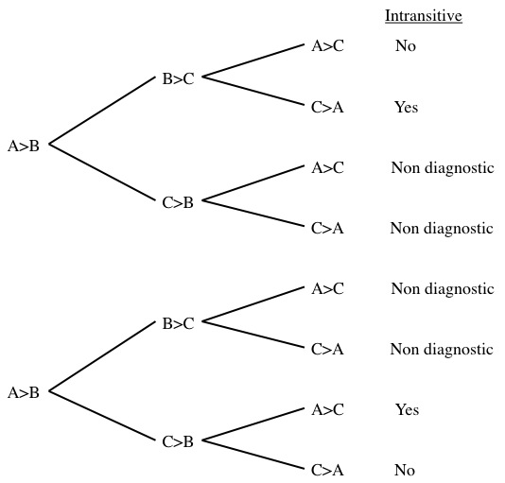
Figure S5: Tree diagram indicating possible intransitive paths from three binary choices

We used simulations to see how the percentage of intransitive choice triplets changed with the amount of random error or noise in people’s subjective preference judgments for each candy bar (from noise=0 for perfect utility judgments to noise=1 for completely random choices). Utilities for each bar were chosen from a standard normal distribution and normally-distributed noise was added to each utility to calculate choice probabilities. The mean level of intransitivities ranged from 0.003% at 1% noise to 25% at 100% noise in 1000 simulations.

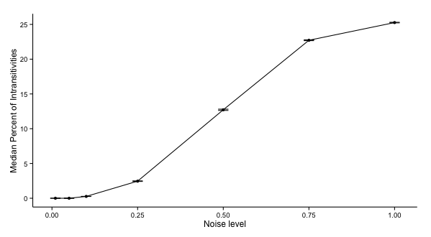

Figure S6: Median percentage of intransitivities at different noise levels, based on 1000 simulations. Error bars indicate standard errors of the simulation means.
Data cleaning
Participants were instructed to indicate their preferences within 5 seconds by pressing “1” (for left) or “4” (for right) on the computer keyboard. There were trials where participants either failed to respond within the time limit or responded using another button. We call the first type of error “timeout trials” and the second “mispress trials.” Mispress trials were recoded as 1 if participants mistakenly pressed 2 repeatedly and as 4 if participants mistakenly pressed 3 or 5 repeatedly. 9 subjects (2 in the control group, 3 in the ETL group and 4 in the MTL group) indicated their preferences using the wrong buttons at least once. 57 subjects (16 in the control group, 16 in the ETL group and 25 in the MTL group) timed out of at least one trial. A single timeout trial, where preference cannot be determined with certainty, affects 19 triplets in the counting intransitivities. Percentage of intransitivities was therefore calculated as the ratio of non-affected intransitive triplets out of total non-affected triplets. 95.61 % of all triplets were immune to these problems (median: 98.25 %).
References
Fischl, B., Salat, D. H., Busa, E., Albert, M., Dieterich, M., Haselgrove, C., … Dale, A. M. (2002). Whole brain segmentation: Automated labeling of neuroanatomical structures in the human brain. Neuron, 33, 341–355. doi:10.1016/S0896-6273(02)00569-X
Fischl, B., van der Kouwe, A., Destrieux, C., Halgren, E., Ségonne, F., Salat, D. H., … Dale, A. M. (2004). Automatically parcellating the human cerebral cortex. Cerebral Cortex (New York, N.Y. : 1991), 14, 11–22. doi:10.1093/cercor/bhg087
Lee, L., Amir, O., & Ariely, D. (2009). In Search of Homo Economicus: Cognitive Noise and the Role of Emotion in Preference Consistency. Journal of Consumer Research, 36(2), 173–187. doi:10.1086/597160

