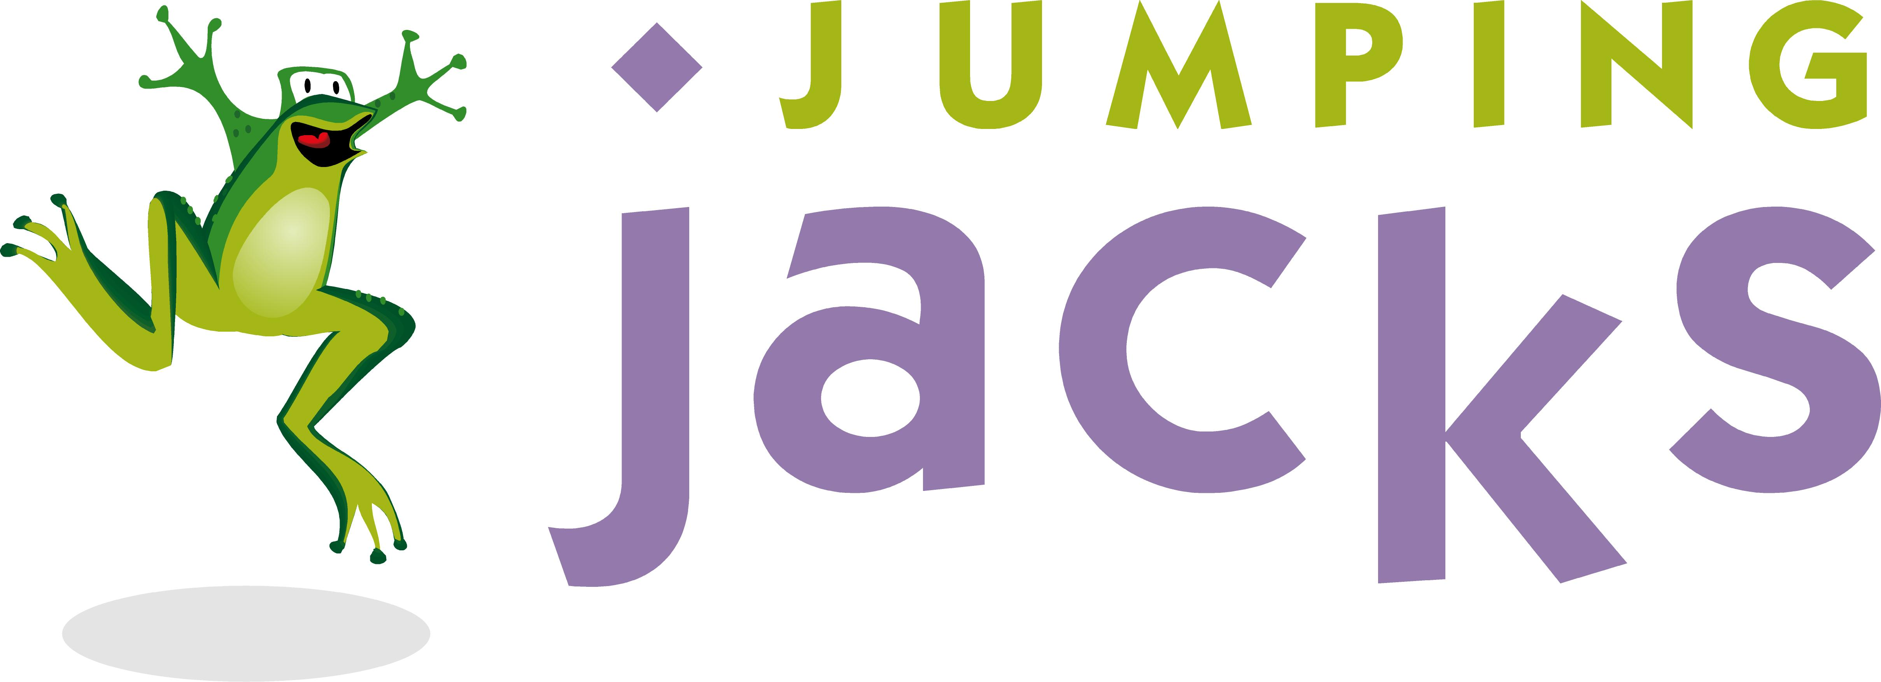 | Food Policy

Thanks for having your party at Jumping Jacks! We’re going to have a great time at your party, but if you would like to provide your own food, there are a few things we need to share with you.

Cleanliness is a primary concern at Jumping Jacks. We strive for all party-goers to have an immaculate environment to enjoy their special day. For this reason, while you are welcome to bring in certain types of food, we cannot allow outside pizza, drinks, or messy foods of any kind. If you do plan to bring in your own food, please confirm your choices with our staff in advance. They will make a written note of the approval, which will be required on the day of your party. Additionally, since we have the largest play area in town, we have no space for cold food storage. It is absolutely impossible for us to store any food you bring in either our refrigerator or our freezer. Finally, we are forced to charge a nominal $10 catering fee to pay for our increased costs of paper and time for cleanup for outside food.

By checking the checkbox on the Client Info page, you indicate that you agree to the terms of the Jumping Jacks Food Policy.

We can’t wait to share part of your day with you when you come in! Please let us know how we can make your time with us even better, now and in the future.

Kind regards,
Jumping Jacks Staff

