**CREATING LAYOUT**

**Creating layout styled <div>elements**

CSS-based layouts have two basic components: a set of **<div>** elements that create a page structure that is useful on its own, and a series of **CSS rules** that define the dimensions and format of key page elements so that the page assumes a functional and attractive appearance.

**Creating the page and defining the body tag**

1. New HTML Doc.
2. New CSS Rules -> All Mode
3. New CSS Rules:

* Selector Type: Tag
* Tag: body
* Define in: This Document Only

1. Properties Window:

* Background: (Choose any color you want)
* Block: Text align = center
* Box: Padding = 0 (Same for all)

Margin = 0 (Same for all)

**Defining the outer wrapper**

* A <div> tag use to contain or wrap all other tags and content.
* It helps establish global settings such as overall width and layout alignments.

1. New CSS Rules
2. New CSS Rules:

* Selector Type: ID
* Name: #wrapper
* Define in: This Document Only

1. Properties Window:

* Block: Text align = left
* Box: width = 760

Margin =(Uncheck same for all)

* + - * + Top: 0
        + Right: auto
        + Bottom: 0
        + Left: auto

1. Insert -> Layout -> Insert Div Tag

Insert: At insertion point

ID: wrapper

**DON’T FORGET TO SAVE YOUR WORK!**

**#wrapper <div> tag serves as a container for other <div> tags. The purpose is to constrain thewidth of the layout.**

**Setting up the primary divisions**

The current design will be divided into three major areas: header, content section, and footer. Each of these areas requires a separate CSS rule and <div> tag.

**HEADER**

1. New CSS Rules:

* Selector Type: ID
* Name: #header
* Define in: This Document Only

1. Properties Window:

Box: Margin = (Uncheck same for all)

* + - * + Top: 12
        + Bottom: 12

**#header CSS rule will provide a little bit of space above and below the <div> tag.**

**CONTENT**

1. New CSS Rules:

* Selector Type: ID
* Name: #content
* Define in: This Document Only

1. Properties Window:

Box: (Uncheck same for all)

* + - * Padding = Top=0
      * Margin = Top=0

**These settings will cause the content to appear immediately under the header with no white space.**

**FOOTER**

1. Duplicate the #header (right click from CSS Panel)
2. Rename as #footer
3. Click **Add Properties**(At the lower part of your CSS Panel)
4. Type: clear

Both (in the opposite side)

**The clear:bothCSS property ensures that no floated elements will intrude on the #footer.**

**Adding CSS Style to <div> tag**

**Header:**

Insert -> Layout -> **Insert Div Tag**

Insert: After start of tag

Adjacent menu: **“<div id=”wrapper”>”**

ID: **header**

**Content:**

Insert -> Layout -> **Insert Div Tag**

Insert: After tag

Adjacent menu: **“<div id=”header”>”**

ID: **content**

**Footer:**

Insert -> Layout -> **Insert Div Tag**

Insert: After tag

Adjacent menu: **“<div id=”content”>”**

ID: **footer**

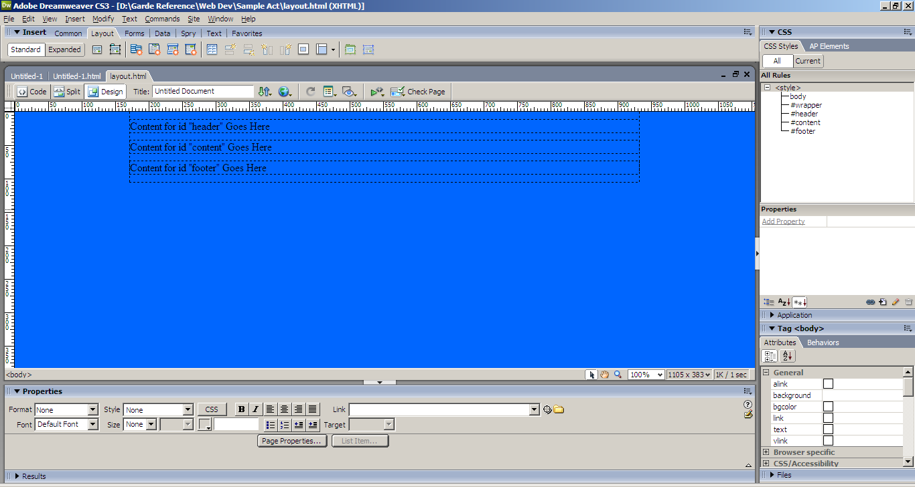

**Adding content areas in the Header**

**Logo:**

1. New CSS Rules:

* Selector Type: ID
* Name: #logo
* Define in: This Document Only

1. Properties Window:

Box: Height = 71

Padding = (Uncheck same for all)

* + - * + Bottom: 12

1. Insert -> Layout -> **Insert Div Tag**

Insert: After start of tag

Adjacent menu: **“<div id=”header”>”**

ID: **logo**

**Navigation:**

1. Duplicate the logo (CSS Rule is similar for the nav)
2. Rename logo to #nav
3. **Properties**(At the lower part of your CSS Panel)change

Box: Height = 28

1. Delete Padding(Right click delete)
2. Insert -> Layout -> **Insert Div Tag**

Insert: After tag

Adjacent menu: **“<div id=”logo”>”**

ID: **nav**

**Banner:**

1. Duplicate the nav
2. Rename logo to #banner
3. **Properties**(At the lower part of your CSS Panel) change

Box: Height = 200

1. Insert -> Layout -> **Insert Div Tag**

Insert: After tag

Adjacent menu: **“<div id=”header”>”**

ID: **banner**

**Not all content areas are nested within the primary layout <div> tags. Banner style is to be placed between the header and content areas.**

**DON’T FORGET TO SAVE YOUR WORK!**

**Content: divided to two columns**

**leftColumn**

1. New CSS Rules:

* Selector Type: ID
* Name: #leftColumn
* Define in: This Document Only

1. Properties Window:

Box: Width = 365

Float: Left

**One key technique for creating columns with CSS is to use the float property. A floated element moves to one side of the containing element and allows other content to flow around it. This is how right-aligned or left-aligned images and columns are styled.**

**rightColumn**

1. Duplicate the leftColumn
2. Rename logo to #rightColumn
3. **Properties**(At the lower part of your CSS Panel) change

float: right

**Add Style to content**

**leftColumn**

Insert -> Layout -> **Insert Div Tag**

Insert: After start of tag

Adjacent menu: **“<div id=”content”>”**

ID: **leftColumn**

**rightColumn**

Insert -> Layout -> **Insert Div Tag**

Insert: Aftertag

Adjacent menu: **“<div id=”leftColumn”>”**

ID: **rightColumn**

**DON’T FORGET TO SAVE YOUR WORK!**

**Your Site should look like this:**

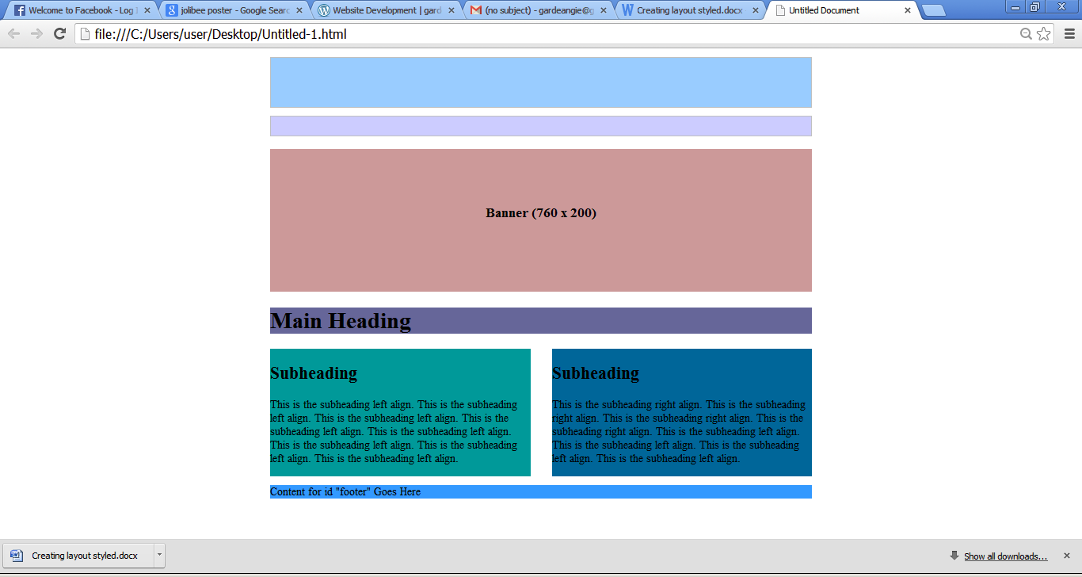

**Logo (760x71)**

**Navigation (760x28)**

