NAME :ALIYAN ASSIMENT#4
ROLL NO:25P-0079 PROGRAMING FUNDAMENTAL

SCREEN SHOTS OF OUTPUT………
ENROLLING STUDENTS AND ADDING COURSES
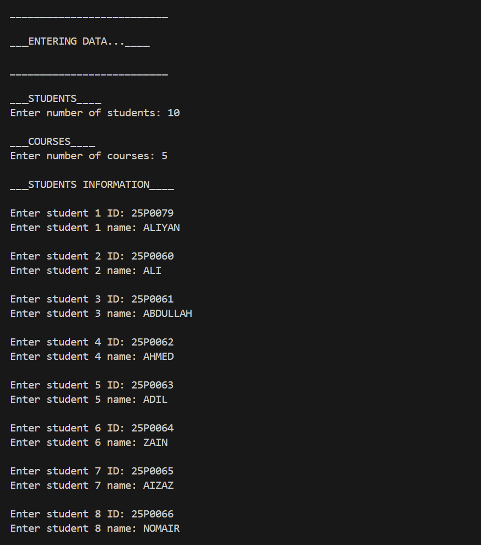

ENTERING OBTAIN NUMBERS OF STUDENTS
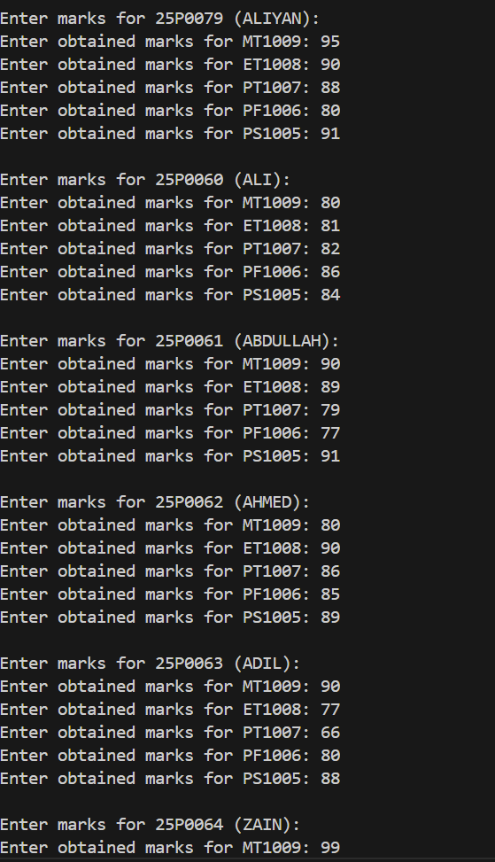
ENTERING ATTENDENCE
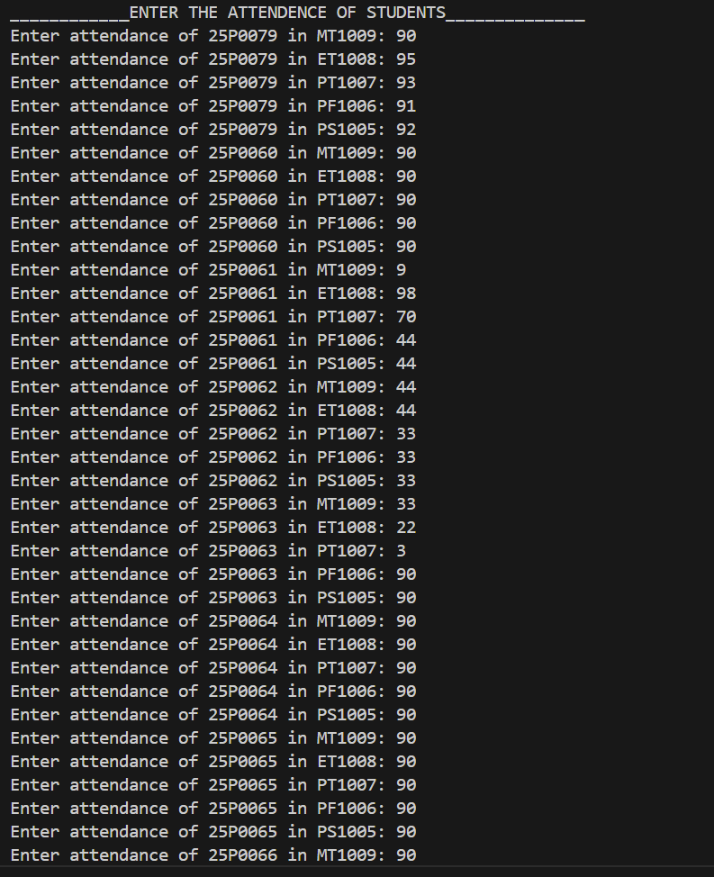

DISPLAYING STORED DATA (STUDENT REPORT)
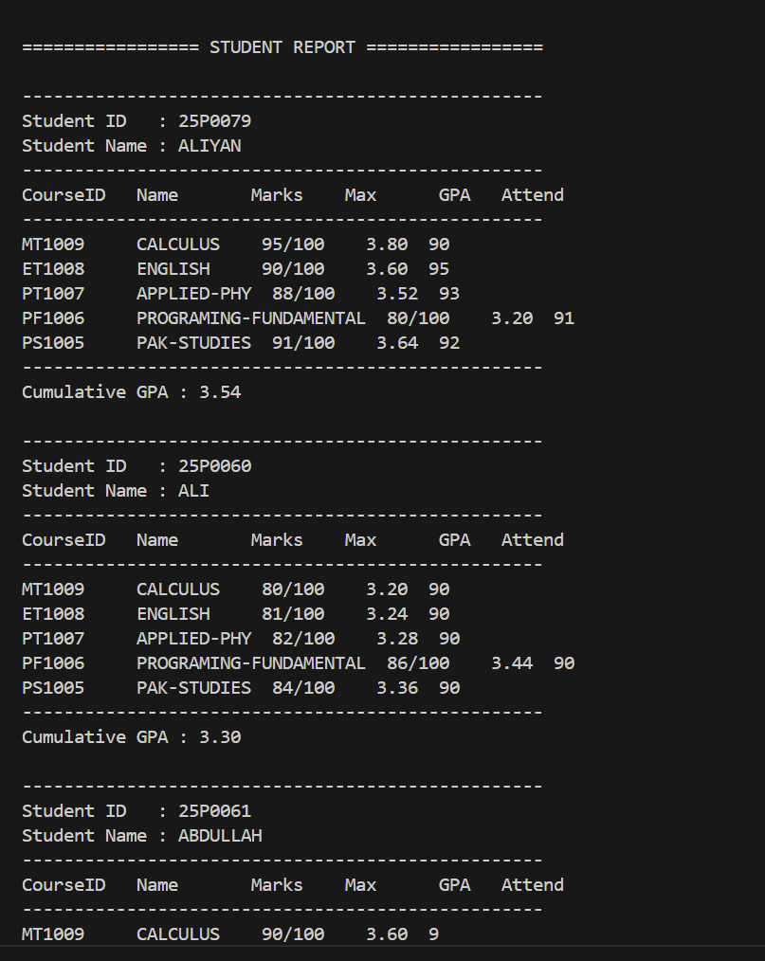

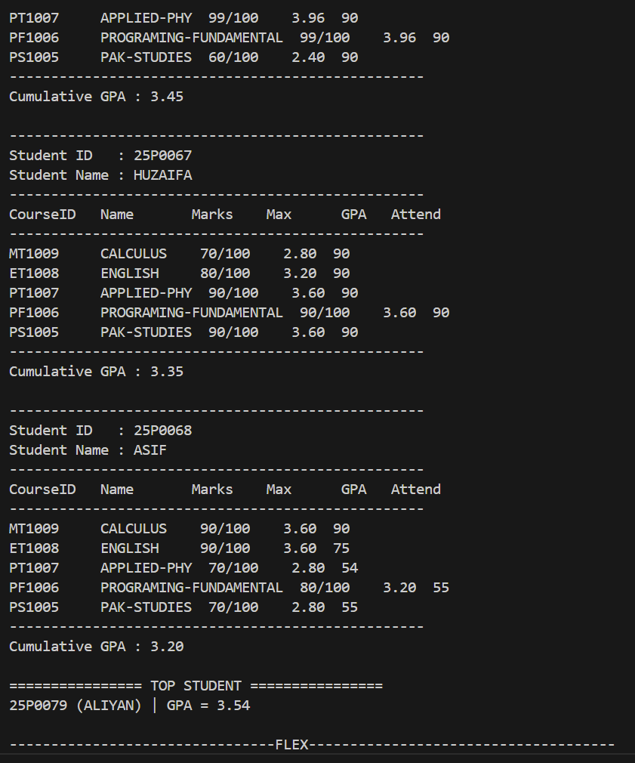

COURSE STATICS
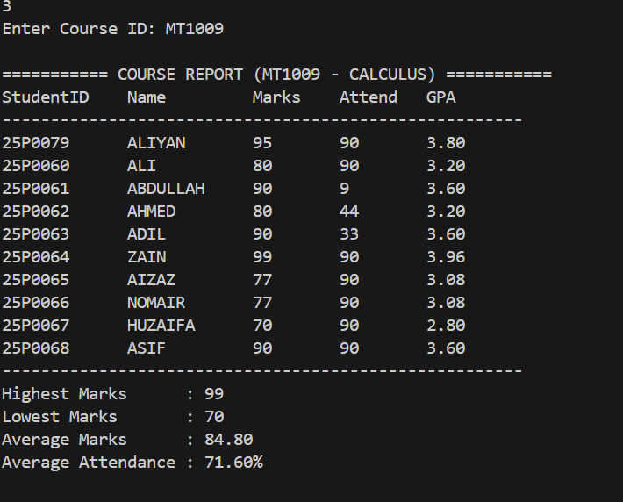
TOPPER
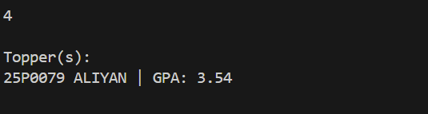
FINDING COURSE
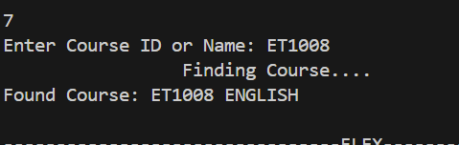
EDITING DAT

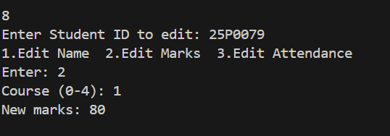

SORTED DATA

