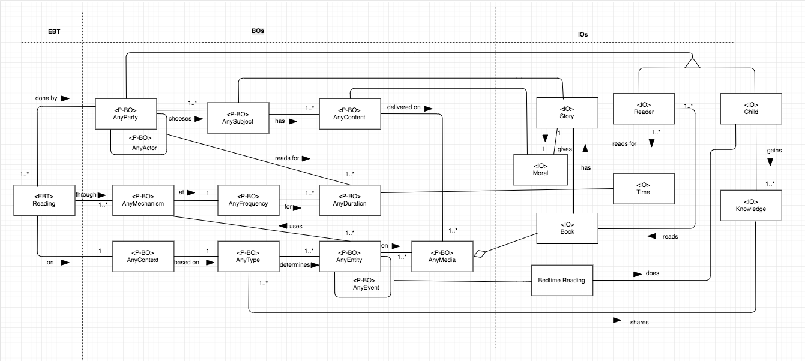

Figure6. Stable Model of Reading stories to children