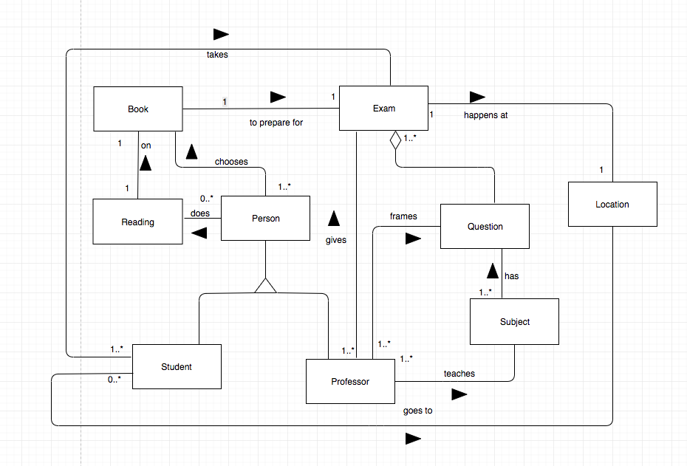

Figure3. Traditional Model of Reading for an exam