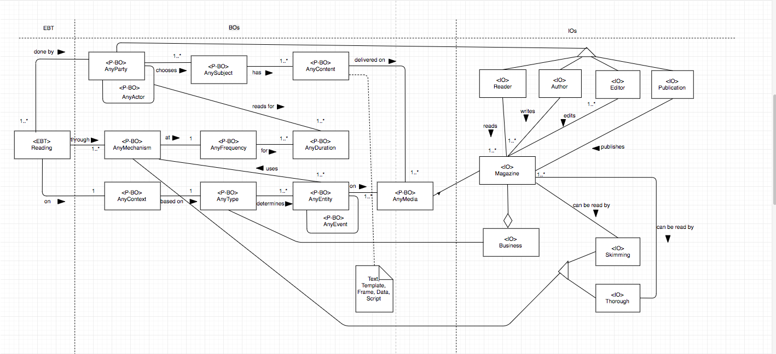

Figure8. Stable Model for Reading for Entertainment