Global Trading

An interconnected world

Authors:  
Brugnara Cristian, Darani Zeno e Martinelli Andrea

Data visualization course

Professor: Profeta Giovanni

Academic Year 2023-24

Index

Project 2

Abstract 2

Introduction 2

Data sources 3

Data pre-processing 3

Data visualizations 4

Interface design 5

Next steps 5

# Project

The whole project is available on the Git-Hub repository:

*Global Trading, An interconnected world;* <https://github.com/zenodarani/transport-visualization-project/>

# Abstract

The project focuses on international trading and the effects of globalization. We showed the values that international trade generates globally every year, and we identified the major actors. Then, the research focuses on energy production, which is currently one of the goods that majorly impacts our modern lifestyles. The work is presented on a web page that enables a deeper exploration of the data, thanks to interactable visualizations and a narrative explanation given by the analysis of the graphs.

# Introduction

We live in an epoch where we can go to the store and buy products from every side of the world. Nowadays trading with foreign countries is essential for the well-being of our economies. Historically, markets were more restricted and isolated by geographic and political matters. The transport of goods required longer times, and the technology needed to be improved. With the rise of steam-powered machines, like trains and steamboats, goods started to circulate faster, increasingly reaching further distances. The high production enabled countries to offer more goods to external markets, and as a result, new connections were created, and the concept of globalization was born. In recent times (2023) with the return of the war in Europe, the fragility of our interconnected globe was shown to us. *Due to the war in Ukraine, a leading grain exporter, has seen a dramatic drop in its exports. This has resulted in significant food security concerns for millions of people around the world. [European Council][1]* The aim of this project is to analyse how countries in this world depend on each other and look at the impact that this can have on our daily lives. To do so we will take data and create visualizations that will enable the reader to get a bigger picture about the topic. Then, with more precise representations, we will get a more profound analysis of the production of energy, what truly powers our daily lives. The results of the projects will be shared to advertise the consequences of globalization in a simple, straightforward, and intuitive way dedicated to European consumers.

# Data sources

**Import and Exports Values Between Countries Visualization:**

Organisation for Economic Co-operation and Development, website: <https://stats.oecd.org/>, *last checked January 2024*

The original data can be found on the website and navigating with the left menu: Globalisation -> Trade by Enterprise Characteristics -> ISIC rev4 -> TEC by partner zones and countries

**Total Trade Value Visualization:**

Organisation for Economic Co-operation and Development, website: <https://stats.oecd.org/>, *last checked January 2024*

The original data can be found on the website and navigating with the left menu: Globalisation -> Trade by Enterprise Characteristics -> ISIC rev4 -> TEC by partner zones and countries

**Energy by Sector Visualization:**

European Commission, website: <https://energy.ec.europa.eu/data-and-analysis/eu-energy-statistical-pocketbook-and-country-datasheets_en#:~:text=The%202023%20edition%20of%20EU,compared%20to%201990%20levels>, *last checked January 2024*

The original data can be found on the website under “Country Datasheets”

# Data pre-processing

**Import and Exports Values Between Countries Visualization:**

Only the total values were taken from the original dataset; all the other non-essential columns have been dropped. The data were exported in CSV format and uploaded into the Flourish web tool.

**Total Trade Value Visualization:**

Only the total values were taken from the original dataset. Each county was associated with a web link to an image of the flag that will be used afterwards in the visualization. Then, the dataset was split into imports and exports. Finally, all the data were exported in CSV format and uploaded into the Flourish web tool.

**Energy by Sector Visualization:**

The first two sheets were discarded because irrelevant to the question. Retrieved the useful rows of every other sheet and merged into a single dataset, specifying those taken during 2021. The data has been reorganized to have one country per row and the types of energy share in the columns. Finally, all the data were exported in CSV format and uploaded into the Flourish web tool.

# Data visualizations

**Import and Exports Values Between Countries Visualization:**

The visualization wants to represent the trade value between countries. For each trade value a connection is drawn over the Globe between the two countries. The connection size is determined by the value of the trade; the higher the value, the bigger it is on the map. The user can interact with the visualization by rotating the Globe around, selecting to visualize the trade import or the trade exports and starting the animation from 2008 to 2021.

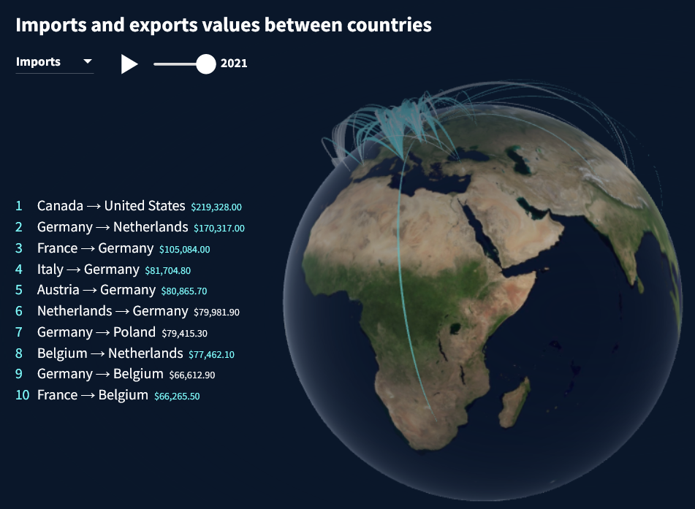

Figure 1 Import and Exports Values Between Countries Visualization

**Total Trade Value Visualization:**

This visualization is an animated ‘race.’ Each country is a horizontal bar where the length represents the value of the trade. When the animation starts, the values increase and decrease, and the position of the bar swaps depending on the ranking by value. Each country has its own flag and the color of their region. Exports and imports are subdivided into two sub-visualizations.

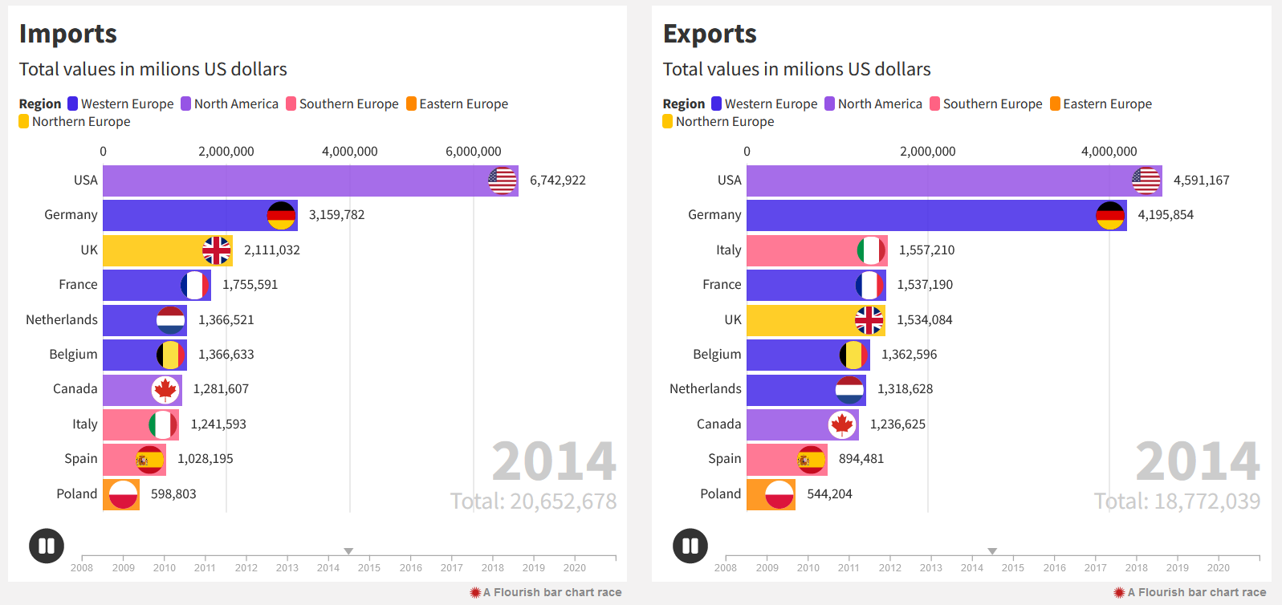

Figure 2 Total Trade Value Visualization

**Energy by Sector Visualization:**

In the visualization is shown the partitioning between types of energy production. The data are represented in form of tree map where each rectangle is a energy source and its area is the fraction over the total production. The user can interact with the visualization by selecting which country wants to visualize with the drop down menu on the top left.

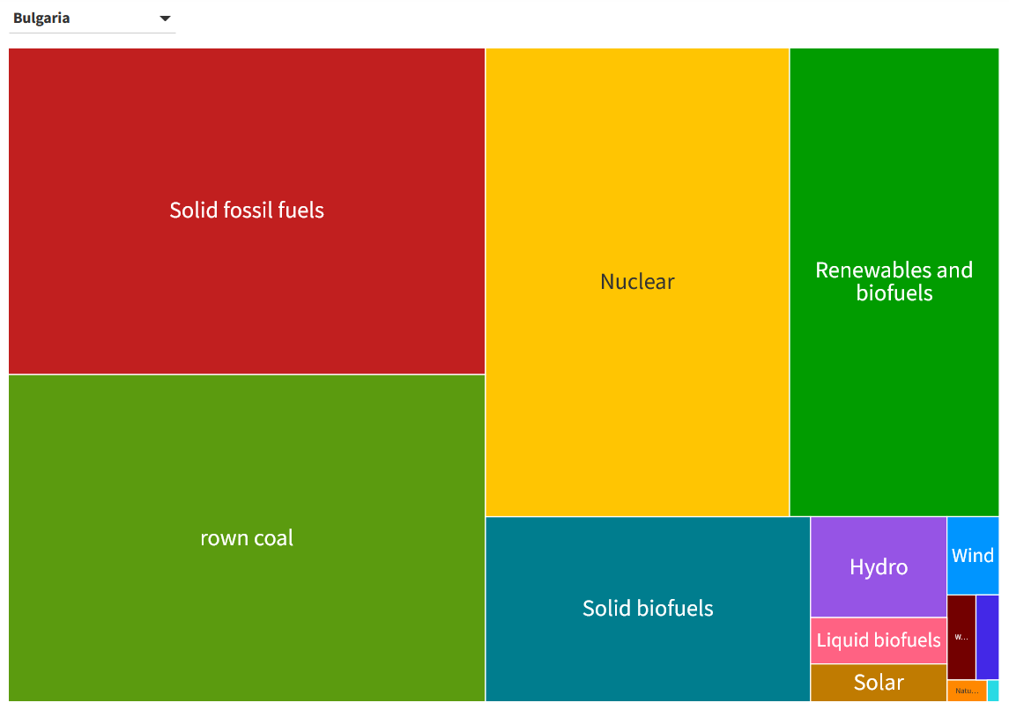

Figure 3 Energy Production by Sector Visualization

# Interface design

The html page is structured in four main sections: the title with the abstract and one for each data visualization. We opted for a white and clean background and titles and subtitle are black or grey in order to maintain simplicity and doesn’t have a lot of visual noise. Each visualization is paired with a text and topics are introduced beforehand. Under the image there are two links to directly get the dataset used and visualize the visualization protocol, from the protocol one can access the data. For what regards the narrative structure the reader is introduced to the topic with the abstract followed by the first visualization of the globe. Then the reader has access to the Index that can use to faster navigate through the page using hyperlinks. Afterwards, the topic is explored, showing the real value of trading and evidencing various important aspects of the problem. Then the research is centred on a more specific topic to focus more on one example of global trading. At the end of the web page, there is a conclusive thought on the argument. To close the page there is the footer with the project information.

# Next steps

In this research, we focused on energy production because the objective was to give the audience one example of goods that are relevant to our daily lives and also dependent on international trading. We think that a similar work can be expanded with an analysis of another type of products.

A deeper dive on the understanding of the topic could also be done. In our project we focused on how trading impacts energy production, but an interesting thing that could be analysed is the opposite verse. The higher availability of energy may surely affect positively the trade capacity of a countries.

One thing one could do, having the right data (something we couldn’t find), is to analyse the transport of energy itself and see which are the main actors and the main products traded.

Another thing that could be added is the expansion of the target audience. We could use different types of data visualizations and slightly change our research questions to reach other types of viewers such as not-European people.

To do that and to fit different situations, one could also try to modify the interface design of the website, adding more details or abstraction depending on the context.

1. *Infographic - How the Russian invasion of Ukraine has further aggravated the global food crisis*; European Council; December 2023; <https://www.consilium.europa.eu/en/infographics/how-the-russian-invasion-of-ukraine-has-further-aggravated-the-global-food-crisis/>