AI Usage DISCLOSURE FORM

1. Team Details
Team Name: Larpers
Project / Product Name: Code Sentinel
Institution: Ramaiah Institute of Technology
Submission Date: 08/05/2026

2. AI Usage Declaration
Did your team use any Artificial Intelligence (AI) in developing this project? Yes / No
_______yes________________________

3. Purpose of AI Usage ( Brief Details)
Idea generation / brainstorming : no
Code generation or assistance : used codex and gemini for the code generation
UI / UX design : no
Content creation : no
Data analysis : no
Testing / debugging : no
Other ________________________

4. Feature Origin Classification ( Please add/delete based on the number of the features
[ I ]. Feature Name : Vulnerability Intelligence (CVE-Sweep)
2. Self-Generated/AI-Generated/Both : both
3. Description ( include AI tools/platform Used, prompt used , Output Summary, Modification) :
[prompt] :
Detecting and scoring risks in the codebase.
* Manifest Parsing: Locate and parse package.json, requirements.txt, etc.
* NVD/GitHub API Integration: Query vulnerability databases for direct dependencies.
* Transitive Graph: Build the full dependency tree (dependencies of dependencies) via lockfiles.
* ActualRisk Scoring: Implement the formula: Severity × Blast Radius × Maintenance Age.
* CRITICAL Alerts: Build logic to detect top-tier risks and trigger Slack warnings.

II. Feature Name : Git Archaeology (Module Passports)
2. Self-Generated/AI-Generated/Both : both
3. Description (include AI tools/platform Used, prompt used , Output Summary, Modification) :
[prompt] :
Reconstructing the "Why" behind the code.
* Git Log Parsing: Extract commits, authors, and dates for specific files.
* Jira Integration: Link commit IDs to Jira ticket summaries to explain historical decisions.
* Ghost Author Identification: Flag files owned by people who have left the organization.
* Module Passport Compilation: Write enriched .md passports to Durable Memory with LLM risk summaries.

III. Feature Name : Blast Radius & PR Analysis (Pre-mortem)
2. Self-Generated/AI-Generated/Both : both
3. Description (include AI tools/platform Used, prompt used , Output Summary, Modification) :
[prompt] :
Predicting the impact of changes during code review.
* Blast Radius Mapping: Build a reverse dependency graph showing which files import which modules.
* GitHub Webhook Listener: Set up the endpoint to receive and validate "Pull Request" events.
* Risk Profiling: Analyze PR changed files against Blast Radius, Ghost authors, and CVE status.
* Pre-mortem Card Generation: Use Claude API to write the "What could go wrong" summary.
* PR Bot Commenting: Post and update the risk card directly as a comment on the GitHub PR.

IV. Feature Name : Proactive Remediation (Auto-Fix)
2. Self-Generated/AI-Generated/Both : both
3. Description (include AI tools/platform Used, prompt used , Output Summary, Modification) :
[prompt] :
Automatically fixing vulnerabilities.
* Manifest Patching: Determine safe semver upgrades and update the manifest files.
* Docker Build Simulation: Run npm install/test in a sandbox to ensure the fix doesn't break the build.
* License Guard: Check if upgrading a library introduces restrictive licenses (e.g., MIT to GPL).
* Auto-Fix Draft PRs: Use GitHub API to open a branch and a Draft PR with the verified patch.
* WhatsApp/Twilio Approval: Send the "YES/NO" merge request to the tech lead's phone.
* E2E Validation: Run a smoke test of the entire "Detect -> Patch -> PR -> WhatsApp" flow.

…

5. Ethical & Compliance Confirmation
AI usage complies with guidelines and policies. Yes
No proprietary or copyrighted data misused. I Agree

6. Declaration & Sign-Off
Name of Team Representative: Naveed H K
Role: Leader
Signature: 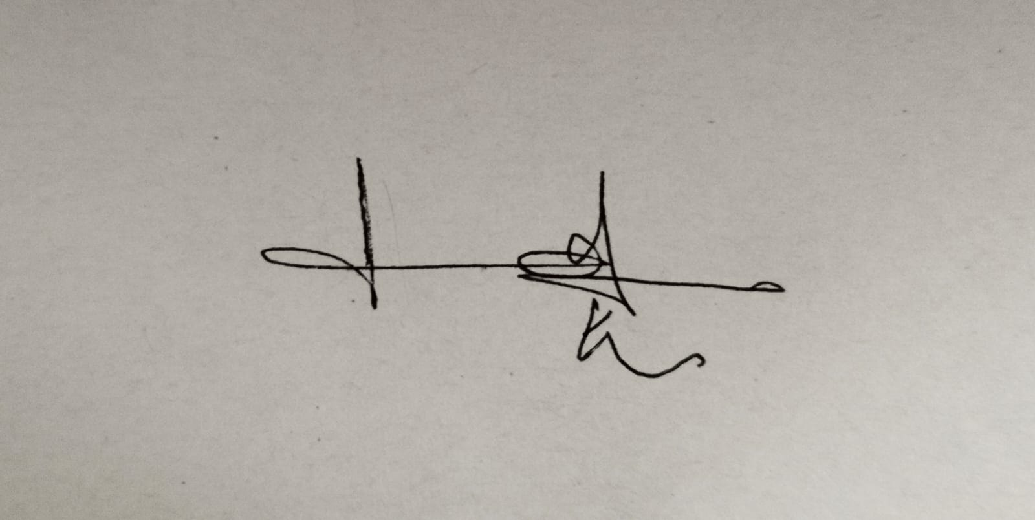

Date: 08/05/2026

