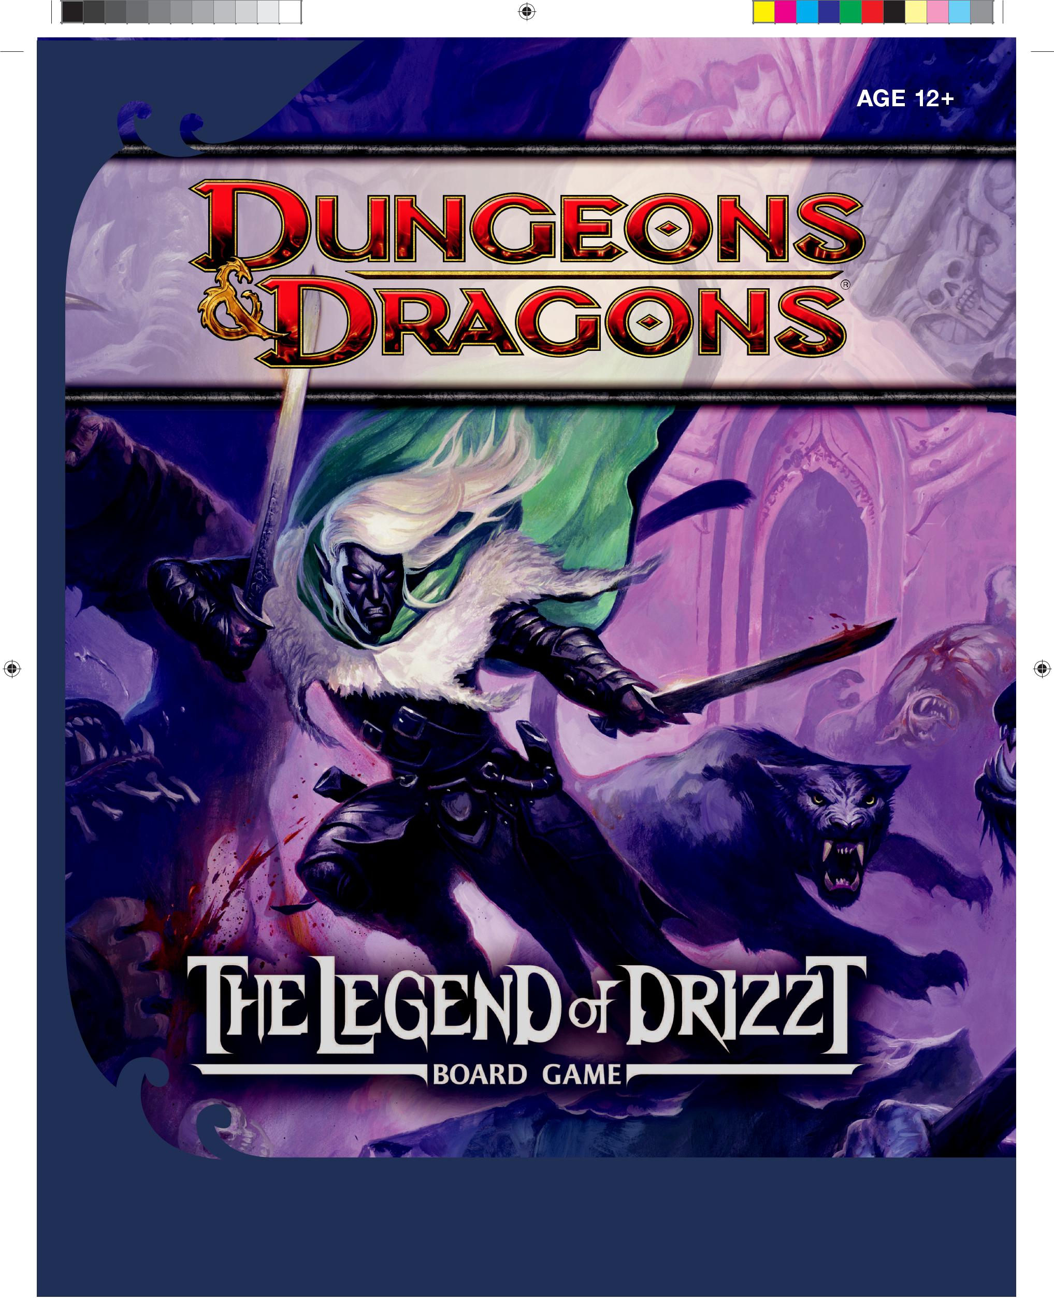

™

КНИГА ПРАВИЛ


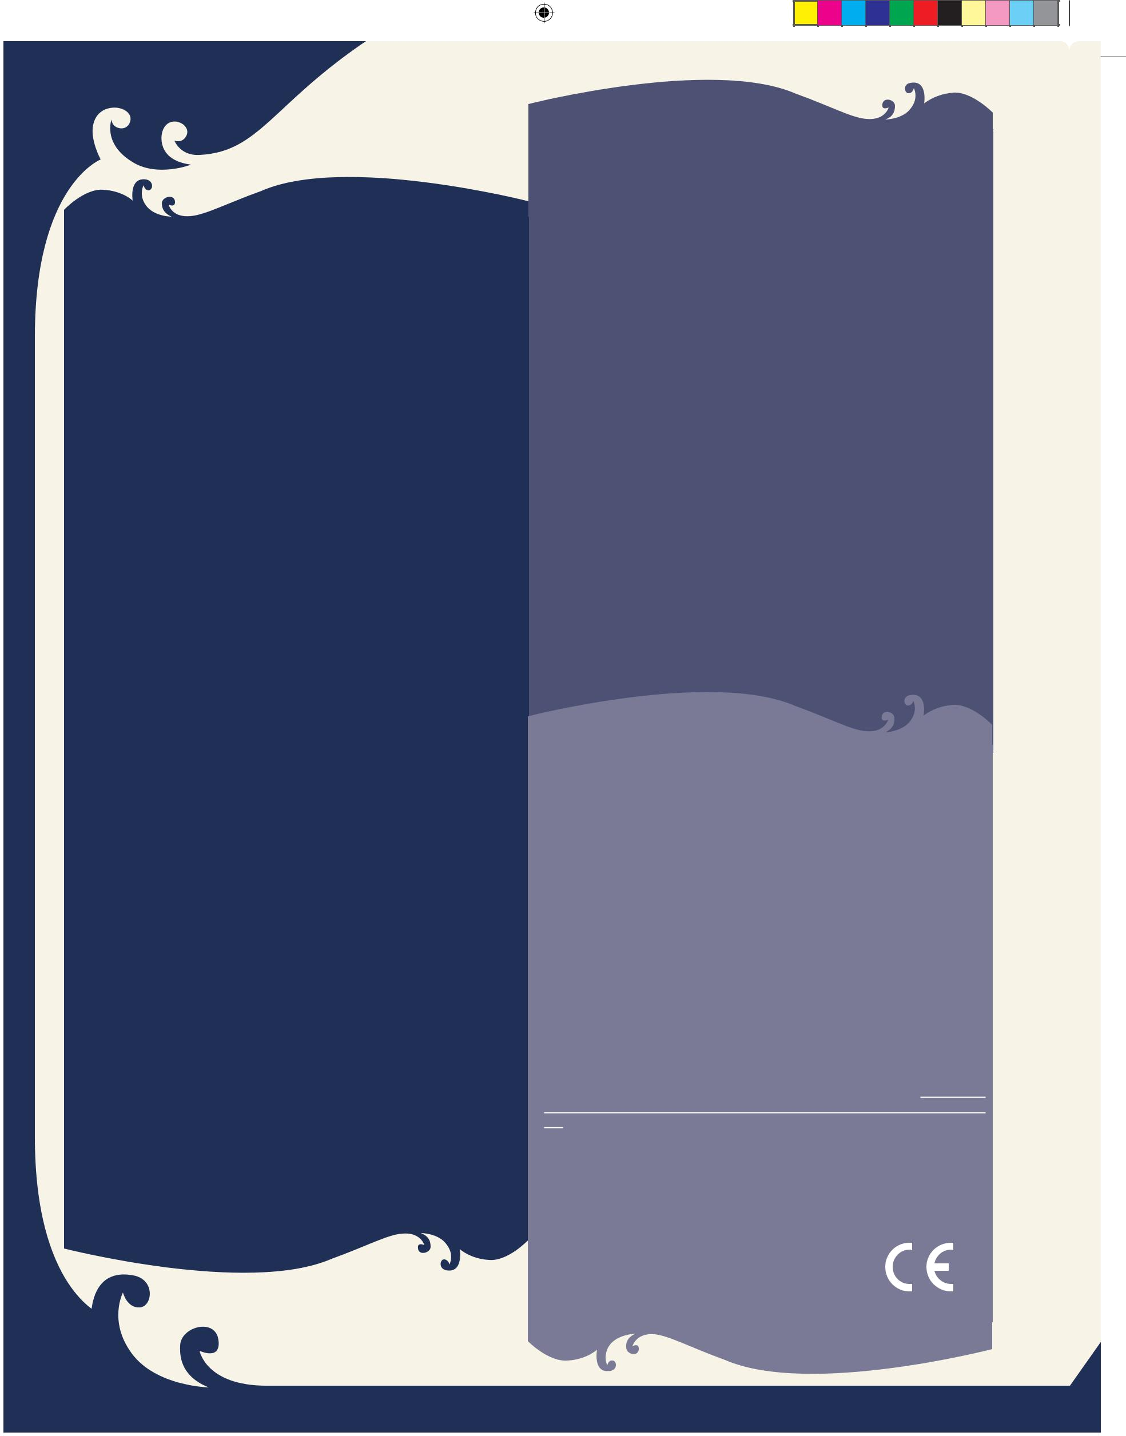

ОГЛАВЛЕНИЕ

ВВЕДЕНИЕ | 3
ОБЗОР ИГРЫ | 3
УСЛОВИЯ ПОБЕДЫ | 3
Настройка игры | 3
Перед началом игры | 4
Очередность ходов | 4
Соединения плиток пещеры | 5
НАСТРОЙКИ ИГРОКА | 6
КАРТА ГЕРОЯ | 6
ХОД ИГРОКА | 7
Фаза героя | 7
Фаза поиска | 7
Фаза врагов | 8
ДВИЖЕНИЕ | 8
Состояние: Обездвижен | 9
Состояние: Отравлен | 9
НАПАДЕНИЯ | 9
Потенциальные силы | 9
Ежедневные силы | 9
Вспомогательные силы | 9
СРАЖЕНИЯ | 9
Нацеливание | 9
AC и HP | 9
Бонус атаки | 10
Проведение атаки | 10
Урон | 10
Поражение монстров | 10
Поражение героев | 10
Исцеление | 10
Дрегие действия | 10
КОЛОДА МОНСТРОВ | 11
КОЛОДА ВСТРЕЧ | 12
КОЛОДА СОКРОВИЩ | 13
ОЧКИ ОПЫТА | 14
Отмена карт встреч | 14
Поднятие уровня | 14
ПРАВИЛА ДЛЯ ДРУГИХ ПРИКЛЮЧЕНИЙ | 14
Продвинутая колода карт | 14
Выбор силовых карт | 14
ОПЦИОНАЛЬНЫЕ ПРАВИЛА | 14
Пещерные плитки | 14
Соревновательные приключения | 15
ЧАСТО ЗАДАВАЕМЫЕ ВОПРОСЫ | 16


2

КОМПОНЕНТЫ ИГРЫ


40 фигурок (7 синих, 9 фиолетовых, 12 | 10 | Маркеров состояний
зелёных, 6 голубых, 1 красная, 5 серых) | 5 | Жетонов лечения
8 Карт героев | 64 | 1 HP жетонов
4 Карт злодеев | 8 | 5 HP жетонов
1 Книга правил | 10 | 1 HP жетонов монстров
1 Книга приключений | 2 | 2 HP жетона монстров
1 d20 кубик | 3 | Жетонов позиции (Бренор,
1 Стартовая плитка двойного |  | Кэтти-Бри, Дзирт)
размера | 2 | Жетонов заряда
3 Плитки назначения двойного | 2 | Жетонов дуэли
размера | 2 | Жетонов двойного удара
32 Пещерных плитки | 6 | Жетонов сильного удара
22 Пещерных заглушки | 1 | Жетон лагеря
(включая 4 разлома с номерами | 1 | Жетон короны
1–5, 6–10, 11–15, 16–20) | 1 | Жетон ключа
200 карт: | 1 | Жетон рычага
Начальная колода | 1 | Жетон карты
• 5 Напоминалок фаз хода | 1 | Жетон храпуна (Snort)
• 20 карт встреч | 2 | Заполненных жетона
• 20 карт монстров | 2 | Жетона секретного прохода
• 29 карт силы | 4 | «–4 AC» жетона
• 26 карт сокровищ | 6 | Жетонов времени
Продвинутая колода | 6 | Жетонов сундуков
• 7 карт союзников | 8 | Жетонов героев
• 22 карт встреч | 8 | Жетонов монстров
• 10 карт монстров | 3 | Маркера обрушенных тоннелей
• 51 карта силы | 9 | Маркеров встреч
• 10 карт сокровищ

CREDITS

Design Peter Lee

Editing Jennifer Clarke Wilkes

Adventure System Design Bill Slavicsek, Mike Mearls, Peter Lee

D&D Senior Creative Art Director Jon Schindehette

Art Director Keven Smith

Cover Illustration Steve Prescott

Graphic Designer Bob Jordan

Additional Graphic Design Emi Tanji

Dungeon Tiles Jason A. Engle

Prepress Manager Jefferson Dunlap

Imaging Technician Sven Bolen

Production Manager Raini Applin Rosta

©2011 Wizards of the Coast LLC, P.O. Box 707, Renton, WA 98057-0707, U.S.A. Manufactured by: Hasbro SA, Route de Courroux 6, 2800 Delemont, CH. Represented
by: Hasbro Europe, 2 Roundwood Ave, Stockley Park, Uxbridge, Middlesex, UB11 1AZ. UK. DUNGEONS & DRAGONS, D&D, WIZARDS OF THE COAST, The Legend of Drizzt, and all other Wizards of the Coast product names and their respective logos are trademarks of Wizards of the Coast LLC in the U.S.A. and other countries. All Wizards characters and their distinctive likenesses are property of Wizards of the Coast LLC. Other trademarks are property of their respective owners. ® denotes Reg. U.S. Pat. & TM Office. All rights reserved. MADE IN CHINA.

300-35594000-001 EN

ISBN: 978-0-7869-5873-3

Visit our website at www.DungeonsandDragons.com

Inspired by the New York Times best-selling novels by

R.A. Salvatore.

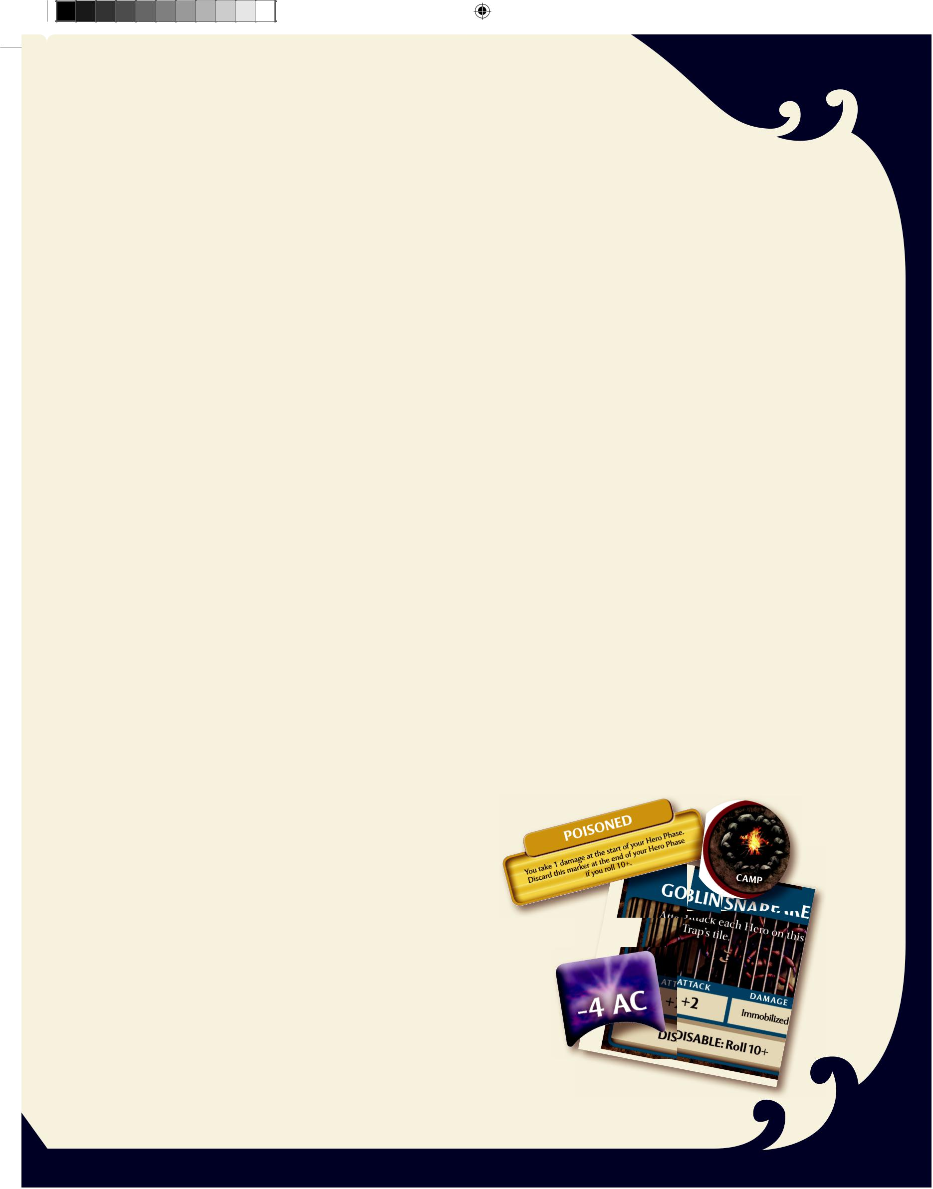
ВВЕДЕНИЕ

Deep below the ground lies the Underdark, a network of caverns forever cloaked in starless night and home to millions of deadly creatures. Only the most courageous surface dwellers dare to travel there. But one epic adven-ture originally hails from the Night Below: the tales of the drow ranger Drizzt and his companions, who travel both above and below the surface.

Легенда о Дзирте

Born in the drow city of Menzoberranzan, Drizzt Do’Urden was forced to flee to the surface or face the wrath of the evil drow goddess, Lolth. Upon reaching the surface in Icewind Dale, Drizzt found a band of friends: a dwarf in search of his clan’s lost home, along with his adopted human daughter; a fierce yet noble barbarian; and a cunning halfling thief. Together, these brave heroes fight against the evil of the Underdark.

The enemies they battle are many. The shadow dragon that conquered Mithral Hall will not give up its new home so easily. The minions of Lolth seek the destruction of Drizzt, and mer-cenaries and assassins have all targeted the renegade dark elf. Worst of all is the balor Errtu—most mortals do not survive long when a demon such as he names them enemies. Fortunately, Drizzt is not like most mortals . . .

GAME OVERVIEW

The DUNGEONS & DRAGONS® The Legend of Drizzt™ Board Game is an adventure game featuring the characters and locations described in the novels by R.A. Salvatore. Some adventures are cooperative, where you and your fellow Heroes must work as a team to succeed. Other adventurers are more competitive, and you must outwit and outmaneuver the other players to win.

Each player selects a Hero, one of the Companions of the Hall.

Choose from the drow ranger Drizzt Do’Urden, the dwarf

fighter Bruenor Battlehammer, the human archer Catti-brie,

the halfling rogue Regis, or the human barbarian Wulfgar.

Later adventurers feature some other characters met by Drizzt,

including the drow mercenary leader Jarlaxle Baenre, the dwarf

battlerager Athrogate, and the dreaded assassin Artemis Entreri.

Once you’ve selected your Heroes, you’re ready to enter the Underdark!

Количество игроков

The game can be played with any number of players, from 1 to 5. Each player controls one Hero—and the game does the rest!

D&D система правил

You can combine this game with other D&D® Adventure System board games to create new and unique experi-ences. Check out www.DungeonsandDragons.com for more information.

УСЛОВИЯ ПОБЕДЫ

Вы выигрываете в том случае, если выполните цель того приключения, в которое играете. Например, в одном приключении целью является уничтожение злого дракона захватившего Мифрилл Холл, когда в другом - остановить нашествие тёмных эльфов.

Unless stated otherwise in an adventure, you lose if any Hero is at 0 Hit Points at the start of that Hero’s turn and there are no Healing Surge tokens left to play. You also lose if you are defeated by the adventure you are playing. Each adventure lists its specific victory and defeat requirements.

Приготовления к игре

Набор содержит очень много хлама. Всё, что там лежит, не надо использовать сразу. Обычно в приключениях используются следующие вещи:

✦ Карты Героев и их фигурки
✦ Карты Силы героев
✦ 32 стандартных площадок пещеры
✦ 1 Стартовая площадка
✦ Карты Встреч
✦ Карты Монстров
✦ Карты Сокровищ
✦ Маркеров состояний (Обездвижен, Отравлен)
✦ Жетонов лечения
✦ Жетонов жизней
✦ «–4 AC» жетона
✦ 6 ловушек - маркеров встреч
✦ Жетон Лагеря
✦ d20 кубик

Жетон лагеря
Маркер отравления

Маркер ловушки

«-4 AC» жетон

3

300_35594000_LegODrizzt_Rules r3.indd 3 |  |  | 3/28/11 3:41 PM


Set aside the following game pieces. You use these pieces only if the adventure you are playing requires them (see the adventure book for details). We recommend that you store these pieces in a plastic bag to keep them separate until you need them.

23 Adventure-specific Cavern tiles:

✦ 3 double-sized Destination tiles: Ancient Throne, Rocky Lair, Surface Hollow

✦ 20 Cavern Edge tiles

7 Ally Adventure cards: Bruenor (Ally), Catti-brie (Ally), Drizzt (Ally), Guenhwyvar (Ally), Regis (Ally), Snort (Ally), Wulfgar (Ally)

3 Stance tokens

2 Charge tokens

2 Duel tokens

2 Double Strike tokens

6 Power Strike tokens

6 Time tokens

6 Treasure Chest tokens

8 Hero tokens

8 Monster tokens

1 Crown token

1 Key token

1 Lever token

1 Map token

1 Snort token

2 Filled Bowl tokens

2 Secret Tunnel tokens

3 Adventure-specific Encounter markers: Crystal Prison, Gauntlgrym Door, Pit

3 Collapsed Tunnel markers

Villain figures and Villain cards:

✦ Artemis Entreri, Human Assassin ✦ Errtu, Balor

✦ Jarlaxle Baenre, Drow Mercenary ✦ Methil El-Viddenvelp, Mind Flayer ✦ Shimmergloom, Shadow Dragon ✦ Yochlol, Handmaiden of Lolth

✦ Yvonnel Baenre, Matron Mother

To Start Playing:



✦ When you first open the box, you’ll find two decks of 100 cards each: the Starting Deck and the Advanced Deck. For your first couple of games, just use the Starting Deck cards (numbered 1–100). Once you’re familiar with how the game plays, you’ll be ready for some of the more advanced cards. See “The Advanced Deck” on page 14.

✦ Give each player a Sequence of Play card as a reminder of how play proceeds.

✦ Place the die and the various figures in easy reach.

✦ Pick an adventure from the adventure book. If you are playing your first game alone, play Adventure 1: Exile. Otherwise, play Adventure 2: Search for Mithral Hall.

✦ Check the “Adventure Setup” section of the adventure book to see if your chosen adventure calls for any of the game pieces you set aside.

✦ Unless the adventure says otherwise, place the Start tile in the center of the table and place two Healing Surge tokens beside it. These are the group’s surges for this adventure.

✦ Each player chooses one of the 1st-level Heroes. When you choose a Hero, take that Hero’s Hero card, Power cards, and the figure that matches the Hero. Adventures and cards refer to the players as “Heroes.”

✦ Unless the adventure says otherwise, place each Hero figure on any square of the Start tile. The name of each Hero is printed on the base of the figure.

✦ Each Hero card tells you how many and which Power cards you can choose for that Hero. In your early games, use the Power cards suggested at the front of the adven-ture book. Set aside any Power cards that aren’t used in this adventure.

✦ Check the “Starting Awards” section of the adventure’s setup to see how many Healing Surge tokens the Heroes start with, as well as any starting Treasure cards.

✦ Set up the Cavern Tile stack (the deck of tiles) using the setup instructions in the adventure you have selected. You are now ready to begin play. The adventure tells you any other rules you need in the “Special Adventure Rules” section, or any rules that change the general game rules presented in this book.

Taking Turns

Play progresses around the table, starting with a player of the group’s choice and then proceeding clockwise. You can also each roll the die and let the player who rolled highest go first.

Your turn consists of three phases: one for your Hero, one for Exploration, and a Villain Phase for the Monsters and Traps under your control.

4

300_35594000_LegODrizzt_Rules r3.indd 4 |  |  | 3/28/11 3:41 PM
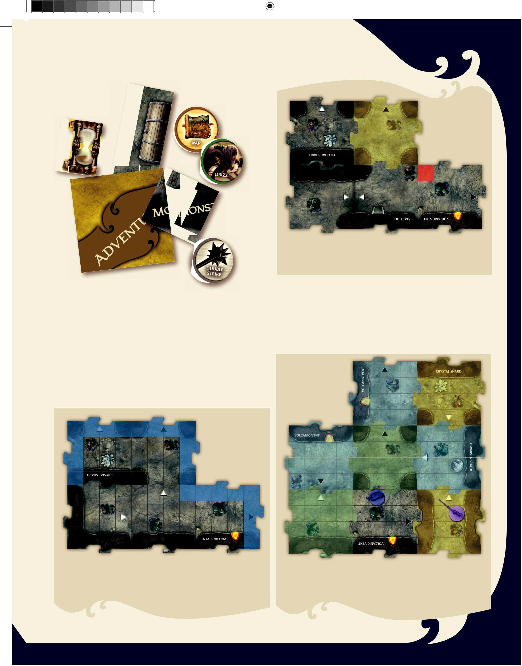

Treasure Chest token

Item token
Time token

Hero token

Monster token

Adventure marker

Double Strike token

The Cavern Tile Stack

You draw from the collected Cavern tiles (referred to as the Cavern Tile stack) to build the network of tunnels representing the Underdark. There are endless caverns in the Underdark, and it is easy to get lost. Each time you play, the caves have a different layout.

A tile is a component of the game board, highlighted in yellow. A square is a part of a tile, highlighted in red. The Start tile is a special tile: it is treated as two tiles.

Each Cavern tile features a mushroom patch (the square where Monsters are placed) and a white or black triangle (used to distinguish between less dangerous and more dangerous tiles). Many tiles have walls, a few tiles have other special features, and some tiles have names to distinguish them for use in certain adventures.

2 3

An unexplored edge is an edge of a tile without a wall that is not adjacent to another tile. There are 6 unexplored edges in this diagram, highlighted in blue.

2 1 2

1 3

When counting tiles, you do not count diagonally and you count around tiles. The Drow Duelist, for example, is 3 tiles away from Drizzt.

5

300_35594000_LegODrizzt_Rules r3.indd 5 |  |  | 3/28/11 3:41 PM

Tiles from other D&D Adventure System board games are labeled “Dungeon Tiles” on the backs rather than “Cavern Tile.” There is no difference in game play between a Dungeon tile and a Cavern tile.

The Start Tile: The Start tile is where the Heroes usually enter the dungeon and begin their adventure. It’s twice the size of the other tiles. The Start tile actually consists of two separate tiles that are already connected; treat each as its own tile for pur-poses of movement and counting tiles.

Unexplored Edge: A Dungeon tile with an unexplored edge is a tile where you could place a new tile. This means that an edge of the tile is open and doesn’t have another tile adjacent to it.

Tiles and Squares

Game cards refer to both tiles and squares.

A tile is the basic building block of the dungeon, drawn from the Cavern Tile stack.

A square is one of the spaces on a Cavern tile.

Diagonal Movement: Your Hero can move diagonally when moving by squares, unless the path is blocked. Your Hero cannot move diagonally when moving by tiles. If you are count-ing squares, you can move diagonally, even between tiles. If you are counting tiles, you never count diagonally; you have to move in straight lines, not diagonal lines, when you count tiles.

Triangles: Each tile features a triangle. When you place a new tile, the triangle points toward the unexplored edge of the tile it is attached to. If the tile has a black triangle, you draw an Encounter card during the Villain Phase of your turn.

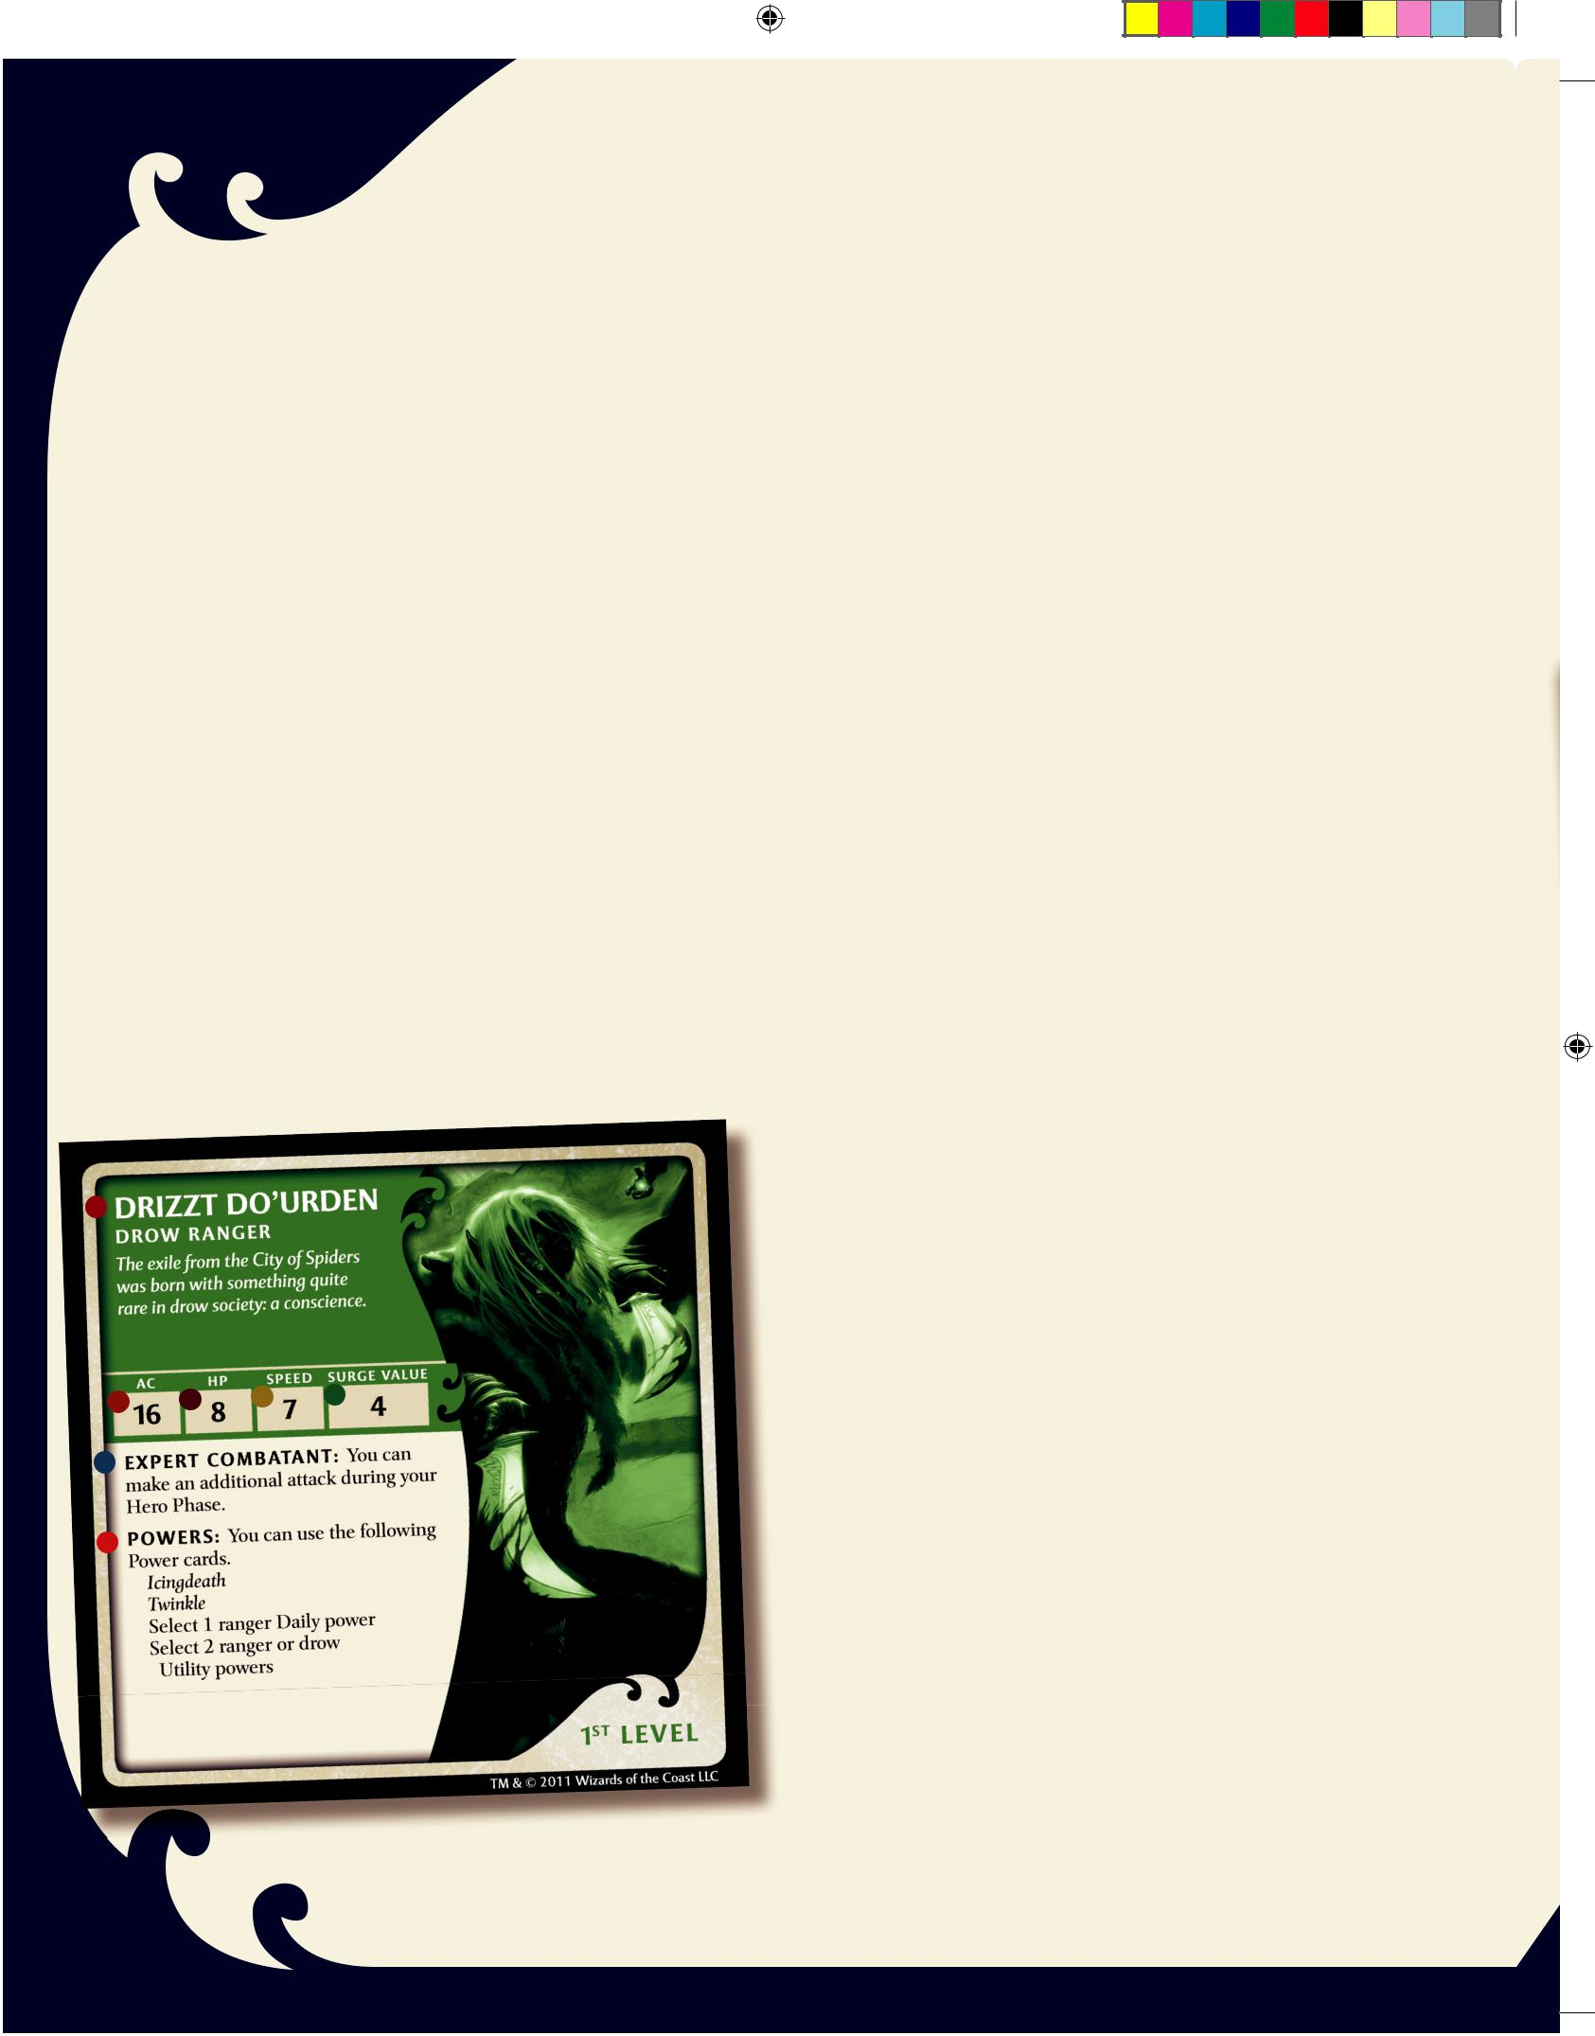

Cavern Edge Tiles

Each of these tiles is about one-quarter the size of a regular Cavern tile. The most common use for Cavern Edge tiles is to create a cavern complex at the start of an adventure. See “Creating a Pre-Built Cavern Complex” on page 14.

PLAYER SETUP

Place your Hero card (1st level) and your selected Power cards face up in front of you.

As you acquire Treasure cards, they also go face up in front of you.

As you acquire Monster cards and Trap cards, place them to one side of your Hero card, in the order in which you received them.

THE HERO CARD

Here’s what a Hero card looks like. The parts of a Hero card are briefly described here and explained in detail on the listed page of this book.

 Hero’s Name, Race, Class, and Level: The top lines show your Hero’s race and character class. The Hero’s level is shown in the bottom right corner.

 AC (Armor Class): The Hero’s defense score. An attack hits the Hero if it equals or exceeds this number (see page 9).

 HP (Hit Points): The Hero’s health. Damage reduces the Hero’s Hit Points (see page 9). A Hero can never regain more Hit Points than his or her Hit Point total.

 Speed: The number of squares the Hero can move by using a single move action (see page 7).

 Surge Value: When a Hero is at 0 Hit Points, he or she must use a Healing Surge token at the start of his or her next Hero Phase. After using the Healing Surge token, the Hero recovers this number of Hit Points (see page 10).

 Special Ability: Each Hero has a Special Ability, as described here.

 Powers: This tells you how many of each type of Power card you can select for use in an adventure, as well as any Power cards the Hero automatically gets to use (see page 9).

6

300_35594000_LegODrizzt_Rules r3.indd 6 |  |  | 3/28/11 3:41 PM
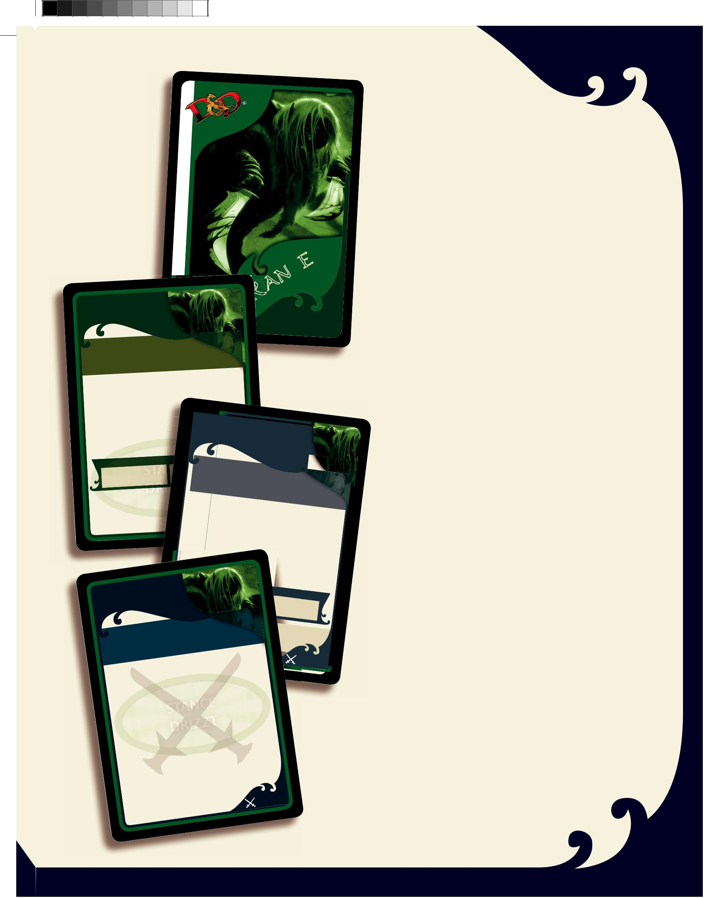
Hero card back

Hero card face | ANGER

RANGER |  |  |  |  |  |  |  |  |  |  | R
AT—WILL POWER |  |  |  |  |  |  |  |  |  |  |  | AT—WILL POWER
TWINKLE |  |  |  |  | -cut sapphire,
This elven | blade, set with a star
This elven |  |  |  | .
magically | protects its wielder
magically |  |  |  |  |  |  |  | then
Attack | 1 adjacent |  |  | Monster, |  |  |  | then
Attack |  |  |  | token on this card.
place your Stance
 |  |  |  |  |  |  | token from
You can remove your Stance
 |  |  |  |  |  |  |  |  |  | hits
this card when an adjacent |  |  |  |  |  | Monster
 |  |  | do, reduce the damage
 |  | by 1. |  |  |  |  |  | RANGER
 | . If you
your Hero
from that attack |  |  |  |  |  |  |  | DAILY
 |  |  |  |  |  |  |  |  |  | POWER
 |  |  |  |  | DAMAG E
 | AT TAC K |  |  |  |  |  | TWIN |  |  |  | STRIKE
 | AT TAC K |  |  |  |  |  |  | 1
 | +6 |  |  |  |  |  |  | 1
 | +6 |  |  |  |  | Drizzt’s |  |  | two scimitars
 |  |  |  |  |  |  |  |  |  |  | flash.

PLAYER TURN

Each player’s turn consists of three phases. On your turn, com-plete these phases in this order:

✦ Hero Phase

✦ Exploration Phase ✦ Villain Phase

Hero Phase

This is the phase in which your Hero moves through the dungeon and makes attacks against the Monsters encountered along the way.

- If your Hero has 0 Hit Points, use a Healing Surge token if one is available (see page 10).

- Perform one of the following actions: ✦ Move and then make an attack.

✦ Attack and then move.

✦ Make two moves.

When you have finished all the steps in your Hero Phase, your Exploration Phase begins.

Exploration Phase

This is the phase in which you add new Cavern tiles, draw Monster cards, and place Monsters.

TM & © 2011 Wizards | of the Coast

RANGER
UTILITY | POWER

Attack 1 |  | adjacent |  | Monster,
attack 1 |  |  |  | Monster,
attack 1 | adjacent |  |  | Monster, | then
 |  |  | Monster. |  | then
LLC |  | 65/200

AT TACK | DA M
+6 |  | AG E
+6 | 2
 | Miss: 1 | damage
1. If your Hero occupies a square along an unexplored edge

(see page 6), go on to Step 2.

If your Hero doesn’t occupy a square along an unexplored edge, you don’t draw and place a new Cavern tile. In this case, go on to the Villain Phase.

2. Draw a Cavern tile and place it with its triangle

pointing to the unexplored edge of the tile your Hero is

exploring from.

 |  |  |  |  |  |  |  |  |  |  | Flip This
LAST |  |  | BLOOD |  |  |  |  |  |  |  |  |  |  | Card |  | Over
 |  |  |  |  |  |  |  |  | Artemis |  |  |  |  |  |  |  | After | U | se.
 |  |  |  |  |  |  | .”—
 | blood is |  |  |  | mine |  |  | TM |  | & ©.”—Drizzt
“First | blood |  | counts |  |  |  | for |  | more |  | 2011 |  | Wizards of |  | the
“Last |  |  |  |  |  |  |  |  |  |  |  |  | . Place |  | yourCoast |  | LLC |  | 67 | /200
 |  | instead |  |  |  | of attacking |  |  |  |  |  |  |  | . |  |  |  |  | 67 | /200
Use |  |  |  |  |  |  |  | on |  | this |  | card
 |  |  |  | token
Stance

 |  |  |  |  |  |  |  |  |  | your |  |  |  | Stance |  |  |  |  |  | token
 |  |  |  | remove |  |  |  |  |  |  |  |  |  |  |  |  |  |  |  | any | Villain
 |  | can |  |  |  |  |  |  |  |  |  |  |  |  |  |  |  | of |  | any
You |  |  |  |  |  |  |  |  |  |  |  |  |  |  |  |  |  |  |  | any |  | up to
 |  |  |  |  | card |  |  |  | at the start |  |  |  |  |  |  |  |  |  |  | Hero
from |  |  | this |  |  |  |  |  |  |  | move |  |  |  |  |  | your |  |  |  |  |  |  | use
 |  |  |  |  |  |  |  | do, |  |  |  |  |  |  |  |  |  |  |  |  | can |  |  | use
 |  |  | . If you |  |  |  |  |  |  |  |  |  |  |  |  |  |  |  |  |  |  |  |  | use
 |  |  |  |  |  |  |  |  |  |  |  | and |  |  | that Hero
Phase |  |  |  |  |  | Speed
his |  | or her |  |  |  |  |  |  |  |  |  |  |  |  |  |  | .
 |  |  |  |  |  |  | attack |  |  |  |  |  | power |  |  |  |  |  |  |  |  |  | 178
 |  |  | -Will |  |  |  |  |  |  |  |  |  |  |  |  |  |  |  |  |  |  |  |  | /200
an |  | At |  |  |  |  |  |  |  |  | of the |  |  |  | Coast |  |  | LLC
 |  |  |  |  |  | Wizards
 | & © 2011
TM

3. Place a Monster on the new tile. To place a Monster, draw

a Monster card and place it in front of you to show that

you control that Monster. Place the corresponding Monster

figure on the mushroom patch of the newly placed Cavern

tile. (The name of each Monster is printed on each figure’s

base.) If you draw a Monster card that matches a Monster

you already control, discard that Monster card and draw

again. If another player has a matching Monster card,

however, that’s okay.

When you have finished all the steps in your Exploration Phase, your Villain Phase begins.

7

300_35594000_LegODrizzt_Rules r3.indd 7 3/28/11 3:41 PM

Villain Phase

This is the phase in which you draw and play Encounter cards, as well as when you activate the Villain (if the Villain is in play) and any Monster and Trap cards you have in front of you.

1. If you didn’t place a Cavern tile in your Exploration Phase, or if you placed a Cavern tile with a black triangle, draw and play an Encounter card.

2. If the Villain is in play, activate the Villain. (There could be more than one Villain in play, depending on the adventure. In this case, activate each Villain, one at a time.)

- Activate each Monster and Trap Card, in turn, in the order you drew them. Follow the tactics on the Monster Card to determine what each Monster does on its turn. If there are multiple Monsters with the exact same name in play, activate each of those Monsters on your turn. So, if you have a Goblin Archer Monster Card and another player has a Goblin Archer Monster Card, you activate both Goblins during your Villain Phase. If both Monsters survive until the other player’s Villain Phase, that player will activate both Goblins again!

When you are done with your Villain Phase, the player to your left begins his or her turn.

MOVEMENT

When you take a move action, your Hero moves through the dungeon to attack Monsters, explore, and achieve the adven-ture’s objective. Use the following rules for movement.

4
 |  |  | 3
A 2 |  |  |  |  |  | 6
1 |  |  | 2 |  | 3 | 5

1 |  |  | 3 |  |  | C
 | B
 | 4
 | 5 |  |  |  |  | D

You can move your Hero to any square, even diagonal ones, with a few minor exceptions. You cannot enter a square with a monster (A). You can move around walls but cannot enter a wall square (B). You cannot move between two adjacent walls (C). You cannot end your move in another Hero’s square (D).

If a creature with a base larger than one square is on more than one tile, it counts as being on all the tiles that the base is on. For example, Errtu counts as being on all the blue tiles. All the green tiles are one tile away from Errtu.

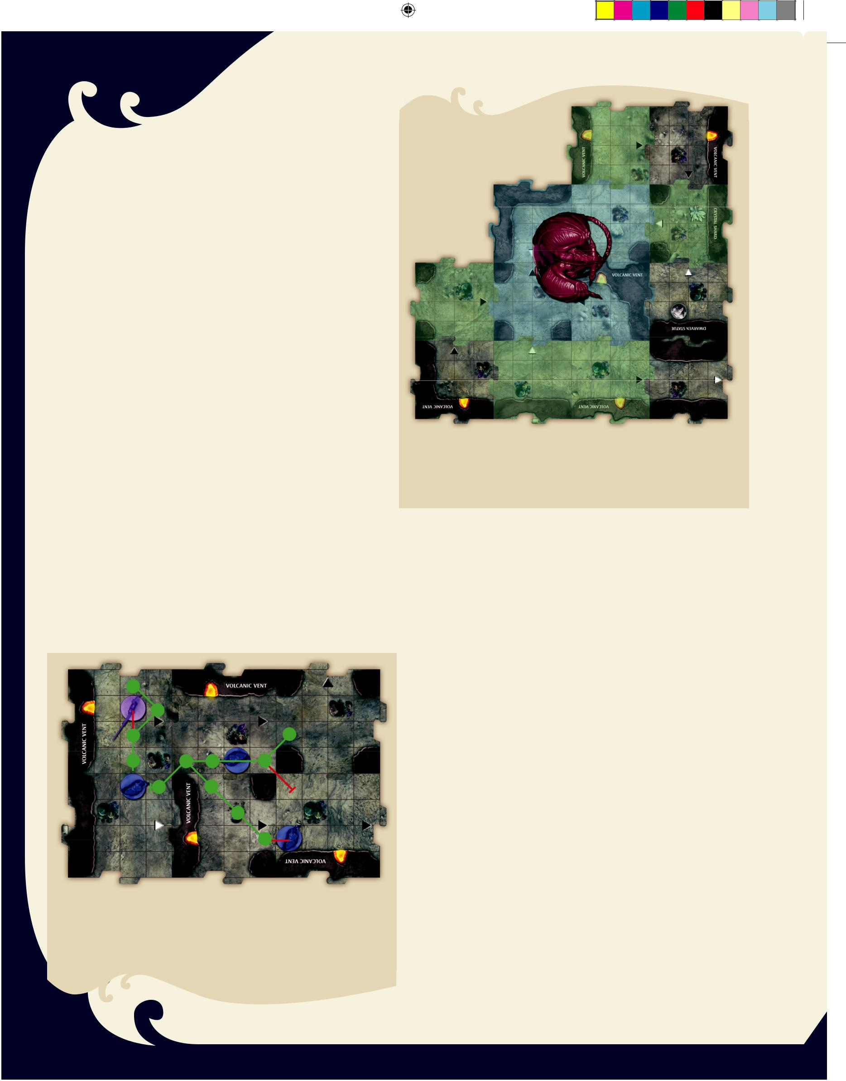

When Do You Move?

Your Hero usually moves during the Hero Phase of your turn.

The effect of a Power card, Treasure card, or Encounter card can make your Hero move at other times, as well.

How Do You Move?

Your Hero moves according to his or her Speed, which is the number of squares you can move your Hero when you take a move action.

Think of your Hero’s Speed as your movement budget. Each time your Hero moves a square, you spend 1 point from that budget. When you have no more Speed left, your Hero can’t move any more.

Each turn, you can spend up to your Speed budget to move your Hero. Your Hero can attack either before or after moving, or move twice instead of making an attack.

✦ Your Hero can move in any direction, including diagonally, as long as you have the necessary Speed to spend.

✦ You can’t move your Hero into a square filled with a wall.

✦ You can’t move your Hero into a square occupied by a Monster.

✦ You can move your Hero through a square occupied by another Hero, but you can’t end your movement there.

8

300_35594000_LegODrizzt_Rules r3.indd 8 |  |  | 3/28/11 3:41 PM
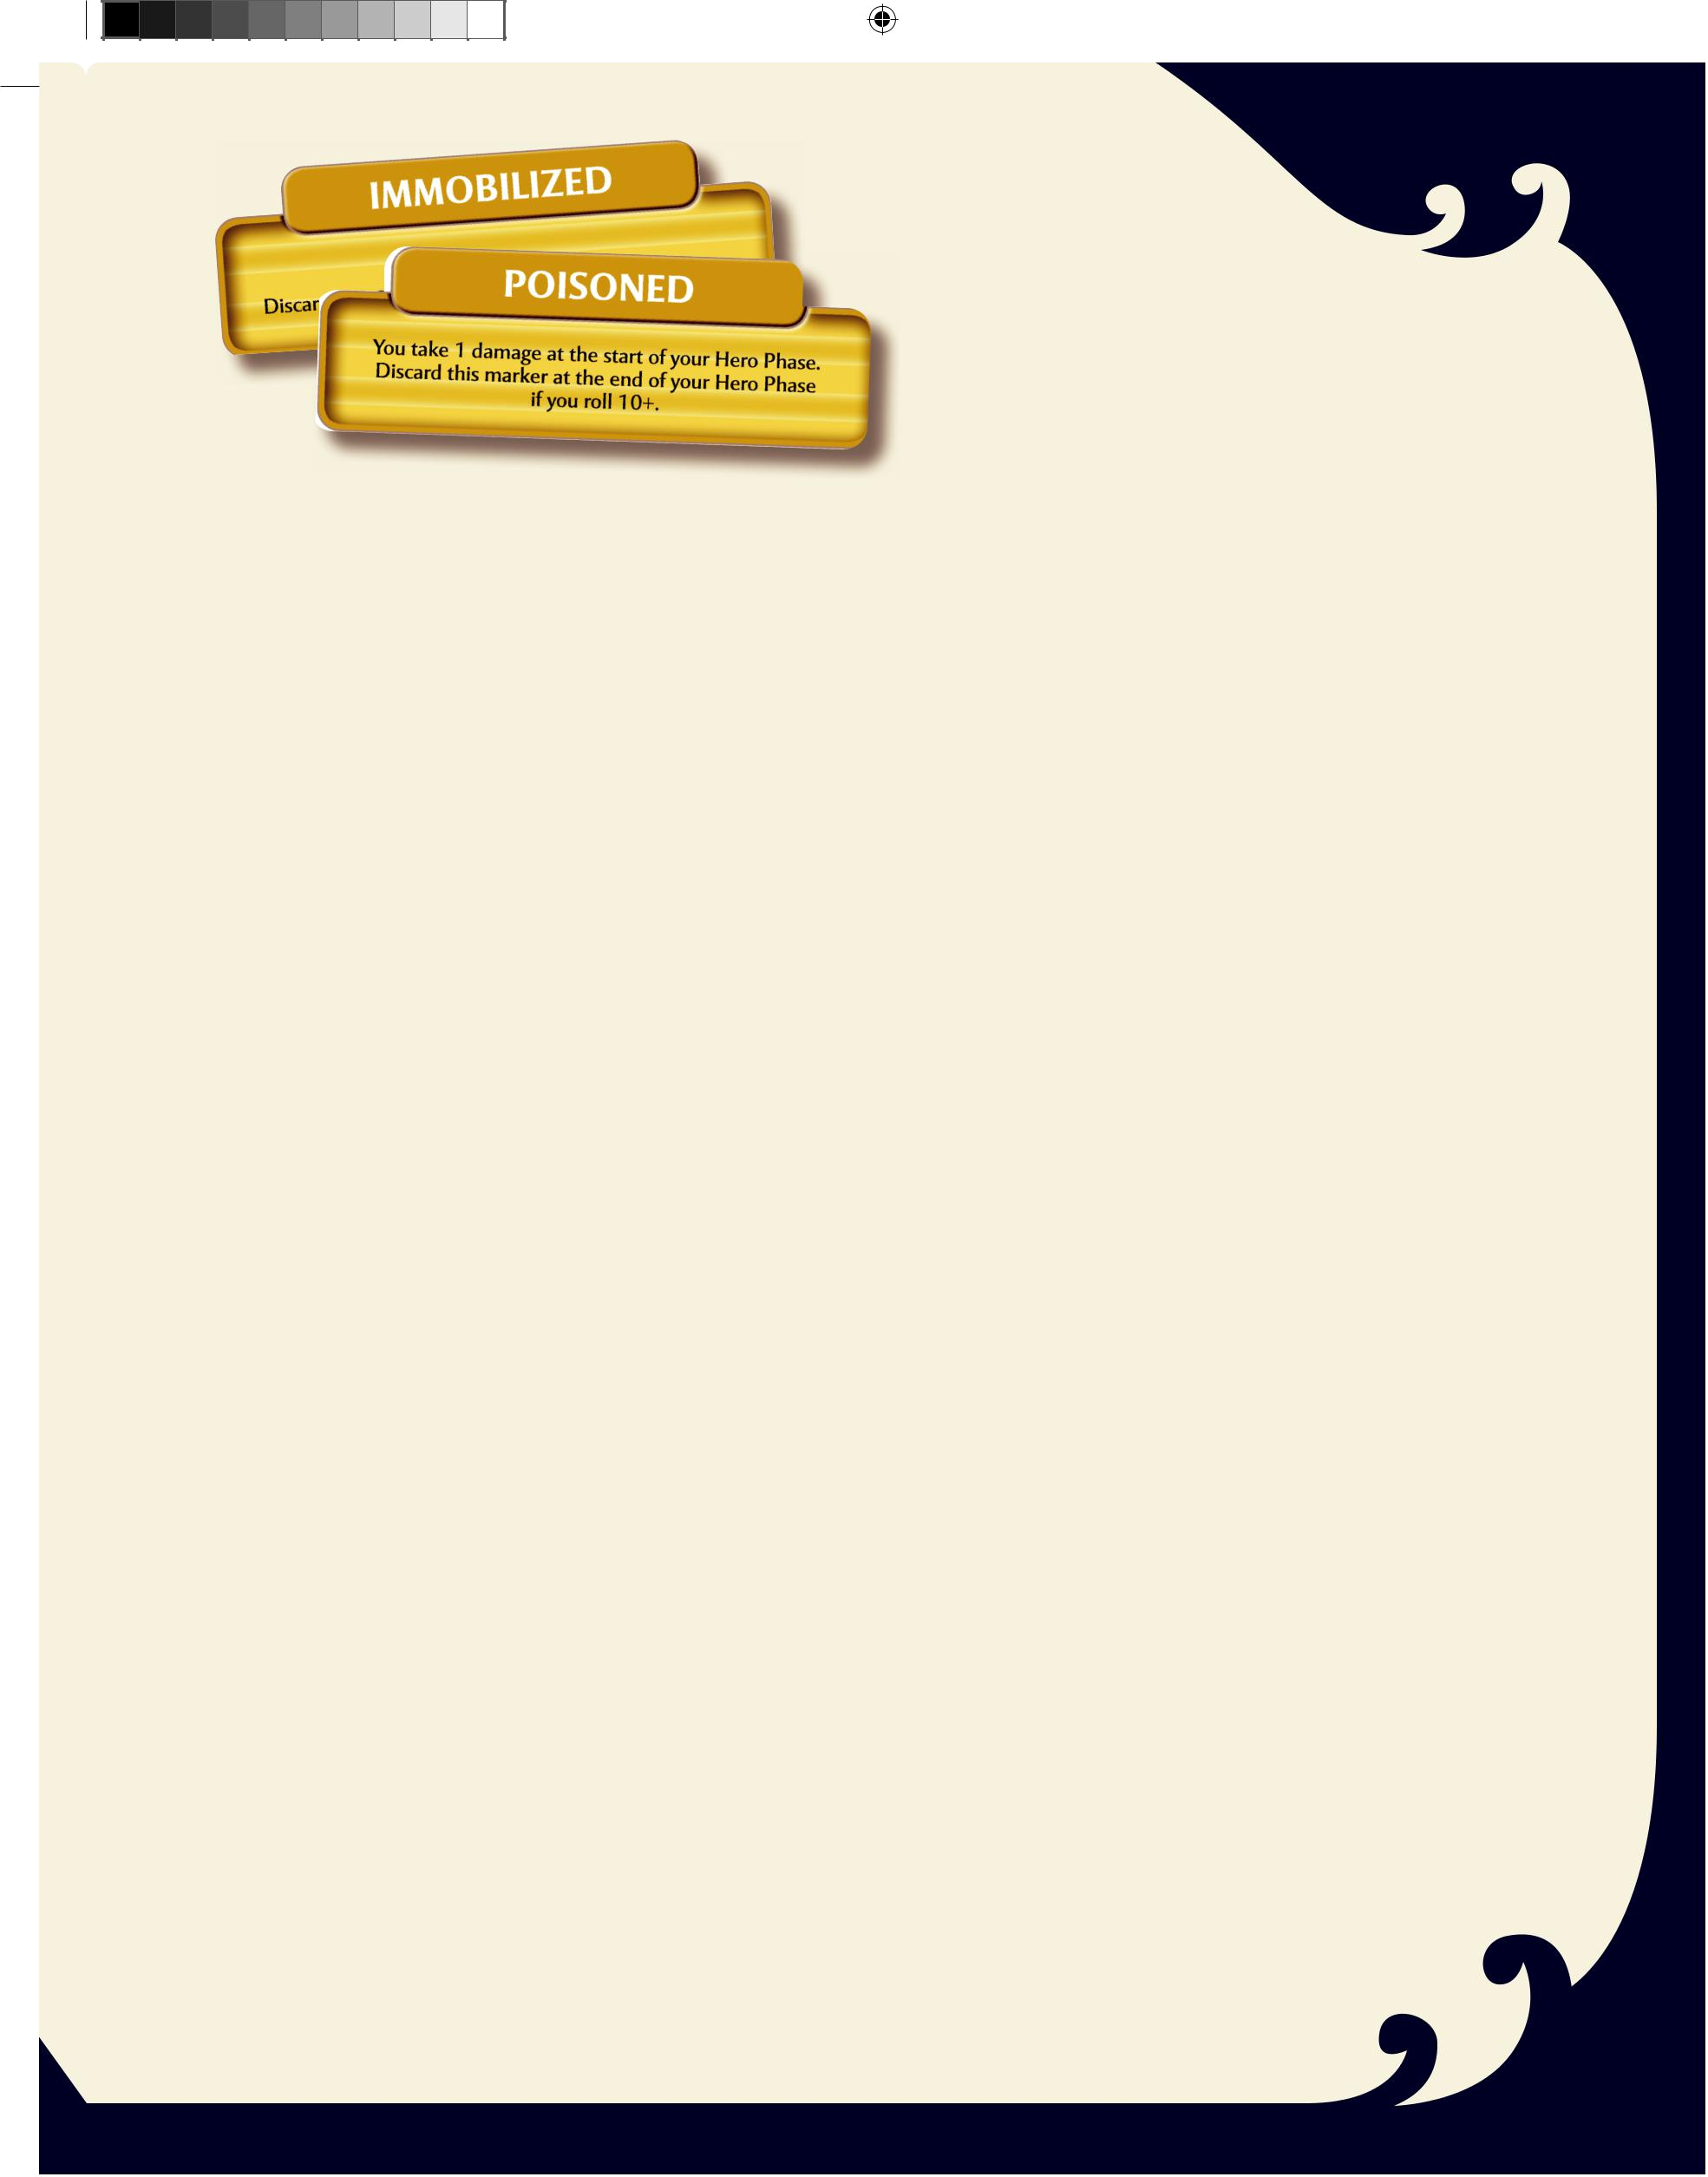

Condition: Immobilized

The sticky filament hurled by a cave fisher wraps itself around a Hero. The magical spellweb cast by a yochlol ensnares the group. These attacks and others like them cause a Hero to be Immobilized.

✦ If your Hero becomes Immobilized, put an Immobilized marker on your Hero card. You can have only one Immobilized marker on your Hero card at a time.

✦ While your Hero is Immobilized, his or her Speed is reduced to 0—that Hero can’t move! However, Immobilized Heroes can still swap positions with other figures or be placed in new positions.

✦ At the end of your Hero Phase, discard the Immobilized marker.

Condition: Poisoned

A swarm of spiders injects toxin into a wound. The poisonous spores from a baruchie colony invade a Hero’s lungs. These attacks and others like them cause a Hero to be Poisoned.

✦ If your Hero becomes Poisoned, put a Poisoned marker on your Hero card. You can have only one Poisoned marker on your Hero card at a time.

✦ While Poisoned, your Hero takes 1 damage at the begin-ning of your Hero Phase. Take this damage before using any Treasure cards and before checking to see if your Hero must spend a Healing Surge.

✦ At the end of your Hero Phase, your roll the die. If the result is 10 or higher, discard the Poisoned marker.

ATTACKS

A Hero makes attacks using either his or her Hero’s Power cards or the powers of Treasure cards. Most Power cards are related to the Hero’s class, but some Heroes also have a racial power (such as the drow’s Cloud of Darkness).

At the start of every adventure, you select Power cards that you have available for that adventure. Set the remaining Power cards aside. For your first few adventures, use the Power cards listed at the front of the adventure book. Once you become familiar with the game, you can select which Power cards you want to use.

Whenever you attack, you pick a power you have in front of you (either from a Power card or a Treasure card) and use it as described in Combat (below).

300_35594000_LegODrizzt_Rules r3.indd 9

At-Will Powers

At-Will powers are relatively simple

attacks, spells, or prayers. Using an At-Will power requires no special effort. It is weaker than a daily power, so when you use it you do not flip it over. You can use it again on your next turn.

Daily Powers

Daily powers represent a significant attack or a spectacular effect. When you use a Daily power, you flip it over and cannot use it again until some other effect (usually a Treasure card) allows you to flip it back up. Daily powers are the strongest attacks you have access to in the game.

Utility Powers

Utility powers are special maneuvers that don’t actively attack Monsters but instead provide other advantages. These advan-tages include a specialized move or the ability to counter a Monster’s attack. Many of these powers don’t require an attack action to use, instead specifying when to use the ability. Unless the card states otherwise, when you use a Utility power, you flip it over and cannot use it again until some other effect (usually a Treasure Card) allows you to flip it back up.

COMBAT

As your Heroes journey through the Underdark, they will encounter drow, goblins, and other Monsters. You must defeat these Monsters before they defeat you!

Targeting

When you decide to attack, first determine which Monsters your Hero can target. A power specifies what Monsters you can target, ranging from only Monsters in an adjacent square to a Monster as far as 3 tiles away.

Remember the difference between squares and tiles when making attacks (see page 6).

Most important, keep in mind that you can never trace a

diagonal path between tiles. If a power lets you attack a

Monster within 1 tile of you, that does not include Monsters

on a Cavern tile that is diagonal to yours. You also cannot attack

a Monster within 1 tile of your Hero if a wall completely blocks

paths between the Hero’s tile and the Monster’s tile.

AC and HP

The AC (Armor Class) of a Hero or a Monster determines how difficult it is to hit. It represents a combination of physical armor, agility, and natural toughness. HP (Hit Points) show how much damage a Hero or Monster can take before being defeated.

9

3/28/11 3:42 PM

Attack Bonus

Most attack powers and Monster attacks have an attack bonus. A power with a higher attack bonus is more likely to hit than one with a lower bonus.

Making an Attack

For each enemy a Hero’s power or a Monster’s attack targets, roll the die and add the power’s attack bonus.

If the result of the die roll plus the bonus is equal to or greater than the target’s Armor Class, the attack hits.

Certain cards and other game effects say “Use instead of attack-ing.” If a Hero (such as Drizzt) can attack more than once in a turn, or attack when it’s not his or her turn, such an effect can replace that attack.

Damage

If an attack hits, it deals the listed damage to the Monster or Hero. Damage that reduces a Monster’s Hit Points to 0 defeats that Monster. Damage that does not reduce a Monster or Hero to 0 Hit Points stays on that Monster or Hero (use the Hit Point tokens to track damage). Some Monsters have powers that let them heal damage. Many Hero powers allow you to heal vary-ing amounts of damage that one or more Heroes have suffered.

Defeating Monsters

If a Monster’s Hit Points are reduced to 0, the Monster is defeated. Remove its figure from the tile. The player controlling that Monster discards the Monster card into the Experience pile (see page 14). If more than one Hero controls that type of Monster, the player who made the attack discards the card if he or she controls one of those Monsters. If not, go clockwise around the table. The first player you reach who controls one of those Monsters discards that Monster card.

When your Hero defeats a Monster, draw a Treasure card (see page 13). You can draw only one Treasure card per turn, no matter how many Monsters you defeat during that turn.

Hit Point token

Monster Hit Point token

Healing Surge token

Defeating Heroes
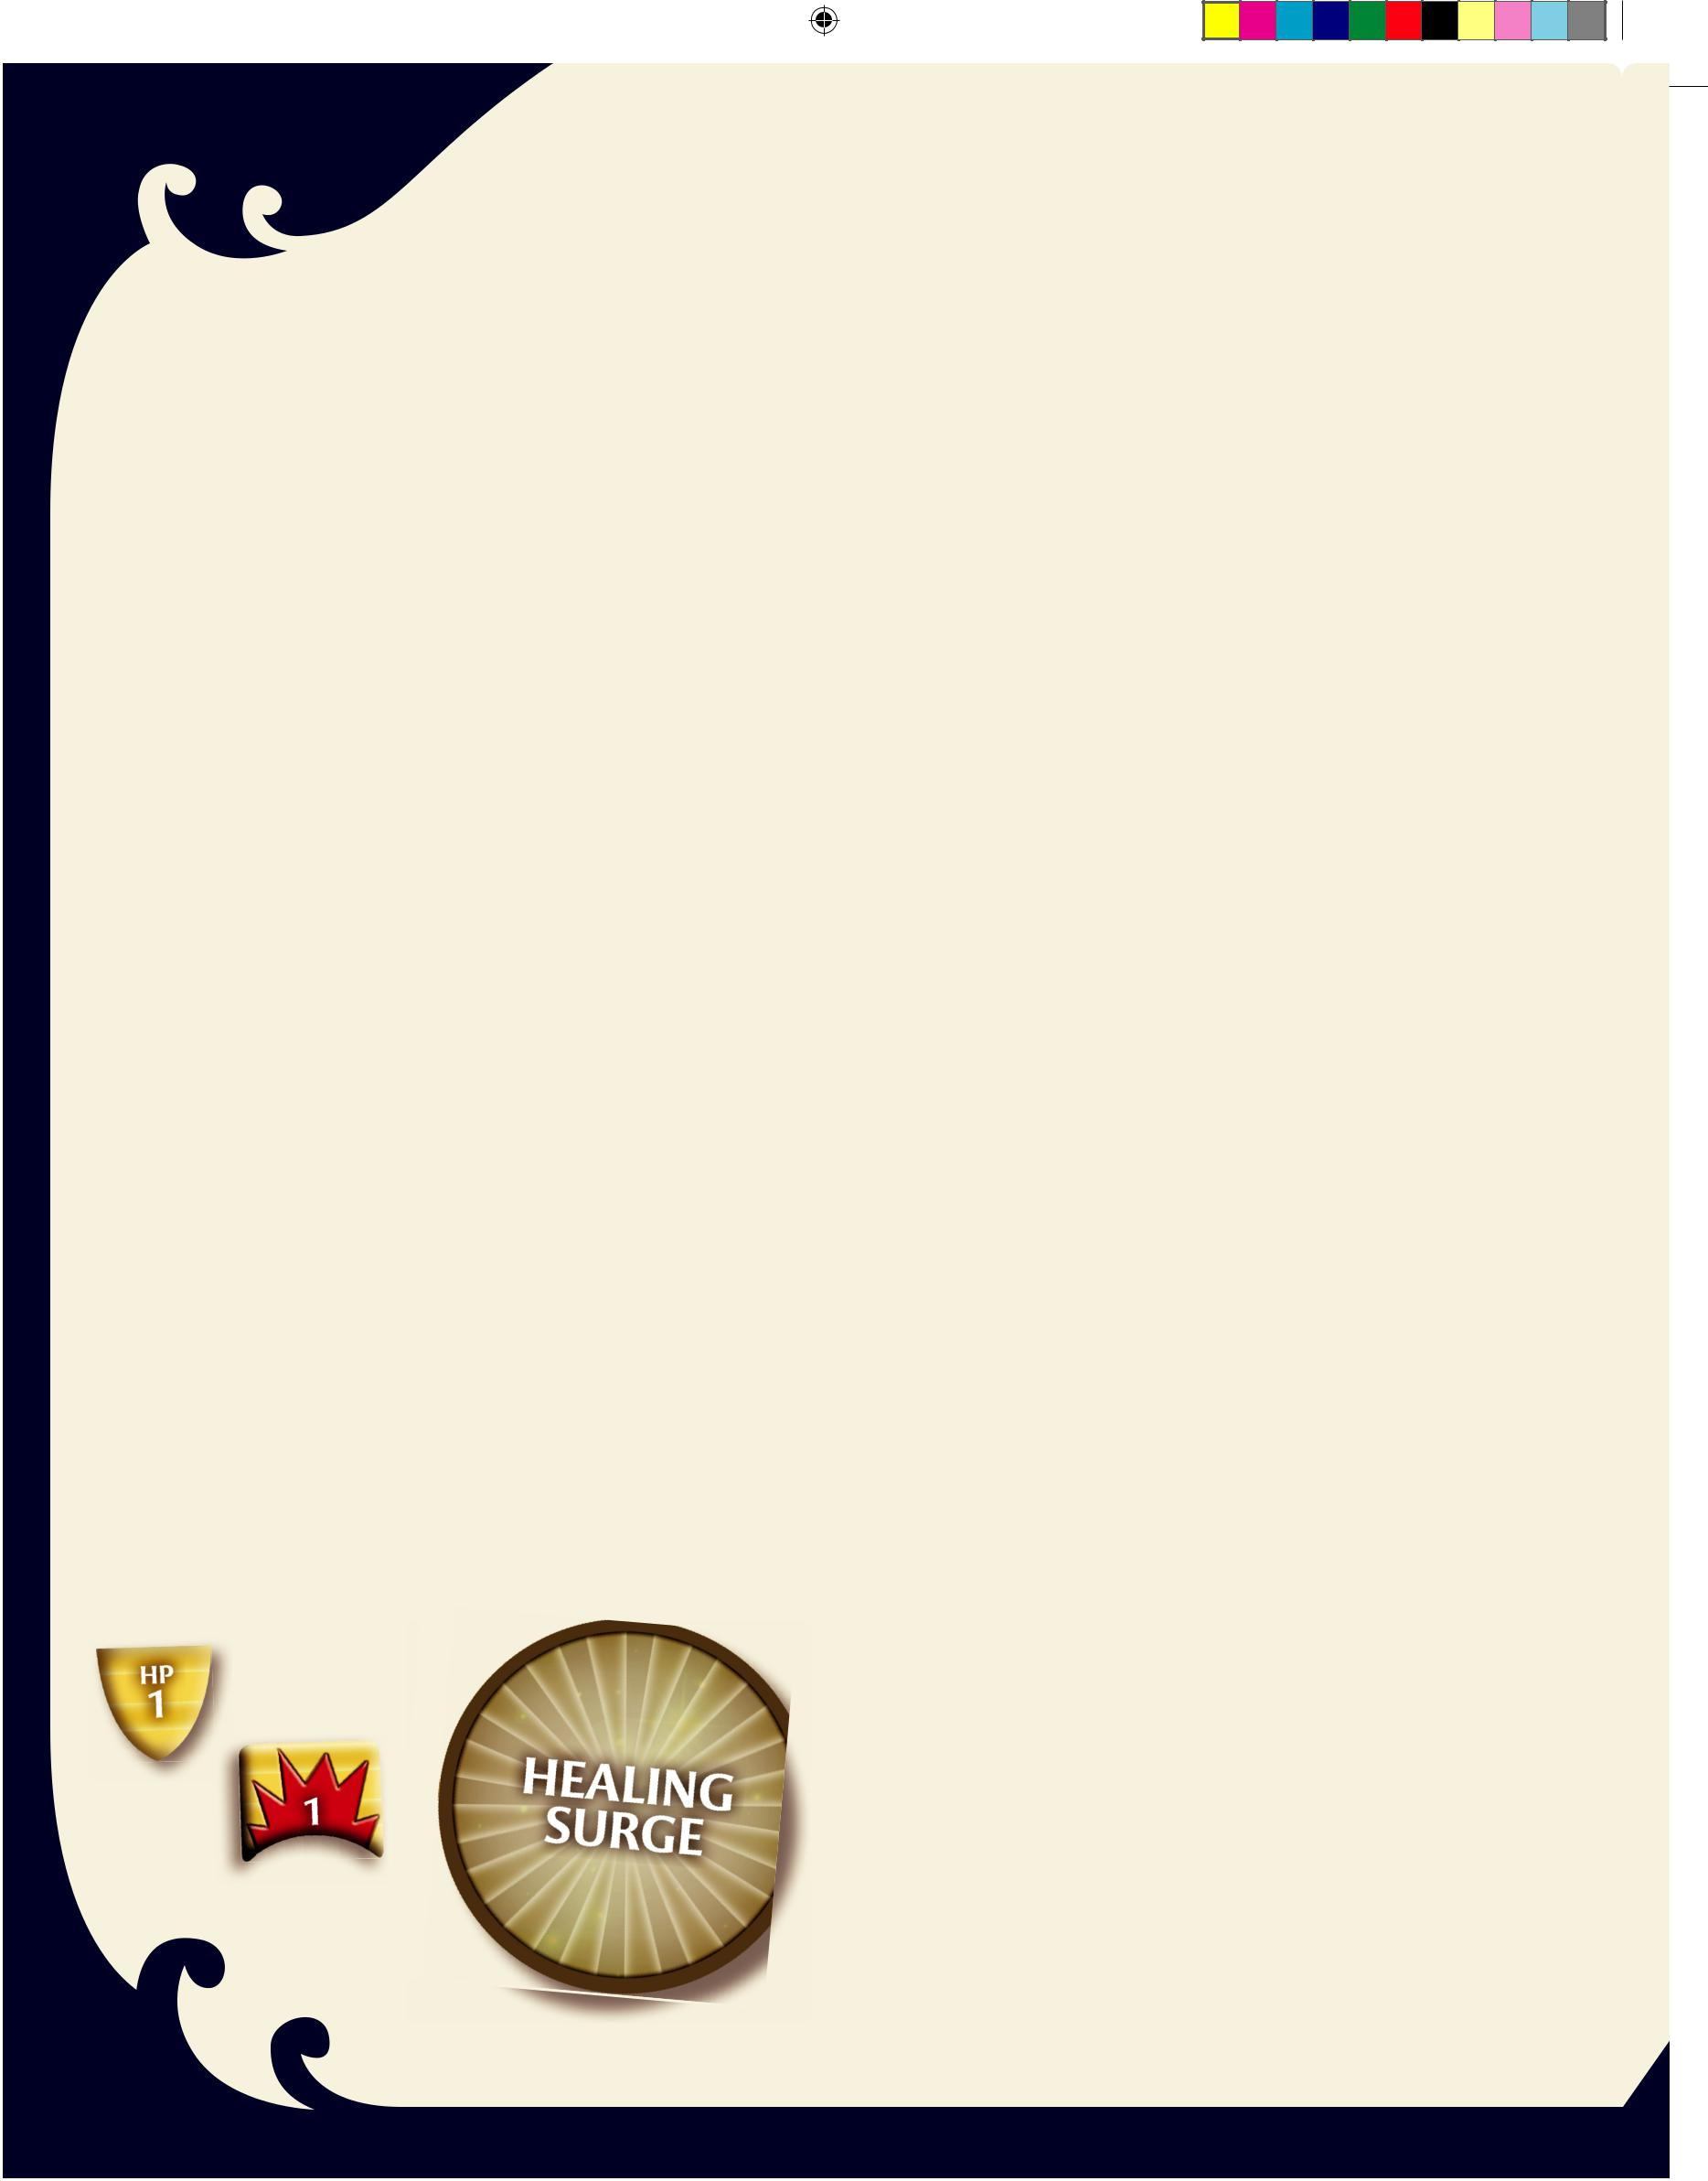


When a Hero is reduced to 0 Hit Points, keep the Hero’s figure on the tile. Knock the figure on its side to show that the Hero is at 0 Hit Points. Monsters ignore the downed Hero, and the Hero cannot take any additional damage or use any powers or items. Conditions, such as Immobilized or Poisoned, still apply to the Hero. If the Hero is healed before the start of his or her turn, stand the figure up—the Hero is back in the fight and can use powers and items normally.

A Hero that starts his or her turn at 0 Hit Points must spend a Healing Surge token. If there are no Healing Surge tokens remaining, the Heroes lose the adventure.

Healing Surges

A Healing Surge represents a Hero’s ability to fight on against overwhelming odds. Despite pain and injuries, a Hero can push forward to continue the battle. The Heroes begin the game with a number of Healing Surge tokens. These tokens are a resource that the entire group shares. You use Healing Surge tokens to revive a Hero that has been reduced to 0 Hit Points.

✦ If your Hero is at 0 Hit Points at the start of your turn, you must use a Healing Surge token. Discard one Healing Surge token and regain Hit Points equal to your Hero’s Surge Value. You then take your turn as normal.

✦ If there are no Healing Surge tokens remaining when your Hero starts your turn at 0 Hit Points, the Heroes lose the adventure and the game ends.

Other Actions

Moving and attacking are the most common types of actions that a Hero takes, but there are other things a Hero can do.

Picking Up and Dropping Objects

Some adventures instruct you to place an object (represented by a token) on a tile. To pick up an object, your Hero needs to be in any square adjacent to the object during your Hero Phase. Likewise, to drop a carried object, the carrying Hero just needs to be in a square adjacent to the location he or she wants to drop it. Your Hero can carry any number of objects. Picking up or dropping an object does not take an action. You can even pick up or drop objects in the middle of a move.

Destroying Objects

An adventure might specify that an object needs to be destroyed to win a particular scenario. If the object has an Armor Class and Hit Points, your Hero can target it just like a Monster. If your Hero has a power that attacks all Monsters on a specific tile, it can also attack an object on that tile. Once you deal damage equal to its number of Hit Points, you destroy the object and remove its marker from the tile.

10

300_35594000_LegODrizzt_Rules r3.indd 10 |  |  | 3/28/11 3:42 PM
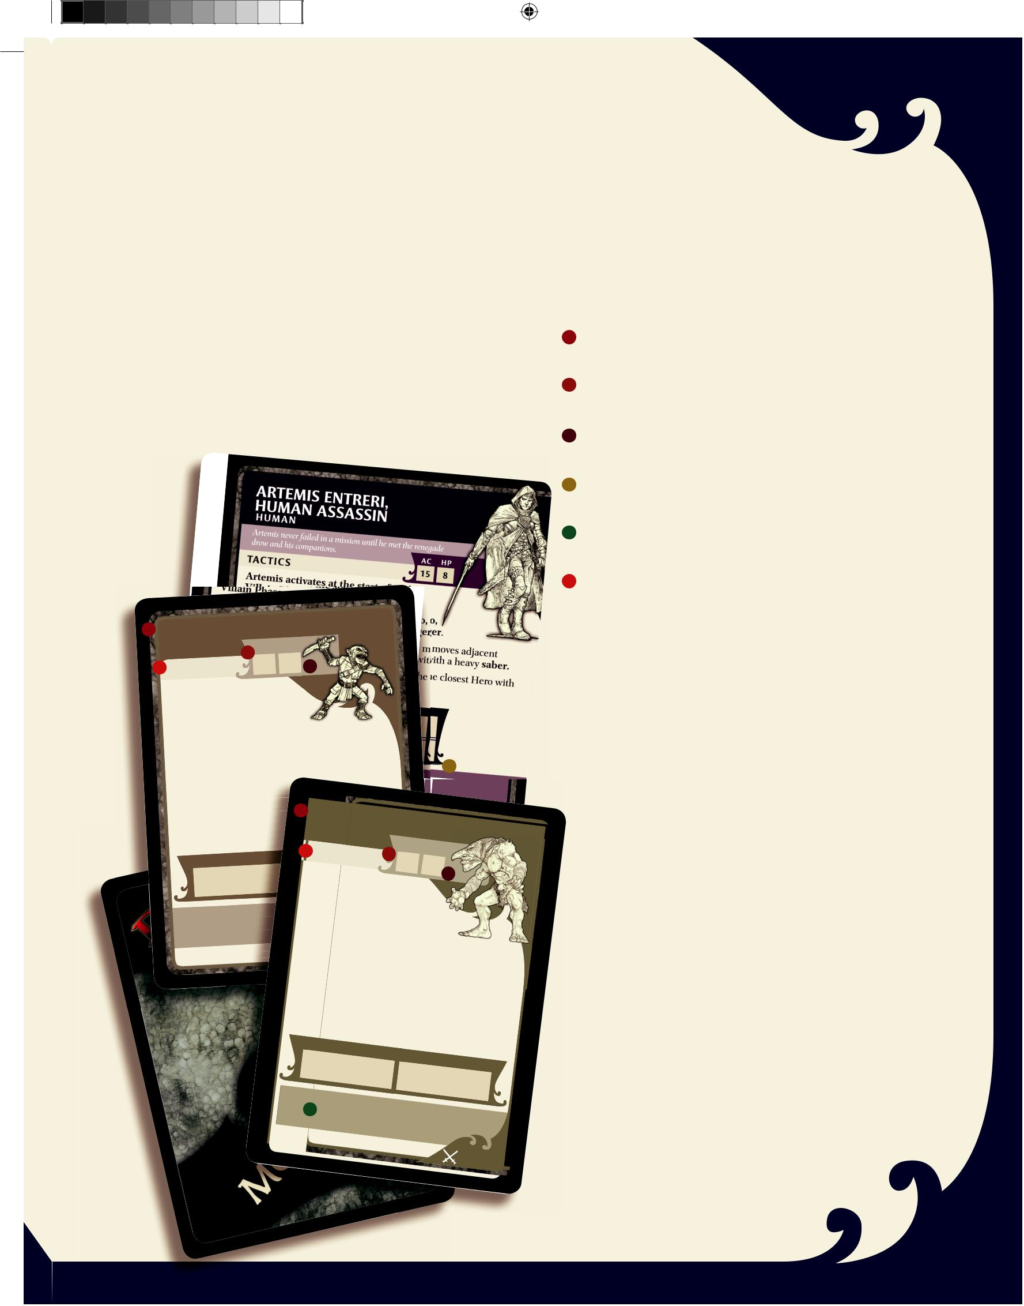
Disabling Traps

A Trap from an Encounter card can be disabled. While a Hero is on a tile with a Trap, he or she can attempt to disable that Trap instead of attacking. If you roll the number listed on the Trap card or higher, discard the Trap card and its marker.

Escaping the Dungeon

Some adventures require Heroes to escape from the dungeon. To escape from the dungeon, your Hero needs to be on the specified location (such as the ladder square on the Start tile or the stairs on the Surface Hollow tile) at the end of your Hero Phase. Unless the adventure specifies otherwise, once your Hero has escaped from the dungeon, you no longer take your Hero Phase or Exploration Phase, or draw Encounter cards, but you do continue to take your Villain Phase and activate any Monster cards or Trap cards that you control.

Villain

card face

GOBLIN CUTTER
G O B L I N |  |  | AC |  | H P
TAC T | I C S |  | 12 |  |  | 1
✦ If the Goblin |  |  |  | 1
Cutter is within
 |  |  | , it moves
tile of a Hero
adjacent |  | to the closest |  |  |  |  |  |  | with a
 |  |  |  | that Hero |  |  |  |  | with a
Hero and attacks |  |  |  |  |  |  |  |  | with a
 |  | .
crude dagger |  |  | , the Goblin Cutter
✦ Otherwise |  |  |  |  |  | the Hero with the
moves 1 tile toward
fewest Hit Points |  |  |  |  | re |  | FERAL |  |  | TROLL
 |  |  |  |  |  |  | T | RO L L |  | TROLL

THE MONSTER DECK

The Monster Deck randomly determines the Monsters that cross the Heroes’ path as they explore the dungeon.

Each Monster Card shows a Monster’s defenses and attacks. Villain cards represent especially tough “boss” monsters but otherwise follow the same rules.

Monster Name and Type: This shows the name of the creature and what kind of creature it is.

AC: This is the Monster’s Armor Class, its defense score (see page 9).

HP: This is the Monster’s Hit Points, its health score (see page 9).

Special Ability: If the Monster has a special ability, it is shown here.

Experience: This is how many Experience Points the Monster is worth when you defeat it (see page 14).

Tactics: Each Monster card provides a Monster’s tactics. The tactics are a script that shows you what the Monster does when you activate it during your Villain Phase.

✦ The Monster’s tactics are presented as a list. Each possible

tactic for the Monster starts with a statement. If that state-

ment is true, the Monster uses the resulting tactic.

✦ If the statement is not true, go on to the next statement.

The final entry in the tactics list is a default action that the

Monster follows if no other statements are true.

✦ If the tactic requires the Monster to move to a new tile,

place the Monster on the new tile’s mushroom patch if

that square is empty. Whenever possible, Monsters move

from tile to tile by following the mushroom patches. If the

AT TAC K

+7

 1 EX

TM & © 2011 Wizards

of

the

 | TAC |  |  |  |  |  |  |  |  |  |  |  |  | AC |  | H P
 | ✦ If |  | TI C S |  |  |  |  |  |  |  |  |  | 12 |  |  | 4
 |  |  | the Feral
 |  |  |  |  |  |  |  |  |  |  | Troll is
within 1 |  |  |  |  |  |  | tile
 |  |  |  |  |  |  |  |  | of a |  |  |  |  |  | Hero,
it moves
 |  |  |  |  |  | adjacent
closest |  |  |  |  |  |  |  |  |  |  |  |  | to the
 |  |  |  | Hero and
 |  |  |  |  |  |  |  |  |  |  |  | attacks |  |  |  |  |  | that
Hero with a
pass this |  |  |  |  |  |  |  | nasty |  |  |  |  | claw. After |  |  |  |  |  |  |  |  | the attack,
 |  |  |  |  | card to the |  |  |  |  |  |  |  |  |  | player
✦ | Otherwise, the |  |  |  |  |  |  |  |  |  |  |  |  |  |  |  |  |  | on your |  |  |  |  | right.
 |  |  |  |  |  |  |  |  |  |  |  |  |  | Feral Troll |  |  |  |  |  |  |  |  |  | right.
lost Hit |  |  | Points and |  |  |  |  |  |  |  |  |  |  |  |  |  |  |  |  |  | regains all
 |  |  |  |  |  |  |  |  |  |  |  |  | moves 1
the Hero |  |  |  | with the |  |  |  |  |  |  |  |  |  |  |  |  |  |  | tile |  |  |  | toward
 |  |  |  |  |  |  |  |  |  |  | fewest Hit
remaining. After |  |  |  |  |  |  |  |  |  |  |  |  |  |  |  |  |  |  |  | Points
 |  |  |  |  |  |  |  |  | the move,
card to |  |  |  |  |  |  |  |  |  |  |  |  |  |  |  |  |  | pass this
 |  | the player |  |  |  |  |  |  |  | on your
 |  |  |  |  |  |  |  |  |  |  |  |  |  |  |  |  | right.
 |  | AT TAC K
 |  |  |  |  |  |  |  |  |  |  |  |  |  |  |  | DA M
 |  | +8 |  |  |  |  |  |  |  |  |  |  |  |  |  |  |  |  |  | AG E
 |  |  |  |  |  |  |  |  |  |  |  |  |  | and |  |  |  | 3
 |  |  |  |  |  |  |  |  |  |  |  |  |  |  | move the |  |  |  |  | Hero 2 tiles

mushroom patch square is occupied, place the Monster anywhere on the tile.

✦ Once a Monster has selected and followed one set of

tactics, the Monster’s turn ends. Do not continue to check

its remaining tactics that turn.

✦ Sometimes a Monster requires you to place a new

Monster. Add that Monster card to the end of any Monster

cards you control. The new Monster acts during your

Villain Phase.
 | 4 |  | EXPERIENCE
 | TM & © |  | EXPERIENCE
Monster | 2011 | Wizards of the
card back |  |  | Coast LLC | 30/200

Monster

card face

11

300_35594000_LegODrizzt_Rules r3.indd 11 3/28/11 3:42 PM

 |  |  |  |  |  |  |  |  | EV E N T — AT TAC K
 |  |  |  |  |  |  |  |  | SPELLWEB
 | Encounter |  |  |  |  | A snare of webs halts |  |  |  |  | Lolth’s foes.
 | card face |  |  |  |  | Attack each
 |  |  |  |  |  |  |  |  | Hero on your Hero’s tile.

 |  |  |  |  |  |  |  | T
 |  |  |  |  |  | EN
 |  |  |  | EV |  |  |  |  |  | SPRAY
VOLCANIC |  |  |  |  |  |  |  |  |  | AT TAC K |  |  |  |  |  |  |  |  |  | DA M AG E
 |  |  |  |  |  |  |  |  |  |  | +8
 |  |  |  |  |  |  |  |  |  |  |  |  |  |  |  |  |  | Immobilized
 |  |  |  |  |  |  |  |  |  |  | .
 | lava |  | burns |  | your |  |  | flesh
Spouting |  |  |  |  |  |  |  |  |  | Discard |  |  |  |  | after playing.
 |  |  |  | TM & © 2011 |  |  |  |  |  |  | Wizards of |  |  |  |  |  |  |  |  |  | C |  | U R S E
 |  |  |  | within |  |  |  |  |  |  |  |  |  |  | the
 |  |  |  |  |  |  |  |  |  |  |  |  |  |  | the | Coast LLC
 |  |  |  |  |  |  |  | 1 |  |  |  |  |  |  | the
Each | Hero |  |  |  |  | 1 |  |  |  |  |  |  |  | MARK |  |  |  |  |  |  |  |  | OF |  |  | LOLTH
Each | tile |  | takes |  |  | 1
Vent |  |  |  |  |  | 1
 |  |  |  |  |  |  |  |  |  | The Spider |  |  |  |  | Queen
 |  |  |  |  |  |  |  |  |  |  |  |  |  |  |  |  |  | desires |  |  |  |  |  | nothing but |  |  |  |  | your death.
 |  |  |  |  |  |  |  |  | Your
 |  |  |  |  |  |  |  |  |  |  |  | Hero is |  |  |  |  | cursed!
 |  |  |  |  |  |  |  | on your |  |  |  |  |  | Hero |  |  |  |  |  |  |  |  |  | Place |  |  |  | this card
 |  |  |  |  |  |  |  |  |  |  |  |  |  |  |  |  | card as a
 |  |  |  |  |  |  |  | Each |  |  |  | Hero |  |  |  |  |  |  |  |  |  |  |  |  | reminder.
 |  |  |  |  |  |  |  | (including |  |  |  |  |  |  | with at |  |  |  |  | least 1 |  |  |  |  |  |  | Curse
 |  |  |  |  |  |  |  |  |  |  |  |  |  |  | yours)
 |  |  |  |  |  |  |  | when |  |  |  |  |  |  |  |  |  |  | takes 1 |  |  |  |  |  |  | damage
 |  |  |  |  |  |  |  |  |  |  |  | this card is
 |  |  |  |  |  |  |  |  |  |  |  |  |  |  |  |  |  |  | played.
 |  |  |  | Discard
TM |  | & © 2011
 |  |  |  |  |  |  | At the |  |  |  |  | end of your
 |  |  |  |  |  |  |  |  |  |  | Hero |  | can take |  |  |  |  |  | Hero |  |  |  |  |  | Phase, |  |  |  | your
 |  |  |  |  |  |  |  |  |  |  |  |  |  |  |  |  |  |  | 1 |  |  |  |  |  |  |  |  |  | your
 |  |  |  |  |  |  |  |  |  |  |  |  |  |  |  |  |  |  |  |  |  | damage |  |  |  |  |  | to | your
 |  |  |  |  |  |  |  |  |  |  |  | discard |  |  |  |  |  | this |  |  |  |  |  |  |  |  |  | to
 |  |  |  |  | TM |  | & © |  | 2011 |  |  |  |  |  |  |  |  |  |  |  | card. |  |  |  |  |  |  | to
 |  |  |  |  |  |  |  |  |  |  |  | Wizards of the
 |  |  |  |  |  |  |  |  |  |  |  |  |  |  |  |  |  | Coast LLC |  |  |  |  |  |  |  |  |  |  | 9/200

Encounter

card back

12

THE ENCOUNTER DECK
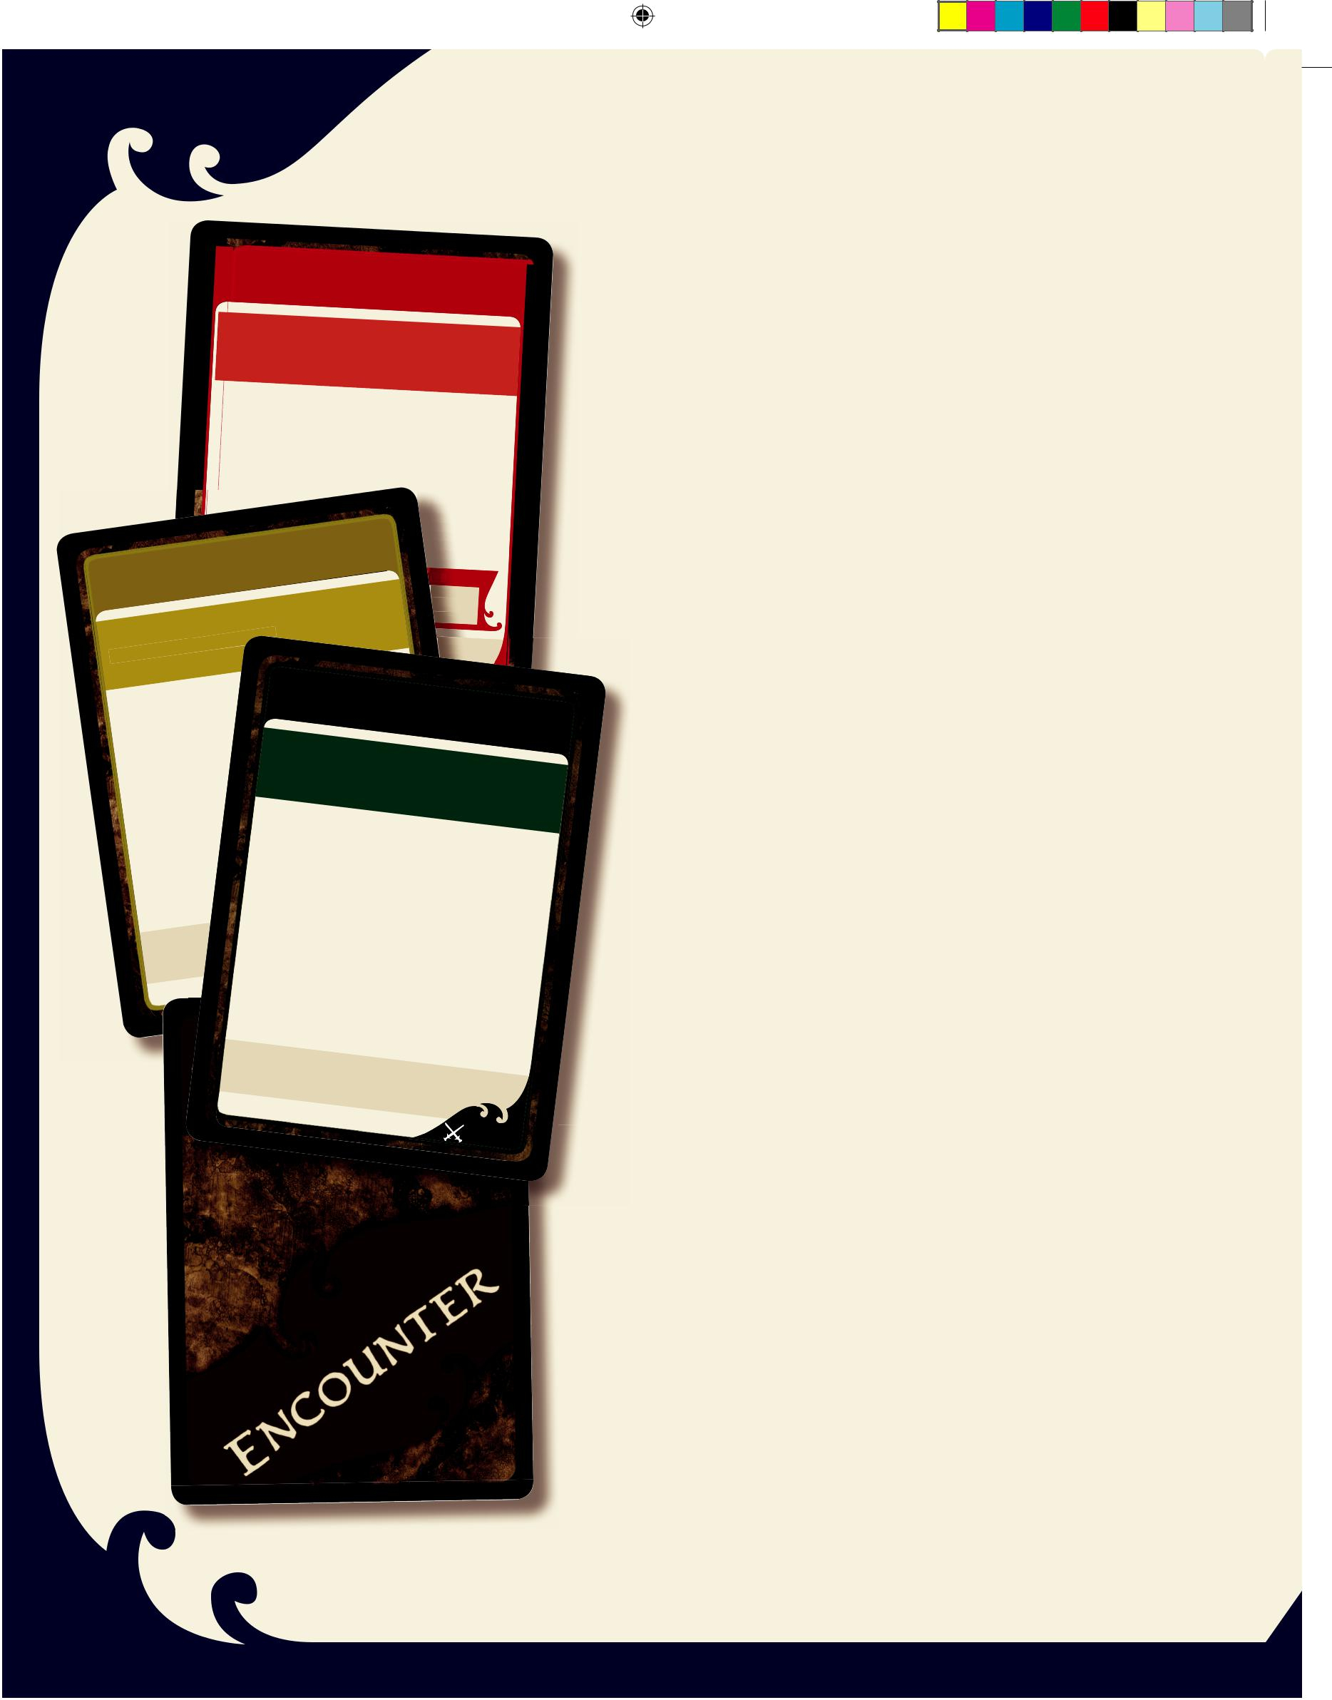
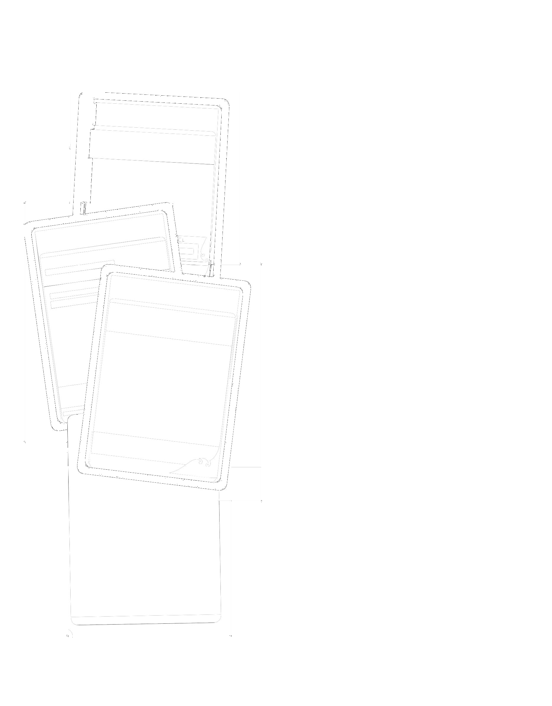

The Encounter deck represents the Events, Traps, and other threats that inhabit the Underdark. There are several types of Encounter cards, each with its own special rules. Whenever you draw an Encounter card, apply its effects immediately.

You can cancel an Encounter Card before applying its effects by spending Experience Points (see page 14).

“Active Hero” and “Your Hero”: Some Encounter cards use the phrase “your Hero.” The card affects the Hero played by the player who drew the card. Encounter cards in other D&D Adventure System games use “the active Hero” instead, but this text always refers to the Hero of the player who drew the card.

Other game effects that refer to “the active Hero” affect which-ever Hero is taking a turn when they take place.

Curses: Some Encounter Cards represent a curse that affects a single Hero. Place a Curse card on top of your Hero card to remember its effect. Curses last a short time, as described on their cards.

Events: An Event card is a strange occurrence, a dreadful sight or sound, or some other incident that befalls your Hero. An Event takes place when you draw the card unless you cancel it with Experience Points. Once you have resolved the Event, discard it.

Most Events are yellow cards. A few Events include an attack roll against one or more Heroes. These events appear on red cards and are called Event—Attacks to distinguish them from the Events that don’t include an attack roll.

Traps: A Trap is a snare or other device placed in the Underdark to injure and hamper the Heroes. Each Trap card has a corre-sponding marker. When you draw a Trap card, place the Trap’s marker on your Hero’s tile. If there is already a Trap marker there, discard the Trap card you just drew and draw another Encounter card.

After placing the Trap marker, put the Trap card in front of you with any other Monster cards and Trap cards you control. During your Villain Phase, the Trap activates like a Monster. Unlike Monsters, Traps lack tactics. Instead, a Trap takes the actions listed on its card. A Trap might attack all the Heroes on its tile, or it might attack the Hero closest to it. A Trap attacks just like a Monster.

Disabling Traps: A Hero can disable a Trap instead of attack-ing, as described on page 10. If the Hero can make more than one attack in a turn, the disable attempt can replace any of those attacks.

300_35594000_LegODrizzt_Rules r3.indd 12 3/28/11 3:42 PM
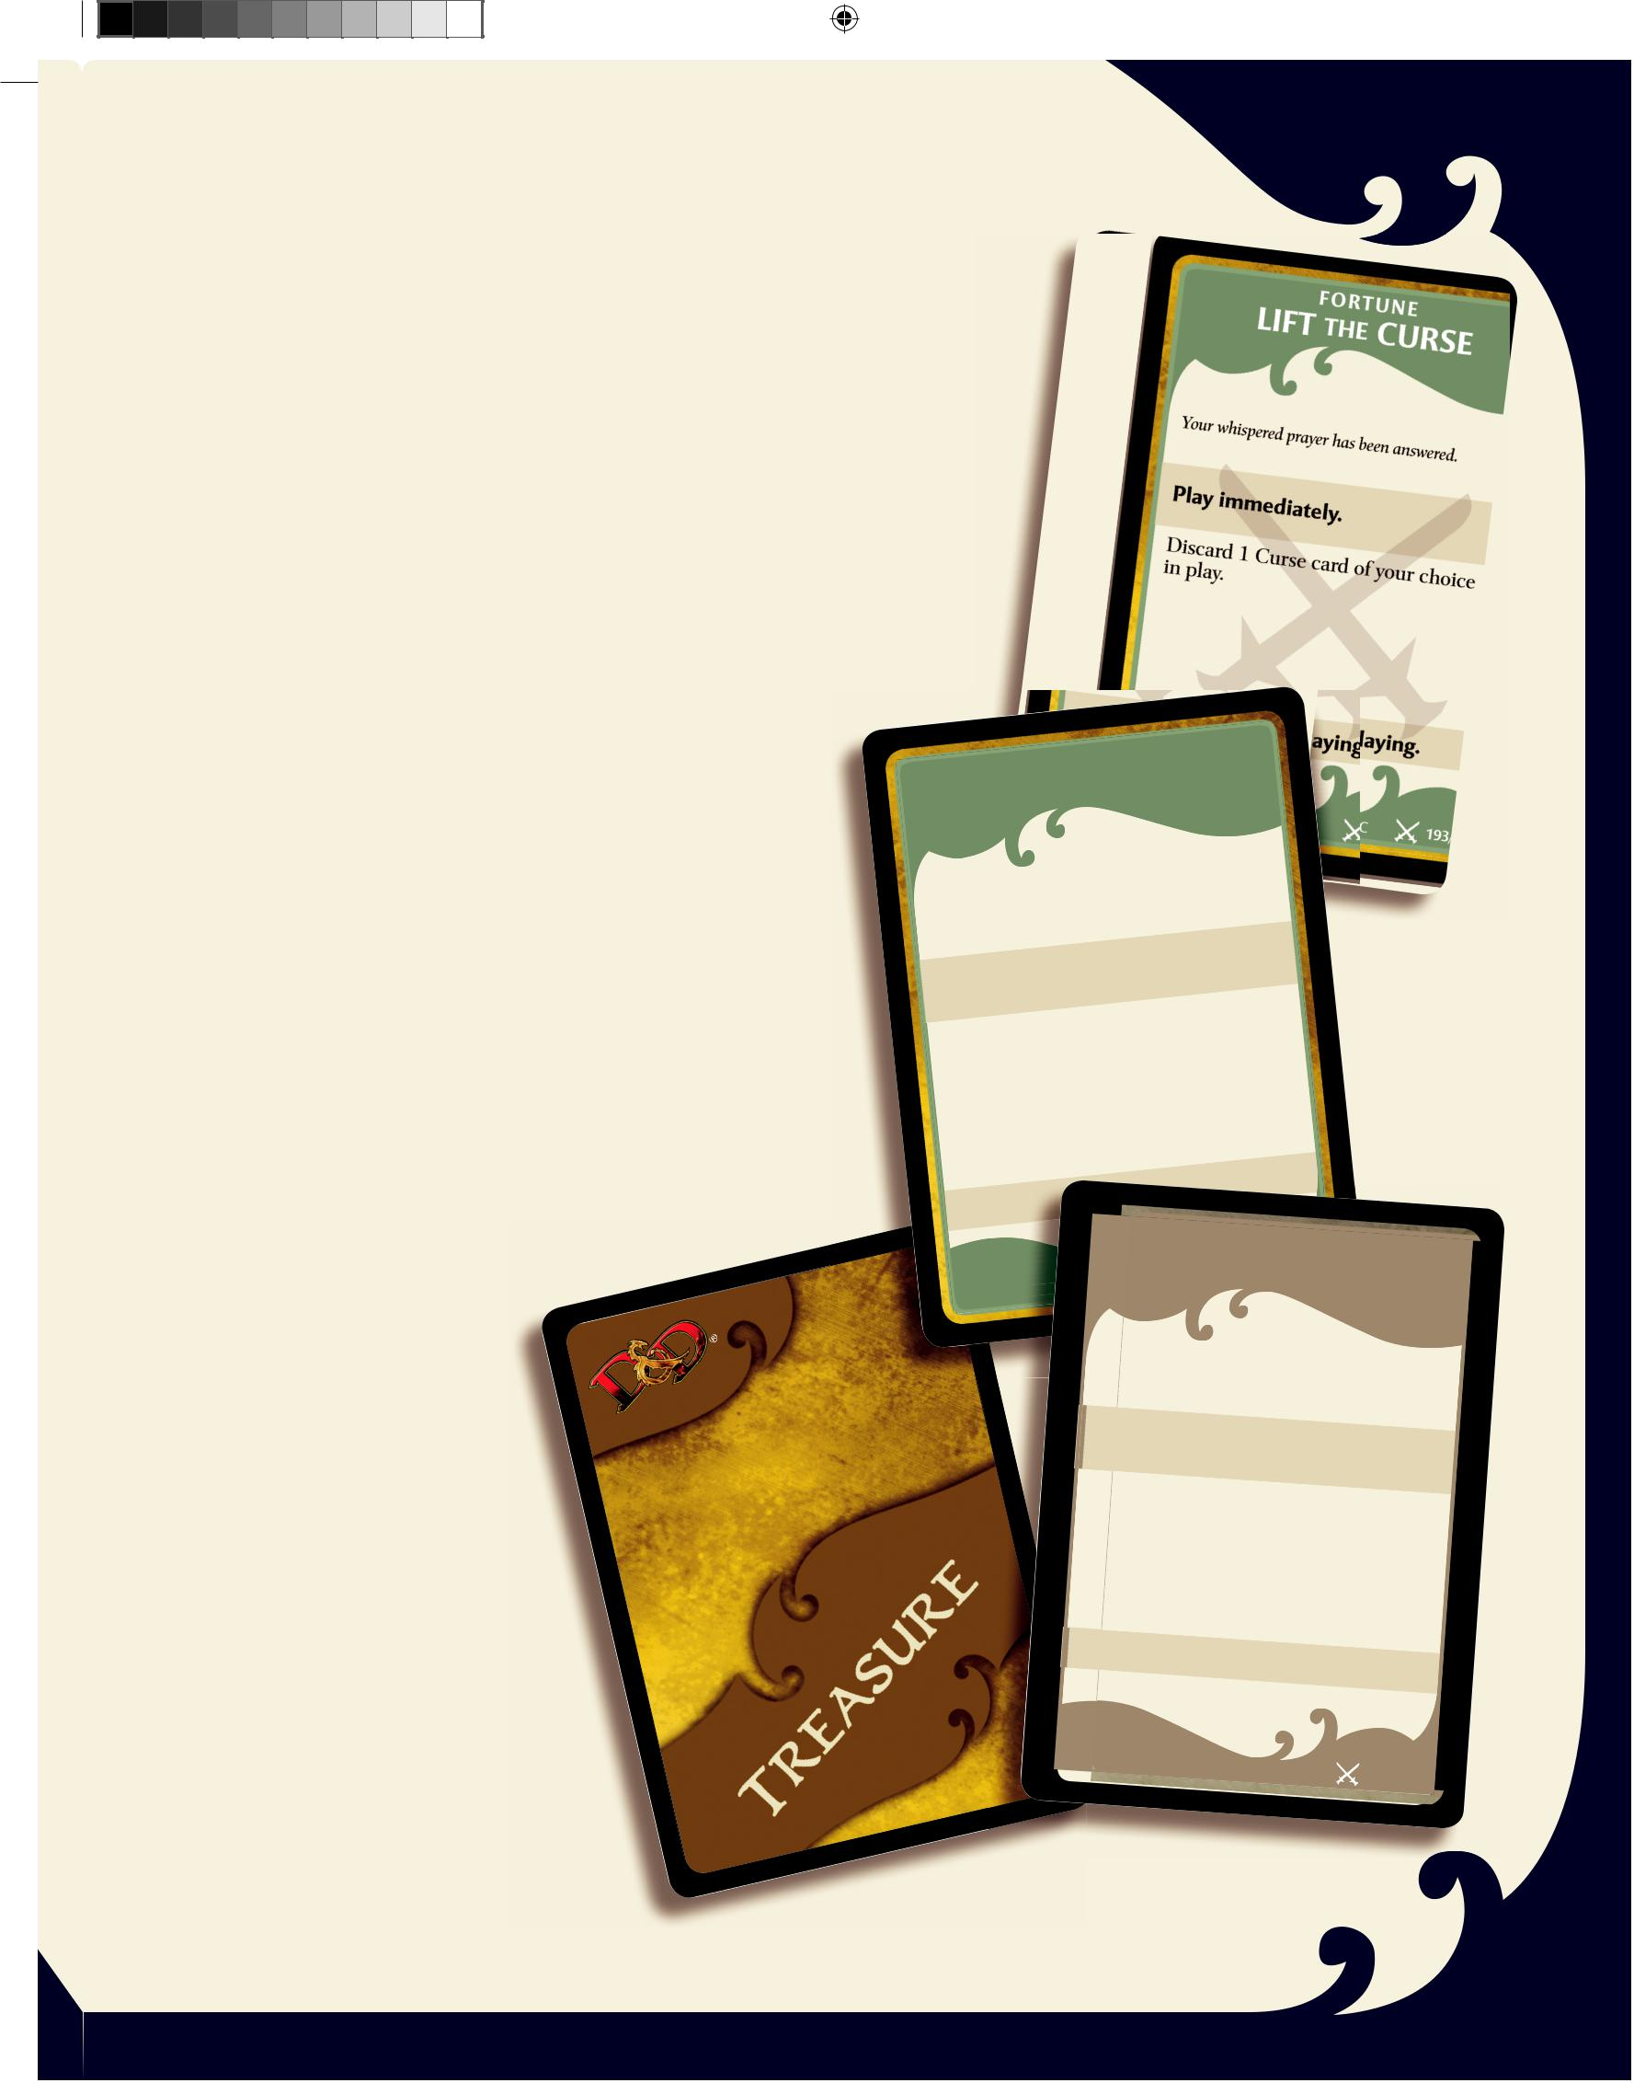

THE TREASURE DECK

The Treasure deck represents the magic items and other valu-ables you can find in the clutches of your defeated enemies. Once per turn, you can draw a Treasure card when you defeat a Monster. If you defeat more than one Monster in a turn, you still draw just a single Treasure card.

You can benefit from multiple Treasure cards in play that apply to your Hero. For example, you can use both a Fortune and an Item to increase the bonus to an attack roll.

The only exception to this rule applies to Items that provide attack or defense bonuses. A Hero can gain only one attack bonus and one defense bonus from Items at a time.

When you use a Treasure card, follow the rules stated on it. The Treasure card also explains when you can use it.

This game includes two types of Treasure cards.

✦ Fortunes are played immediately and provide an immedi-ate benefit. If the benefit has no effect, nothing happens. Discard a Fortune Treasure card immediately.

✦ Items provide a lasting benefit. When you draw an Item Treasure card, decide if you want to keep it for your Hero or if you want to give it to another Hero. Place the Item Treasure card in front of that Hero’s player. Once you’ve decided who gets the Item, you can’t give it to another Hero later.

Treasure

card face

 |  |  |  |  |  | FO RT |  |  |  |  | U N E
HARROWED |  |  |  |  |  |  |  |  |  | EXPERIENCE
 |  |  | have |  |  |  | come |  |  | this far without |  |  |  |  |  |  | learning
You couldn’t
 | .
something
 |  |  |  |  |  |  |  |  |  |  |  | . |  |  |  |  |  |  |  |  |  | Treasure
Play | immediately |  |  |  |  |  |  |  |  |  |  |  |  |  |  |  |  |  |  | . |  | card face
 |  |  |  |  | counts |  |  |  |  | as 1 Experience |  |  |  |  |  |  |  |  | Point
This | card |  |  |  |  |  |  |  |  |  |  |  |  |  | pile, |  | and
This |  |  |  |  |  |  | Experience
This |  |  |  |  |  |  |  |  |  |  |  |  |  |  |  |  | party uses
Put it in the |  |  |  |  |  |  |  |  |  |  |  |  |  |  |  | the
 |  |  |  |  |  |  |  |  | card |  |  | when |  |  |  | the
discard |  |  |  | this
 |  |  |  |  |  |  |  |  |  | .
it for Experience
 |  |  |  |  |  |  |  |  | 1 EXPERIENCE
 |  |  |  |  |  |  |  |  |  |  |  |  | POTIONLLC |  |  |  |  |  |  | I T E M
 |  |  |  |  |  |  |  |  |  |  |  |  |  |  |  |  |  |  |  | 82/200
 |  |  |  |  |  |  |  |  |  |  |  |  |  |  |  |  |  |  |  | OF | HEALING
 |  |  |  | 0 |  |  | Wizards |  |  |  |  | of the Coast
TM & © 2011
 |  |  |  |  |  |  |  |  |  | This glass vial |  |  |  |  |  |  | contains a thin liquid that |  |  |  |  |  |  | tastes like
 |  |  |  |  |  |  |  |  |  | honey. |  |  |  |  |  |  |  |  |  |  |  |  |  | tastes like
 |  |  |  |  |  |  |  |  |  | Use during
 |  |  |  |  |  |  |  |  |  |  |  |  |  |  |  |  |  | your Hero Phase.
 |  |  |  |  |  |  |  |  |  | Your Hero |  |  |  |  |  |  |  |  |  |  |  | Hero
 |  |  |  |  |  |  |  |  |  | 2 Hit |  |  |  |  |  | or 1 adjacent |  |  |  |  |  | Hero | regains
 |  |  |  |  |  |  |  |  |  |  |  |  |  | Points.

 | Discard
 | after use.
 | Price: 600 gold
TM & ©
2011 Wizards
 | of the Coast LLC | 94/200

Treasure
Treasure
card back
card face

13

300_35594000_LegODrizzt_Rules r3.indd 13 3/28/11 3:42 PM

EXPERIENCE POINTS

Heroes earn Experience Points by defeating Monsters. When you defeat a Monster, the Hero who controls it puts that Monster card in the Heroes’ Experience pile. Each Monster card lists the Experience Points it provides. The tougher the Monster, the more Experience Points it provides.

The Heroes can spend Experience Points in two ways:

✦ To cancel an Encounter card ✦ To level up

Canceling Encounter Cards

Canceling an Encounter card represents using the hard-fought experience your Hero has gained to avoid danger. For example, your Hero spots a Trap and disables it before it activates, or avoids an Event before it inflicts any injuries.

Whenever you draw an Encounter card, you can spend a total of 5 Experience Points to cancel it. The Monster cards you choose from your Experience pile must add up to at least 5 Experience Points. Discard the cards after you spend them. You can’t use any excess points from one cancellation in a later turn.

When you cancel an Encounter card, discard it and ignore its effects. You can cancel an Encounter card only when you draw it. Once the card comes into play, you cannot cancel it on a later turn.

Example: There are three Monsters worth 3 Experience each and one Monster worth 2 Experience in the Heroes’ Experience pile. If you want to cancel an Encounter card, you could spend one 3-point Monster card and the 2-point Monster card. That would leave you with two 3-point Monster cards in the pile. If you then wanted to cancel another Encounter card, you would have to spend the two 3-point Monsters. Even though you have 6 total Experience Points and need to spend only 5, you don’t have the right mix of cards to make exactly 5. The extra point is wasted and both cards are discarded, though you still cancel the Encounter card.

Leveling Up

A Hero starts play at 1st level. Whenever a Hero rolls a natural 20 when making an attack roll or a disable trap roll, that Hero can choose to spend 5 Experience Points to become 2nd level! Discard the Monster cards after you spend them. Flip your 1st-level Hero Card over to the 2nd-level side. Leveling up to 2nd level increases your Hero’s Hit Points, Armor Class, and Surge

14

Value. It also allows you to choose a new Daily power, and your Hero gains the special ability to make critical attacks (shown on the Hero card).

In addition to the natural roll of 20, the Battlefield Promotion Treasure card also provides an opportunity to level up your Hero.

RULES FOR LATER ADVENTURES

Once you have played the first two adventures and are com-fortable with the rules, try the rest of the adventures in the adventure book. Here are rules for your later games.

The Advanced Deck

The Legend of Drizzt board game includes two decks of cards. For your first couple of games, just use the Starting Deck (cards 1–100). Adventures 1 through 4 need only this deck. For Adventures 5 and beyond, you will need the Advanced Deck (cards 101–200), which adds more cards and introduces more complex effects.

Choosing Power Cards

Once you have a better understanding of the game, you don’t have to stick to the suggested Power cards for your Hero listed in the front of the adventure book. Each 1st-Level Hero card tells you how many powers of each type you get—you can choose which At-Will, Utility, and Daily Power cards you want to use for any particular Adventure.

For a slightly easier game, choose the Power cards you want. This way you can set up the perfect balance of powers and you’ll know exactly what to expect from your Hero.

For a slightly more challenging game, choose your Power card in each category randomly. You’ll have the fun of figuring out how to get the most out of surprising combinations of powers using this method of selection.

OPTIONAL RULES

Some adventures make use of optional rules and include some or all of the pieces we suggested you set aside during setup (see page 4). Here’s a brief rundown on some of these rules.

Cavern Edge Tiles

Some adventures use these special tiles, which close off some unexplored edges.

Creating a Pre-Built Cavern Complex

Some adventures require you to create a finite cavern complex before you begin play. To do this, follow these instructions.

300_35594000_LegODrizzt_Rules r3.indd 14 |  |  | 3/28/11 3:42 PM
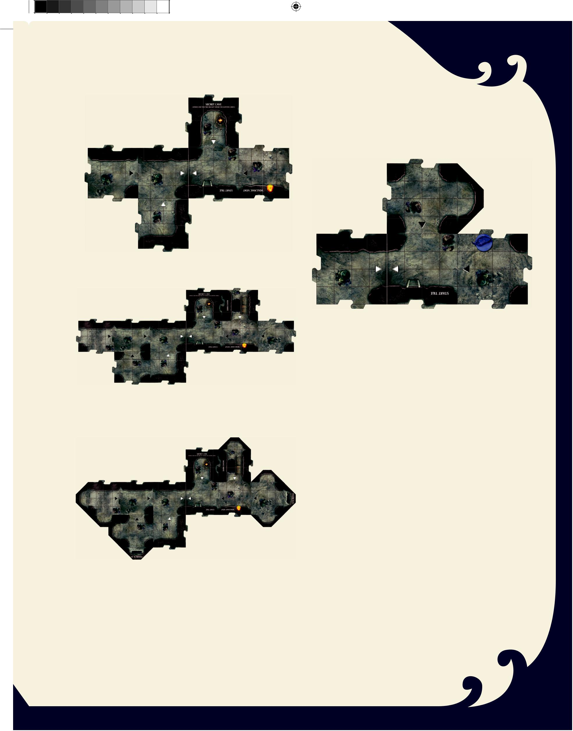
First, place the Start tile on the table. Shuffle the Cavern tile stack, and then place a Cavern tile next to each unexplored edge of the Start tile.

Next, place another Cavern tile next to each unexplored edge, as shown here.

Blocked Edges

Some adventures call for you to add Cavern Edge tiles to the map during play. If you cannot physically place a tile because a Cavern Edge tile is in the way, your Hero cannot explore in that direction.

Drizzt cannot explore from his current location because the Cavern Edge tile blocks the placement of Cavern tiles on that unexplored edge.

Count the number of unexplored edges that remain, and then take that many Cavern Edge tiles. If the adventure calls for the numbered Fissure tiles, take them before other Cavern Edge tiles.

Shuffle the Cavern Edge tiles, and then place a Cavern Edge tile next to each unexplored edge in your cavern complex.

You now have a completed cavern complex and can start play-ing through the adventure.

Competitive Adventures

Some adventures direct the players to compete against each other. Even in a competitive adventure, a Hero cannot attack another Hero unless the adventure so specifies.

Team Adventures

A competitive adventure might split the Heroes into teams. A team can include a single Hero.

Each team has its own Experience pile. If a new team is cre-ated in the middle of a game, that team starts with an empty Experience pile. The active Hero has the final say on spending Experience to cancel Encounter cards or to level up.

Villainous Heroes

Some competitive adventures might involve one or more Villainous Heroes. A Villainous Hero counts as both a Villain and a Hero, and he or she can use Power cards and Treasure cards against other Heroes as if they were Monsters. The other Heroes treat Villainous Heroes as Villains. A Villainous Hero acts during that player’s Hero Phase, not during each player’s Villain Phase.

Villainous Heroes are still susceptible to attacks from Monsters and Encounter cards unless otherwise specified by the adventure.

For more adventures and other optional rules, check out www.DungeonsandDragons.com.

15

300_35594000_LegODrizzt_Rules r3.indd 15 |  |  | 3/28/11 3:42 PM
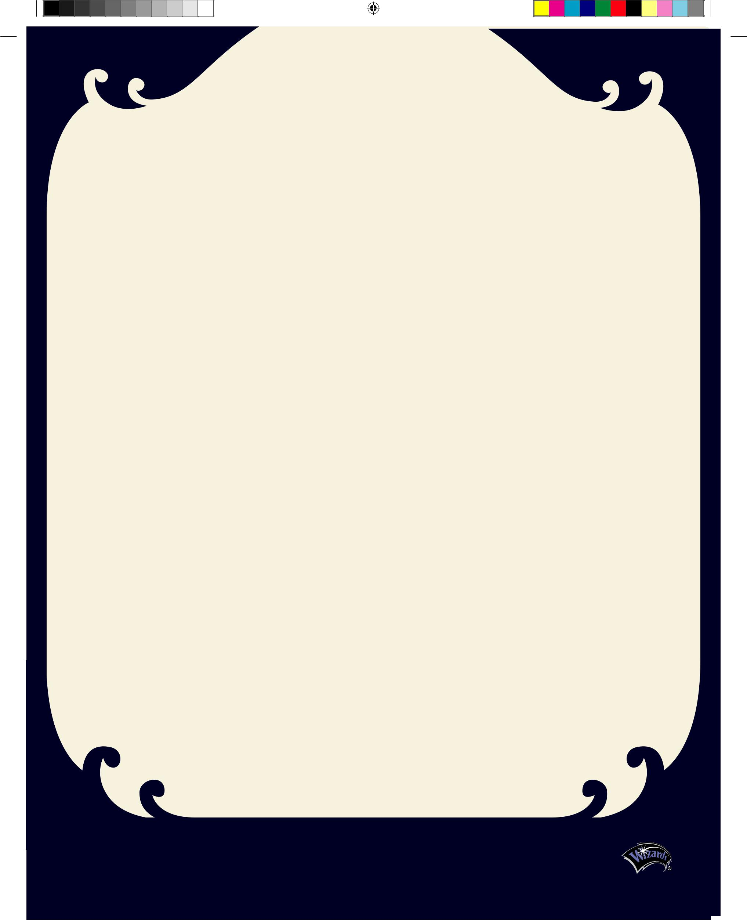
D&D Adventure System FAQ

We’ve scoured the message boards and our personal mailbags to put together this list of frequently asked questions and the appropriate answers. Many of these have already been worked into the newest version of the rulebook, but some questions still need answers. So here they are. Check out www.DungeonsandDragons.com for the most up-to-date rules and FAQ for the D&D Adventure System board games.

What does a Monster do when a Hero is at 0 Hit Points? Monsters ignore Heroes that are at 0 Hit Points. Follow the tactics on a Monster’s card as though any Hero at 0 Hit Points were not there. If all of the Heroes are at 0 Hit Points during a player’s Villain Phase, the Monsters do nothing and the phase ends immediately.

What is a marker?

Markers are 2-inch squares used to show where something is on a Cavern or Dungeon tile. Markers represent Hazards, Traps, some Items, and some terrain features (such as the Crystal Prison).

What do we do when we draw all the cards from a deck?

If you play through an entire deck of cards, shuffle that deck’s discard pile and keep playing.

Does each Hero maintain an Experience pile?

Experience is a party resource. There is only one Experience pile, which all the Heroes share. Any Hero can choose to spend Experience to cancel an Encounter card or to level up. Players should decide together when to spend Experience, but the active Hero can always choose to spend or not to spend Experience.

I just defeated a Monster by rolling 20. Can I use the Experience from that Monster to level up?
Yes.

What’s the difference between a Monster and a Villain?

A Villain is a special kind of Monster. Anything that affects a Monster also affects a Villain.

Do I get Experience for defeating a Villain?

Yes. When you defeat a Villain, add the Villain’s card to the Experience pile. That Experience can be spent just like other Monster cards.

My Hero is currently not on a tile due to a Power or Encounter card. What happens when another card is drawn that affects each Hero?

A Hero might be trapped in the Pit or be hiding for a turn. A Hero that isn’t on a tile due to the effects of a card is not affected by other cards drawn while he or she is not on a tile.

Sometimes a Monster’s card says to move it adjacent to the closest Hero. What do I do if that Monster is already adjacent to a Hero?
You can simply leave the Monster where it is, or you can move it to any other unoccupied square adjacent to that Hero.

What do I do when placing a Monster on a tile that has an occupied mushroom patch?
You instead place the Monster on any square on that tile.

Where do I put a Monster that I move with one of my Powers or Treasure cards?

You can place the Monster in any unoccupied square that meets the effect’s requirements. For example, Tide of Iron allows you to place the Monster on any unoccupied square on any tile within 1 tile of
your Hero’s current location.

What does “within 1 tile” mean?

An object (such as another figure, a token or marker, or an unexplored edge) is within 1 tile

of a figure when that object is on the figure’s current tile or on a tile connected to the figure’s current tile. (Diagonally touching tiles are not connected.)

The Legend of Drizzt Specific Cards

Mark of Lolth (6–10, 108–110): The newly cursed Hero takes 1 damage when this card is played. A Hero takes only 1 damage when a Mark of Lolth card is played, regardless of how many Curse cards that Hero has. This damage also applies if a Hero has Curse cards from other D&D Adventure System games.

Dinin Do’Urden, Drider (26): If you are playing a solo game, you do not pass the card after Dinin acts.

Feral Troll (30, 131): If you are playing a solo game, you do not pass the card after the Feral Troll acts.

Hypnotic Spirit (38–39, 135): If your Hero is Immobilized, he or she does not move toward the Hypnotic Spirit.

Khazid’hea (46): You do not take the damage from using this power until after all attacks are completed. If an effect (for example, from Battle Trance) allows you to regain Hit Points when attacking, you regain the Hit Points before taking the damage from Khazid’hea.

Ruby Pendant (70): You can deal the 1 damage to any Monster on the Monster’s tile, including the Monster targeted by the attack.

Battlefield Promotion (75): A Hero doesn’t spend Experience to level up by using this card.

Drizzt (Ally) (103), Wulfgar (Ally) (107): If no Monster is in play, the Ally does nothing.

Hunting Party (138–139): If any of the cards you draw match a Monster that you already control, discard that card and draw a new one.

Immobilized: This Condition takes effect during your Hero’s move action and any time the Hero would move due to some other effect. Immobilized Heroes can still swap positions with other figures or be placed in new positions.

Villain Clarification

Yochol, Handmaiden of Lolth: This Villain’s card starts with the Drow Form side face up. Once the Yochlol takes 5 damage, flip over its Villain card. It takes 10 total damage to defeat the Yochlol, regardless of which side of its Villain card is showing.

Dark Chasm/Underground River

The squares of the chasm or river are impassable to figures with bases that occupy only 1 square; you cannot place a figure in those squares or move one through them, only the bridge squares. A larger figure, such as Errtu or a Feral Troll, can occupy such a square as

long as the figure is also on at least 1 bridge square. A Hero cannot use an effect to place a Monster in a chasm or river square unless the adventure specifically allows it.

U.S., Canada, Asia Pacific, & Latin America | U.K., Eire, & South Africa | All Other European Countries
www.wizards.com/customerservice | wizards@hasbro.co.uk | custserv@hasbro.be
Wizards of the Coast LLC | Wizards of the Coast LLC | Wizards of the Coast p/a Hasbro Belgium NV/SA
P.O. Box 707 | c/o Hasbro UK Ltd. | Industriallan 1
Renton WA 98057-0707 | Caswell Way, Reevesland Industrial Estate, | 1702 Groot-Bijgaarden
U.S.A. | Newport NP19 4YH | BELGIUM
Tel: 1-800-324-6496 (within the U.S.) | UK | Tel: +32.70.233.277
1-425-204-8069 (outside the U.S.) | Tel: +44(0)8457 12 55 99 | Please retain these addresses for future reference.

A

D&D®ADVENTURE SYSTEM

COOPERATIVE GAME

300_35594000_LegODrizzt_Rules r3.indd 16 |  |  | 3/28/11 3:43 PM

