BILKENT UNIVERSITY

DEPARTMENT OF COMPUTER ENGINEERING

CS223: DIGITAL DESIGN

RACER

FINAL REPORT

ALPER KILIÇASLAN - 21502103

SECTION 4

11.05.2017

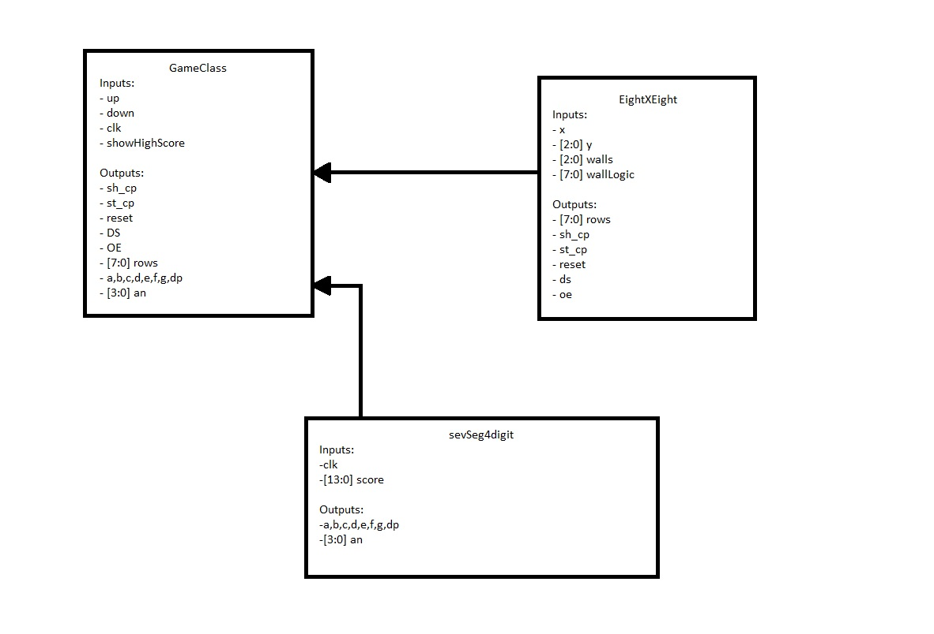

**GameClass**

GameClass is Racer’s top module. It controls order of the stages, collisions, and clock.

“up, down, and showHighScore” inputs are components of the game logic.

“sh_cp, st_cp, reset, DS, OE, and [7:0] rows” inputs are the components of the 8x8 led display module.

“a, b, c, d, e, f, g, dp, and [3:0] an” inputs are the components of seven segment 4 digit display module.

GameClass contains an algorithm for random state selection in order to get random stages. It also has end game logic. When player hit the wall, game stops and shows the score. Whenever player passes 5 walls, game gets faster and faster. Moreover, it has a collision logic that ends the game when collision happens.

**EightXEight**

EightXEight class is a class that moves the walls from top to bottom, creates the walls and the car.

**SevSeg4Digit**

I used SevSeg4Digit class to show how many walls that user passes. After the game ends, user can see the last score.

In addition, I used “clk” in every class, because all of them depends on the clock.

**Conclusion**

In conclusion, I managed to light up the 8x8 led display module, and I used the 8x8 led display module. I tried to put the walls next to each other, but I cannot implement, because I did not understand how the frames work. I can send 1 wall for each frame. I did not use the 4x4 keypad for the project, because I have no time left, and I did not understand how it is working.

**Appendices**

**8x8 Led Display Module**

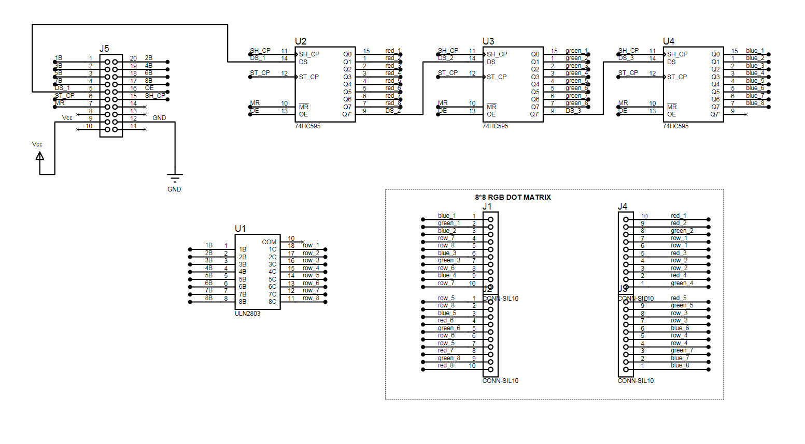

**References**

When I started the project, I got help from Alper Şahıstan, and I used his code and I modified most of the parts. Also, I used the code, which is given in the lab, for seven segment digit module, which is on the BASYS3.