Ghazian Proposal

York University, Toronto, ON

June 2022

**The relative importance of microclimatic heterogeneity across desert communities.**

Submitted to the Faculty of Graduate Studies in Partial Fulfillment of the Requirements for the Degree of Doctor of Philosophy (PhD)

**Examination Committee:**

Dr. Suzanne MacDonald (Supervisor)

Dr. Christopher J. Lortie (Co-Supervisor)

Dr. Laura McKinnon (Advisor)

Dr. Bridget Stutchbury (Graduate Program Director)

Dr. Radu Guiasu (External)

Dr. Sandra Rehan (External)

Table 1. Ph.D. Research chapters and timeline.

|  |  |  |  |
| --- | --- | --- | --- |
| **Chapter** | **Title** | **Timeline** | **Theory** |
| **1** | **Finding the sweet spot in camera trapping: a global synthesis and meta-analysis of net abundance and richness detection rates as an index of sampling effort.** | * Re-submission of the second draft of the manuscript is under review at *the Journal of Ecological Management and Restoration.* * Manuscript attached. | * Sampling theory. |
| **2** | **Quantifying the extent of microclimatic amelioration of natural fabrics.** | * Trials were conducted in the lab. * Data are cleaned and statistically analyzed. * Manuscript will be written after cognates and submitted to the *Journal of Material Science* or *Materials Today* by the end of July 2022. | * Microclimatic amelioration. * Relationship between property and performance of materials. |
| **3** | **The impact of artificial shelter deploys on meso and microclimate across two aridity gradients.** | * Spring-summer 2022 and 20203 field season. | * Spatial heterogeneity and climatic amelioration. |
| **4** | **The impact of artificial shelter deploys on vertebrate communities in deserts.** | * Spring-summer 2022 and 20203 field season. | * Facilitation and context-dependence. * Mechanistic analysis of facilitation effects of shelters on animals. |
| **5**  **Bonus Paper** | **Examining the relationship between microclimate and size of foundation shrubs across the Californian aridity gradient.** | * Co-authored with Mario Zuliani. * Spring-summer 2022 and 20203 field season. | * Microclimatic heterogeneity. |

**Background**

Anthropogenic disturbances are becoming more common and stronger in all systems around the world. By reducing the amount of available terrestrial habitat for both plants and animals, these changes limit biodiversity (Nopper et al. 2018; Irwin et al. 2010; Elmqvist 2013). If current trends continue, resident species will most likely be unable to adapt to climatic and land-use changes, such as urbanization and agriculture dryland systems (Germano et al. 2011). Many dryland species are sensitive, not solely to large-scale changes, but also small, fine-scale oscillations (Shrode and Gerking 1977; Hadley 1970). Because species' capacity to adapt to a changing climate is finite (Bauwens, Hertz, and Castilla 1996; Visser 2008), changes in the environment at fine scales can push species beyond the point of no return and force local extirpations (Lennox et al. 2016; Seebacher and Post 2015). Long-term climate patterns can influence reproduction and distribution (Bellard et al. 2012; Walther 2010), while microclimatic data on a finer scale can affect day-to-day survival. As a result, the scale at which climate is assessed is critical for various species since solely evaluating macro-level data might be damaging to the survival of species. Effective conservation and management methods must incorporate microclimatic (measured using data loggers) and microclimatic data (measured using handheld instrument) with coarse-scale measurements (pulled from satellite or local weather station) in decision-making strategies.

Vegetation supplies habitat for various trophic levels; thus, its existence is critical for ecosystem stability. The ability of a community to recover its composition and function and to continue to exist following disturbances is characterized as resilience (Torok et al. 2020). Shrubs, and presumably many perennials with a canopy, can act as structural agents of facilitation, improving the microclimate and providing benefits to other taxa thus increasing the resiliency of ecosystems (Filazzola et al. 2017). Microclimates in the canopy are often cooler, more humid, and have less direct sun exposure (Filazzola et al. 2017; Holzapfel and Mahall 1999). Many vertebrate species use vegetation as a refuge during the warmest hours of the day, and vegetation is a major driver of habitat selection for many of them (Kline et al. 2019). As a result, shrubs can assist plants and animals in dealing with climatic challenges at finer scales that matter to them. *Ephedra californica* (commonly known as Mormon Tea) is a popular foundation shrub native to California's southwestern areas (Sawyer, Keeler-Wolf, and Evens 2009a). Mormon tea is an excellent example of abiotic amelioration through its canopy structure as it benefits both resident plants and animal species (Lortie et al. 2018; Ivey et al. 2019). *Larrea tridentata* (creosote bush) is a dominant or co-dominant flowering shrub that is often found in sandy soils, desert pavements, and the well-developed cryptogram layer of the Mojave (Sawyer et al. 2009). The shrub is a long-lived evergreen extremely resistant to high temperatures. Larrea is well-studied with regard to pollination (Minckley, Cane, and Kervin 2000), yet relatively understudied in terms of association with vertebrate communities. Hence, it is important to not only examine the abiotic stress amelioration properties of these foundation shrubs but also their association patterns with the vertebrate community.

Shelters are often used in deserts and are significant for both ecological interactions and as a physical presence or natural and manmade form of architecture. For instance, certain birds use shelters for perching (Athiê and Dias 2016), while some snakes use them to thermoregulate (Lelièvre et al. 2010). Shelters and vegetation forms such as shrubs increase the environmental heterogeneity of a given area. Environmental heterogeneity is the non-uniformities in physical and ecological landscape characteristics (Dronova 2017). Our previous pilot study with artificial shelters showed that they can provide a consistent temperature and reduce direct solar radiation (Ghazian, Zuliani, and Lortie 2020). In other words, shelters provided less variation in both light and temperature throughout the day compared to the open sites, and their canopy effects were similar to those of shrubs. These shelters can be beneficial, especially if the canopy is made of environmentally friendly materials. However, its ecological effects and association with the resident fauna still need to be investigated. The overreaching hypothesis of this thesis is that eco-friendly, artificial shelters can improve canopy microclimate and increase spatial variability in the landscape, both of which are necessary for animal survival. To evaluate this thesis’ goal, we use a meta-analysis to establish the relative sampling efforts required to quantify biodiversity in animals using camera traps. Second, we undertook in-lab trials to evaluate a range of fabrics before testing the winning fabric in the field to ensure that artificial shelters are not only beneficial but also environmentally friendly. Then, in the field, we assessed and will continue to assess the microclimatic and mesoclimatic heterogeneity benefits of shelter deployment at two sites, using camera trapping and climate data loggers to investigate animal use.

**Main Thesis Objectives**

1. Identify key sampling designs with camera traps.
2. Record microclimatic impacts of eco-friendly fabrics under controlled conditions.
3. Demonstrate the ecological effects of shelters in the field and compared that to natural shrubs.
4. Compile frequency and ecological strength of microclimate facilitation of shelters for resident vertebrate species.

**Chapter 1. Finding the sweet spot in camera trapping: a global synthesis and meta-analysis of net abundance and richness detection rates as an index of sampling effort (Manuscript and Supplementary Appendix attached).**

**Purpose:** To use effect size measure for both net vertebrate abundance and net vertebrate richness detection rates to examine the relative efficacy of deploying more camera traps for a given period in different ecosystems.

**Hypothesis:** Sampling effort positively, but non-linearly, influences the net animal abundance and richness detection rates at a site/region sampled.

**Findings:** Increasing sampling effort through the number of cameras showed significantly positive net abundance detection rates in grasslands and mixed ecosystems, as well as net richness detection rates in mixed, tropical, deciduous, and grassland ecosystems. Regression analyses for both net abundance and net richness against the total number of days were not shown to be significant.

**Chapter 2. Quantifying the extent of microclimatic amelioration of natural fabrics.**

**Purpose:**  To quantify the extent to which different natural fabrics ameliorate the understory microclimate compared to the open gap.

**Questions:** How do different natural fabrics such as burlap, cotton, and nursery seedling cloth affect microclimatic parameters such as relative humidity (RH), temperature, and light intensity under their canopy?

**Hypothesis:** Fabrics will lower the amplitude of variation in microclimatic parameters such as temperature, RH, and radiation relative to the open.

**Predictions:**

* Different fabrics influence light permeability to different extents. Natural fabrics create a barrier from direct radiation, create shade, and lower the variation experienced in temperature under the canopy compared to the open.
* An artificial barrier/canopy can increase humidity and create a windbreak environment, which in turn aids in the increase in understory RH.

**Materials & Methods**

***Microsite deployment***

Trials were conducted in controlled lab conditions. We selected three environmentally-friendly fabrics: natural burlap (“The Felt Store” 2021), 100% cotton canvas (“Trimaco” 2021), and seedling nursery fabric (“Endpoint” 2021). Natural burlap is made from hemp or jute fibers that are generally treated to resist decay (Kuhns 1997). Cotton canvas has a structure made of cellulose and is great for short time use, however over time when subjected to tension, humidity alongside temperature fluctuations, as well as UV irradiation, over time it can degrade the fabric (Nechyporchuk et al. 2017). Biodegradable nursery fabrics are superior to plastic ones and are used to increase the rates of seedling establishment as they hold more moisture (Wightman et al. 2001). In this experiment, fabrics were set up at an angle to the ground to create shade. Each fabric was approximately ~366 x 122 cm.

***Abiotic measurements***

Data loggers were attached to pegs using zip ties (to ensure ambient and not ground climatic parameters were recorded, they were ~10 cm above ground) and placed in cups filled with sand under each fabric and in the open measuring RH (%), light intensity (lum/ft2), and temperature (°C) at 1-hour intervals. OMEGA OM-91 pendant loggers were used to measure RH and temperature (OMEGA Engineering 2021). Onset HOBO Temperature/Light Pendant (64K) loggers were used to record light intensity and temperature (Hoskin Scientific 2021). 150 LED chip, 70-watt lamps (“Likesun” 2021) provided UV for a total of 12hours/day (suggested in the manual for dryland species). 60-watt heat lamps were used to create artificial heat and remained lit for the entire duration of the study. There were a total of three fabric-open microsites. Fabrics were each tested for 31 days. Trials took place from March 13th to October 13th, 2021. Logger data was saved and exported as a CSV file.

***Statistical analyses***

All statistics were performed using R version 4.2.0 (R Development Core Team 2022). Q-Q plots were used to examine the distribution of data and to check for normality and homoscedasticity (Schützenmeister, Jensen, and Piepho 2012). The relationship between temperature and light intensity was examined using Kendall’s rank correlation (non-parametric, continuous data). Furthermore, the relationship between temperature and RH was examined using Kendall’s rank correlation (non-parametric, continuous data) Generalized Linear Models (GLM) were used to compare temperature, light intensity, cover type, and microsite (Nelder and Wedderburn 1972). GLM dispersion parameters with AIC scores were used to compare and select the appropriate family to fit to models (Richards, Whittingham, and Stephens 2011). We explored spread in histograms by examining variance and used a Levene Test to check heterogeneity of variances for temperature and solar radiation across microsites (Schultz 1985). Post-hoc tests were done using the function *emmeans* from the emmeans R package (Lenth and Herve 2019)

**Preliminary Findings**

* The amplitude of variation experienced in light intensity, temperature, and RH was significantly different between the different fabrics and the open (p<0.0001).
* Light and temperature were significantly, positively correlated (Kendall’s tau= 0.34, p<0.0001).
* There exists a slight, positive, but nonetheless significant relationship between temperature and relative humidity (Kendall’s tau= 0.013, p=0.0099).
* Light intensity was the lowest under burlap (EMM 1.96 ± 0.261) and canvas (EMM 2.56 ± 0.295), but there was no significant difference between the two fabrics. Both fabrics were significantly darker than the open (p<0.0001) (Figure 1).
* Canvas, burlap, and nursery fabric provided cooler temperatures than the open (p<0.001). (Figure 2).
* Nursery fabric provided the greatest moisture underneath its canopy (EMM 55.2 ± 0.305). The relative humidity levels under nursery fabric were significantly higher than all fabrics and the open gap (p<0.0001) (Figure 3).
* Given that nursery fabric was extremely hard to assemble and did not provide enough shading, burlap was chosen as the best fabric to be tested in the field.

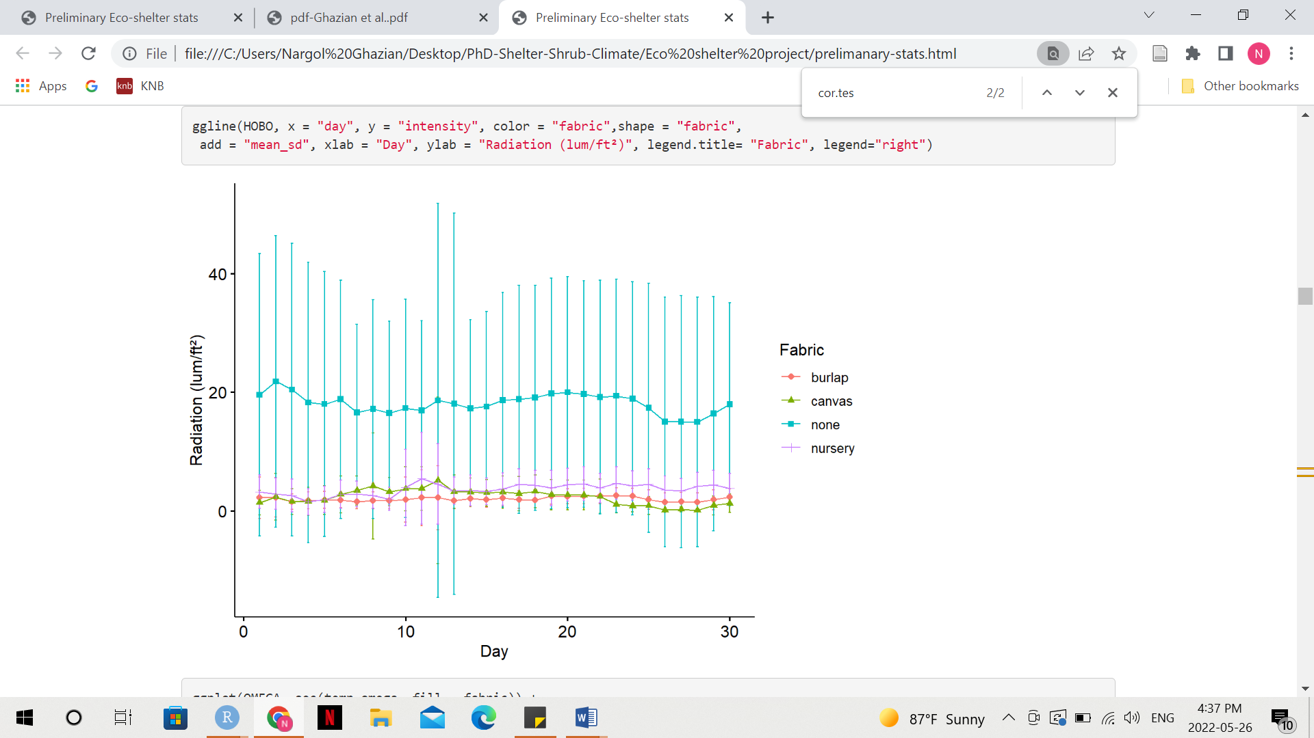

**Figure 1**. Mean daily light intensity/radiation (lum/ft2) over the course of the 31 days trial recorded at each fabric and in the open using microdata loggers. Point shapes represent different microsites. Solid lines connect daily means. Errors bars are standard error (SE).

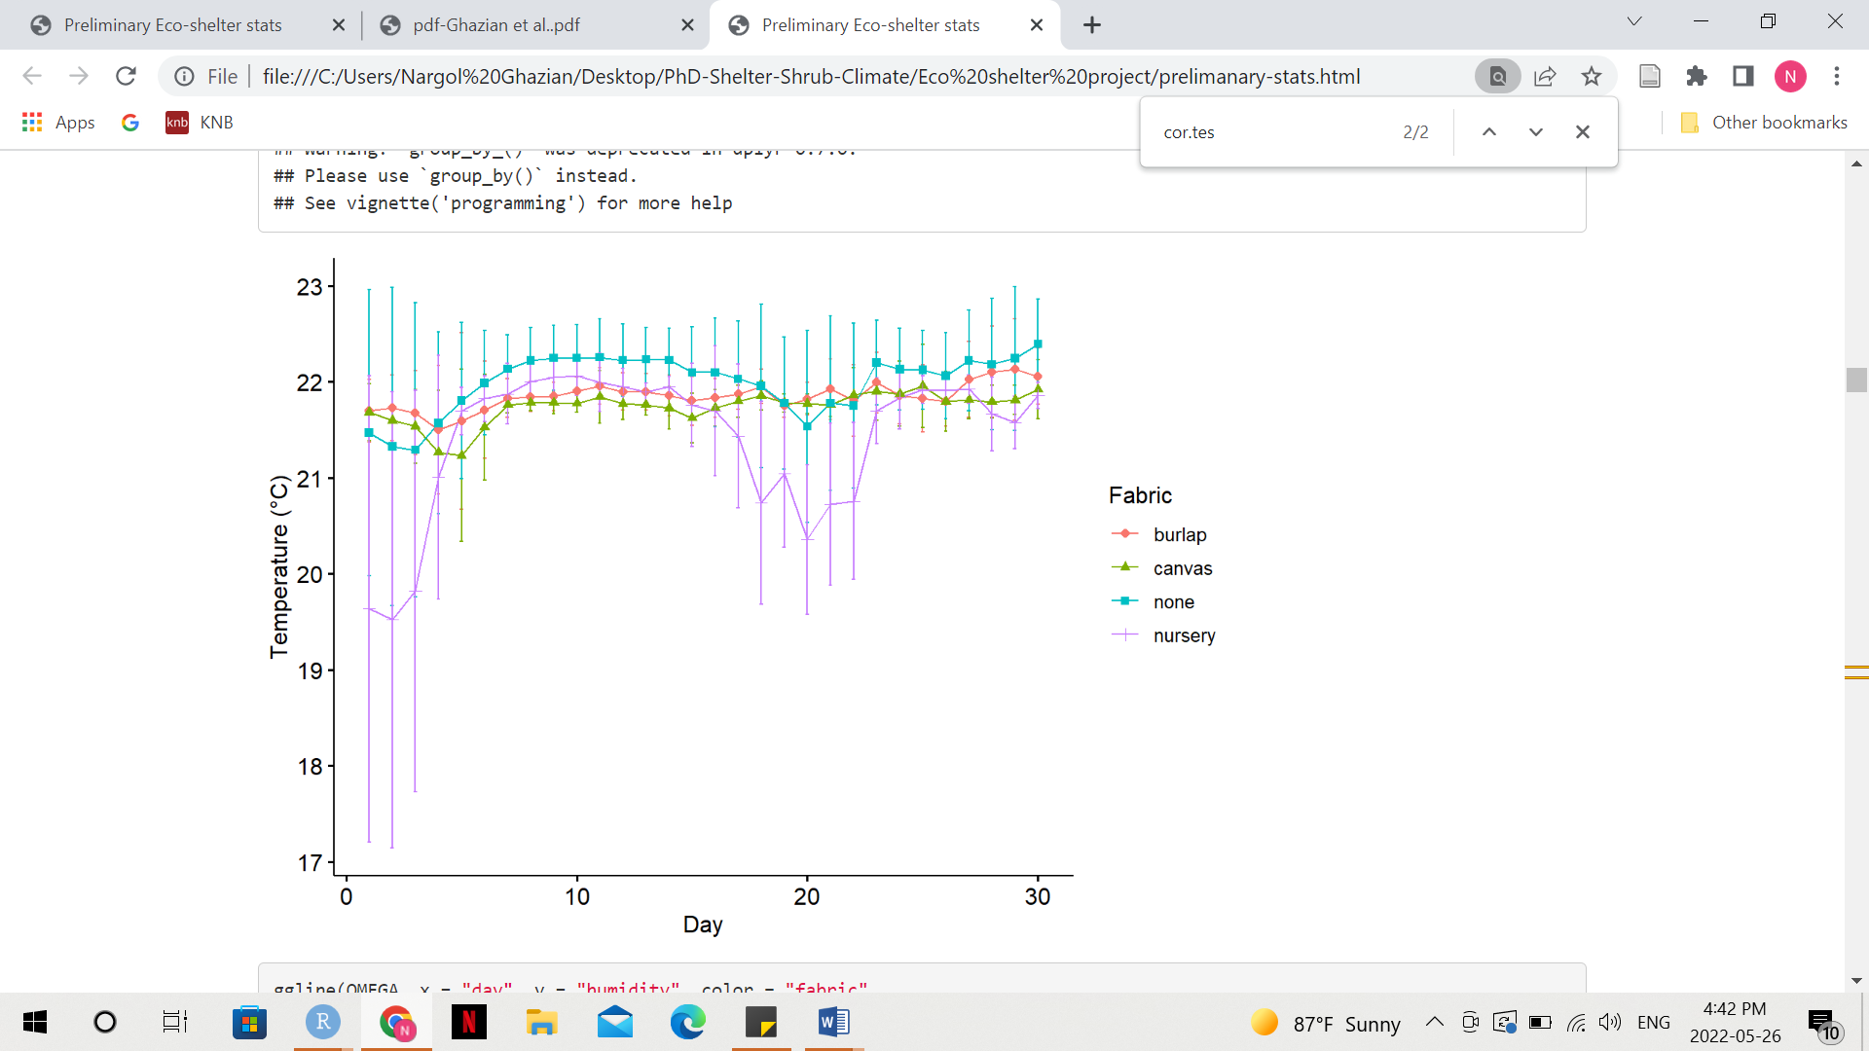

**Figure 2.** Mean daily temperature (°C) over the course of the 31 days trial recorded at each fabric and in the open using microdata loggers. Point shapes represent different microsites. Solid lines connect daily means. Errors bars are standard error (SE).

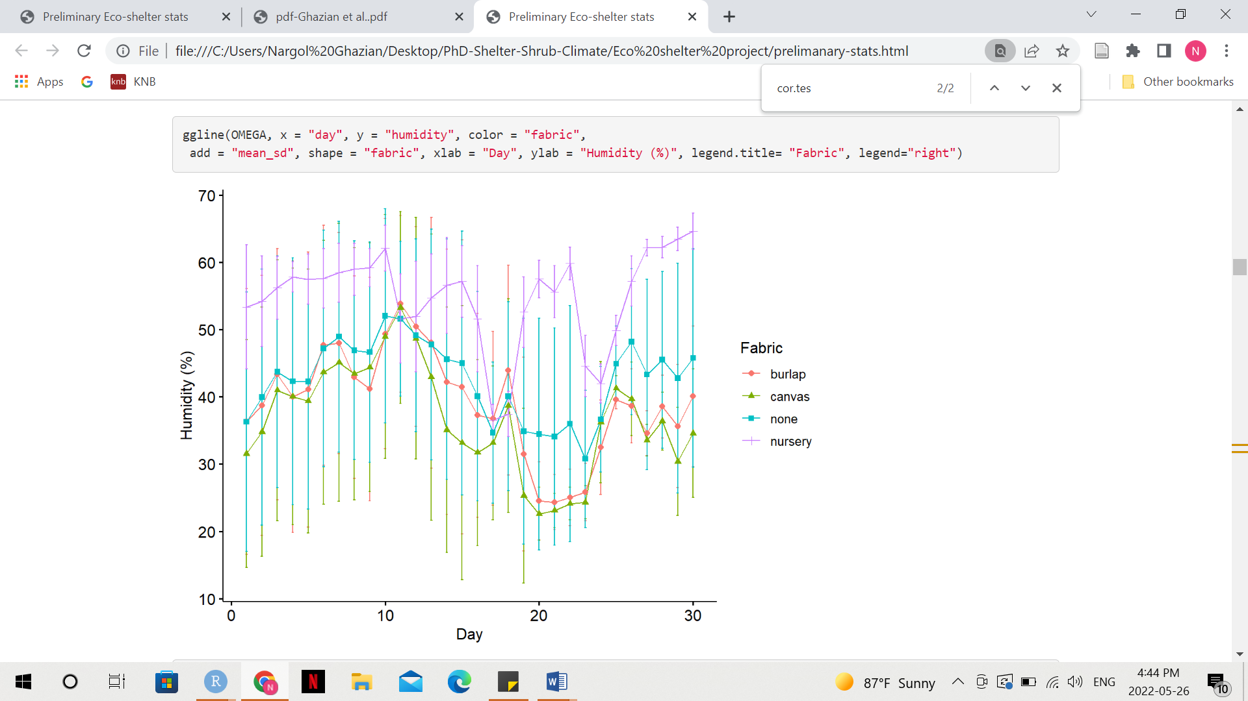

**Figure 3.** Mean daily relative humidity (%) over the course of the 31 days trial recorded at each fabric and in the open using microdata loggers. Point shapes represent different microsites. Solid lines connect daily means. Errors bars are standard error (SE).

**Chapter 3: The impact of artificial shelter deploys of different natural fabrics on meso and microclimate across two aridity gradients.**

**Purpose:** To quantify the extent a natural fabric meliorates the understory microclimate compared to the open gap at two aridity gradients in California.

**Questions:** To what extent does the natural fabric burlap affect microclimatic parameters such as relative humidity (RH), temperature, and light intensity under the shelter canopy? Is there a significant difference in the above measurements for differently-shaped shelters? Is there a difference in how the shelters affect the above parameters at a southern, dry site versus a milder northern site? Is there significant variability between climatic measurements taken using data loggers, versus a handheld device, and ones pulled from the local weather station? What is the implication of this study for different climate change scenarios?

**Hypothesis:** Eco-friendly, burlap shelters will lower the amplitude of variation in microclimatic parameters such as temperature, RH, and light intensity relative to the open at both sites.

**Predictions:**

* Shelters have the ability to reduce the mean variation of RH, solar radiation, and temperature regardless of location on the aridity gradient.
* Shelters offer a more consistent microclimate relative to the open.
* Shape can have a significant effect on microclimate.
* Data loggers are most likely a more accurate measure of climatic heterogeneity compared to courser scale data such as those taken by a handheld device or pulled from a weather station.
* Shelters will likely offer a more consistent climate throughout the day and night in northern sites.

**Materials & Methods:**

***Study site***

The study will take place in the Spring-Summer of 2022 and 2023. Two major sites were chosen, including Tecopa, California (35.8515, -116.1867) and the Carrizo Plain National Monument (35.1913, -119.7929). Within both sites, two mesosites were established, including a shrubbed site (Tecopa: 35.8530, -116.1840; Carrizo: 35.1156, -119.6206) and an entirely open site (Tecopa: 35.8553, -116.1790; Carrizo: 35.0562, -119.6012). Tecopa is located in the Mojave Desert in southeast California. The dominant foundation species in the site is *Larrea tridentata* (creosote bush). Carrizo Plain is located within the San Joaquin Valley in California and falls between two counties, including San Luis Obispo and Kern. The climate is cooler and less arid than Tecopa. The main foundation shrub in the plain is *Ephedra californica* (Mormon tea). The region is also heavily dominated by invasive grasses such as *Bormus rubens.*

***Microsite deployment***

Shelters were constructed using Ghazian et al.'s protocol (2020) with a slight modification of the fabric type. Instead of UV permeable shade cloths, natural jute burlap was used to cover the shelters (“Woolsack Burlap” 2022). We set up 8 microsite triplets (foundation shrub, square, and triangular shelter) and georeferenced each triplet at both Tecopa and Carrizo. We set up 8 open microsites that were each paired to a shelter in the open mesosites in both Tecopa and Carrizo and georeferenced each pair. Shrub canopy was measured at the x, y, and z planes where height (x) was the widest dimension of the canopy and perpendicular to the ground. There were a total of 16 shelters (8 squares and 8 triangles) at each shrubbed mesosite and a total of 8 shelters (4 squares and 4 triangles) and each open mesosite. We had a camera trap paired to each shelter, shrub, and open (details can be found in the next chapter). There were more shelters in the shrubbed mesosites because there are generally more animals where vegetation is present and we wanted to maximize the detected species richness by increasing the number of cameras deployed based on our findings in chapter 1.

***Abiotic measurements***

To measure the difference in light intensity and temperature within shelters and between shelters, shrubs, and open microsites, Onset HOBO Temperature/Light Pendant (64K) loggers (Hoskin Scientific 2021) were placed inside shelters, directly beneath the shrub canopy, and in the open. To measure the difference in RH within shelters and between shelters, shrubs, and open, OMEGA OM-91 pendant loggers were used (OMEGA Engineering 2021). Pendants were tied to a plastic stake using zip ties. Stakes were hammered into the ground until stable with ~10 cm remaining above ground. This was done to ensure that logger data were not influenced by ground cover, and true ambient conditions were recorded. Air temperature (ºC), light intensity (lum/ft2), and RH (%) were recorded hourly. The 2022 field season took place from May 11th to June 6th, 2022. Furthermore, we took temperature and humidity measurements using a handheld meter (“Mengshen Temperature and Humidity Meter” 2022) under shrubs, shelters, and in the open every time we went to check on the microsites.

**Future Directions:**

* Re-conduct the study during the 2023 spring-summer field season to establish long-term data.
* Use sandbags to secure shelters to the ground in the open sites in Tecopa because the soil was extremely soft, the rebar went completely through and shelters blew away.
* Conduct the study for a longer duration in 2023.
* Pull climate data from local weather stations.
* Format all climate data into a CSV so they are ready for statistical analyses.
* Use Generalized Linear Models (GLM) to model the different climatic parameters and use *emmeans* to do a pairwise analysis between the microsites.
* Examine variance in climate using a Levene Test to check heterogeneity of variances for climate across microsites.
* Calculate Relative Interaction Indices (RII) (Armas, Ordiales, and Pugnaire 2004) and used it as an effect size measure to estimate the strength and direction of the microsite effects.

**Chapter 4: The impact of artificial shelter deploys on vertebrate communities in deserts.**

**Purpose:** To examine wildlife interactions with artificial shelters.

**Questions:** How often do vertebrates interact with artificial shelters? Which species interact with shelters the most often? Does that differ between the two sites? What are they doing when interacting with shelters? Is the frequency and direction of vertebrate interaction with shelters different from shrubs and the open? How does climate impact the frequency of interaction of vertebrates with artificial shelters? Is the frequency of interaction comparable to natural shrubs?

**Hypothesis:** Animals will associate more with shelter microsites and shrubs than the open as canopied microsites ameliorate the microclimatic environment of the understory.

**Predictions:**

* Artificial shelters increase RH, and reduce microclimatic extremes.
* Vertebrates will positively associate with shelters and shrubs as temperature, drought, and duration of intense solar radiation increase to take refuge and to thermoregulate.
* Overall, animal richness in the shrubbed mesosites is greater than those of the open mesosites.

**Materials & Methods:**

We used the same methodology described in the previous chapter. We camtrapped at all sheltered, shrubbed, and open microsites across the two sites. Cameras were secured to pegs and placed ~1m away facing the microsite. Vikeri model A1 1520P 20MP trail cams with no glow were used (“Vikeri Trail Cam” 2022). All images were downloaded from SD cards and saved as Joint Photographic Expert Group (JPEG) files. Microsites were regularly maintained to ensure adequate SD storage and battery in the trail cams.

**Future Directions:**

* Process all camera trap imagery data and record information such as presence and absence, species binomial name, microsite type, and what the animals were doing in a CSV file.
* The most common species to be observed are desert cottontail (*Sylvilagus audubonii*), kit fox (*Vulpes macrotis*), black-tailed jackrabbit (*Lepus californicus*), and the Giant Kangroo Rat (GKR) (Dipodomys ingens).
* Point biserial correlation will be used to assess the relationship between the animal presence (binary variable) and climatic variables. GLMM will be used to model climatic parameters, richness, and diversity estimates.

**Chapter 5 (Bonus): Examining the relationship between microclimate and size of foundation shrubs across the Californian dryland gradient (mini paper or note).**

**Purpose:** To examine the relationship between shrub size (volume) and microclimate across five sites in the Californian dryland.

**Questions:** How do shrub size influence canopy temperature and humidity? Are bigger shrubs cooler and more humid? Is this the case across the northern and southern drylands of California?

**Materials and Methods:**

We choose Carrizo Plain National Monument (35.1913, -119.7929), Cuyama Valley (35.0978, -119.404), Sheephole (35.1233, -115.4320), Heart of Mojave (35.5178, -116.1120), and Tecopa (35.8515, -116.1867) to conduct this study. Within each site, we measured the x, y, and z planes where height (x) was the widest dimension of the canopy and perpendicular to the ground for 18-25 shrubs. We took temperature and humidity measurements using a handheld meter (“Mengshen Temperature and Humidity Meter” 2022) under each shrub's canopy. This protocol will be repeated during the 2023 field season.

**Literature Cited**

Armas, Cristina, Ramón Ordiales, and Francisco I. Pugnaire. 2004. “Measuring plant interactions: a new comparative index.” *Ecology* 85 (10): 2682–86. https://doi.org/10.1890/03-0650.

Athiê, S., and M. M. Dias. 2016. “Use of Perches and Seed Dispersal by Birds in an Abandoned Pasture in the Porto Ferreira State Park, Southeastern Brazil.” *Brazilian Journal of Biology* 76 (1): 80–92. https://doi.org/10.1590/1519-6984.13114.

Bauwens, Dirk, Paul E. Hertz, and Aurora M. Castilla. 1996. “Thermoregulation in a Lacertid Lizard: The Relative Contributions of Distinct Behavioral Mechanisms.” *Ecology* 77 (6): 1818–30. https://doi.org/10.2307/2265786.

Bellard, Céline, Cleo Bertelsmeier, Paul Leadley, Wilfried Thuiller, and Franck Courchamp. 2012. “Impacts of Climate Change on the Future of Biodiversity: Biodiversity and Climate Change.” *Ecology Letters* 15 (4): 365–77. https://doi.org/10.1111/j.1461-0248.2011.01736.x.

Dronova, Iryna. 2017. “Environmental Heterogeneity as a Bridge between Ecosystem Service and Visual Quality Objectives in Management, Planning and Design.” *Landscape and Urban Planning* 163 (July): 90–106. https://doi.org/10.1016/j.landurbplan.2017.03.005.

“Endpoint.” 2021. 2021. https://www.amazon.ca/gp/product/B086BWR6FB/ref=ppx_yo_dt_b_asin_title_o08_s02?ie=UTF8&psc=1.

Filazzola, Alessandro, Michael Westphal, Michael Powers, Amanda Rae Liczner, Deborah A. (Smith) Woollett, Brent Johnson, and Christopher J. Lortie. 2017. “Non-Trophic Interactions in Deserts: Facilitation, Interference, and an Endangered Lizard Species.” *Basic and Applied Ecology* 20 (May): 51–61. https://doi.org/10.1016/j.baae.2017.01.002.

Germano, David J., Galen B. Rathbun, Lawrence R. Saslaw, Brian L. Cypher, Ellen A. Cypher, and Larry M. Vredenburgh. 2011. “The San Joaquin Desert of California: Ecologically Misunderstood and Overlooked.” *Natural Areas Journal* 31 (2): 138–47. https://doi.org/10.3375/043.031.0206.

Ghazian, Nargol, Mario Zuliani, and Christopher Lortie. 2020. “Micro-Climatic Amelioration in a California Desert: Artificial Shelter Versus Shrub Canopy.” *Journal of Ecological Engineering* 21 (8): 216–28. https://doi.org/10.12911/22998993/126875.

Hadley, Neil F. 1970. “Micrometeorology and Energy Exchange in Two Desert Arthropods.” *Ecology* 51 (3): 434–44. https://doi.org/10.2307/1935378.

Holzapfel, Claus, and Bruce E. Mahall. 1999. “Bidirectional facilitation and interference between shrubs and annuals in the mojave desert.” *Ecology* 80 (5): 1747–61. https://doi.org/10.1890/0012-9658(1999)080[1747:BFAIBS]2.0.CO;2.

Hoskin Scientific. 2021. “HOBO Pendant Temperature/Light 64K Data Logger.” 2021. https://shoponset.hoskin.ca/products/hobo-pendant-temperature-light-8k-data-logger?variant=42959120400.

Ivey, Kathleen N., Margaret Cornwall, Hayley Crowell, Nargol Ghazian, Malory Owen, Emmeleia Nix, Mario Zuliano, Lortie Christopher J., Michael Westphal, and Emily Taylor. 2019. “Thermal Ecology of the Federally Endangered Blunt-Nosed Leaopard Lizard (Gambelia Sila).” *Manuscript Submitted for Publication.*

Kline, Holley N., Timothy E. Fulbright, Eric D. Grahmann, Fidel Hernández, David B. Wester, Leonard A. Brennan, and Michael W. Hehman. 2019. “Temperature Influences Resource Use by Chestnut-Bellied Scaled Quail.” *Ecosphere* 10 (2): e02599. https://doi.org/10.1002/ecs2.2599.

Kuhns, Michael R. 1997. “Penetration of Treated and Untreated Burlap by Roots of Balled-and-Burlapped Norwar Maples.” 23 (1).

Lelièvre, Hervé, Gabriel Blouin-Demers, Xavier Bonnet, and Olivier Lourdais. 2010. “Thermal Benefits of Artificial Shelters in Snakes: A Radiotelemetric Study of Two Sympatric Colubrids.” *Journal of Thermal Biology* 35 (7): 324–31. https://doi.org/10.1016/j.jtherbio.2010.06.011.

Lennox, Robert J., Jacqueline M. Chapman, Christopher M. Souliere, Christian Tudorache, Martin Wikelski, Julian D. Metcalfe, and Steven J. Cooke. 2016. “Conservation Physiology of Animal Migration.” *Conservation Physiology* 4 (1): cov072. https://doi.org/10.1093/conphys/cov072.

“Likesun.” 2021. 2021. https://www.amazon.ca/gp/product/B083TXX56T/ref=ppx_yo_dt_b_asin_image_o08_s03?ie=UTF8&psc=1.

Lortie, Christopher J., Eva Gruber, Alex Filazzola, Taylor Noble, and Michael Westphal. 2018. “The Groot Effect: Plant Facilitation and Desert Shrub Regrowth Following Extensive Damage.” *Ecology and Evolution* 8 (1): 706–15. https://doi.org/10.1002/ece3.3671.

“Mengshen Temperature and Humidity Meter.” 2022. 2022. https://www.amazon.com/dp/B01CY29SC2?psc=1&ref=ppx_yo2ov_dt_b_product_details&fbclid=IwAR3Q0PtBNM1KtMcIgZkia1yYR1bQrjildU_Wxx5Ax0tDrli-FeyZJcp3gO4.

Minckley, R.L., J.H. Cane, and L. Kervin. 2000. “Origins and Ecological Consequences of Pollen Specialization among Desert Bees.” *Proceedings of the Royal Society of London. Series B: Biological Sciences* 267 (1440): 265–71. https://doi.org/10.1098/rspb.2000.0996.

Nechyporchuk, Oleksandr, Krzysztof Kolman, Marta Oriola, Michael Persson, Krister Holmberg, and Romain Bordes. 2017. “Accelerated Ageing of Cotton Canvas as a Model for Further Consolidation Practices.” *Journal of Cultural Heritage* 28 (November): 183–87. https://doi.org/10.1016/j.culher.2017.05.010.

OMEGA Engineering. 2021. “OMEGA OM-91 Temperature and Humidity Data Logger.” 2021. https://www.omega.com/en-us/temperature-measurement/temperature-and-humidity-data-loggers/p/OM-90-Series.

R Development Core Team. 2022. *R* (version 4.2.0).

Sawyer, John O, Todd Keeler-Wolf, and Julie Evens. 2009a. *A Manual of California Vegetation*. Sacramento, Calif.: California Native Plant Society Press. http://books.google.com/books?id=y40lAQAAMAAJ.

———. 2009b. *A Manual of California Vegetation*. Sacramento, Calif.: California Native Plant Society Press. http://books.google.com/books?id=y40lAQAAMAAJ.

Seebacher, Frank, and Eric Post. 2015. “Climate Change Impacts on Animal Migration.” *Climate Change Responses* 2 (1): 5. https://doi.org/10.1186/s40665-015-0013-9.

Shrode, Joy B., and Shelby D. Gerking. 1977. “Effects of Constant and Fluctuating Temperatures on Reproductive Performance of a Desert Pupfish, Cyprinodon n. Nevadensis.” *Physiological Zoology* 50 (1): 1–10. https://doi.org/10.1086/physzool.50.1.30155710.

“The Felt Store.” 2021. 2021. https://www.amazon.ca/gp/product/B003CS9LFW/ref=ppx_yo_dt_b_asin_title_o00_s00?ie=UTF8&psc=1.

Torok, Peter, James M. Bullock, Borja Jimenez-Alfaro, and Judit Sonkoly. 2020. “The Importance of Dispersal and Species Establishment in Vegetation Dynamics and Resilience” 31 (6). https://doi.org/10.1111/jvs.12958.

“Trimaco.” 2021. 2021. https://www.amazon.ca/gp/product/B000WCOXFO/ref=ppx_yo_dt_b_asin_title_o01_s00?ie=UTF8&th=1.

“Vikeri Trail Cam.” 2022. 2022. https://www.amazon.com/Hunting-120%C2%B0Wide-Angle-Waterproof-Wildlife-Monitoring/dp/B08DJ5WKVQ/ref=sr_1_2?crid=293I65B2RBKS3&keywords=vikeri+A1+camtrap&qid=1653942541&sprefix=vikeri+a1%2Caps%2C2248&sr=8-2.

Visser, Marcel E. 2008. “Keeping up with a Warming World; Assessing the Rate of Adaptation to Climate Change.” *Proceedings of the Royal Society B: Biological Sciences* 275 (1635): 649–59. https://doi.org/10.1098/rspb.2007.0997.

Walther, Gian-Reto. 2010. “Community and Ecosystem Responses to Recent Climate Change.” *Philosophical Transactions of the Royal Society B: Biological Sciences* 365 (1549): 2019–24. https://doi.org/10.1098/rstb.2010.0021.

Wightman, Kevyn Elizabeth, Ted Shear, Barry Goldfarb, and Jeremy Haggar. 2001. “Nursery and Field Establishment Techniques to Improve Seedling Growth of Three Costa Rican Hardwoods.” *New Forests* 22 (1/2): 75–96. https://doi.org/10.1023/A:1012020023446.

“Woolsack Burlap.” 2022. 2022. https://www.amazon.com/Woolsacks-Burlap-Fabric-Yards-Natural/dp/B08HW2FSHG/ref=sr_1_4?crid=3LI74EJPDRFWA&keywords=burlap&qid=1649785685&sprefix=burlap%2B%2Caps%2C113&sr=8-4&th=1.

**Finding the sweet spot in camera trapping: a global synthesis and meta-analysis of net abundance and richness detection rates as an index of sampling effort.**

Nargol Ghazian*1 and Christopher J. Lortie1

1Department of Biology, York University, 4700 Keele St, Toronto, ON M3J 1P3, Canada

*Corresponding Author: Department of Biology, York University, 4700 Keele St, Toronto, ON, M3J 1P3, Canada. Email: [nargolg1@my.yorku.ca](mailto:nargolg1@my.yorku.ca)

**Abstract**

1. Camera traps are one of the most common tools in wildlife and conservation biology. Sampling can document and measure animal presence and activity. Captures can be used to estimate population parameters such as presence, relative abundance, habitat suitability, and resident species richness of specific populations.
2. A total of 292 full-text articles were returned from the Web of Science using the search terms camera* and trap* and richness* or diversity*, and rarefaction* curve*. Full-text reviews of each for sampling effort in total number of days and total number of cameras returned 149 studies that reported animal abundance and species richness captured using this tool. We used an effect size measure for both net vertebrate abundance and net vertebrate richness detection rates to examine the relative efficacy of deploying more camera traps for a given period in different ecosystems.
3. Increasing sampling effort through an increased number of cameras significantly increased net positive abundance detection rates in grasslands and mixed ecosystems. Net richness detection rates in mixed, tropical, deciduous, and grassland ecosystems similarly increased with the number of cameras deployed. The total number of days however was not a significant predictor of abundance or richness rates detected in any ecosystem.
4. These findings suggest that deploying relatively more cameras for relatively fewer days provides the most effective estimates of vertebrate abundance and richness for a region.
5. Effective camera trapping is relevant to conservation and management for many reasons. For instance, they can be used to inform pre and post-restoration efforts, monitor the use of artificial structures by species, and assess behaviours like predator-prey interactions. This sampling approach can aid in assessing diversity change, habitat change, pre/post restoration efforts, artificial structure effects, species presence, and animal behaviour.

**Keywords**

Abundance, camera traps, conservation, diversity, meta-analysis, population estimates, richness, sampling effort, vertebrates.

**Introduction**

Monitoring and measuring the number of animals and diversity of animal communities in terrestrial ecosystems comprises an important set of methods in ecology and evolution. Camera traps are frequently a primary tool to survey wildlife and their interactions with the surrounding environment. These survey devices normally record animal presence via a triggered passive, infrared motion sensor (Rowcliffe et al. 2011). They are one of the most popular survey tools in current wildlife research, particularly in the domain of terrestrial vertebrate biology (Meek et al. 2014). Cameras can record activity patterns and be used to infer occupancy, abundance, and species diversity (O’Connell, Nichols, and Karanth 2011; Kelly 2008). Camera traps have also been used in studies to examine behaviour (Rowcliffe et al. 2014), habitat use (Rovero et al. 2014), detection of rare species in a community (Thomas et al. 2020), estimation of population size and species richness (Whytock et al. 2021), and occupation of human-built structures (O’Connell, Nichols, and Karanth 2011). Thus, camera trap data can be used to quantify many ecological parameters and help advance theories such as niche partitioning, habitat use, as well as various behavioural models (Smith et al. 2020; Frey et al. 2017). They are also a fundamental biodiversity monitoring tool in critical ecosystems such as the Serengeti (Swanson et al. 2015) and the Amazon basin (Trolle 2003). Anthropogenic changes are impacting species re-distribution and range shifts (Franklin 2010) and we need to be able to measure biodiversity for mobile species in different ways. Camera traps provide a relatively easy method that enables us to do this and gather big data (Norouzzadeh et al. 2018; Carl et al. 2020). These data can then be used to evaluate the efficacy of survey designs (Kays et al. 2020) to support management and conservation.

Various aspects can influence the number of species detected by camera traps, as well as the trapping rate (ratio of photographs to camera trapping duration) (Rovero and Marshall 2009). The camera model, placement and orientation, temperature differentials, and species behavioural responses are some of the factors that impact the collected data (Meek, Ballard, and Fleming 2015). Thus, experimental decisions and methods include camera model, number of cameras, duration, and placement within a system. The factors above can be summarized as trapping effort and design and influence abundance and diversity estimates (Yasuda 2004; Wegge, Pokheral, and Jnawali 2004). Trapping rate is a useful index for abundance and diversity estimates (Rovero and Marshall 2009; Rowcliffe et al. 2008; Silveira, Jácomo, and Diniz-Filho 2003). Minimum trapping effort (MTE) is another important factor for population estimates (Si, Kays, and Ding 2014). MTE refers to the number of camera trap days required to record species of interest in an area and varies extensively across studies (Si, Kays, and Ding 2014). The number of camera traps used in a study is directly related to both trapping design and effort as a small number of cameras can result in low detection probabilities and affect the strength of population estimates (Foster and Harmsen 2012). The interplay amongst these elements provides us with an excellent opportunity to explore the relationship between trapping duration, number of cameras, and richness and abundance estimates across the literature, worldwide.

Globally, many species are threatened by anthropogenic challenges such as climate change, pollution, habitat loss, and hunting. In particular, climate change can force migration and dispersal (Malcolm et al. 2002), whilst habitat loss frequently extirpates species (Kerr and Deguise 2004; Mac Nally et al. 2009). Camera trap survey experiments support monitoring wildlife in varied ecological contexts including this threatened by change (Ahumada, Hurtado, and Lizcano 2013; Caravaggi et al. 2017). Camera traps can be used to effectively estimate species presence (Srbek-Araujo and Chiarello 2013), community diversity (Ahumada et al. 2011), and a wide variety of population metrics (Harris et al. 2020). These capacities show that this simple technological if effectively deployed can be used in directing conservation actions including when and where species doing well or declining and what factors are different between these stations (Wich and Piel 2021), in addition to the extent that species diversity is changing (Rich et al. 2017). Camera trapping different habitats can be used to identify species habitat preferences, niche models, and range models (Wich and Piel 2021) such that biologists can inform assessments of the effectiveness of different potential management strategies. For example, the distribution patterns of secretive mammals in Tanzania were documented using camera traps for the distribution of bushy-tailed mongoose (*Bdeogale crassicauda*) (N. Pettorelli et al. 2010). This species was detected at higher rates in national park areas than in-game reserves. Spatial comparison using camera traps can also serve as a threat assessment (de Oliveira et al. 2020). In a private reserve in Africa, camera trap imagery demonstrated that trophy hunting of leopards contributed to the fall of the population size below carrying capacity (Chapman and Balme 2010). Furthermore, camera trapping not only allows for the monitoring of wildlife but also enables the evaluation of conservation actions. The TEAM project is an excellent example of a partnership between various organizations that does standardized camera trapping of 17 protected areas worldwide (Fegraus et al. 2011). In one of their studies, this partnership examined the protection of threatened mammal populations by comparing and contrasting poorly-protected forest sites and reserve sites in Tanzania. They found a reduction in species richness, community structure, and species-specific occupancy in unprotected sites (Oberosler et al. 2020). This partnership has also shown that ban of threats, such as firewood, can positively affect animal communities Wildlife biologists commonly rely on camera trap studies for conservation. Synthesis of the effectiveness of experimental deployments of camera traps thus falls at the heart of informing conservation.

To evaluate the relative importance of sampling effort design decisions, we examined total number of cameras and total number of days in a meta-analysis. Previous methods such as rarefaction curves and extrapolations developed by Chao et al. (2014) do provide us with the means to quantify the relationship between sampling effort and estimates of richness and abundance. However, herein we develop the indices net abundance detection rate and the net richness detection rate using effect size measures of incidence rates used in other fields (Ilies et al. 2003; Li et al. 2018), to evaluate the above relationship when you do not have diversity or population estimate data from the field. The global peer-reviewed literature was used to test the hypothesis that sampling effort positively, but non-linearly, influences the net animal abundance and richness detection rates at a site/region sampled. The importance of these critical design decisions was also assessed for different ecosystems. Given that camera traps are increasingly used in ecology and evolution (Tabak et al. 2019), this synthesis provides an insight into the ‘sweet spot’ for potential optimal sampling before one begins a field study in any ecosystem. The capacity for this method to provide meaningful and sufficient animal data will better inform conservation and management practices and fundamental theory.

**Methods**

***Literature review***

We conducted a systematic review using the terms camera trap* and richness*, or diversity*, and camera* trap* and rarefaction* curve* in ISI Web of Science (WoS) (Web of Science, 2021) as two searches. These searches were done in the latter quarter of 2021. Additionally, we conducted supplemental searches in book chapters and Google Scholar to validate the publication coverage of WoS. This process resulted in a total of 557 publications, once duplicates were removed, spanning the years 2001-2021. A PRISMA diagram illustrates the exclusion and review process (2009) (Supplementary Appendix, Figure A). We used best practices to ensure that workflow and synthesis were reproducible and transparent (Bayliss and Beyer 2015). We screened the abstracts and excluded papers based on relevance, whether they were a review, opinion, or idea paper, focused on aquatic ecosystems, were not written in English (or English text version was unavailable), were qualitative, did not examine vertebrate species, and if they focused on one species or a group of animals (such as wild cats) and ignored other observed animals. A total of 292 full-text articles were further reviewed for a measure of richness or diversity, the number of captures, and/or duration of camera trapping (i.e. days). Data were extracted from article text or table. Variables such as the location of study, number of cameras, sites, and ecosystem were also recorded.

***Meta-Analyses***

All meta-statistical analyses were performed in R version 4.1.2 (R Development Core Team 2021) using the package *metafor* version 3.0-2 (Viechtbauer 2010). Effect sizes were calculated using the number of species and the number of animals (captures) using the escalc function for incidence rates. Number of species or captures were used as incidence rates (PT Higgins, Li, and Deeks 2021). The incidence rates calculated the effect size measure by dividing the number of animals or number of species against the total number of cameras and the total number of study days. Random-effects models (*rma)* were used to analyze estimated values and standard error for the number of animals/number of cameras/number of days and number of species/number of cameras/number of days using the method = "ML", test = “knha" with ecosystem serving as moderator. Hartung and Knapp (knha) is a test statistic based on the estimation function for the variance of the treatment overall effect estimator and keeps the prescribed significance level much better compared to other tests used in random-effect models (Hartung and Knapp 2001). Maximum likelihood (ML) refers to a method of estimation in which given the particular model, the likelihood of producing estimates similar to ones that were actually observed are maximized. Mixed ecosystem referred to any ecosystem that was a combination of the other ecosystems included in the analysis. Weighted regression models were applied to analyze estimated values for the number of animals per number of cameras and the number of species per number of cameras over the total number of days. The method and test remained the same as above. Heterogeneity in all models was examined to ensure that variance was not unduly inflated from grouping similar measures into the random-effect models (Langan et al. 2019). Heterogeneity was tested by examining Cochran’s Q statistic (Bowden et al. 2011). Publication bias was tested using Egger’s regression test (Egger et al. 1997).

**Results**

A total of 149 articles were included in the meta-analysis comprising 3428 unique sites. The supporting R scripts are published on Zenodo (Ghazian and Lortie, 2021), and data are published on Knowledge Network for Biocomplexity (KNB) (Ghazian and Lortie 2021). The most common ecosystem for the studies was deciduous forest (25 studies). Observed vertebrates were small and large mammals, birds, and reptiles. Net abundance detection rate estimates resulted in an asymmetric funnel plot, suggesting systematic differences between the studies (Supplementary Appendix, Figure B, heterogeneity p<0.0001). Ecosystem was a significant moderator in the model for net abundance detection rates (F = 4.8830, p = 0.0003, *df* = 6). The effect of deploying more cameras was significantly positive in grassland and mixed ecosystems (Figure 1 and Table 1). Systematic differences between studies were also shown in funnel plots of net richness detection rates (Supplementary Appendix, Figure C, heterogeneity p<0.0001). Ecosystem was a significant moderator in the model (F = 14.79, p<0.0001, *df* = 6). Furthermore, The net effect of deploying more cameras was positive in mixed, tropical, deciduous, and grassland ecosystems (Figure 1, Table 1). Abundance per camera regressed against the total number of days showed significant heterogeneity between groups (Figure 2, R2 = 0.0%, heterogeneity p<0.0001). This was also shown for richness regressed against the number of days (Figure 2, R2 = 0.73%, heterogeneity p<0.0001). There was no effect of the duration of the study (i.e. total number of days) on abundance (F = 0.0037, p<0.952, *df* = 1), or richness per camera deployed (F = 0.3698, p<0.545, *df* = 1).

**Discussion**

The importance of effective wildlife detection and estimating biodiversity is fundamental to community assembly of resident fauna and ultimately the management, conservation, and restoration of most ecosystems globally. The hypothesis that increasing sampling effort leads to increased richness and abundance was supported for increased number of captures in different systems, but not the total number of days. Deploying more camera traps, but not necessarily for more days, is likely the most effective ecological tool to estimate relative abundance in grassland and mixed ecosystems, as well as local species richness in all but coniferous forests and deserts. Ecosystem was relevant and some systems clearly require additional study or different experimental design considerations to promote more effective and positive effect size measures for abundance and richness. This evidence suggests that at the minimum, one should increase the number of cameras versus the number of days (Rovero et al. 2013) for some ecosystems and frame quantitative expectations based on the returns published in similar studies or summarized in syntheses like this study.

Camera traps effectively estimate population parameters in many different ecosystems worldwide. Herein, we did not only examine the relative importance of days but also the net abundance detection rate and net richness detection rate. Examining both these indices, we found evidence that richness and abundance were influenced by the number of cameras deployed at a site or region. The primary finding of this synthesis is that success in detecting species in a given system was highly dependent on the number of cameras. This is aligned with the findings of Ferreras et al. (2017) that suggest for effective detection, it is more efficient to deploy more camera traps for a shorter duration rather than to deploy fewer camera traps for a longer period. Although the number of cameras is important, there are at least two other design decisions associated with camera deployment: placement and habitat type. The number of cameras is not independent of camera deployment because more cameras can increase the likelihood of overlap and sampling more environmental heterogeneity. To increase sampling effort through more cameras, a systematic trap placement design or a design suited to that particular habitat is essential if the primary goal of the survey is population parameter estimation, such as richness (O’Brien 2008). To limit the chance of missing species, camera traps should not be too close together and maximize the total area covered (O’Connell, Nichols, and Karanth 2011). Random and systematic (grid) camera setups can both result in similar estimates of species richness and group size, but differ in estimates of abundance and activity pattern (Tanwar, Sadhu, and Jhala 2021). Sampling effort is also a critical design topic in all of ecology and evolution (Hamel et al. 2013; Albert et al. 2010), particularly in field studies. In this study, we found that increasing the number of trapping days is not a significant predictor of increased capacity for cameras to detect more animals neither in abundance, nor diversity. This is directly related to Minimum Trapping Effort (MTE) (Si, Kays, and Ding 2014) because MTE is the number of camera trap days required to detect a terrestrial species of interest in an area record. The interdependence of camera trap placement and the number of cameras is not a hypothesis explicitly tested in this meta-analysis. However, it is integral in maximizing the potential of camera traps for wildlife monitoring. Understanding how many cameras are needed for how long, and how far apart they need to be placed relative to the particular ecosystem of study will ensure more precise data obtained for species diversity and habitat change, behaviour and use of artificial strucutures which is critical for conservation.

It was striking that although grasslands and mixed ecosystems were not the most frequently monitored system of study, increasing the number of cameras does significantly increase the net abundance detection rate in these two ecosystems. One reason that animal abundance was higher in grasslands, as opposed to other arid lands, maybe due to the abundance of prey, such as mice or birds, alongside the natural grass and vegetation. This in turn attracts more mid-size or larger mammals that feed on these small animals (Silveira, Jácomo, and Malzoni Furtado 2005). Vegetation can augment the abundance of prey and predators, hence increasing the total observed animal abundance in the area (Barbosa and Castellanos 2005). Arid and semi-arid systems are globally threatened with increased rates of anthropogenic changes, such as climate and land-use changes (Mahmoud and Gan 2018), and species in these regions face extensive ecological shifts (Barrows 2011; Bachelet et al. 2016). Camera traps are an effective monitoring tool for mobile species in these anthropogenically disturbed areas thus allowing us to conduct studies to better plan for future conservation and management scenarios under the current paradigms. Furthermore, mixed systems support relatively higher habitat diversity because they are comprised of many different types of plant species (Felton et al. 2010). It is likely that this hetereogeneity supports a greater diversity of animals because of resources and habitats (MacArthur and MacArthur 1961). Landscape-level differences influence animal assemblage in different ecosystems offer us valuable insight into the utility of camera traps in different regions.

**Implications for conservation, restoration, and management frameworks**

This synthesis provides both a critical insight into experimental design considerations associated with sampling effort and of the relative efficacy of camera traps as a tool in monitoring changes in wildlife populations in different ecosystems. Deploying more camera traps over a shorter duration, with appropriate placement, is the most effective strategy as estimated from the relevant published scientific literature to date. Biologists and other stakeholders in the region can thus compare and contrast between protected and unprotected sites, assess threats to vulnerable species and develop habitat preference models particularly for motile species using this finding to design effective and efficient sampling efforts. Similarly, a study by Green et al. (2018) using camera traps found that elephants used corridors for movement and habitat extension, and this highly depended on vegetation cover and levels of human disturbance suggesting that sampling more varied habitats with relatively more cameras for less time would be more effective. Anthropogenic changes including land use and fragmentation, are increasing in all-natural systems worldwide (Findell et al. 2007; Said et al. 2016; Galvin et al. 2008). Thus, conservation monitoring is directly incorporated into management strategies and policies that aid to reduce human-wildlife conflict such as electric fences and trenches, wildlife corridors, and acoustic, light-based, and agricultural deterrents provided deployment of cameras is done effectively (Shaffer et al. 2019). One implication of our study is that camera traps can be used in examining vegetation dynamics and wildlife activity to better assess habitat change (Sun et al. 2021) making them even more relevant in conservation. Additionally, camera traps data collected from such studies can be further used to measure responses to restoration such as measuring small mammals' responses to peatland restoration showing that small mammal detection is higher in restoration areas than in unmodified bogs (Littlewood et al. 2021). Camera traps can also be used to study animal behaviour with reduced observer biases (Caravaggi et al. 2020), meaning cameras are set up and left alone; hence, there are fewer human perturbations. For instance, behaviour of endangered species such as the Sumatran tiger (*Panthera tigris sumarae*) was assessed in response to stimuli such as predators using temporal and spatial scales to better guide future management strategies (Linkie and Ridout 2011). Lastly, cameras trap presence/absence data can be used to evaluate if an endangered species continues to exist in a given region (Burns et al. 2018). The implementation of cameras for conservation and management is thus varied and there are many other implications and uses (Table 2). Cameras are more affordable than intensive sampling via direct observational surveys. Purchasing more cameras is hence far more efficient for conservation biology and stakeholders. Of course, our suggestion is not to replace researchers because nonetheless photos captured by cameras still need to be processed and direct surveys also allow for obtaining high-quality data; though, this synthesis strongly shows that more cameras are likely more effective in most ecosystems than leaving them out for longer. Our results direct us towards the necessity to better examine survey efforts, experimental design, and camera trap placement to increase detection probabilities of wildlife to ensure good data for management to make better-informed management, restoration, and conservation decisions.

**Work Cited**

Ahumada, Jorge A., Johanna Hurtado, and Diego Lizcano. 2013. “Monitoring the Status and Trends of Tropical Forest Terrestrial Vertebrate Communities from Camera Trap Data: A Tool for Conservation.” Edited by Michael Somers. *PLoS ONE* 8 (9): e73707. https://doi.org/10.1371/journal.pone.0073707.

Ahumada, Jorge A., Carlos E. F. Silva, Krisna Gajapersad, Chris Hallam, Johanna Hurtado, Emanuel Martin, Alex McWilliam, et al. 2011. “Community Structure and Diversity of Tropical Forest Mammals: Data from a Global Camera Trap Network.” *Philosophical Transactions of the Royal Society B: Biological Sciences* 366 (1578): 2703–11. <https://doi.org/10.1098/rstb.2011.0115>.

Albert, Cécile H., Nigel G. Yoccoz, Thomas C. Edwards, Catherine H. Graham, Niklaus E. Zimmermann, and Wilfried Thuiller. 2010. “Sampling in Ecology and Evolution - Bridging the Gap between Theory and Practice.” *Ecography* 33 (6): 1028–37. https://doi.org/10.1111/j.1600-0587.2010.06421.x.

Bachelet, D., K. Ferschweiler, T. Sheehan, and J. Strittholt. 2016. “Climate Change Effects on Southern California Deserts.” *Journal of Arid Environments* 127 (April): 17–29. <https://doi.org/10.1016/j.jaridenv.2015.10.003>.

Barbosa, Pedro, and Ignacio Castellanos, eds. 2005. *Ecology of Predator-Prey Interactions*. Oxford ; New York: Oxford University Press.

Barrows, C.W. 2011. “Sensitivity to Climate Change for Two Reptiles at the Mojave–Sonoran Desert Interface.” *Journal of Arid Environments* 75 (7): 629–35. https://doi.org/10.1016/j.jaridenv.2011.01.018.

Bayliss, Helen R., and Fiona R. Beyer. 2015. “Information Retrieval for Ecological Syntheses: Information Retrieval for Ecological Syntheses.” *Research Synthesis Methods* 6 (2): 136–48. https://doi.org/10.1002/jrsm.1120.

Bowden, Jack, Jayne F Tierney, Andrew J Copas, and Sarah Burdett. 2011. “Quantifying, Displaying and Accounting for Heterogeneity in the Meta-Analysis of RCTs Using Standard and Generalised Qstatistics.” *BMC Medical Research Methodology* 11 (1): 41. https://doi.org/10.1186/1471-2288-11-41.

Burns, Phoebe A., Marissa L. Parrott, Kevin C. Rowe, and Benjamin L. Phillips. 2018. “Identification of Threatened Rodent Species Using Infrared and White-Flash Camera Traps.” *Australian Mammalogy* 40 (2): 188. https://doi.org/10.1071/AM17016.

Caravaggi, Anthony, Peter B. Banks, A Cole Burton, Caroline M. V. Finlay, Peter M. Haswell, Matt W. Hayward, Marcus J. Rowcliffe, and Mike D. Wood. 2017. “A Review of Camera Trapping for Conservation Behaviour Research.” Edited by Nathalie Pettorelli and Rahel Sollmann. *Remote Sensing in Ecology and Conservation* 3 (3): 109–22. https://doi.org/10.1002/rse2.48.

Caravaggi, Anthony, A. Cole Burton, Douglas A. Clark, Jason T. Fisher, Amelia Grass, Sian Green, Catherine Hobaiter, et al. 2020. “A Review of Factors to Consider When Using Camera Traps to Study Animal Behavior to Inform Wildlife Ecology and Conservation.” *Conservation Science and Practice* 2 (8). https://doi.org/10.1111/csp2.239.

Carl, Christin, Fiona Schönfeld, Ingolf Profft, Alisa Klamm, and Dirk Landgraf. 2020. “Automated Detection of European Wild Mammal Species in Camera Trap Images with an Existing and Pre-Trained Computer Vision Model.” *European Journal of Wildlife Research* 66 (4): 62. <https://doi.org/10.1007/s10344-020-01404-y>.

Chao, Anne, Nicholas J. Gotelli, T. C. Hsieh, Elizabeth L. Sander, K. H. Ma, Robert K. Colwell, and Aaron M. Ellison. “Rarefaction and Extrapolation with Hill Numbers: A Framework for Sampling and Estimation in Species Diversity Studies.” *Ecological Monographs* 84 (1): 45–67. https://doi.org/10.1890/13-0133.1.

Chapman, Shannon, and Guy Balme. 2010. “An Estimate of Leopard Population Density in a Private Reserve in KwaZulu-Natal, South Africa, Using Camera—Traps and Capture-Recapture Models.” *South African Journal of Wildlife Research* 40 (2): 114–20. https://doi.org/10.3957/056.040.0202.

De Oliveira, Tadeu G., Breno C. Lima, Lester Fox-Rosales, Renata S. Pereira, Elienê Pontes-Araújo, and Alana L. de Sousa. 2020. “A Refined Population and Conservation Assessment of the Elusive and Endangered Northern Tiger Cat (Leopardus Tigrinus) in Its Key Worldwide Conservation Area in Brazil.” *Global Ecology and Conservation* 22 (June): e00927. https://doi.org/10.1016/j.gecco.2020.e00927.

Egger, M., G. D. Smith, M. Schneider, and C. Minder. 1997. “Bias in Meta-Analysis Detected by a Simple, Graphical Test.” *BMJ* 315 (7109): 629–34. https://doi.org/10.1136/bmj.315.7109.629.

Fegraus, Eric H., Kai Lin, Jorge A. Ahumada, Chaitan Baru, Sandeep Chandra, and Choonhan Youn. 2011. “Data Acquisition and Management Software for Camera Trap Data: A Case Study from the TEAM Network.” *Ecological Informatics* 6 (6): 345–53. https://doi.org/10.1016/j.ecoinf.2011.06.003.

Felton, Adam, Matts Lindbladh, Jörg Brunet, and Örjan Fritz. 2010. “Replacing Coniferous Monocultures with Mixed-Species Production Stands: An Assessment of the Potential Benefits for Forest Biodiversity in Northern Europe.” *Forest Ecology and Management* 260 (6): 939–47. https://doi.org/10.1016/j.foreco.2010.06.011.

Ferreras, P., F. Díaz-Ruiz, P. C. Alves, and P. Monterroso. 2017. “Optimizing Camera-Trapping Protocols for Characterizing Mesocarnivore Communities in South-Western Europe.” *Journal of Zoology* 301 (1): 23–31. <https://doi.org/10.1111/jzo.12386>.

Findell, Kirsten L., Elena Shevliakova, P. C. D. Milly, and Ronald J. Stouffer. 2007. “Modeled Impact of Anthropogenic Land Cover Change on Climate.” *Journal of Climate* 20 (14): 3621–34. <https://doi.org/10.1175/JCLI4185.1>. Forrester, Tavis, Tim O’Brien, Eric Fegraus, Patrick Jansen, Jonathan Palmer, Roland Kays, Jorge Ahumada, Beth Stern, and William McShea. 2016. “An Open Standard for Camera Trap Data.” *Biodiversity Data Journal* 4 (December): e10197. https://doi.org/10.3897/BDJ.4.e10197.

Foster, Rebecca J., and Bart J. Harmsen. 2012. “A Critique of Density Estimation from Camera-Trap Data: Density Estimation From Camera-Trap Data.” *The Journal of Wildlife Management* 76 (2): 224–36. https://doi.org/10.1002/jwmg.275.

Franklin, Janet. 2010. “Moving beyond Static Species Distribution Models in Support of Conservation Biogeography: Moving beyond Static Species Distribution Models.” *Diversity and Distributions* 16 (3): 321–30. https://doi.org/10.1111/j.1472-4642.2010.00641.x.

Frey, Sandra, Jason T. Fisher, A. Cole Burton, and John P. Volpe. 2017. “Investigating Animal Activity Patterns and Temporal Niche Partitioning Using Camera-Trap Data: Challenges and Opportunities.” Edited by Marcus Rowcliffe. *Remote Sensing in Ecology and Conservation* 3 (3): 123–32. <https://doi.org/10.1002/rse2.60>.

Galvin, Kathleen A., Robin S. Reid, Roy H. Behnke Jr, and N. Thompson Hobbs, eds. 2008. *Fragmentation in Semi-Arid and Arid Landscapes*. Dordrecht: Springer Netherlands. https://doi.org/10.1007/978-1-4020-4906-4.

Ghazian, Nargol, and Christopher Lortie. 2021. “A Global Synthesis and Meta-Analysis of Net Capture Abundance and Richness Detection Rates as an Index of Sampling Effort, 2021.” Text/xml. KNB Data Repository. <https://doi.org/10.5063/3J3BC3>.

Ghazian, Nargol, and Christopher Lortie. 2021. “Finding the sweet spot in camera trapping: a global synthesis and meta-analysis of net abundance and richness detection rates and an index of sampling effort- Statistical Analyses.” Zenodo. https://10.5281/zenodo.5307279

Green, Siân E., Zeke Davidson, Timothy Kaaria, and C. Patrick Doncaster. 2018. “Do Wildlife Corridors Link or Extend Habitat? Insights from Elephant Use of a Kenyan Wildlife Corridor.” *African Journal of Ecology* 56 (4): 860–71. <https://doi.org/10.1111/aje.12541>.

Hamel, Sandra, Siw T. Killengreen, John-Andre Henden, Nina E. Eide, Lars Roed-Eriksen, Rolf A. Ims, and Nigel G. Yoccoz. 2013. “Towards Good Practice Guidance in Using Camera-Traps in Ecology: Influence of Sampling Design on Validity of Ecological Inferences.” Edited by Robert B. O’Hara. *Methods in Ecology and Evolution* 4 (2): 105–13. https://doi.org/10.1111/j.2041-210x.2012.00262.x.

Harris, Grant M., Matthew J. Butler, David R. Stewart, Eric M. Rominger, and Caitlin Q. Ruhl. 2020. “Accurate Population Estimation of Caprinae Using Camera Traps and Distance Sampling.” *Scientific Reports* 10 (1): 17729. https://doi.org/10.1038/s41598-020-73893-5.

Hartung, Joachim, and Guido Knapp. 2001. “On Tests of the Overall Treatment Effect in Meta-Analysis with Normally Distributed Responses.” *Statistics in Medicine* 20 (12): 1771–82. <https://doi.org/10.1002/sim.791>.

Ilies, Remus, Nancy Hauserman, Susan Schwochau, and John Stibal. 2003. “reported incidence rates of work-related sexual harassment in the united states: using meta-analysis to explain reported rate disparities.” *Personnel Psychology* 56 (3): 607–31. https://doi.org/10.1111/j.1744-6570.2003.tb00752.x.

Kays, Roland, Brian S. Arbogast, Megan Baker‐Whatton, Chris Beirne, Hailey M. Boone, Mark Bowler, Santiago F. Burneo, et al. 2020. “An Empirical Evaluation of Camera Trap Study Design: How Many, How Long and When?” Edited by Diana Fisher. *Methods in Ecology and Evolution* 11 (6): 700–713. https://doi.org/10.1111/2041-210X.13370.

Kelly, M. J. 2008. “Design, Evaluate, Refine: Camera Trap Studies for Elusive Species.” *Animal Conservation* 11 (3): 182–84. <https://doi.org/10.1111/j.1469-1795.2008.00179.x>.

Kerr, Jeremy T., and Isabelle Deguise. 2004. “Habitat Loss and the Limits to Endangered Species Recovery.” *Ecology Letters* 7 (12): 1163–69. https://doi.org/10.1111/j.1461-0248.2004.00676.x.

Langan, Dean, Julian P.T. Higgins, Dan Jackson, Jack Bowden, Areti Angeliki Veroniki, Evangelos Kontopantelis, Wolfgang Viechtbauer, and Mark Simmonds. 2019. “A Comparison of Heterogeneity Variance Estimators in Simulated Random‐effects Meta‐analyses.” *Research Synthesis Methods* 10 (1): 83–98. <https://doi.org/10.1002/jrsm.1316>.

Li, Hailong, Jiasi Li, Xiya Yu, Huiwen Zheng, Xu Sun, Yue Lu, Yanbo Zhang, Chunbo Li, and Xiaoying Bi. 2018. “The Incidence Rate of Cancer in Patients with Schizophrenia: A Meta-Analysis of Cohort Studies.” *Schizophrenia Research* 195 (May): 519–28. <https://doi.org/10.1016/j.schres.2017.08.065>.

Linkie, M., and M. S. Ridout. 2011. “Assessing Tiger–Prey Interactions in Sumatran Rainforests.” *Journal of Zoology* 284 (3): 224–29. https://doi.org/10.1111/j.1469-7998.2011.00801.x.

Littlewood, Nick A., Mark H. Hancock, Scott Newey, Gorm Shackelford, and Rose Toney. 2021. “Use of a Novel Camera Trapping Approach to Measure Small Mammal Responses to Peatland Restoration.” *European Journal of Wildlife Research* 67 (1): 12. https://doi.org/10.1007/s10344-020-01449-z.

Mahmoud, Shereif H., and Thian Y. Gan. 2018. “Impact of Anthropogenic Climate Change and Human Activities on Environment and Ecosystem Services in Arid Regions.” *Science of The Total Environment* 633 (August): 1329–44. <https://doi.org/10.1016/j.scitotenv.2018.03.290>.

Mac Nally, Ralph, Andrew F. Bennett, James R. Thomson, James Q. Radford, Guy Unmack, Gregory Horrocks, and Peter A. Vesk. 2009. “Collapse of an Avifauna: Climate Change Appears to Exacerbate Habitat Loss and Degradation.” *Diversity and Distributions* 15 (4): 720–30. <https://doi.org/10.1111/j.1472-4642.2009.00578.x>.

MacArthur, Robert H., and John W. MacArthur. 1961. “On Bird Species Diversity.” *Ecology* 42 (3): 594–98. https://doi.org/10.2307/1932254.

Malcolm, Jay R., Adam Markham, Ronald P. Neilson, and Michael Garaci. 2002. “Estimated Migration Rates under Scenarios of Global Climate Change.” *Journal of Biogeography* 29 (7): 835–49. https://doi.org/10.1046/j.1365-2699.2002.00702.x.

Marcus Rowcliffe, J., Chris Carbone, Patrick A. Jansen, Roland Kays, and Bart Kranstauber. 2011. “Quantifying the Sensitivity of Camera Traps: An Adapted Distance Sampling Approach: *Quantifying Camera Trap Sensitivity*.” *Methods in Ecology and Evolution* 2 (5): 464–76. https://doi.org/10.1111/j.2041-210X.2011.00094.x.

McDonald, Peter J., Anthony D. Griffiths, Catherine E.M. Nano, Chris R. Dickman, Simon J. Ward, and Gary W. Luck. 2015. “Landscape-Scale Factors Determine Occupancy of the Critically Endangered Central Rock-Rat in Arid Australia: The Utility of Camera Trapping.” *Biological Conservation* 191 (November): 93–100. https://doi.org/10.1016/j.biocon.2015.06.027.

Meek, Paul D., Guy-Anthony Ballard, and Peter J. S. Fleming. 2015. “The Pitfalls of Wildlife Camera Trapping as a Survey Tool in Australia.” *Australian Mammalogy* 37 (1): 13. https://doi.org/10.1071/AM14023.

Meek, Paul, Peter J. S Fleming, Guy Ballard, Peter Banks, Andrew W Claridge, James Sanderson, Don E Swann, Australasian Wildlife Management Society, and Royal Zoological Society of New South Wales, eds. 2014. *Camera Trapping: Wildlife Management and Research*.

Moher, David, Alessandro Liberati, Jennifer Tetzlaff, Douglas G. Altman, and The PRISMA Group. 2009. “Preferred Reporting Items for Systematic Reviews and Meta-Analyses: The PRISMA Statement.” *PLoS Medicine* 6 (7): e1000097. https://doi.org/10.1371/journal.pmed.1000097.

Norouzzadeh, Mohammad Sadegh, Anh Nguyen, Margaret Kosmala, Alexandra Swanson, Meredith S. Palmer, Craig Packer, and Jeff Clune. 2018. “Automatically Identifying, Counting, and Describing Wild Animals in Camera-Trap Images with Deep Learning.” *Proceedings of the National Academy of Sciences* 115 (25): E5716–25. https://doi.org/10.1073/pnas.1719367115.

Oberosler, Valentina, Simone Tenan, Elise F. Zipkin, and Francesco Rovero. 2020. “When Parks Work: Effect of Anthropogenic Disturbance on Occupancy of Tropical Forest Mammals.” *Ecology and Evolution* 10 (9): 3881–94. https://doi.org/10.1002/ece3.6048.

O’Brien, T. G. 2008. “On the Use of Automated Cameras to Estimate Species Richness for Large- and Medium-Sized Rainforest Mammals.” *Animal Conservation* 11 (3): 179–81. https://doi.org/10.1111/j.1469-1795.2008.00178.x.

O’Connell, Allan F., James D. Nichols, and K. Ullas Karanth, eds. 2011. *Camera Traps in Animal Ecology: Methods and Analyses / Allan F. O’Connell, James D. Nichols, K. Ullas Karanth, Editors*. Tokyo ; New York: Springer.

Pettorelli, N., A. L. Lobora, M. J. Msuha, C. Foley, and S. M. Durant. 2010. “Carnivore Biodiversity in Tanzania: Revealing the Distribution Patterns of Secretive Mammals Using Camera Traps.” *Animal Conservation* 13 (2): 131–39. https://doi.org/10.1111/j.1469-1795.2009.00309.x.

PT Higgins, Julian, Tianjing Li, and Jonathan J. Deeks. 2021. “Choosing Effect Measures and Computing Estimates of Effect.” *Cochrane Training* (blog). 2021. https://training.cochrane.org/handbook/current/chapter-06#section-6-1.

R Development Core Team. 2021. *R* (version 4.1.2).

Rich, Lindsey N., Courtney L. Davis, Zach J. Farris, David A. W. Miller, Jody M. Tucker, Sandra Hamel, Mohammad S. Farhadinia, et al. 2017. “Assessing Global Patterns in Mammalian Carnivore Occupancy and Richness by Integrating Local Camera Trap Surveys: RICH et Al.” *Global Ecology and Biogeography* 26 (8): 918–29. https://doi.org/10.1111/geb.12600.

Rovero, Francesco, and Andrew R. Marshall. 2009. “Camera Trapping Photographic Rate as an Index of Density in Forest Ungulates.” *Journal of Applied Ecology* 46 (5): 1011–17. <https://doi.org/10.1111/j.1365-2664.2009.01705.x>.

Rovero, Francesco, Fridolin Zimmermann, Duccio Berzi, and Paul Meek. 2013. “‘Which Camera Trap Type and How Many Do I Need?’ A Review of Camera Features and Study Designs for a Range of Wildlife Research Applications.” *Hystrix, the Italian Journal of Mammalogy* 24 (2). https://doi.org/10.4404/hystrix-24.2-8789.

Rovero, Francesco, Emanuel Martin, Melissa Rosa, Jorge A. Ahumada, and Daniel Spitale. 2014. “Estimating Species Richness and Modelling Habitat Preferences of Tropical Forest Mammals from Camera Trap Data.” Edited by Danilo Russo. *PLoS ONE* 9 (7): e103300. <https://doi.org/10.1371/journal.pone.0103300>.

Rowcliffe, J. Marcus, Juliet Field, Samuel T. Turvey, and Chris Carbone. 2008. “Estimating Animal Density Using Camera Traps without the Need for Individual Recognition.” *Journal of Applied Ecology* 45 (4): 1228–36. https://doi.org/10.1111/j.1365-2664.2008.01473.x.

Rowcliffe, J. Marcus, Roland Kays, Bart Kranstauber, Chris Carbone, and Patrick A. Jansen. 2014. “Quantifying Levels of Animal Activity Using Camera Trap Data.” Edited by Diana Fisher. *Methods in Ecology and Evolution* 5 (11): 1170–79. https://doi.org/10.1111/2041-210X.12278.

Said, Mohammed Y., Joseph O. Ogutu, Shem C. Kifugo, Ogeli Makui, Robin S. Reid, and Jan de Leeuw. 2016. “Effects of Extreme Land Fragmentation on Wildlife and Livestock Population Abundance and Distribution.” *Journal for Nature Conservation* 34 (December): 151–64. https://doi.org/10.1016/j.jnc.2016.10.005.

Shaffer, L. Jen, Kapil K. Khadka, Jamon Van Den Hoek, and Kusum J. Naithani. 2019. “Human-Elephant Conflict: A Review of Current Management Strategies and Future Directions.” *Frontiers in Ecology and Evolution* 6 (January): 235. https://doi.org/10.3389/fevo.2018.00235.

Si, Xingfeng, Roland Kays, and Ping Ding. 2014. “How Long Is Enough to Detect Terrestrial Animals? Estimating the Minimum Trapping Effort on Camera Traps.” *PeerJ* 2 (May): e374. <https://doi.org/10.7717/peerj.374>.

Silveira, Leandro, Anah T.A. Jácomo, and José Alexandre F. Diniz-Filho. 2003. “Camera Trap, Line Transect Census and Track Surveys: A Comparative Evaluation.” *Biological Conservation* 114 (3): 351–55. https://doi.org/10.1016/S0006-3207(03)00063-6.

Silveira, Leandro, Anah T.A. Jácomo, and Mariana Malzoni Furtado. 2005. “Pampas Cat Ecology and Conservation in the Brazilian Grasslands.”

Smith, Justine A., Justin P. Suraci, Jennifer S. Hunter, Kaitlyn M. Gaynor, Carson B. Keller, Meredith S. Palmer, Justine L. Atkins, et al. 2020. “Zooming in on Mechanistic Predator–Prey Ecology: Integrating Camera Traps with Experimental Methods to Reveal the Drivers of Ecological Interactions.” Edited by Ben Dantzer. *Journal of Animal Ecology* 89 (9): 1997–2012. <https://doi.org/10.1111/1365-2656.13264>.

Srbek-Araujo, Ana Carolina, and Adriano Garcia Chiarello. 2013. “Influence of Camera-Trap Sampling Design on Mammal Species Capture Rates and Community Structures in Southeastern Brazil.” *Biota Neotropica* 13 (2): 51–62. https://doi.org/10.1590/S1676-06032013000200005.

Sun, Catherine, Christopher Beirne, Joanna M. Burgar, Thomas Howey, Jason T. Fisher, and A. Cole Burton. 2021. “Simultaneous Monitoring of Vegetation Dynamics and Wildlife Activity with Camera Traps to Assess Habitat Change.” Edited by Marcus Rowcliffe and Tim Hofmeester. *Remote Sensing in Ecology and Conservation*, June, rse2.222. https://doi.org/10.1002/rse2.222.

Swanson, Alexandra, Margaret Kosmala, Chris Lintott, Robert Simpson, Arfon Smith, and Craig Packer. 2015. “Snapshot Serengeti, High-Frequency Annotated Camera Trap Images of 40 Mammalian Species in an African Savanna.” *Scientific Data* 2 (1): 150026. https://doi.org/10.1038/sdata.2015.26.

Tabak, Michael A., Mohammad S. Norouzzadeh, David W. Wolfson, Steven J. Sweeney, Kurt C. Vercauteren, Nathan P. Snow, Joseph M. Halseth, et al. 2019. “Machine Learning to Classify Animal Species in Camera Trap Images: Applications in Ecology.” Edited by Theoni Photopoulou. *Methods in Ecology and Evolution* 10 (4): 585–90. <https://doi.org/10.1111/2041-210X.13120>.

Tanwar, Kamakshi S., Ayan Sadhu, and Yadvendradev V. Jhala. 2021. “Camera Trap Placement for Evaluating Species Richness, Abundance, and Activity.” *Scientific Reports* 11 (1): 23050. https://doi.org/10.1038/s41598-021-02459-w.

Thomas, Morgan L., Lynn Baker, James R. Beattie, and Andrew M. Baker. 2020. “Determining the Efficacy of Camera Traps, Live Capture Traps, and Detection Dogs for Locating Cryptic Small Mammal Species.” *Ecology and Evolution* 10 (2): 1054–68. https://doi.org/10.1002/ece3.5972.

Trolle, M. 2003. “Mammal Survey in the Rio Jauaperí Region, Rio Negro Basin, the Amazon, Brazil.” *Mammalia* 67 (1). https://doi.org/10.1515/mamm.2003.67.1.75.

Viechtbauer, Wolfgang. 2010. “Conducting Meta-Analyses in *R* with the **Metafor** Package.” *Journal of Statistical Software* 36 (3). https://doi.org/10.18637/jss.v036.i03.

“Web of Science.” 2021. https://www.webofknowledge.com.

Wegge, Per, Chiranjibi Pd. Pokheral, and Shant Raj Jnawali. 2004. “Effects of Trapping Effort and Trap Shyness on Estimates of Tiger Abundance from Camera Trap Studies.” *Animal Conservation* 7 (3): 251–56. https://doi.org/10.1017/S1367943004001441.

Whytock, Robin C., Jędrzej Świeżewski, Joeri A. Zwerts, Tadeusz Bara‐Słupski, Aurélie Flore Koumba Pambo, Marek Rogala, Laila Bahaa‐el‐din, et al. 2021. “Robust Ecological Analysis of Camera Trap Data Labelled by a Machine Learning Model.” Edited by Carlos Alberto Silva. *Methods in Ecology and Evolution*, March, 2041-210X.13576. https://doi.org/10.1111/2041-210X.13576.

Wich, Serge A., and Alex K. Piel, eds. 2021. *Conservation Technology*. New York: Oxford University Press.

Willi, Marco, Ross T. Pitman, Anabelle W. Cardoso, Christina Locke, Alexandra Swanson, Amy Boyer, Marten Veldthuis, and Lucy Fortson. 2019. “Identifying Animal Species in Camera Trap Images Using Deep Learning and Citizen Science.” Edited by Oscar Gaggiotti. *Methods in Ecology and Evolution* 10 (1): 80–91. <https://doi.org/10.1111/2041-210X.13099>.

Yasuda, Masatoshi. 2004. “Monitoring Diversity and Abundance of Mammals with Camera Traps: A Case Study on Mount Tsukuba, Central Japan.” *Mammal Study* 29 (1): 37–46. https://doi.org/10.3106/mammalstudy.29.37.

**Figures and Tables**

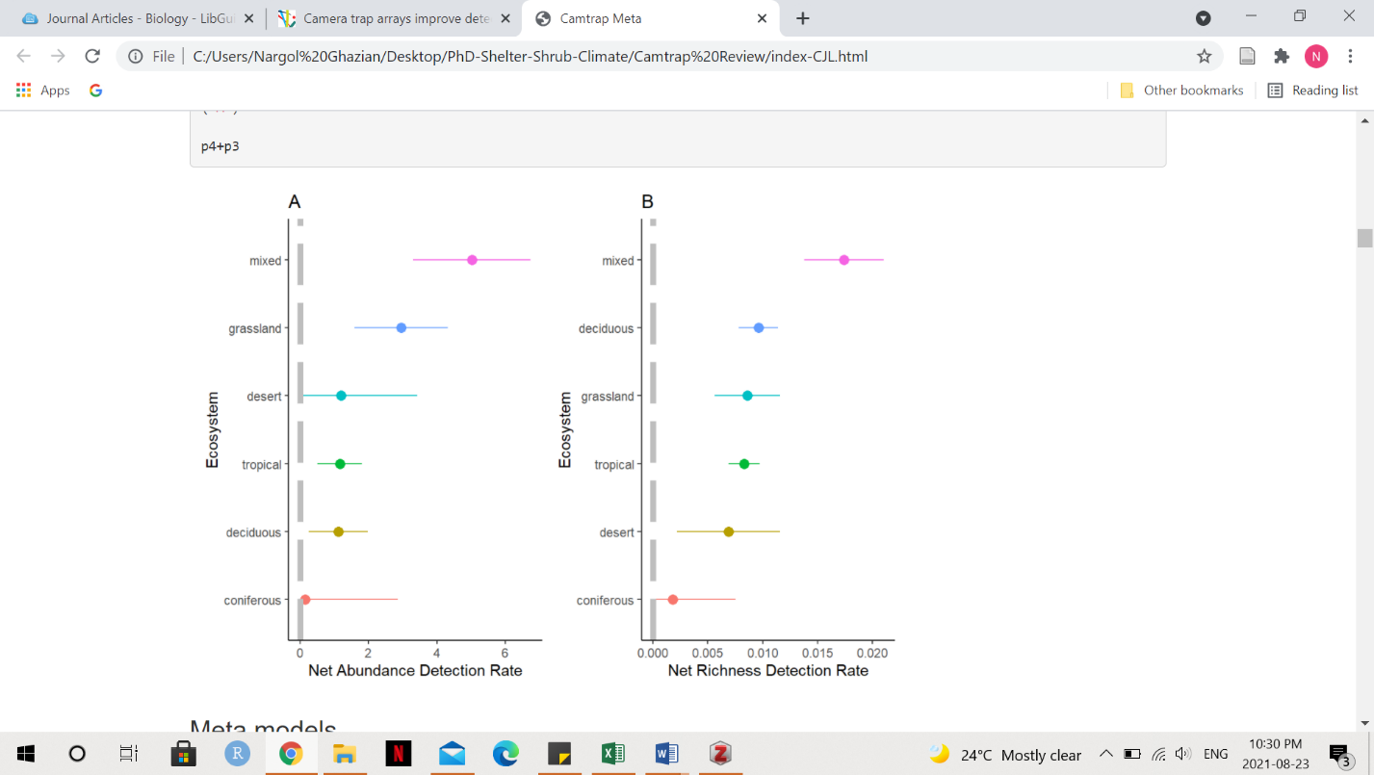

**Figure 1. Forest plots showing estimate effect sizes from random-mixed model output for net abundance detection rate (A, number of animals/number of cameras/number of days) and net richness detection rate (B, number of species/number of cameras/number of days) in 6 different ecosystems of study. Dots represent the meta-analytic mean and dashed lines represent the 95% confidence intervals.**

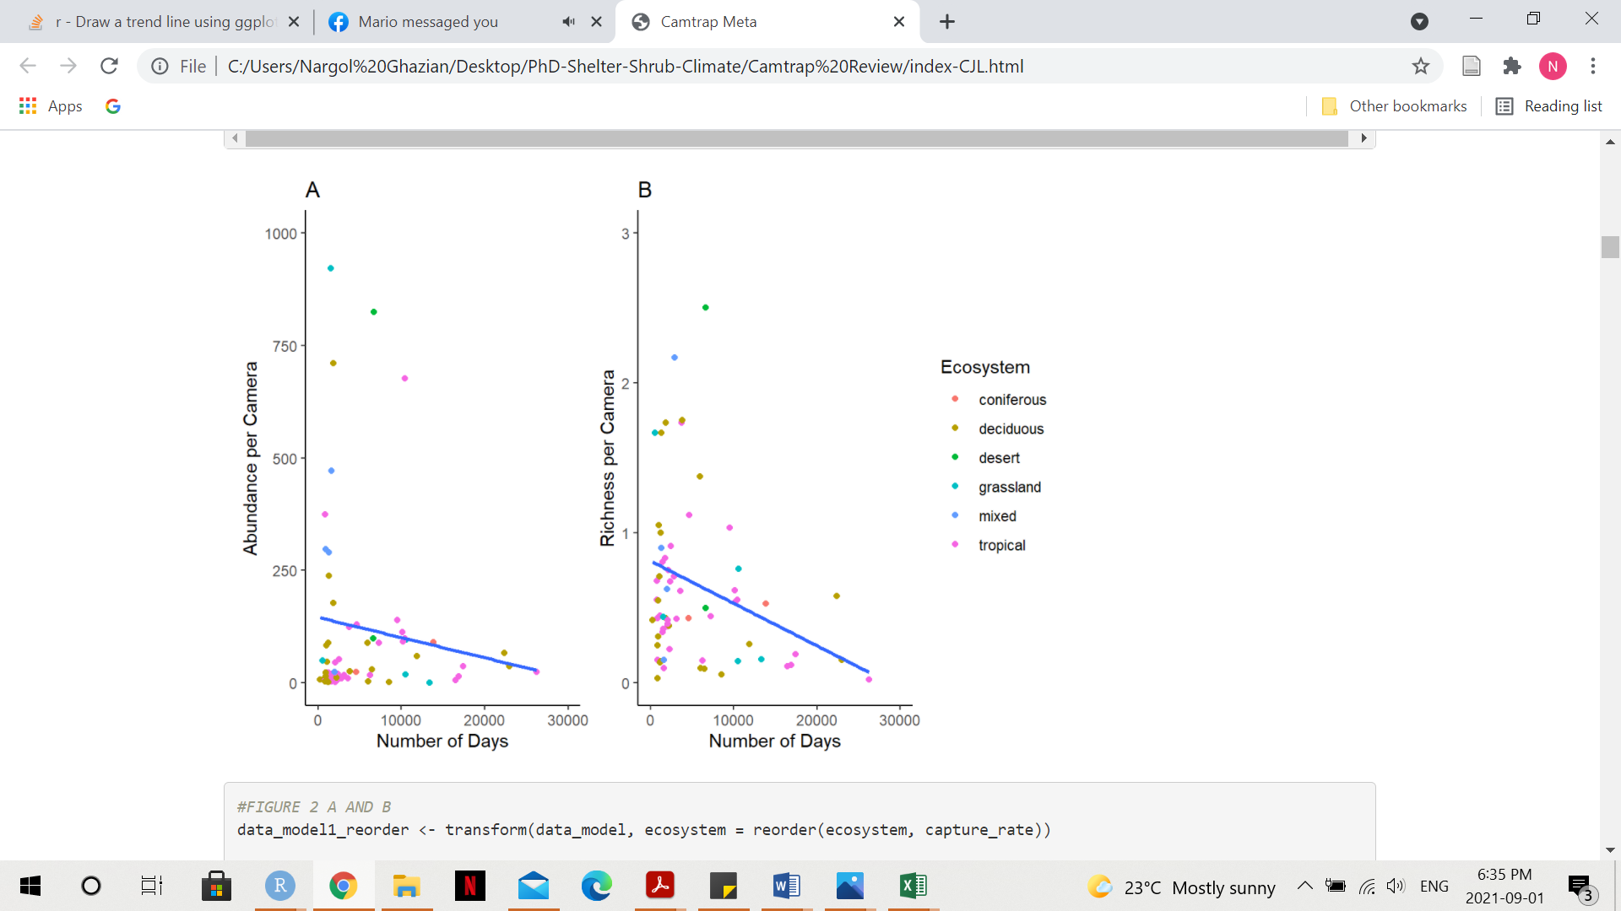

**Figure 2. Weighted regression plot showing the relationship between the number of animals per camera (A) and the number of species per camera (B) throughout the duration of the study (days), weighted by the variation in abundance or richness. Coloured dots represent the ecosystem of study. Blue lines represent smooth conditional mean fitted using the method linear model.**

**Table 1. Mixed-effect model estimates and standard error (SE) for net abundance detection rate (number of animals/number of cameras/number of days) and net richness detection rate (number of species/number of cameras/number) are given. Ecosystem served as a moderator in the model. Significant p-Values are bolded.**

|  |  |  |  |  |  |  |  |
| --- | --- | --- | --- | --- | --- | --- | --- |
| ***Detection Rate*** | ***Ecosystem*** | ***Estimate*** | ***SE(±)*** | ***t-Value*** | ***95% CI.lb*** | ***95% CI.ub*** | ***p-Value*** |
| ***Abundance*** | ***Coniferous*** | 0.1417 | 2.6849 | 0.0528 | -5.2057 | 5.4891 | 0.9580 |
| ***Abundance*** | ***Deciduous*** | 1.0125 | 0.7594 | 1.3333 | -0.5000 | 2.5250 | 0.1864 |
| ***Abundance*** | ***Desert*** | 1.1951 | 2.1922 | 0.5452 | -3.1710 | 5.5612 | 0.5872 |
| ***Abundance*** | ***Grassland*** | 2.9580 | 1.3424 | 2.2035 | 0.2843 | 5.6317 | **0.0306** |
| ***Abundance*** | ***Mixed*** | 6.8013 | 1.5501 | 4.3876 | 3.7139 | 9.8886 | **<0.0001** |
| ***Abundance*** | ***Tropical*** | 1.0870 | 0.6160 | 1.7647 | -0.1398 | 2.3138 | 0.0816 |
| ***Richness*** | ***Coniferous*** | 0.0018 | 0.0063 | 0.2825 | -0.0108 | 0.0144 | 0.7784 |
| ***Richness*** | ***Deciduous*** | 0.0104 | 0.0018 | 5.8472 | 0.0069 | 0.0140 | **<0.0001** |
| ***Richness*** | ***Desert*** | 0.0069 | 0.0052 | 1.3454 | -0.0033 | 0.0172 | 0.1826 |
| ***Richness*** | ***Grassland*** | 0.0086 | 0.0034 | 2.5522 | 0.0019 | 0.0153 | **0.0127** |
| ***Richness*** | ***Mixed*** | 0.0153 | 0.0036 | 4.2010 | 0.0081 | 0.0226 | **<0.0001** |
| ***Richness*** | ***Tropical*** | 0.0077 | 0.0014 | 5.3384 | 0.0048 | 0.0106 | **<0.0001** |

**Table 2. A summary of ways camera trap data uses that can be incorporated in directing management and conservation actions. Implications and descriptions, as well as examples from the literature, are presented.**

|  |  |  |  |
| --- | --- | --- | --- |
| **Use in Conservation or Management** | **Implication** | **Description** | **Illustrative Studies** |
| Examining the types of species living in a region. | **Diversity change** | Monitor the extent of species diversity change to direct conservation action. | Rich et al. 2017 |
| Observing the impacts of changes in spatial and temporal dynamics of an ecosystem. | **Habitat change** | Examine habitat change, such as changes in vegetation dynamic, to make better-informed management decisions. | Sun et al. 2021 |
| Examining wildlife parameters in areas before and after restoration. | **Pre/post-restoration** | Compare and contrast between protected and unprotected sites to examine species richness and community dynamics. | Littlewood et al. 2021  Oberosler et al. 2020 |
| Gathering information about how species in a region interact with artificial structures. | **Artificial structure** | Monitor the use of artificial construction such as electric fences and trenches, wildlife corridors, and acoustic, light-based, and agricultural deterrents that reduce human-wildlife conflict. | Green et al. 2018  Shaffer et al. 2019 |
| Assessing if threatened species have ceased or continue to exist in a given region. | **Presence/absence** | Assess the presence and absence of endangered or hard-to-identify species using camera traps. | Burns et al. 2017 |
| Gathering information about what animals are doing on a daily or in specific situations such as respond to stimuli. | **Animal behaviour** | Assess behaviour such as predator-prey interactions to guide future management efforts of endangered species. | Linkie and Ridout 2010 |

**Supplementary Appendix**

## **Identification**

Papers obtained through database searching (Web of Science) Keywords:

Camera* Trap* AND Richness*, Diversity*, and Rarefaction* Curve*

(n= 716)

(n = 1090)

Papers obtained from other sources, such as book chapter bibliographies

(n= 0)

## **Eligibility**

Records after duplicates removed   
(n = 557)

Records excluded for: relevance, review, opinion or idea paper, focus on one species, qualitative, not English.

Records screened by abstract (n = 557)

## **Screening**

Full-text articles assessed for eligibility (n = 292)

(n = )

Full-text articles excluded:

Not reporting richness or diversity, number of records, and any measure of duration, aquatic studies.

Include in synthesis

(n = 149)

## **Included**

Extracted data:

Location (latitude, longitude), camera trap days, number of records, animal richness, common name, scientific name, year, number of cameras, presence of bait, number of cameras, number of sites, and ecosystem.

**A. PRISMA diagram used for camera trapping effort systematic review (Moher et al. 2009). Search was done with keywords: Camera Trap* and Richness*, or Diversity*, and Camera* Trap* and Rarefaction* Curve* in July of 2021.**

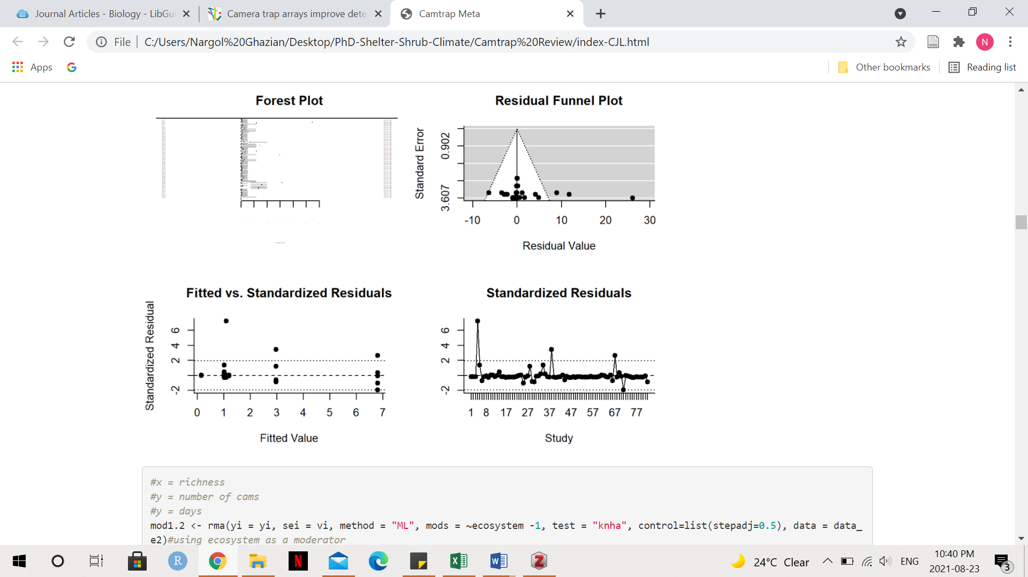

**B. Residual funnel plot from random-effect model for net abundance detection rate estimates.**

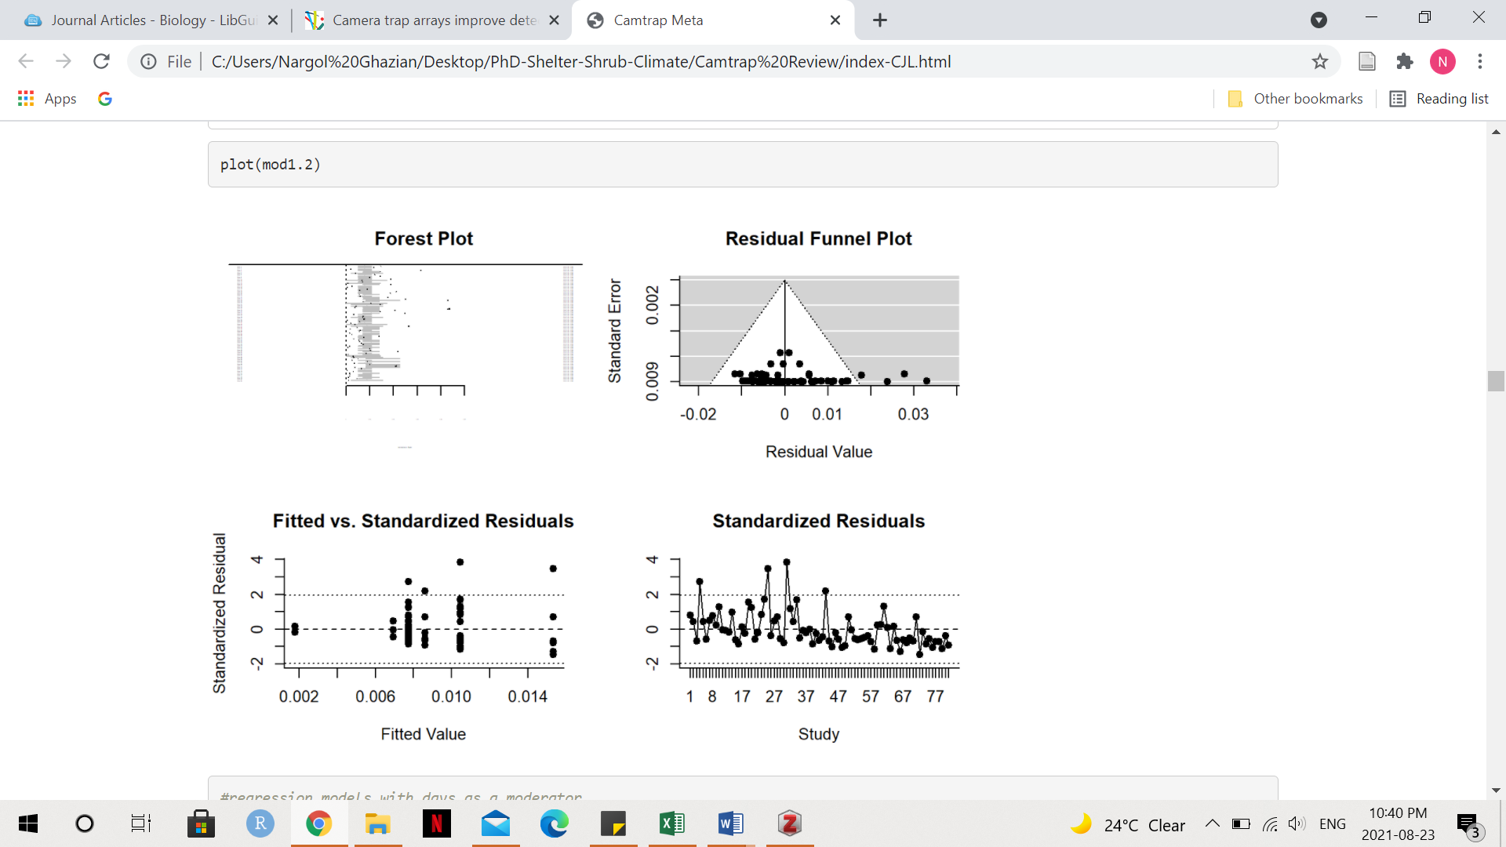

**C. Residual funnel plot from random-effect model for net richness detection rate estimates.**