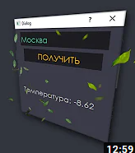

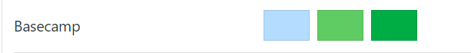

b3dcff

5ecc62

00ad45



05cc47

4dc47d

181a1b



39c2d7

a3c644

464547

b22746

8e244d



66aa33

99cc33

41811e

222222

666666

e8e8e8

e9a820 df8f2d ff6600

ff8800 fabd42fdb913

https://brandcolors.net/