Oscar De Paz

Mr. Baker

Cyber Security

23 June 2023

Intro to Minecraft Python

**Make Sure You Create a Minecraft World Before running code!**

**First Thing to Put in Your Minecraft Code Should Be:**

**import** mcpi.minecraft **as** minecraft

**import** mcpi.block **as** block

**import** math

mc=minecraft.Minecraft.create()

**Code Lines and What They Do:**

mc.player.setPos(**x,y,z**)

(this sets the player position from the coordinates)

mc.setBlocks(**x,y,z, x,y,z, Block #**)

(put in the first coordinate and the second coordinate and just the number of the block)

(This grabs the first coordinate and the second coordinate you put and fills it with the block you choose)

**#=======Block #======**

# Air 0

# Stone 1

# Grass 2

# Dirt 3

# Cobblestone 4

# Wood Planks 5

# Sapling 6

# Bedrock 7

# Water Flowing 8

# Water Stationary 9

#Lava Flowing 10

# Lava Stationary 11

# Sand 12

# Gravel 13

# Gold Ore 14

# Iron Ore 15

# Coal Ore 16

# Wood 17

# Leaves 18

# Glass 20

# Lapis Lazuli Ore 21

# Lapis Lazuli Block 22

# Sandstone 24

# Bed 26

# Cobweb 30

# Grass Tall 31

# Wool 35

# Flower Yellow 37

# Flower Cyan 38

# Mushroom Brown 39

# Mushroom Red 40

# Gold Block 41

# Iron Block 42

# Stone Slab Double 43

# Stone Slab 44

# Brick Block 45

# TNT 46

# Bookshelf 47

# Moss Stone 48

# Obsidian 49

# Torch 50

# Fire 51

# Stairs Wood 53

# Chest 54

# Diamond Ore 56

# Crafting Table 58

# Farmland 60

# Furnace Inactive 61

# Furnace active 62

# Door Wood 64

# Ladder 65

# Stairs Cobblestone 67

# Door Iron 71

# Redstone Ore 73

# Snow 78

# Ice 79

# Snow Block 80

# Cactus 81

# Clay 82

# Sugar Cane 83

# Fence 85

# Glowstone Block 89

# Bedrock Invisible 95

# Stone Brick 98

# Glass Pane 102

# Melon 103

# Fence Gate 107

# Glowing Obsidian 246

# Nether Reactor Core 247

**How to Send your Minecraft code to Someone else's Raspberry pi?**

write: ip = **“The ip of the person you want to send it to”**

**In the line “mc=minecraft.create()” put ip inside the parenthesis so it should look like this mc=minecraft.create(ip)**

**How do you get your IP?**

In terminal write: ip a

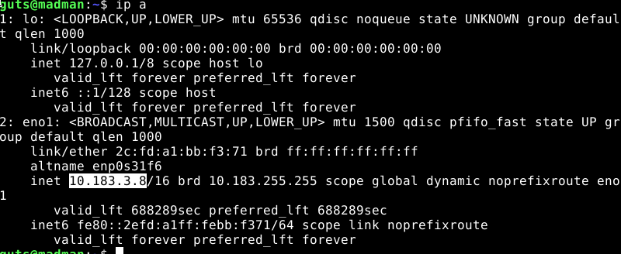

The highlighted part is the numbers you need