Editor Track Add-In for ArcGIS Desktop 10
EditorTrack.esriAddIn is an editor extension Add-In that replaces template variables with actual values when a feature is created or changed.
The extension is configured with an XML file called EditorTrackFields.xml which is contained in the esriAddIn file.
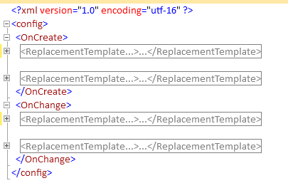
A replacement template can be created for a specific feature class name or for any feature class (i.e. GLOBAL).
Replacement templates inside the OnCreate XML node will only update a field when the feature is created and replacement templates inside the OnChange XML node will only update a field when the feature is modified.
There are built-in field replacements for commonly used items:
{MachineName} - Machine name
{UserName} - User Name
{DomainName} - Domain Name
{NOW} - Current Date/Time
{WKB} - Geometry as WKB
{GEOHASH} - Geometry as Geohash (Point features only).
{EDITVERSION} - Version in which the feature was last modified.
{e:[Environment Variable]} - Environment Variable

In order to set up a global Replacement template, use #GLOBAL# as the FeatureclassName:
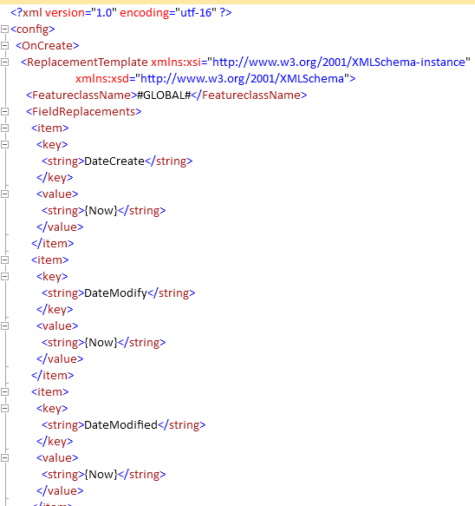

Modifying the EditorTrackFields.xml in the esriAddIn file.

Currently, the EditorTrackFields.xml is in the actual esriAddIn file.
- The esriAddIn file is a zip file with the extension changed to esriAddIn. Open the esriAddIn file with your zip file application (e.g. 7-Zip File Manager).
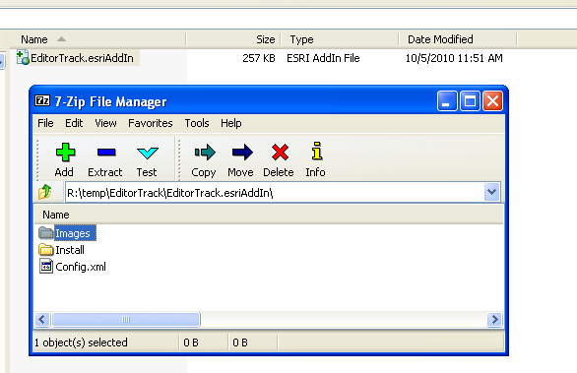
- Extract the EditorTrackFields.xml into a folder.
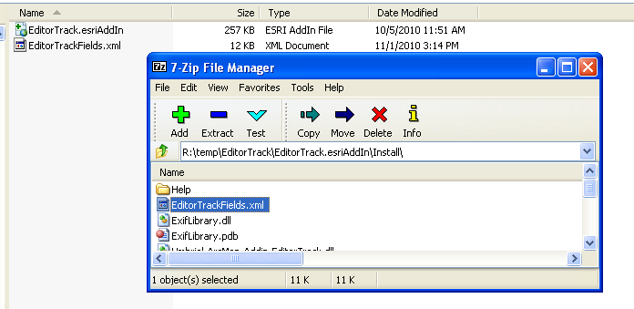
- Modify the XML file using your favorite XML editor.
- Replace the EditorTrackFields.xml file in the zip file with the new one that you modified.
- If the changes don’t take effect, the Assembly Cache or the AddIn folder under My Documents may not have been updated with your latest version of the AddIn. Locate the EditorTrack AddIn and remove. Then re-add your updated AddIn.
My Documents\ArcGIS\AddIns\Desktop10.0
Local Settings\Application Data\ESRI\Desktop10.0\AssemblyCache\

